

SURANA COLLEGE-AUTONOMOUS
Affiliated to Bangalore University
Recognized under 2(f) and 12 B of UGC, Certified by ISO, Re-accredited by NAAC with A+
No 16, South End Road, Bengaluru-560 004

PROJECT REPORT
CRUD OPERATIONS ON PRODUCT INVENTORY MANAGEMENT

WEB PROGRAMMING

Submitted By
ABHISHEK. V U03ME23S0037

NITHISH S U03ME23S0052

Submitted to
The Department of Computer Science

Date of Submission 17 – 11 – 2025

Abhishek V NOVEMBER 2025
Nithish S

We, Abhishek V and Nithish S hereby declare that the project report, entitled "Product Inventory Management " submitted to SURANA COLLEGE - AUTONOMOUS, in partial fulfilment for the curriculum requirement for BACHELOR OF COMPUTER APPLICATIONS done by me during 2025-2026 under the guidance of Prof. Vidya.A, Head Of the Department, Department of Computer Science, SURANA COLLEGE AUTONOMOUS, Bengaluru. It has not formed the basis for the award any Degree/Diploma/Associateship/Fellowship or other similar title to any candidate in any College/University.

Abhishek V Nithish S

Date: 17/11/2025

This is to certify that the Project Report entitled “PRODUCT INVENTORY MANAGEMENT” submitted to Department of Computer Science in partial fulfilment for the curriculum requirement for BACHELOR OF COMPUTER APPLICATIONS done by
ABHISHEK.V U03ME23S0037

during 2025-2026, under the guidance of Ms. Vidya A and Ms. Vidhya H B, Assistant Professor,
Department of Computer Science, SURANA COLLEGE AUTONOMOUS, Bengaluru.

It has not formed the basis for the award of any Degree or other similar title to any candidate in any College.

Project Coordinator Head of the Department

.





Date: 17/11/2025

This is to certify that the Project Report entitled “ PRODUCT INVENTORY MANAGEMENT” submitted to Department of Computer Science in partial fulfilment for the curriculum requirement for BACHELOR OF COMPUTER APPLICATIONS done by
NITHISH S U03ME23S0052

during 2025-2026, under the guidance of Ms. Vidya A and Ms. Vidhya H B, Assistant Professor,
Department of Computer Science, SURANA COLLEGE AUTONOMOUS, Bengaluru.

It has not formed the basis for the award of any Degree or other similar title to any candidate in any College

Project Coordinator Head of the Department

ACKNOWLEDGEMENT

We take this opportunity to express our sincere thanks and wholehearted gratitude to our beloved Principal,
Dr. Veena K N.

We also take this opportunity to express our gratitude to our respected HOD, Ms. Vidya A, for her constant cooperation and support in developing this project.
The satisfaction and successful completion of any task would be incomplete without the mention of people whose ceaseless cooperation made it possible, and whose constant guidance and encouragement crown all efforts with success.
We are grateful to our project guide, Asst. Prof. Vidhya H B, for her guidance, inspiration, and constructive suggestions that helped us in the preparation of this project. We would also like to extend our thanks to all the teachers of the Department of Computer Science for their kind cooperation.
Finally, we would like to thank our parents and friends for their encouragement in completing our project successfully.

ABHISHEK.V NITHISH S

TABLE CONTENTS

Sl.  No. | Content |  | Page No
1 | Chapter 1: | ABSTRACT | 01
2 | Chapter 2: | INTRODUCTION | 02
3 | Chapter 3: | OBJECTIVES | 03-04
4 | Chapter 4: | SYSTEM REQUIREMENTS | 05-06
5 | Chapter 5: | SYSTEM DESIGN | 07-12
6 | Chapter 6: | IMPLEMENTATION | 13-17
7 | Chapter 7: | RESULTS AND OUTPUT | 18-21
8 | Chapter 8: | CONCLUSION | 22
9 | Chapter 9: | REFERENCES | 23

CHAPTER 1: ABSTRACT

This project is a fundamental Inventory Management System designed to teach and demonstrate core database operations. Built using PHP for server-side logic and MySQL for data storage (accessed via phpMyAdmin), the system focuses on implementing the essential CRUD (Create, Read, Update, Delete) functionalities required for managing product inventory. The application allows users to effectively add new products, display current stock records (including pricing and supplier details), modify existing entries (such as updating price or quantity), and delete obsolete items. The frontend utilizes HTML, CSS, and JavaScript to provide a responsive and accessible interface.
By integrating these technologies, the system offers practical, hands-on experience in PHP-MySQL integration, dynamic form handling, and applying basic inventory logic, making it an ideal exercise in foundational database-driven web development.
Functionally, the application allows users to add new products, view all inventory records (including stock and pricing), modify existing product details (like quantity or price), and delete obsolete entries.
It serves as a core, practical exercise demonstrating effective PHP-MySQL integration, dynamic form handling, and the application of basic inventory logic within a data-driven web environment. This blend of technologies not only delivers a functional system but also provides hands-on experience across the full stack from interface design and dynamic forms to robust backend scripting and database interaction—serving as a crucial foundation for aspiring backend and full-stack developers.

CHAPTER 2: INTRODUCTION

Overview of the Project:

The modern business landscape, characterized by high volumes of transactions and diverse product lines, necessitates sophisticated and reliable methods for managing physical and digital assets. This project, Product Inventory Management System, addresses this need by creating a foundational, database-driven web application designed to efficiently track and manage product stock. Built using the LAMP stack specifically PHP for server-side execution, MySQL for data persistence, and HTML, CSS, and JavaScript for the responsive user interface the system provides a comprehensive platform for the systematic entry, retrieval, modification, and deletion of inventory records.
Importance of CRUD Operations in Applications:

At the heart of every functional data-driven application are the four fundamental operations: Create, Read, Update, and Delete (CRUD). These operations constitute the lifeblood of data interaction, defining how information flows between the client layer and the persistent storage layer (the database). The successful implementation of CRUD is crucial as it governs data integrity, enables real-time changes to be recorded, and ensures the application accurately reflects the current state of the inventory. Therefore, mastering the technical implementation of CRUD via server-side scripting is essential for understanding the architecture and flow of full-stack development.
Aim and Scope of the Project:

The primary aim of this project is to successfully implement all four CRUD operations for managing product inventory data. This involves establishing a stable, secure connection between the PHP backend and the MySQL database, utilizing effective SQL commands to manipulate data, and presenting the information clearly to the user. The scope of this project is focused specifically on the management of core product attributes, including unique identifiers, product name, current quantity in stock, unit price, and primary supplier information.
This exercise serves as a critical foundation in database interaction and dynamic web content generation, demonstrating core skills required for developing more complex enterprise applications.

CHAPTER 3: OBJECTIVE

The primary objective of this project is to build a functional, database-driven Product Inventory Management System capable of executing all four fundamental CRUD operations. This involves designing a responsive user interface and a corresponding MySQL database schema to ensure accurate data storage. Furthermore, the goals extend beyond basic functionality to include promoting data integrity through robust validation, automating the tracking of stock levels to minimize manual errors, and developing a clear Managerial Dashboard for full control over product and supplier data. The overarching goal is to gain practical experience in integrating client-side design with PHP server-side logic, showcasing how technology can transform logistical challenges into efficient, data- driven processes.
The specific objectives of this project are as follows:

- Interface Design: To design an interactive, user-friendly, and responsive interface that simplifies navigation for the Inventory Manager, ensuring smooth access across various devices.
- CRUD Implementation: To implement Create, Read, Update, and Delete (CRUD) operations effectively, allowing managers to manage Product Listings and Supplier Profiles.
- Security and Validation: To establish robust data validation mechanisms that protect the database from invalid entries (e.g., negative stock, non-numeric prices) and ensure system integrity.
- Database Integration: To integrate a robust MySQL database for efficient data storage, retrieval, and management, ensuring consistency and reliability of all product and supplier information.
- Dashboard Development: To develop a clear dashboard for the Inventory Manager that allows for full CRUD management of all product listings and Read and Update access to supplier details.

- Data Integrity and Traceability: To promote accuracy and trust by ensuring every stock change is accurately recorded and that the system prevents data conflicts, such as entering negative stock.
- Technical Awareness: To enhance technical awareness by showcasing how modern web technologies can transform traditional logistical challenges into smart, data-driven platforms for efficient business operations.
- Scalability: To create a scalable and extendable platform that can be further improved by integrating advanced features like Barcode Scanning, Stock In/Stock Out tracking, or Advanced Reporting in future iterations.

CHAPTER 4: SYSTEM REQUIREMENTS

To develop and test the CRUD-based Student Management System, the following system configuration was used. These requirements ensure smooth performance, reliable database connectivity, and proper execution of all web functionalities.
Since the system is built using PHP and MySQL within a XAMPP environment It can be implemented efficiently on any standard computer system with moderate specifications

  - Hardware Requirements
The project was developed on a machine with the following specifications:
    - Processor: Intel Core i5 / AMD Ryzen 5 (or equivalent)
    - RAM: Minimum 16 GB (Recommended for multitasking, running the local server, and
    - browser testing)
    - Storage: At least 30 GB of free disk space for project files, XAMPP installation, and
    - database storage.
    - Hard Disk: 1024 GB SSD (Solid State Drive) preferred for better performance.
    - Display: 1024 × 768 resolution or higher for proper interface visualization.
    - Input Devices: Standard keyboard and mouse for navigation and data entry.
    - Network Connectivity: Stable internet or local network connection for hosting and
    - accessing the application during testing.

The above configuration is sufficient for developing and running the web-based application in a local or institutional environment. For large-scale implementation, higher specifications and dedicated server systems are recommended.

  - Software Requirements

The software stack and tools used include:
    - Operating System: Windows 10 or later / macOS / Linux (Ubuntu preferred for open-
    - source environment).
    - Development Environment: Visual Studio Code, php Storm, or Sublime Text (for
    - editing HTML, CSS, PHP, and JavaScript files).
    - Local Server Package: XAMPP (includes Apache, PHP, and MySQL) for local
    - hosting and database management.
    - Backend Technology: PHP 8.0+ for server-side scripting and logic execution.
    - Database: MySQL (5.7+ or MariaDB 10.0+) for storing and retrieving user, profile,
    - and donation data.
    - Frontend Technologies: HTML5, CSS3, and JavaScript for user interface design and
    - interactivity.
    - Browser: Google Chrome, Mozilla Firefox, or Microsoft Edge for running and testing
    - the application.
    - Version Control (Optional): Git/GitHub for project version tracking and
    - collaboration.

These software components ensure that the project runs efficiently, allowing the developer to design, test, and deploy all modules within a controlled and secure environment.

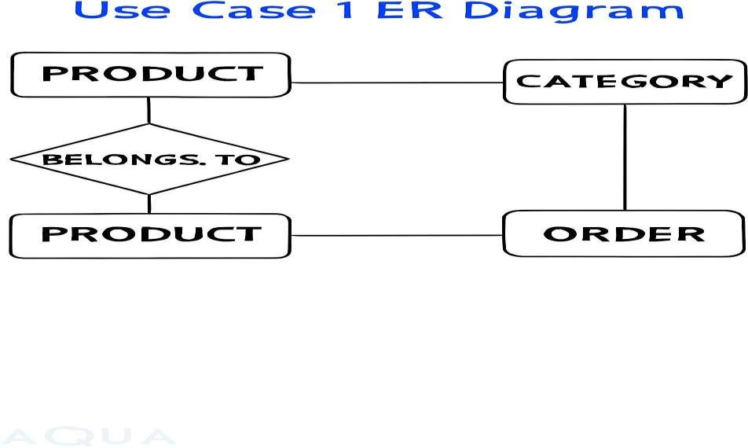

CHAPTER 5: SYSTEM DESIGN
  - ER Diagram (Entity Relationship Diagram)
The Entity-Relationship Diagram represents the logical relationships between different entities involved in the “Product Inventory Management”. It illustrates how data such as users, products, and the donations themselves are connected within the system database. This diagram illustrates the logical structure of the database, showing the entities, their attributes.

Entity | Attributes | Key | Relationship
User | User ID, Username, Full Name, Email, Password Hash | PRIMARY KEY:  User ID | 1: N with Product (One User can manage Many Products)
Product | Product ID, User ID, SKU, Name, Price, Stock Quantity, Category, Summary, Image URL | PRIMARY KEY:  Product ID, FOREIGN-KEY:  User ID | N:1 with User

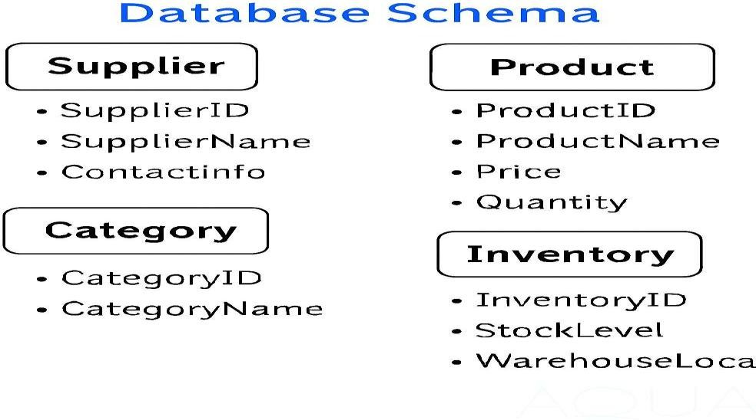

  - Database Schema:

This is the SQL representation of the ER diagram, defining the tables and their columns. Table: Users (Stores user authentication and profile information)
CREATE TABLE Users (
User id INT PRIMARY KEY AUTO_INCREMENT, username VARCHAR (50) NOT NULL UNIQUE,
password hash VARCHAR (255) NOT NULL, -- Storing a hash of the password email VARCHAR (100) UNIQUE,
full name VARCHAR (100),
created at TIMESTAMP DEFAULT CURRENT_TIMESTAMP
);
Table: Products (Stores all inventory items managed by a user) CREATE TABLE Products (
Product id INT PRIMARY KEY AUTO_INCREMENT,
user_ id INT NOT NULL,
sku VARCHAR (50) NOT NULL UNIQUE, -- Stock Keeping Unit name VARCHAR (255) NOT NULL,
price DECIMAL (10, 2) NOT NULL,

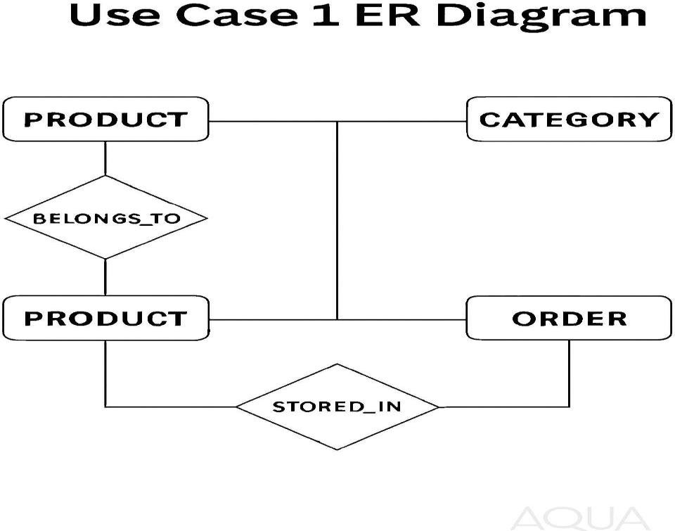

stock quantity INT NOT NULL DEFAULT 0, category VARCHAR (100),
summary TEXT,
image URL VARCHAR (255),
created at TIMESTAMP DEFAULT CURRENT_TIMESTAMP,
updated at TIMESTAMP DEFAULT CURRENT_TIMESTAMP ON UPDATE CURRENT_TIMESTAMP,
Define Foreign Key relationship
FOREIGN KEY (user id) REFERENCES Users (user id) ON DELETE CASCADE
);.
  - Use Case Diagrams (2 Use Cases):
Use Case diagrams illustrate the functional requirements of the system by showing how different actors interact with the system.
    - Use Case Diagram 1: User Authentication & Account Management:
This diagram focuses on the access control and user profile features of the system.

PRODUCT: Represents individual items available for sale or stock. Attributes typically include Productid, ProductName, Price, and Quantity.
      - CATEGORY: Defines logical groupings of products (e.g., Electronics, Apparel, Groceries). Attributes include Category id and Category Name.
      - INVENTORY: Captures physical storage details such as Inventory id, Stock Level, and Warehouse Location.
      - Relationships:
      - PRODUCT → BELONGS_TO → CATEGORY
This relationship ensures that every product is assigned to a specific category. It supports: Easier filtering and browsing by category.
Category-level analytics (e.g., sales trends, stock turnover). Streamlined product management for suppliers and managers.
      - PRODUCT → STORED_IN → INVENTORY
This relationship maps each product to its physical storage location. It enables:
      - Real-time stock level tracking.
      - Efficient warehouse operations (e.g., restocking, retrieval).
      - Location-based inventory audits and optimization. Strategic Relevance:
This ER model is crucial for systems that require both logical classification and physical traceability of products. It supports:
      - Multi-category product listings.
      - Distributed inventory systems across multiple warehouses.
      - Integration with order processing and supplier modules.

Graph TD:
subgraph System Boundary: Inventory Tracker UC1[Sign Up]
UC2[Log In] UC3[Log Out] UC4[Forgot Password] end

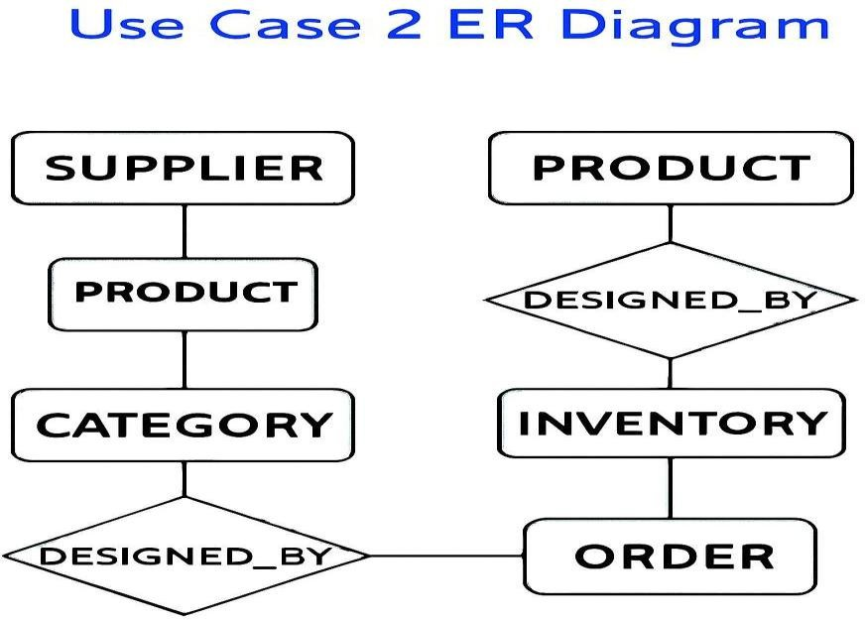

A[User] -- interacts with --> UC1 A -- interacts with --> UC2 A -- interacts with --> UC3 A -- interacts with --> UC4
UC2 --> Logged in Session (Session Started)): <<includes>>

    - Use Case Diagram 2: Inventory Management (CRUD Operations):
This diagram focuses on the core functionality of managing product data within the inventory.

This expanded ER diagram captures the broader operational flow involving Supplier, Product, Order, Category, and Inventory.
      - Suppliers are connected to Products through the SUPPLIES relationship, denoting sourcing origins.
      - Each Product is linked to an Order via PRODUCED_BY, and the Order is further tied to a Category through DESIGNED_BY, reflecting product planning and classification.

      - The Inventory entity is connected to Product through CONTAINS, indicating stock levels and warehouse placement.
This structure supports procurement, order tracking, and inventory control across multiple dimensions.
Graph TD:
subgraph System Boundary: Product Inventory Management UC1[Manage Products]
UC2[View Dashboard/Reports] UC3[Search/Filter Products]

UC1 -- <<includes>> --> C [Add Product (Create)] UC1 -- <<includes>> --> R [View Products (Read)]
UC1 -- <<includes>> --> U [Update Product Details (Update)] UC1 -- <<includes>> --> D [Delete Product (Delete)]
end

B [Authenticated User] -- interacts with --> UC1 B -- interacts with --> UC2
B -- interacts with --> UC3.

CHAPTER 6: IMPLEMENTATION
CRUD Operation Details:
  - Create: How New Records are Added
<?php
include 'db_connect.php'; header('Content-Type: application/json');
$response = ['success' => false, 'message' => 'An error occurred.'];
$name = $_POST['name'] ?? '';
$price = $_POST['price'] ?? 0;
$summary = $_POST['summary'] ?? '';
$image_path = null;
// Handle file upload
if (isset($_FILES['image']) && $_FILES['image']['error'] == 0) {
$target_dir = "../uploads/";
$image_name = time() . '_' . basename($_FILES["image"]["name"]);
$target_file = $target_dir . $image_name;
// Move the uploaded file to the 'uploads' directory
if (move_uploaded_file($_FILES["image"]["tmp_name"], $target_file)) {
$image_path = "uploads/" . $image_name;
} else {
$response['message'] = 'Failed to upload image.'; echo json_encode($response);
exit;
}
}
$stmt = $conn->prepare("INSERT INTO products (name, summary, price, image_path) VALUES (?, ?,
?, ?)");
$stmt->bind_param("ssds", $name, $summary, $price, $image_path);

if ($stmt->execute()) {
$response['success'] = true;
$response['message'] = 'Product added successfully!';
} else {
$response['message'] = 'Database error: ' . $stmt->error;
}

$stmt->close();
$conn->close();
echo json_encode($response);
?>

The Create operation adds a new Product record to the database.
- User Action: The user fills out the form in add.html and clicks the "Add Product" button.
- Client-Side (JavaScript - from add.html):
  - The form data, including text fields and the Product Image file, is packaged into a Form Data object.
  - An asynchronous fetch request is sent using the POST method.
  - The request target is the backend PHP script responsible for creation:Api /create product

  - Read: How Data is Displayed or Fetched:

<?php
include 'db_connect.php'; header('Content-Type: application/json');
$result = $conn->query("SELECT id, name, summary, price, image_path FROM products ORDER BY created_at DESC");
$products = [];
if ($result->num_rows > 0) {
while($row = $result->fetch_assoc()) {

$products[] = $row;

}
}
echo json_encode($products);
$conn->close();
?>

Client-Side (JavaScript - from sim.html):
- A function (load Products or equivalent) is called on page load.
- An asynchronous fetch request is sent using the GET method to a dedicated read endpoint.
- The received JSON data (an array of product objects) is iterated over, and corresponding HTML table rows (<tr>) are dynamically constructed and inserted into the product table.

Update: How Existing Data is Modified
<?php
include 'db_connect.php'; header('Content-Type: application/json');

// We are getting data as JSON from the frontend
$data = json_decode(file_get_contents('php://input'), true);

$id = $data['id'];
$name = $data['name'];
$summary = $data['summary'];
$price = $data['price'];

$stmt = $conn->prepare("UPDATE products SET name = ?, summary = ?, price = ? WHERE id = ?");
$stmt->bind_param("ssdi", $name, $summary, $price, $id);
if ($stmt->execute()) {
echo json_encode(['success' => true, 'message' => 'Product updated successfully.']);
} else {
echo json_encode(['success' => false, 'message' => 'Error updating product: ' . $stmt->error]);
}

$stmt->close();
$conn->close();
?>

- User Action: The user clicks the Edit button in the product table, an edit modal pops up, the user changes fields, and clicks Save Changes.
- Client-Side (JavaScript - from sim.html):
- The "Save Changes" button listener collects the updated data from the modal form fields.
- The data (including the hidden id of the product) is converted into a JSON string.
- An asynchronous fetch request is sent using the POST method to the update endpoint: Api/update, product. Php

6.4.Delete: How Data is Removed:

<?php

include 'db_connect.php'; header('Content-Type: application/json');
$data = json_decode(file_get_contents('php://input'), true);

$id = $data['id'];

// Optional: Also delete the image file from the server

$stmt_select = $conn->prepare("SELECT image_path FROM products WHERE id = ?");

$stmt_select->bind_param("i", $id);

$stmt_select->execute();
$stmt_select->bind_result($image_path);
$stmt_select->fetch();

$stmt_select->close();

if ($image_path && file_exists('../' . $image_path)) { unlink('../' . $image_path);
}

// Delete the record from the database

$stmt_delete = $conn->prepare("DELETE FROM products WHERE id = ?");

$stmt_delete->bind_param("i", $id);

if ($stmt_delete->execute()) {

echo json_encode(['success' => true, 'message' => 'Product deleted successfully.']);

} else {

echo json_encode(['success' => false, 'message' => 'Error deleting product: ' .
$stmt_delete->error]);

}

$stmt_delete->close();

$conn->close();

?>

- User Action: The user clicks the Delete button next to a product on the table.
- Client-Side (JavaScript - Inferred logic from sim.html):
- The Product ID is retrieved from the button's data attribute (data-id).
- A confirmation dialog is typically displayed for safety.
- An asynchronous fetch request is sent to the delete endpoint (e.g., Api/delete product. php), typically including the ID in the request body or URL.


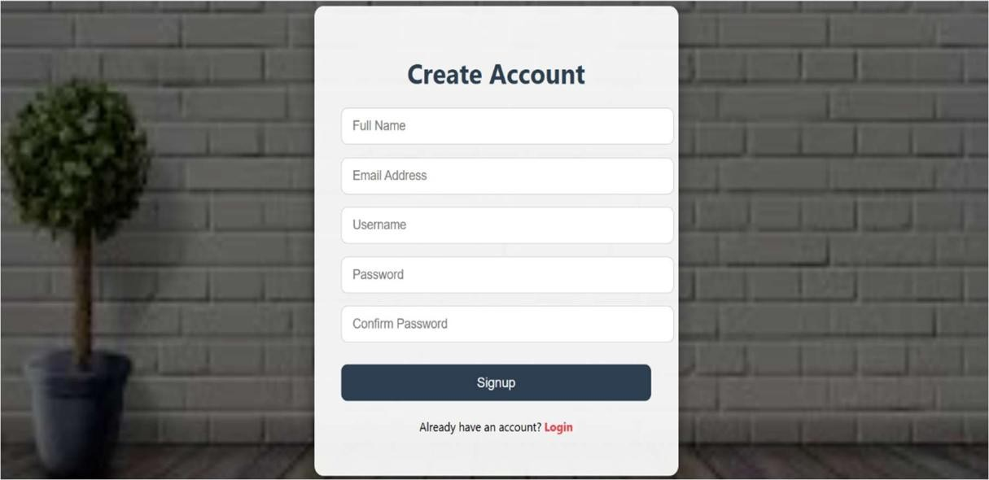

CHAPTER 7: RESULTS AND OUTPUT
Fig 7.1

Fig 7.2

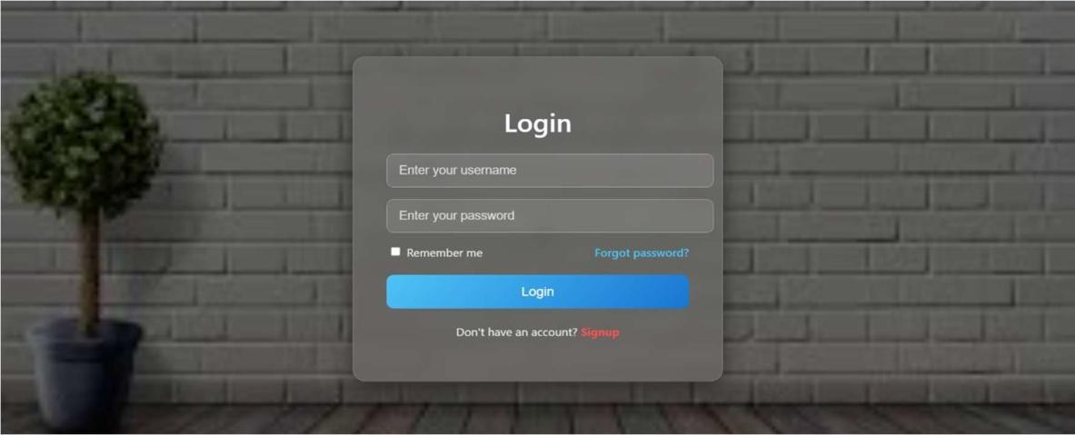
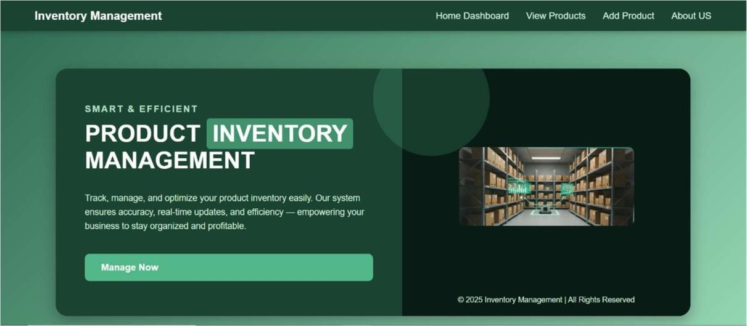
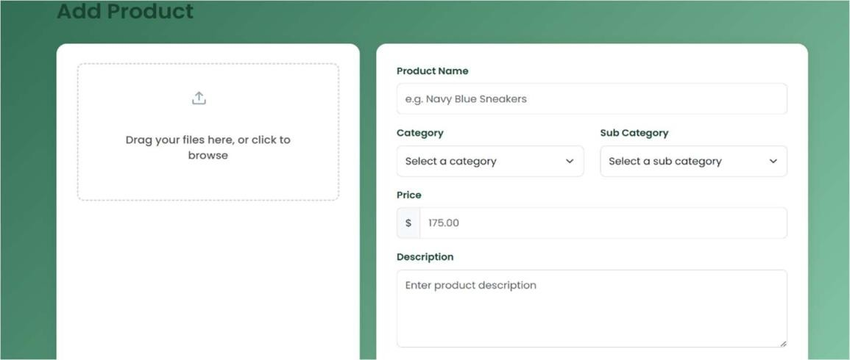

Fig 7.3

Fig 7.4

Fig 7.5

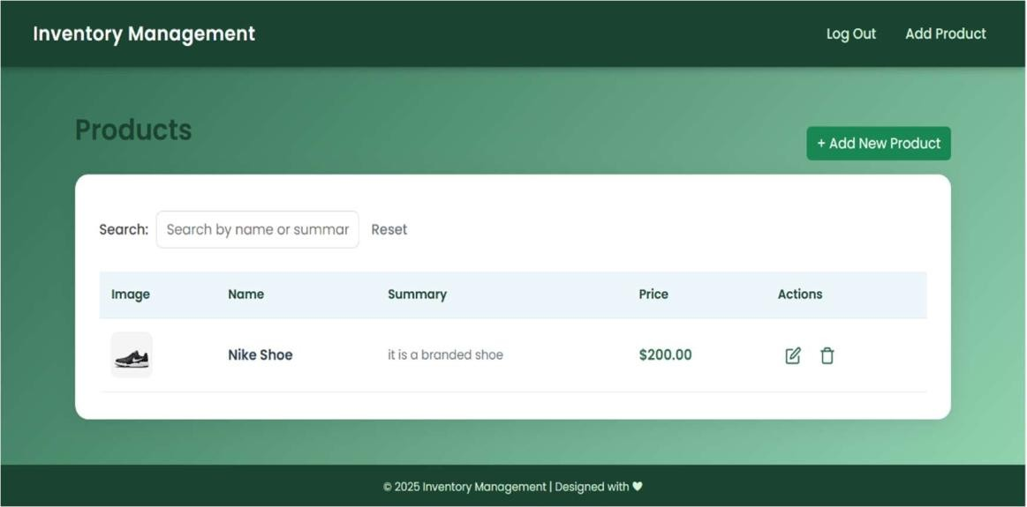



Fig 7.6

Fig 7.7

Fig 7.8

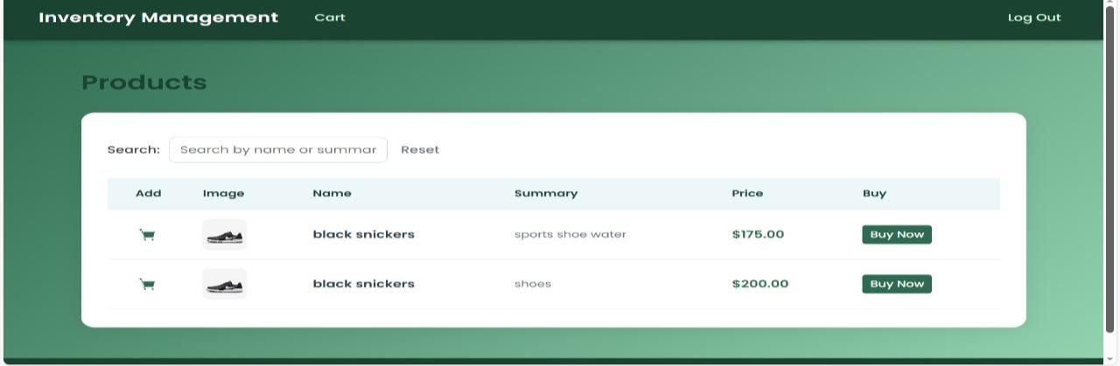
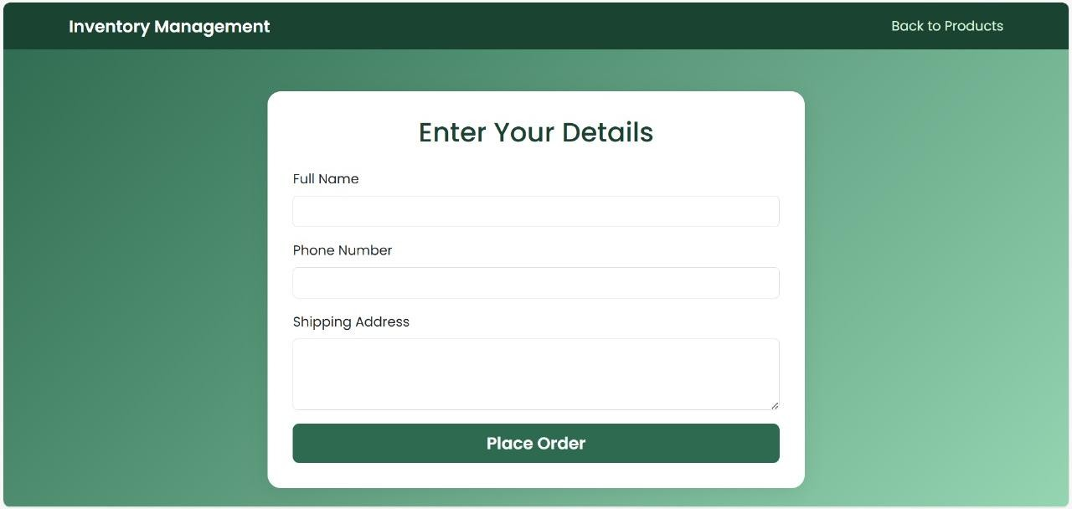
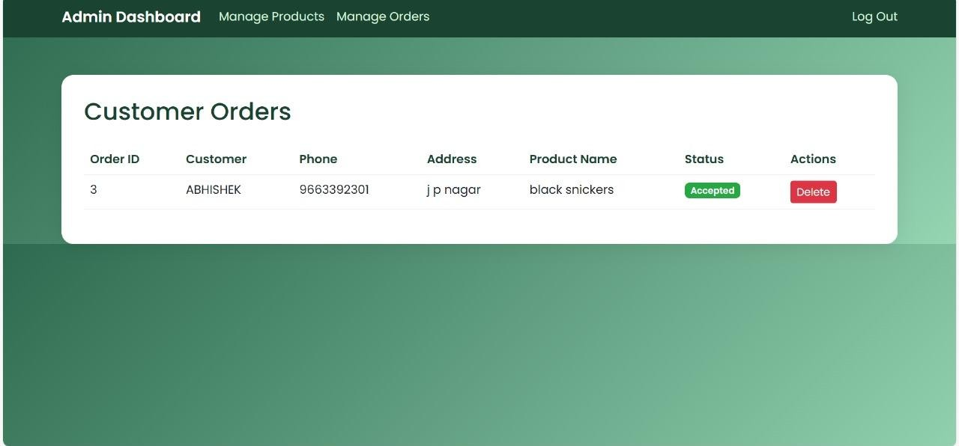

Fig 7.8

Fig 7.9

Fig 7.9

CHAPTER 8: CONCLUSION

- Key Learning Outcomes:

- The project successfully demonstrated the complete lifecycle of a web application: designing a database schema, building an interactive user interface, and implementing the data persistence layer. The key takeaway is the practical understanding of Full-Stack Integration, specifically how client-side events (JavaScript) trigger server-side logic (PHP) to manipulate data stored in a relational database (MySQL).
- Project Significance
- This system serves as a foundational exercise, proving competence in the CRUD paradigm the functional core of nearly all database-driven applications. It shows mastery over AJAX/JSON data handling and the essential requirement of separating client-side presentation from secure server-side processing.
- Scope for Future Enhancement
- The project is ready for advanced development in three major areas:

- Security: Implement robust server-side input sanitization and transition from simple alerts to secure Session/JWT-based authentication.
- Scalability: Separate the product data by introducing a Category entity to improve filtering and reporting.
- Advanced Features: Develop reporting tools (e.g., total value calculation, low-stock alerts) and implement a sophisticated Stock In/Stock Out tracking system to manage inventory levels beyond a simple quantity field.

CHAPTER 9: REFERENCES

The following websites, books, and documentation were utilized during the development of the Inventory Management System, specifically for understanding and implementing the full-stack architecture and CRUD operations:
Category Reference Purpose

Official Documentation

MDN Documentation (Mozilla Developer Network)
Comprehensive guides on JavaScript syntax, especially the fetch API for asynchronous communication and DOM manipulation.

Official Documentation

https://www.mysql.com
Reference for SQL syntax, database design principles, and structuring the Users and Products tables.

Official Documentation

https://getbootstrap.com
Documentation for the Bootstrap 5 framework, used for responsive styling, components (like the navigation bar and modals in sim.html), and general layout.

Tutorials & Education

https://www.w3schools.com
Quick reference for fundamental HTML structure, CSS properties, and basic PHP/MySQL data handling examples.

Framework & Language

PHP Manual (php.net)
Documentation for server-side logic, handling POST requests, managing Form Data (especially file uploads in api/create-product.php), and interacting with the database layer

