# Predicting Train Arrival Status Project

## Adanna Alutu

## July 27, 2017

Performance summary of Random Forest model at different **ntree** values:

R-squared @ntree = 22

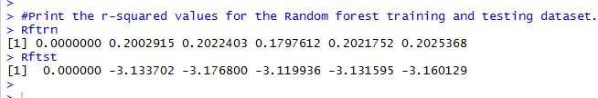

R-squared @ntree = 15

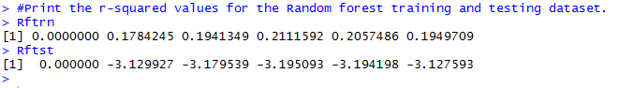

R-squared @ntree = 10

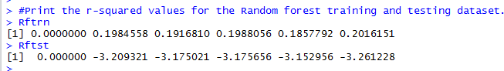

R-squared @ntree = 5

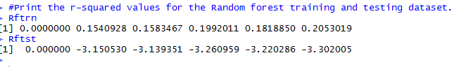

R-squared @ntree = 1

