Tool Installation and Setup Instructions

AADL Architecture Models

# Import the UxAS Project

In OSATE, go to File -> Import. Choose “Existing Projects into Workspace.” Click “Next >”.

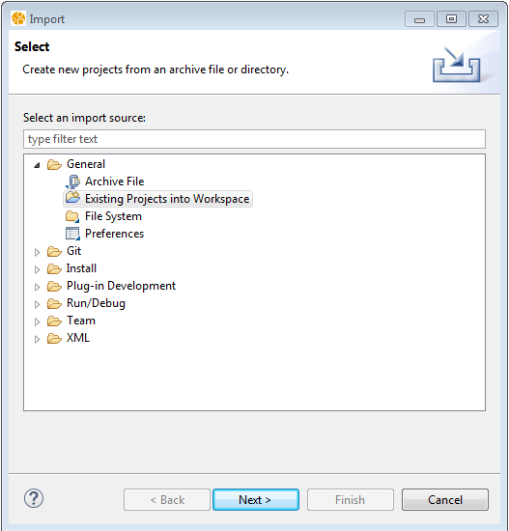

Browse to the AADL_Project directory under the OpenUxAS folder on the architecture branch of the OpenUxAS git repository. Select “UxAS” and click “Finish.”

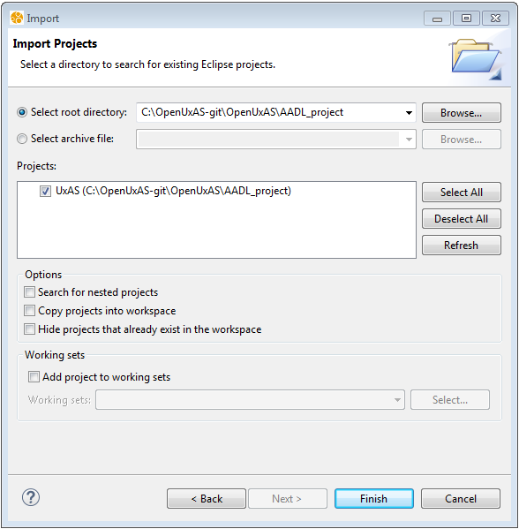

You should now see the UxAS project under the AADL Navigator window on the left-hand-side of OSATE.

