UNCLASSIFIED

 |  | REFERENCES | ISSUE | DATE








µXAV Layer 1 EPS Architectural Specification
Draft

SCOPE

Page : 1 / 11

This document is the intellectual property of RESSAC members It may not be used, reproduced, modified or disclosed without its authorization.
RESSAC members Proprietary Data.

signatures
 | REFERENCES | APPROVERS
 |  | Fonction 1

 |  | Name 1
 |  | Fonction 2

 |  | Name 2
 |  | Fonction 3

 |  | Name 3
 |  | Fonction 4
 |  | Name 4
 |  | Fonction 5
 |  | Name 5

Table of contentS
1. PREAMBLE 4
1.1 Document issues 4
1.2 Executive Summary 4
2. references 5
3. acronyms 6
4. Purpose of the document 8
5. overview 9

PREAMBLE

Document issues
Date | Issue | Author(s) | Updating purpose
18/10/2017 | 1 | E. Ledinot | Creation of the document.

Executive Summary
The document describes the architecture of the Electrical Propulsion System, increment after increment.
It gives some implementation characteristics assigned to the electrical components of the system.

references
[1] µXAV Lifecycle Process
[2] µXAV layer 0 Architectural Specification

acronyms
Acronym | Definition
ATC | Air Traffic Control
AV | Air Vehicle
AWC | Adverse Wind Conditions
BAT | Battery
BITE | Built-In Test Equipment
CCA | Common Cause Analysis
CL | Confidence Level
CMA | Common Mode Analysis
CPS | Cyber Physical System
ECU | Electronic Control Unit
EPS | Electrical Propulsion System
FB | Failure Bit
FC | Fuel Cell
FCs | Failure Conditions
FCS | Flight Control System
F_BC | Function Braking Control
F_CM | Function Communication Management
F_EL | Function Emergency Landing
F_EM | Function Energy Management
F_MC | Function Mission Control
F_MM | Function Mission Management
F_PC | Function Propulsion Control
FDIR | Fault Detection Isolation Recovery
FWC | Favourable Wind Conditions
GNC | Guidance Navigation Control
HBS | Hydraulic Braking System
HVCC | High Voltage Continuous Current
ICD | Interface Control Document
IS | International System (of physical units)
ISO OSI | International Standard Organisation Open Systems Interconnection
kt | Knot
LED | Light Electroluminescent Diode
MMI | Man Machine Interface
MS | Maintenance System
MMS | Mission Management System
MTOW | Maximal Take-Off Weight
MTTR | Mean Time To Repair
n.m | nautic miles
PDI | Parameter Data Item
PEPS | Primary Electrical Power Source
PI | Proportional Integral
SEPS | Secondary Electrical Power Source
SIC | Standard Icing Conditions
SWC | Standard Wind Condition
UAV | Unmanned Air Vehicle

Purpose of the document
This document is needed to:
- Map EPS’ functions on EPS’ resources,
- Perform EPS’ PSSA and SSA,
- Specify implementation constraints to suppliers (ICDs).
It describes the resource types, some of their physical constraints, and their interconnection, to implement EPS.
As no actual implementation is planned, description is shallow.
Information is provided as far as needed by the safety assessment activities, simulation, or model-based dimensioning.

overview
Reminder of layer 0 architecture:
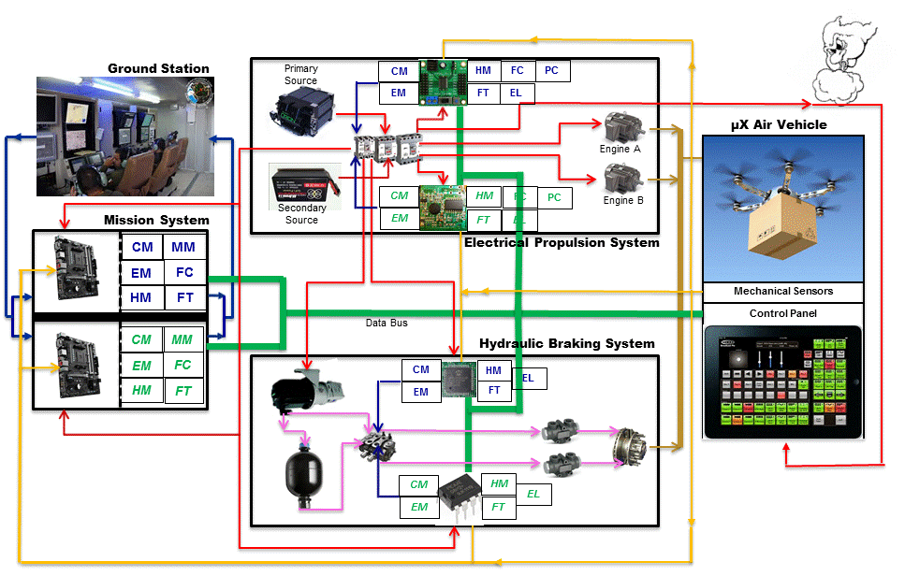
See [2] for a comprehensive account of electrical wiring and digital connectivity.
EPS has a dual-source dual-controller architecture to meet the allocated safety and availability requirements (handled by the safety process).
The controllers are hardware COTS.
EPS provides two electrical sources, the primary (whose technology is to be chosen and dimensioned) and the secondary (Li-Ion battery).
The primary source is energy efficient and the secondary one is power efficient. They have complementary roles and operate jointly under computerized control.
Two adaptors (2-redundancy for fail-safe design) are in charge of modulating the tensions delivered by the two sources to the two engines, depending on the commanded propulsion torque.
The tensions delivered to the DC motors (two identical DC motors fixed on the same propeller shaft) must be such that the sum of the resulting torques is close to the propulsion torque commanded by MMS. The engines can fail independently, with the same failure rate λ.
EPS entails a computer controlled crossbar for all current/voltage switches. The crossbar is unique because its reliability (electromechanical device) is good enough for the quantified safety, availability, and reliability objectives.
- The design is High Voltage Continuous Current (HVCC): the primary and the secondary sources deliver 270V tension,
- The two propulsion engines are DC motors,
- The secondary source is a Li-Ion battery. Its energy and power densities are respectively ~150Wh/kg and ~400W/kg. Its mass is a design parameter.
In EPS Incr2
- Primary electrical energy source,
- Computer-controlled voltage modulator,
- Computer-controlled multiple-switch for reconfigurable power supply,
- Electrical engine fixed to the master shaft,
- Electronic Control Unit (ECU), with DC/AC converters,
- Electrical wiring,

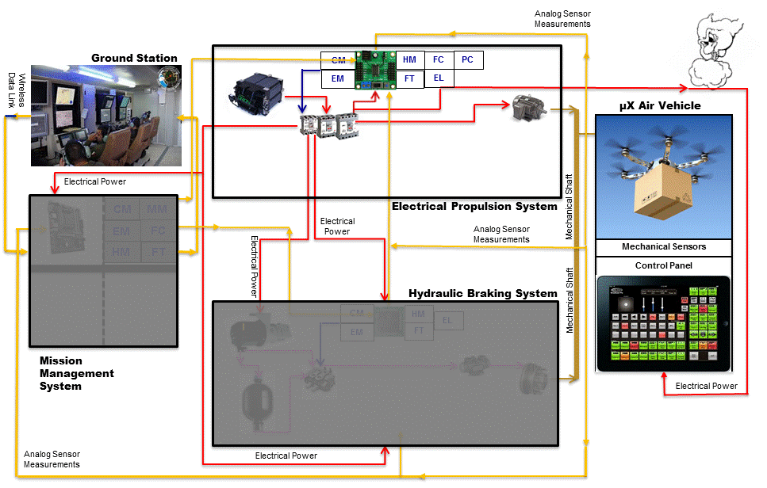

Additional in EPS Incr3
- Secondary source,
- Second electrical engine (suffixed B), fixed to the master shaft,
- Second ECU (suffixed B),
- Additional wiring,
