UNCLASSIFIED

 |  | REFERENCES | ISSUE | DATE








Specification
µXAV System Requirements Allocated to MMS Software
Increment 1

SCOPE

Page : 1 / 34

This document is the intellectual property of RESSAC members It may not be used, reproduced, modified or disclosed without its authorization.
RESSAC members Proprietary Data.

signatures
 | REFERENCES | APPROVERS
 |  | Fonction 1

 |  | Name 1
 |  | Fonction 2

 |  | Name 2
 |  | Fonction 3

 |  | Name 3
 |  | Fonction 4
 |  | Name 4
 |  | Fonction 5
 |  | Name 5

Table of contentS
1. PREAMBLE 5
1.1 Document issues 5
1.2 References 5
1.3 Executive Summary 5
2. Purpose of the document 6
3. glossary 7
4. allocated information flows 9
4.1 Inputs 9
4.1.1 Ground-based Mission Preparation and Supervision 9
4.1.2 AV-based Mission Preparation (Control Panel) 9
4.1.3 Physical Parameters 10
4.2 Outputs 10
4.2.1 Ground-based Mission Monitoring 10
4.2.2 Control Panel Displays 10
4.2.3 Physical Parameters 10
5. ALLOCATED functions 11
6. function payload transport (F_PT) 12
6.1 Increment 1 Overview 12
6.2 Interface 12
6.2.1 Inputs 12
6.2.2 Outputs 12
6.3 Contract 13
6.3.1 Assumptions 13
6.3.2 Guarantees 13
6.4 Functional Decomposition 14
6.5 Behavioural Specification 15
6.5.1 Overview 15
6.5.2 Sub-function Activation Logic 16
6.6 Sub-function Mission Management (F_MM) 16
6.6.1 Increment 1 Overview 16
6.6.2 Interface 16
6.6.3 Contract 18
6.6.4 Behavioural Specification 19
6.7 Sub-function Flight Control (F_FC) 23
6.7.1 Increment 1 Overview 23
6.7.2 Interface 23
6.7.3 Contract 24
6.7.4 Behavioural Specification 25
6.8 Sub-function Energy Management (F_EM) 28
6.8.1 Increment 1 Overview 28
6.8.2 Interface 29
6.8.3 Contract 29
6.8.4 Behavioural Specification 29
6.9 Sub-Function Communication Management (F_CM) 30
6.9.1 Increment 1 Overview 30
6.9.2 Interface 30
6.9.3 Contract 31
6.9.4 Behavioural Specification 31
7. Function emergency landing (F_EL) 33
7.1 Increment 1 Overview 33
7.2 Interface 33
7.2.1 Inputs 33
7.2.2 Outputs 33
7.3 Contract 33
7.3.1 Assumptions 33
7.3.2 Guarantees 34
7.4 Behavioural Specification 34

PREAMBLE

Document issues
Date | Issue | Author(s) | Updating purpose
2017/04/03 | 1 | E. Ledinot | Creation of the document.
2017/04/30 | 2 | E. Ledinot | Consistency with the life-cycle process (References). Addition of figures (F_PT’s functional architecture). Completion of F_CM and F_EL.  Editorial changes.

References
[1] µXAV Systems Process Definition,
[2] µXAV Case Study – Development Increments,
[3] µXAV Operational specification and scenarios
[4] µXAV Layer 0 Functional Specification
[5] Layer 0 Functional model
[6] Layer 0 Architecture model
[7] Layer 0 Mapping model
[8] MMS Functional Scenarios
[9] MMS Functional Specification
[10] µXAV regulatory functional safety specifications

Executive Summary
In conformance with [1] and [2], increment 1 layer 2 development of µXAV systems is limited to MMS software. It consists in flight control and mission management aspects.
This document provides the AV level and MMS level system requirements allocated to MMS software. These requirements are grouped into functions and sub-functions, in conformance with ARP 4754 and ARP 4761 approach to system safety.
The two functions specified in this document and mapped on MMS software are:
- Payload transport: flight control and mission management,
- Emergency landing: mission cancellation and grounding.

Purpose of the document
This document provides the AV level and MMS level system requirements allocated to MMS software at increment 1 stage.
The design rationale of the specification is not provided.
See “µXAV Specification (Overarching Properties Oriented)” document to find it.

glossary
Acronym | Definition
AV | Air Vehicle
AWC | Adverse Wind Conditions
BAT | Battery
BITE | Built-In Test Equipment
CCA | Common Cause Analysis
CL | Confidence Level
CMA | Common Mode Analysis
CPS | Cyber Physical System
ECU | Electronic Control Unit
EPS | Electrical Propulsion System
FB | Failure Bit
FCs | Failure Conditions
FCS | Flight Control System
F_BC | Function Braking Control
F_CM | Function Communication Management
F_EL | Function Emergency Landing
F_EM | Function Energy Management
F_FC | Function Flight Control
F_MM | Function Mission Management
F_PC | Function Propulsion Control
FDIR | Fault Detection Isolation Recovery
FWC | Favourable Wind Conditions
GNC | Guidance Navigation Control
HBS | Hydraulic Braking System
HVCC | High Voltage Continuous Current
IS | International System (of physical units)
ISO OSI | International Standard Organisation Open Systems Interconnection
kt | Knot
LED | Light Electroluminescent Diode
MMI | Man Machine Interface
MS | Maintenance System
MMS | Mission Management System
MTOW | Maximal Take-Off Weight
n.m | nautic miles
PDI | Parameter Data Item
PID | Proportional Integral Derivative control law
PEPS | Primary Electrical Power Source
PID | Proportional Integral Derivative
SEPS | Secondary Electrical Power Source
SIC | Standard Icing Conditions
SWC | Standard Wind Condition
UAV | Unmanned Air Vehicle

allocated information flows
Since MMS is made exclusively of a software item at increment 1, the allocated flows are those defined in [7] and [9].
Ranges are indicated by the following notation: [a:p:b] (u).
Interpretation:
- from minimum value a
- to maximum value b,
- with increments, p,
- with physical unit u.

Inputs

Ground-based Mission Preparation and Supervision
Flow Name | Content | Comment
NavigationParameters | Distance [1:1:100] (n.m)  Speed [1:1:250] (kt)  Altitude [-500, 3000] (ft)
NavigationMode | {‘RP’,’A’} | Enumerated type RP=Remotely Piloted  A=Autonomous
NavigationOption | {‘SPEED’,’ALTITUDE’,’ENERGY’} | Enumerated type
GO | event
EmergencyLanding | event

AV-based Mission Preparation (Control Panel)
Flow Name | Content | Comment
ON/OFF_PushButton | event
START_PushButton | event
ModeSwitch | {‘A’,’RP’} | Two stable states  A=Autonomous, RP=Remotely Piloted
BaySwitch | {‘OPEN’,’CLOSED’} | Two stable states
PayloadMass | integer
USB_Key | Distance [1:1:100] (n.m)  Speed [1:1:250] (kt)  Altitude [-500, 3000] (ft)

Physical Parameters
Flow Name | Content | Comment
p | float | Drives distance
pdot | float | Drives speed
q | float | Drives altitude and pitch

Outputs

Ground-based Mission Monitoring
Flow Name | Content | Comment
CP_Switches | Power: Boolean;  Mode: {‘RP’,’A’};  Bay:{‘OPEN’,’CLOSED’}  START:Boolean;  Rotactor1:[1:1:9] (kg)  Rotactor2:[1:1:9] (kg)
CP_Displays | READY:Boolean;  CANCELLED:Boolean;  COMPLETE:Boolean;  ABORTED:Boolean;  PrimarySource [1:1:100] (%)  SecondarySource [1:1:100] (%) | Capacities are relative to full charge
PropulsionEnergy | PrimarySourceCapacity [1:1:99999] (J)  SecondarySourceCapacity [1:1:9999] (J) | Capacities are absolute in Joule

Control Panel Displays
Flow Name | Content | Comment
MissionCANCELLED | true/false
MissionCOMPLETE | true/false
MissionABORTED | true/false
PrimarySource | [1:1:100] (%)
SecondarySource | [1:1:100] (%)

Physical Parameters
Flow Name | Content | Comment
PropulsionTorque | [-10e-6:0.0001:+10e-6] (N.m)
BrakingTorque | [-10e-6:0.0001:+10e-6] (N.m)

ALLOCATED functions
MMS software is in charge of supporting two functions:
- Payload Transport (F_PT) is the main one. It manages AV’s control and mission until a hazardous situation is detected, in which case the mission is aborted.
- Emergency Landing (F_EL) is in charge of detecting occurrence of hazardous situations not detected by F_PT. In such situations F_EL aborts F_PT (mission cancellation), takes over and lands the AV.
Both functions are activated after MMS set-up. F_PT manages the set-up phase.
Both functions monitor the AV’s dynamics and have the capability to activate emergency landing.
For increment 1, these functions are centralized in MMS. Later, part of them will also be mapped on EPS and HBS.
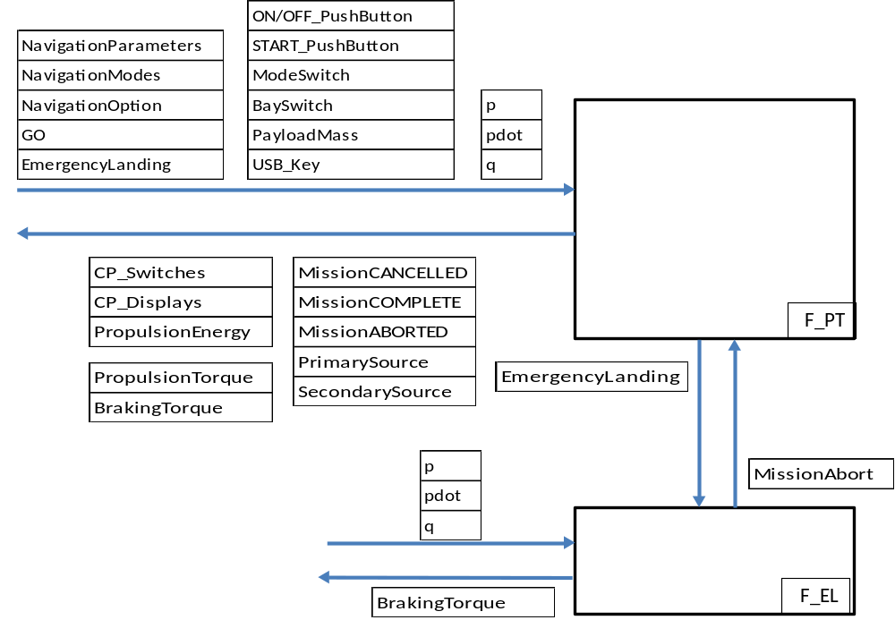
Figure 1- Functions mapped to MMS Software and information flows

function payload transport (F_PT)

Increment 1 Overview
MMS is the unique system at layer 0.
Since the energy sources, the sensors and the actuators are located in EPS and HBS, strictly speaking MMS cannot actuate the AV’s mechanical body. However, increment 1 requires developing a physical model of the AV’s body to develop, verify and validate the control aspects of F_PT and F_EL. Sensing and actuation are taken for granted, directly from software to mechanics, and conversely.
In order to facilitate development of the other increments, all the F_PT sub-functions are put in place at increment 1. In particular, regarding communications, sub-function F_CM concentrates all I/Os with the outer world as if digital and analog communications with the other systems had to be managed (increment 4, [2]). Computationally speaking, F_CM is limited to dispatching data and events.
The architectural redundancies and the information flows related to failure mode management are dropped from the interfaces.
References to the physical nature of the propulsion and braking energies are erased from the flow names.

Interface

Inputs
F_PT uses all the software inputs, F_PT’s input interface includes that defined in 4.1.
F_PT may be aborted by F_EL in case of a confirmed safety escape not detected by F_PT itself.
Flow Name | Content | Comment
MissionAbort | true/false | Signal sent by F_EL when it diagnoses that F_PT does not detect dangerous behaviour of the AV

Outputs
F_PT computes all the software outputs defined in 4.2.
F_PT sends one information to F_EL.
Flow Name | Content | Comment
EmergencyLanding | true/false | True when F_PT decides to abort the mission. Leads to soft landing when enough electrical energy is still available, to hard landing otherwise

Contract
This is the contract formulated on F_PT’s interface.
It has to be ensured by the interaction between F_PT’s sub-functions and F_PT’s context (F_EL and MMS software’s outer world).

Assumptions
- Foreseable operating conditions for wind gusts are the regulatory ones (see [10]),
- Foreseable operating conditions for icing are the regulatory ones (see [10]),
- Standard Weather Conditions (SWC) are defined in [10],
- Good Weather Conditions (GWC) is defined by no icing and tailwind (no vertical component) lower than 15kt, distributed uniformly in [0,15]kt,
- Adverse Weather Conditions (AWC) is defined by no icing and headwind with some vertical component. AWC wind is characterized by:
    - Horizontal headwind:
      - speed fluctuates in [10, 25]kt distributed as GL(18,5),
      - direction fluctuates uniformly in [-π/4, +π/4],
    - Vertical headwind: intensity fluctuates in [-10kt, +20kt] as GL(10,5),
- Operators may enter in µXAV any mission parameters by means of the GS or by means of the USB key. For robustness reasons, one makes no assumption on the content of the input datas. However, since security is excluded from the use case, well-typedness and boundedness are assumed.

Guarantees
- Viability guarantee: no take-off if energy aboard is incompatible with mission completion under SWC assumption,
- Any mission cancelation is signalled on CP and to GS,
- Climb safety constraints:
  - max take-off speed: 75kt,
  - climb rate guaranteed in [0.3, 3] m/s,
  - precision of flight level capture: +/- 50ft,
  - precision of speed capture: +/- 5kt.
- Cruise safety constraints:
  - Minimum flight level: 500ft,
  - Maximum flight level: 1500ft,
  - Flight level precision: +/- 50ft,
  - Maximum speed: 125kt,
- Descent safety constraints:
  - descent rate guaranteed in [0.1, 1] m/s,
  - maximum landing speed: 25kt.
- RP mode is identical to A mode when no command is sent to the AV. All control laws are left invariant by ‘A’↔‘RP’ commutations,
- In ideal weather conditions (no wind, no icing) all initiated missions run to completion,
- In GWC, at MTOW, when the range is lower than 100 n.m, the mission success ratio is at least 90% (95% confidence level),
- In AWC, at MTOW, when the range is lower than 50 n.m, the success ratio is at least 60% (95% confidence level),
- When compensation of external disturbances (keeping the AV within the flight safety envelope) or mission completion are no longer possible, soft landing is ensured (see F_EL),
- In J conditions, if propulsion is no longer available, hard landing is ensured (see F_EL),

Functional Decomposition
F_PT’s behaviour results from the interaction of four sub-functions:
- F_MM: Mission Management, in charge of mission preparation and supervision,
- F_FC: Flight Control, in charge of mechanical control of the AV’s body,
- F_EM: Energy Management, in charge of the mission’s energetic viability,
- F_CM: Communication Management, gateway making MMS’ functions communicate with the outer world. The sub-functions communicate directly to each other.
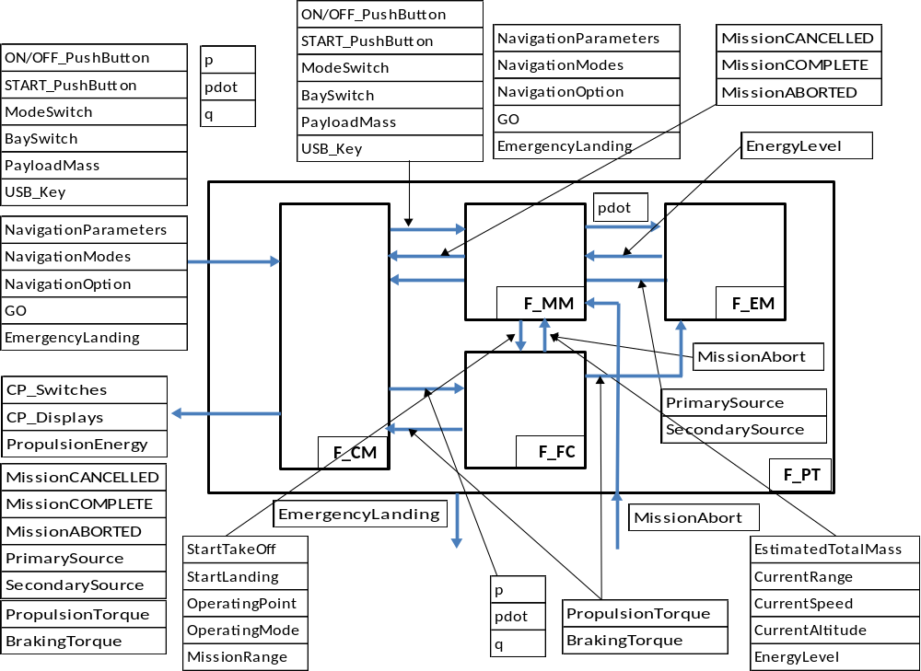
Figure 2: Functional decomposition and information flows
of function Payload Transport (F_PT)

Behavioural Specification

Overview
This section is a synopsis of the behavioural interaction of F_PT’s sub-functions. Detailed specification of F_PT is at sub-function level (F_MM, F_FC, F_EM, and F_CM).
F_PT performs flight control and navigation management, which are conditioned by:
- mission preparation,
- possible ground station updates of the navigation options,
- weather conditions.
Navigation is limited to flying a specified distance (no waypoints, no 2D or 3D flight paths) at a specified flight level or at a specified speed.
F_PT periodically receives AV’s sensed state vector (p, pdot, q), and computes the mechanical controls of the airframe (propulsion torque and braking torque). It plays the role usually devoted to Guidance Navigation and Control (GNC) software.
The so-called flight control is handled by sub-function F_FC, and the so-called navigation is performed by F_MM.
Flight control laws are phase dependent PID controllers.
In A mode, the cruise set-point can’t be modified; The cruise set-point is the navigation operating point (mode, altitude, speed). It is read from the USB key or received from the ground station, and then frozen once for all. Phase sequencing is limited to take-off, climb, cruise as defined by the set-point, descent, and landing.
In RP mode the navigation parameters may be modified any number of times by the remote pilot located in the ground station. Every modification triggers a new capture phase (climb or descent) for the new set-point, followed by a regulation phase servoing on the new set-point (new cruise phase).
F_FC is in charge of ensuring the safety properties of the AV’s dynamics (keeping it within the flight safety envelope).
F_MM monitors AV’s dynamics, energy consumption and mission progress (range completion defined by the Distance parameter). Depending on these three factors, it decides whether mission continuation is viable or not. When viability is ensured, it anticipates descent to land at the specified range. When the mission is no longer viable, F_MM aborts it and activates F_EL.
There are two modes of emergency landing:
- soft landing: enough energy is left to enable propulsion and braking during the descent phase. Perturbation compensation is possible to land at as slow a speed as possible.
- hard landing: propulsion is no longer available. Descent is a braking-only glide, trying not to damage the platform in case of perturbation.
Soft landing is triggered in two ways:
- By F_MM: when mission is aborted because of excessive energy consumption to complete the range. Descent is started with enough energy margin to benefit from propulsion during the descent and landing phases,
- By F_EL: it monitors AV’s dynamics independently from F_PT (functional independence only, hardware independence is impossible in increment 1). When persisting hazardous behaviours are detected, F_EL takes over F_PT. When energy is available F_EL performs soft landing with its independent control laws. In case of energy shortage it performs hard landing.
Hard landing is triggered in a single way: F_EL detects lasting safety escapes and propulsion is no longer available in this failure condition.

Sub-function Activation Logic
F_EL plays the role of a FDIR mechanism wt. F_PT. Both functions are activated after power-on.
F_EL deactivates F_PT in case of persistent hazard detection not managed by F_PT.

Sub-function Mission Management (F_MM)

Increment 1 Overview
F_MM ensures supervision of µXAV missions, i.e. phase sequencing and handling of the high level events (energy shortage, ground operator events etc.).
It does not detect the safety escapes, F_FC and F_EL are in charge of those detections.
Increment 1 implies that there is no distinction between propulsion and braking energies, and no resource failure can occur (no failure modes). Mission viability may be jeopardized only by wind, icing and ensuing energy shortage.

Interface
For mission preparation, there are redundant input channels: GS messages and CP devices (USB key, rotators and switches). The communication function (F_CM) manages the possible inconsistencies between the redundant channels. F_MM receives mission parameters consolidated by F_CM.

Inputs
Flow Name | Content | Comment
NavigationParameters | Distance [1:1:100] (n.m)  Speed [1:1:250] (kt)  Altitude [-500, 3000] (ft) | From F_CM
NavigationMode | {‘RP’,’A’} | From F_CM
NavigationOption | {‘SPEED’,’ENERGY’} | From F_CM
GO | event | From F_CM
MissionAbort | event | From F_FC or F_EL
ON/OFF_PushButton | event | From F_CM
START_PushButton | event | From F_CM
ModeSwitch | {‘A’,’RP’} | From F_CM
BaySwitch | {‘OPEN’,’CLOSED’} | From F_CM
PayloadMass | [1:0.1:5kg] | From F_CM
USB_Key | Distance [1:1:100] (n.m)  Speed [1:1:250] (kt)  Altitude [-500, 3000] (ft) | From F_CM
EstimatedTotalMass | [5,10]kg | From F_FC: instantaneous empty AV mass + payload mass + icing mass
CurrentRange | [1:1:1000000](m) | From F_FC: continuously computed estimated ground distance flown since take-off
CurrentSpeed | [1:1:500] (km/h) | From F_FC: continuously computed instantaneous air speed
CurrentAltitude | [-200:1:1000] (m) | From F_FC: continuously computed instantaneous altitude
EnergyLevel | [0:1:500] (kJ) | From F_EM: current energy storage

Outputs
Flow Name | Content | Comment
MissionCANCELLED | true/false | To F_CM
MissionCOMPLETE | true/false | To F_CM
MissionABORTED | true/false | To F_CM
EmergencyLanding | event | To F_EL: diagnosed catastrophic situation
StartTakeOff | event | To F_FC
StartLanding | event | To F_FC
OperatingPoint | Altitude and Speed | To F_FC. (same ranges as the ones at interface)
OperatingMode | value in {‘SPEED’,’ALTITUDE’,’ENERGY’} | To F_FC
MissionRange | Same range as the Distance mission parameter | To F_FC used to trigger landing when the mission range is within reach

Parameter Data Items
Four surrogate models are loaded and updated independently of the software (tabulated functions or response surfaces that compute the estimated needed energy from the mission characteristics):
- Viability_Amode_initial,
- Viability_Amode_cruise,
- Viability_RPmode_initial,
- Viability_RPmode_cruise.
These four PDIs are not mission dependent. They are drone dependent. They depend on the drone’s empty mass, engines, and energy capacity.

Contract
The safety and performance properties presented in F_PT’s contract can also be formulated on F_MM’s interface. In other words, F_MM inherits F_PT’s contract on the part of its interface that is common with F_PT’s.
This subcontract is not repeated here:
- Assumptions A, B, C, D, E, F.
- Guarantees A, B.
F_MM’s contract contains also additional properties, specific to the exchanges with F_FC, F_EM and F_CM.

Assumptions
Additional one:
- The physical parameters received from F_EM and F_FC are accurate or conservative (lower than 10% excess),
Because of:
- systematic contract-based specification,
- systematic contract-based implementation (system modelling, software and hardware development),
- an assumption on sufficient effectiveness of development assurance,
- assumption A,
F_MM has no mechanism to mitigate a wrong perception of µXAV’s physical state: dynamics and energy capacity. F_MM does not try, using its own estimation algorithm, to cross check the physical data it receives from F_CM, F_EM and F_FC.
In the use case, there is no functional redundancy motivated by possible development assurance failure. If functional redundancy is introduced, it is on request of the safety group, to cope with F_PT’s Functional Failure Set (FFS). F_PT’s FFS takes into account the physical failures (introduced at increment 3) and the development faults (likely to be present since increment 1). The double detection of safety escapes by F_PT and F_EL in MMS is a provision whose safety group’s justification appears at increment 3: the “no single component failure” objective.
This functional redundancy with (intended later) independence is not some “on the fly" defensive approach to development errors in F_FC and F_MM.

Guarantees
Additional one:
- Missions cancelled for energy reasons can be proven infeasible (under assumption of existence of an embedded MS’ flight data recorder for a posteriori analysis),

Behavioural Specification
F_MM relies on F_FC and F_EM for all the physical parameters it needs to make mission related decisions.
GS and CP MMIs display values in aeronautical units (knots, nautical miles, feet etc.) but system and item implementation are based on IS units (m, kg, s).
A mission decomposes into six stages. The navigation mode (‘RP’ or ‘A’) bears only on cruise phases. Fig 3 gives the hierarchical state machine that specifies the phase sequencing logic.
The stages are:
- Payload boarding: initiated by opening the bay after putting the CP’s switch in OPENED position. Mass of the payload must be given to the system (GS message or CP’s rotators, or USB key). The rotators supersede any other means, unless value 99 is configured on the two wheels. In RP mode, GS supersedes the USB key, whereas in A mode the key supersedes any GS input.
- Mission set-up: must be given prior to take-off:
  - Transport distance (n.m),
  - Cruise speed (kt),
  - Flight level (ft).

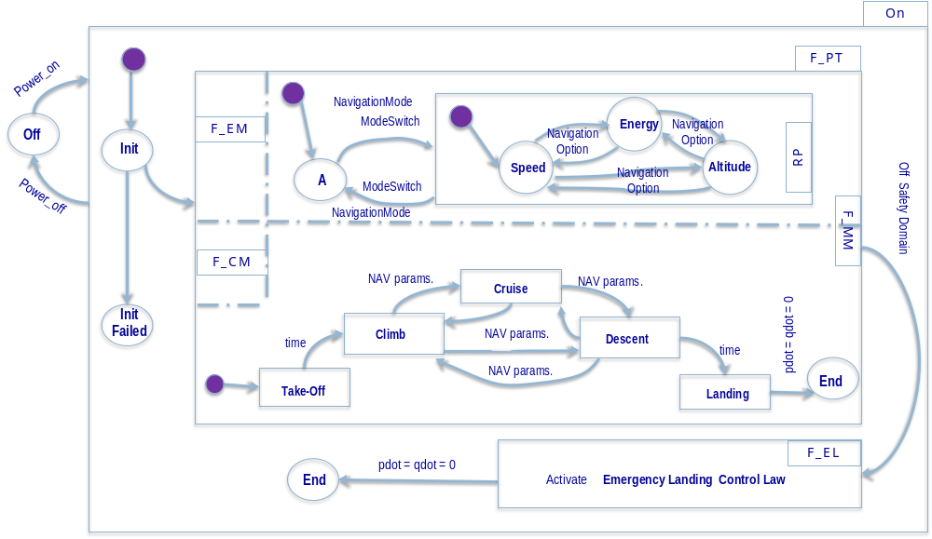
Figure 3: F_MM mission phase logic and navigation mode logic
- Take-off: Initialization of the systems must have succeeded (READY lighted on). Press of the START button or reception of the GO message from GS is needed to start take-off,
- Cruise: F_FC is in charge of controlling the (p, pdot, q, qdot) state vector, in the neighbourhood of the operating point (altitude, speed, or energy minimization). Range updates are not possible after take-off, even in RP mode. It may invalidate the viability analysis (range extensions).
In RP mode, any navigation parameter update provokes termination of the current cruise phase. It activates a transient climb or descent phase to capture the new operating point (also named set-point),
- Descent: F_FC performs simultaneous speed and altitude decrease to reach the specified range at landing time,
- Landing: terminal phase of descent,
- Payload unloading: the OPEN/CLOSED switch is activated again. End of the mission cycle.
RP mode is identical to A mode when GS operator sends no command to the AV.
RP mode enables modification of:
- The distance (i.e range) parameter before take-off. Any later modification provokes no error, but has no effect on AV’s navigation,
- The altitude and speed parameters, at any time. It conditions the cruise phases, and indirectly the climb or descent phases to capture the updated cruise operating point.
Remote parameter update is the only way of ‘guiding’ or ‘controlling’ the AV.
Remote piloting is impossible because of excessive communication lag (and pointless because there is no true flight mechanic equations in AV’s physical model).
F_MM and F_FC have jointly to handle the external and internal disturbances.
External disturbances:
- Wind conditions: fluctuating 3D wind vector which can accelerate or slow down the AV in any direction. Wind can cause the AV to quit the prescribed altitude. It can lead to energy saving or to energy over consumption.
- Icing conditions: may be temporary or persistent during the mission. They are handled as in-flight mass perturbation. F_FC continuously estimates the AV’s mass by mechanical feedback analysis, and diagnoses icing conditions when a significant and rapidly evolving mass increase is estimated,
Internal disturbances:
- Energy run-out: should never occur because of faulty initial conditions, i.e inconsistency between the on-board energy level and the mission to perform (under SWC assumption). Energy run-out may happen because of en-route unexpected weather conditions,
- Breakdowns: the multi-system architecture is designed to tolerate all single physical item failures (increments 3 and 4). Some combinations of failures can’t be tolerated. F_EL has to be triggered before AV becomes uncontrollable.
In increment 1, all disturbances apart from breakdowns are considered. The external ones are handled by F_FC, and the internal ones by F_MM.
F_MM schedules the beginning and the end of the mission. In between, operating point tracking by F_FC provokes the phase changes in case of parameter update.
Mission set-up management
F_MM checks that the following conditions are satisfied (in any order), before launching the mission.
- The payload bay is closed,
- The mission parameters are defined. In case of inconsistency between multiple sources not resolved by priority policy, the mission is cancelled,
- The mission is viable (see viability conditions below).
Operating point update management
The operating point is the reference value F_FC regulates on at a given instant. When it regulates on an altitude value or on a speed value, these values are sent by F_MM to F-FC. When F_FC is in energy mode, the altitude or the speed reference value is computed by F_FC.
F_MM ensures freeze of the operating point once landing is activated.
Mission Viability Logic
Viability analysis is energetic assessment of the mission’s feasibility as defined at initial conditions. It is done before take-off to prevent launching the drone on unfeasible missions. This analysis is then periodically updated during flight (low rate, 0.1 Hz) as bad flight weather conditions may invalidate the standardized assumptions used at set-up phase.
Set-up phase
A response surface (surrogate model) tabulates the energy needed to perform a mission defined by the following parameters:
- Payload mass,
- Distance,
- Navigation mode
- Altitude
- Speed
The response surface is given by two tabulated functions (one for A mode, one for RP mode), each one parameterized by four variables (mass, distance, altitude, speed).
Before take-off, computation of the mission’s viability consists in:
- Assembling the mission’s profile (MP). MP=(mass, distance, altitude, speed),
- Selecting the tabulated function that corresponds to the navigation mode (A or RP),
- Computing the nearest neighbours of MP in the selected table, and the distances of MP to its nearest neighbours,
- Extracting the energy levels for these neighbours,
- Computing MP’s energy level by interpolation of that of its neighbours, i.e by distance-based averaging (the further the neighbour, the smaller its weight).
Then F_MM compares the result to the energy capacity available on board and makes the viability decision with 10% energy margin in RP mode, and 30% in A mode.
In-flight updates
The same computation, with distance equated to the remaining distance to fly, is repeated at periodic rate (f_viability = 0.1Hz) and with two other response surfaces (similar structures, but discount of a flat rate climb energy).
Mission termination control
F_MM monitors CurrentRange (received from F_FC) and activates landing when:
(Distance–CurrentRange) < GlideDistance(CurrentAltitude).
GlideDistance is a tabulated function that gives the ground distance needed to reach altitude zero from CurrentAltitude.
F_MM freezes any change on the operating point.

Sub-function Flight Control (F_FC)

Increment 1 Overview
The so-called ‘flight control laws’ are fully developed at increment 1. They remain unchanged in the next increments.
The physical process to be controlled is simpler than flight mechanics of a small drone. There is an actual mechanical body which is actually dimensioned and controlled to meet definite performance and safety objectives. The dynamic is nonlinear (the differential equations are given in the Modelica model).
Control has mode switches since the GS operator can switch to different operating points defined by new speeds, new altitudes, or by selection of the energy saving mode.
Control design is addressed in a standard piecewise linear way, using PID controllers (sometimes only PI or PD controllers) to stabilize and regulate each local linear system. Sliding mode non linear control is envisioned for later versions.

Interface

Inputs
Flow Name | Content | Comment
p | float | Drives distance
pdot | float | Drives speed
q | float | Drives altitude and pitch
Note: qdot is not measurable (because of AV’s sensor architecture), it can only be estimated. It is not listed as an input.
OperatingPoint | Altitude and Speed
OperatingMode | value in {‘SPEED’,’ALTITUDE’,’ENERGY’}
MissionRange | Same range as the Distance mission parameter

Outputs
Flow Name | Content | Comment
EstimatedTotalMass | [5,10]kg
CurrentRange | [1:1:1000000](m)
CurrentSpeed | [1:1:500] (km/h)
CurrentAltitude | [-200:1:1000] (m)
PropulsionTorque | [0:0.1:100000] (N.m) | To AV
BrakingTorque | [0:0.1:100000] (N.m) | To AV

Parameter Data Items
Similarly to F_MM’s tabulated viability functions, three association tables, one per phase (climb, cruise, descent), give the means to select the appropriate PID gain triple (Kd, Kp, Ki) applicable to AV’s current sate vector.
The three tables are named:
- ClimbGains
- CruiseGains
- DescentGains
They all have the same three indexing parameters:
- Mass
- Altitude
- Speed
They are used to compute the interpolated (Kd, Kp, Ki) triple from the triples of the nearest neighbours to the current state.

Contract

Assumptions
- The measurements of (p, pdot, q) are noiseless and unbiased,
- The values of the operating points (speed, altitude) are safe. Since security is out of the scope of the use case, no integrity check is applied to the values received from F_CM,
- Every mission is viable or cancelled, at any time.

Guarantees
- The regulatory behavioural properties are met (see the specific document “µXAV regulatory functional safety properties”, intentionally separated from this one),
- AV’s body is always stable (under SWC assumption),
- AV is kept in its flight safety envelope, i.e meets phase-dependent constraints on p, pdot, q, qdot:
  - Climb: (qdot_minCl < qdot < qdot_maxCl) and (q < q_maxCl)
  - Cruise: (qdot_minCr < qdot < qdot_maxCr) and (q > q_minCr) and (pdot < pdot_maxCr)
  - Descent: (qdot_minDs < qdot < qdot_maxDs) and (q < q_maxDs)
The constants bounding the safety envelope are given at model level. (see also 6.3.2, clause C of F_PT’s contract),

Constant Name | Unit | Value
qdot_minCl | Angle.s⁻¹ | TBD
qdot_maxCl | Angle.s⁻¹ | TBD
q_maxCl | Angle | TBD
qdot_minCr | Angle.s⁻¹ | TBD
qdot_maxCr | Angle.s⁻¹ | TBD
q_minCr | Angle | TBD
pdot_maxCr | Angle.s⁻¹ | TBD
qdot_minDs | Angle.s⁻¹ | TBD
qdot_maxDs | Angle.s⁻¹ | TBD
q_maxDs | Angle | TBD

- Propulsion and braking torque actions are in mutual exclusion,
- In-flight mission cancellation with remaining propulsion capacity implies occurrence of safety escapes for more than EscapeTime consecutive seconds.

Behavioural Specification
Propulsion-Braking Mutual Exclusion
When safety escapes are pending because of wind gusts, F_FC strives to keep the AV’s body safe by stopping propulsion and preparing the brakes.
This transition is necessary for physically effective mutual exclusion between the antagonist torque actions. There is a need to take into account inertia and delays on actuation lines (hydraulic and electrical, defined at increment 2)
The parameter
Name | Unit | Value
CommutationDuration | s | TBD
is defined to separate the two incompatible actuation phases. Safety and/or lifetime of the drone is at stake: the engines are damaged when powered during braking action.
In case of persistency in the hazardous region more than HazardDuration consecutive seconds or in case of fast evolution to a safety escape, braking is activated after propulsion has been stopped for CommutationDuration seconds.
Braking is stopped when AV’s dynamics re-enters the safety domain. The same CommutationDuration timeout is applied before resuming propulsion to cope with physical latencies in both ways.
The numerical value of CommutationDuration is defined at model level.

Reference Trajectory Generation
The piecewise linear approach may need small increments of the set-point. The set-point is either an altitude value or a speed value. For landing, a distance objective is added to the zero-altitude objective. Landing must occur exactly at range completion.
The reference trajectory is the discrete evolution curve of intermediate set-points generated and added between the set-points defined by µXAV’s user.
Reference trajectory generation is in charge of splitting the amplitude of the set-point updates into smaller steps, to facilitate prevention of overshoot.
Instead of giving the true set-point on altitude or speed to Propulsion Control, it gives half of the change amplitude, i.e the mid-value between the current state and the set-point.
IntermediateSetPoint_forX(t)=½*(CurrentX(t)+ SetPoint_X(t))
X stands for Speed or Altitude.
It can be computed at each cycle. Slower rates are possible, but not too slow. When the current intermediate set-point is reached the next one is computed, and so on until the user-defined set-point is reached.
The propulsion and braking controllers use IntermediateSetPoint_X instead of SetPoint_X. IntermediateSetPoint_X tends to SetPoint_X over time (zeno-like aspects to be addressed when convergence).
This module is reset by any navigation parameter change.
Gain Scheduling
The flight domain is discretized in (speed x altitude) cells in which the linear approximation of AV’s dynamics remains valid.
A matrix FlightDomainMesh(I,J) contains the (si,aj) values of the cells’ centres.
To each cell centre (si,aj) is associated a triple (Kp,Kd,Ki)(i,j), the gains associated to that center.
Similarly to viability computation, the PID gains applicable at instant t when µXAV‘s state vector is (Altitude(t), Speed(t)), is a triple computed by component-wise averaging of the corresponding constants for the state’s 4 nearest neighbours in the 2D FlightDomainMesh. The 4 weights are inversely proportional to the 4 distances of the neighbours to the current state.
The gain scheduling policy applies to propulsion and braking control. There is a gain table swap at each Propulsion ↔ Braking swap.
Propulsion Control
In this version, the energy minimization option is not actually implemented as an optimal control algorithm (will be supplied later). When “Energy” option is active, the “Altitude” or “Speed” option is selected, depending on the respective energy cost induced by the two pre-set Altitude and Speed values. The selected option is the less energetically demanding one.
Two systems of two equations in (pdotA, qA), (pdotS, qS) are to be solved.
First:
- g/L= (pdotA)² . cos(qA)
- Altitude = L.(1 - cos(qA))
Second :
- g/L= (pdotS)² . cos(qS)
- Speed= pdotS.L.sin(qS)
If pdotA < pdotS, option “Altitude” is selected otherwise “Speed” is selected.
The navigation option conditions the computation of variable error(t) used by the PID algorithms:
- in Speed mode, error(t)=Speed(t)–OperatingPoint.Speed(t)
- in Altitude mode, error(t)=Altitude(t)–OperatingPoint.Altitude(t)
The PID controller computes PropulsionTorque(t) as a sum of three torques, each one dependent on error(t), but on different time horizons:
- instantaneous error at time t: error(t),
- cumulative past error during the last Ti seconds:
  - integral_error(t)= 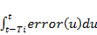
- error variation at time t:
  - derivative_error(t)= 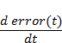
Hence the three letters P, I, D.
PropulsionTorque(t)= Kp(t)*error(t) +
Ki(t)*integral_error(t) + Kd(t)*derivative_error(t).
Kp(t),Ki(t),Kd(t) are the scheduled gains for current state (CurrentSpeed(t), CurrentAltitude(t)).
Similarly to viability computation, CurrentSpeed(t), CurrentAltitude(t) define the current position of AV for selecting its nearest neighbors in the 2D FlightDomainMesh. The distances to the 4 nearest neighbors (d1(t), d2(t), d3(t), d4(t)) are computed, the 4 weights wi(t)=1/di(t) i=1..4, are computed, and finally the four neighbors’ gain triplets are extracted (limit cases di(t)=0 to be properly handled).
Then, Kp(t),Ki(t), Kd(t) are the wi(t)-weighted averages of the 4 neighbors’ corresponding coefficients,
Braking Control
The algorithm is a simpler version of the preceding one: the Speed/Altitude option has no longer influence. error(t) is always computed from the speed.
Braking is an emergency phase triggered to quickly pull back the AV’s dynamics in the safety region. It consists in sharp speed decrease (short duration, drop of pdot and q).
A constant speed level, named RecoverySpeed, is used as set point.

Name | Unit | Value
RecoverySpeed | m/s | TBD

AV mechanical parameters
The AV’s mechanical body is dimensioned by means of the following parameters:
Name | Unit | Value
J0 | kg.m² | TBD
L | m | TBD
M0 | kg | TBD
The parameter values will be supplied with the layer 0 model and the associated simulation scenarios conformant to [3].
AV’s State Vector
The AV’s state vector is defined by:
- Speed(t) = L.sin(q(t)).pdot(t)
- Altitude(t) = L.(1 – cos(q(t)))
- Distance(t) = 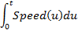
Mass(t) = M0 + Mpayload + Micing(t), where Micing is an unknown perturbation to be estimated, and Mpayload is given by the two rotators of the control panel.

Sub-function Energy Management (F_EM)

Increment 1 Overview
Increment 2 addresses the energy management aspects of the use case. In increment 1, a simplistic approach is adopted:
- F_EM stores the initial energetic capacity of µXAV, the same one for every mission preparation. The operator of the drone cannot modify this parameter. The refuelling aspects are not defined in the use case (in later increments as well).
- F_EM computes a simple estimation of the energy dispensed, as commanded by F_FC,
- It computes the left capacity by subtracting the dispended energy to the initial capacity.
- The two energy sources (primary and secondary) are used in order: complete unload of the primary source, followed by unload of the secondary, as extension of the primary.

Interface

Inputs
Flow Name | Content | Comment
pdot | Angle.s⁻¹ | From F_MM (could be also from F_CM)
PropulsionTorque | N.m | From F_FC
BrakingTorque | N.m | From F_FC

Outputs
Flow Name | Content | Comment
EnergyLevel | J | Sums the remaining capacities of the two sources.
PrimarySource | % | Relative capacity, for CP display
SecondarySource | % | Relative capacity, for CP display

Contract

Assumptions
- The mechanical body is actuated and reacts exactly as commanded (i.e the computed digital torques are exactly converted into physical torques),
- The mechanical body behaves exactly as sensed (i.e the digital p, pdot, q state vector coincides with the AV’s actual physical state vector, at any time).

Guarantees
- Under SWC assumption the mission remains viable at any time,
- EnergyLevel (energy left) is accurate (equates to the actual embedded energy)
- The CP-displayed primary and secondary relative capacities are accurate.

Behavioural Specification
Parameters:
- PrimaryInitialCapacity (J)
- SecondaryInitialCapacity (J)
At t=0, start of mission:
InitialCapacity=PrimaryInitialCapacity +
SecondaryInitialCapacity.
DispendedEnergy(t)= PropulsionEnergy(t) + BrakingEnergy(t).
PropulsionEnergy(t)= 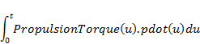
BrakingEnergy(t)= 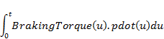
PrimaryEnergyLeft(t)=PrimaryInitialCapacity-DispendedEnergy(t)
PrimarySource(t)=100*(PrimaryInitialCapacity-DispendedEnergy)/
PrimaryInitialCapacity.
Before PrimarySource(t)=0%, SecondarySource(t)=100%.
After PrimarySource(t)=0%, this value stays constant and :
SecondaryEnergyLeft(t)=
SecondaryInitialCapacity-DispendedEnergy(t).
SecondarySource(t)=
100*(SecondaryInitialCapacity-DispendedEnergy)/
SecondaryInitialCapacity.

Sub-Function Communication Management (F_CM)

Increment 1 Overview
F_CM has limited influence before increment 4, where inner and outer communication protocols are introduced along with analog-digital conversions.
For increment 1, F_CM has two roles:
- It manages possible inconsistencies between GS-supplied and AV-supplied navigation parameters,
- It dispatches the software inputs to the functions,
- It collects the functions’ outputs and dispatches them to software outputs

Interface
Inputs | From | Outputs | To
MissionSetUp(  [Distance:float;  Speed:float;  Altitude:float]) | GS | CP_Displays(  [READY:Boolean;  CANCELLED:Boolean;  COMPLETE:Boolean;  ABORTED:Boolean;  PSRC_CAPACITY:Integer;  SSRC_CAPACITY:Integer  ]) | CP
NavigationMode({‘RP’,’A’}) | GS | LEDs(bitarray[20]) | CP
NavigationOption({‘SPEED’,’ALTITUDE’,’ENERGY’}) | GS | MissionCompleted([PRIMARY_SOURCE:Integer;  SECONDARY_SOURCE:Integer; ]) | GS
GO | GS | PropulsionTorque | AV
EmergencyLanding | GS | BrakingTorque | AV
AV_CP_Switches(  [Power: Boolean;  Mode: {‘RP’,’A’};  Bay:{‘OPEN’,’CLOSED’};  START:Boolean;  Rotactor1:Integer;  Rotactor2:Integer;}]) | CP
(p, pdot, q) | AV

Contract

Assumptions
- The data-link with GS is not lossy,
- Transfer preserves integrity of contents (no security aspects),
- Ideal digital to mechanical conversion of torques,
- Ideal mechanical to digital conversion of the sensed mechanical state variables (p, pdot, q),
- All communications are continuous time signals (including the messages that will become event-driven at increment 4).

Guarantees
- Outer to inner information mapping is correct and complete,
- Inner to outer information mapping is correct and complete,
- When A mode is set on CP, the navigation options/parameters are that of the USB-Key or mission is cancelled.

Behavioural Specification
Management of navigation modes/options/parameters
There are two ways to supply F_MM with the navigation datas: from GS or from CP.
When the two channels are active and provide conflicting values for the same entity, the following selection logic is applied:
- In case of conflict on the navigation mode, CP prevails over GS,
- In case of RP mode, GS prevails over CP,
- In case of A mode, CP prevails over GS.
Input dispatch
Inputs | From | Dispatched as | To
MissionSetUp(  [Distance:float;  Speed:float;  Altitude:float]) | GS | NavigationParameters | F_MM
NavigationMode({‘RP’,’A’}) | GS | NavigationModes | F_MM
NavigationOption({‘SPEED’,’ALTITUDE’,’ENERGY’}) | GS | NavigationOptions | F_MM
GO | GS | GO | F_MM
EmergencyLanding | GS | EmergencyLanding | F_MM
AV_CP_Switches(  [Power: Boolean;  Mode: {‘RP’,’A’};  Bay:{‘OPEN’,’CLOSED’};  START:Boolean;  Rotactor1:Integer;  Rotactor2:Integer;}]) | CP | ON/OFF_PushButton  START_Button  ModeSwitch  BaySwitch  PayloadMass | F_MM
USB_Key(  [Distance:float;  Speed:float;  Altitude:float]) | CP | USB_Key | F_MM
(p, pdot, q) | AV | (p, pdot, q) | F_FC
Output dispatch
Collected outputs | From | Dispatched as | To
MissionCANCELLED  MissionCOMPLETE  MissionABORTED  PrimarySource  SecondarySource | F_MM  F_MM  F_MM  F_EM  F_EM | CP_Displays(  [READY:Boolean;  CANCELLED:Boolean;  COMPLETE:Boolean;  ABORTED:Boolean;  PSRC_CAPACITY:Integer;  SSRC_CAPACITY:Integer  ]) | CP
N/A |  | LEDs(bitarray[20]) | CP
PrimarySource  SecondarySource | F_EM  F_EM | MissionCompleted([PRIMARY_SOURCE:Integer;  SECONDARY_SOURCE:Integer; ]) | GS
PropulsionTorque | F_FC | PropulsionTorque | AV
BrakingTorque | F_FC | BrakingTorque | AV

Function emergency landing (F_EL)

Increment 1 Overview
F_EL is fully defined at increment 1. It has two roles:
- Performing the hard landings activated by F_MM,
- Monitoring the safety escapes not diagnosed by F_MM which lead to self-activation of hard landing
Hard landing is named so because it is brake only control. It may lead to terrain contact at excessive speed with ensued drone damage.

Interface
F_EL contains an F_CM sub-function, like F_PT, in charge of communications with the external world.
Since it is an analogous version of F_PT’s, much simpler, it is not detailed.

Inputs
Flow Name | Content | Comment
p | float | Drives distance
pdot | float | Drives speed
q | float | Drives altitude and pitch
EmergencyLanding | event | Trigger from F_PT.F_MM

Outputs
Flow Name | Content | Comment
BrakingTorque | [-10e-6:0.0001:+10e-6] (N.m)
MissionAbort | event | To F_PT.F_MM

Contract

Assumptions
No assumption.
F_EL is the ultimate control process to avoid crash.
Its robustness has to be maximal; it has to be operative in any condition.

Guarantees
- Under assumption of continued braking power and SWC, there is no damage to the AV (defined as |qdot| < MaxTouchSpeed when q=0; MaxTouchSpeed=0.5 m/s).
- Under AWC assumption, damage may occur in at most 25% of the cases (95% confidence level).

Behavioural Specification
F_EL is a PID controller without gain scheduling.
A linear reference trajectory of q and qdot are defined from q and qdot at F_EL activation time, down-to q=0, qdot=0 at grounding time. These trajectories are defined with safety margins wt. descent safety envelope. (xxxDs parameters of § 6.7.3.2 table).

No sensor for qdot
i.e an initiative of the development team to enhance safety in addition to the safety requirements issued by the safety process.
Range (of mission) and Distance (parameter) are synonymous in the document.
Designers are assumed to consult FAR 2x / CS 2x regulation, and to derive the behavioral or airframe requirements that ensure conformance to it. There is a form of implicitly inherited regulatory contract.
needs the MS flight data recorder option,
Intentionally left unformal. Example of a safety critical system-software transition issue.
MMS hardware I/Os will be defined at increment 4. Clear-cut definition of how the MMS software I/Os interact the external world is postponed to that increment. The difference of naming between F_CM’s I/Os and Software I/Os makes manifest this HW-SW integration issue to be addressed at increment 4. It is assumed that F_CM’s inputs (resp. outputs) are the hardware level input (resp. outputs) variables.
This register is not loaded at increment 1, like failure LEDs. Boot-like failures, and all failure modes in general, are addressed at increment 3.
Surrogate models are common in engineering but may be unfamiliar in system and software engineering. They approximate the results of time-consuming computation (detailed PDE physical models, results of design of experiments, etc.). They use tables of parameters and interpolation functions in suitable bases (splines, radial basis functions, polynomials etc.).

