UNCLASSIFIED

 |  | REFERENCES | ISSUE | DATE








µXAV Layer 0 Functional Specification

SCOPE

Page : 1 / 32

This document is the intellectual property of RESSAC members It may not be used, reproduced, modified or disclosed without its authorization.
RESSAC members Proprietary Data.

signatures
 | REFERENCES | APPROVERS
 |  | Fonction 1

 |  | Name 1
 |  | Fonction 2

 |  | Name 2
 |  | Fonction 3

 |  | Name 3
 |  | Fonction 4
 |  | Name 4
 |  | Fonction 5
 |  | Name 5

Table of contentS
1. PREAMBLE 5
1.1 Document issues 5
1.2 Executive Summary 5
2. GLOSSARY 6
3. REFERENCES 8
4. Purpose of the document 9
5. layer 0 functional INTERFACE 10
5.1 Inputs 10
5.1.1 Ground-based Mission Control 10
5.1.2 AV-based Mission Preparation 10
5.1.3 Physical Parameters 10
5.2 Outputs 11
5.2.1 Ground-based Mission Monitoring 11
5.2.2 Control Panel Displays 11
5.2.3 Physical Parameters 11
6. LAYER 0 functional architecture 13
7. payload transport function (F_PT) 15
7.1 Inputs 15
7.1.1 Ground-based Mission Preparation and Supervision 15
7.1.2 AV-based Mission Preparation (Control Panel) 15
7.1.3 Physical Parameters 15
7.2 Outputs 16
7.2.1 Outputs 16
7.2.2 Ground-based Mission Monitoring 16
7.2.3 Control Panel Displays 16
7.2.4 Physical Parameters 16
7.3 Contract 17
7.3.1 Assumptions 17
7.3.2 Guarantees 17
7.4 Behaviour 18
7.5 Sub-functions 18
7.5.1 Overview 18
7.5.2 Communication Management (F_CM) 20
7.5.3 Mission Management (F_MM) 22
7.5.4 Flight Control (F_FC) 24
7.5.5 Energy Management (F_EM) 27
7.5.6 Fault Tolerance (F_FT) 28
8. emergency landing function (F_el) 29
8.1 Inputs 29
8.2 Outputs 29
8.3 Contract 29
8.3.1 Assumptions 29
8.3.2 Guarantees 29
8.4 Behavior 29
9. health monitoring function (F_HM) 31
9.1 Inputs 31
9.2 Outputs 31
9.3 Contract 31
9.4 Behaviour 32

PREAMBLE

Document issues
Date | Issue | Author(s) | Updating purpose
05/06/2017 | 1 | E. Ledinot | Creation of the document.

Executive Summary
This document describes the functions at air vehicle level.
They constitute the multi-system level specification, structured in a way compliant with the safety assessment process.
The layer0 functional specification supplements the layer0 operational specification. Instead of describing a finite number of usage scenarios it describes behavioural units coping with all combinatorial cases.
The description is abstracted from implementation resources.
The specification rationale is the following:
- The top-level functions are assumed to be defined and agreed with the safety process,
- Decomposition of these top-level functions into sub-functions is a design choice made to ease formulation of the specifications. This choice is an output of multi-system functional specification. It is exposed to the safety process but under control of the development process,
- To ensure mapping flexibility, including re-mapping of some functions from one system to another system, each function specification contains a “layer1-independent” section. The behavioural units of these sections have maximal potential for multiple mappings.
Function specifications are decomposed into three parts:
- Interface: physical or informational flows,
- Contract: observable and verifiable behavioural properties,
- Behaviour: the dynamics, in way addressing all combinatorial cases,
The document specifies increments 1 to 4.

GLOSSARY
Acronym | Definition
ATC | Air Traffic Control
AV | Air Vehicle
AWC | Adverse Wind Conditions
BAT | Battery
BITE | Built-In Test Equipment
CCA | Common Cause Analysis
CL | Confidence Level
CMA | Common Mode Analysis
CPS | Cyber Physical System
ECU | Electronic Control Unit
EPS | Electrical Propulsion System
FB | Failure Bit
FC | Fuel Cell
FCs | Failure Conditions
FCS | Flight Control System
F_BC | Function Braking Control
F_CM | Function Communication Management
F_EL | Function Emergency Landing
F_EM | Function Energy Management
F_MC | Function Mission Control
F_MM | Function Mission Management
F_PC | Function Propulsion Control
FDIR | Fault Detection Isolation Recovery
FWC | Favourable Wind Conditions
GNC | Guidance Navigation Control
HBS | Hydraulic Braking System
HVCC | High Voltage Continuous Current
IS | International System (of physical units)
ISO OSI | International Standard Organisation Open Systems Interconnection
kt | Knot
LED | Light Electroluminescent Diode
MMI | Man Machine Interface
MS | Maintenance System
MMS | Mission Management System
MTOW | Maximal Take-Off Weight
MTTR | Mean Time To Repair
n.m | nautic miles
PDI | Parameter Data Item
PEPS | Primary Electrical Power Source
PI | Proportional Integral
SEPS | Secondary Electrical Power Source
SIC | Standard Icing Conditions
SWC | Standard Wind Condition
UAV | Unmanned Air Vehicle

REFERENCES
[1] µXAV Life-cycle Process
[2] µXAV Operational Specification
[3] µXAV Layer0 Architectural Specification
[4] µXAV Certification specification

Purpose of the document
The document constitutes layer0 functional specification. It is an input to the following activities:
- Mapping of functions to MMS (Mission Management System), EPS (Electrical Propulsion System), HBS (Hydraulic Breaking System), MS (Maintenance System),
- Air vehicle level Functional Hazard Analysis (AFHA activity of the safety assessment process).
- Layer1 functional specifications that refine the mapped layer0 functions.

layer 0 functional INTERFACE

Inputs
The following tables provide the precise interfaces of the three upper level functions.

Ground-based Mission Control
Flow Name | Content | Comment
NavigationParameters | Distance [1:1:100] (n.m)  Speed [1:1:250] (kt)  Altitude [-500, 3000] (ft)
NavigationMode | {‘RP’,’A’} | Enumerated type RP=Remotely Piloted  A=Autonomous
NavigationOption | {‘SPEED’,’ALTITUDE’,’ENERGY’} | Enumerated type
GO | event
EmergencyLanding | event

AV-based Mission Preparation
Flow Name | Content | Comment
ON/OFF_PushButton | event
START_PushButton | event
ModeSwitch | {‘A’,’RP’} | Two stable states  A=Autonomous, RP=Remotely Piloted
BaySwitch | {‘OPEN’,’CLOSED’} | Two stable states
PayloadMass | integer
USB_Key | Distance [1:1:100] (n.m)  Speed [1:1:250] (kt)  Altitude [-500, 3000] (ft)

Physical Parameters
Flow Name | Content | Comment
p | float | Drives distance
pdot | float | Drives speed
q | float | Drives altitude and pitch

Outputs

Ground-based Mission Monitoring
Flow Name | Content | Comment
CP_Switches | Power: Boolean;  Mode: {‘RP’,’A’};  Bay:{‘OPEN’,’CLOSED’}  START:Boolean;  Rotactor1:[1:1:9] (kg)  Rotactor2:[1:1:9] (kg)
CP_Displays | READY:Boolean;  CANCELLED:Boolean;  COMPLETE:Boolean;  ABORTED:Boolean;  PrimarySource [1:1:100] (%)  SecondarySource [1:1:100] (%) | Capacities are relative to full charge
PropulsionEnergy | PrimarySourceCapacity [1:1:99999] (J)  SecondarySourceCapacity [1:1:9999] (J) | Capacities are absolute in Joule

Control Panel Displays
Flow Name | Content | Comment
MissionCANCELLED | true/false
MissionCOMPLETE | true/false
MissionABORTED | true/false
PrimarySource | [1:1:100] (%)
SecondarySource | [1:1:100] (%)

Physical Parameters
Flow Name | Content | Comment
PropulsionTorque | [-10e-6:0.0001:+10e-6] (N.m)
BrakingTorque | [-10e-6:0.0001:+10e-6] (N.m)

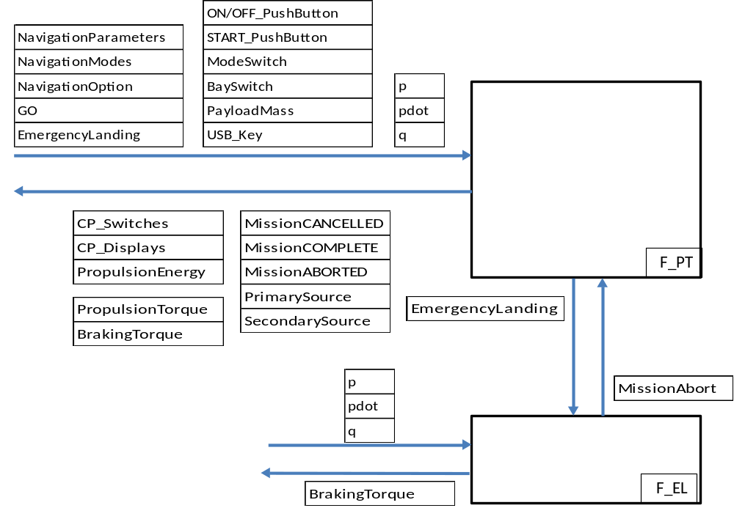

LAYER 0 functional architecture
Behaviour at air vehicle level is decomposed into three operational functions:
- Payload Transport (F_PT), ensures the mission when the drone is operated in conditions compatible with mission completion,
- Emergency Landing (F_EL), takes over in any condition where mission completion is no longer possible, and has to be aborted. The drone has to be grounded, more or less smoothly depending on energy and resources available,
- Health Monitoring (F_HM), operates in background on all digital resources. It provides to F_PT and F_EL the health status of the resources (energetic, computational, physical, etc.) they depend on.
The operational functions are supported by two transverse (or technical) functions:
- Communication (F_CM), ensures communication of the system with the external world: Ground Station (GS) and field operator.
It also ensures communication between the systems, and within.
- Fault Tolerance (F_FT), ensures isolation and recovery in case of random or systematic failure. Failure detection is ensured by the operational functions.
Transverse functions are available within operational functions.
F_HM, as distributed over resources as F_CM and F_FT, could have been addressed as a transverse function. Intended to grow with predictive maintenance capabilities, its future status lead to isolate it as a top level operational function.
Functional architecture represented in figure 1 below is supposed to carry only interface and decomposition information.
If function B is nested as sub-function into function A, it does not imply that function A controls the activation of function B, or influences its behaviour in any way. This architectural trait provides location and role separation information (in the functional space). It constrains the degrees of freedom for mapping of functions on implementation resources.
Consequently it conditions the safety analyses, Functional Failure Set (FFS) modelling in particular [1], and DAL assignment.
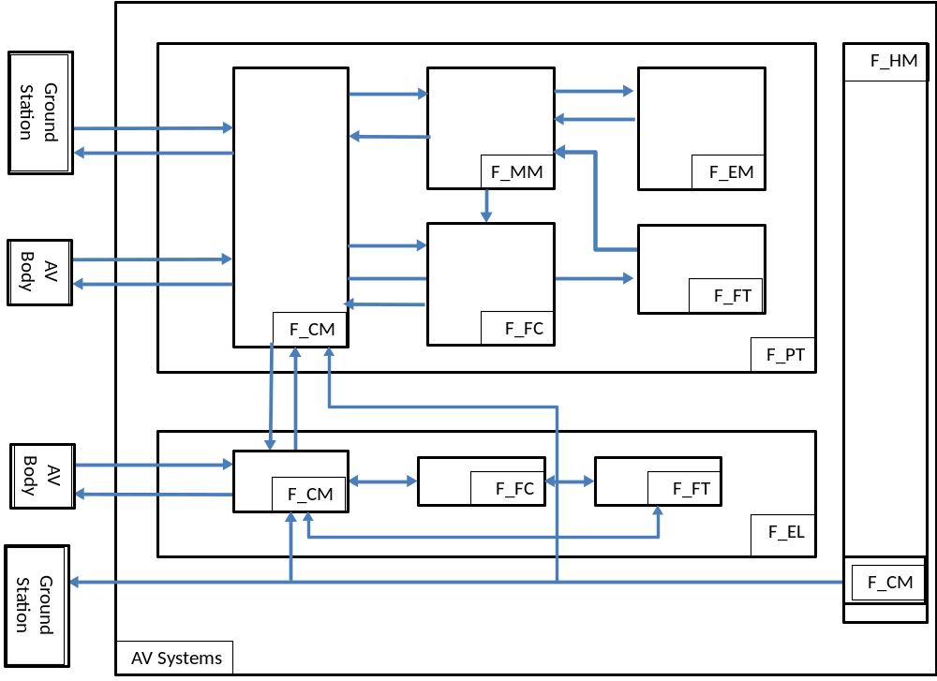
Figure 1 AV level (layer 0) functional architecture

payload transport function (F_PT)

Inputs

Ground-based Mission Preparation and Supervision
Flow Name | Content | Comment
NavigationParameters | Distance [1:1:100] (n.m)  Speed [1:1:250] (kt)  Altitude [-500, 3000] (ft)
NavigationMode | {‘RP’,’A’} | Enumerated type RP=Remotely Piloted  A=Autonomous
NavigationOption | {‘SPEED’,’ALTITUDE’,’ENERGY’} | Enumerated type
GO | event
EmergencyLanding | event

AV-based Mission Preparation (Control Panel)
Flow Name | Content | Comment
ON/OFF_PushButton | event
START_PushButton | event
ModeSwitch | {‘A’,’RP’} | Two stable states  A=Autonomous, RP=Remotely Piloted
BaySwitch | {‘OPEN’,’CLOSED’} | Two stable states
PayloadMass | integer
USB_Key | Distance [1:1:100] (n.m)  Speed [1:1:250] (kt)  Altitude [-500, 3000] (ft)

Physical Parameters
Flow Name | Content | Comment
p | float | Drives distance
pdot | float | Drives speed
q | float | Drives altitude and pitch

Flow Name | Content | Comment
MissionAbort | true/false | Signal sent by F_EL when it diagnoses that F_PT does not detect dangerous behaviour of the AV

Outputs

Outputs

Ground-based Mission Monitoring
Flow Name | Content | Comment
CP_Switches | Power: Boolean;  Mode: {‘RP’,’A’};  Bay:{‘OPEN’,’CLOSED’}  START:Boolean;  Rotactor1:[1:1:9] (kg)  Rotactor2:[1:1:9] (kg)
CP_Displays | READY:Boolean;  CANCELLED:Boolean;  COMPLETE:Boolean;  ABORTED:Boolean;  PrimarySource [1:1:100] (%)  SecondarySource [1:1:100] (%) | Capacities are relative to full charge
PropulsionEnergy | PrimarySourceCapacity [1:1:99999] (J)  SecondarySourceCapacity [1:1:9999] (J) | Capacities are absolute in Joule

Control Panel Displays
Flow Name | Content | Comment
MissionCANCELLED | true/false
MissionCOMPLETE | true/false
MissionABORTED | true/false
PrimarySource | [1:1:100] (%)
SecondarySource | [1:1:100] (%)

Physical Parameters
Flow Name | Content | Comment
PropulsionTorque | [-10e-6:0.0001:+10e-6] (N.m)
BrakingTorque | [-10e-6:0.0001:+10e-6] (N.m)

F_PT sends one information to F_EL.

Flow Name | Content | Comment
EmergencyLanding | true/false | True when F_PT decides to abort the mission. Leads to soft landing when enough electrical energy is still available, to hard landing otherwise

Contract

Assumptions
- Foreseable operating conditions for wind gusts are the regulatory ones [4],
- Foreseable operating conditions for icing are the regulatory ones [4],
- Standard Weather Conditions (SWC) are defined by [4],
- Good Weather Conditions (GWC) are defined by no icing and tailwind (no vertical component) of strength less than 15kt, distributed as uniform law [0,15],
- Adverse Weather Conditions (AWC) are defined by no icing and headwind with some vertical component. AWC wind is characterized by:
  - Horizontal headwind:
    - speed fluctuates in [10kt, 25kt] distributed as GL(18,5),
    - direction with respect to heading fluctuates in [-π/4, +π/4] uniformly,
  - Vertical headwind: strength fluctuates in [-10kt, +20kt] as GL(10,5),
- Operators may enter any value by GS channel or by the USB key. The values are assumed to be well-typed and appropriately bounded (no security in the use case).

Guarantees
- No take-off if on-board energy is incompatible with mission completion under SWC,
- Climb performance:
  - ascending spee: [0.2, 3] m/s,
  - precision of flight level capture: +/- 50ft,
  - precision of speed capture: +/- 5 kt.
- AV is kept in its flight safety envelope (phase-dependent constraints on pdot, q, qdot),
- RP mode is identical to A mode when no command is sent to the AV. All control laws and FDIR behaviours are left invariant by ‘A’↔‘RP’ switches,
- In ideal weather conditions (no wind, no icing), in case of at most 1 failure per component type, all initiated missions run to completion,
- In GWC, at MTOW, when range is lower than 100 n.m, the mission success ratio is at least 90% (95% confidence level),
- In AWC, at MTOW, when the range is lower than 50 n.m, the success ratio is at least 60% (95% confidence level),
- As soon as AV’s safety is compromised or mission completion is no longer possible, soft emergency landing should be triggered,
- As soon as AV’s safety is compromised or mission completion is no longer possible and propulsion is no longer available, hard emergency landing should be triggered,

Behaviour
Defined as interaction of the sub-functions.

Sub-functions

Overview
At aircraft level, functions are too complicated for direct specification.
They are containers of interacting sub-functions, whose individual and collective behaviour have role aspects in common (as perceived by either crew, ATM, maintainers, etc).
Even on a tiny development like muXAV, straightforward specification of the main functions was perceived as difficult and inappropriate. Decomposition was needed.
This section gives the rationale of role partitioning.
For safety critical behaviours, role partitioning like architectural partitioning are safety-related notions (Common Cause Analyses).
Function sharing, when used in functional architecting, undermines role partitioning (addressed by Functional Failure Sets computation, CCA, PRA).
At AV level:
- F_PT: is in charge of all aspects related to operating a mission (ground & flight), except resource monitoring and maintenance,
- F_EL: is in charge of all aspects (except resource monitoring and maintenance) as soon as abort of the mission has been decided.
- F_HM: monitors all the cyber and physical resources, and compute health statuses (Boolean status for flight diagnostics that trigger fail-safe fault tolerance logics, numerical status for progressive failure modes candidates for prognosis).
At F_PT level:
- F_CM: in charge of:
- data encoding/decoding (DC/AC converters),
- protocols (message formats and scheduling), cable or wireless,
- communications between and within systems / equipments,
F_CM does not consolidate redundant transfers (voting).
- F_MM: in charge of:
- mission preparation (ground station and/or field operator),
- mission cancellation when initial conditions lead to mission failure likelihood,
- navigation and performance (constraints, precision of payload delivery),
- mission interruption as soon as mission success conditions are no longer met.
- F_FC: in charge of:
- ensuring stability of the AV (flight safety envelope) within specified normal and abnormal conditions,
- propulsion and control,
- F_EM: is in charge of:
- Monitoring electrical energy capacity (two sources),
- Monitoring hydraulic energy capacity (accumulator),
- F_FT: is in charge of:
- dynamic aspects of fail-safe design by architectural mitigation (isolation / recovery – cold redundancy logics),
- passivation (fail-operational – hot redundancies).
Layer 0 functional specification contains only interfaces and contracts: layer 0 behaviours are composite behaviours tentative description of which would be approximate, partially incomplete or partially redundant with lower level behavioural specifications.

Communication Management (F_CM)

Interface
At AV level there is no awareness of system-to-system communication.
Following the operator’s standpoint, the communications considered are that with the external devices: GS and CP. From the point of view of the three operational functions, CP is regarded as a peripheral device.
Inputs | From | Outputs | To
GS_MissionSetUp(  [Distance:float;  Speed:float;  Altitude:float]) | GS | AV_CP_Displays(  [READY:Boolean;  missionCANCELLED:Boolean;  missionCOMPLETED:Boolean;  missionABORTED:Boolean;  PES_CAPACITY:Integer;  SES_CAPACITY:Integer  ]) | CP
GS_NavigationMode({‘RP’,’A’}) | GS | AV_CP_LEDs(bitarray[20]) | CP
GS_NavigationOption({‘SPEED’,’ENERGY’}) | GS | AV_MissionCompleted([PRIMARY_SOURCE:Integer;  SECONDARY_SOURCE:Integer;  ]) | GS
GS_GO | GS
GS_EmergencyLanding | GS
AV_CP_Switches(  [Power: Boolean;  Mode: {‘RP’,’A’};  Bay:{‘OPEN’,’CLOSED’};  START:Boolean;  Rotactor1:Integer;  Rotactor2:Integer;}  ]) | CP
Analog signals from the three mechanical sensors (p, pdot, q) | AV

Contract

Assumptions
- The data-link is not a lossy (lower layers: medium access etc.),
- Hardwired links connected to mechanical sensors can’t fail.

Guarantees
- No loss (upper layers: transfer, presentation, application),
- Communication latencies are bounded (2s) and meet the deadlines specified by the operational functions,
- Transfer preserves integrity of content,

Mission Management (F_MM)

Interface
Inputs | From | Outputs | To
NavigationParameters(  [Distance:Integer.m;  Altitude:Integer.m;  Speed:Integer.(m/s)]) | F_CM | MissionCancelled(Boolean) | F_CM
NavigationOption(‘ALTITUDE’,‘SPEED’,’ENERGY’) | F_CM | MissionComplete(Boolean) | F_CM
NavigationMode({‘A’,’RP’}) | F_CM | MissionAborted(Boolean) | F_CM
PowerSwitch({‘ON’,’OFF’}) | F_CM
PayloadBay(‘OPENED’,’CLOSED’) | F_CM
StartButtonPress(Booelan) | F_CM
PayloadMass(Integer.kg) | F_CM
MechanicalSensors(p,pdot,q) | F_CM
EnergyLevel(J) | F_EM
RessourcesOK(Boolean) | F_HM

Contract
The safety and performance properties presented at F_PT level that can be formulated on F_MM’s interface are not repeated here (contract inheritance). So to speak, this part of F_MM’s contract is the projection of F_PT’s contract on F_MM’s interface.
F_MM’s contract contains also additional properties, specific to the exchanges with F_EM and F_CM. These exchanges are unobservable on F_PT’s interface.

Assumptions
- RessourcesOK is correct, i.e never misleading. When true, propulsion, braking, computation and communication and should actually be available,
- EnergyLevel(J) is accurate or conservative. If conservative, not in excess by 10% of the estimated capacity.
- Icing can occur only in climb and descent phases (no icing at µXAV’s cruise altitudes),
Because of:
- systematic contract-based specification,
- systematic contract-based implementation (system modelling, software and hardware development),
- assumption of development assurance’s effectiveness,
- assumptions A and B,
F_MM has no mitigation mechanism to tolerate faults that would lead to a wrong perception of µXAV’ state.
F_MM does not try, using estimation algorithms, to reconstruct information on its own in order to cross check the data it receives. In the use case, there is no functional redundancy motivated by possible weakness of development assurance.
If functional redundancy had to be introduced, it would be on request of the safety group, for architectural safety reasons.

Guarantees
The inherited.

Flight Control (F_FC)

Interface

Inputs
Flow Name | Content | Comment
p | float | Drives distance
pdot | float | Drives speed
q | float | Drives altitude and pitch

OperatingPoint | Altitude and Speed
OperatingMode | value in {‘SPEED’,’ALTITUDE’,’ENERGY’}
MissionRange | Same range as the Distance mission parameter

Outputs
Flow Name | Content | Comment
EstimatedTotalMass | [5,10]kg
CurrentRange | [1:1:1000000](m)
CurrentSpeed | [1:1:500] (km/h)
CurrentAltitude | [-200:1:1000] (m)
PropulsionTorque | [0:0.1:100000] (N.m) | To AV
BrakingTorque | [0:0.1:100000] (N.m) | To AV

Contract

Assumptions
- Sensing of (p, pdot, q) is noiseless and unbiased,
- The values of the operating points (speed, altitude) are safe (from F_MM). Since security is out of the scope of the use case, no integrity check is applied to the values received from F_CM,
- Every mission is viable or cancelled or aborted.

Guarantees
- The regulatory functional safety properties are met [4],
- AV is kept in its flight safety envelope, i.e meets phase-dependent constraints on p, pdot, q, qdot:
  - Climb: (qdot_minCl < qdot < qdot_maxCl) and (q < q_maxCl)
  - Cruise: (qdot_minCr < qdot < qdot_maxCr) and (q > q_minCr) and (pdot < pdot_maxCr)
  - Descent: (qdot_minDs < qdot < qdot_maxDs) and (q < q_maxDs)
The constants bounding the safety envelope are given at model level. (see also Error: Reference source not found.2, clause C of F_PT’s contract),

Constant Name | Unit | Value
qdot_minCl | Angle.s⁻¹ | TBD
qdot_maxCl | Angle.s⁻¹ | TBD
q_maxCl | Angle | TBD
qdot_minCr | Angle.s⁻¹ | TBD
qdot_maxCr | Angle.s⁻¹ | TBD
q_minCr | Angle | TBD
pdot_maxCr | Angle.s⁻¹ | TBD
qdot_minDs | Angle.s⁻¹ | TBD
qdot_maxDs | Angle.s⁻¹ | TBD
q_maxDs | Angle | TBD

- Propulsion and braking torque actions are in mutual exclusion,
- In-flight mission abort with remaining propulsion capacity implies occurrence of safety escapes lasting more than EscapeTime seconds.

Energy Management (F_EM)

Interface
At AV level, from the operator or maintainer standpoints, energy management is almost fully abstracted. The maintainer, because of the CP’s 20 LEDs, is aware of the architecture, in particular the electrical/hydraulic aspects.
Inputs | From | Outputs | To
 |  | EnergyLevel(float.J) | F_PT.F_MM

Contract

Assumptions
- PrimaryEnergyLevel(float.J) is accurate or conservative (at most by 10% at 95% CL)
- SecondaryEnergyLevel(float.J) is accurate or conservative (at most by 20% at 95% CL)

Guarantees
- EnergyLevel(float.J) is accurate or conservative (at most by 20% at 95% CL)

Fault Tolerance (F_FT)

Interface
Empty.
Inputs | From | Outputs | To
Effects of this function are unobservable at AV level. Internal only.

Contract

Assumptions
- F_HM detects all the single cause failures addressed by the safety process (physical failures)

Guarantees
- All single cause failures are fail-safe tolerated

emergency landing function (F_el)

Inputs
Flow Name | Content | Comment
p | float | Drives distance
pdot | float | Drives speed
q | float | Drives altitude and pitch

Outputs
Flow Name | Content | Comment
PropulsionTorque | float
BrakingTorque | float

Contract

Assumptions
- No assumption. F_EL is the ultimate recovery process to avoid crash, its robustness has to be maximal,

Guarantees
- No false negative of the activation logic when F_EL(as safety monitor), takes over MMS/(F_MM + F_FC).
- No false positive of the activation logic, i.e undue loss of mission,
- Soft landing: under assumption of enough energy and SWC, no damage to the AV (specified as dynamic constraints on the state vector),
- Hard landing: no guarantee.

Behavior
F_EL degrades AV’s mechanical energy as quickly as possible to zero altitude and speed, while limiting ground impact.
F_EL is activated by:
- MMS:
  - Viability: energy shortage to complete the mission, but enough energy for soft landing. F_EL performs soft landing.
  - MMS-detected safety escapes: MMS is aware it is losing control of the AV, so triggers soft emergency landing to be performed by EPS.
- EPS
  - Safety escapes:
    - MMS up: suspicion of design/development error in MMS, EPS take over MMS,
    - MMS down: EPS.F_FC is losing control and switches to EPS.F_EL. Mission transitions from “frozen” to ABORTED.
  - Failures:
    - MMS up: EPS.F_HM emits the failures, but makes no landing decision,
    - MMS down:
      - too many EPS components are failed, EPS triggers F_EL, to be performed by HBS
      - shortage of energy: mission ABORTED by EPS, F_EL triggered and performed by EPS,
- HBS
  - MMS up: no action.
  - MMS down and EPS up: safety monitoring of EPS in “mission frozen” mode, takes over in case of safety escape. HBS.F_EL performs hard emergency landing.
  - EPS down: hard emergency landing performed by HBS.F_EL.
F_EL is never deactivated (irreversible, ends with drone on ground).
F_EL performs a PID (reference value set to 0: that of the active option).

health monitoring function (F_HM)

Inputs
- All digitized sensor values (AV body, electrical, hydraulical), They are detailed at layer 1 (dependent on systems’ internal architecture).
- All BITEs from computation units. They are detailed at layer 1 (dependent on systems’ internal architecture).
- At air vehicle level, F_HM receives system-level health statuses.
Inputs | From | Outputs | To
PropulsionRessourcesOK(Boolean) | EPS | RessourcesOK(Boolean) | F_PT.F_MM
BrakingRessourcesOK(Boolean) | HBS
MissionManagementRessourcesOK(Boolean) | MMS

Outputs
The outputs of the function are high level functionalized failure statuses. Functionalized means that F_HM gives to MMS the functions that are lost:
- Payload transport at AV level,
- Propulsion, braking, mission control at system level.
Health management does not address energy level issues.
- For diagnosis
  - Power fail: primary 0%, secondary 0%,
  - Component fail: sensors, ECUs, sender/receiver,
  - Function fail: navigation (freeze of ALTITUDE/SPEED/ENERGY), mission Abort
- For prognosis
  - Electrical engine degradation
  - Hydraulic pump degradation
  - Clutch degradation

Contract

Assumptions
- Sensors are ideal. In later versions the sensors will include fault models (bias, noise, lag) to deal with robustness analysis at AV and system level,
- Actuators are ideal. Similarly in later versions the actuators will be biased and lagging,
- Some item level components have no failure modes (mechanical parts, wiring, pipes, see Architecting),
- The synthetic information from EPS, HBS, MMS are accurate or conservative. Conservative means that if wrong, it does not compromise safety. Inaccuracy, provided it is mastered by design, may be correct as far as OP Correctness is concerned.

Guarantees
- No false negatives on safety critical components or functions.
- No false positives (mission critical). Nice to have, though classified minor by FHA (bears only on availability).
- RessourcesOK is accurate or conservative.

Behaviour
F_PT ressources are OK as long as propulsion, braking and mission management resources are OK.

It may be the case, but it is not the default case
needs the MS flight data recorder option,

