7UNCLASSIFIED

 |  | REFERENCES | ISSUE | DATE








µXAV Layer 0 Architectural Specification

SCOPE

Page : 1 / 24

This document is the intellectual property of RESSAC members It may not be used, reproduced, modified or disclosed without its authorization.
RESSAC members Proprietary Data.

signatures
 | REFERENCES | APPROVERS
 |  | Fonction 1

 |  | Name 1
 |  | Fonction 2

 |  | Name 2
 |  | Fonction 3

 |  | Name 3
 |  | Fonction 4
 |  | Name 4
 |  | Fonction 5
 |  | Name 5

Table of contentS
1. PREAMBLE 4
1.1 Document issues 4
1.2 Executive Summary 4
2. Purpose of the document 6
3. references 7
4. overview 8
4.1 Synoptic Plan 8
4.2 Architecting Rationale 9
4.2.1 Mission Resources 9
4.2.2 Fail-Safe Design 10
5. increment 1 architecture 14
5.1 Synoptic Plan 14
5.2 Systems 14
5.3 Physical Devices 15
5.4 Electrical Wiring 15
5.5 Communication Networks 15
6. increment 2 architecture 16
6.1 Synoptic Plan 16
6.2 Systems 16
6.3 Physical Devices 16
6.4 Electrical Wiring 17
6.5 Communication Networks 18
7. increment 3 architecture 19
7.1 Synoptic Plan 19
7.2 Physical Devices 19
7.3 Electrical Wiring 20
7.4 Communication Networks 21
8. increment 4 architecture 22
8.1 Synoptic Plan 22
8.2 Physical Devices 22
8.3 Electrical Wiring 23
8.4 Communication Networks 23
8.4.1 Ground-Board Network 23
8.4.2 Air Vehicle Network 23

PREAMBLE

Document issues
Date | Issue | Author(s) | Updating purpose
12/07/2017 | 1 | E. Ledinot | Creation of the document

Executive Summary
This document describes the physical and informational architecture that connects the three systems embedded in the air vehicle µXAV (layer 0):
- The Mission Management System (MMS) in charge of mission supervision,
- The Electrical Propulsion System (EPS) in charge of propulsion,
- The Hydraulic Braking System (HBS), in charge of emergency braking.
Architectural aspects are limited to the logical ones (topology of connections) and to the dimensioning parameters of the physical devices (mass, power, capacity, throughput etc.). The technological characteristics of the embedded components are not addressed.
The installation aspects into the 3D digital mock-up of the drone are not addressed either. This option has impact on safety assessment of implementation (e.g Zonal Safety Analysis) and on representativeness of physical modelling (e.g in hydraulics, consistency between pressure drop parameters and 3D tubing layout in the drone).
These abstractions, consistent with present industrial practice, may have some impact on representativeness of flight control modelling and simulation.
Specification and modelling adequacy are also at stake in contract-based compositional reasoning experimented in the use case as support for certification (conformity to [1]).
The document provides the complete view of the architecture, and then proceeds with its 4-step incremental development.

Purpose of the document
The document is an input to the following activities:
- Layer 0 mapping of functions to systems,
- Preliminary Air vehicle Safety Assessment (PASA – safety assessment process),
- Layer 0 functional specification,
- Layer 1 MMS functional specification,
- Layer 1 MMS architectural specification,
- Layer 1 EPS functional specification,
- Layer 1 EPS architectural specification,
- Layer 1 HBS functional specification,
- Layer 1 HBS architectural specification,
This document is assumed to be written by the multi-system architect in charge of the air vehicle level (layer 0).
It describes the physical and electronic hardware items specified in the multi-system architecture, and how they are interconnected.

references
[1] µXAV Certification Specification
[2] µXAV Systems Process Definition
[3] µXAV Air Vehicle Level Functional Hazard Analysis
[4] µXAV Layer 1 MMS Architectural Specification
[5] µXAV Layer 1 EPS Architectural Specification
[6] µXAV Layer 1 HBS Architectural Specification
[7] µXAV Layer 0 Functional Specification
[8] µXAV Layer 1 MMS Functional Specification
[9] µXAV Layer 1 EPS Functional Specification

overview
Architecture at layer 0 addresses multi-system and multi-physics aspects, without digging into the internal architecture of the systems (addressed at layer 1).
The so-called “aircraft level” multi-system is made of:
- The Mission Management System (MMS), in charge of mission supervision. It represents software-intensive systems in large airplanes (e.g avionics systems supporting Flight Management Systems, flight decks etc.),
- The Electrical Propulsion System (EPS), powering propulsion, the computation resources and the switching resources of the drone. It exemplifies the pervasive role of electrical power in architectures, subjected to regulatory safety-related independence constraints. Treatment of physics in the electrical energy domain is most basic (continuous current, simplistic active and passive components).
- The Hydraulic Braking System (HBS) is in charge of braking in flight emergency situations. In addition to the mechanical and electrical energy domains, HBS provides a third one with its proper time scales of phenomena. These timing aspects are the reason why hydraulics has been introduced in the case study. Physical causality representativeness of multi-system simulation, or co-simulation, with software in the loop (model-based virtualized integration), is a tricky engineering and certification issue.

Synoptic Plan
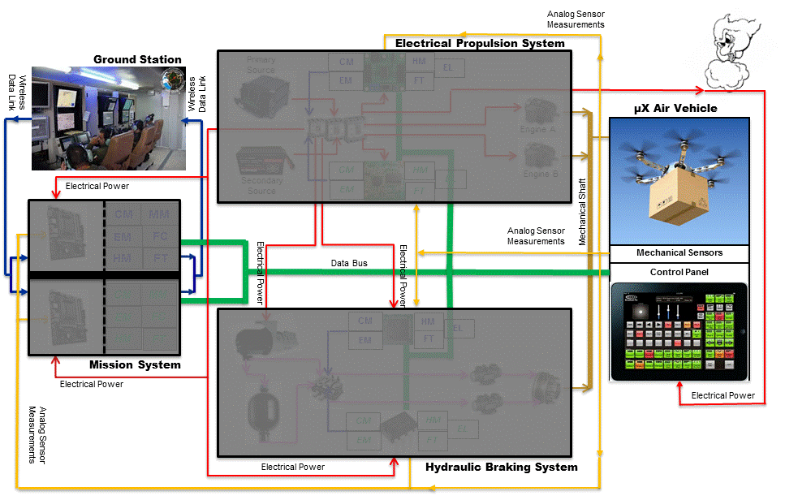
Figure 1: Air vehicle level multi-system architecture
Layer 1 architectures have been left partially visible to help interpretation of layer 0 connections.
The control panel and ground station icons suggest higher complexity than that of the use case. The chart of the functionally accurate control panel is given below. See [7] or [8] for the functional description of the device.
Beware: figure 1 is not complete regarding the analogous communication links between MMS, EPS and HBS, to avoid the mess of exhaustiveness in dual-dual architecture connections.
A comprehensive list of the missing drawings is given in the sequel.

Architecting Rationale

Mission Resources

Mission Control
There are two resources:
- The ground station, the contribution of which in the case study is limited to the data link and to its message protocol (see Increment 4 below).
- The control panel. Its front-end is given figure 2 (see [8] for its behaviour).
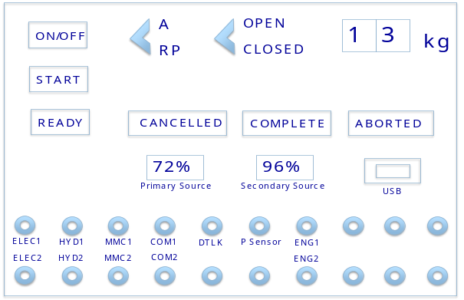
Figure 2: front-end of the control panel

Flight Control
Propulsion resources
- Six propellers are powered by a unique master shaft, which in turn is powered by two electrical engines. Electrical supply of the engines is performed by EPS, under MMS command and monitoring,
- The master shaft is fixed to a clutch that can perform sharp braking actions for fast speed reduction of the propellers when electrical cut-off of the engines would not suffice,
- The clutch is powered by HBS, under MMS command and monitoring,
Energy resources
- A primary electrical source (high capacity battery or small fuel cell),
- A secondary electrical source (battery),
- An electrical hydraulic pump,
- A hydraulic accumulator.
Energy sources are doubled in the electrical and hydraulic energy domains to meet the regulatory “no single failure” requirement.
Control resources
- MMS is a dual-channel computer with memory segregation, power independence, but hardware similarity,
- EPS ensures dual-channel control of the engines with full independence (memory, power, and hardware dissimilarity)
- HBS ensures dual-channel control with full independence, like EPS.

Freight
A bay, closed by two doors, can host one or several parcels to be fastened in the bay.

Fail-Safe Design
Fail-safe design is a regulatory requirement [1], to be addressed by development and development assurance.
In particular, it copes with development assurance failures.
It deserves specific care in any attempt of assurance reformation that encompasses system, software and hardware.
Fail-safe design motivated the choice of the dual-dual architectures (at layers 0 and 1), though quite unrealistic for drone business: too complicated, too heavy and unaffordable.
These architectures are however deemed amenable to minimal exercising of:
- interaction between the system development process and the safety assessment process (FDAL and IDAL assignment, PASA, PSSAs, functional safety requirement verification, etc.),
- substantiation of conformance to Part 25-like airworthiness regulation [1], especially 25.1309.
Does this architectural specification meet the regulatory safety requirements? It will be assessed at layer 0:
- on architectural aspects by PASA and ASA, reviewed by the development process,
- on functional aspects by the verification activities at system, software and hardware levels.
OPs-based development assurance covers both aspects, in spite of delegation of the architectural aspects to the safety assessment process [2].
This document presents the resource redundancy and the resource connectivity principles specified to meet the fail- safe design requirement.
The behavioural aspects are covered in the functional specification documents ([7], [8], [9]).
µXAV’s fail-safe mechanisms are stratified:
- at layer 0 EPS and MMS ensure mutual independent monitoring of each other, for the two most safety critical functions:
  - EPS monitors MMS’ flight control function (also monitored within MMS itself at layer 1). It can take over MMS in case of detected MMS failure,
  - MMS monitors EPS’ estimation of the remaining energy capacity (also monitored within EPS itself at layer 1). MMS can disregard EPS’ estimation as over optimistic and abort mission,
- at layer 1, MMS, EPS and HBS have all dual-channel architectures that ensure various degrees of independent monitoring and redundancy.

Tolerated Failures
Random failures
- Electrical power lines,
- Electrical engines,
- Electrical hydraulic pump,
- Electrical switches,
- Electrical hydraulic valves,
- Electronic control units (computation, networks),
Systematic failures
- System specification faults,
- Software specification faults,
- Software implementation faults,
- Hardware specification faults,
- Hardware implementation faults.
Regarding random and systematic failures, µXAV’s fail-safe design does not claim to detect and passivate all the physical failure modes and all the development faults previously listed.
It claims to detect the failure effects of some of the physical failure modes and of some of the activated residual development faults belonging to these lists.
The tolerated failure effects are specified in the contracts of the health monitoring (F_HM) and of the fault-tolerance (F_FT) functions, at any level (i.e layer 0, 1, 2).

Resource Redundancy Policy
Sensors
All critical sensors are doubled:
- The p, pdot, q attitude sensors,
- The voltage sensor on the primary electrical source,
- The voltage sensor on the secondary electrical source,
- The hydraulic pressure sensor,
Actuators
- The electrical propulsion engine is doubled,
Power paths
- Each device (sensor, actuator, switch, pump, computation unit, etc.) has a single power line,
Processing
- MMS: dual channel
  - Identical hardware (memory segregation between channels, channels are powered independently). MMS hardware is distinct from EPS’.
  - Identical functions are performed the two channels (semi-cold redundancy, the high rate states are shared by the two channels via cross-channel communication).
  - The software implementation of the functions are dissimilar between the two channels (SCADE – Spark Ada),
- EPS: dual channel
  - Hardware dissimilarity (micro-processors plus independent power supplies),
  - Identical functions,
  - Software implementations are dissimilar,
- HBS: dual channel
  - Hardware dissimilarity between the two channels (micro-processors plus independent power supplies), plus independence of the two microprocessors wt. MMS’ and EPS’. HBS’ controllers ensure the ultimate degraded mode (hard emergency landing),
  - Identical functions are executed on the two channels (semi-cold redundancy),
  - Identical software implementations,

Resource Connectivity Policy
Power lines per device are always unique, but the computer-controlled power switch (m-switch) provides reconfiguration capabilities. See layer 1 specifications, there is no energy routing managed across systems, even though electrical power is distributed from EPS to MMS and HBS.
Cross-system control of physics is a key aspect of the use case. Flight control is distributed over MMS, EPS and HBS, with some ensuing engineering difficulties and safety challenges:
- Physical adequacy of “software in the loop” layer 0 simulations,
- Stability of control in multi-system wide FDIR transients,
- End-to-end timing analysis.
Informational connectivity and data path redundancy across systems are addressed in this section. Analogous sections exist at layer 1 for MMS and EPS.
‘Data’ encompasses:
- Continuous signals, e.g sensor measurements, transmitted by low-power electrical wiring,
- Digital information transmitted on the serial bus.
The design rules are the following ones:
- Any information exchange needed by a function whose FDAL is A or B must be supported by two independent physical means (or more). Since the bus is unique, this implies addition of point-to-point analogous transmissions.
- Any information exchange of criticality C or lower is only bus-supported.
List of the safety critical data items subjected to dual-path transmissions:
- Mechanical sensing: each sensor of the three (p, pdot, q) pairs is linked to MMS’, EPS’, and HBS’ computation units (6 x 6 analogous links). The analogous values of the measurements are digitally encoded six times by three systems. MMS and EPS bus-exchange their value pairs for consolidation and mutual monitoring.
- Mechanical actuation:
  - Propulsion torque commands are DAL A. In nominal modes (MMS operative) they are computed by MMS’ master computer. They are transmitted to EPS’ computers by bus and by analogous links (2 x 2 links),
  - Braking torque commands are DAL A. A similar redundancy pattern is applied on transmission of the command from MMS to HBS’ computation units.
- Energy capacities:
  - Primary source: the analogous value of its capacity sensor (DAL A) is encoded by EPS’ ECUs. Each ECU transmits the value MMS’ computers,
  - Secondary source: the capacity sensor is encoded by EPS’ ECUs. Each ECU transmits its value (DAL C) to MMS’ computers by bus only.
- Switching commands:
  - MMS failures:
    - Self-detected: when both channels are lost, MMS hands over to EPS by means of an electrical interrupt signal sent to EPS’ ECUs and to HBS’ ECUs. It starts monitoring of EPS’ (new master system) by HBS.
    - EPS-detected: EPS can shut-down the two MMS channels by means of 2 x 2 electrical interrupt signals. These signals are also sent to HBS’ ECUs, by bus and analogous links.
  - Mission aborts:
They may be initiated by MMS when MMS is the master system, by EPS or HBS when EPS is the master system. Such events have to be digitally and electrically notified to all the active ECUs. Wiring supports the needs for soft and hard emergency landings [7], [8].

increment 1 architecture

Synoptic Plan
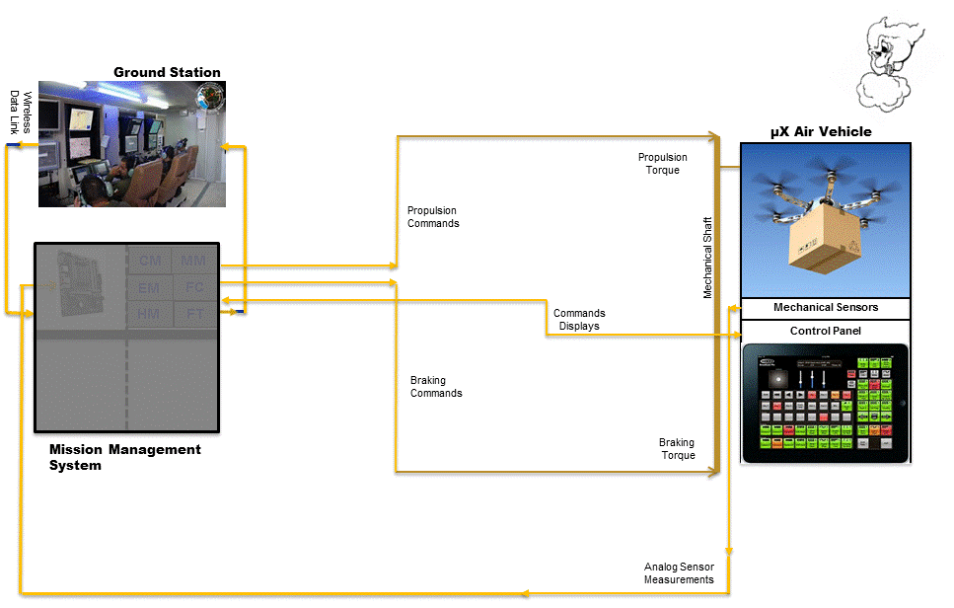
Figure 3: “Multi-system” architecture of increment 1
The main characteristics of this ‘architecture’ are:
- No use of energy to fly the drone. Torque commands (propulsion and braking), i.e floating point variables, are converted “by magic” into mechanical torque actions without physical devices to perform these actions. The “magic” is represented by the lines that begin as (orange) commands and end as (brown mechanical torques (N.m),
- MMS entails a single computation unit (no redundancy at increment 1),
- The ground station and the control panel are active but information transfers are supported by continuous time signals to facilitate control-oriented modelling and simulation. Increment 1 is focused on design, modelling and simulation of the flight control laws.

Systems
MMS is the only system at increment 1.
Computer hardware is not addressed.
A single instance of software is executed (see [8]). Six in eight functions have some level of implementation. F_FT and F_HM are not supported at all in this first increment.

Physical Devices
They are limited to:
- The mechanical devices of the control panel (switches, dialling wheels, doors, etc.),
- The flying mechanical body, that converts the propulsion/braking torques to:
  - motion of the AV’s mass centre (2D horizontal & vertical motion),
  - some attitude motion around the mass centre.

Electrical Wiring
No electrical power supply.
No analogous signals though all signals are continuous time at model level.

Communication Networks
Not applicable.

increment 2 architecture

Synoptic Plan
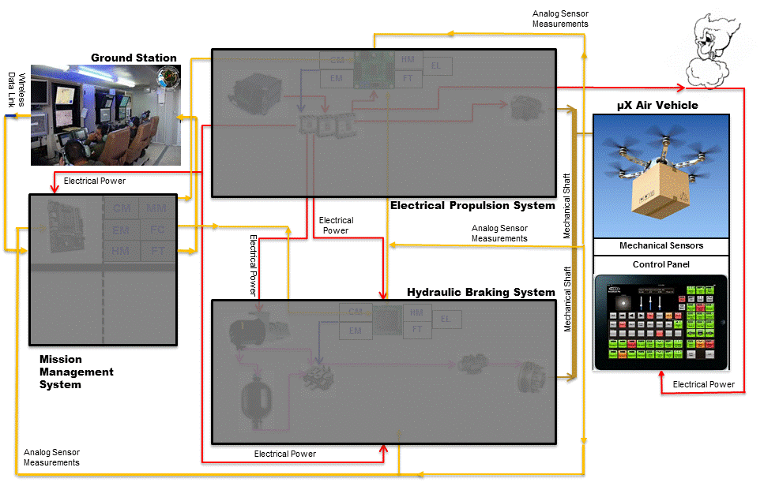
Figure 4: Multi-system architecture of increment 2
The analogous links are partially represented. See 6.4 for the exhaustive list.

Systems
EPS and HBS are introduced, without resource redundancy at layer 1. However the unique layer 1 components are suffixed A in view of the twin B instances introduced by increment 3.
All connections between systems are continuous time:
- Power supplies (red lines)
- Analogous signals (orange lines). For clarity they are represented as bi-directional links whereas pairs of wires should be represented for comprehensiveness (see 4.2.2.3).

Physical Devices
In MMS
- Upgrade of the computer’s I/O hardware with DC/AC converters to communicate through the analogous links.
In EPS
- Primary electrical energy source,
- Computer-controlled voltage modulator,
- Computer-controlled multiple-switch for reconfigurable power supply,
- Electrical engine fixed to the master shaft,
- Electronic Control Unit (ECU), with DC/AC converters,
- Electrical wiring,
In HBS
- Electrical hydraulic pump,
- Oil accumulator,
- Computer-controlled valves,
- Pipes,
- Clutch attached to the master shaft,
- Electronic Control Unit (ECU), with DC/AC converters,

Electrical Wiring
Power supplies
- From the primary source to the computer-controlled multiple-switch (m-switch),
- From the m-switch to MMS’ ECU A,
- From the m-switch to EPS’ ECU A,
- Form the m-switch to HBS’ ECU A,
- From the m-switch to the control panel,
- From the m-switch to the voltage modulator,
- From the voltage modulator to engine A,
- From the m-switch to the hydraulic pump.
Analogous signals
- From the (p, pdot, q) A-sensors to MMS’ ECU A,
- From the (p, pdot, q) A-sensors to EPS’ ECU A,
- From the (p, pdot, q) A-sensors to HBS’ ECU A,
- The propulsion torque command signal from MMS’ ECU A to EPS’ ECU A,
- The braking torque command signal from MMS’ ECU A to HBS’ ECU A,
- From the primary source’s capacity sensor to EPS’ ECU A,
- The primary capacity signal transmitted from EPS’ECU A to MMS’ ECU A,
- from MMS’ ECU A to EPS’ ECU A the MMS-to-EPS hand-over signal (self-detected case),
- from MMS’ ECU A to HBS’ ECU A the MMS-to-EPS hand-over signal (self-detected case),
- the shut-down signal from EPS’ ECU A to MMS’ ECU A,
- the mission abort signal from MMS’ ECU A to EPS’ ECU A,
- the mission abort signal from MMS’ ECU A to HBS’ ECU A.

Communication Networks
Not applicable.

increment 3 architecture

Synoptic Plan
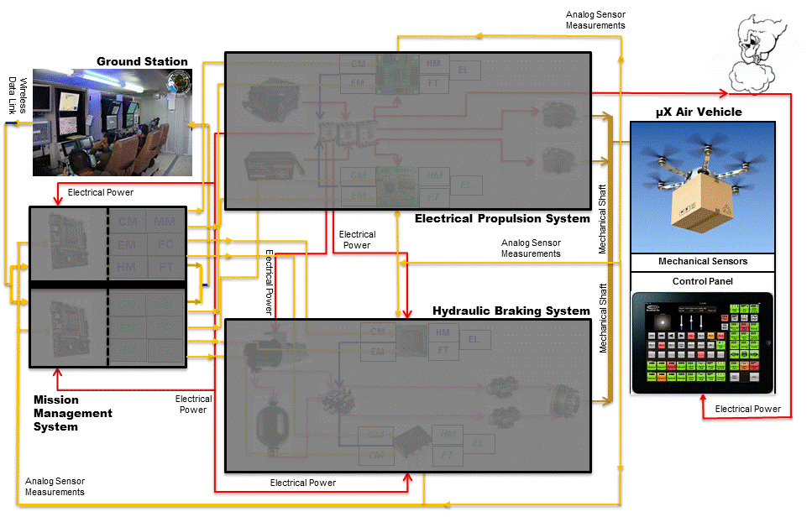
Figure 5: Multi-system architecture of increment 3
Redundancies have been introduced in the three systems.
Like in figure 4, the analogous communications are partially represented. See 7.3 for comprehensiveness.

Physical Devices
Additional in EPS
- Secondary source,
- Second electrical engine (suffixed B), fixed to the master shaft,
- Second ECU (suffixed B),
- Additional wiring,
Additional in HBS
- Pipes for secondary supply of the clutch,
- Second ECU (suffixed B).

Electrical Wiring
Additional power supplies
Some items of the list are layer 1, they are given for informative and consistency reasons.
- From the secondary source to the computer controlled multiple-switch (m-switch). The switch is unique but it is resilient to loss of one power supply.
- From m-switch to MMS’ ECU B,
- From m-switch to EPS’ ECU B,
- Form m-switch to HBS’ ECU B,
- From voltage modulator to engine B,
Additional analogous signals
- From the (p, pdot, q) B-sensors to MMS’ ECU A,
- From the (p, pdot, q) B-sensors to MMS’ ECU B,
- From the (p, pdot, q) B-sensors to EPS’ ECU A,
- From the (p, pdot, q) B-sensors to EPS’ ECU B,
- From the (p, pdot, q) B-sensors to HBS’ ECU A,
- From the (p, pdot, q) B-sensors to HBS’ ECU B,
- Propulsion torque command signal from MMS’ ECU A to EPS’ ECU B,
- Propulsion torque command signal from MMS’ ECU B to EPS’ ECU A,
- Propulsion torque command signal from MMS’ ECU B to EPS’ ECU B,
- Braking torque command signal from MMS’ ECU A to HBS’ ECU B,
- Braking torque command signal from MMS’ ECU B to HBS’ ECU A,
- Braking torque command signal from MMS’ ECU B to HBS’ ECU B,
- Primary source’s capacity sensor to EPS’ ECU B,
- Secondary source’s capacity sensor to EPS’ ECU A,
- Secondary source’s capacity sensor to EPS’ ECU B,
- Primary capacity transmitted from EPS’ECU B to MMS’ ECU B,
- Secondary capacity transmitted from EPS’ECU A to MMS’ ECU A,
- Secondary capacity transmitted from EPS’ECU B to MMS’ ECU B,
- MMS-to-EPS hand-over signal (self-detected case), from MMS’ ECU A to EPS’ ECU B,
- MMS-to-EPS hand-over signal (self-detected case), from MMS’ ECU B to EPS’ ECU A,
- MMS-to-EPS hand-over signal (self-detected case), from MMS’ ECU B to EPS’ ECU B,
- MMS-to-EPS hand-over signal (self-detected case), from MMS’ ECU A to HBS’ ECU B,
- MMS-to-EPS hand-over signal (self-detected case), from MMS’ ECU B to HBS’ ECU A,
- MMS-to-EPS hand-over signal (self-detected case), from MMS’ ECU B to HBS’ ECU B,
- Shut-down signal from EPS’ ECU A to MMS’ ECU B,
- Shut-down signal from EPS’ ECU B to MMS’ ECU A,
- Shut-down signal from EPS’ ECU B to MMS’ ECU B,
- Mission abort signal from MMS’ ECU A to EPS’ ECU B,
- Mission abort signal from MMS’ ECU B to EPS’ ECU A,
- Mission abort signal from MMS’ ECU B to EPS’ ECU B,
- Mission abort signal from MMS’ ECU A to HBS’ ECU B,
- Mission abort signal from MMS’ ECU B to HBS’ ECU A,
- Mission abort signal from MMS’ ECU B to HBS’ ECU B.

Communication Networks
Not applicable in increment 3: all communications are continuous time and synchronous.

increment 4 architecture

Synoptic Plan
Figure 6: Multi-system architecture of increment 4
Figure 6, like figure 5, is incomplete regarding power supplies (red arrows) and analogous signals (orange arrows).
The lists of sections 6.4 and 7.3 are the reference data.
The two deltas of increment 4 introduce asynchronous event-triggered or time triggered communications:
- Ground station: wireless protocol (to be defined by the implementer), represented by blue arrows,
- ECUs and control panel: serial bus protocol (to be defined by the implementer), represented by a green thick line that connects all the digital-friendly equipments. This unique bus ensures both intra-system (layer 1) and inter-system (layer 0) communications.

Physical Devices
No new additional devices.
Upgrades of the ECUs’ I/O boards and drivers have to be performed to manage the serial bus.
In addition to the DC/AC converters, scheduling of digital communications and interaction with multi-tasked software become design and implementation issues.
Technological solutions (micro-controllers, RTOS, scheduling policies) have to meet the timing contracts specified by the control engineers (rates, jitters, deadlines) [7], [8] to ensure control performance and control safety.

Electrical Wiring
No additional wiring (power or information).
The data-link antennas are assumed to be included in MMS computer’s packaging.
The serial bus is assumed to be “powered” by its subscribers, especially the bus master (if any).

Communication Networks
There are two networks, supported by different technologies and protocols, with different assigned IDALs.

Ground-Board Network
The choice of the wireless technology is left to the implementer.
Communication can be periodic (1Hz rate) or event-based (1s deadline).
Some mechanism must prevent message losses.
In case of message re-emission timing failures are acceptable.
The messages to be sent and received are specified in the system functional specifications [7], [8].

Air Vehicle Network
The choice of the serial bus technology is left to the implementer (CAN bus, TTech, Ethernet based, 1553 etc.).
Subscribers rely on no message loss.
Time stamping and ordering of messages preserves causal ordering of events throughout the multi-system.
In case of local clocks synchronization, 1ms precision (or lower) is required.
Bus-based global synchronization is acceptable with the same precision.
The specified rates for periodic messages are:
- 50Hz (sensors, actuator commands, hand-over, mission aborts). No jitter is required.
- 10Hz (control panel, failure bits), 5ms-jitter is acceptable.
- 1 Hz (ground station datas, capacities), 100ms-jitter is acceptable.
1Hz messages can be handled in event-driven mode.
Causal ordering of transmission of all the failure modes (failure bit messages) must be preserved throughout the multi-system.

Not provided in this first issue. Provision for revision after modelling and simulation.
It does not mean that the document has to be completed before start of the listed activities. It means that it is used as early as the first stage of architecture definition, and then continuously as it matures into the final architecture.
Reminder: the use case, to be kept as simple as possible, does not entail true 6-dof flight mechanics. It entails 2-dof attitude control, and 2D navigation. However, dimensioning of physical devices is performed in the use case as it plays a major role on software validation and catastrophic failure conditions [3].
i.e caused by development assurance failures (fault prevention failures and fault elimination failures)
Contracts of the detection functions.
Fault Detection Isolation and Recovery
Electronic Control Unit

