UNCLASSIFIED

 |  | REFERENCES | ISSUE | DATE








µXAV Case Study
Preliminary Air Vehicle level Safety Assessment

SCOPE

Draft

Page : 1 / 18

This document is the intellectual property of RESSAC members It may not be used, reproduced, modified or disclosed without its authorization.
RESSAC members Proprietary Data.

signatures
 | REFERENCES | APPROVERS
 |  | Fonction 1

 |  | Name 1
 |  | Fonction 2

 |  | Name 2
 |  | Fonction 3

 |  | Name 3
 |  | Fonction 4
 |  | Name 4
 |  | Fonction 5
 |  | Name 5

Table of contentS
1. PREAMBLE 4
1.1 Document issues 4
1.2 Executive Summary 4
2. Purpose of the document 5
3. references 6
4. PASA overview 7
5. PASA inputs 8
5.1 Failure Conditions and Associated Functions from AFHA 8
5.2 Requirements 9
5.3 Initial Operational Considerations 9
5.4 Proposed Aircraft Architecture 10
5.4.1 Conceptual architecture 10
5.4.2 Failure Condition Classification 10
6. inTERdependence analysis 13
7. failure condition evaluation 15
7.1 Assignment of FDALs 15
7.2 Multi-functions and multi-systems analysis 15
7.3 Supporting Analyses 16
7.3.1 Combined Functional Failure Effects Analysis 16
7.3.2 Common Resource Considerations 16
7.3.3 Common Cause Considerations 16
7.3.4 Cascading Effect Analysis 16
8. achievability of safety considerations 17
9. assessment documentation 18
9.1 Aircraft function FDALs 18
9.2 FDALs assigned to system functions 18
9.3 Updated Failure Condition List 18
9.4 Analyses of Failure Conditions 18
9.5 Key Assumptions 18
9.6 Proposed Safety Requirements 18

PREAMBLE

Document issues
Date | Issue | Author(s) | Updating purpose
30/12/2017 | 1 | E. Ledinot | Creation of the document.

Executive Summary
The document presents what a PASA is, as defined by ARP 4761 rev. A, and illustrates on the RESSAC case study.

Purpose of the document
Introduction to ARP 4761A Preliminary Aircraft Safety Assessment (PASA) for the people who are not familiar this analysis, and instantiation on the drone example.
The quotes from ARP 4761A’s Appendix B devoted to PASA are in italic.
This document is aligned on Appendix B’s structure to facilitate conformance assessment of the safety assessment side.

references
- [1] µXAV Air Vehicle Operational Specification
- [2] µXAV Air Vehicle Functional Specification
- [3] µXAV Air Vehicle Architectural Specification
- [4] µXAV Air Vehicle Mapping
- [5] µXAV Air Vehicle Functional Hazard Analysis
- [6] µXAV Certification Specification

PASA overview
The Preliminary Aircraft Safety Assessment (PASA) process is a systematic examination of a proposed aircraft architecture.
The PASA identifies the interactions and dependencies between the aircraft systems, assesses how their failures can lead to the aircraft level failure conditions identified by the AFHA, and determines whether the AFHA objectives can be met.
The PASA also identifies aircraft level safety requirements (e.g. FDAL, independence and probabilistic requirements) to address AFHA failure conditions whether they are allocated to one system or many systems.
The PASA process interacts with the development process by evaluating the aircraft architecture and identifies the need for specific safety requirements.
Just as the development process is iterative, the PASA process is iterative throughout the development cycle.
The PASA is particularly important when evaluating complex integration of aircraft systems that pose additional failure combinations that might not otherwise be present when aircraft functions are implemented by stand-alone systems.

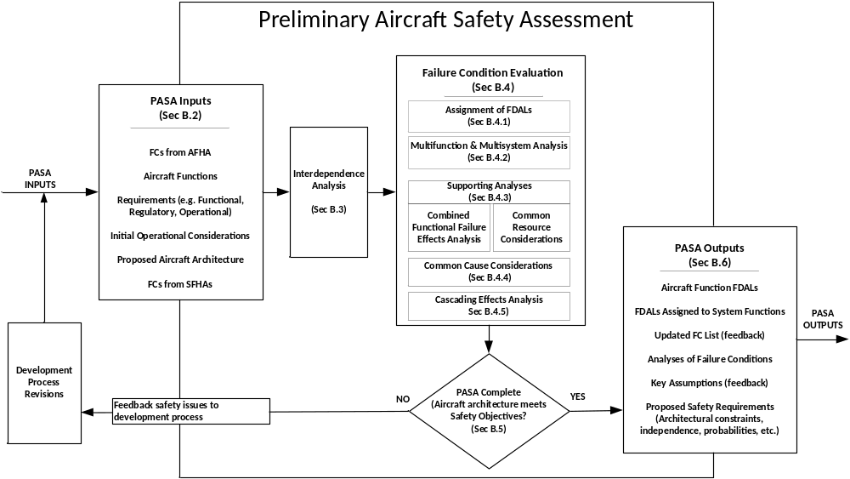
PASA Activity Flow
If the PASA evaluation determines that the safety considerations are not achievable, feedback is provided to adjust the aircraft architecture and/or aircraft operations early in the development

PASA inputs

Failure Conditions and Associated Functions from AFHA
All failure conditions from the AFHA should be identified for evaluation in the PASA.
The Failure Conditions (FCs) as defined in [5] are:

ID # | Aircraft Function |  | Total Loss |  | Partial Loss | Malfunction
F_PT | Payload Transport
F_PT.  F_CM | Manages internal and external communications
CM1 | External communication | CM1.TL: No interaction with the ground station |  | CM1.PL: One-way communication, or lossy two-way channel |  | CM1.Ma: Content failures  CM1.Mb:Timing failures
CM2 | Digital internal communications | CM2.TL: Isolated systems, except for the analog links |  | CM2.PL: Some senders off, some receivers off |  | CM2.Ma: Content failures  CM2.Mb : Timing failures
CM3 | Analog internal communications | CM3.TL: All analog sensing and actuation links are off |  | CM3.PL: Some peer-to-peer links are off, |  | CM3.M: Content failures (noise)
F_PT.  F_EM | Energy Management
EM | Estimation of energy storage | EM.TL: No estimate |  | EM.PLa: No estimate on the primary source  EM.PLb: No estimate on the secondary source |  | EM.M: non detected wrong estimate (misleading)
F_PT.  F_FC | Flight Control
FC1 | Attitude  Control | FC1.TL: permanent safety escape (stall, swirl, etc.) |  | FC1.PL: transient safety escapes |  | FC1.M: unstable control
FC2 | Speed & Altitude  Control | FC2.TL: permanent violation of avigation constraints |  | FCL2.PLa:transient violation of preset altitude  FCL2.PLb: transient violation of preset speed |  | FCL2.M: unstable regulation (oscillatory, overshoots in dampening perturbations etc.)
F_PT.  F_MM | Mission Management
MM | Navigation settings | MM.TL: freeze of parameters and modes |  | MM.PLa: modes frozen  MM.PLb: parameters frozen |  | MM.M: the mode or some parameter has a non detected erroneous value

ID # | Aircraft Function | Total Loss | Partial Loss | Malfunction
F_EL | Emergency Landing
EL1 | Flight envelope monitoring | EL1.TL: permanently undetected safety escapes | EL1.PL: transient unavailability of safety escape detection | EL1.M: unpredictable false positives and false negatives on safety escapes
EL2 | Hard landing command | EL2.TL: crash prevention by fast descent and landing unavailable | EL2.PL: possibly poorly controlled landing (high energy at impact) | EL2.M: possibly uncontrolled landing (crash or severe damage)

ID # | Aircraft Function | Total Loss | Partial Loss | Malfunction
F_HM | Health Monitoring
HM | Detection and notification of component failure modes | HM.TL: No detection, no alarms | HM.PL: detection and alarm available for some components, or some failure modes only | HM.M: arbitrary errors in signaling component losses or failure modes

Note: The failure conditions of F_FT are missing (an update AFHA is needed).

Requirements
Requirements which aid in the understanding of how the aircraft and systems should be used and how they interact with their environment need to be considered to provide context of the description of the aircraft architecture.
The AV level operational and functional specifications are available in [1] and [2].
The part of regulation (CS25-based) that is to be considered for actual applicability in the development of µXAV is defined in [6].

Initial Operational Considerations
The initial information such as operational procedure recommendations, training outlines or flight limitations is used by the PASA to reflect the intended usage of the aircraft.
Such initial information might be included in:
- Aircraft Flight Manual (AFM),
- Operations Manual,
- Annunciation checklists,
- Training syllabus,
- Instructions for Continuing Airworthiness (ICA),
- Expected aircraft usage parameters (e.g. flight phases, ETOPS, flight lengths).
The training and maintenance aspects of system development are not considered in the use case.
Document [1] is assumed to provide all the needed operational information for the development process and for the safety assessment process.

Proposed Aircraft Architecture
A conceptual representation of the proposed architecture is essential to allow the architecture to be evaluated for compliance with the Failure Condition Classifications from the AFHA and other applicable safety requirements. This aircraft architecture definition should include the aircraft function allocations to systems, system interactions, common resource systems, and other dependencies.

Conceptual architecture
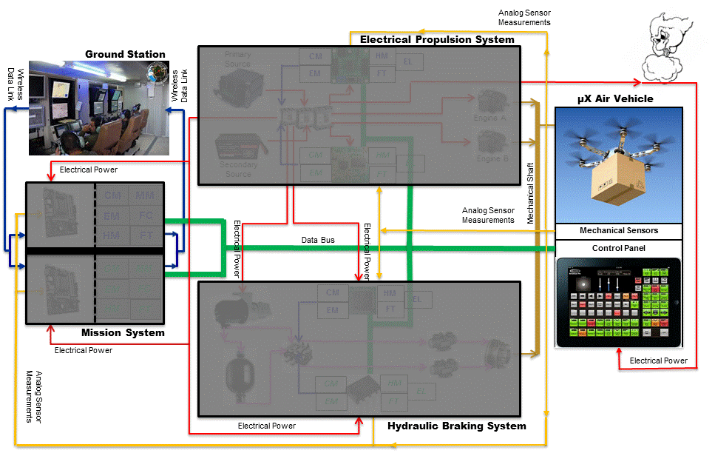
This figure from [3] gives the conceptual architecture proposed by development. No technology is chosen (e.g communication, ground station, engines, etc.).

Failure Condition Classification
The following table summarizes the conclusions of document [5].
FC Id. | Function | Description Summary | Classification
FC_CM1 | Communication | Total or partial loss of communication with the ground station | Major
FC_CM2 | Communication | Total or partial loss of the embedded data bus | Hazardous
FC_CM3 | Communication | Total or partial loss of the analogue signals supporting perception and actuation | Catastrophic
FC_EM | Energy Management | Unavailable or wrong electrical energy estimation | Catastrophic
FC_FC1 | Flight Control | Safety escapes related to attitude control | Catastrophic
FC_FC2 | Flight Control | Safety escapes related to speed regulation or altitude regulation | Hazardous
FC_MM | Mission Management | Frozen or erroneous navigation parameters | Major

Reminder: to be updated when Fault Tolerance related failure conditions are added.

Applicable regulatory safety requirements

A subset of the document “mu Certification Specification”: 2 properties design + 2 properties aircraft or system functional safety.

Function allocation to systems
Copy the tables of L0 mapping doc.

System interactions
A table for systematicity (available in SFHAs)

Common resource systems
MMS
Bus
AV sensors

Other dependencies
Physical dependencies (power line network) – BG map TBDL.

inTERdependence analysis
Once the available input data has been gathered, the PASA process identifies the interdependencies of the systems functions that contribute to each aircraft level failure condition.
An interdependence analysis is used to provide visibility of the interactions between aircraft functions and systems so that they may present a more complete view of the interactions for the AFHA Failure Conditions evaluations.
An interdependence analysis can be conducted systematically by following these process steps:
- Select an aircraft-level function and associated AFHA Failure Conditions to analyze,
- List all systems in the aircraft architecture (which may include resource systems),
- Identify which systems could contribute to that aircraft-level failure condition,
- Repeat above steps for each aircraft level function and associated AFHA failure condition.

 |  |  | System | Wheel Brake System |  |  |  | … | Flight Control System |  |  |  |  |  |  | Engine |  | …
Aircraft Function | Aircraft Failure Cond # | Aircraft Failure Condition | System Function /Implementation | Control normal brake | Control emergency brake | Provide anti-skid | Provide auto-brake | … | Control ailerons | Control spoilers | Control rudder | Control elevator | Control stabilizer | Control flaps | Control slats | Thrust Reverser | Throttle Control | …
Decelerate aircraft on ground | 3.2.3.L1 | Inability to stop the aircraft within the available runway |  | X | X | X | X | … |  | X |  |  |  | X | X | X | X | …
Decelerate aircraft on ground | # | Inadvertent activation of deceleration function on the ground |  | X | X | … | X | … | … | X | … | … | … | … | … | X |  | …
Table B-1: Interdependence Table – Example
Particular attention should be paid to those system functions (row 2) which do not contribute to the aircraft level function but whose functional failures may nonetheless contribute to the aircraft level failure condition, e.g. the high-lift system does not contribute directly to the aircraft level function “Deceleration on ground”, however a non-extension of the flaps may contribute to the failure condition due to an aircraft approach speed that will be higher than normal.
An interdependence diagram may additionally be used to provide a pictorial representation for each aircraft level function and the factors that affect it.
Further exploration of the interdependent nature of these relationships occurs in the Combined Functional Failure Effects (CoFFE) Analysis (Error: Reference source not found) as well as in the system’s SFHA.

failure condition evaluation
The aircraft-level failure conditions are evaluated to determine the contribution of the functional failures of the systems identified in the Interdependence Analysis.
The interdependence analysis activity also helps to derive safety and design requirements for the various systems in order to establish that aircraft level system architecture can reasonably be expected to meet the aircraft level safety requirements.
The steps discussed below are used in evaluating the systems functional failure combinations that contribute to those Aircraft Failure Conditions of interest:
- FDAL Assignment: The FDALs are assigned for each top level aircraft function based on its failure condition classification(s) and for system functions related to the aircraft level failure condition(s)
- Multifunction/Multisystem Analysis: This analysis consists of a traditional top-down safety analysis which includes considerations such as failure probability allocations to systems and may capture additional independence principles to be assessed by the common cause methods.
- Combined Functional Failure Effects Analysis: This analysis maps combined failures (whether loss of function or a malfunction) of system functions to assess the impact on the aircraft and helps to model branches in a Fault Tree Analysis.
- Common Resource Considerations: This activity assesses the integrated effect of the loss (or erroneous outputs) of resources that have effect on systems functions involved in the aircraft-level function, and may need independence principles to be assessed by the common cause methods.
- Cascading Effects Analysis examines the direct and indirect connections between the systems and evaluates the effects resulting from the propagation of an initiating condition (e.g. a single failure or a combination of failures). The CEA is useful for understanding the behaviors of highly integrated aircraft and system architectures.

Assignment of FDALs
Sqsqsqs

Multi-functions and multi-systems analysis
Cxcxx

Supporting Analyses

Combined Functional Failure Effects Analysis

Common Resource Considerations

Common Cause Considerations

Cascading Effect Analysis

achievability of safety considerations
Qsddsfsdfds

assessment documentation
Sdsdds

Aircraft function FDALs
Ssdsd

FDALs assigned to system functions
Sdsdd

Updated Failure Condition List
Sdsd

Analyses of Failure Conditions
Dsdsdsd

Key Assumptions
sdsfdsdf

Proposed Safety Requirements
sdsqdsff

