The Satellite around the Earth
The purpose of this exercise is to use records to store information about the celestial bodies
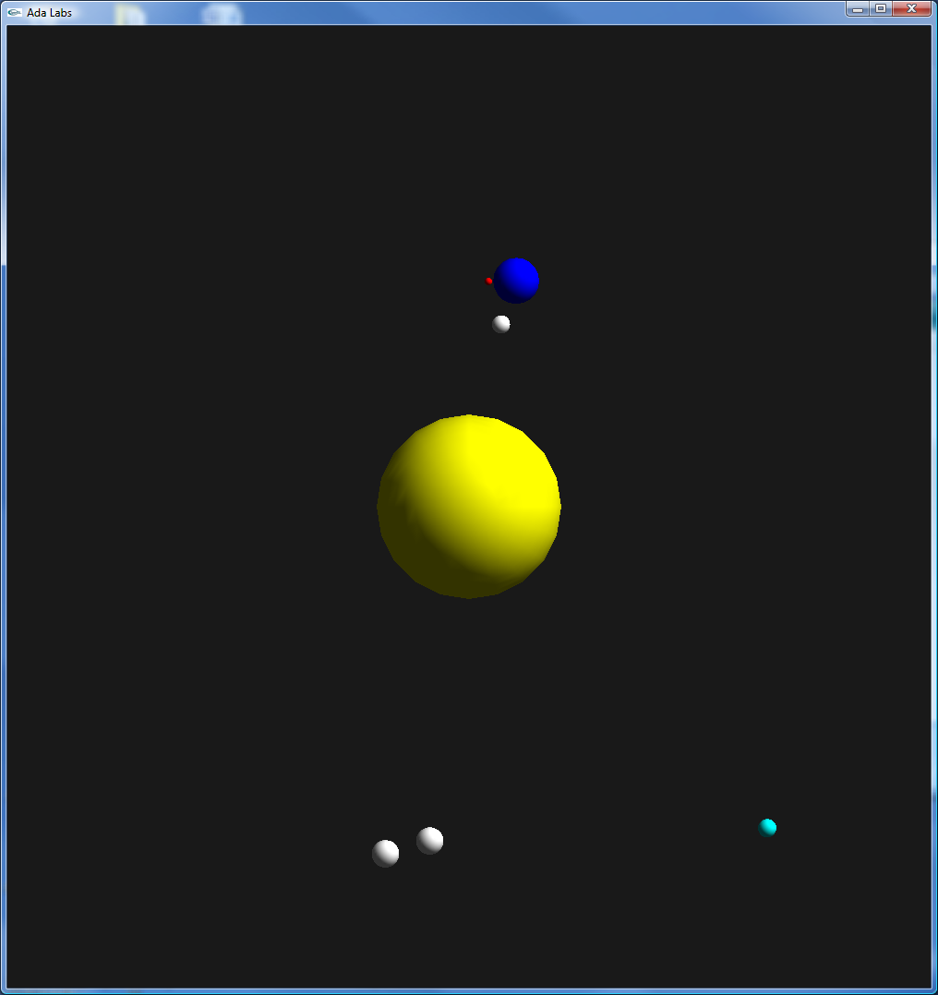 | Question 1  Create a record type that holds all the information needed to describe an object, (Speed, Distance, Angle, X, Y, Radius, Color). Replace the two arrays solution of the previous exercise by one array indexed by Bodies_Enum and containing components of this record.  Remark : Initialize each body using aggregate notation.  Question 2  Add a Turns_Around field to the record, in order to store the object around which the object rotates, instead of forcing it to always rotate around the previous object of the system. Have both the Satellite and the Moon turn around the Earth.  Question 3  All the objects are turning counter-clockwise, make the Moon turning clockwise.  Question 4 (advanced)  Implement black holes. Modify your record to handle the case of an invisible object which does not have Radius and Color properties (hint: use discriminated record with a Boolean discriminant named Visible).

