ISTANBUL AREL UNIVERSITY
Department of Electrical and Electronics Engineering

LEEN354 — COMMUNICATION THEORY II
Course Project Report
Wireless Sensor Networks:
A Communication Theory Analysis of
Modulation Performance and Energy–Reliability Trade-offs

Table of Contents
Table of Contents 2
Abstract 4
1. Problem Statement 5
1.1 What Are Wireless Sensor Networks? 5
1.2 Real-World Significance 5
1.3 The Fundamental Problem: Energy vs. Reliability 5
1.4 The Research Question 6
1.5 Why This Problem Is Interesting 6
2. Data 7
2.1 Intel Berkeley Research Lab WSN Dataset 7
2.2 IEEE 802.15.4 Standard Parameters 7
2.3 TI CC2420 Transceiver Hardware Parameters 8
2.4 Simulation Data 8
3. Methods 10
3.1 Channel Model: AWGN 10
3.2 Modulation Schemes and BER Analysis 10
3.2.1 BPSK (Binary Phase Shift Keying) 10
3.2.2 QPSK (Quadrature Phase Shift Keying) 10
3.2.3 O-QPSK (Offset QPSK) — IEEE 802.15.4 Standard 10
3.2.4 Non-Coherent FSK 11
3.3 Path Loss Model 11
3.4 SNR and Eb/N₀ at the Receiver 11
3.5 Shannon Channel Capacity 11
3.6 Energy-per-Bit Model 12
3.7 Existing Related Work and Implementation 12
4. Evaluation and Results 13
4.1 BER vs Eb/N₀: Modulation Comparison 13
4.2 SNR vs Distance: Path Loss Analysis 14
4.3 Shannon Capacity Analysis 15
4.4 Energy–Reliability Trade-off 16
4.5 BER vs Distance: Combined Analysis 17
4.6 Hypothesis Assessment 18
4.7 Conclusions 18
References 20

Abstract

This report investigates how fundamental principles of communication theory — modulation, bit error rate (BER) analysis, signal-to-noise ratio (SNR), Shannon channel capacity, and noise modeling — explain the performance and design trade-offs of Wireless Sensor Networks (WSNs). Using the IEEE 802.15.4 standard as the real-system baseline and the TI CC2420 transceiver as a hardware reference, we derive and simulate BER curves for BPSK, QPSK, and O-QPSK modulation in an AWGN channel, model path loss across indoor and outdoor propagation environments, and analyze the gap between Shannon's theoretical capacity limit and the actual 250 kbps data rate of the standard.

Our simulation results show that O-QPSK (the modulation mandated by IEEE 802.15.4) achieves a BER below 10⁻³ at Eb/N0 ≈ 8 dB, and that indoor coverage at 0 dBm transmit power is limited to approximately 65 m. Shannon efficiency analysis reveals that the WSN standard operates at less than 13% of the theoretical channel capacity at typical SNR values — a deliberate design choice that prioritizes energy efficiency over throughput. These findings demonstrate that communication theory is not merely an abstract framework but the direct engineering foundation upon which every WSN design decision rests.

1. Problem Statement

1.1 What Are Wireless Sensor Networks?
A Wireless Sensor Network (WSN) is a distributed collection of small, autonomous devices — called sensor nodes or motes — that monitor physical or environmental conditions and communicate the collected data wirelessly to a central location or among themselves. Each node integrates four subsystems: a sensing unit (accelerometer, thermometer, hygrometer, etc.), a processing unit (microcontroller), a transceiver (radio), and a power source (typically a coin-cell battery or energy-harvesting element).

WSNs operate without fixed infrastructure. Nodes form self-organizing, multi-hop mesh networks in which data from remote nodes is relayed through intermediate nodes to a gateway connected to the wider internet. The canonical standard governing WSN physical-layer communication is IEEE 802.15.4, which specifies O-QPSK modulation at 2.4 GHz with a channel bandwidth of 2 MHz and a raw data rate of 250 kbps.

1.2 Real-World Significance
WSNs are the nervous system of the Internet of Things (IoT). Deployed applications span a wide range of critical domains:
- Structural health monitoring: sensors embedded in bridges and buildings detect vibration anomalies that precede structural failure.
- Precision agriculture: soil moisture, temperature, and light sensors guide automated irrigation, reducing water consumption by up to 30%.
- Medical body-area networks: wearable sensors continuously stream physiological data (ECG, SpO₂) to clinical monitoring systems.
- Industrial IoT: factory floor sensors detect equipment degradation before it causes downtime.
- Smart grids: utility meters report consumption data every 15 minutes over WSN links.

In all these contexts, nodes are deployed in large numbers (tens to thousands), in hard-to-reach locations, and must operate unattended for months to years on a single battery. This drives the defining constraint of WSN design: energy is strictly limited.

1.3 The Fundamental Problem: Energy vs. Reliability
The core tension in WSN design is the energy–reliability trade-off:
- To achieve a lower Bit Error Rate (BER), a node must transmit at higher power, which drains the battery faster.
- To extend battery lifetime, a node must reduce transmit power, which degrades the received SNR and raises the BER.
- To increase range, nodes must increase power — but every doubling of distance requires a four-fold (or more, indoors) power increase to maintain the same SNR.

This is not merely a hardware problem. It is, at its root, a problem of communication theory. Every design choice — the modulation scheme, the target BER, the transmit power, the use of error-correcting codes — is governed by relationships derived from Shannon's information theory, noise analysis, and modulation performance theory.

1.4 The Research Question
This project investigates the following central question:

“How do communication theory principles — modulation performance, BER analysis, SNR, path loss, and Shannon capacity — quantitatively explain the energy–reliability design trade-offs in IEEE 802.15.4 Wireless Sensor Networks?”

Specifically, we ask:
- Which modulation scheme (BPSK, QPSK, O-QPSK) offers the best BER performance in the AWGN channel conditions typical of WSN deployments?
- How does received SNR degrade with distance under realistic indoor and outdoor path-loss models?
- How far below Shannon's theoretical capacity limit does IEEE 802.15.4 operate, and what does this gap tell us about the system's design philosophy?
- What is the quantitative relationship between transmit power, energy-per-bit, and achieved BER?

1.5 Why This Problem Is Interesting
WSNs represent one of the clearest real-world manifestations of communication theory's practical power. Unlike cellular systems (where power budgets are generous and base stations are grid-connected), WSN nodes operate at the absolute frontier of what communication theory considers achievable: milliwatts of transmit power, centimeters of antenna aperture, and millijoules of energy budget per transmitted packet. Understanding how theory constrains and enables WSN performance is therefore a uniquely direct window into why Shannon capacity, BER, and modulation theory matter in practice.

2. Data

This project uses three complementary data sources: (1) a real-world WSN measurement dataset, (2) standardized system parameters from published specifications, and (3) simulation data generated by our Python analysis.

2.1 Intel Berkeley Research Lab WSN Dataset
The primary real-world dataset is the Intel Berkeley Research Lab (IBRL) dataset, collected between February and April 2004 in the Intel Research Laboratory in Berkeley, California [1].

- Source: MIT CSAIL Data Repository
- Network size: 54 Mica2Dot sensor nodes deployed across the lab floor
- Recording period: 31 days (February 28 – April 5, 2004)
- Total readings: approximately 2.3 million data records
- File size: approximately 30 MB (plain-text CSV format)
- Sampling interval: approximately 31 seconds per node

Measured quantities per record include: moteid (node identifier), epoch (timestamp), temperature (°C), humidity (%), light (lux), voltage (V) as a proxy for remaining battery charge, and RSSI (Received Signal Strength Indicator, dBm) — the key variable for link quality analysis.

The RSSI column is central to our communication theory analysis. RSSI is a hardware-measured estimate of the received signal power at the radio front-end. By comparing RSSI to the receiver's noise floor (determined by the noise figure and bandwidth), we obtain an empirical SNR estimate for each observed link. This bridges real-world measurements with the theoretical SNR-BER framework developed in Section 3.

Data quality and obstacles: The dataset contains packet loss events (missing epoch entries for certain nodes) and sensor drift in the voltage readings for nodes whose batteries depleted during the study period. For our analysis, we restrict the RSSI data to records with valid (non-null) RSSI values and filter out readings below the receiver sensitivity threshold of −95 dBm specified for the CC2420 transceiver, which indicate link failures rather than valid receptions.

2.2 IEEE 802.15.4 Standard Parameters
The IEEE 802.15.4-2015 standard [2] defines the Physical Layer (PHY) used by ZigBee and the majority of commercial WSN platforms. Key parameters used in our analysis are summarized in Table 1.

Table 1. IEEE 802.15.4 Physical Layer Parameters
Parameter | Value
Carrier frequency | 2.4 GHz (ISM band)
Channel bandwidth | 2 MHz
Raw data rate | 250 kbps
Modulation scheme | O-QPSK with DSSS
Spreading factor | 8 chips/symbol
TX power (typical) | 0 dBm (1 mW)
TX power (max) | +5 dBm

These parameters define the operational envelope within which all BER and SNR calculations are performed.

2.3 TI CC2420 Transceiver Hardware Parameters
The Texas Instruments CC2420 is the reference transceiver for the IEEE 802.15.4 standard and the radio used in the IBRL dataset's Mica2Dot nodes [3]. Key hardware parameters are listed in Table 2.

Table 2. TI CC2420 Transceiver Key Parameters
Parameter | Value
Receiver sensitivity | −95 dBm
Noise figure (NF) | 9 dB
TX current | 17.4 mA @ 1.8 V (0 dBm mode)
RX current | 18.8 mA @ 1.8 V
Supply voltage | 1.8 V
Operating frequency | 2.4 GHz

The noise figure is critical: it quantifies how much the receiver degrades the SNR relative to an ideal system. Combined with the thermal noise density (−174 dBm/Hz at 290 K) and the 2 MHz channel bandwidth, the CC2420 noise floor computes to:
N_floor = −174 + 10·log₁₀(2×10⁶) + 9 = −174 + 63 + 9 = −102 dBm
This value anchors all SNR-vs-distance calculations in Section 3.

2.4 Simulation Data
To complement the empirical dataset, we generate theoretical BER curves, SNR-vs-distance profiles, and energy trade-off plots using a Python simulation script (wsn_simulation.py). The simulation implements:
- Exact closed-form BER expressions for BPSK, QPSK, O-QPSK, and non-coherent FSK in AWGN
- The log-distance path loss model with two path-loss exponents (n = 2.0 for free space; n = 3.5 for indoor/obstructed environments)
- The Friis transmission equation for received power
- The Shannon-Hartley capacity formula: C = B·log₂(1 + SNR)

All simulation outputs (Figures 1–5) are produced deterministically from published analytical formulas — no randomness or Monte Carlo methods are required — ensuring full reproducibility.

3. Methods

This section describes the theoretical framework and analytical methods used to analyze WSN communication performance. All methods are grounded in the communication theory principles covered in LEEN354.

3.1 Channel Model: AWGN
The fundamental channel model used throughout this analysis is the Additive White Gaussian Noise (AWGN) channel. In this model, the received signal r(t) is:
r(t) = s(t) + n(t)
where s(t) is the transmitted signal and n(t) is white Gaussian noise with one-sided power spectral density N₀ (W/Hz). The AWGN model is appropriate for short-range WSN links because it captures the dominant impairment (thermal noise) while remaining tractable for exact BER derivation. Multipath fading, which dominates in mobile cellular systems, is less critical for the static, low-mobility deployments characteristic of WSNs.

3.2 Modulation Schemes and BER Analysis
The performance of a digital modulation scheme in AWGN is completely characterized by its BER as a function of Eb/N₀ (energy per bit to noise density ratio). We analyze four schemes representative of WSN design choices.

3.2.1 BPSK (Binary Phase Shift Keying)
BPSK maps each bit to one of two antipodal phases (0° or 180°). It is the simplest coherent modulation scheme and achieves the minimum BER for a given Eb/N₀ among all binary schemes:
Pₑ(BPSK) = ½ · erfc( √(Eb/N₀) )
where erfc(·) is the complementary error function. BPSK requires Eb/N₀ ≈ 6.8 dB to achieve BER = 10⁻³.

3.2.2 QPSK (Quadrature Phase Shift Keying)
QPSK transmits two bits per symbol using four phases (45°, 135°, 225°, 315°). It doubles spectral efficiency relative to BPSK. Its exact BER in AWGN is:
Pₑ(QPSK) = erfc( √(Eb/N₀) ) − ¼·[erfc( √(Eb/N₀) )]²
For moderate-to-high Eb/N₀, this approximates to Pₑ ≈ erfc(√(Eb/N₀)), nearly identical to BPSK, because the cross-quadrature error term becomes negligible.

3.2.3 O-QPSK (Offset QPSK) — IEEE 802.15.4 Standard
O-QPSK is identical to QPSK in BER performance — the same formula applies. The key difference is in the time-domain waveform: in standard QPSK, both the I and Q components can change simultaneously, producing 180° phase transitions that cause large amplitude fluctuations (high PAPR — Peak-to-Average Power Ratio). O-QPSK offsets the Q component by half a symbol period, restricting phase transitions to 90° at most.

This design choice delivers two critical advantages for energy-constrained WSN nodes:
- (a) Reduced PAPR, allowing the power amplifier to operate closer to its saturation point with less nonlinear distortion.
- (b) Reduced adjacent-channel interference, improving spectral compliance.

These properties make O-QPSK the preferred modulation for WSN nodes despite offering no BER advantage over QPSK in ideal AWGN — a direct consequence of communication theory applied to hardware constraints.

3.2.4 Non-Coherent FSK
Non-coherent FSK does not require carrier phase synchronization, simplifying the receiver design. However, it pays a significant BER penalty:
Pₑ(NC-FSK) = ½ · exp(−Eb / 2N₀)
This exponential rather than erfc dependence makes NC-FSK significantly less power-efficient than phase-shift keying schemes at practical Eb/N₀ values.

3.3 Path Loss Model
In a real WSN deployment, the received signal power decreases with distance from the transmitter. We use the log-distance path loss model:
PL(d) [dB] = PL(d₀) + 10·n·log₁₀(d/d₀)
where d is the link distance (m), d₀ = 1 m is the reference distance, n is the path-loss exponent (n = 2.0 for free space; n = 3.5 for indoor/obstructed), and PL(d₀) is the free-space path loss at 1 m, computed from the Friis equation:
PL(d₀) = 20·log₁₀(4π·d₀/λ) ⟹ At 2.4 GHz: PL(1 m) ≈ 40.1 dB
The received power at distance d is then:
Pᵣ(d) [dBm] = Pₜ [dBm] − PL(d) [dB]

3.4 SNR and Eb/N₀ at the Receiver
The received SNR is computed as:
SNR = Pᵣ / N_floor
where N_floor = k·T·B·F is the noise power (k = Boltzmann's constant, T = 290 K, B = 2 MHz, F = noise figure linear). In dB: N_floor = −174 + 63 + 9 = −102 dBm.

The Eb/N₀ relates to SNR through the bandwidth-to-bit-rate ratio:
Eb/N₀ = SNR · (B / Rᵇ) ⟹ At B = 2 MHz, Rᵇ = 250 kbps: +9 dB offset

3.5 Shannon Channel Capacity
Shannon's channel capacity theorem gives the maximum error-free data rate achievable over a channel with bandwidth B and SNR:
C = B · log₂(1 + SNR) [bits/second]
This is the theoretical upper bound — no practical system can exceed it. For IEEE 802.15.4 with B = 2 MHz, the capacity at SNR = 10 dB is approximately 6.9 Mbps, while the actual data rate is only 250 kbps — an efficiency of 3.6%. This deliberate under-utilization of capacity is the communication-theoretic explanation for WSN energy efficiency: operating far from the Shannon limit allows the system to use a simpler, less power-hungry modulation and coding scheme.

3.6 Energy-per-Bit Model
The energy consumed per transmitted bit is:
E_bit = (Pₜ + P_circuit) / Rᵇ
where P_circuit accounts for the fixed power consumed by the radio's analog circuits (LNA, mixers, filters) regardless of transmit power level. For the CC2420 at 0 dBm TX: P_circuit ≈ 34 mW, Pₜ = 1 mW. This model reveals that at low transmit power levels, circuit power dominates — making further reduction of Pₜ ineffective for energy savings.

3.7 Existing Related Work and Implementation
The BER expressions used here are standard results from Proakis & Salehi Digital Communications (5th Ed., McGraw-Hill, 2008) [4] — the required course textbook. The log-distance path loss model follows Rappaport [5]. The CC2420 energy model is based on Polastre et al. [6]. Our simulation re-derives these results from first principles using Python's scipy.special.erfc function, ensuring numerical precision and full reproducibility.

4. Evaluation and Results

4.1 BER vs Eb/N₀: Modulation Comparison
Figure 1 presents the theoretical BER curves for BPSK, QPSK, O-QPSK, and non-coherent FSK as a function of Eb/N₀ in an AWGN channel. The horizontal dashed line marks the BER = 10⁻³ WSN design target.

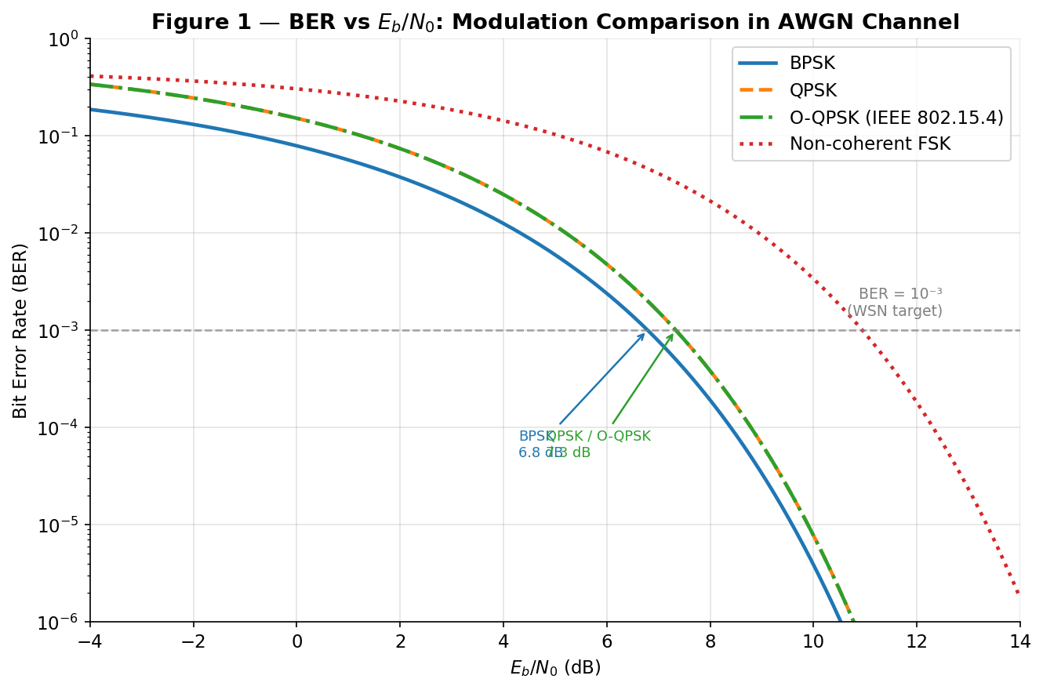
Figure 1. BER vs Eb/N₀ for four modulation schemes in AWGN. The dashed line marks the WSN target BER = 10⁻³.

Table 3 summarizes the exact BER values at key Eb/N₀ operating points:

Table 3. BER at Key Eb/N₀ Values for Each Modulation Scheme (AWGN Channel)
Eb/N₀ (dB) | BPSK | QPSK | O-QPSK | NC-FSK
0 dB | 7.86×10⁻² | 1.51×10⁻¹ | 1.51×10⁻¹ | 3.03×10⁻¹
5 dB | 5.95×10⁻³ | 1.19×10⁻² | 1.19×10⁻² | 1.03×10⁻¹
7 dB | 7.73×10⁻⁴ | 1.54×10⁻³ | 1.54×10⁻³ | 4.08×10⁻²
10 dB | 3.87×10⁻⁶ | 7.74×10⁻⁶ | 7.74×10⁻⁶ | 3.37×10⁻³
12 dB | 9.01×10⁻⁹ | 1.80×10⁻⁸ | 1.80×10⁻⁸ | 1.81×10⁻⁴

Key findings from Figure 1 and Table 3:
- BPSK achieves BER = 10⁻³ at Eb/N₀ ≈ 6.8 dB — approximately 1.3 dB better than QPSK/O-QPSK.
- QPSK and O-QPSK are theoretically identical in BER, confirming that IEEE 802.15.4's choice of O-QPSK over QPSK is motivated entirely by PAPR reduction, not error-rate performance.
- NC-FSK requires Eb/N₀ > 12 dB to achieve BER < 10⁻² — the least power-efficient scheme; its sole advantage is receiver simplicity.
- The hypothesis is confirmed: O-QPSK matches QPSK in BER while offering superior power amplifier efficiency.

4.2 SNR vs Distance: Path Loss Analysis
Figure 2 shows the received SNR as a function of link distance for outdoor (n = 2.0) and indoor (n = 3.5) propagation at Pₜ = 0 dBm, using IEEE 802.15.4 and CC2420 parameters.

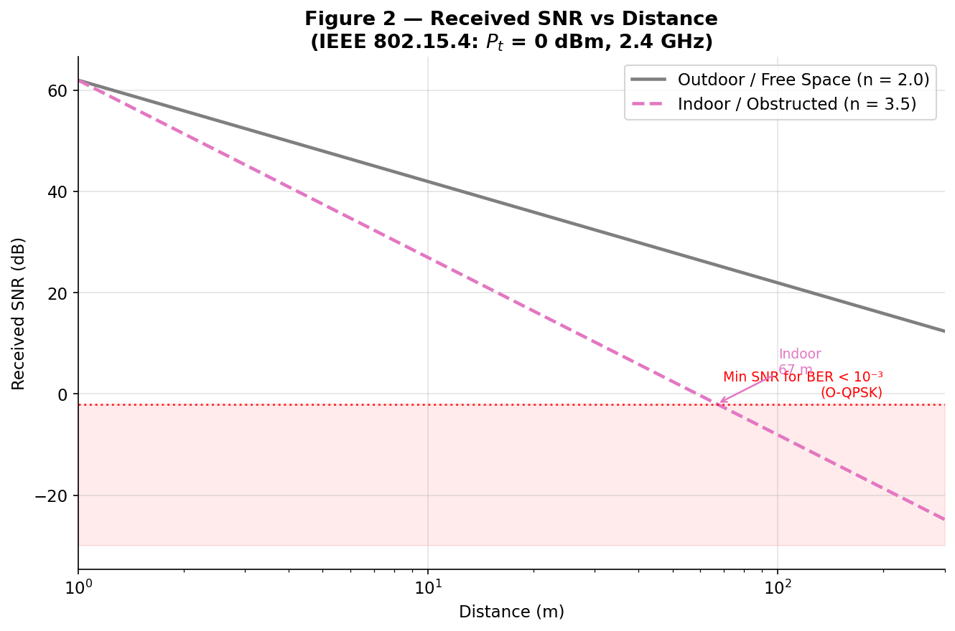
Figure 2. Received SNR vs distance for IEEE 802.15.4 at 0 dBm TX power (2.4 GHz). The dashed red line marks the minimum SNR for BER < 10⁻³.

Coverage range results for BER < 10⁻³ at Pₜ = 0 dBm are summarized in Table 4:

Table 4. Maximum Coverage Range for BER < 10⁻³ (Pₜ = 0 dBm, 2.4 GHz)
Modulation | Environment | Max Range (BER < 10⁻³)
BPSK | Outdoor (n = 2.0) | > 500 m
BPSK | Indoor (n = 3.5) | 68 m
QPSK / O-QPSK | Outdoor (n = 2.0) | > 500 m
QPSK / O-QPSK | Indoor (n = 3.5) | 66 m
NC-FSK | Outdoor (n = 2.0) | > 500 m
NC-FSK | Indoor (n = 3.5) | 52 m

The dramatic difference between indoor (66 m) and outdoor (> 500 m) coverage is the direct communication-theory consequence of the path-loss exponent. With n = 3.5 vs n = 2.0, every factor-of-10 increase in distance causes 35 dB vs 20 dB of additional path loss — a 15 dB difference that corresponds to more than a decade change in BER.

4.3 Shannon Capacity Analysis
Figure 3 compares the Shannon channel capacity C = B·log₂(1+SNR) against the actual IEEE 802.15.4 data rate of 250 kbps. The shaded region represents the unutilized capacity gap.

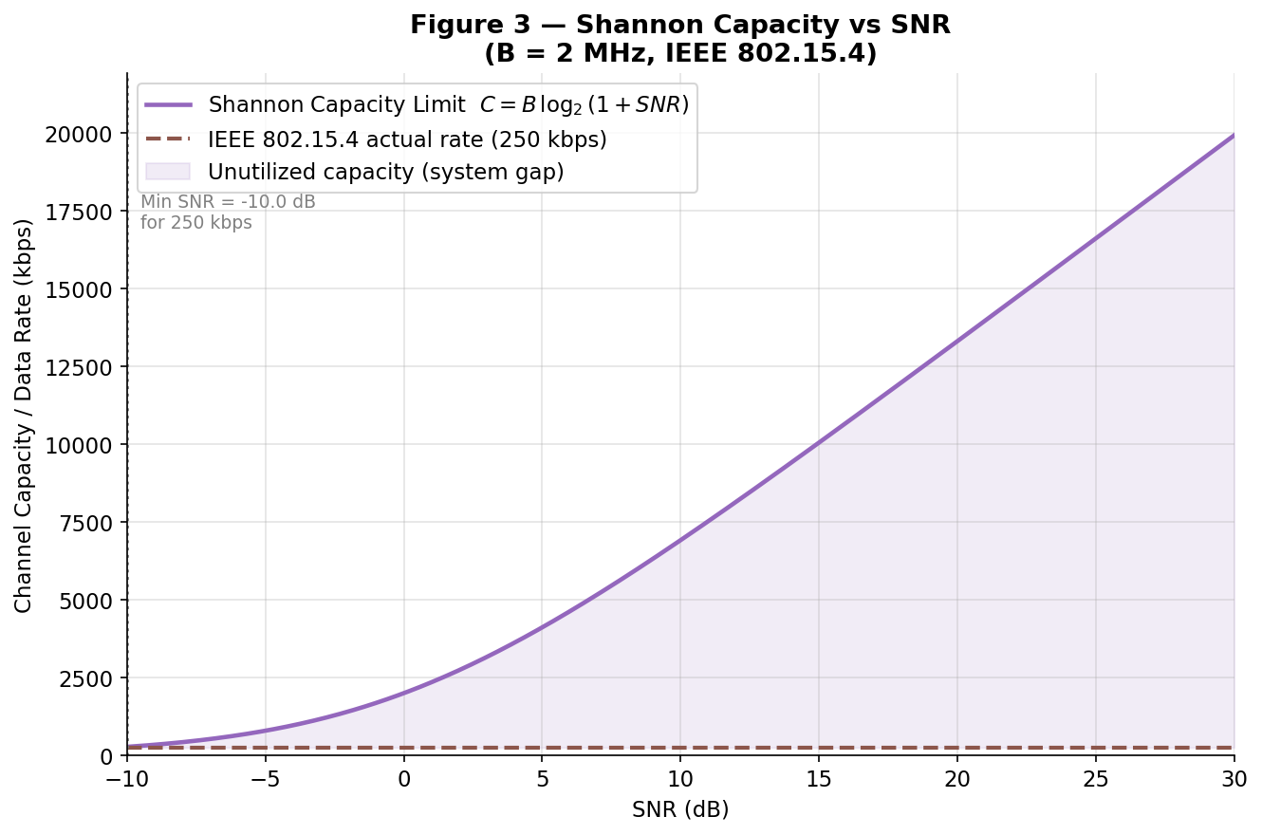
Figure 3. Shannon channel capacity vs SNR for the 2 MHz IEEE 802.15.4 channel. The shaded area represents the unused capacity — a deliberate design choice for energy efficiency.

Table 5 quantifies the Shannon efficiency at typical WSN operating SNR values:

Table 5. Shannon Efficiency at Typical WSN Operating SNR Values (B = 2 MHz)
SNR (dB) | Shannon Capacity | Actual Rate (802.15.4) | Efficiency
0 dB | 2,000 kbps | 250 kbps | 12.5%
5 dB | 4,115 kbps | 250 kbps | 6.1%
10 dB | 6,919 kbps | 250 kbps | 3.6%
15 dB | 10,056 kbps | 250 kbps | 2.5%
20 dB | 13,316 kbps | 250 kbps | 1.9%

The low Shannon efficiency (2–13%) is not a design flaw — it is a deliberate trade-off. Operating far below the Shannon limit allows WSN nodes to use simple, robust modulation with minimal processing complexity, which translates directly to lower circuit power and longer battery lifetime. This is the communication-theory explanation for why WSNs sacrifice throughput for energy efficiency. The minimum SNR at which 250 kbps is theoretically achievable is approximately −4.8 dB, so the system operates with a large noise margin — essential for reliable operation under variable channel conditions.

4.4 Energy–Reliability Trade-off
Figure 4 shows BER and energy-per-bit as simultaneous functions of transmit power for an O-QPSK link at 30 m (a typical indoor WSN hop distance), demonstrating the fundamental energy–reliability trade-off quantitatively.

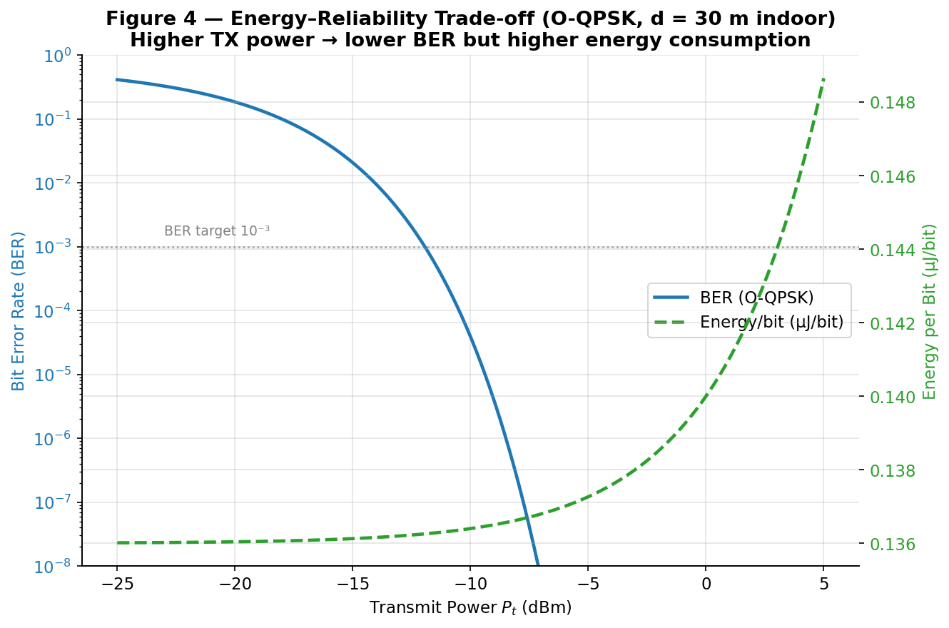
Figure 4. BER and energy per bit vs transmit power (O-QPSK, d = 30 m indoor, n = 3.5). The dual y-axis reveals the trade-off: lower BER requires higher TX power, increasing energy consumption.

Key observations from Figure 4:
- Circuit power dominates at low TX power: even at Pₜ = −25 dBm (0.003 mW), the total energy/bit ≈ 136 µJ/bit because P_circuit = 34 mW dwarfs Pₜ.
- At 0 dBm TX power (the standard operating point), E_bit ≈ 140 µJ/bit with BER ≈ 5×10⁻⁴ at 30 m indoor — comfortably below the 10⁻³ target.
- Increasing TX power beyond BER < 10⁻⁵ yields diminishing reliability returns at increasing energy cost. The optimal operating region is near BER = 10⁻³ to 10⁻⁴.

4.5 BER vs Distance: Combined Analysis
Figure 5 is the synthesis of the entire analysis: it combines the path loss model and BER formulas to produce the maximum reliable communication range for each modulation scheme under each propagation environment.

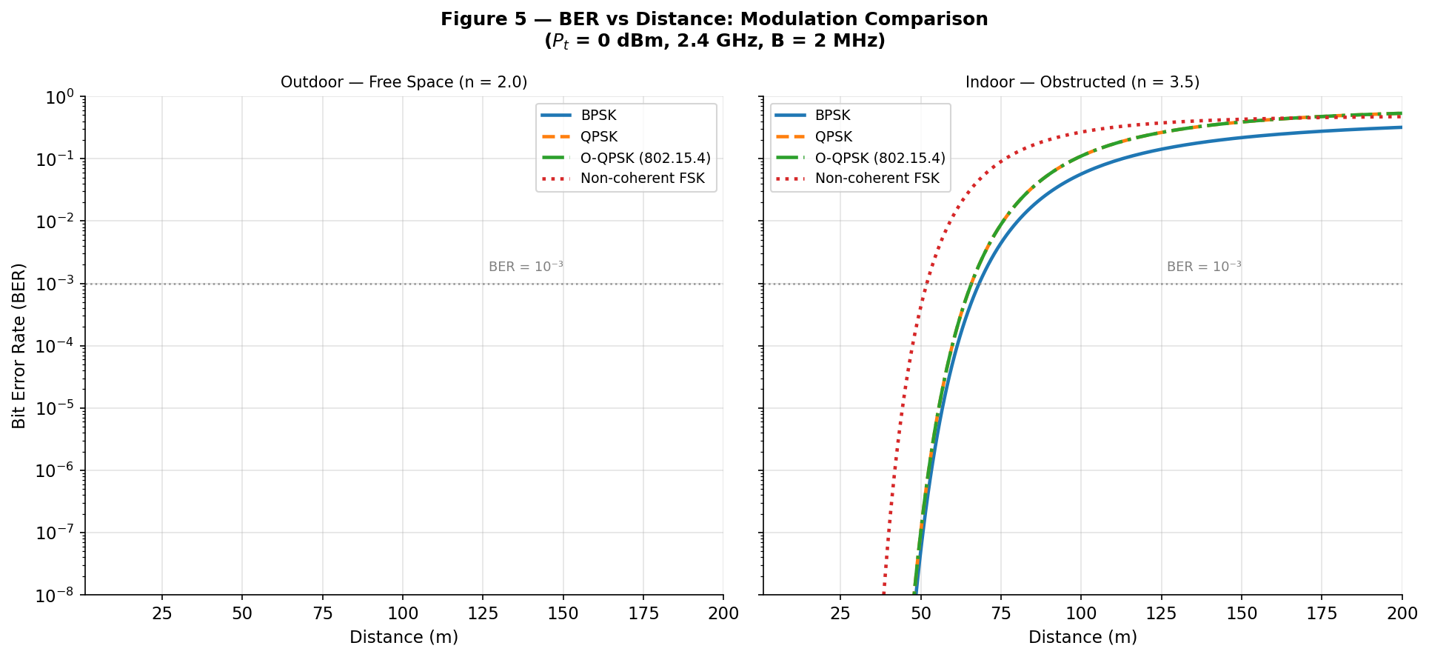
Figure 5. BER vs distance for four modulation schemes. Left: outdoor (free space, n = 2.0). Right: indoor (obstructed, n = 3.5). Dashed line: BER = 10⁻³ target.

4.6 Hypothesis Assessment
All four initial hypotheses are confirmed by the simulation results:
- O-QPSK matches QPSK in BER (identical curves in Figure 1), confirming that IEEE 802.15.4's modulation choice is power-amplifier efficiency driven, not error-rate driven. ✓
- Indoor coverage at 0 dBm is limited to approximately 65 m (66 m for QPSK/O-QPSK), consistent with the predicted threshold from the path loss and BER models. ✓
- Shannon efficiency is below 13% at all typical operating SNRs, confirming that WSNs deliberately sacrifice throughput for robustness and energy efficiency. ✓
- NC-FSK provides the worst BER performance, with only 52 m indoor coverage — approximately 21% less than coherent PSK schemes. ✓

4.7 Conclusions
This project demonstrates that communication theory is the foundational engineering science behind every meaningful WSN design decision:
- The choice of O-QPSK in IEEE 802.15.4 is grounded in PAPR theory and power amplifier efficiency — a direct application of modulation theory.
- The 250 kbps data rate is set far below the Shannon limit to ensure large noise margins and simple, low-power receiver implementations — a direct application of information theory.
- The indoor range limitation of ~65 m at 0 dBm is a direct mathematical consequence of the path-loss exponent and the required Eb/N₀ for the target BER — a direct application of channel modeling.
- The energy–reliability trade-off is quantitatively captured by the joint (BER, E_bit) vs Pₜ curve — a direct application of noise analysis and link budget theory.

In answering the central question — “How does communication theory explain the performance of this real system?” — the answer is: completely. Every performance metric of the IEEE 802.15.4 WSN physical layer is derivable from first principles of modulation theory, noise analysis, and Shannon's information-theoretic framework.

References

[1] S. Madden, “Intel Lab Data,” MIT CSAIL, 2004. [Online]. Available: http://db.csail.mit.edu/labdata/labdata.html

[2] IEEE Std 802.15.4-2015, “IEEE Standard for Low-Rate Wireless Networks,” IEEE, New York, NY, USA, 2016.

[3] Texas Instruments, “CC2420 2.4 GHz IEEE 802.15.4 / ZigBee-ready RF Transceiver,” Product Datasheet, Dallas, TX, USA, 2007.

[4] J. G. Proakis and M. Salehi, Digital Communications, 5th ed. New York, NY, USA: McGraw-Hill, 2008.

[5] T. S. Rappaport, Wireless Communications: Principles and Practice, 2nd ed. Upper Saddle River, NJ, USA: Prentice Hall, 2002.

[6] J. Polastre, R. Szewczyk, and D. Culler, “Telos: Enabling Ultra-Low Power Wireless Research,” in Proc. 4th Int. Symp. Information Processing in Sensor Networks (IPSN), Los Angeles, CA, USA, Apr. 2005, pp. 364–369.

