Evaluation

We use the error rate of classification to evaluate the accuracy of the makeup recognition classification:

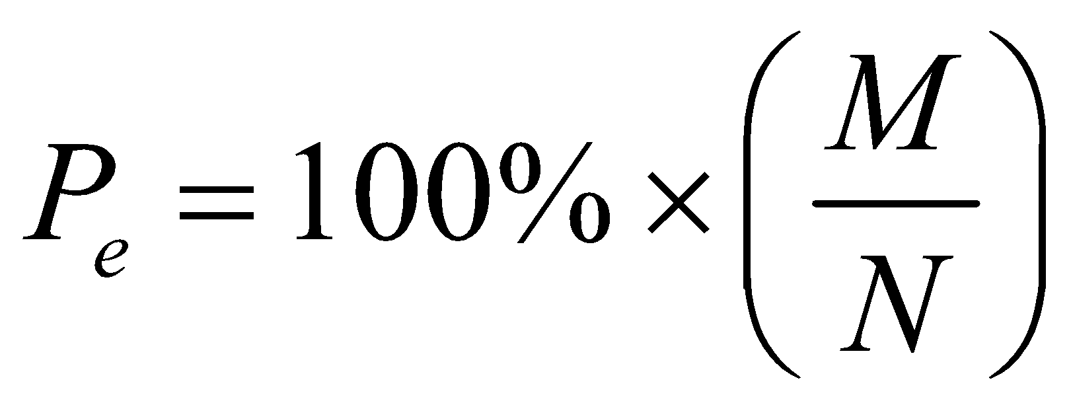

Where  is the number of sample datasets that can be classified correctly;  is the total number of the testing dataset.