Zomato Dataset Analysis Report

1. Introduction
This project analyzes the Zomato restaurant dataset to understand customer ratings, cuisine preferences, restaurant locations, and factors affecting restaurant ratings. The analysis was performed using Python, Pandas, Matplotlib, and Seaborn.

2. Dataset Overview

The dataset contains information about restaurants including their names, locations, cuisines, ratings, votes, and approximate costs.
Original Dataset Size:
- Rows: 56,252
- Columns: 13

3. Data Cleaning
The following cleaning steps were performed:
- Removed 15,703 duplicate records.
- Removed rows with missing values in important columns such as rate, cuisines, and location.
- Cleaned invalid rating values such as ‘Top floor’.
- Cleaned invalid cost values containing review text.
- Converted rating and cost columns into numeric format.
Final Cleaned Dataset Size:
- Rows: 31,162

4. Rating Analysis

The average restaurant rating was 3.71 out of 5
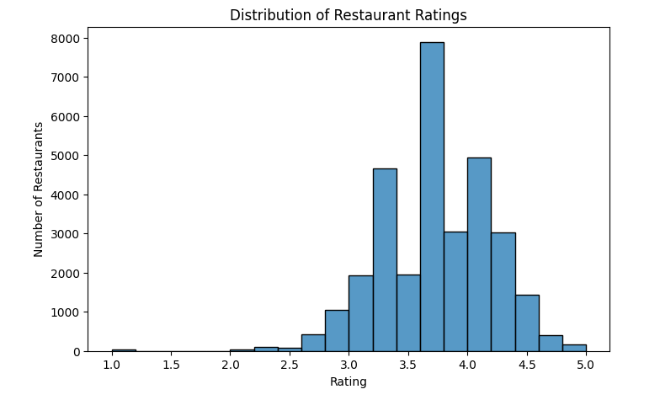

5. Location Analysis
Top restaurant locations:
- BTM – 2,434 restaurants
- Koramangala 5th Block – 1,587 restaurants
- HSR – 1,553 restaurants
- Indiranagar – 1,544 restaurants
- Whitefield – 1,475 restaurants
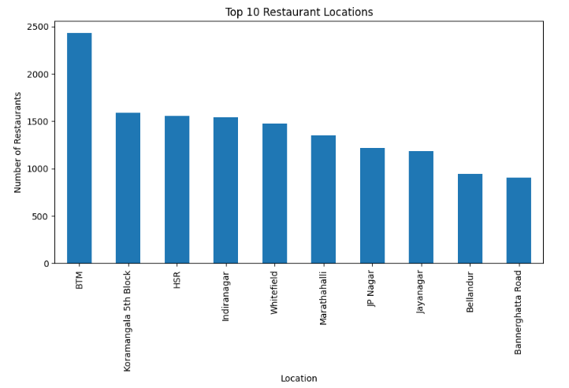

6. Cuisine Analysis
Most popular cuisines:
- North Indian – 1,582 restaurants
- North Indian, Chinese – 1,448 restaurants
- South Indian – 877 restaurants
- Bakery, Desserts – 477 restaurants
- Biryani – 437 restaurants
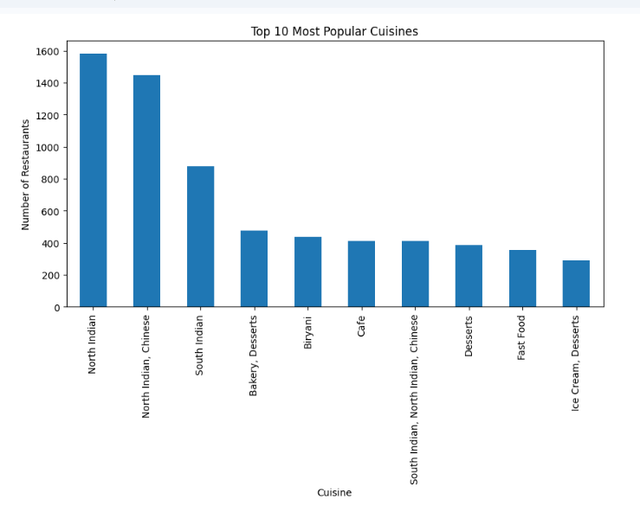

7. Correlation Analysis
The heatmap showed:
- Ratings and votes have a moderate positive correlation (0.43).
- Cost has almost no impact on ratings (-0.009).
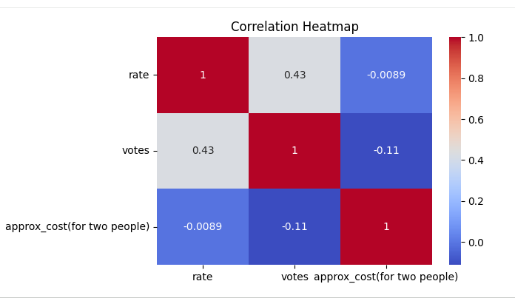

8. Word Cloud Analysis
The word cloud highlighted the most common cuisine categories in the dataset.
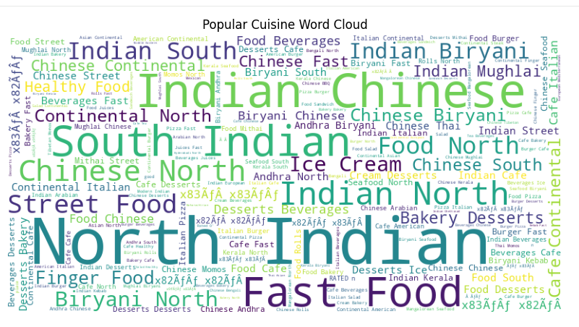

9. Recommendations
- Partner with highly rated restaurants.
- Promote popular cuisines such as North Indian and Chinese.
- Focus marketing on restaurant hotspot locations.
- Improve recommendation systems using ratings and votes.
- Highlight affordable restaurants with high ratings.

10. Conclusion
The Zomato dataset was successfully cleaned and analyzed. The study identified popular cuisines, restaurant hotspots, and factors influencing ratings.

