INTERNSHIP PROJECT
Data Analysis with Python & Pandas

Submitted By: | [A.Vidhathri]
Tools Used: | Python 3, Pandas, Matplotlib, Seaborn, NumPy
Dataset: | sales_data.csv — Retail Sales Jan–Jul 2024 (40 records)
Date: | April 2025

1. Project Objective

The goal of this project is to demonstrate data analysis skills using Python and Pandas on a real-world retail sales dataset. The analysis covers all key stages: data loading, cleaning, transformation, aggregation, filtering, and visualization.

Project Requirements Addressed:
- Load a CSV file using the Pandas library
- Perform data cleaning (handle nulls, parse dates, remove duplicates)
- Apply filtering and grouping for business insights
- Generate summary statistics and meaningful insights
- Create 4 visualizations (bar chart, pie chart, line graph, horizontal bar)

2. Dataset Overview

The dataset (sales_data.csv) contains retail sales transactions from January to July 2024 with 40 records and 10 columns:

Column | Data Type | Description
Order_ID | Integer | Unique identifier for each order
Date | Date | Transaction date (Jan–Jul 2024)
Region | String | Sales region: North, South, East, West
Category | String | Product category (Electronics, etc.)
Product | String | Product name (Laptop, Phone, etc.)
Quantity | Integer | Number of units sold
Unit_Price | Integer | Price per unit in INR
Discount | Float | Discount rate (0.0 to 0.15)
Sales_Rep | String | Sales representative name
Customer_Rating | Float | Rating given by customer (3.5–5.0)

3. Code Walkthrough

3.1 Loading the Dataset
import pandas as pd
import numpy as np
import matplotlib.pyplot as plt
import seaborn as sns

df = pd.read_csv('sales_data.csv')
print(df.shape) # (40, 10)
print(df.head())

3.2 Data Cleaning
The raw data contained 3 missing values and 2 intentionally dirty rows for practice:
# Drop rows with missing critical columns
df.dropna(subset=['Date', 'Category'], inplace=True)

# Fill missing Customer_Rating with median
df['Customer_Rating'].fillna(df['Customer_Rating'].median(), inplace=True)

# Parse dates and extract month/quarter features
df['Date'] = pd.to_datetime(df['Date'])
df['Month'] = df['Date'].dt.month_name()
df['Quarter'] = df['Date'].dt.to_period('Q').astype(str)

# Remove duplicate rows
df.drop_duplicates(inplace=True) # None found

print(df.isnull().sum().sum()) # 0

3.3 Feature Engineering
# Compute Revenue = Quantity × Unit_Price × (1 - Discount)
df['Revenue'] = df['Quantity'] * df['Unit_Price'] * (1 - df['Discount'])
df['Revenue'] = df['Revenue'].round(2)

3.4 Grouping & Aggregation
# Revenue by Category
rev_by_cat = df.groupby('Category')['Revenue'].agg(['sum','mean','count'])

# Revenue by Region
rev_by_region = df.groupby('Region')['Revenue'].sum().sort_values(ascending=False)

# Sales Rep Performance
rep_perf = df.groupby('Sales_Rep').agg(
Total_Revenue=('Revenue','sum'),
Orders=('Order_ID','count'),
Avg_Rating=('Customer_Rating','mean')
)

# Monthly Trend
monthly_rev = df.groupby('Month_Num').agg(
Month=('Month','first'), Revenue=('Revenue','sum')
).reset_index().sort_values('Month_Num')

3.5 Filtering
# High-value orders
high_value = df[df['Revenue'] > 100_000]

# Top-rated transactions
top_rated = df[df['Customer_Rating'] >= 4.7]

# Electronics in Q1 2024
elec_q1 = df[(df['Category']=='Electronics') & (df['Quarter']=='2024Q1')]

4. Summary Statistics

Metric | Quantity | Unit Price | Discount | Revenue | Cust. Rating
Count | 38 | 38 | 38 | 38 | 38
Mean | 16.61 | ₹19,820 | 4.5% | ₹48,013 | 4.24
Std Dev | 28.49 | ₹26,004 | 3.7% | ₹51,622 | 0.39
Min | 1 | ₹30 | 0.0% | ₹1,500 | 3.50
Median | 5 | ₹8,000 | 5.0% | ₹21,850 | 4.20
Max | 120 | ₹75,000 | 15.0% | ₹2,02,500 | 4.90

5. Key Insights

Insight | Value
Total Revenue | ₹18,24,490.20
Total Orders | 38
Best Category | Electronics — ₹15,59,100 (85.5%)
Best Region | North — ₹6,99,350
Best Sales Rep | Alice — ₹6,75,033 (13 orders)
Top Product | Laptop — ₹7,58,250
Average Discount | 4.5%
Avg Customer Rating | 4.24 / 5.0
High-Value Orders (>₹1L) | 6 orders
5-Star-Class Orders (≥4.7) | 7 orders — All Electronics

Notable Findings:
- Electronics dominates — it accounts for 85.5% of total revenue despite being just 42% of orders.
- North region leads in revenue; all three other regions are within 17% of each other.
- March 2024 was the best month (₹4,30,750), while February was the weakest (₹1,65,728).
- All 7 top-rated orders (Rating ≥ 4.7) belong to Electronics — indicating high customer satisfaction for tech products.
- Alice has the most orders (13) and the highest total revenue — a top performer.

6. Data Visualizations

The following 4 charts were generated using Matplotlib and Seaborn:

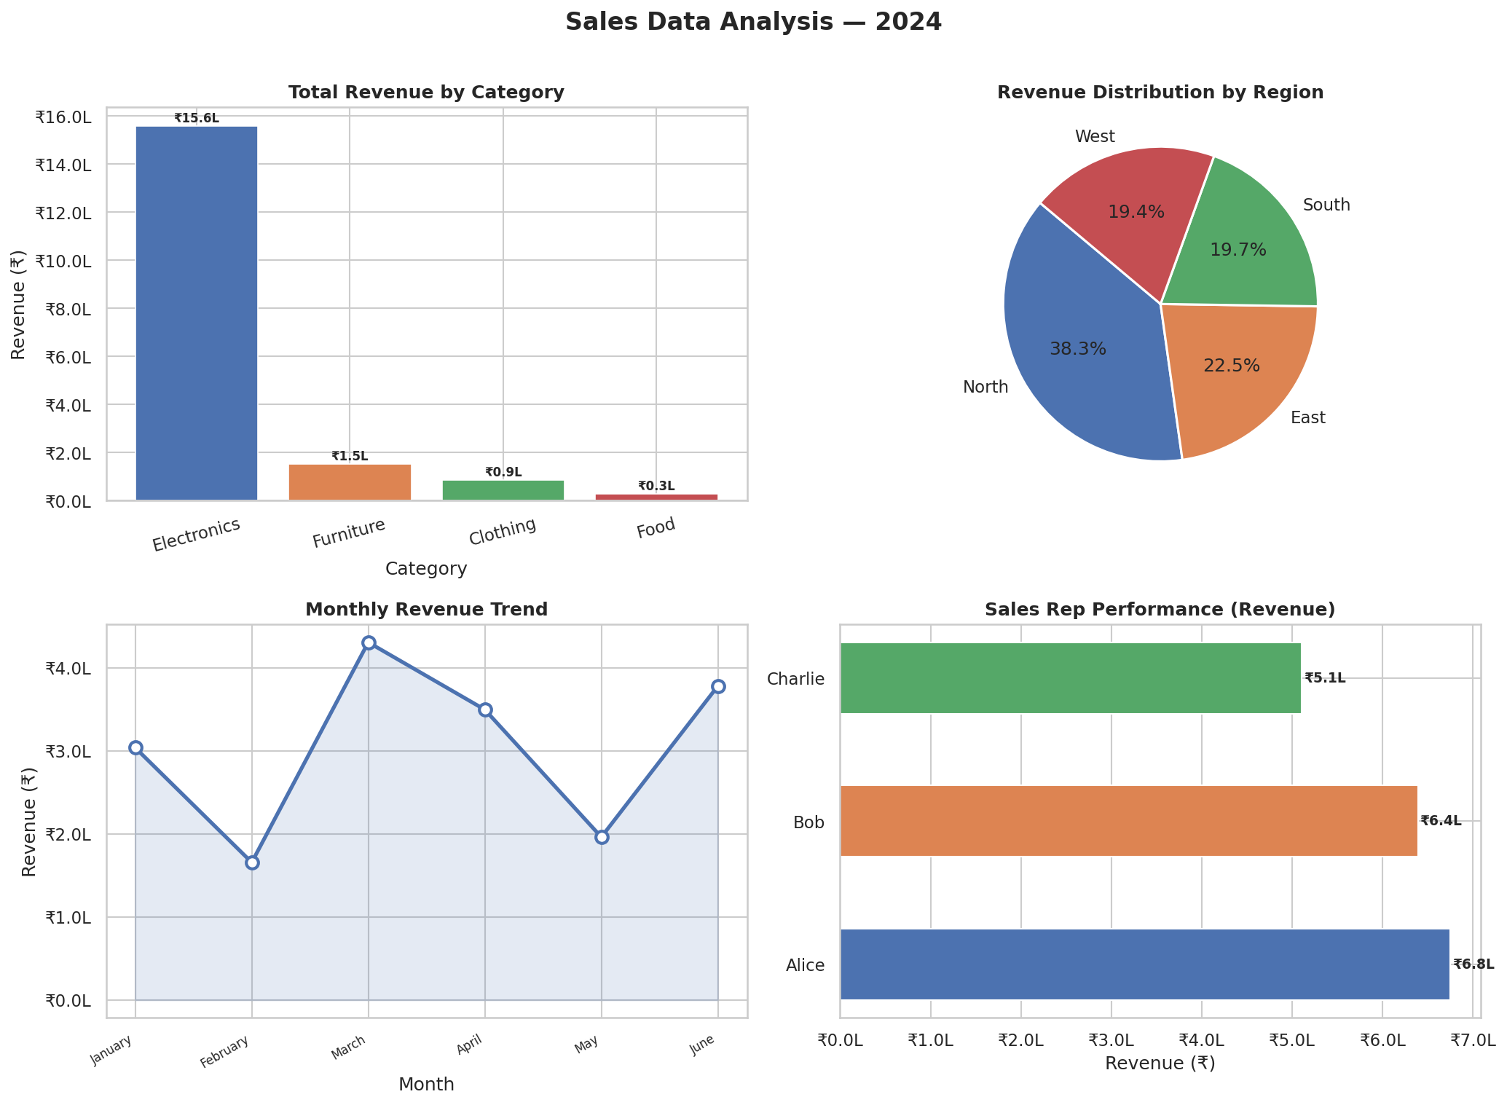

Chart Descriptions:
- Top-left: Bar chart of Total Revenue by Category — Electronics leads by a large margin.
- Top-right: Pie chart showing Revenue share by Region — fairly balanced across all 4 regions.
- Bottom-left: Line chart of Monthly Revenue Trend — March peak clearly visible.
- Bottom-right: Horizontal bar chart comparing Sales Rep performance by revenue.

7. Deliverables & Submission

Files submitted:
- sales_analysis.py — Complete Python script (Pandas analysis)
- sales_data.csv — Dataset used for analysis
- sales_analysis_charts.png — Generated visualizations
- Task1_DataAnalysis_Report.docx — This submission document

GitHub Repository:
[Paste your GitHub public link here]

Google Drive Link:
[Paste your Google Drive public link here]

Data Analysis Internship Project | Python & Pandas | 2025

