Population Change in Developed Countries

Adachi Kazuya (242X003X)

1. **Introduction**

In recent years, Japan's population decline has become more apparent, and it is expected to continue decreasing in the future. I became concerned about how Japan's national strength would be affected if this trend continues. Therefore, I investigated how many developed countries are experiencing population decline and how their national strength has actually changed.

1. **Method**

To visualize the changes in national strength, I will use a scatter plot with the changes in GNI and GDP on each axis. The scatter plot allows for an intuitive understanding of the trends in the data for each axis. Additionally, to compare the number of countries with declining populations versus those with increasing populations among developed nations, I will use a bar graph. The bar graph provides an intuitive understanding of the difference in sample sizes between the two groups.

**Scatter plot** 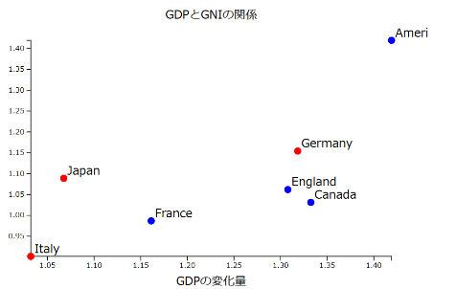

**Bar graph** 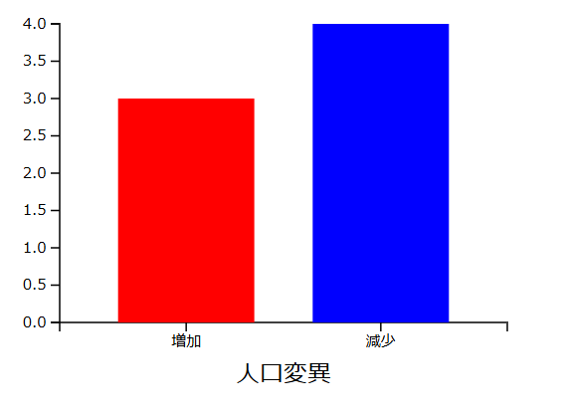

1. **Result**

The data used for this analysis was from 2010 and 2020. Specifically, I examined the population and national strength (GDP and GNI) changes in developed countries, including Japan, the United States, Germany, France, the United Kingdom, Italy, and Canada. As a result, no clear patterns could be observed regarding the changes in GNI and GDP due to population decline. Since national strength is an indicator that gradually changes depending on the country's situation, I believe that measuring it over a longer period may reveal some trends.

