Test 2 - Module 2

VOCABULARY
A. Cross out the odd word.

1. orange purple short green
2. hair passport ticket map
3. brother girl father husband
4. cheap jacket trendy horrible
5. shirt shoes trainers boots
6. slim handsome overweight chubby
6
score

B. Complete the sentences with the words in the box.

expensive wife dictionary beautiful backpack

1. This is my Linda.
2. A: Where’s my camera?
B: It’s in your .
3. Alice is a(n) young woman.
4. This jacket is nice but it’s very .
5. This word isn’t in the .
5
score

Communication
Match.
a. No, I’ve got a sister.
b. I’m your cousin’s flatmate.
c. Ben.
d. I’m so sorry.
e. They’re Kelly’s.
f. He’s in his fifties.
1. Who’s got my mobile phone?

2. Whose trainers are these?
3. Are you an only child?
4. How old is your father?
5. That’s my jacket, it isn’t your jacket.
6. You look familiar.
6
score

grammar
A. Write the sentences in the plural.

1.This umbrella is black and blue. 2. That torch is new.
3. That woman has got long hair.
4. Has Tina got a black dress?
5. This passport is Canadian.
5

score

B. Complete with the correct form of the verb have got.
1. A: your dad a map of the USA?
B: Yes, he . He a map of Canada, too.
2. I two daughters and one son. My daughters
fair hair and blue eyes but my son dark hair and brown eyes.
3. A: you a camera?
B: No, I . But my brother two cameras.

9
score

C. Choose a or b.

1. Is your camera?
a. This b. these
2. My has got a lot of T-shirts.
a. flatmate b. flatmate’s
3. My eyes aren’t grey, blue.
a. it’s b. they’re
4. Dave has got a .
a. blue suit b. suit blue
5. This umbrella is .
a. my father b. my father’s
6. A: I’m sorry but my jumper.
B: You’re right. I’m sorry.
a. That b. that’s
7. That is a very .
a. dress beautiful b. beautiful dress
7
score

LISTEN
Listen to three dialogues and circle the correct answer.

1. Wayne is Penny’s friend / brother.
2. The ticket is Jason’s / Linda’s.
3. The top is cheap / expensive.
6

score

read
Read and tick the correct pictures.

Dylan, Henry and Luke are brothers but they look very different. Dylan is tall and slim but Henry and Luke are medium-height and chubby. Dylan and Henry have got dark hair but Luke has got fair hair.

Dylan Henry Luke
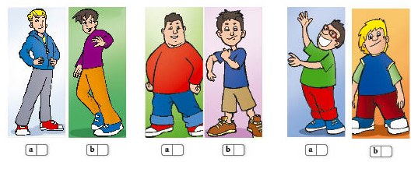

6

score

write
Choose two family members and write a few sentences about them.

What are their names?
How old are they?
What do they do?
What do they look like?

10

score

60

Total score

