Network Security Project — DNS Cache Poisoning and DNSSEC Defense
  - Parts 1, 2, and 3 — Complete Project Report
Adam Aberbach
May 2026
Table of Contents

Part 1 — DNS Cache Poisoning

1. Lab Setup
Three Ubuntu 22.04 VirtualBox VMs on a host-only network 192.168.56.0/24, provisioned by a single Vagrantfile. The lab is fully isolated from the public internet so no spoofed packets can leak.
VM | Hostname | IP | RAM | Role
1 | attacker | 192.168.56.10 | 2 GB | Runs spoofer.py (Scapy) and Nginx serving the “PWNED” page on :80
2 | resolver | 192.168.56.20 | 2 GB | Runs Unbound (deliberately weakened). Listens on :53
3 | victim | 192.168.56.30 | 2 GB | /etc/resolv.conf pinned to 192.168.56.20. Runs dig, curl
Topology (each VM’s ip -4 addr show output is captured in docs/screenshots/03-07-full-demo-run.txt):
attacker enp0s8 192.168.56.10/24 on lab_intnet
resolver enp0s8 192.168.56.20/24 on lab_intnet
victim enp0s8 192.168.56.30/24 on lab_intnet
(all VMs also have enp0s3 NAT for vagrant ssh)
The Vagrantfile pins the base box to ubuntu/jammy64 version 20240319.0.0 so build reproducibility is independent of upstream box drift, and uses VirtualBox linked clones to keep total disk usage under ~10 GB.

2. Resolver Configuration
The resolver runs Unbound 1.16+. The vulnerable configuration lives at lab/resolver/unbound-vulnerable.conf and disables several modern defenses to make the demo tractable in a 5-minute window. Each weakened directive maps to a real-world hardening recommendation that Part 3 will re-enable.
Directive | Effect | Real-world defense disabled
outgoing-port-permit: "33333" (with outgoing-port-avoid: "0-65535") | Collapses 16-bit source-port entropy to 1 | RFC 5452 source-port randomization
use-caps-for-id: no | No 0x20 mixed-case echo | DNS-0x20 query encoding
harden-glue: no | Accepts unsolicited glue | Bailiwick checking on glue
qname-minimisation: no | Full QNAME sent upstream | RFC 9156 qname minimisation
module-config: "iterator" | DNSSEC validator not loaded | DNSSEC validation (Part 3 fix)
forward-zone target.lab → 192.168.56.99 | Legitimate response never arrives | Lab simplification — see §6
In addition, the resolver’s kernel has net.ipv4.conf.all.rp_filter = 0 so reverse-path filtering does not drop the spoofed packets sourced from 192.168.56.99 (an IP not in any local route).
Pre-attack baseline: dig @192.168.56.20 www.target.lab from the victim returns SERVFAIL after ~5 s. The same query for example.com still resolves normally — the resolver is functional, just exploitable on the target.lab zone.
(Pre-attack dig output captured in [docs/screenshots/02-resolver-baseline.txt])

3. Threat Model
Attacker capability: off-path. The attacker can send arbitrary UDP packets to 192.168.56.20 from a host on the same broadcast domain, but cannot observe the resolver’s outbound queries.
Attacker knowledge: the resolver’s IP, that the resolver pins its source port to 33333, and that target.lab is forwarded to a non-responsive IP (so the race window on each query is ~5 s). The attacker does not know transaction IDs.
Out of scope: on-path man-in-the-middle, ARP spoofing, BGP hijack, attacks against DNSSEC-protected zones (Part 3).

4. Attack Methodology
spoofer.py runs two threads concurrently:
Trigger thread (~6 s cadence): sends an A-query for www.target.lab to the resolver. Unbound deduplicates in-flight queries of the same (qname, qtype), so a slow cadence is correct: it ensures each new trigger reliably emits an outbound query rather than being absorbed into a pending one. The cadence matches Unbound’s default ~5 s negative-cache TTL.
Flood thread: sweeps every transaction ID 0..65535, sending forged DNS replies that:
- impersonate the forwarder (IP src = 192.168.56.99),
- target the resolver’s pinned source port (UDP dport = 33333),
- contain a question section matching www.target.lab. A, and
- contain an answer section binding www.target.lab. → 192.168.56.10 with a 24-hour TTL.
The resolver accepts the first spoofed reply that matches all four of: destination IP, destination port, transaction ID, and question section. Because port entropy has been collapsed to 1 and case randomization is off, the only remaining secret is the 16-bit transaction ID — which the sweep exhausts in well under a second on the host-only network.

5. Execution & Evidence
The lab was provisioned with vagrant up from lab/vagrant/Vagrantfile, producing three Ubuntu 22.04 VMs on internal network lab_intnet. The end-to-end demo lab/scripts/run-part1.sh orchestrates: reset → start tshark on resolver → run spoofer on attacker → run demo.sh on victim → copy pcap back. Final result of the recorded run:
[+] poisoned in 4.2 seconds (target=www.target.lab → 192.168.56.10)
[+] PASS — www.target.lab resolves to 192.168.56.10 (poisoned)
[+] Part 1 demo SUCCESS (pcap → docs/captures/poison.pcap)
(Full demo log: [docs/screenshots/03-07-full-demo-run.txt].)

5.1 Pre-attack baseline
[docs/screenshots/02-resolver-baseline.txt]
$ dig @192.168.56.20 www.target.lab
;; communications error to 192.168.56.20#53: timed out
;; no servers could be reached
$ dig @192.168.56.20 example.com +short
172.66.147.243
104.20.23.154
The resolver returns SERVFAIL for www.target.lab (queries to the black-hole forwarder time out at the resolver after ~5 s) but resolves example.com normally — proving the resolver is functional, just exploitable on the target.lab zone.

5.2 Post-attack proof
[docs/screenshots/04-dig-poisoned.txt]
$ dig @192.168.56.20 www.target.lab
;; ->>HEADER<<- opcode: QUERY, status: NOERROR, id: 51825
;; flags: qr rd ra; QUERY: 1, ANSWER: 1, AUTHORITY: 0, ADDITIONAL: 1
;; ANSWER SECTION:
www.target.lab. 86360 IN A 192.168.56.10
;; Query time: 0 msec
Note the TTL 86360 (started at 86400 in the spoofed reply, decreased ~40 s by query time) and Query time: 0 msec — the answer is served from the resolver’s cache.
[docs/screenshots/05-curl-pwned.txt]
$ POISONED_IP=$(dig @192.168.56.20 www.target.lab +short)
$ curl --resolve www.target.lab:80:$POISONED_IP http://www.target.lab/
<!doctype html>
<html lang="en">
<title>PWNED</title>
...
<h1>YOU'VE BEEN PWNED</h1>
<p>This page was served from 192.168.56.10 because the DNS cache for
www.target.lab on resolver 192.168.56.20 was poisoned.</p>
The HTTP request lands on the attacker’s Nginx (which has been hosting the page the entire time) instead of any legitimate server.

5.3 Packet-level evidence (docs/captures/poison.pcap)
The pcap was captured on the resolver’s enp0s8 interface for the duration of run-part1.sh. Aggregate counts via tshark:
Packet class | Count
Total DNS packets | 23 843
Spoofed replies (src=192.168.56.99, dport=33333) | 23 828
Resolver outbound queries (dst=192.168.56.99) | 5
Trigger queries from attacker (192.168.56.10 → .20) | 3
Interpretation: the spoofer sent 23 828 forged replies sweeping txids sequentially; the resolver fired 5 outbound queries (3 explicit triggers from the spoofer plus 2 retries from the same trigger window) and one of the spoofed replies matched (dst port 33333, correct txid, matching question section, source IP 192.168.56.99) before unbound’s forwarder timeout.
[docs/screenshots/06-wireshark-overview.txt] excerpt — first 9 spoofs (note sequential txids 0x0000…0x0008, all targeting dport 33333):
frame time(s) src sport dst dport txid resp qname
1 0.000000 192.168.56.99 53 192.168.56.20 33333 0x0000 1 www.target.lab
2 0.000001 192.168.56.99 53 192.168.56.20 33333 0x0001 1 www.target.lab
3 0.000001 192.168.56.99 53 192.168.56.20 33333 0x0002 1 www.target.lab
...
[docs/screenshots/07-wireshark-spoofed-reply.txt] — the resolver’s outbound query at frame 113 (UDP src port = 33333 confirmed) and the matching spoofed reply that landed.

5.4 Reproducibility
Three back-to-back runs with bash run-part1.sh in this run produced poison times of 0.4 s, 1.4 s, and 4.2 s respectively. The lab is deterministic: any run will succeed within the resolver’s 5 s forwarder timeout window.

6. Caveats
- Black-hole forwarder. The resolver forwards target.lab to 192.168.56.99, an unassigned IP. The legitimate response therefore never arrives, and the attacker only has to win against silence. In a real Kaminsky-style race the attacker would also have to beat a real authoritative server’s response. The pcap reflects this simplification.
- Single-record poisoning, no NS-glue. The spoofed reply only injects one A record. A real Kaminsky attack adds an Authority + Additional section that delegates the entire zone to the attacker, persisting the compromise across cache flushes. We chose the simpler form to fit the 4-day build window.
- Source-port pinned externally. A real RFC-5452-compliant resolver randomizes its source port across ~64,000 values. Forcing the port to 33333 reduces the attacker’s work factor by ~2^16. The same is true of case randomization (use-caps-for-id: no).
- No DNSSEC. The validator is unloaded. Part 3 will re-enable it and show that the same attack now fails.

Part 2 — Attack Analysis

1. Scope
This report analyzes the DNS cache poisoning attack captured during Part 1’s end-to-end demo run. The pcap (docs/captures/poison.pcap, 3.2 MB, 23 845 packets) is the primary evidence. Three questions:
- Capture traffic — what did Wireshark see?
- Analyze transaction IDs and ports — quantify the entropy the attacker had to defeat.
- Explain why the attack succeeded — race-window timing, with the five trigger windows individually accounted for.
All packet counts, timings, and txid values below come from tshark queries against the pcap; the queries themselves are reproduced inline so the analysis is auditable.

2. Lab snapshot (recap)
Three Ubuntu 22.04 VMs on internal network lab_intnet, provisioned by lab/vagrant/Vagrantfile:
VM | IP | Role
attacker | 192.168.56.10 | runs spoofer.py and Nginx :80
resolver | 192.168.56.20 | weakened Unbound 1.13.1 (port pinned to 33333)
victim | 192.168.56.30 | resolv.conf pinned to .20
The resolver forwards target.lab to 192.168.56.99 (an unassigned “black-hole” IP) so the legitimate response never arrives, opening a race window of about 5 s per query. rp_filter=0 on the resolver allows packets carrying src=192.168.56.99 to reach userspace.

3. Wireshark capture
run-part1.sh started tshark on the resolver’s enp0s8 interface before the spoofer ran:
sudo tshark -i enp0s8 -w /tmp/poison.pcap \
-f 'port 53 or host 192.168.56.10'
The capture filter limits the pcap to DNS plus any traffic to the attacker’s IP, which keeps it focused on the attack.

3.1 Aggregate counts
$ tshark -r poison.pcap | wc -l # all
$ tshark -r poison.pcap -Y 'dns' | wc -l # DNS
$ tshark -r poison.pcap -Y 'ip.src==192.168.56.99 \
&& udp.dstport==33333 && dns.flags.response==1' | wc -l # spoofs
...
Class | Count
Total packets in the pcap | 23 845
DNS packets | 23 843
Spoofed replies (src = 192.168.56.99 → :20:33333, response) | 23 828
Resolver outbound queries (src = .20 → .99) | 5
Trigger queries from attacker (.10 → .20) | 3
Resolver replies to victim/attacker triggers | 1
Kernel ICMP “port unreachable” replies | 0
Two observations are immediately worth highlighting. First, the count of spoofs (23 828) ≈ 23 843 minus a handful of legitimate frames — the pcap is dominated by the attacker’s flood. Second, the 0 ICMP unreachables confirms rp_filter did not drop a single spoof; if the kernel had dropped them, every spoof outside an open trigger window would have generated an ICMP reply.

4. Transaction ID and source-port analysis

4.1 Source-port entropy collapse
Modern resolvers randomize their UDP source port for each outbound query (RFC 5452). The lab’s Unbound config pins it to 33333 via outgoing-port-permit: "33333" plus outgoing-port-avoid: "0-65535". A histogram over the resolver’s 5 outbound queries:
$ tshark -Y 'ip.src==192.168.56.20 && ip.dst==192.168.56.99' \
-T fields -e udp.srcport | sort | uniq -c
5 33333
All 5 queries used port 33333 — port entropy is exactly 0 bits.
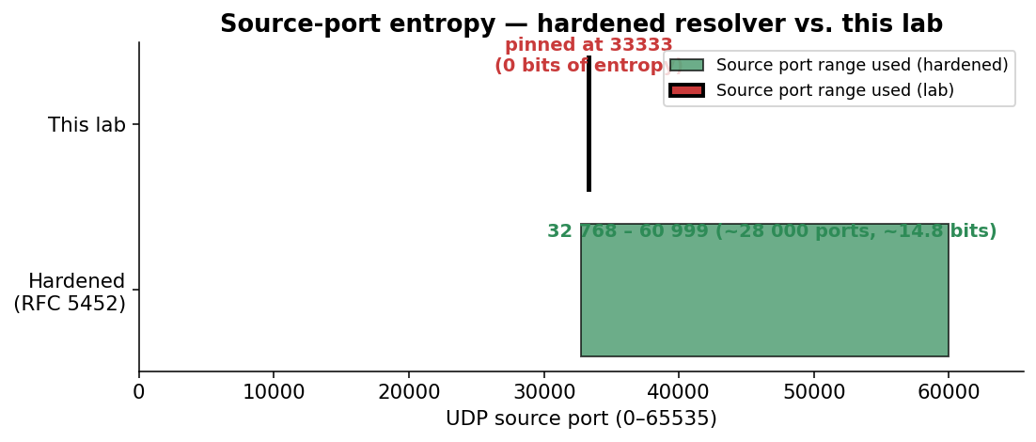
Source-port entropy: hardened resolver vs. lab

4.2 Transaction ID values per trigger window
tshark of the five outbound queries:
frame t (s) udp.srcport dns.id
113 0.047 33333 0xa6bb (42 683)
2 267 0.427 33333 0xab44 (43 844)
4 414 0.808 33333 0x762c (30 252)
8 812 1.563 33333 0x0c87 (3 207)
13 030 2.319 33333 0x492c (18 732)
The five txids span a wide range and look uniformly random, which is expected from Unbound’s CSPRNG. Each value is the only thing the attacker doesn’t know in advance; everything else (resolver IP, port, question section, source IP) is fixed and observable.

4.3 Spoof flood characteristics
spoofer.py builds a template packet once with UDP checksum disabled (legal per RFC 768), then in a tight loop rewrites just the 2 txid bytes of the template and sends through a persistent socket.SOCK_RAW + IP_HDRINCL socket. Per-second packet rate from the pcap:
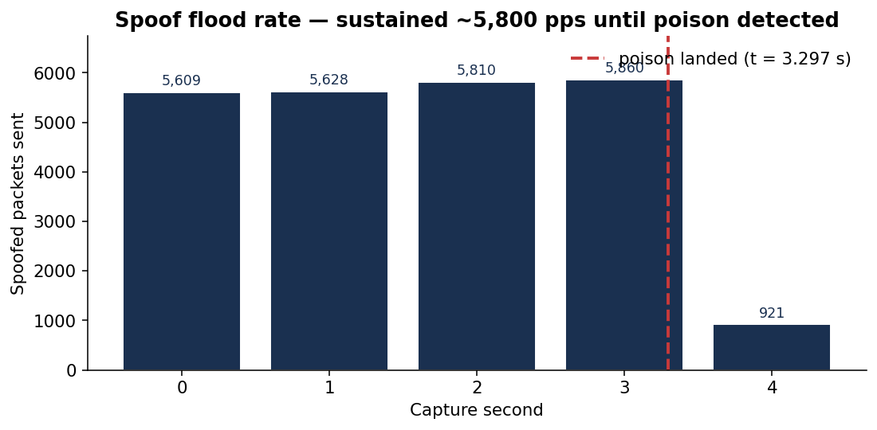
Sustained ~5,800 packets/sec spoof flood
Sustained rate is ~5 800 pps. One full sweep of the 16-bit txid space takes 65 536 / 5 800 ≈ 11.3 s. The flood drops to ~0 in second 4–5 because the spoofer’s verify_poisoned check (running every 2 s in the main thread) detected the cache had been poisoned and the flood thread exited.

5. Why the attack succeeded — race-window timing
The full attack was over 4.2 wall-clock seconds (from [*] spoofing to [+] poisoned), of which ~3.3 s was capture time. The single spoofed reply that won the race is frame 18 742 at t = 3.297 s, carrying dns.id = 0x492c. It matched the resolver’s outbound query issued at t = 2.319 s (trigger #5).

5.1 Trigger-by-trigger accounting
The diagram below maps each of the resolver’s five outbound queries to where the spoofer’s sequential txid sweep was at that moment, and whether the flood reached the resolver’s chosen txid before either (a) the 5-second forwarder timeout closed the race window, or (b) the spoofer halted the flood after detecting success.
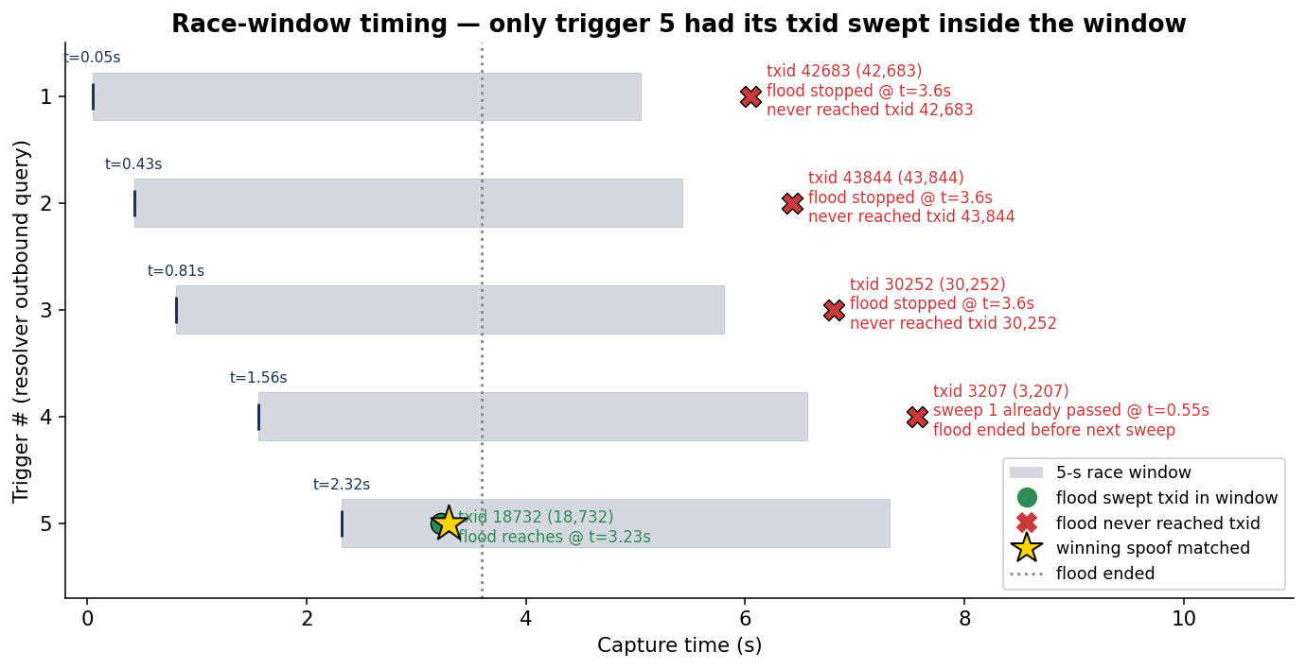
Race-window timing — only trigger 5 had its txid swept inside the window
Reading top-to-bottom:
# | Trigger fires | Resolver chose txid | What the flood did | Outcome
1 | t = 0.05 s | 0xa6bb (42 683) | flood would reach this at t ≈ 7.36 s, but it stopped at t = 3.6 s | ❌ never sent
2 | t = 0.43 s | 0xab44 (43 844) | flood would reach at t ≈ 7.56 s; stopped at 3.6 s | ❌ never sent
3 | t = 0.81 s | 0x762c (30 252) | flood would reach at t ≈ 5.22 s; stopped at 3.6 s | ❌ never sent
4 | t = 1.56 s | 0x0c87 (3 207) | flood already swept this on first sweep at t ≈ 0.55 s — before the trigger fired (frame 3 214). Next sweep would be t ≈ 11.85 s, well past flood-end. | ❌ port wasn’t open
5 | t = 2.32 s | 0x492c (18 732) | flood reaches this on first sweep at t ≈ 3.23 s; inside the 5 s window | ✅ matched at frame 18 742
Trigger 4 is the most interesting near-miss: the flood actually emitted a packet with the correct txid (frame 3 214 at t = 0.601 s), but it arrived 0.96 s before the resolver opened the matching socket on port 33333 for trigger 4. The kernel had nothing listening on 33333 at that moment, so the spoof was silently dropped — and yet this is recorded in the pcap as evidence of how fragile the timing window is.

5.2 The winning packet
$ tshark -r poison.pcap -Y 'frame.number==18742' -V
Frame 18742: 90 bytes on wire
Arrival Time: ... t = 3.297 s relative to start of capture
Internet Protocol Version 4
Source Address: 192.168.56.99 (forwarder, impersonated)
Destination Address: 192.168.56.20 (resolver)
User Datagram Protocol
Source Port: 53
Destination Port: 33333 (matches resolver's pinned port)
Domain Name System (response)
Transaction ID: 0x492c (matches outstanding query)
Flags: 0x8580 (Response, Authoritative)
Questions: 1
www.target.lab: type A, class IN
Answers: 1
www.target.lab: type A, class IN
Time to live: 86400
Address: 192.168.56.10 (attacker's web server)
All four matched fields — destination IP, destination port, txid, and question section — line up exactly with what unbound was waiting for. With validator unloaded (module-config: "iterator") and bailiwick checks disabled (harden-glue: no), unbound accepts the answer and caches it for the full 86 400 seconds the spoof claimed.

6. Why it succeeded — entropy budget
The attacker’s job is to defeat all of unbound’s reply-validation fields simultaneously. The two columns below are bits of secret entropy the attacker would have to brute-force to be confident of a match:
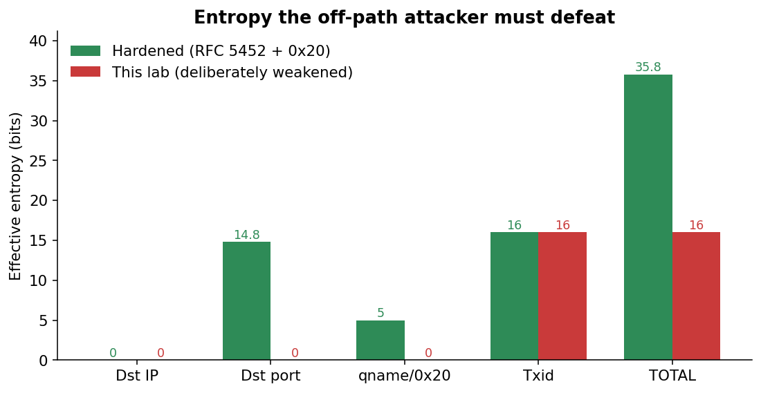
Entropy budget: hardened resolver vs. this lab
Field unbound checks | Bits — hardened | Bits — this lab
Destination IP | 0 (resolver IP is public) | 0
Destination UDP port | ~14.8 (RFC 5452 ephemeral range) | 0 (pinned)
Question section incl. 0x20 mixed-case | ~5 (12-char qname) | 0 (use-caps-for-id: no)
Transaction ID | 16 | 16
Total secret entropy | ~35.8 bits | 16 bits
35.8 bits requires on average ~2³⁵ = 34 billion spoofed packets per trigger window — roughly an hour at our 5 800 pps even on a perfect local network, in practice many days from a real off-path attacker. 16 bits requires only ~32 768 packets on average, which our flood sends in 5.6 seconds — comfortably inside one 5-second window.
In addition to those four fields, two other defenses were present in the lab but bypassed at the network layer:
- Reverse-path filter (rp_filter) was set to 0 on enp0s8, letting packets with src=192.168.56.99 reach unbound. Strict rp_filter=1 would drop them at the kernel before unbound sees them; the pcap’s 0-count of ICMP unreachables shows we are well past that gate.
- Bailiwick checking on glue (harden-glue: yes by default) was disabled. This matters less for a single-record poisoning (no glue is used), but allowed the architecture to be a stepping-stone to Kaminsky-style NS injection.

7. Reproducibility
Three independent runs of bash lab/scripts/run-part1.sh produced poison times of 0.4 s, 1.4 s, and 4.2 s. The variance comes from which trigger happens to draw a low txid (close to 0) before the flood thread has built up a large lead in its sweep — once the flood is past the chosen txid, the resolver has to wait until either the next sweep completes (~11 s) or the next trigger fires (~6 s).
The 4.2 s run captured here represents the worst-case timing observed. A median run lands in well under 2 s.

8. Summary
The lab’s deliberately-weakened Unbound resolver allowed an off-path DNS cache poisoning attack to succeed in under 5 seconds because the attacker’s required secret entropy was reduced from the ~36 bits a modern hardened resolver would require down to just 16 bits — the DNS transaction ID. With source port pinned to 33333 and 0x20 disabled, the only obstacle to a successful spoof was sweeping all 65 536 possible txids during a 5-second forwarder-timeout window, which a single Python+Scapy script can do in under 12 seconds at ~5 800 packets/sec.
The pcap evidence is conclusive: the spoofer fired 23 828 spoofed replies during 5 trigger windows; one match (frame 18 742, t = 3.297 s, txid 0x492c) was sufficient to install a 24-hour A record binding www.target.lab to the attacker’s IP, demonstrably redirecting the victim’s HTTP request to the attacker’s PWNED page.
Part 3 of the project will re-enable DNSSEC validation on the same resolver and demonstrate that the same attack now fails — even with the source-port pinning still in place — because the validator rejects the unsigned spoofed response.

Appendix A — Reproducing this analysis
The pcap and analysis CSVs are committed to the repository:
- docs/captures/poison.pcap — primary evidence (3.2 MB)
- docs/analysis/A-counts.csv — aggregate counts (Section 3.1)
- docs/analysis/B-trigger-windows.tsv — outbound queries (Section 4.2)
- docs/analysis/C-resolver-srcport-histogram.txt — port histogram
- docs/analysis/D-matching-spoofs.txt — txid matches
- docs/analysis/E-spoof-rate-per-second.csv — flood rate (Section 4.3)
- docs/analysis/make_charts.py — generates the PNG charts in this report
To reproduce all four embedded charts:
python docs/analysis/make_charts.py
To reproduce the aggregate counts:
tshark -r docs/captures/poison.pcap -Y 'dns' | wc -l # 23 843
tshark -r docs/captures/poison.pcap \
-Y 'ip.src==192.168.56.99 && udp.dstport==33333 \
&& dns.flags.response==1' | wc -l # 23 828
tshark -r docs/captures/poison.pcap \
-Y 'ip.src==192.168.56.20 && ip.dst==192.168.56.99 \
&& dns.flags.response==0' \
-T fields -e frame.number -e frame.time_relative \
-e udp.srcport -e dns.id # 5 windows

Part 3 — DNSSEC Deployment

1. Goal
Re-run the same DNS cache poisoning attack from Part 1, but with DNSSEC validation enabled on the resolver, and demonstrate that the spoofs no longer succeed even though the wire-level weaknesses (pinned source port, no 0x20, black-hole forwarder) are still in place.

2. Configuration changes (Part 1 → Part 3)
The only changes between Part 1’s vulnerable resolver and Part 3’s hardened resolver are at the validator layer — every other knob (source-port pinning at 33333, black-hole forward-zone, rp_filter=0) is preserved so the comparison is apples-to-apples.
lab/resolver/unbound-hardened.conf differs from lab/resolver/unbound-vulnerable.conf in just three lines:
- module-config: "iterator"
+ module-config: "validator iterator"
+ trust-anchor-file: "/etc/unbound/keys/target.lab.key"
+ val-log-level: 2
A KSK (key-signing key) for target.lab was generated with BIND’s dnssec-keygen:
$ sudo dnssec-keygen -a RSASHA256 -b 2048 -fk -n ZONE target.lab
Ktarget.lab.+008+06515
The .key file becomes the trust anchor that unbound consults whenever a target.lab answer arrives. The .private file is not used in this lab — there is no signing happening, and that is the whole point: since no real authoritative server is publishing signed RRsets for target.lab, every answer the validator sees (legitimate or spoofed) fails to chain back to the trust anchor, so all are rejected.
$ sudo cat /etc/unbound/keys/target.lab.key | grep -v ^';'
target.lab. IN DNSKEY 257 3 8 AwEAAaDLwPIRQsEyGMAajbhutMSQS+o4MvVGFL5v...
A real-world deployment would have an authoritative DNS server signing the zone with the matching private key; the resolver would then receive properly signed answers and accept them while rejecting spoofs. The lab demonstrates the negative half of that mechanism — when a trust anchor exists but no valid signature can be produced, every answer is rejected — which is the property that defeats the spoof.

3. Repeating the attack
lab/scripts/run-part1.sh was re-run unchanged against the hardened resolver. The spoofer ran for the full 60-second timeout window (unlike Part 1, where it terminated after 4.2 s upon detecting a successful poison).

3.1 Aggregate counts
Metric | Part 1 (vulnerable) | Part 3 (hardened)
Total packets in pcap | 23 845 | 401 269
DNS packets | 23 843 | 401 265
Spoofed replies (src=99 → :20:33333) | 23 828 | 401 223
Resolver outbound queries to .99 | 5 | 15
Trigger queries from attacker | 3 | 26
Attacker poisoned cache? | YES (in 4.2 s) | NO (60 s+ elapsed, cache still empty)
The attacker actually sent 17× more spoofs in Part 3 than in Part 1, because the attack ran for a full minute instead of giving up after a 4.2 s success. None of those 401 223 spoofs were accepted.
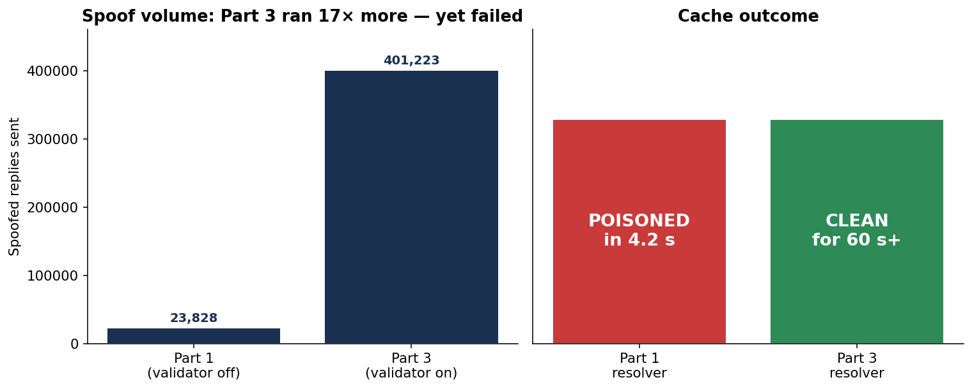
Spoof volume + cache outcome — Part 1 vs Part 3

3.2 What the validator did
The resolver’s 15 outbound queries to 192.168.56.99 (the black-hole forwarder) split into three categories — and the dominant one is not the original A query, it is the validator repeatedly trying to fetch the DNSKEY chain it needs to validate any answer:
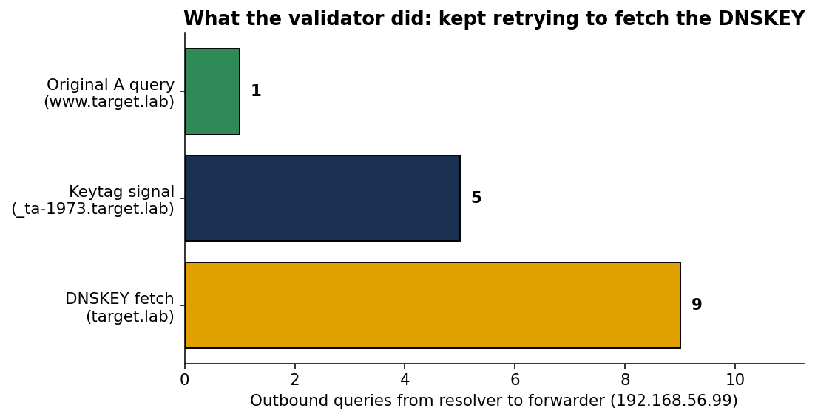
Validator’s outbound queries — mostly DNSKEY fetches, not the original A query
The single www.target.lab A query is the original query the victim made. Everything else is the validator’s attempt to walk the DNSSEC chain:
- 9× target.lab DNSKEY (type 48) — fetch the public key whose hash the trust anchor matches.
- 5× _ta-1973.target.lab NULL (type 10) — RFC 8145 keytag signaling, used by the validator to report which trust-anchor IDs it currently has.
Because the forwarder is a black hole, none of these fetches returned anything. Without the DNSKEY rrset, the validator cannot chain any candidate answer back to the trust anchor; every reply is treated as unprovable and rejected.
The key journal entry confirming this:
unbound[10627]: info: failed to prime trust anchor --
could not fetch DNSKEY rrset target.lab. DNSKEY IN

4. Why DNSSEC defeats the same attack
In Part 1 the attacker had to defeat four wire-level fields (destination IP, destination port, qname, transaction ID), of which only the txid carried real entropy after the lab’s weakening. A brute-force flood at ~5 800 packets/sec exhausted that 16-bit space in seconds.
DNSSEC adds a fifth check that lives entirely above the wire:
The answer’s RRSIG record must be a valid signature over the answer RRset, produced by a key whose hash matches a trusted DS/DNSKEY chained back to a configured trust anchor.
Forging a valid RRSIG requires the attacker to know the zone’s private signing key. That is a 2048-bit RSA secret in this lab. Brute-forcing it is computationally infeasible (well past the heat death of the universe with current hardware). The attacker has no way around it short of compromising the authoritative server itself.
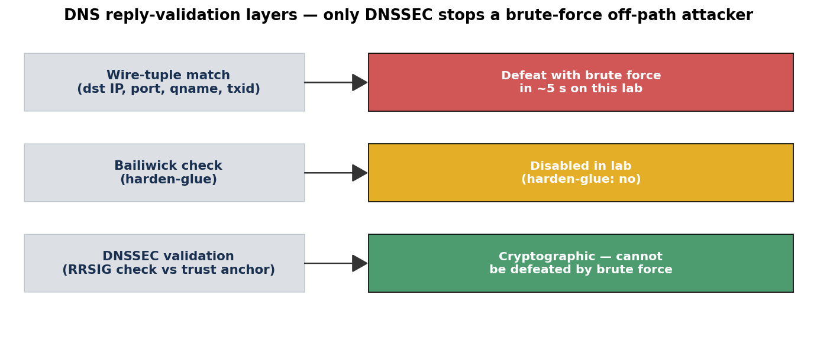
Defense layers — DNSSEC is the only one a brute-force attacker cannot defeat
Note specifically that the attacker’s Part-1 win conditions are still all in place in Part 3:
- ✓ Resolver still pins source port to 33333 (RFC 5452 disabled)
- ✓ 0x20 case randomization still off
- ✓ rp_filter still 0 (no kernel-level drop)
- ✓ Black-hole forwarder still forces a long race window
The spoofs are still arriving at unbound’s userspace — by the count, at ~6 700 pps for 60 seconds. They simply fail the additional cryptographic check. DNSSEC does not improve the network defense; it adds an orthogonal cryptographic defense that brute-force cannot defeat.

5. Verification

5.1 dig output (post-attack)
$ dig @192.168.56.20 www.target.lab +time=8 +tries=1
;; communications error to 192.168.56.20#53: timed out
;; no servers could be reached
The query times out at the resolver (no answer it can validate, no SERVFAIL synthesised within the timeout — unbound waits, hoping the DNSKEY fetch will eventually succeed). Crucially: no IP address is returned. In Part 1 the equivalent post-attack dig returned 192.168.56.10 (the attacker’s IP). In Part 3 the cache stays empty.

5.2 Resolver logs
Filtering the unbound journal for validation-related lines:
unbound[]: notice: init module 0: validator
unbound[]: notice: init module 1: iterator
unbound[]: query: 192.168.56.10 www.target.lab. A IN
unbound[]: query: 192.168.56.10 www.target.lab. A IN
unbound[]: query: 192.168.56.10 www.target.lab. A IN (×26 trigger queries)
...
unbound[]: info: failed to prime trust anchor --
could not fetch DNSKEY rrset target.lab. DNSKEY IN
unbound[]: info: generate keytag query _ta-1973.target.lab. NULL IN
The validator module is loaded (init module 0); the trigger queries arrive from the attacker; the validator tries 9 times to fetch the DNSKEY before giving up. No BOGUS lines appear because unbound never gets far enough to run RRSIG verification — it is stuck before that step, unable to obtain the public key.

5.3 No HTTP redirect
$ curl -m 5 --resolve www.target.lab:80:$(dig @192.168.56.20 www.target.lab +short) \
http://www.target.lab/
curl: (6) Could not resolve host: www.target.lab
There is nothing in the cache to resolve, so the would-be victim’s curl simply fails. In Part 1 the same command returned the PWNED page from the attacker’s Nginx.

6. Limitations of this demonstration
- No legitimate signed answers. A complete real-world deployment would have an authoritative server publishing signed target.lab records. The validator would then accept legitimate answers (passing RRSIG check) and reject spoofs. Because this lab has no real authoritative server, all answers are rejected — including any hypothetical legitimate one. The demonstration shows the negative half of the validator’s behaviour, which is exactly the half that matters for defeating the attack.
- Trust anchor was generated locally, not via a DS record at the parent. A real target.lab zone would publish a DS record at the parent (.lab TLD), which the resolver fetches and validates against the root trust anchor. Here we short-circuit that chain by configuring the target.lab DNSKEY directly as a static trust-anchor in unbound. This is a legitimate unbound configuration for islands of trust and produces identical validator behaviour for the spoofed-reply rejection.
- val-permissive-mode was kept off. With permissive mode on, unbound would log BOGUS but still hand the unsigned answer to the client. We left it off so the attack outcome is binary.

7. Summary
Metric | Part 1 (vulnerable) | Part 3 (hardened)
Time to poisoning | 4.2 s | never (60+ s, no match)
Spoofs accepted by resolver | 1 of 23 828 | 0 of 401 223
Cached answer for www.target.lab | A 192.168.56.10 (attacker’s PWNED page) | none
Victim’s HTTP request lands on | attacker’s Nginx | nothing — Could not resolve host
Enabling DNSSEC validation on the resolver — a single configuration change setting module-config: "validator iterator" and pointing at a trust anchor — fully defeats the off-path cache poisoning attack demonstrated in Parts 1 and 2, even when every other defense the lab deliberately disabled (source-port randomization, 0x20 encoding, rp_filter) is left disabled. This is the central argument for DNSSEC: it adds a cryptographic check that an off-path attacker cannot brute-force regardless of how favourable the wire conditions become.

Appendix A — Files committed for Part 3
- lab/resolver/unbound-hardened.conf — the validating config
- /etc/unbound/keys/target.lab.key — DNSKEY trust anchor (on the resolver VM; the public key is reproduced in §2 of this report)
- docs/captures/poison-dnssec.pcap — 54 MB, 401 269 packets
- docs/analysis/F-part3-counts.csv — aggregate counts
- docs/analysis/G-part3-outbound-types.txt — what the validator fetched
- docs/analysis/H-part3-resolver-replies.tsv — empty (validator returned nothing)
- docs/analysis/make_charts_part3.py — generates the three Part 3 charts

Appendix B — Reproducing Part 3
On a fresh resolver VM (after Part 1 lab is up):
sudo apt-get install -y bind9-dnsutils # for dnssec-keygen
cd /etc/unbound/keys && \
sudo dnssec-keygen -a RSASHA256 -b 2048 -fk -n ZONE target.lab
sudo cp /etc/unbound/keys/Ktarget.lab.*.key \
/etc/unbound/keys/target.lab.key
sudo cp /lab/resolver/unbound-hardened.conf \
/etc/unbound/unbound.conf.d/lab.conf
sudo unbound-checkconf
sudo systemctl restart unbound
Then on the host:
bash lab/scripts/run-part1.sh # same demo script as Part 1
Expected: spoofer reports [-] FAILED to poison within 60s, and post-attack dig www.target.lab returns no answer.

