Database

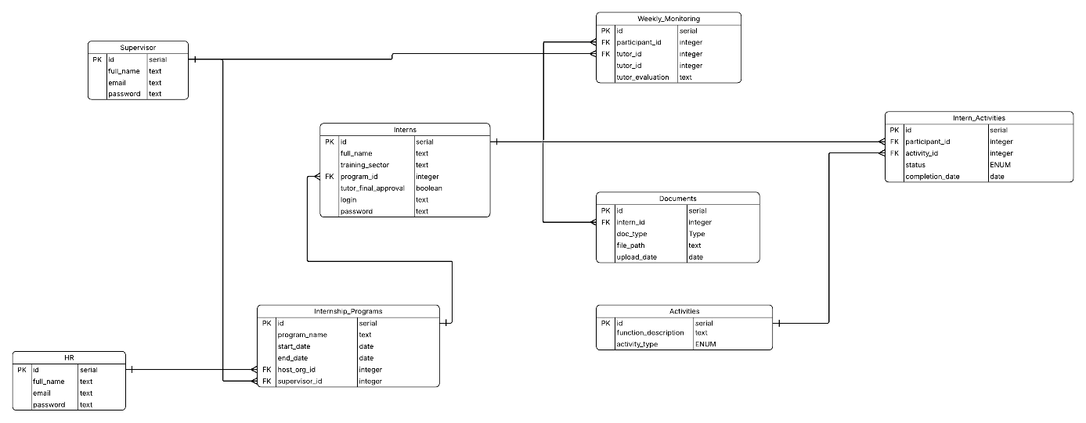

Relations:
Table | Field name | Type  key | Relation | Type  key | Field name | Table
Supervisor | id | PK | 1 … N | FK | participant_id | Weekly_Monitoring
Weekly_Monitoring | participant_id | FK | N .. 1 | PK | id | Interns
Interns | program_id | FK | N … 1 | PK | id | Internship_Programs
Interns | id | PK | 1 … N | FK | participant_id | Intern_Activities
Interns | id | PK | 1 … N | FK | intern_id | Documents
Intern_Activities | activity_id | FK | N … 1 | PK | id | Activities
HR | id | PK | 1 … N | FK | host_org_id | Internship_Programs
Internships_Programs | Supervisor_id | FK | N … 1 | PK | id | Supervisor

Intern 3 has created this database project using a program called LucidChart.
The final (proper) version was written in PostgreSQL.
The main task of this project is to manage student practices.
This database stores information about interns, supervisors, programs, activities, and important documents.
The main element of this system is the table “Interns”, which connects personal information about students’ progress, their supervisors, and programs.
Supervisors oversee students and evaluate their efforts based on their weekly reports.
Every practice program is defined, and progress is monitored in the table “Intern_Activities”.
This system can also store documents from interns such as reports, agreements, etc.
There is also information about HR, which is responsible for the administrative aspects of Erasmus.
Everything creates a coherent system that helps the organization monitor and manage student practices.

Tables:
1) Supervisor:
• (PK) id – unique identifier for every row in the table (type – serial)
• full_name – this field stores the name and surname of every supervisor (type – text)
• email – this field stores the supervisor’s email (type – text)
• role_type – this field helps us declare which type of supervisor we have. We can have, for example, one where we will practice our skills or one who comes from our school (type – ENUM. You can choose between “Host” or “Sending”)
• password – this field stores text that allows the supervisor to log in (type – text)
2) Weekly_Monitoring:
• (PK) id – unique identifier for every row in the table (type – serial)
• (FK) participant_id – this field contains the intern id from the table “Interns” (type – integer)
• (FK) tutor_id – this field contains the supervisor id from the table “Supervisor” (type – integer)
• week_number – this field stores the number of the week in the intern’s work
• tutor_evaluation – this field shows how much (or not) the intern improved their technical or soft skills (type – text)
3) Interns:
• (PK) id – unique identifier for every row in the table (type – serial)
• full_name – this field stores the name and surname of every intern (type – text)
• training_sector – this field stores information about the intern’s sector in which they will be working (type – text)
• (FK) program_id – this field contains the program id from the table “Internship_Programs” (type – integer)
• tutor_final_approval – this field tells us if the supervisor approved the intern’s practice time at work (type – boolean)
• login – this field contains text that allows access to intern data (their email) (type – text)
• password – this field stores text that allows the intern to log in (type – text)
4) Documents:
• (PK) id – unique identifier for every row in the table (type – serial)
• (FK) intern_id – this field contains the intern id from the table “Interns” (type – integer)
• doc_type – this field contains information about the file extension, like PDF or other (type – text)
• file_path – this field contains information about the path where the file is saved (type – text)
• upload_date – this field tells us when the document was uploaded (type – date)
5) Intern_Activities:
• (PK) id – unique identifier for every row in the table (type – serial)
• (FK) participant_id – this field contains the intern id from the table “Interns” (type – integer)
• (FK) activity_id – this field contains the activity id from the table “Activities” (type – integer)
• status – this field allows us to declare the progress of an intern’s activity (type – ENUM. You can choose between “Completed”, “In progress” or “Pending”)
• completion_date – this field tells us when the activity has ended. If it doesn’t have an end date, then the value is NULL (type – date)
6) HR:
• (PK) id – unique identifier for every row in the table (type – serial)
• full_name – this field stores the name and surname of the HR employee (type – text)
• email – this field stores the HR employee’s email (type – text)
• password – this field stores text that allows HR to log in (type – text)
7) Internship_Programs:
• (PK) id – unique identifier for every row in the table (type – serial)
• program_name – this field contains the name of the program (type – text)
• start_date – this field contains information about when the program starts (type – date)
• end_date – this field contains information about when the program ends (type – date)
• (FK) host_org_id – this field contains the HR id from the table “HR” (type – integer)
- (FK) supervisor_id – this field contains the supervisor id from the table „Supervisor” (type - integer)
8) Activities:
• (PK) id – unique identifier for every row in the table (type – serial)
• function_description – this field specifies what the activity is
• activity_type – this field allows us to declare what kind of activity the intern is performing (type – ENUM. You can choose between “Technical”, “Safety” or “Soft”)

