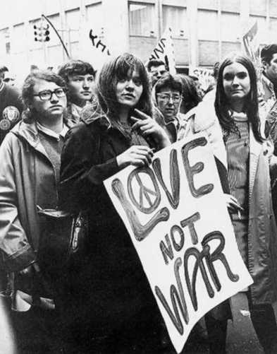

Whether drugs or rock music, they all limited to the level of sensory enjoyment, that is, to achieve freedom through sensory stimulation and physiological satisfaction, so sex as the most natural way for humans to enjoy physiological enjoyment is obviously one of the important contents of counter-culture culture. For this, it comes to sexual Liberation movement.

## Sexual Liberation (Sexual Revolution)

A counter culture social movement that challenged traditional codes of behavior related to sexuality and interpersonal relationships throughout the US and even the whole world from 1960s to the 1980s. It changed people's perception of sex to a great extent.

Sexual liberation included increase publics’ understanding and acceptance of unconventional sex outside the traditional area like heterosexual and monogamous relationship.

It mainly about the normalization of contraception and the pill, premarital sex, homosexuality, legalization of abortion and others alternative forms of sexuality.

Origin:

1. The increased public acceptance brought by counter culture trends in society.
2. Support from feminist thinkers
3. The development of the birth control pill in 1960
4. The discovery of penicillin led to significant reductions in syphilis mortality, which, in turn, spurred an increase in non-traditional sex during the mid to late 1950s.
5. Baby Boom Generation – grow up in relatively prosperous and safe conditions, within a middle class on the rise and with better access to education and entertainment than ever before. Leads to more permissive and informalized attitudes.
6. By people who shared a belief in the detrimental impact of sexual repression.

Ambition:

1.The counterculture wanted to explore the body and mind, and free the personal self from the moral and legal sexual confines of modern America, as well as from 1940s-50s morals in general.

2.The sexual revolution of the 1960s was grew from a conviction that the erotic should be celebrated as a normal part of life and not repressed by family, industrialized sexual morality, religion and the state.

## Free love

A social movement beginning in San Francisco in the mid-1960s, "free love" emerged as a new culture. Its initial goal was to separate the law from sexual matters such as marriage, birth control, it argued that sexual relations should be freely entered into and should not be regulated by law and advocacy for women to use her body in any way that they please. Hippies use free love to preach the power of love and the beauty of sex.

## Non-marital sex

Premarital sex became more widely accepted. The increased availability of birth control (and the legalization of abortion in some places) helped reduce the chance that pre-marital sex would result in unwanted children. By the mid-1970s the majority of newly married American couples had experienced sex before marriage.

Central to the change was the development of relationships between unmarried adults, which resulted in earlier sexual experimentation reinforced by a later age of marriage. On average, Americans were gaining sexual experience before entering into monogamous relationships. The increasing divorce rate and the decreasing stigma attached to divorce during this era also contributed to sexual experimentation. By 1971, more than 75% of Americans thought that premarital sex was acceptable, a threefold increase from the 1950s, and the number of unmarried Americans aged twenty to twenty-four more than doubled from 1960 to 1976. Americans were becoming less and less interested in getting married and settling down and as well less interested in monogamous relationships. In 1971, 35% of the country said they thought marriage was obsolete.

## Feminism and sexual liberation

The sexual liberation movement was aided by feminist ideologues in their mutual struggle to challenge traditional ideas regarding female sexuality and queer (homo) sexuality.

Many feminist thinkers believed that assertion of the primacy of sexuality would be a major step towards the ultimate goal of women's liberation, thus women were urged to initiate sexual advances, enjoy sex and experiment with new forms of sexuality.

Core ideology: Support for women's right to choose her sexual partners free of outside interference or judgments.

Confirm the women right to pursuit sexual pleasure, which subsequently was to set the foundation for female independence.

The feminist movement has helped create a social climate in which LGBT people and women are increasingly able to be open and free with their sexuality, which enabled a spiritual liberation of sorts with regards to sex. Rather than being forced to hide their sexual desires or feelings, women and LGBT people have gained and continue to gain increased freedom in this area. Consequently, the feminist movement to end sexual oppression has and continues to directly contribute to the sexual liberation movement.

## Make Love, No war (Part of the Hippie Movement)

Two of the leaders of the women’s movement in the 1960s: Kate Millett (left), author of a controversial book of the time, *Sexual Politics*, and journalist and activist Gloria Steinem.

影响：

1. 非婚姻性，增加人们的性经验， 对婚姻制度产生影响
2. 促进妇女解放和妇女性意识觉醒，为今后女权运动奠定基础
3. 呼吁人们释放天性，解放自我意识