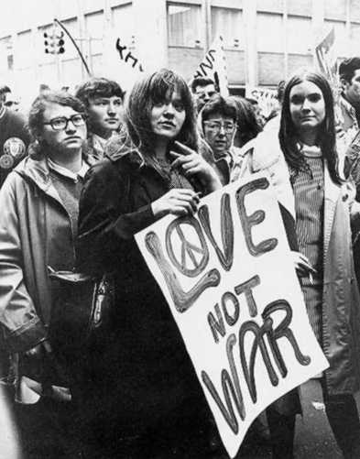

Sexual Revolution (Sexual Liberation)

A social movement that challenged traditional codes of behavior related to sexuality and interpersonal relationships throughout the US and even the whole world from 1960s to the 1980s. Sexual liberation included increased acceptance of sex outside of traditional heterosexual, monogamous relationships (primarily marriage). The normalization of contraception and the pill, public nudity, pornography, premarital sex, homosexuality, masturbation, alternative forms of sexuality, and the legalization of abortion all followed.

While the general permissiveness of the counterculture encouraged sexual freedom, other factors also contributed to the change in attitudes toward sexuality. Oral contraceptives became available, and by 1970, 12 million women were “on the pill.” The use of other means of birth control, such as diaphragms and IUDs, also increased. Many states had already legalized abortion, and the new women's movement was committed to making the procedure even more widely available.

Origin:

1. The development of the birth control pill in 1960
2. The discovery of penicillin led to significant reductions in syphilis mortality, which, in turn, spurred an increase in non-traditional sex during the mid to late 1950s.
3. Baby Boom Generation – grow up in relatively prosperous and safe conditions, within a middle class on the rise and with better access to education and entertainment than ever before. Leads to more permissive and informalized attitudes.
4. Initiated by people who shared a belief in the detrimental impact of sexual repression.

Ambition:

1.The counterculture wanted to explore the body and mind, and free the personal self from the moral and legal sexual confines of modern America, as well as from 1940s-50s morals in general.

2.The sexual revolution of the 1960s was grew from a conviction that the erotic should be celebrated as a normal part of life and not repressed by family, industrialized sexual morality, religion and the state.

## Free love

Beginning in San Francisco in the mid-1960s, a new culture of "free love" emerged, with thousands of young people becoming "hippies", inspired by Indian culture, who preached the power of love and the beauty of sex as part of ordinary life. This is part of a counterculture that continues to exist. By the 1970s, it was socially acceptable for colleges to permit co-ed housing.

## Non-marital sex

Premarital sex, heavily stigmatised for some time, became more widely accepted. The increased availability of birth control (and the legalisation of abortion in some places) helped reduce the chance that pre-marital sex would result in unwanted children. By the mid-1970s the majority of newly married American couples had experienced sex before marriage.

Central to the change was the development of relationships between unmarried adults, which resulted in earlier sexual experimentation reinforced by a later age of marriage. On average, Americans were gaining sexual experience before entering into monogamous relationships. The increasing divorce rate and the decreasing stigma attached to divorce during this era also contributed to sexual experimentation. By 1971, more than 75% of Americans thought that premarital sex was acceptable, a threefold increase from the 1950s, and the number of unmarried Americans aged twenty to twenty-four more than doubled from 1960 to 1976. Americans were becoming less and less interested in getting married and settling down and as well less interested in monogamous relationships. In 1971, 35% of the country said they thought marriage was obsolete.

Make Love, No war (Part of the Hippie Movement)

Two of the leaders of the women’s movement in the 1960s: Kate Millett (left), author of a controversial book of the time, *Sexual Politics*, and journalist and activist Gloria Steinem.