1. Example 3-3 on AWS

Command for compiling Java file:

javac -cp src/:hadoop-common-2.6.1.jar:hadoop-mapreduce-client-core-2.6.1.jar:commons-cli-2.0.jar -d . FileSystemDoubleCat.java

Command for copying file from local dish to HDFS:

hdfs dfs -copyFromLocal quangle.txt

Command for running Java in Hadoop:

hadoop FileSystemDoubleCat hdfs:///user/hadoop/quangle.txt

Screenshot of final result in EMR:

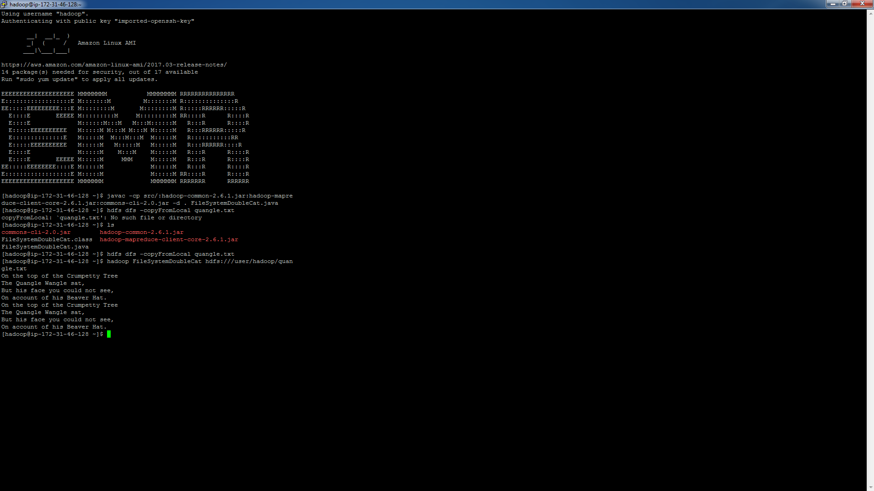

1. Example 3-4 on AWS

Command for compiling Java file:

javac -cp src/:hadoop-common-2.6.1.jar:hadoop-mapreduce-client-core-2.6.1.jar:commons-cli-2.0.jar -d . FileCopyWithProgress.java

Command for running Java in Hadoop:

hadoop FileCopyWithProgress /home/hadoop/1400-8.txt hdfs:///user/hadoop/1400-8.txt

Screenshot of final result in EMR:

