Lab 4.6.1 & 4.6.2

Lei Deng, STAT 6620, ti7597

May 18, 2017

## Lab 4.6.1

library(ISLR)  
# The Stock Market Data  
  
names(Smarket)

## [1] "Year" "Lag1" "Lag2" "Lag3" "Lag4" "Lag5"   
## [7] "Volume" "Today" "Direction"

dim(Smarket)

## [1] 1250 9

summary(Smarket)

## Year Lag1 Lag2   
## Min. :2001 Min. :-4.922000 Min. :-4.922000   
## 1st Qu.:2002 1st Qu.:-0.639500 1st Qu.:-0.639500   
## Median :2003 Median : 0.039000 Median : 0.039000   
## Mean :2003 Mean : 0.003834 Mean : 0.003919   
## 3rd Qu.:2004 3rd Qu.: 0.596750 3rd Qu.: 0.596750   
## Max. :2005 Max. : 5.733000 Max. : 5.733000   
## Lag3 Lag4 Lag5   
## Min. :-4.922000 Min. :-4.922000 Min. :-4.92200   
## 1st Qu.:-0.640000 1st Qu.:-0.640000 1st Qu.:-0.64000   
## Median : 0.038500 Median : 0.038500 Median : 0.03850   
## Mean : 0.001716 Mean : 0.001636 Mean : 0.00561   
## 3rd Qu.: 0.596750 3rd Qu.: 0.596750 3rd Qu.: 0.59700   
## Max. : 5.733000 Max. : 5.733000 Max. : 5.73300   
## Volume Today Direction   
## Min. :0.3561 Min. :-4.922000 Down:602   
## 1st Qu.:1.2574 1st Qu.:-0.639500 Up :648   
## Median :1.4229 Median : 0.038500   
## Mean :1.4783 Mean : 0.003138   
## 3rd Qu.:1.6417 3rd Qu.: 0.596750   
## Max. :3.1525 Max. : 5.733000

pairs(Smarket)

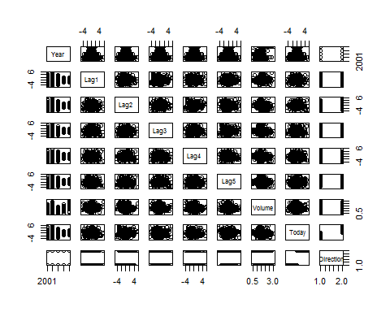

cor(Smarket[, -9])

## Year Lag1 Lag2 Lag3 Lag4  
## Year 1.00000000 0.029699649 0.030596422 0.033194581 0.035688718  
## Lag1 0.02969965 1.000000000 -0.026294328 -0.010803402 -0.002985911  
## Lag2 0.03059642 -0.026294328 1.000000000 -0.025896670 -0.010853533  
## Lag3 0.03319458 -0.010803402 -0.025896670 1.000000000 -0.024051036  
## Lag4 0.03568872 -0.002985911 -0.010853533 -0.024051036 1.000000000  
## Lag5 0.02978799 -0.005674606 -0.003557949 -0.018808338 -0.027083641  
## Volume 0.53900647 0.040909908 -0.043383215 -0.041823686 -0.048414246  
## Today 0.03009523 -0.026155045 -0.010250033 -0.002447647 -0.006899527  
## Lag5 Volume Today  
## Year 0.029787995 0.53900647 0.030095229  
## Lag1 -0.005674606 0.04090991 -0.026155045  
## Lag2 -0.003557949 -0.04338321 -0.010250033  
## Lag3 -0.018808338 -0.04182369 -0.002447647  
## Lag4 -0.027083641 -0.04841425 -0.006899527  
## Lag5 1.000000000 -0.02200231 -0.034860083  
## Volume -0.022002315 1.00000000 0.014591823  
## Today -0.034860083 0.01459182 1.000000000

attach(Smarket)  
plot(Volume)

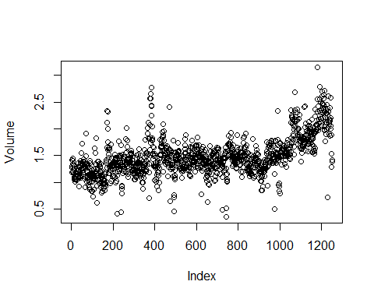

## ## Lab 4.6.2

# Logistic Regression  
  
glm.fits = glm(Direction ~ Lag1 + Lag2 + Lag3 + Lag4 + Lag5 + Volume,  
 data = Smarket,  
 family = binomial)  
summary(glm.fits)

##   
## Call:  
## glm(formula = Direction ~ Lag1 + Lag2 + Lag3 + Lag4 + Lag5 +   
## Volume, family = binomial, data = Smarket)  
##   
## Deviance Residuals:   
## Min 1Q Median 3Q Max   
## -1.446 -1.203 1.065 1.145 1.326   
##   
## Coefficients:  
## Estimate Std. Error z value Pr(>|z|)  
## (Intercept) -0.126000 0.240736 -0.523 0.601  
## Lag1 -0.073074 0.050167 -1.457 0.145  
## Lag2 -0.042301 0.050086 -0.845 0.398  
## Lag3 0.011085 0.049939 0.222 0.824  
## Lag4 0.009359 0.049974 0.187 0.851  
## Lag5 0.010313 0.049511 0.208 0.835  
## Volume 0.135441 0.158360 0.855 0.392  
##   
## (Dispersion parameter for binomial family taken to be 1)  
##   
## Null deviance: 1731.2 on 1249 degrees of freedom  
## Residual deviance: 1727.6 on 1243 degrees of freedom  
## AIC: 1741.6  
##   
## Number of Fisher Scoring iterations: 3

coef(glm.fits)

## (Intercept) Lag1 Lag2 Lag3 Lag4   
## -0.126000257 -0.073073746 -0.042301344 0.011085108 0.009358938   
## Lag5 Volume   
## 0.010313068 0.135440659

summary(glm.fits)$coef

## Estimate Std. Error z value Pr(>|z|)  
## (Intercept) -0.126000257 0.24073574 -0.5233966 0.6006983  
## Lag1 -0.073073746 0.05016739 -1.4565986 0.1452272  
## Lag2 -0.042301344 0.05008605 -0.8445733 0.3983491  
## Lag3 0.011085108 0.04993854 0.2219750 0.8243333  
## Lag4 0.009358938 0.04997413 0.1872757 0.8514445  
## Lag5 0.010313068 0.04951146 0.2082966 0.8349974  
## Volume 0.135440659 0.15835970 0.8552723 0.3924004

summary(glm.fits)$coef[, 4]

## (Intercept) Lag1 Lag2 Lag3 Lag4 Lag5   
## 0.6006983 0.1452272 0.3983491 0.8243333 0.8514445 0.8349974   
## Volume   
## 0.3924004

glm.probs = predict(glm.fits, type = "response")  
glm.probs[1:10]

## 1 2 3 4 5 6 7   
## 0.5070841 0.4814679 0.4811388 0.5152224 0.5107812 0.5069565 0.4926509   
## 8 9 10   
## 0.5092292 0.5176135 0.4888378

contrasts(Direction)

## Up  
## Down 0  
## Up 1

glm.pred = rep("Down", 1250)  
glm.pred[glm.probs > .5] = "Up"  
table(glm.pred, Direction)

## Direction  
## glm.pred Down Up  
## Down 145 141  
## Up 457 507

(507 + 145) / 1250

## [1] 0.5216

mean(glm.pred == Direction)

## [1] 0.5216

train = (Year < 2005)  
Smarket.2005 = Smarket[!train, ]  
dim(Smarket.2005)

## [1] 252 9

Direction.2005 = Direction[!train]  
glm.fits = glm(  
 Direction ~ Lag1 + Lag2 + Lag3 + Lag4 + Lag5 + Volume,  
 data = Smarket,  
 family = binomial,  
 subset = train  
)  
glm.probs = predict(glm.fits, Smarket.2005, type = "response")  
glm.pred = rep("Down", 252)  
glm.pred[glm.probs > .5] = "Up"  
table(glm.pred, Direction.2005)

## Direction.2005  
## glm.pred Down Up  
## Down 77 97  
## Up 34 44

mean(glm.pred == Direction.2005)

## [1] 0.4801587

mean(glm.pred != Direction.2005)

## [1] 0.5198413

glm.fits = glm(  
 Direction ~ Lag1 + Lag2,  
 data = Smarket,  
 family = binomial,  
 subset = train  
)  
glm.probs = predict(glm.fits, Smarket.2005, type = "response")  
glm.pred = rep("Down", 252)  
glm.pred[glm.probs > .5] = "Up"  
table(glm.pred, Direction.2005)

## Direction.2005  
## glm.pred Down Up  
## Down 35 35  
## Up 76 106

mean(glm.pred == Direction.2005)

## [1] 0.5595238

106 / (106 + 76)

## [1] 0.5824176

predict(glm.fits,  
 newdata = data.frame(Lag1 = c(1.2, 1.5), Lag2 = c(1.1, -0.8)),  
 type = "response")

## 1 2   
## 0.4791462 0.4960939