groceries analysis

Lei Deng, STAT 6620, ti7597

May 25, 2017

## Step 1 - Colleting data

Read the data to the R

# load the necessary library  
library(arules)

## Loading required package: Matrix

##   
## Attaching package: 'arules'

## The following objects are masked from 'package:base':  
##   
## abbreviate, write

groceries <- read.transactions("groceries.csv",sep = ",")

## Step 2 - Exploring and preparing the data

summary(groceries)

## transactions as itemMatrix in sparse format with  
## 9835 rows (elements/itemsets/transactions) and  
## 169 columns (items) and a density of 0.02609146   
##   
## most frequent items:  
## whole milk other vegetables rolls/buns soda   
## 2513 1903 1809 1715   
## yogurt (Other)   
## 1372 34055   
##   
## element (itemset/transaction) length distribution:  
## sizes  
## 1 2 3 4 5 6 7 8 9 10 11 12 13 14 15   
## 2159 1643 1299 1005 855 645 545 438 350 246 182 117 78 77 55   
## 16 17 18 19 20 21 22 23 24 26 27 28 29 32   
## 46 29 14 14 9 11 4 6 1 1 1 1 3 1   
##   
## Min. 1st Qu. Median Mean 3rd Qu. Max.   
## 1.000 2.000 3.000 4.409 6.000 32.000   
##   
## includes extended item information - examples:  
## labels  
## 1 abrasive cleaner  
## 2 artif. sweetener  
## 3 baby cosmetics

# look at the first five transactions  
inspect(groceries[1:5])

## items   
## [1] {citrus fruit,   
## margarine,   
## ready soups,   
## semi-finished bread}   
## [2] {coffee,   
## tropical fruit,   
## yogurt}   
## [3] {whole milk}   
## [4] {cream cheese,   
## meat spreads,   
## pip fruit,   
## yogurt}   
## [5] {condensed milk,   
## long life bakery product,  
## other vegetables,   
## whole milk}

# examine the frequency of items  
itemFrequency(groceries[, 1:3])

## abrasive cleaner artif. sweetener baby cosmetics   
## 0.0035587189 0.0032536858 0.0006100661

# plot the frequency of items  
itemFrequencyPlot(groceries, support = 0.1)

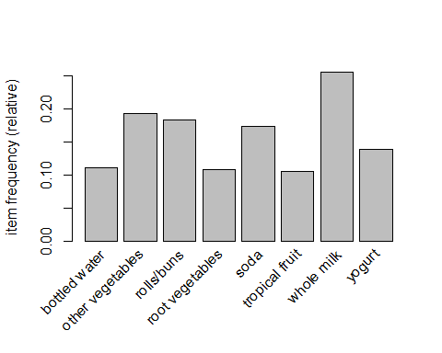

itemFrequencyPlot(groceries, topN = 20)

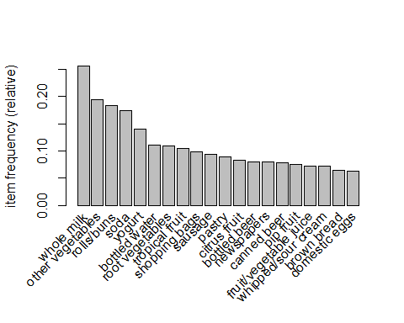

# a visualization of the sparse matrix for the first five transactions  
image(groceries[1:5])

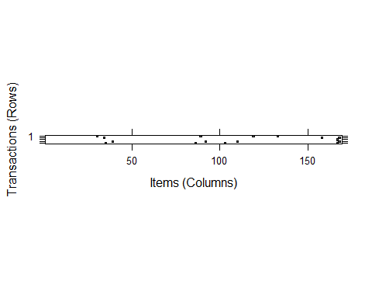

# visualization of a random sample of 100 transactions  
image(sample(groceries, 100))

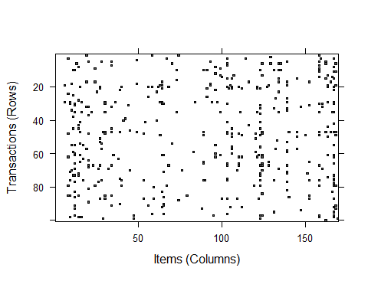

## Step3 - Training a model on the data

# default settings result in zero rules learned  
apriori(groceries)

## Apriori  
##   
## Parameter specification:  
## confidence minval smax arem aval originalSupport maxtime support minlen  
## 0.8 0.1 1 none FALSE TRUE 5 0.1 1  
## maxlen target ext  
## 10 rules FALSE  
##   
## Algorithmic control:  
## filter tree heap memopt load sort verbose  
## 0.1 TRUE TRUE FALSE TRUE 2 TRUE  
##   
## Absolute minimum support count: 983   
##   
## set item appearances ...[0 item(s)] done [0.00s].  
## set transactions ...[169 item(s), 9835 transaction(s)] done [0.00s].  
## sorting and recoding items ... [8 item(s)] done [0.00s].  
## creating transaction tree ... done [0.00s].  
## checking subsets of size 1 2 done [0.00s].  
## writing ... [0 rule(s)] done [0.00s].  
## creating S4 object ... done [0.00s].

## set of 0 rules

# set better support and confidence levels to learn more rules  
groceryrules <- apriori(groceries, parameter = list(support =  
 0.006, confidence = 0.25, minlen = 2))

## Apriori  
##   
## Parameter specification:  
## confidence minval smax arem aval originalSupport maxtime support minlen  
## 0.25 0.1 1 none FALSE TRUE 5 0.006 2  
## maxlen target ext  
## 10 rules FALSE  
##   
## Algorithmic control:  
## filter tree heap memopt load sort verbose  
## 0.1 TRUE TRUE FALSE TRUE 2 TRUE  
##   
## Absolute minimum support count: 59   
##   
## set item appearances ...[0 item(s)] done [0.00s].  
## set transactions ...[169 item(s), 9835 transaction(s)] done [0.00s].  
## sorting and recoding items ... [109 item(s)] done [0.00s].  
## creating transaction tree ... done [0.00s].  
## checking subsets of size 1 2 3 4 done [0.00s].  
## writing ... [463 rule(s)] done [0.00s].  
## creating S4 object ... done [0.00s].

groceryrules

## set of 463 rules

## step4 - Evaluating model performance

# summary of grocery association rules  
summary(groceryrules)

## set of 463 rules  
##   
## rule length distribution (lhs + rhs):sizes  
## 2 3 4   
## 150 297 16   
##   
## Min. 1st Qu. Median Mean 3rd Qu. Max.   
## 2.000 2.000 3.000 2.711 3.000 4.000   
##   
## summary of quality measures:  
## support confidence lift   
## Min. :0.006101 Min. :0.2500 Min. :0.9932   
## 1st Qu.:0.007117 1st Qu.:0.2971 1st Qu.:1.6229   
## Median :0.008744 Median :0.3554 Median :1.9332   
## Mean :0.011539 Mean :0.3786 Mean :2.0351   
## 3rd Qu.:0.012303 3rd Qu.:0.4495 3rd Qu.:2.3565   
## Max. :0.074835 Max. :0.6600 Max. :3.9565   
##   
## mining info:  
## data ntransactions support confidence  
## groceries 9835 0.006 0.25

# look at the first three rules  
inspect(groceryrules[1:3])

## lhs rhs support confidence lift   
## [1] {potted plants} => {whole milk} 0.006914082 0.4000000 1.565460  
## [2] {pasta} => {whole milk} 0.006100661 0.4054054 1.586614  
## [3] {herbs} => {root vegetables} 0.007015760 0.4312500 3.956477

## step5 - Improving model performance

# sorting grocery rules by lift  
inspect(sort(groceryrules, by = "lift")[1:5])

## lhs rhs support confidence lift  
## [1] {herbs} => {root vegetables} 0.007015760 0.4312500 3.956477  
## [2] {berries} => {whipped/sour cream} 0.009049314 0.2721713 3.796886  
## [3] {other vegetables,   
## tropical fruit,   
## whole milk} => {root vegetables} 0.007015760 0.4107143 3.768074  
## [4] {beef,   
## other vegetables} => {root vegetables} 0.007930859 0.4020619 3.688692  
## [5] {other vegetables,   
## tropical fruit} => {pip fruit} 0.009456024 0.2634561 3.482649

# finding subsets of rules containing any berry items  
berryrules <- subset(groceryrules, items %in% "berries")  
inspect(berryrules)

## lhs rhs support confidence lift   
## [1] {berries} => {whipped/sour cream} 0.009049314 0.2721713 3.796886  
## [2] {berries} => {yogurt} 0.010574479 0.3180428 2.279848  
## [3] {berries} => {other vegetables} 0.010269446 0.3088685 1.596280  
## [4] {berries} => {whole milk} 0.011794611 0.3547401 1.388328

# writing the rules to a CSV file  
write(groceryrules, file = "groceryrules.csv",  
 sep = ",", quote = TRUE, row.names = FALSE)  
  
# converting the rule set to a data frame  
groceryrules_df <- as(groceryrules, "data.frame")  
str(groceryrules_df)

## 'data.frame': 463 obs. of 4 variables:  
## $ rules : Factor w/ 463 levels "{baking powder} => {other vegetables}",..: 340 302 207 206 208 341 402 21 139 140 ...  
## $ support : num 0.00691 0.0061 0.00702 0.00773 0.00773 ...  
## $ confidence: num 0.4 0.405 0.431 0.475 0.475 ...  
## $ lift : num 1.57 1.59 3.96 2.45 1.86 ...