**Reviewers' comments:**

**Reviewer #1:**

|  |
| --- |
| Dear reviewer #1,  Thank you for your many helpful comments. We have tried to respond to each one with the attention that it deserves. We are very grateful for your time in creating such a constructive review of this paper, and we hope that the new draft will be to your satisfaction.  We have submitted a document with the tracked changes.  Sincerely,  Adam and Marta |

Summary:  
The manuscript analyzes how the decrease in the PV price and other characteristics of solar resources affect the optimal share of electricity demand supplied by solar in different energy systems. The authors studied four isolated regions and a multi-country, networked, sector-coupled model of the European energy system. They found that assumptions of system properties such as transmission or sector coupling can greatly affect the optimal solar penetration at the country level.  
  
The following comments/suggestions are divided into “highly recommended/required” and “optional.” I would appreciate if you could reply to the “highly recommended/required” comments. Moreover, I hope the “optional” comments add value to the manuscript.  
  
Highly recommended/required:

Abstract:

1. Page 1, Line 19 (left column): “isolated regions, with only wind and solar generation allowed” did you use storage as well?

Yes, we used battery storage. Thank you, this is now explicit in the abstract.

Methods:  
2. Page 2, Line 51 (left column): I think 2011 is too old. The same data set has 2019 data; why did you use 2011? You can also check the following link for the 2021 data for California (<http://www.caiso.com/informed/Pages/ManagingOversupply.aspx>)

Thank you for pointing this out. While we said that we used renewables.ninja for the solar and wind capacity factor, we actually used model.energy. We regret this error and have corrected this in the paper. On the other hand, model.energy only has 2011 and 2012 years, which is why we used 2011.

3. Page 2, Line 55 (left column): reference [20] has the CF for Solar in Europe. It has 5 data sets 1-axis tracking, 2-axis tracking, Delta, Optimal, and rooftop. Which one did you use?

Thanks for pointing out this discrepancy. We used the optimal tilt. This is now made clear in the text.

4. How did you get the CF for solar and wind for CA and CO? Did you select a specific location in each state and get the data for this location, or you got an average CF across the state

We assume a capacity factor distribution of CF^2 with model.energy, so a place with a 0.2 capacity factor will have four times more than a place with 0.1 average capacity factor (0.04 vs 0.01).

5. Figure 1: Can you add the data source in the figure caption, please?

Yes, these are now added.

6. Figure 1: I was expecting a seasonality in the solar CF in California and Colorado, as mentioned in figure 1 in the publication in point 3. Can you recheck this figure?

As the figure was previously shown, no seasonality appeared to be shown. However, with the modified figure, we hope that the seasonality is clearer.

7. Page 2, Line 55 (right column): “we assume that all heating demand ….”. Do you have any reason/reference for this selection?

When all heating demand is assumed electrified, this provides the most stress on the energy system—ie, it is the extreme, “worst case” scenario, showing a case where we need even more energy than one would think we would need. We are not trying to predict the future, however.

8. Page 3, Line 2 (left column): for the 17˚C, do you have any reason/reference for this selection?

Yes, this threshold has been used previously in one of our previous papers (Victoria et al. “Early Decarbonization…Pays Off” (2020)). We have found 17˚C matches best (ie, for Denmark) based on our internal calculations. In addition, it is common to use 17˚C as a threshold.

See section 3.2 “Heating Sector” in the supplementary info of this paper https://static-content.springer.com/esm/art%3A10.1038%2Fs41467-020-20015-4/MediaObjects/41467_2020_20015_MOESM1_ESM.pdf

9. Page 3, Line 16 (left column): “To estimate the total heating demand, we assume that the percentage of household heating demand of the total is the same as that of the electricity demand.” Do you have any justification/reference for this assumption?

We did not have complete data for the heating demand, so we had to make an estimation. Unfortunately, there is no reference for this assumption.

10. Page 3, Line 32 (right column): “Nevertheless, we plot values up to 0.01 C/Wp as an academic exercise to better understand what would happen in a universe with extremely cheap solar.” Should it be down to instead of up to?

Yes, it should be “down to” here, thanks for the correction. This has been fixed in the text.

11. Figure 4: it is nice to relate between the source of energy and the color used in the figure, but I am not able to distinguish between solar elect + heat and solar elec, especially for Spain also the same for Wind elec + heat and Wind elec.

Thanks, we acknowledge that the Figure used to be quite confusing—this was because one data set was plotted on top of the other, which meant that only one additional color can be seen where it overlaps. We hope that the new Figure better labels the colors.

12. Figure 4: Can you add to the figure legend what is the orange line and the light Orange line

Yes, this is now added

Results:  
13. Figure 5: Is the red number for each case the average for all the countries?

The red number is the percent of the energy in the entire system, including all of the countries provided by solar.

14. Page 4, Line 59 (right column): last line, you may need to add the figure number.

Thank you for this catch. This was in reference to a Figure from a previous draft of the paper, which has since been removed. The sentence has been modified.

15. Figure 6: you can use a smaller yellow dot size than the red one to show both.

Thanks for this great idea. It has been applied.

16. The x-axis is too small and full of X-tick marks; you may use a double column if possible.

We have implemented a “double column” to assist with readability.

Reference  
17. Reference [10]: talks about wind, not solar; it is mentioned in the text to refer to solar.

We believe reference 10 now refers to solar, thanks for the catch.

18. References [27] and [28] are the same thing; moreover, ref. [28] should be related to Europe’s goals of getting to neutral by 2050. You may find this interesting link <https://climate.ec.europa.eu/eu-action/climate-strategies-targets/2050-long-term-strategy_en>

Thank you for pointing out this typo. The wrong link was included for ref. 28. We have also included your link, thanks for the suggestion.

Optional:  
Introduction:  
1. Line 54: you may find the following links interesting as well:  
<https://electrek.co/2022/05/02/california-runs-on-100-clean-energy-for-the-first-time-with-solar-dominating/>  
<https://www.solarpowerworldonline.com/2022/04/california-grid-set-record-with-97-percent-renewable-power-april-3/>

Day April 30 in this link  <https://www.caiso.com/TodaysOutlook/Pages/supply.html>  
<http://www.caiso.com/Documents/MonthlyRenewablesPerformanceReport-Apr2022.html>  
<http://www.caiso.com/Documents/MonthlyRenewablesPerformanceReport-May2022.html>

Thank you very much for all of these links. They are very interesting, especially as a Californian (--Adam)

2. Line 39 (second column): “we do not include any fuel-based generators because we model scenarios with zero CO2 emissions”. You may find it interesting to see a zero CO2 emission technology powered by natural gas <https://netpower.com>

Very interesting! Thank you for the link.

3. Line 54 (second column): you may refer to the same studies in point number 2 or similar studies.

Thanks,.

Methods:  
4. Line 31: it will be better for readers unfamiliar with the copper-plate model to see a sentence or two about how does this work?

Thanks for the suggestion. We have incorporated a sentence on how it works.

5. Line 54: it is more accurate to say “onshore wind” instead of “wind.”

Thanks, we have included this.

Results  
6. Line 58: “While analyzing latitude should be similar to analyzing the solar CF, it is still worthwhile to do this separate analysis.”. I am sorry; I didn’t get what you meant in this sentence. Can you rewrite it to be clear?

Thanks. It now reads as “While latitude should be correlated with solar CF, it is not perfectly so.”

7. Figure 5: you may find it interesting if you generate a similar figure for the curtailed electricity.

We regretfully ran out of time on this revision before finishing the review, but we hope to get around to this in a possible next round.

8. Figure 7: you may find it interesting if you color these dots by the average latitude for each country

Thank you for this interesting idea. We regretfully ran out of time on this revision before finishing the review, but we hope to get around to this in a possible next round.

9. Figure 8: you may find it interesting if you color these dots by the average latitude for each country

Thank you for this interesting idea. We regretfully ran out of time on this revision before finishing the review, but we hope to get around to this in a possible next round.

Discussion  
10. Usually, it is better to start the discussion with a more substantial sentence than this one. Please keep the first sentence attractive to the reader as a motivation to continue reading the section. In the first sentence, you can focus on your best results.

Thank you for this constructive advice. We have modified the beginning of the discussion to start with our best results.

**Reviewer #2:**

|  |
| --- |
| Dear reviewer #2,  Thank you for your many helpful comments. We have tried to respond to each one with the attention that it deserves. We are very grateful for your time in creating such a constructive review of this paper, and we hope that the new draft will be to your satisfaction.  Sincerely,  Adam and Marta |

Comments to the Author  
The authors propose the work entitled: "What is the Optimal Electricity Share for Very Inexpensive Solar PV Energy?". The work is compelling and valuable to the community to understand how the cost of solar will change the electricity mix as many countries transition to zero-carbon grids. However, to justify the publication of this manuscript, the authors must expand the literature review as the research question has been explored or addressed in other regions of the world. Therefore, the authors should include this expanded literature and further explain the knowledge gap this work can fill. This version of the manuscript needs major revision for publishing in JPV. These revisions are listed below:

Thank you for your nice comments on our paper, and thank you for your suggestion of expanding the literature review. We hope that the added literature is sufficient (see the end of the Introduction section).

Concerns:  
  
1. As mentioned by the author, the topic is complex and has many variables interacting. The study might benefit or see different results if it analyzed a single country and modeled the capacity additions instead of analyzing a multi-country spatial resolution.

Thank you for this suggestion. We believe that the “no transmission” portions of our Figures 6, 7, and 8 serves as this single country analysis. We regret not having the space to do more in depth analysis on single countries.

2. It needs to be clarified what period was analyzed using the PyPSA. It is mentioned that it is a yearly resolution, but there is no mention of what year it is.

The year of analysis for the simple model using PyPSA is stated to be 2015 for Denmark and Spain, and 2011 for California and Colorado. We did not previously make clear the year for PyPSA-Eur-Sec, which is what we are assuming you are asking about. This is now made explicit in the text (2013)

3. The authors must include or mention which input assumptions and constraints are relevant to the results shown in the manuscript.

Thank you for this comment. We believe that we have sufficiently outlined the assumptions and constraints of the simple model, and outlining the many input assumptions of the pypsa-eur-sec model is well documented in other papers (we believe it is beyond the scope of this one). We would greatly appreciate input on specific further missing input assumptions and constraints.

4. The author should include behind-the-meter (BTM) installations or mention why they were not included in the model. BTM systems impact electrical demand, and the number of installations has been growing worldwide. The omission of this kind of system could represent a bias in the results.

Thank you for this point. In the case of the simple model, we are only modelling a very basic system. In PyPSA-Eur-Sec, BTM installations are included, as utility solar PV and household solar PV are separated.

5. Since the author lists California and Colorado as study locations, a national source for the cost of the technologies should be included since the source reference is only applicable to Europe. The author can look at NREL-ATB for this information and contrast it with its reference.

We agree, the NREL-ATB is the default reference for costs in the USA. We cite the NREL ATB for our price assumption for today’s cost of solar in the USA as our reference 38.

6. The author should justify why the coefficient of performance for the heat pump was set to 3.

The coefficient of performance for heat pumps can be between 3-4. We assume the worst case scenario because heat pumps will be most in use in colder places, where coefficient of performances are lower—it is these places that will cause most strain on the system.

7. The units of figure 1 need to be clarified. Please include units on the y-axis.

Thank you for this comment. Before, it was confusing about what Figure 1 showed. Now, it should be more clear. Since the values of capacity factor and demand are normalized to 1 for the respective averages, there are no units.

8. Capacity factors for Solar PV and Wind for both Colorado and California locations are low compared to other references. See <https://windexchange.energy.gov/maps-data/17>. Also, the author should list if these are AC or DC capacity factors.

Thank you for this note. We would first like to apologize for an error—we cited renewables.ninja for the capacity factors, but we were actually using model.energy.

The annual capacity factor for wind might be less than expected because through model.energy, we assume a capacity factor distribution of CF^2 with model.energy, so a place with a 0.2 capacity factor will have four times more than a place with 0.1 average capacity factor (0.04 vs 0.01). This yields the found wind capacity factor of 0.18. However, if we assume a capacity factor distribution of CF^3, then this yields a new wind capacity factor of 0.27. Solar is not affected by this assumption.

In real life, the wind and solar farms are in generally in the places with the most wind and solar, respectively. This leads to higher capacity factors, as you point out. However, assuming massive deployment of solar and wind, many generators may need to be installed in places at less-than-ideal capacity factors. Therefore, when using capacity factor time series that represent California or Colorado in 2050, we feel comfortable using these numbers.

It is now listed that the capacity factors are DC

9. While the methodology seems solid overall, the author should further explain the role of energy storage and hydrogen to increase the share of solar further. As mentioned by the author, the model only assumes battery and hydrogen to balance the grid. However, these assets need to be further mentioned in the manuscript on how they help meet the demand or reduce renewable curtailment.

Thank you, we have modified a sentence to the following in the results section: “We see that solar curtailment increases significantly as the price of solar decreases, approaching near-100\% of produced energy curtailed, illustrating that the system is opting to install more solar PV rather than a more expensive battery, which could reduce curtailment.”

10. The authors should contrast the heating demand value obtained with other references.

Thank you for the suggestion. Can you please specify which heating demand value?

11. For the networked sector-coupled model, the author should list the limitations of using the 3-hourly temporal resolution since this can affect the share of renewable generation and energy storage. How does it contrast if an hourly resolution model is used instead?

We agree, using 3-hour temporal resolution has limitations compared to hourly. Solar PV and other variable renewable energy sources will benefit most because of the smoothing, At the same time, 3-hour time resolution is shown to capture most of the variation that determines the solar share.

12. Figure 4 needs to clearly show the difference between Wind/electric and Solar /Electric. The figure shows a third greenish color that is not listed in the figure labels.

Thank you for this point. Figure 4 now clearly shows the difference between the three colors.

13. There is a missing Figure reference on line 59.

Thank you for this catch. This was in reference to a Figure from a previous draft of the paper, which has since been removed. The sentence has been modified.

14. The references should be checked, and the referring style of this journal should be met.

We have checked the references, and we hope that the referring style is met.

15.The conclusion must be rewritten to include the main metrics and findings obtained. For example, the authors should include the correlation coefficients or the share of solar at the expected price point.

Thank you for these suggestions. We have included the correlation coefficients. We do believe that the main findings of this paper are not necessarily the raw values at a given price point (ie, we are not claiming to predict the future), but the behavior of the systems given our assumptions.

**Reviewer #3:**

|  |
| --- |
| Dear reviewer #3,  Thank you for your many helpful comments. We have tried to respond to each one with the attention that it deserves. We are very grateful for your time in creating such a constructive review of this paper, and we hope that the new draft will be to your satisfaction.  Sincerely,  Adam and Marta |

Review of Dvorak & Victoria “What is the Optimal Electricity Share for Very Inexpensive Solar PV Energy?” The paper analyzes the fraction of solar and wind that could be used to meet the electricity demand in selected locations including two studies (one that compares four locations using a single-node model and a second that studies Europe including sector-coupling and transmission). The first study’s results show that the Denmark would use mostly wind and California would use mostly solar regardless of the cost of solar while Spain and Colorado might switch from wind to solar if the price of solar drops low enough. The second study explores the effects of latitude, solar quality, wind quality, transmission and sector coupling on the fraction of solar vs wind finding that sector coupling increases use of solar while transmission increases use of wind while no single variable determined the amount of solar. The overall conclusions are not surprising but provide some insights that some readers may find interesting and useful. However, I was disappointed– this group has published some excellent papers in the past, but this paper I found to be confusing, and I question the accuracy of the data. It needs to be revised before publication.

We hope that the revisions have improved the quality of the paper, made less confusing, and verified accuracy of the data

**1. Concerns about data:**

Fig. 1 shows a seasonal variation in solar capacity factor for Denmark, but very little seasonal variation for other locations. This is puzzling because all four locations have longer days during the summer than during the winter. For example, here are EIA data for solar in California showing strong seasonality:

Similarly, the loads are expected to have seasonal variations. Again, here are data for California showing seasonal variation much greater than shown in Fig. 1:

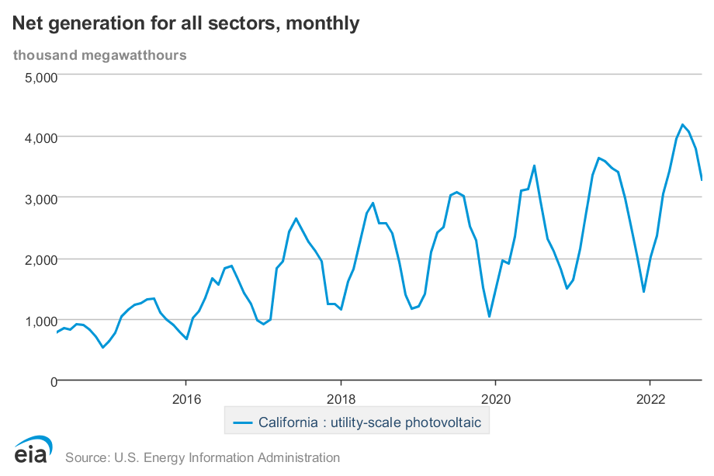

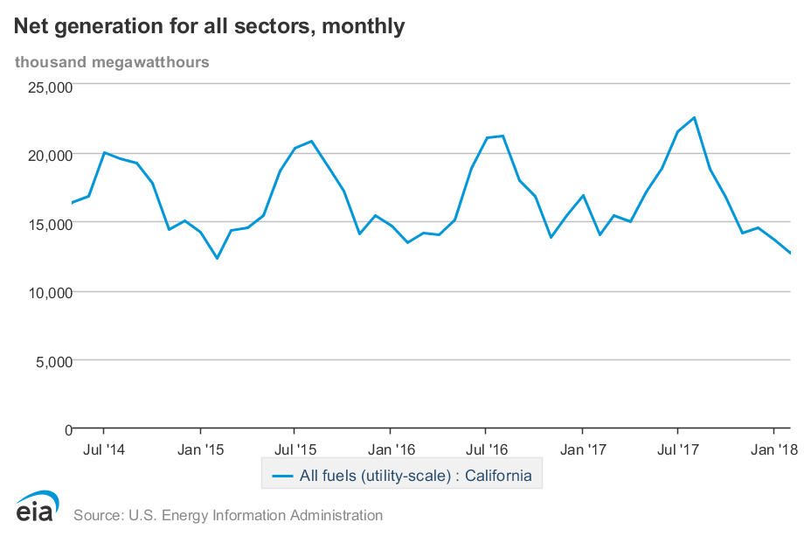

I spent a little time trying to understand how Fig. 1 could suggest data so different from what I would expect – I even went to the sites specified in references 20 and 22, but I found that the data I accessed at those references showed strong seasonality, in contradiction to Fig. 1. Given the dependence of the solar capacity factors on mounting (e.g. tilt and tracking or fixed), it is important that the paper describe what was assumed and it is important that the data be relevant to reality. For example, the annual capacity factor for wind quoted for California is substantially less than what is observed. Is this intentional or accidental?

One could argue that it is better to average the capacity factor that would be observed if the entire state or country were filled with wind turbines or solar plants, but it is more likely that generators would be built in the best sites rather than uniformly. Using the observed values would, therefore, be more realistic in my opinion than using average simulated data, especially when the simulated data differ so much from observed data.

Thank you for your efforts verifying our data. While conducting our own extensive verification on your points, we found that we made a major error in referencing—instead of using renewables.ninja, we used the site model.energy for the capacity factors of wind and solar of California and Colorado. In addition, the solar and wind lines in Figure 1 (though not the average CF values) between California and Colorado were switched. These were careless errors and we are very grateful for your detailed review.

We believe that Figure 1 as previously presented was doing an inadequate job of showing the real seasonal trends for every country. Thanks to your comments, it is now presented in a way which we hope is truer to the seasonality.

The annual capacity factor for wind might be less than expected because through model.energy, we assume a capacity factor distribution of CF^2 with model.energy, so a place with a 0.2 capacity factor will have four times more than a place with 0.1 average capacity factor (0.04 vs 0.01). This yields the found wind capacity factor of 0.18. However, if we assume a capacity factor distribution of CF^3, then this yields a new wind capacity factor of 0.27. Solar is not affected by this assumption.

As you note, this difference is likely because present-day windmills are built in the optimal regions. However, as more windmills are installed, more of them will have to be installed in less optimal locations. This is even more applicable when considering conditions for social acceptance. We do not actually know what the future distribution will be, or how many windmills will be installed in non-ideal locations.

In any case, the exact value of the capacity factor of California is not of the utmost importance. We are not claiming to predict the future, nor can we (or anybody). It does not detract from our goal of showing patterns within the data given a certain set of assumptions.

We have added a few sentences in the methodology with assumptions of solar and wind in mind, which read as follows: “The solar CFs for DNK and ESP are obtained assuming the optimal fixed tilt angle for the respective regions, while the solar CFs for CO and CA are obtained assuming a 35\degree tilt. Distribution of solar and wind plants are proportional to CF$^2$, such that a location with a solar CF of 0.2 will receive four times as many solar plants as a location with a CF of 0.1.”

If the input data to the calculations are inaccurate, then all of the results are questionable. Thus, this concern about the data needs to be straightened out before the paper can be published. If the data used in the calculations were incorrect, then I expect that the calculations need to be repeated and the paper revised accordingly.

We do not believe that the input data is inaccurate, and we hope that this discussion and the major revisions to Figure 1 are sufficient to assuage your concerns.

**2. Bias in price data:**

The representation of literature price data appear to be biased. For example, “The price of utility scale solar PV in 2020 can be estimated to be 0.529 C/Wp [30], but can also reach up to 1.3 C/Wp [31]. The cost of solar PV is known to vary widely by region [32].” Suggests that 0.529 Euros/Wp is an average price. I tried to understand how this was arrived at: I could not find any mention of this price in reference 30. Reference 31, which is implied by this passage to be on the high end of the price statistics is a study that assessed many data and identified something like a median (not high-end) price, so might be better taken as the “estimated price.”  
The authors note that using the module learning rate for system analysis is inappropriate, which I agree with. The authors conclude “Nevertheless, we plot values up to 0.01 C/Wp as an

academic exercise to better understand what would happen in a universe with extremely cheap solar.” While it is reasonable to plot values outside of a realistic range as an academic exercise, the analysis of the expected price should be accurate and the shaded “Today’s range” and “Future range” regions in Fig. 4 should be objective and consistent with the literature. For example, reference 32, Fig. 3.3 suggests a much wider range for today’s prices.

To me, the focus on unrealistically low prices detracts from the paper. The major conclusions are all found using realistic prices, so why spend time persuading the readers that the authors are biased? It would be a stronger paper without the bias.

Thank you for bringing our attention to this issue. It is true that 0.529 Euros/Wp is unreasonably cheap in the USA for 2020, but on the other hand, this is the going rate for utility solar in Europe, with cheaper installations available in the present day. We have modified the text to read in a less biased way. In addition, we added the missing reference for the “low” European cost, which was the Danish Energy Agency—thank you for the catch.

While it is true that a very wide range of solar prices is possible, the focus of the paper is on European and American regions, so we feel it is sufficient to only list the prices in these countries. We have modified the sentence as follows to more clearly show that a wider range for the world is more accurate.

“Though the cost of solar PV is known to vary widely by region, including costs much higher than the 2020 US price, we consider will consider the US and Europe costs as the bounds for today's range.”

We agree that the focus should be more on the more “realistic” price range and have shifted focus in the text accordingly. We have adjusted the price ranges in Figure 4 such that we now use only the historical learning rate of 23% on both the European and USA 2020 solar prices to find the “optimistic” and “less optimistic” cost levels.

**3. Title and take-away messages:**

It appears to me that the title was selected to reflect the academic exercise of using “Very Inexpensive Solar PV” for answering the important question of “In the future (2050?) what fraction of electricity generation will be from solar?” My first question is whether that’s the useful question to ask. If solar is essentially free so it’s installed at a level that 90% of the electricity is curtailed, what fraction of the land will be covered? There is some value to a purely academic study, but the study would be much more useful if the authors would explore realistic scenarios (this is underscoring my conclusion in the previous paragraph). A second question is whether the title does the paper justice – Fig. 4 shows not only the very inexpensive solar, but a cost range spanning something like a factor of 200 – it seems that the study is broader than the title would suggest. Perhaps the authors would be interested in a title like “Key Determinants of Solar Fraction in Solar- and Wind-Driven Grids”.

We agree with your discussion on this issue, and we thank you for the suggestion of the title. We have respectfully stolen it for our use.

I would also encourage the authors to think about the scope of the paper. I see many ideas mentioned as part of the consideration, but then not treated very well or being confusing. For example:  
4. The authors mention doing analysis of the effects of battery and other costs, but no data are presented.

Thank you for this comment. The original scope of the paper was much broader and included analysis of these components, but the current scope of the paper does not include them. We have removed mention of battery cost analysis and other factors not present in the paper. We apologize for the confusion.

5. I found Fig. 2/3 to be very interesting, but it appears that the heating load has very little effect on the solar-wind ratio. The authors budgeted 2 figures to explaining the calculation of the heating loads, but the effects aren’t discussed in the conclusion.

Thank you for bringing our attention to this issue. The effect of heating loads is now discussed in the conclusion. We have added a sentence that reads as follows: “We did not find the assumption of electrified heating to have either a major effect nor a consistent one on the solar share.”

6. I am puzzled why the authors focus on capacity factor as the quality factor rather than the total potential resource. For example, a small country could have a very large capacity factor reflecting strong wind or cloudless skies, but not enough land to have a large wind and solar potential. I don’t know what to make of the author’s statement “This could help explain why the simple model shows CA to be so solar dominated and CO to be more balanced–it is not that CA has better solar than CO, but worse wind.” since the capacity factor observed for wind in CA is greater than that for solar (though the potential is less because the high capacity factor is found in some sites, but not everywhere.

We agree with your point and have modified our discussion of capacity factor to focus on capacity factor as the potential resource.

7. If the overall goal of the paper is to identify the (key?) factors that might affect the solar fraction and when each contributes, it could be useful to the reader to have a table of all of the factors and then comment on the effect that each one has and how it varies depending on the situation. The authors already do this to some extent, but I found that there was lengthy discussion of some things that I thought were obvious and then no discussion of some other factors. The paper would be stronger if the scope and major takeaways were better defined and then presented consistently throughout the paper. A specific example is how the title currently suggests that only very low cost solar will be considered, but the paper actually documents the effect of variable cost. The title and abstract will help the reader understand the paper by defining the scope precisely.

We have taken your suggestion of title as well as refined the abstract to more precisely define the scope.

More detailed comments

1. Throughout, the authors talk about the “less optimistic” and “optimistic” prices. Table 1

specifies the costs that were used in the calculations, so should also include these, in my

opinion.

Can you please clarify this point? Do you wish us to include the “less optimistic” and “optimistic” prices in Table 1, or to include the costs in Table 1 somewhere else?

1. It seems strange that the efficiency of the batteries is not specified.

We have already included the efficiency of the battery inverter, but we have also added the assumed efficiency of the battery storage, which is 100%.

1. Some of the lettering in the figures is too small to be seen. Also, the colors used are

difficult to distinguish in Fig. 6.

Thank you for this comment. We hope that the lettering in all of the Figures and the colors in Figure 6 are more appropriate.

1. I don’t understand how the colors are assigned to the regions in Fig. 4 – I can see three

regions, but the legend specifies four regions and I can’t see four colors.

Thank you for the comments on the plot. The plot is made such that the lighter colors are plotted on top of the darker ones. So, the visible colors did not actually reflect what was in the legend. Now, each of the three visible colors is properly labelled.

1. I realize that it’s not possible for every detail of this sort of modeling be specified, but I

would appreciate seeing the following details added: a) definition of sector coupling (section B. of the methods section just gives a reference) and b) I’m not clear on the assumptions for the space heating. It says “To estimate the total heating demand, we assume that the percentage of household heating demand of the total is the same as that of the electricity demand.” Could you clarify this – I could better understand something like “Effectively, this assumes that all residential and commercial natural gas furnaces and hot water heaters are replaced by heat pumps.” Having this sort of useful perspective would be helpful both to supplement the cryptic “We use heating data from Victoria et al. for Denmark and Spain.” (with no reference number) and “...scale the timeseries to match the annual energy demand for space heating [26].”

Thank you for these notes. For a) we have added a definition of sector coupling, which reads: “Sector coupling includes the assumption that sectors such as future transport and heating methods will be coupled to the electricity sector, for example, in the form of battery electric vehicles and heat pumps, respectively.”

For b) we think that there is a slight misinterpretation—we were lacking information on household heating data compared to the total, even though we had household electricity demand compared to the total. So, we scaled up the total heating demand from our knowledge of the household electricity demand percentage.

We have added the reference number to Victoria et al.