Lab 4 - Design
Ensure you rename this document to your student number before uploading to git.

Task 1 - Other Products in your market

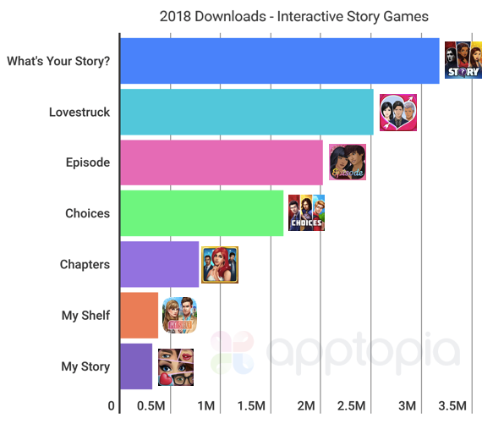
There are lots of similar products that are quite popular in the mobile app market, but not many for browser. For this reason it would be important to have the website function on a mobile browser.
The popular products on the market have teen, and romance focuses, and are marketed towards young girls from ages 10-15.

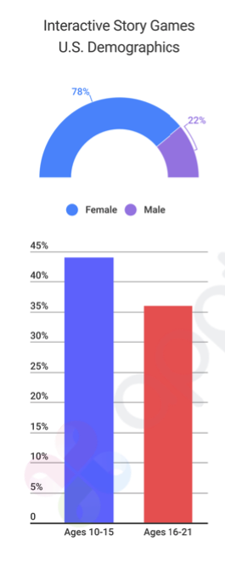
CYOCYOA is a browser based version. It has more of a focus towards young males and has more traditional adventure stories. It also has the ability to create your own interactive stories.

It also has the function to vote on stories so you can know which ones are supposed to be good. But the website itself is quite outdated.

Task 2 - Potential customer (what do they want, make them as real as possible)

The target customer is advertisers. By being a website aimed at users frequently coming back and spending long periods of time on this means ad space can be particularly valuable especially for advertisers with the same target audience as us.

Task 3 - Potential end-user (fictional biography, highlight why they would care about your product)

There are 2 different potential end-users. People who primarily play the stories, and people who primarily create the stories.

Someone who likes to play through the stories may be a 12 year old boy (whenever fortnite is down). Adventure or action stories may appeal to them, aswell as colourful or vivid images.

The other user may be a 37 year old woman who likes writing creative stories. As they have no experience actually creating or even playing video games, they are attracted to the easy to use story designing features.

Task 4 - What will attract end users (reference existing products)

The best way to attract users is with a polished design and easy to use interface.
Our product will have no truly revolutionary features but will be aimed at giving the user the best possible experience.

Task 5 - Suggest essential & nice-to-have features (make them emotional not technical)

Home Page:
About the website, Log-in/Register Forms, Most popular adventures.

Search for Adventure by Category Page

Task 6 - Use case (A story of one of your end users first experience and feelings interacting with your website)

John Bustard is a middle-aged man who is struggling to find the meaning in his life. Recently laid off from his job as a video game developer for Sony, he is yearning for the opportunity to bring his game ideas to life. Unfortunately, he is seen by many as too old for the business. He laments the fact that the game under his management, Heavenly Sword did not break even despite being seen as a gameplay success. Now forced to work a boring job as a lecturer just to make ends meet, he feels hopeless.
Until he finds Adventure71. John thinks this website is his savior. With its simple to use story designing features, John now is able to unleash his imagination upon gamers across the world despite his job eating at most of his free time. Furthermore, ever since he started using Adventure71, John’s once failing marriage has inexplicably been rekindled…

Task 7 - Minimal list of pages necessary for your team to deliver your usecases

Four Pages:
Login, Browse Games, Play Games, Create Games

Upload your basic HTML page exploring your use case (see use case example document for help).

Also upload this document to you project folder (same folder containing src & httpdocs) ensuring you have renamed to your student number.

Screenshot this in your github repository and submit this to QOL by Monday.

