Lab 4 - Design
Ensure you rename this document to your student number before uploading to git.

Task 1 - Other Products in your market

http://www.adrift.co/
Adrift is a downloadable application in which you can make interactive story games. It claims to have a reputation for being the easiest and most intuitive tool to make a game as it is GUI driven.
textadventures.co.uk/quest
Textadventures is a product similar to ours in that it allows users to create their own text based story games and play games that other users have created.

Task 2 - Potential customer (what do they want, make them as real as possible)

Large companies who publish physical or video games may want to advertise their games on our website as a means to attract people who play the games on our site, which span many different genres, to also become aware of their games and eventually to buy or play them.
Other companies who want their products to be advertised through banners at the top or side of the pages on our site may also want to place advertisements for their products their through Google Ads or through direct sponsorship if the company or developer thought that their target demographic overlapped with ours for example, a retail interactive story game or book. In the case of direct sponsorship the person/people wanting to advertise would have to contact us through e-mail or social media.
Quite commonly advertisers who advertise through banners are either advertising products targeted directly at the user, such as Amazon, or to display sensational article headlines to entice the user to click on them, which will then give that article more exposure and the owner of the site more money.

Task 3 - Potential end-user (fictional biography, highlight why they would care about your product)

Using demographic information from a similar product (textadventures) the end user is most likely from an English speaking western country such as the United States, United Kingdom. Australia or Canada.
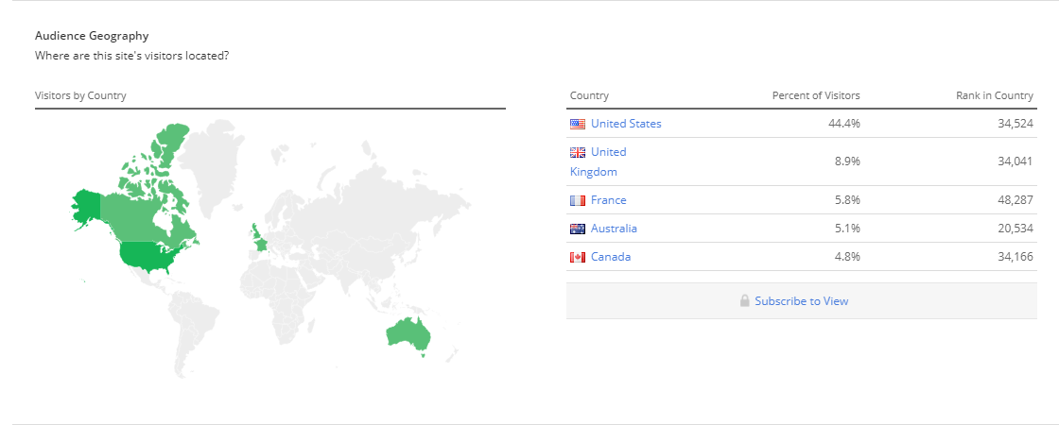

The nature of the site allows the user to create a game based in whatever genre they want, so it will probably appeal to a creative person who like to write stories and has an interest in games, but perhaps not the technical expertise or time to create an advanced graphics based game. Many of the people creating games will also be the people playing other user created games too. The main feature users seem to value, based on various posts on the forum of textadventures, is making it easy for the user to do exactly what they want, rather than having to to rely on ambiguous but more user friendly GUI features.
Users who come to the site will probably be varied too. Young users who are interested in stories and games but do not have any money to buy or the hardware to run more developed or high end games may find the user created interactive stories appealing. On the opposite end of the spectrum older people who grew up playing these sorts of games may also find the site appealing to their nostalgia of games like Zork.

Task 4 - What will attract end users (reference existing products)

Sites like Adrift require you to download their applications to create and play games, whereas ours will allow users to do both within the browser. This is a major convenience for end users of our site as it reduces the time it takes for users to actually start creating or playing games after opening our website.

Textadventures already has this ability, as well as the ability to play games on mobile devices however the actual design of the website is quite inconsistent as the buttons especially are not colour coded but do not have a consistent colour or design. Some of the games displayed on the front page show how they are rated with stars (parts of which are cut off) but most do not. Furthermore it seems that the main emphasis when displaying games on the browse section is the thumbnail of the game rather than a brief description, which only appears if the game is clicked on or the thumbnail hovered over, and the games rating. This makes choosing a bit of a guessing game for a user who wants to try some user created content. The website itself is also quite slow.
A large problem textadventures has is that it does not separate adult material for younger users in an acceptable manner. It will automatically hide games tagged as adult for users whose birthday is under 18, but many adult games are tagged as “Work in Progress” or any other genre as the creator is unable to tag them as both adult and for example fantasy. A simple solution to this would be to allow creators to flag their game as adult or not without setting it as a genre and then simply let the user set their own filters. This could also be expanded to games that include other sensitive topics such as religion and politics.

Task 5 - Suggest essential & nice-to-have features (make them emotional not technical)

Essential
- A tool to allow users to write, develop and publish their own interactive story game using a specially made mini language to ensure that the game is made and functions exactly as they want it to
- An intuitive and informative place for users to quickly find relevant games with ease and play these user created games from within their browser so that they can spend more time playing the games rather than downloading software and looking for a game that interests them
- An account system that allows users to publish their games and rate, comment or play other user made games
Nice-To-Have features
- A rating and review system where users can leave feedback and reviews of games they have played
- Filtering of games based on their genre or their themes (adult, religion, politics etc.)

Task 6 – Use case (A story of one of your end users first experience and feelings interacting with your website)

Larry is a 48 year old man. He grew up playing games like Zork and sometimes feels nostalgic for the times when developers were making real video games. He misses the engaging story and charming simplicity of old interactive adventure games which he feels is missing from the contemporarily created ones. Larry has big ideas on how to breathe life back into the genre but has no clue about how to even start making a game. He searched the internet for something to help him get started and found our website. It immediately got his attention as it looked clean and easy to navigate. He was overjoyed as he discovered not only had he found a new source of interactive games to play, games made by other passionate users and all free of charge, but that he could create his own game too. He is able to set up an account quickly and free of cost and begins reading up on how to create his own game. He finds that using the simple but versatile mini language used to create games he can not only put his ideas down easily but that he has no problem tailoring his story and game exactly to his specifications. Once he is finished he publishes, again with no financial charge, his game for the entire world to enjoy and is satisfied that he has single handedly saved the interactive gaming genre. Now he is free to enjoy other users games, which doesn’t require him to download anything or pay any money, and finds that he could easily find whatever game he wanted to play. This is a much different and more pleasing experience than he previously experienced trying to find, buy and download games on other storefronts. He is so happy with this experience that he introduces his kids who are both under 11 to the website. He sets them up an account and is happy to find he can filter adult content. His kids are entertained and Larry is now free to spend the afternoon building his model spitfire. Furthermore, he has even introduced them to the basic concepts of programming through learning the mini language to create games which has made him a proud parent.

Task 7 – Minimal list of pages necessary for your team to deliver your usecases

- Browse Games
- Play Games
- Create/Publish Games
- Sign Up/Log In/Account

Upload your basic HTML page exploring your use case (see use case example document for help).

Also upload this document to you project folder (same folder containing src & httpdocs) ensuring you have renamed to your student number.

Screenshot this in your github repository and submit this to QOL by Monday.

