**Adam Randall**

www.adam-randall.tech

Wellington 6012, New Zealand

+64 27 631 0698

[ajp.randall@gmail.com](mailto:ajp.randall@gmail.com)

Residency Status: British and New Zealand Citizen

**PROFILE** 

Intermediate software developer with three and a half years of development and support within the Government sector, and Telecommunications domain. AWS certified, with skills in Java and Ruby on Rails. Exposure to all facets of development, from research analysis and project design, to development, implementation, and support. Key interest in a Dev-ops approach to development with automation and deployment to Cloud Services. Strong work ethic, diligent, takes ownership, and is reliable. Able to acquire new skills quickly, and can adapt to new environments while building and maintaining excellent working relationships. 

**WORK EXPERIENCE** 

**Datacom**  Wellington, New Zealand

*Software Developer*  Sep. 2012 – Feb. 2016

**Discretion**:

Was the primary developer on an application called Discretion, which is an application to showcase security, messaging, and collaboration features. It has two-factor authentication, and it allows two-way encrypted end-to-end messaging with native apps, backed by Open Whispers Systems (Signal).

It includes two-way emailing, group messaging, and the ability to secure image / video uploads, as well as providing multi tiers of privacy and sensitivity of messages.

Discretion is a Ruby on Rails application that works in conjunction with a Java application. It relies on a number of API calls, using callbacks to complete end-to-end transactions between the applications. It is backed by a Postgres database using Redis for background jobs. A lot of research was required, as well as a deep understanding of Open Whisper Systems libraries.

***Gems Of Note:*** *u2f, devise, devise_google_authenticator, devise_invitable, paperclip, interactor, foreman, pundit, mailgun-ruby, minitest, pry*

**Checkmate**:

Helped to develop Checkmate, which was designed to enable Chorus (telecommunication company) technicians to retrieve diagnostic information about a data line, whilst located at a customer location. It gives the technicians the ability to send a SMS code to a designated number, and receive relative information directly to their mobile.   
  
This was a Java application that needed to be re-platformed to Ruby on Rails, with a number of additional features. It needed to handle both Web-Service and REST calls, with the ability to manage both incoming and outgoing SMS messages. This was developed using a test driven approach in an agile, iterative environment.

***Gems Of Note:*** *sidekiq, interactor, savon, foreman, bootstrap, excon, kaminari, lograge, devise, devise_ldap_authenticatable, minitest, pry, ruby-oci8, activerecord-oracle_enhanced-adapter*

**Ministry of Justice Case Management System (CMS)**:  
Worked as a development and support analyst on CMS; a Government application enabled to deliver Court and Tribunal services for Civil, Criminal, Family, and Environmental Courts. It is a large, complex, legacy Java application which required regular legislative changes. These changes had to be made within strict time-lines to meet Parliament requirements. It is the central block for the courts system, which provides several interfaces connecting different agencies including Police, Corrections, and Collections. Development was undertaken with a waterfall approach.

Discretion, Checkmate, and CMS all required production support, and test support. Main aspects of these were:

**Production Support**

* Defect analysis from initial investigation to final solution
* Day to day problem solving (using JIRA)
* Resolving showstoppers (P1) / P2 production issues
* Solution verification and testing
* 24/7 On-Call support
* Support of development and test environments

**Test Support**

* Creating mini-test suites to run on CircleCI within Github
* Supporting test team with test scripts
* Providing performance reports of environments
* Creating automated test scripts using [Watir](http://watir.com/) (open source Ruby tool for automation)
* Managing automation of test scripts

**Turbo Web**  Dunedin, New Zealand

*Web Developer*  Nov. 2011 – Sep. 2012

An internship that turned into a part-time job while studying. The job involved creating web based solutions for clients, and improving businesses through online marketing. Websites were effective, efficient, and to a high industry standard.

A number of projects were worked on involving front-end development, converting Photoshop mock-ups, and back-end development. Technologies used the Zend framework, CodeIgniter, Magneto eCommerce, and an internal MVC product.

**PROFESSIONAL DEVELOPMENT** 

**Amazon Web Services** Wellington, New Zealand  
*AWS Certified Developer Associate* 2015  
 **Peoplecert** Wellington, New Zealand   
*ITIL® Foundation Certificate in IT Service Management* 2015   
 **Oracle** Wellington, New Zealand   
*Oracle PL/SQL Developer Certified Associate* 2014   
*Oracle Database 11g Administrator Certified Associate*

**Datacom** Wellington, New Zealand *Wellington SVN Administrator* 2014

**SKILL SUMMARY** 

**Interpersonal Skills**

* Ability to deal with complaints and conflicts appropriately and effectively
* Able to work well as part of a team or unsupervised
* Reliable, courteous, and a well-presented professional demeanour
* Excellent computing and oral communication skills
* Caring, attentive, and always giving 100%
* Enthusiastic and outgoing

**Technical Skill Levels**

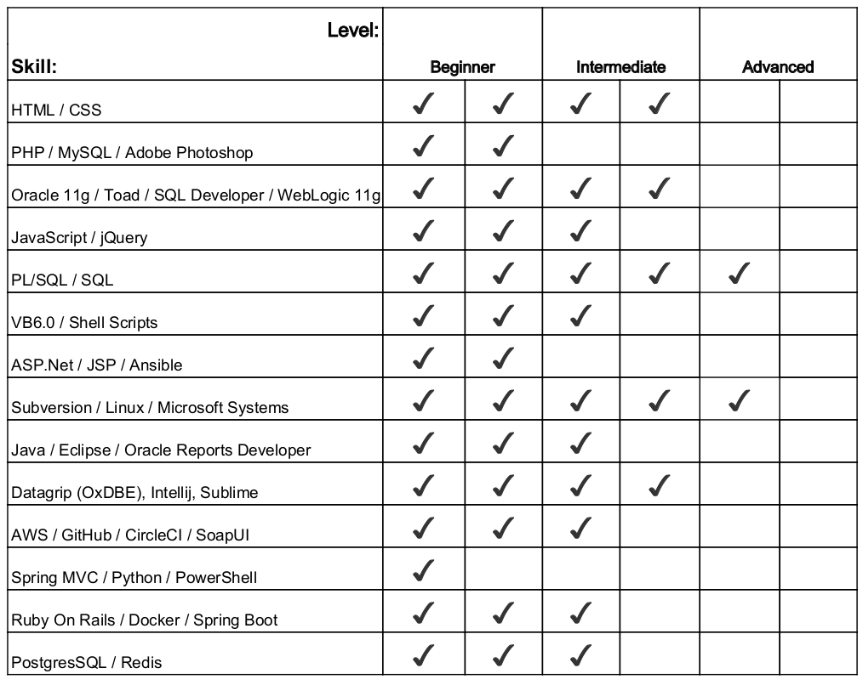

**EDUCATION** 

**Otago Polytechnic**  Dunedin, New Zealand 

*Bachelor in Information Technology* 2008–2012

*Certificate in Information Service and Support*   
*Certificate in Network Administration*

**INTERESTS** 

* Involved in Rugby, Soccer, Basketball, Dragon Boating, and Soccer teams
* Participated in multiple running events including Rotorua Full Marathon, and The Goat (22km hill climb around Mount Tongariro)
* Participated in a charity event called IT Heavy Hitters, which is a boxing event to raise money for the Key to Life charitable trust

**REFERENCES** 

Available on request.