Rent Convergence in England
A 1–3 Bed Affordable-Housing Investment Screen
Where market rent, LHA, Affordable Rent and social rent line up

Measured from official open data — 97 local authorities scored
ONS Private Rental Market Statistics · DWP/VOA LHA · Regulator of Social Housing
July 2026

Executive summary
What this is
- A screen for English areas where all four rent levels for 1–3 bed homes sit close together — lower rent risk, stronger housing-benefit alignment.
- Four layers compared: market rent, LHA (benefit cap), Affordable Rent (80% of market), and social rent.
- 97 local authorities scored from official open data; studios and shared housing excluded.
Headline finding
- Geography: Convergence is concentrated in the low-cost North & Midlands; the least-converged areas are all in the high-rent South.
- Every one of the top 25 areas is northern or Midlands; the bottom five are Cambridge, Brighton, Bristol, Exeter, Oxford.
- Why: The driver is social-rent attachment — near-uniform social rent only sits close to market rent where market rent is low.
Top 5 investment picks (convergence + demand)
- Teesside (Hartlepool / Redcar / Middlesbrough) · Kingston upon Hull · Doncaster · Sunderland · Stoke-on-Trent.
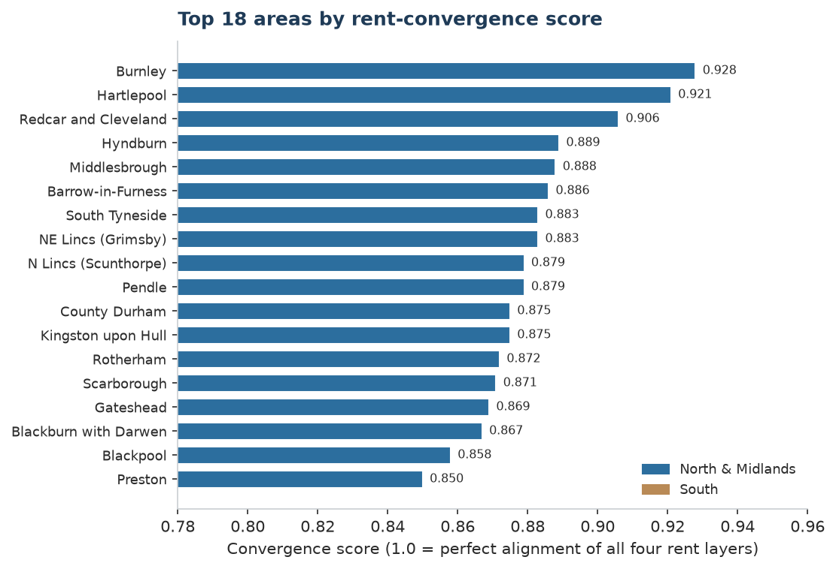

The convergence idea
- Aligned when: LHA close to market rent — benefit-backed demand is well supported.
- Affordable Rent (80% of market) sits near or below LHA — coverable by a benefit tenant.
- Social rent not wildly detached from market rent.
- 1/2/3-bed rents relatively compressed (low variation).
Score = 0.40 × LHA-alignment + 0.30 × social-attachment + 0.30 × rent-compression (0–1; higher = tighter).
The mechanism the data exposes
- LHA-to-market alignment is high almost everywhere — LHA is the 30th percentile by design (even Cambridge, Guildford score well).
- Social rent barely varies nationally (~£380–£490/mo here) but market rent ranges ~£475–£1,400.
- Result: So four-layer convergence needs a low-rent market — the northern signature.
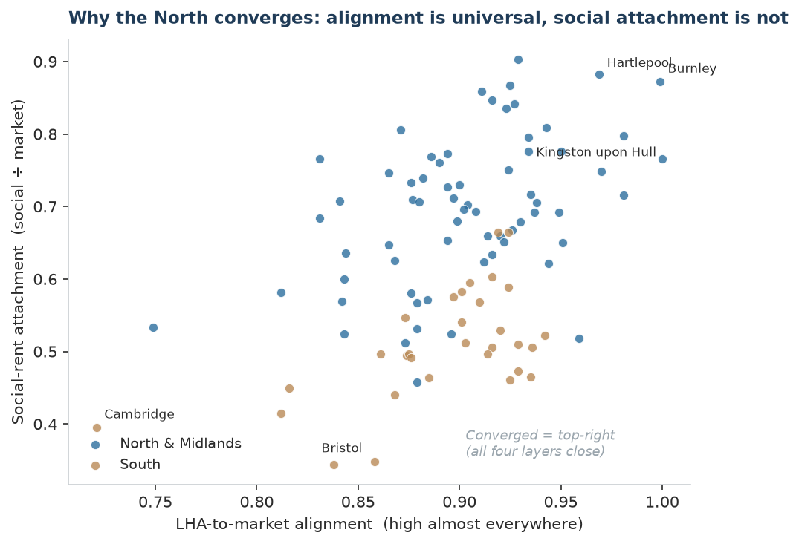

Measured results — Top 20 areas
# | Area | Region | Mkt 2-bed | LHA 2-bed | Social 2-bed | Score
1 | Burnley | North West | £475 | £474 | £425 | 0.928
2 | Hartlepool | North East | £500 | £474 | £441 | 0.921
3 | Redcar and Cleveland | North East | £510 | £474 | £461 | 0.906
4 | Hyndburn | North West | £495 | £474 | £403 | 0.889
5 | Middlesbrough | North East | £525 | £474 | £450 | 0.888
6 | Barrow-in-Furness | nan | £550 | £499 | £493 | 0.886
7 | South Tyneside | North East | £500 | £549 | £396 | 0.883
8 | NE Lincs (Grimsby) | Yorks & Humber | £525 | £479 | £426 | 0.883
9 | N Lincs (Scunthorpe) | Yorks & Humber | £525 | £494 | £421 | 0.879
10 | Pendle | North West | £520 | £474 | £404 | 0.879
11 | County Durham | North East | £450 | £399 | £390 | 0.875
12 | Kingston upon Hull | Yorks & Humber | £495 | £474 | £407 | 0.875
13 | Rotherham | Yorks & Humber | £550 | £499 | £401 | 0.872
14 | Scarborough | nan | £600 | £549 | £493 | 0.871
15 | Gateshead | North East | £580 | £549 | £406 | 0.869
16 | Blackburn with Darwen | North West | £524 | £474 | £412 | 0.867
17 | Blackpool | North West | £550 | £540 | £404 | 0.858
18 | Preston | North West | £600 | £573 | £422 | 0.850
19 | Sunderland | North East | £550 | £474 | £418 | 0.850
20 | Stoke-on-Trent | West Midlands | £515 | £479 | £380 | 0.846
Rents matched to the LHA reference window (Oct 2022–Sep 2023); measures structural convergence, not today's live gap. Full 97-area table in the accompanying spreadsheet/CSV.

Regional pattern
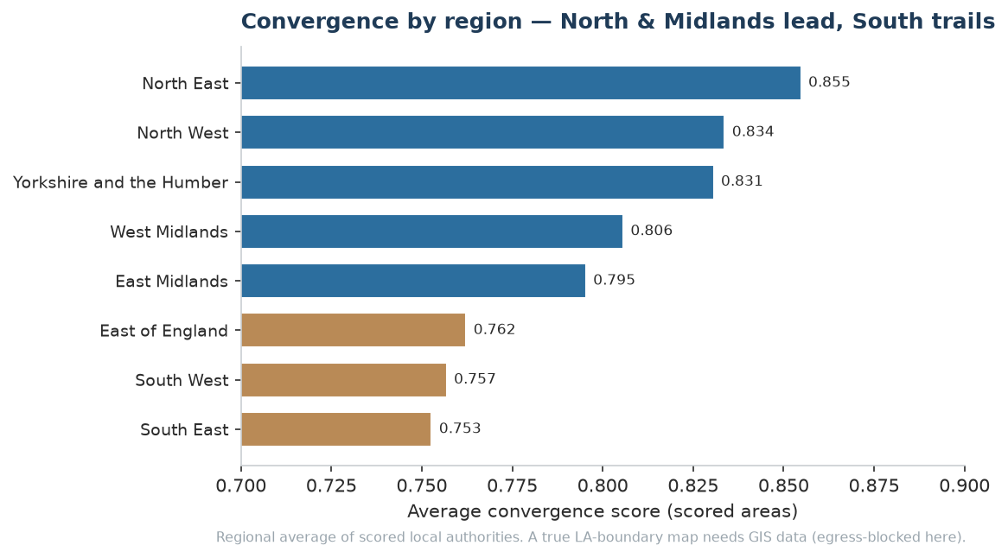

Top 5 investment picks
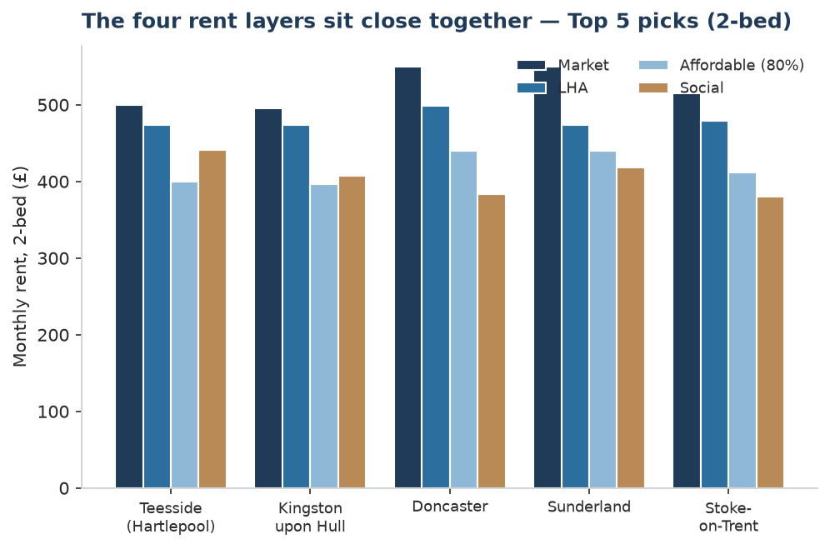

1 · Teesside — Hartlepool / Redcar / Middlesbrough
- Why: Elite convergence (Hartlepool #2, Redcar #3, Middlesbrough #5) with the clearest new-demand story: Teesworks / Freeport and energy investment.
- Watch: Keep to the regeneration footprint; avoid deprived peripheral estates.
2 · Kingston upon Hull (#12)
- Why: Top-tier convergence, a large deep market, and a real demand engine — Humber energy cluster, port, university.
- Watch: Flood-zone and older-stock demand pockets; social rents unusually low.
3 · Doncaster (#22)
- Why: Strong convergence with a genuine logistics / rail employment base and Sheffield city-region pull.
- Watch: Post-industrial low-demand micro-markets.
4 · Sunderland (#19)
- Why: Strong convergence plus Riverside regeneration and automotive employment.
- Watch: Peripheral estates weaker; single-employer exposure.
5 · Stoke-on-Trent (#20)
- Why: Strong convergence with regeneration and affordability-led in-migration.
- Watch: Pockets of low-demand terraced stock; buy in sound sub-markets.
Highest pure convergence but thinner demand: Burnley / Hyndburn / Pendle / Blackburn (East Lancs), Grimsby, Scunthorpe, Rotherham. Blackpool scores well but stays a watch (weak demand, poor stock).

Operators active in the stream
Registered providers (RP) and council ALMOs already delivering social & affordable rent in each pick. RSH grades: G=governance, V=viability, C=consumer (1 = strongest). * = widely-reported figure.
Area | Organisation | Type | Homes | RSH (G/V/C)
Teesside | Thirteen Group | RP | ~34,000 | G1 / V1 / C1
Teesside | Beyond Housing | RP | ~15,350 | G1 / V1 / —
Teesside | North Star Housing | RP | ~4,000 | G1 / V1 / —
Hull | Riverside | RP | ~75,000* | G1 / V2 / —
Hull | Sanctuary | RP | ~120,000* | G1 / V2 / C2
Hull | Pickering & Ferens Homes | RP | ~1,400 | n/v
Doncaster | St Leger Homes of Doncaster | ALMO | ~20,000 | — (council-held)
Doncaster | Together Housing | RP | ~36,000 | G1 / V2 / —
Doncaster | Housing 21 | RP | ~23,300 | G1 / V1 / C1
Sunderland | Gentoo Group | RP | ~29,000 | G1 / V2 / C1
Stoke-on-Trent | Aspire Housing | RP | ~9,300 | G1 / V2 / C1
Stoke-on-Trent | Honeycomb Group (Staffs Housing) | RP | ~3,118 | n/v
Stoke-on-Trent | EPIC Housing | RP | ~1,400 | n/v
Maps who is active — not an endorsement or a claim of current tenders. Verify current pipeline/JV appetite and re-check RSH judgements before acting.

Method, data & caveats
Data sources (official, open)
- Market rent — ONS/VOA Private Rental Market Statistics: median monthly rent by bedroom, by local authority (Oct 2022–Sep 2023).
- LHA — DWP/VOA April-2024 rates (frozen), 1/2/3-bed, by BRMA.
- Social rent — Regulator of Social Housing 2024/25: per-LA, per-bedsize general-needs rent.
- Affordable Rent — derived as 80% of market (statutory definition).
How it was built
- Three layers joined per area; convergence score computed and ranked (see score formula).
- 92 of 97 areas use local social rent; 5 use the England average as fallback.
- LA→BRMA geography: 56 exact matches + 37 web-verified + 4 genuinely multi-BRMA (flagged).
Caveats
- Structural, not live — rents matched to the frozen-LHA window; today's market-vs-LHA gap is wider.
- A convergence screen, not a demand / yield / asset-quality model — pair with local demand work.
- Small-sample areas flagged in the data; treat cautiously.
- 97 areas scored (not all ~300) — full national coverage needs the official LA→BRMA lookup.
Sources
ONS Private Rental Market Statistics · DWP/VOA Local Housing Allowance rates · Regulator of Social Housing, Registered provider social housing stock and rents 2024/25 · RSH regulatory judgements (provider grades). All Open Government Licence. Reproducible via run_measured_ranking.py.

