http://blog.csdn.net/u011673111/article/details/50962862
http://www.centoscn.cn/mysql/2015/1225/6576.html
http://www.centoscn.cn/mysql/2014/1211/4290.html

yum 不能用：
在/etc/resolv.conf添加nameserver 8.8.8.8
还不能得话就检查一下/etc/yum.repos.d/CentOS-Base.repo

1, 安装mysql前需要查询系统中含有的有关mysql的软件。
rpm -qa | grep -i mysql //grep -i是不分大小写字符查询，只要含有mysql就显示
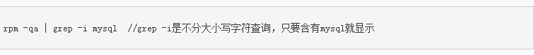
mysql-libs-5.1.71-1.el6.i686 //它是好几个软件的依赖，其中在mini版本中postfix软件依赖mysql-libs，网络上很多建议都是直接删除，
yum remove mysql-libs 或者 rpm -e --nodeps mysql-libs-5.1.71-1.el6.i686，总觉得这样做不好。
查找mysql官方资料，得到安装方法是用MySQL-shared-compat将mysql-libs-5.1.71-1.el6.i686替换为同版本后在安装mysql。

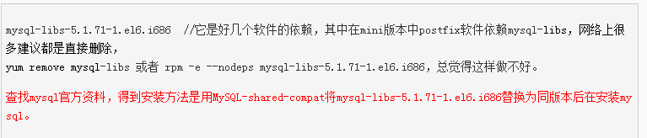

2 检测系统是否自带安装MySQL
#yum list installed | grep mysql
3 : 删除系统自带的mysql及其依赖 命令：
# yum -y remove mysql-libs.x86_64 不能用这种方式，否则会将docker弄挂
rpm -e --nodeps mysql-libs-5.1.71-1.el6.i686 用这种方式
4 给CentOS添加rpm源，并且选择较新的源 命令：
wget http://dev.mysql.com/get/mysql57-community-release-el7-7.noarch.rpm
yum localinstall -y mysql57-community-release-el7-7.noarch.rpm
yum install -y mysql-community-server

5 安装mysql 服务器 命令：
# yum install mysql-community-server

6 启动mysql 命令:
#service mysqld start
7 查看mysql是否自启动,并且设置开启自启动 命令:
# chkconfig --list | grep mysqld
# chkconfig mysqld on

# 启动后，查看安装后自动生成的密码
shell> grep "password" /var/log/mysqld.log
## 输出
2015-12-24T02:12:21.721431Z 1 [Note] A temporary password is generated for root@localhost: s8)9B9)!#iWJ
2015-12-24T02:12:25.495271Z 0 [Note] Execution of init_file '/var/lib/mysql/install-validate-password-plugin.lv0PNr.sql' started.
2015-12-24T02:12:25.506256Z 0 [Note] Execution of init_file '/var/lib/mysql/install-validate-password-plugin.lv0PNr.sql' ended.
2015-12-24T02:12:27.323654Z 0 [Note] Shutting down plugin 'sha256_password'
2015-12-24T02:12:27.323657Z 0 [Note] Shutting down plugin 'mysql_native_password'
2015-12-24T02:12:29.351753Z 2 [Note] Access denied for user 'UNKNOWN_MYSQL_USER'@'localhost' (using password: NO)

## 第一行“root@localhost:”后面的字符就是密码了，我们需要用它来设置我们自己的root登录密码
shell> mysql_secure_installation
## 输出
Securing the MySQL server deployment.

Enter password for user root: [请在这里输出自动生成的密码，如：s8)9B9)!#iWJ]
## 注：密码必须满足1)长度大于8；2)包含至少1个数字，1个大写字母，1个小写字母，1个非字母数字的符号；3)长度不得超过32位。
## 完成后还需要设置一些初始化的配置，请按照提示来做

# 以上步骤结束后，可以使用root用户登录mysql试试了
shell> mysql -u root -p

# mysql的配置文件所在目录
shell> find / -name my.cnf
## 输出
/etc/my.cnf
查看mysql的端口号
netstat -nltp|grep mysql
更改Mysql的端口号
/etc/my.cnf下
mysqld
port=3316 // 将3306改为了3316

二 更改mysql的目录位置/var/lib/mysql
http://www.osyunwei.com/archives/566.html

http://blog.csdn.net/fungleo/article/details/49903427
这是centos 7下mysql 5.7版本的更改路径
只需要在/etc/my.cnf下更改就行了

2204的服务
1 先在/data目录下建立一个mysqldata目录-R 777 mysqldata
2 用cp -a 命令将/var/lib/mysql复制到mysqldata目录下
cp -a /var/lib/mysql /data/mysqldata后如下
/data/mysqldata/mysql
注意 ：此处一定要用cp -a，否则会更改文件权限
用 cp -rf /var/lib/mysql /data/Mysqldata/mysqldata后 文件目录权限更改为了 root
而 ll /var/lib/mysql的权限是mysql

3 然后我们修改配置文件，一共有三个
修改第一个文件：修改之前先备份cp /etc/my.cnf /etc/my.cnfbak
vim /etc/my.cnf
[client]
port=3316
socket=/data/mysqldata/mysql/mysql.sock
[mysqld]
datadir=/data/mysqldata/mysql
socket=/data/mysqldata/mysql/mysql.sock
port=3326
user=mysql
server_id=9207
log-bin=mysql-bin
#max_connections=1000
#character-set-server=utf8
## Disabling symbolic-links is recommended to prevent assorted security risks
symbolic-links=0
#log-error=/var/log/mysqld.log
#pid-file=/var/run/mysqld/mysqld.pid
innodb_buffer_pool_size=16G
其中 [mysqld]是要加上的否则启动的时候可以正常启动但是在登录的时候报错

修改第二个文件：修改之前先备份 cp /etc/init.d/mysqld /etc/init.d/mysqldbak

注意：准确的位置是/etc/rc.d/init.d/mysqld，由于这里这里有一个/etc/init.d到/etc/rc.d/init.d的映射，
所以用上面的命令即可，也简单。
把其中datadir=/var/lib/mysql一行中，等号右边的路径改成你现在的实际存放路径：/data /mysqldata/mysql

修改第三个文件：修改之前先备份 cp /usr/bin/mysqld_safe /usr/bin/mysqld_safebak
vim /usr/bin/mysqld_safe
这里也是修改datadir的目录为/data/Mysqldata/mysqldata/mysql
至此所有的修改都完成了，下面启动mysql
service mysqld start

错误：Job for mysqld.service failed because the control process exited with error code. See "systemctl status mysqld.service" and "journalctl -xe" for details.
setenforce 0

三 mysql的远程访问
[Warning] IP address '220.195.2.250' could not be resolved: Temporary failure in name resolution
access denied for user mysql123 @% to database
http://www.uedsc.com/ip-address-could-not-be-resolved.html
报如上错误
查看日志 /var/log/mysqld.log
[Warning] IP address '220.195.2.250' could not be resolved: Temporary failure in name resolution
access denied for user mysql123 @% to database

解决：
在my.cnf的 mysqld下面加上
skip-host-cache
skip-name-resolve

使得mysql将不通过DNS解析地址

update user set host=’%’ where user=’root’

GRANT ALL PRIVILEGES ON *.* TO 'root'@'%' IDENTIFIED BY 'Passw0rd$mysql' WITH GRANT OPTION;
重启数据库就可以了

Mysql -u root -p进入mysql的mysql的下面
use msyql;
update user set host = '%' where user = 'root';
这样的话就可以了

先创建用户

再给用户授权
CREATE USER 'mysqluser'@'%' IDENTIFIED BY 'Mysql$321';
mysql 用户授权
grant create,select,update,insert,delete on SNESOR.* to mysqluser@'%' identified by 'Mysql$321';

查看数据库的编码格式
show variables like 'character%';

四 mysql的配置my.cnf
My.cnf中
explicit_defaults_for_timestamp
如果没有配置的话，在创建表的时候如果创建有两个字段都为 TIMESTAMP的时候会报错，即只能存在一个字段TIMESTAMP,
CREATE TABLE WEATHER_MEASURE_BJ (
ID BIGINT NOT NULL auto_increment primary key,
DATETIME TIMESTAMP NOT NULL ,
TIME TIMESTAMP NOT NULL ,
TYPE INTEGER NOT NULL ,
SITEID INTEGER ,
VALUE DOUBLE ,
AREAID INTEGER )
;
上面就会报错
如果在my.cnf里加了explicit_defaults_for_timestamp
就可以存在多个 TIMESTAMP 了

五 Centos7下安装mysql
mysql5.7的安装
http://www.centoscn.com/mysql/2016/0626/7537.html
# 下载mysql源安装包
shell> wget http://dev.mysql.com/get/mysql57-community-release-el7-8.noarch.rpm
# 安装mysql源
shell> yum localinstall mysql57-community-release-el7-8.noarch.rpm
检查mysql源是否安装成功
shell> yum repolist enabled | grep "mysql.*-community.*"
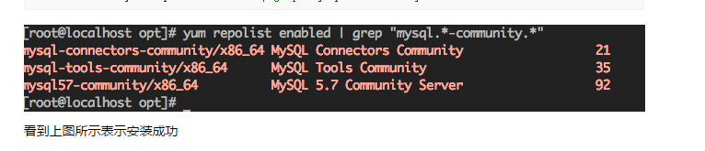
2、安装MySQL

shell> yum install mysql-community-server
3、启动MySQL服务

shell> systemctl start mysqld

查看MySQL的启动状态

shell> systemctl status mysqld

4、开机启动

shell> systemctl enable mysqld
shell> systemctl daemon-reload
5、修改root默认密码

mysql安装完成之后，在/var/log/mysqld.log文件中给root生成了一个默认密码。通过下面的方式找到root默认密码，然后登录mysql进行修改：

shell> grep 'temporary password' /var/log/mysqld.log

shell> mysql -uroot -p
mysql> ALTER USER 'root'@'localhost' IDENTIFIED BY 'MyNewPass4!';
或者

mysql> set password for 'root'@'localhost'=password('MyNewPass4!');
注意：mysql5.7默认安装了密码安全检查插件（validate_password），默认密码检查策略要求密码必须包含：大小写字母、数字和特殊符号，并且长度不能少于8位。否则会提示ERROR 1819 (HY000): Your password does not satisfy the current policy requirements错误，如下图所示：

通过msyql环境变量可以查看密码策略的相关信息：

mysql> show variables like '%password%';

http://www.centoscn.com/mysql/2014/0919/3778.html
http://www.cnblogs.com/starof/p/4680083.html
下面是mysql5.6的安装
CentOS 7的yum源中貌似没有正常安装mysql时的mysql-sever文件，需要去官网上下载
# wget http://dev.mysql.com/get/mysql-community-release-el7-5.noarch.rpm
# rpm -ivh mysql-community-release-el7-5.noarch.rpm
# yum install mysql-community-server
成功安装之后重启mysql服务
# service mysqld restart
初次安装mysql是root账户是没有密码的
设置密码的方法
# mysql -uroot
mysql> set password for ‘root’@‘localhost’ = password('mypasswd');
mysql> exit
搞定！

在本机上连接本机的linux虚拟机里的Mysql不能成功：
防火墙也要关了,service iptables stop 或者 systemctl stop firewalld.service

六 配置log_bin日志
server-id=3
log_bin=mysql-bin

7 mysql安装出现问题

InnoDB: auto-extending data file ./ibdata1 is of a different size 640 pages (rounded down to MB) than specified in the .cnf file: initial 768 pages, max 0 (relevant if non-zero) pages!
问题描述：
$yum install mysql-server
安装之后执行命令mysql
报错：
查看mysql的启动日志：
[ERROR] InnoDB: auto-extending data file ./ibdata1 is of a different size 640 pages (rounded down to MB) than specified in the .cnf file: initial 768 pages, max 0 (relevant if non-zero) pages!
2016-02-22 23:02:55 29830 [ERROR] InnoDB: Could not open or create the system tablespace. If you tried to add new data files to the system tablespace, and it failed here, you should now edit innodb_data_file_path in my.cnf back to what it was, and remove the new ibdata files InnoDB created in this failed attempt. InnoDB only wrote those files full of zeros, but did not yet use them in any way. But be careful: do not remove old data files which contain your precious data!
2016-02-22 23:02:55 29830 [ERROR] Plugin 'InnoDB' init function returned error.
2016-02-22 23:02:55 29830 [ERROR] Plugin 'InnoDB' registration as a STORAGE ENGINE failed.
2016-02-22 23:02:55 29830 [ERROR] Unknown/unsupported storage engine: InnoDB
2016-02-22 23:02:55 29830 [ERROR] Aborting
解决方法：
执行删除命令：rm -rf /var/lib/mysql/ib*
删除：ibdata1、ib_logfile0、ib_logfile1文件
重新启动：service mysqld start
解决mysql启动错误：Fatal error: mysql.user table is damaged. Please run mysql_upgrade.
删除/var/lib/mysql下的三个文件；
然后使用如下命令，重新初始化mysql
mysqld --initialize --user=mysql

如果按照上述报错：执行如下
mysql --initialize specified but the data directory has files in it. Aborting.
然后清空 /var/lib/mysql下的文件
重启 service mysqld start就可以了

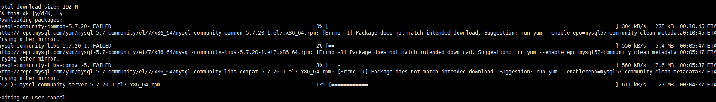

mysql-community-libs-5.7.20-1. FAILED 99% [============================================================================================-] 531 kB/s | 4.4 MB 00:00:00 ETA
http://repo.mysql.com/yum/mysql-5.7-community/el/7/x86_64/mysql-community-libs-5.7.20-1.el7.x86_64.rpm: [Errno -1] Package does not match intended download. Suggestion: run yum --enablerepo=mysql57-community clean metadata 00:00:00 ETA
Trying other mirror.

执行：
[root@node9223 liuquanwei]# yum --enablerepo=mysql57-community clean metadata

http://repo.mysql.com/yum/mysql-5.7-community/el/7/x86_64/repodata/97ba2118ecc5f7d6af3961dd7787a189da4e6d0d-primary.sqlite.bz2: [Errno -1] Metadata file does not match checksum
Trying other mirror.

Yum -y remove lib….

