Exploring Titanic Dataset with Pandas

1. Import the Required Libraries
You should import Pandas (import pandas as pd) and Matplotlib (import matplotlib.pyplot as plt) for data manipulation and visualization.
import pandas as pd
import matplotlib.pyplot as plt

2. Load the Dataset
Load the Titanic dataset from a CSV file named 'titanic.csv' into a Pandas DataFrame.
df=pd.read_csv('/Users/adam0725/1332/1233/Pratice/titanic.csv')

3. Data Exploration
Display the first few rows of the dataset to understand its structure.
print(df.head())
Print information about the columns and their data types.
df.info()
Show summary statistics for numerical columns (e.g., mean, min, max, etc.).
df.describe()

4. Data Cleaning
Identify and handle missing values in the dataset (e.g., fill missing age values with median).
Perform any necessary data transformations or cleaning steps.
median_age = df['Age'].median()
df['Age'].fillna(median_age, inplace=True)
5. Data Analysis
Calculate and display the count of passengers by gender.
passenger_count_by_gender = df['Sex'].value_counts()
print("乘客數量按性別分組：", passenger_count_by_gender)

Compute the average age of passengers.
Determine the survival rate by passenger class.
survival_rate_by_class = df.groupby('Pclass')['Survived'].mean()
print("存活率按乘客等級分組：", survival_rate_by_class)

6. Data Visualization
Create a bar chart to visualize the survival rate by passenger class.
Add appropriate labels and a title to the chart.
plt.figure(figsize=(8, 6))
survival_rate_by_class.plot(kind='bar', color='skyblue')
plt.title('Survival Rate by Passenger Class')
plt.xlabel('Passenger Class')
plt.ylabel('Survival Rate')
plt.show()

7. Conclusion
Summarize your findings or insights gained from analyzing the Titanic dataset.
Reflect on the importance of data cleaning and exploration in data analysis.
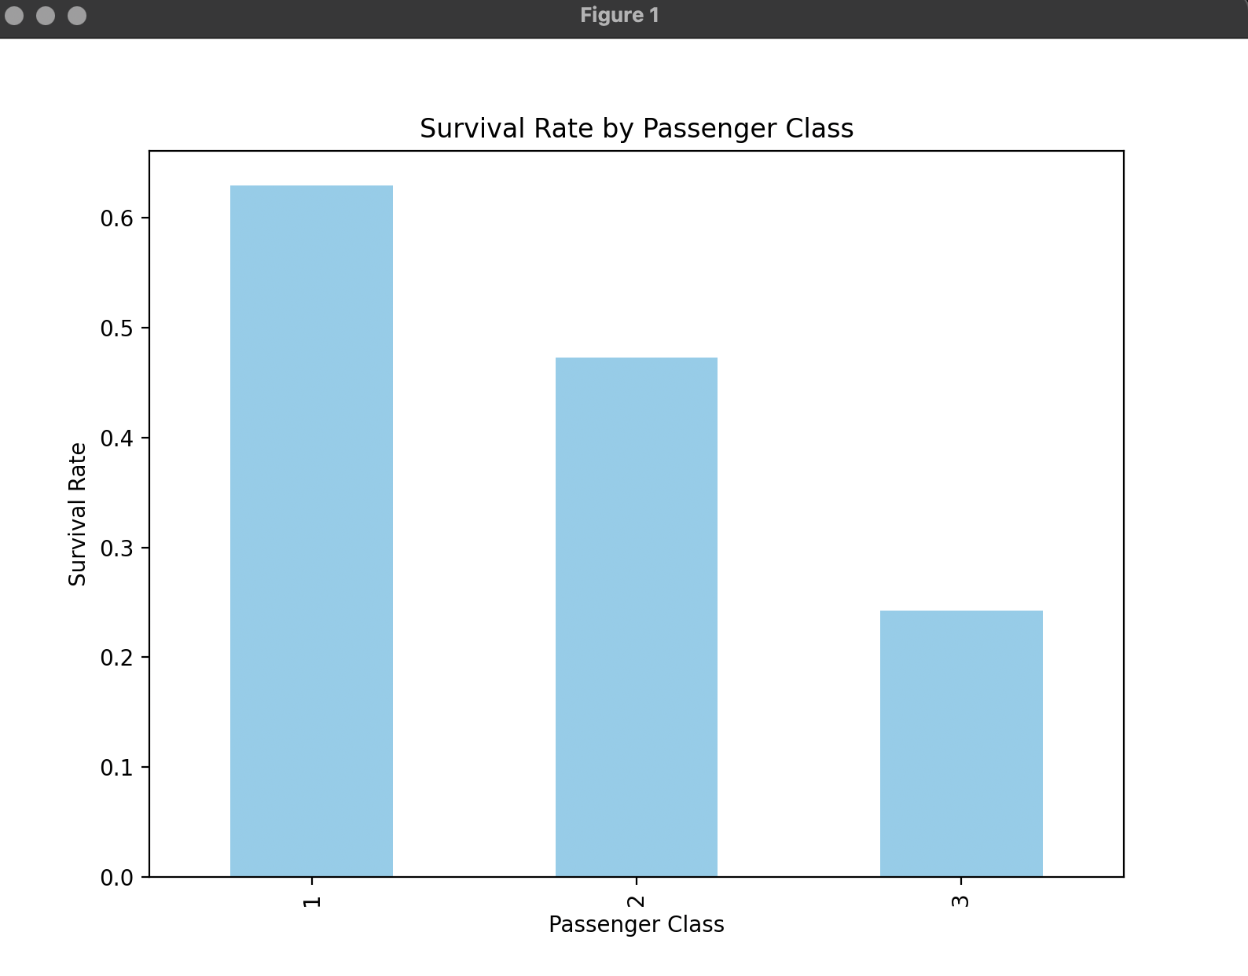
According to the bar chart presented by Python, we concluded that people who lives in class1 has the highest survival rate, which is the most expensive one. People who live in class3 has the lowest survival rate, which is the cheapest one.

