

Software Engineering Department - Braude College

Capstone Project Phase B – 61999
SkillBridge: Learning and Teaching Application

(25-2-D-29)
GitHub
Supervisor: Dr. Zeev Frenkel

Adam Hasarme: Adam.Hasarme@e.braude.ac.il

Raed Haddad: Raed.Haddad@e.braude.ac.il

Abstract 4
1. Introduction 5
2. Background 6
2.1 Motivation 6
2.1.1 Social Learning 6
2.1.2 Gamification 6
2.1.3 Peer Teaching 6
2.2 Existing Tools and Methods 7
2.2.1 Existing platform with similar functionality (“SkillSwap”) 7
2.2.2 Platforms with Partial Functionality 7
2.2.3 Summary of Limitations 7
2.3 Summary 8
3. Core Algorithms 8
3.1 Matching Algorithm 8
3.2 Gamification Algorithm 9
3.3 Cheating Prevention 9
4. System Architecture 10
4.1 High-Level Architecture: 10
4.2 Key Data Entities (MongoDB Collections) 11
4.3 Security and Reliability 11
5. Research and Development Process 12
5.1 Research and Planning 12
5.2 System Design and Development 12
5.3 Agile Workflow and Iterations 12
6. Challenges and Solutions 13
6.1 Analytical Challenges 13
6.2 Technical Challenges 13
7 Diagrams 14
7.1.1 Use Case Diagram 14
7.1.2 Activity Diagram 14
7.2 Architecture Overview 15
7.3 Layered Architecture 16
8. Results and Conclusions 20
8.1 Achievement of Objectives 20
8.2 Decision-Making 20
8.3 Handling Challenges 20
9. Verification and Evaluation 21
9.1 Evaluation Criteria 21
9.2 Workflow Verification 22
9.3 Feature-Based Test Table 23
10.User manual 24
11.Maintenance Guide 44
Objective 44
11.1 System Architecture Overview 44
11.1.1 Frontend 44
11.1.2 Backend 44
11.1.3 Database 45
11.1.4 Real-Time Communication 45
11.2 Operating Environment 45
11.2.1 Software Requirements 45
11.2.2 Hardware Requirements 45
11.3 Installation and Startup (Developer / Maintenance Use) 46
11.3.1 Backend Setup (Local or Server) 46
11.3.2 Frontend Setup (Local Development) 46
11.4 Regular Maintenance Tasks 47
11.4.1 Dependency Updates 47
11.4.2 Database Maintenance 47
11.4.3 Log Monitoring 47
11.5 Security Maintenance 47
11.6 Monitoring and Future Improvements 48
11.6.1 Monitoring 48
11.6.2 Alerts 48
11.7 Troubleshooting 48
Common Issues 48
11.8 Documentation and Updates 48
12. References 49

Abstract

SkillBridge is an innovative platform designed to revolutionize the way individuals exchange knowledge. By enabling real-time learning sessions between users through chat, voice, video calls, and screen sharing, the app promotes a dynamic and collaborative learning environment. Users can teach skills they already know to earn points and use those points to learn new skills, creating a balanced and engaging knowledge-sharing economy.
The platform addresses the limitations of traditional learning tools by combining intelligent user matching, gamification, and peer-to-peer interaction. A sophisticated matching algorithm pairs users based on skills, availability, and preferences, while a point-based system encourages active participation and fairness.
For peer-to-peer interaction, SkillBridge introduces a Zoom-like session environment, integrating multiple communication tools such as video conferencing, real-time chat, screen sharing, and file exchange to enrich learning interactions. Built with Next.js, React, Node.js, and MongoDB, the system provides a responsive, web-first interface for seamless knowledge exchange.

1. Introduction
In today’s world, where self-learning is becoming increasingly necessary, many learners struggle to access quality educational support. Private tutoring is expensive, passive learning often lacks engagement, and finding the right person to explain a concept in real time is not always possible. These barriers can significantly reduce the effectiveness of independent learning.
The goal of our project is to develop a collaborative learning platform called SkillBridge that allows users to teach topics they know and earn points in return. These points act as internal currency that can then be used to learn from others. This creates a self-sustaining, fair cycle of peer-to-peer knowledge exchange, where users are both learners and teachers.
Our solution enables real-time interaction through a Zoom-like interface that supports multiple communication modes: video calls, live chat, screen sharing, and file exchange. Rather than simply using external tools like Zoom or Google Meet, SkillBridge integrates similar functionality directly into the platform to provide seamless, structured, and focused skill-sharing sessions.
SkillBridge is primarily designed for students, but it is open to anyone who wants to exchange skills in a meaningful way. By promoting mutual learning and eliminating financial barriers, the platform fosters inclusivity and community-based education. Our aim is to support short, goal-oriented sessions where users can quickly learn or teach something specific in a dynamic and interactive setting.
The design of SkillBridge is informed by established educational principles such as social learning and gamification, which emphasize the importance of interaction, motivation, and active participation in the learning process. These principles guide the structure of the platform and its core mechanisms, including intelligent user matching and a point-based reward system. The project focuses on the practical implementation of these ideas through a technically advanced system rather than on empirical educational evaluation at this stage.
To implement the platform, we adopted an Agile development process, working in iterative sprints and continuously refining the system based on internal testing and incremental development [1]. The technological stack includes Next.js with React for a responsive, web-first user interface [2], Node.js with Express for backend services and business logic [3], and MongoDB for storing data such as user profiles, skill tags, availability, and point balances [4]. Real-time communication is enabled through third-party solutions such as WebRTC, which provide scalable and reliable support for video, voice, and screen-sharing sessions [5].
To better position SkillBridge within the current landscape of learning technologies, we examined several existing platforms, including YouTube (https://www.youtube.com/), Coursera (https://www.coursera.org/), Chegg (https://www.chegg.com/), Brainly (https://brainly.com/), HelloTalk (https://www.hellotalk.com/), and Khan Academy (https://www.khanacademy.org/). While these platforms offer valuable resources for self-learners, they generally do not provide an integrated solution that combines real-time peer-to-peer learning sessions, a structured point-based exchange system, and multi-modal communication within a single environment.

2. Background
In today’s world, many people want to learn new skills — whether it’s language, programming, design, or public speaking. But learning on your own can be difficult. Watching videos or reading articles online is helpful, but it doesn’t replace live interaction with a real person who can guide you, answer your questions, and even share their screen or video in real time. True learning often happens through meaningful, human conversation — and that’s exactly what SkillBridge enables.

2.1 Motivation
Although there are many digital tools available for self-learning, they often fail to support the deeper, social, and interactive aspects of learning that educational research emphasizes. Most platforms focus on either consuming content or getting fast answers, but they don’t help learners connect with others in real-time or encourage them to teach what they know — which are proven ways to improve understanding and motivation. Several well-established theories and models in education help explain why a platform like SkillBridge is needed. With SkillBridge’s new Zoom-style session interface, users aren’t just chatting — they’re engaging in live video, screen sharing, and interactive discussions, replicating the experience of private tutoring in a modern, peer-based environment.

2.1.1 Social Learning
Psychologist Lev Vygotsky proposed that people learn more effectively when they engage in social interaction (Vygotsky, 1978). His theory of the Zone of Proximal Development (ZPD) explains that the best learning happens when a learner is guided by someone slightly more experienced — not too advanced, but just enough to help bridge the gap. Most existing platforms don’t support this. Watching videos or reading content is passive, and there is no one available to explain things interactively or adapt to your current level. SkillBridge is based on this principle. It allows users to connect in real-time with others who know the topic just a little better — like a virtual study partner who helps you at the right level.

2.1.2 Gamification
Gamification means using points, rewards, and progress indicators to make activities more engaging. Research shows that gamification helps keep learners motivated, improves focus, and increases the chances of continuing long-term (Deterding et al., 2011). Traditional platforms may have certificates or badges, but most don’t use gamification in a way that rewards both teaching and learning. SkillBridge does this by awarding points for helping others and allowing those points to be spent to receive help — creating a motivational cycle that encourages participation from both sides.

2.1.3 Peer Teaching
Studies show that people learn better when they teach others — a concept known as peer tutoring (Roscoe & Chi, 2007). Explaining a concept reinforces the tutor’s own understanding and builds confidence. SkillBridge encourages this by allowing users to teach even if they’re not experts. As long as someone is one step ahead, they can be helpful. The platform makes this feel valuable by recognizing and rewarding teaching just like learning.

2.2 Existing Tools and Methods
Many learners rely on online platforms to acquire new skills. These platforms differ in their goals, level of interactivity, and learning models. This section reviews existing tools that provide learning or communication functionality and highlights their limitations in supporting structured peer-to-peer learning.

2.2.1 Existing platform with similar functionality (“SkillSwap”)
SkillSwap (https://skillswap.io/)
SkillSwap is a commercial platform that enables professionals to exchange skills in a marketplace-like environment. While it supports skill matching and paid interactions, it focuses mainly on professional services and monetization. It does not emphasize mutual peer learning, gamification, or academic collaboration, which are central goals of SkillBridge.

2.2.2 Platforms with Partial Functionality
Many popular platforms provide only part of the peer-learning experience:
- Video content platforms (e.g., YouTube, Coursera, Udemy)
These platforms offer high-quality recorded content but lack real-time interaction and personalized feedback.
- Q&A platforms (e.g., Stack Overflow, academic forums)
These allow users to ask questions and receive answers, but communication is asynchronous and not suitable for live explanation or guided learning.
- Communication tools (e.g., Zoom, Discord, Microsoft Teams)
These support real-time audio and video communication but do not provide learning-oriented matching, progress tracking, or motivation mechanisms.

2.2.3 Summary of Limitations
Across the reviewed platforms, several shared limitations can be identified:
- Lack of real-time interaction with peers at a similar learning level
- No personalized matching based on skills, goals, or availability
- Low learner motivation due to absence of rewards or progress systems
- No balance between teaching and learning contributions
- Fragmented workflow requiring multiple unrelated platforms

2.3 Summary
Existing platforms provide valuable learning resources but fail to offer a unified peer-learning environment. SkillBridge addresses these gaps by combining intelligent matching, gamification, and real-time communication into a single platform designed specifically for reciprocal learning.

3. Core Algorithms
The SkillBridge platform relies on intelligent algorithms to create a seamless and engaging user experience. These algorithms serve as the backbone of the system, enabling automated decisions that make the platform scalable, fair, and responsive. In the context of SkillBridges new Zoom-style, web-based learning sessions, the core algorithms also ensure that sessions are relevant, rewarding, and technically smooth.
The primary goals of these algorithms are to:
- Automate matching between users with complementary skills and time availability
- Maintain balance through a point-based give-and-take system
- Increase user engagement through rewards and motivational feedback
- Prevent system abuse or manipulation
- Personalize user experiences based on behavior, ratings, and session history
Two main algorithms drive the SkillBridge experience: the Matching Algorithm, which connects learners and teachers based on skills, time, and preferences, and the Gamification Algorithm, which uses a point economy to motivate, track, and reward meaningful user activity.

3.1 Matching Algorithm
Purpose: The Matching Algorithm is designed to facilitate intelligent pairing between users who want to teach and those who want to learn specific skills. It plays a central role in ensuring the relevance and quality of peer-to-peer sessions on the SkillBridge platform.
Mechanism and Process: The algorithm evaluates user compatibility across three main dimensions:
Skills: The system compares the skills a user wants to learn with the skills that others are offering to teach.
Availability: It checks for overlapping time slots to ensure that both users are free at the same time.
Preferences: It considers each user's preferred communication method (chat, voice call, or screen sharing) and language.
Each potential match is given a score based on how well it satisfies these criteria. For instance:
- Exact skill match: +50 points
- Shared availability window: +20 points
- Preferred communication method match: +15 points
- High rating (optional): +10 points
The highest-ranking users are returned to the current user as top match suggestions.
Data Utilized:
- Skill tags from user profiles
- Availability calendars
- User preference settings
- Optional: user rating and past session feedback
Adaptability and Feedback: Over time, the algorithm can improve by incorporating feedback from post-session ratings. Matches that consistently lead to successful sessions may increase in weight, while mismatches can help refine scoring logic.

3.2 Gamification Algorithm
Purpose: The Gamification Algorithm aims to maintain user engagement and motivation by rewarding positive behavior and encouraging consistent participation in the SkillBridge platform. It transforms the educational experience into an interactive, rewarding journey.
Mechanism and Process: The algorithm assigns and deducts points based on user activity. These points act as an internal currency that regulates access to learning sessions and promotes teaching contributions. Points are calculated based on actions such as:
- Teaching a session: +10 points
- Receiving a high rating: +2 bonus points
- Completing a streak (e.g., 3 sessions in a row): +5 points
- Booking a session to learn: -10 points
- Cancelling a session late: -2 points
Users are required to earn points by teaching before they can spend them on learning, ensuring a give-and-take system.

3.3 Cheating Prevention
To protect the system from abuse, several safeguards will be implemented. Users will not be able to match themselves or repeatedly match with the same partner in a short time to farm points. All sessions must meet a minimum duration to be eligible for point transfer, and points will only be awarded if both users submit session feedback. Suspicious behavior — such as frequent cancellations, repeated low ratings, or abnormal point of activity — may trigger a review or temporary suspension.
Behavioral Analytics: The platform tracks metrics such as frequency of sessions, session duration, and rating trends. This help determine:
- How often rewards are granted
- Which activities are most motivating
- Whether users should receive encouragement or challenge messages
For example, if a user hasn't taught in a while, the system may send reminders or offer a "double point" incentive. If a user excels, it might introduce harder challenges and higher-tier rewards (e.g., badges or unlockable features).
Adaptability and Progression: As users progress, the system dynamically adjusts challenge levels and rewards to ensure continued engagement. For instance, after reaching a certain milestone, users may unlock advanced features or new categories of skills.

4. System Architecture
SkillBridge is implemented using a modular client–server architecture with a clear separation of concerns between the presentation layer, business logic, data management, and real-time communication services. This architectural approach improves scalability, maintainability, security, and allows future extensions such as web clients or additional services.

4.1 High-Level Architecture:
The system is composed of the following main components:
- Frontend
A web-based client developed using Next.js (React).
The frontend is responsible for:
  - User authentication and profile management
  - Skill selection and preference configuration
  - Viewing matches and scheduling sessions
  - Messaging and entering real-time learning sessions
- Backend
Implemented using Node.js with Express, providing RESTful APIs and core business logic.
The backend handles:
  - User management and authentication (JWT-based)
  - Matching algorithm execution
  - Point economy enforcement and transaction processing
  - Session validation and lifecycle management
  - Integration with real-time communication services
- Database
MongoDB is used as the primary data store.
It persists:
  - User profiles and skill information
  - Availability and scheduling data
  - Session history and feedback
  - Point balances and transaction logs
- Real-Time Communication Layer
Real-time interaction is enabled usingWebRTC, providing:
  - Voice calls
  - Video calls
  - Screen sharing
- The backend generates secure session tokens and channel metadata, while the RTC provider handles media streaming between participants.

4.2 Key Data Entities (MongoDB Collections)
The main data entities stored in the database include:
- Users
Stores identity and profile information, including:
  - skillsToTeach
  - skillsToLearn
  - availability
  - communication preferences
  - point balance
  - average rating
- Sessions
Represents scheduled or completed learning sessions:
  - participants (teacher and learner)
  - scheduled time
  - session status
  - duration
  - real-time communication channel information
- Feedback
Contains post-session evaluations:
  - numerical rating
  - optional textual feedback
  - references to related users and sessions
- PointTransactions (Gamification Logs)
Records all point-related operations:
  - transaction reason (e.g., teaching, booking, cancellation)
  - point delta (gain or loss)
  - timestamps
  - resulting balances

4.3 Security and Reliability
SkillBridge incorporates several mechanisms to ensure system security and data reliability:
- Password hashing and JWT-based authentication
- Server-side enforcement of all point economy rules
- Input validation and consistent error handling
- Atomic database updates for point transfers to prevent inconsistencies
- Restricted access to sensitive operations through authenticated APIs
This architecture ensures that SkillBridge operates as a secure, scalable, and reliable platform for real-time peer-to-peer learning.

5. Research and Development Process

5.1 Research and Planning
The development of SkillBridge began with an analysis of common challenges faced by self-learners, particularly the lack of real-time interaction, personalization, and motivation. We reviewed existing learning platforms and identified gaps related to synchronous peer learning, incentive mechanisms, and integrated communication tools.
During the planning phase, we defined the system’s core goals: enabling peer-to-peer learning, maintaining fairness through a point-based economy, and providing a seamless real-time learning experience. Based on these goals, we identified the key system components: user profiles with skills and availability, a matching engine, a gamification engine, and a real-time communication layer.

5.2 System Design and Development
System design focused on modularity and scalability. We adopted a web-first architecture using Next.js and React for the frontend, Node.js with Express for backend services, and MongoDB for data persistence. This stack allows rapid development while supporting real-time interactions and future expansion.The development process emphasized separating concerns between the presentation layer, business logic, and data storage. Core algorithms such as matching, point calculation, and cheating prevention were implemented server-side to ensure consistency and security.

5.3 Agile Workflow and Iterations
We followed an Agile development approach, working in short iterations (sprints). Each sprint focused on implementing a small set of features, followed by internal testing and refinement. This iterative process allowed us to gradually build the platform while continuously validating functionality and fixing issues early.

6. Challenges and Solutions

6.1 Analytical Challenges
Designing a Fair Point Economy
A major algorithmic challenge was designing a point system that encourages teaching without enabling abuse.
Solution:
A balanced reward system was implemented in which points are earned only through completed teaching sessions and spent when learning. Additional constraints such as minimum session duration and mandatory post-session feedback were enforced to ensure fairness.To reduce the risk of automated abuse (e.g., bot-driven point farming), point allocation was restricted to authenticated users participating in verified real-time sessions. Server-side validation was used to ensure that points were granted only after successful session completion and mutual confirmation by both participants. These measures limited the ability to exploit the system through automated or scripted interactions.
Matching Quality
Ensuring meaningful matches between users with compatible skills and availability required careful scoring logic.
Solution:
A weighted matching algorithm was implemented, considering skills, availability, preferences, language compatibility, and user ratings.

6.2 Technical Challenges
Real-Time Communication Integration
Integrating video, voice, and screen sharing without building infrastructure from scratch was challenging.
Solution:
We used WebRTC to handle media streaming, while managing session logic and tokens on the backend.
Data Consistency and Security
Maintaining consistent point balances and preventing unauthorized actions was critical.
Solution:
All sensitive operations are handled server-side with JWT authentication, atomic database updates, and input validation.

7 Diagrams

7.1.1 Use Case Diagram
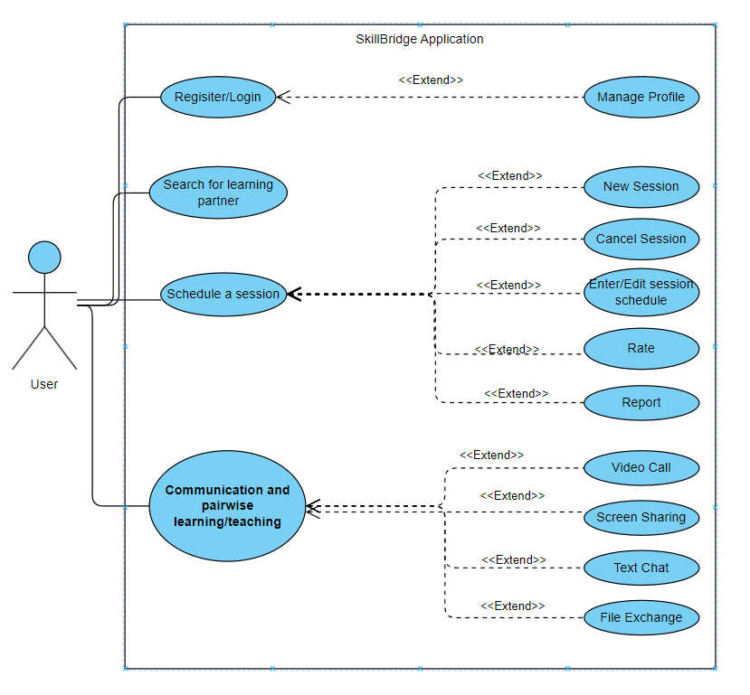

7.1.2 Activity Diagram
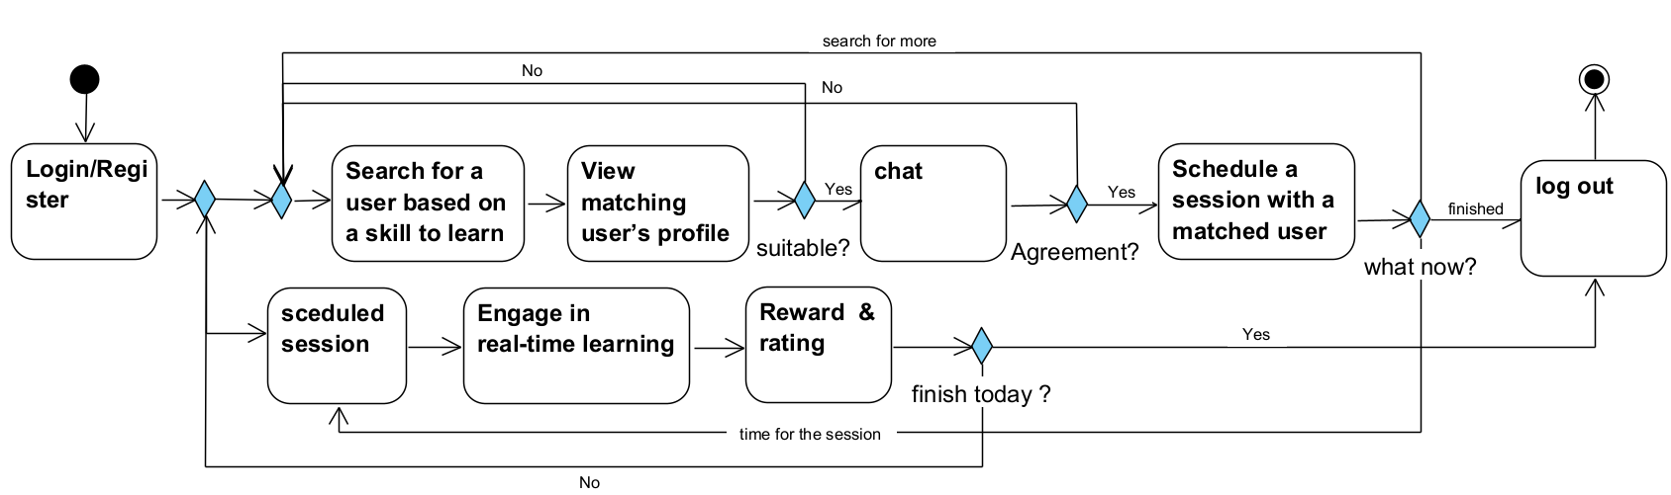

7.2 Architecture Overview
SkillBridge is built using a modular, layered web-based architecture that cleanly separates concerns across user interfaces, business logic, and data storage. This enhances scalability, maintainability, and supports future extensions such as web apps or additional services.
Key Components:
- Frontend: Next.js (React Framework) Delivers a responsive, SEO-optimized web interface for users to register, match, communicate, and schedule sessions.
- Backend: Node.js + Express.js Handles business logic, REST API endpoints, session validation, and integrations with communication services and databases.
- Database: MongoDB (NoSQL) Stores user profiles, skills, availability, feedback, point balances, and session history.
- Real-Time Communication API: Uses WebRTC
- to provide integrated voice, chat, and screen sharing between users.
- Matching Engine + Gamification Logic Algorithms for intelligent pairing and reward management are implemented server-side.
Features Enabled:
- Voice Chat
- Video Calls
- Screen Sharing
Integration Logic:
- When a session begins, the backend generates a secure session token generated by the backend for WebRTC signaling based on several parameters, including the WebRTC App ID, channel identifier, user identifier (UID), user role (e.g., publisher or subscriber), and an expiration timestamp. The channel identifier and user role define the user’s permissions within the session, while the expiration time limits the token’s validity to prevent unauthorized reuse.
- The token and session channel ID are passed to both users’ web clients via the API.
- WebRTC handles media streams, and the React app renders the communication UI accordingly.
- If either user drops the connection, the session is paused, and logs are updated in MongoDB.
3. Presentation Layer
This is the part users see and interact with. Next.js Web App (React)
- Web-first design (PWA-ready)
- Displays dashboard, points, matches, and session status
- Interface for booking, messaging, and giving feedback
- Sends real-time alerts and browser notification

7.3 Layered Architecture
The SkillBridge system follows a three-layer architecture, each with a clear responsibility:
1. Data Layer
The Data Layer is the foundation of the SkillBridge system. It is responsible for persistently storing and retrieving all the critical data required for the application's operations. It ensures data consistency, integrity, and availability, supporting the other layers (Logic and Presentation) by providing structured access to stored information.
1.1 Database Technology – MongoDB
SkillBridge uses MongoDB, a NoSQL document-oriented database. It stores data in flexible, JSON-like documents, making it ideal for managing diverse and evolving data structures such as user profiles, session history, and feedback.
1.2 Key Collections and Schemas
The main collections in MongoDB include:
- Users: Stores personal details, authentication data, skills to teach and learn, point balance, average rating, availability slots, and preferences.
- Sessions: Logs each learning session, including participants, scheduled time, session status, and feedback.
  - Tracks who initiated the session, timestamps, duration, and completion status.
- Feedback & Ratings: Contains post-session ratings and qualitative feedback given by users to one another.
- Gamification Logs: Records point transactions, including reason (e.g., “taught a session”, “booked a session”), timestamp, and updated balances.
1.3 Indexing & Query Optimization
To support efficient real-time matching and retrieval:
- Indexes are created on fields like skillsToTeach, skillsToLearn, and availability.day for fast filtering.
- Text indexes may be used for flexible skill tag matching.
Compound indexes help the matching algorithm efficiently filter based on combined criteria.
1.4 Security & Data Integrity
- Passwords are hashed using bcrypt and stored securely in the Users collection.
- Sensitive data (e.g., tokens, personal info) is never returned to the client unless authenticated.
- Data validation is enforced both at the API layer (Express.js) and at the schema/model level (using Mongoose).
1.5 Backup & Recovery
To ensure data safety and platform reliability:
- Daily automatic backups are scheduled to external secure storage.
- Recovery scripts exist to restore the latest full backup in case of database corruption or system failure.
- Versioning of critical data structures allows safe rollback during updates.

2. Logic Layer
This is the core of the platform — it processes data, applies business logic, and enforces system rules.
2.1 Matching Algorithm
The Matching Algorithm is fundamental to the SkillBridge experience. It is responsible for connecting users who want to learn with those who are willing to teach. Unlike simple keyword-based searches, our algorithm considers multiple weighted factors to ensure that the match quality is relevant, timely, and valuable.
Core Logic and Weighting:
- Skill Compatibility: If a user wants to learn Python, and another user has Python listed in their "can teach" list, they score +50 points.
- Time Availability Match: If both users have a common free slot in their availability calendar, the score increases by +20 points.
- Preferred Learning Method: Matching on communication style — for example, if both users prefer voice chat — adds +15 points.
- User Reputation: Teachers with higher average ratings (e.g., 4.5 stars and above) receive a bonus score of +10.
- Language Compatibility: Ensuring that both parties can communicate in a common language is a required filter.
Technical Operation:
- User input from profile (skills, availability, preferences) is normalized and indexed.
- When a user initiates a search, the backend performs a real-time query against this indexed data using a scoring function.
- Matches are returned as a ranked list, which is passed to the UI via a secured API.
This logic ensures that learning sessions are meaningful and minimizes failed or canceled bookings due to incompatibility.
2.2 Gamification Engine
SkillBridge incorporates a Gamification Engine to motivate user participation and ensure fairness. Users earn points by teaching and spend them when learning. This cyclical balance incentivizes teaching while discouraging passive consumption.
Rules and Triggers:
- Teach a Session: +10 points
- Receive High Rating: +2 bonus points
- Complete 3 Sessions in a Row: +5 streak bonus
- Book a Learning Session: –10 points
- Cancel a Session Last-Minute: –2 points
Logic Flow:
- After a session is marked as complete, a POST request triggers a backend update to both users' point balances.
- Ratings are also stored and calculated as part of the user's global average score, which is then used by the Matching Algorithm.
- Points are stored in MongoDB and are updated atomically to prevent data corruption.
2.3 Express.js API
The Express.js API is the backbone of SkillBridge’s communication architecture. It handles requests from the React frontend and provides access to the MongoDB database while enforcing system-wide logic and security policies.
Core Responsibilities:
- Routing: Handles RESTful endpoints (e.g., /api/match, /api/session, /api/points) to manage all user actions.
- Validation: Ensures that all inputs are sanitized to prevent injection attacks or malformed queries.
- Authentication: Uses JWT (JSON Web Tokens) to validate user identity before performing sensitive actions like scheduling or rating.
- Error Handling: All endpoints return clear HTTP codes and error messages for frontend error management.

8. Results and Conclusions

8.1 Achievement of Objectives
SkillBridge successfully implements the core project objectives:
- Peer-to-peer skill exchange with real-time communication
- Intelligent matching based on skills and availability
- A functional gamified point economy
- Integrated session scheduling and feedback mechanisms

8.2 Decision-Making
Key architectural decisions — such as using a web-first approach, server-side matching logic, and third-party RTC services — were made to balance development complexity, scalability, and system reliability.

8.3 Handling Challenges
Challenges encountered during development were addressed through iterative refinement and architectural adjustments. The Agile workflow allowed rapid response to design issues and technical limitations.

9. Verification and Evaluation
The SkillBridge platform will be evaluated from the perspective of both learners and teachers, recognizing that users can switch between these roles. Our goal is to ensure the platform is user-friendly, reliable, and functional across all use cases — including session matching, teaching, learning, and real-time interaction.

9.1 Evaluation Criteria
We will evaluate SkillBridge based on the following dimensions:
- Usability: How intuitive the app interface is, and whether users can easily navigate the app to match, schedule, and interact.
- Functionality: Ensuring each feature works as intended, including skill matching, point exchange, session setup, and feedback.
- Performance: Response times for chat, loading screens, point updates, and session operations should be under 2 seconds.
- Scalability: The app should support at least 500 concurrent users with no major performance degradation.
- Engagement: How often users participate in sessions, give feedback, and earn/spend points, as tracked through backend metrics.
- Adaptability: The system must function well across different devices and learning preferences (chat vs. voice, quick vs. deep sessions).

9.2 Workflow Verification
Learner/Teacher Workflow (Since each user can be both)

Workflow Step | Test Description
Login Process | Verify users can sign in securely and access their dashboard
Set Skills and Preferences | Confirm users can select skills they want to teach or learn and save their preferences.
View Matches | Ensure the system shows appropriate user matches based on skill compatibility
Book a Session | Check that users can select a match and schedule a session successfully
Communicate in Real-Time | Test that users can exchange messages or voice calls during sessions.
Complete Session | Verify both users can mark a session as completed
Earn/Spend Points | Ensure teaching adds points and learning deducts points correctly
Rate the Partner | Confirm users can leave feedback and rate each other after the session.
View Activity History | Check that users can view past sessions and point transactions.

9.3 Feature-Based Test Table

Test No. | Module | Tested Function | Expected Result
1 | User Management | Registration/Login | Valid credentials allow login; errors for invalid input.
2 | Skill Management | Add/Edit Skills | Users can add and edit skill sets, saved correctly.
3 | Matching Engine | Generate Matches | Top 3+ users shown based on score (skill, time, rating).
4 | Scheduling | Book/Cancel Session | Sessions are booked and can be canceled or rescheduled.
5 | Real-Time Chat | Send/Receive Messages | Messages are delivered within 250ms; no message loss.
6 | Voice/Screen Sharing | Start/End Call | Call starts and ends successfully using integrated tool
7 | Gamification | Earn/Spend Points | Points updated correctly after each session.
8 | Feedback System | Submit/Store Ratings | Feedback is submitted, saved, and affects user rating.
9 | UI Performance | App Responsiveness | UI components work properly across modern web browsers (Chrome,Firefox, Edge)

10.User manual
Welcome to the SkillBridge(https://skill-bridge-prod.vercel.app) Learning and Teaching Platform user documentation. SkillBridge is an interactive web-based platform designed to enable peer-to-peer learning through real-time communication and intelligent skill matching. The system allows users to both teach and learn skills using live video, voice, chat, and screen-sharing, while maintaining motivation through a point-based gamification model.
This user manual describes the standard successful usage flow of the SkillBridge system. Error cases and exceptional scenarios are intentionally omitted.

Login:
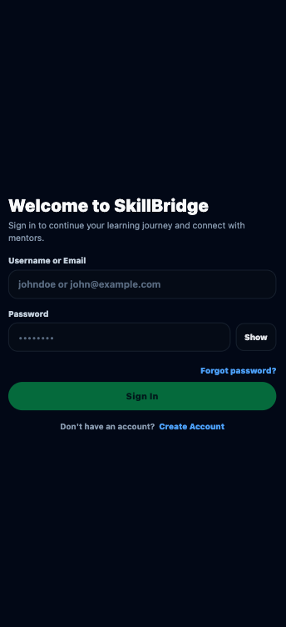
The Login screen allows existing users to access the SkillBridge platform.
Users can sign in by entering either their username or email address together with their password.
After successful authentication, the user is redirected to the main application where they can search for mentors, start learning sessions, and communicate with other users.
If the user does not yet have an account, they can navigate to the Create Account page using the link at the bottom of the screen.

Registration:
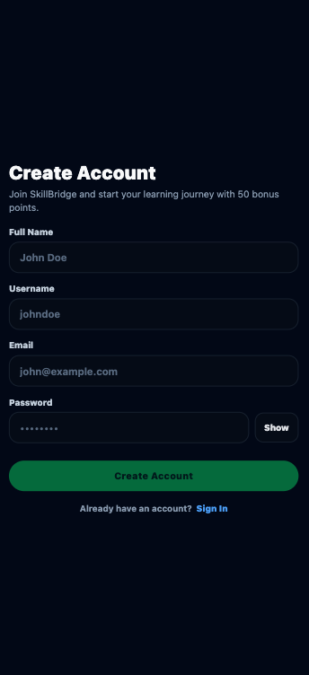
This screen allows new users to create a SkillBridge account.
The user enters their full name, a unique username, email address, and a password.

HomeScreen:
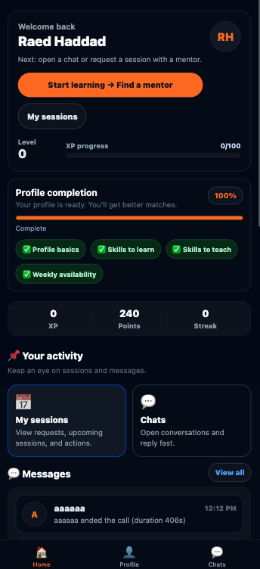
This is the main dashboard of SkillBridge. From here, the user can start learning by finding a mentor, view active or upcoming sessions, and access chats and messages. The screen also shows the user’s level, points, XP progress, profile completion status, and recent activity in one place.

User Profile:
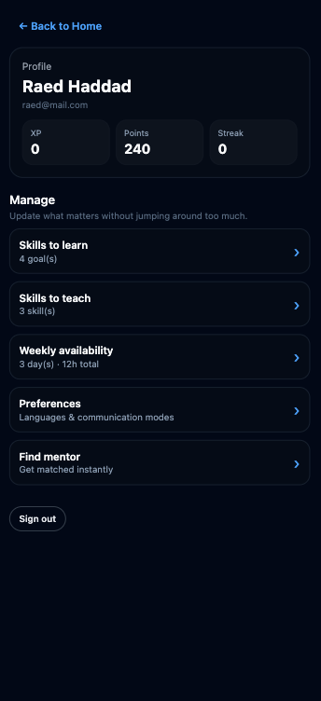
This screen shows the user’s personal profile and current status in SkillBridge.
Here the user can see their XP, earned points, and streak, manage skills to learn and teach, set weekly availability, update preferences, find a mentor, and sign out of the application.
Find a mentor:
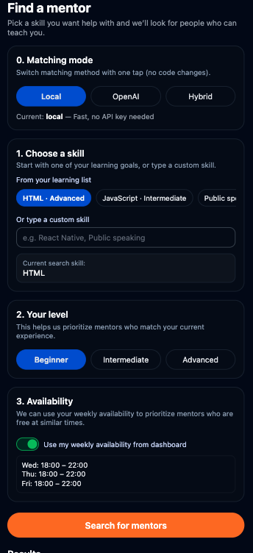
This screen allows the user to search for a mentor. The user selects a skill they want to learn, chooses their experience level, and sets their availability. The system then matches them with suitable mentors based on these preferences.
Search Result - Mentor Matching:
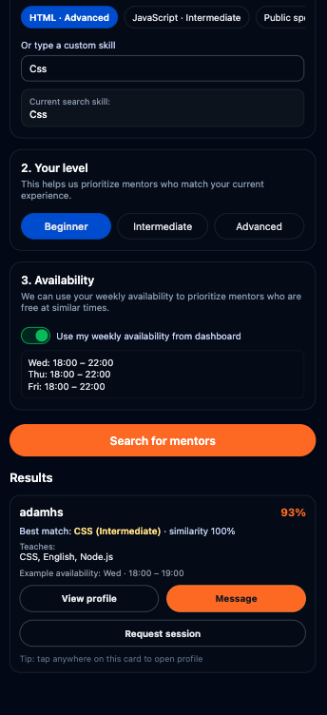
After clicking “Search for mentors”, the system displays a list of mentors who match the selected skill (CSS), experience level, and availability.
Each result shows the mentor’s compatibility percentage, skills, language, and example availability, with options to view the mentor profile, send a message, or request a learning session.
Skill you want to learn:
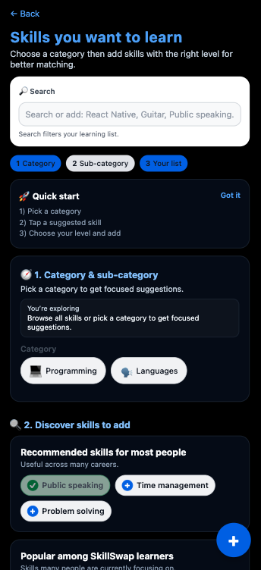
This screen allows the user to define the skills they want to learn.
The user selects a category and sub-category, searches or adds skills, and chooses the appropriate level to improve mentor matching accuracy.

Skill you want to teach:
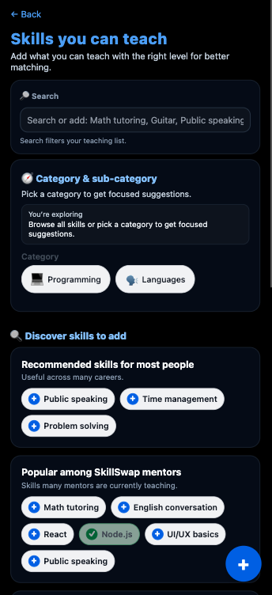
This screen allows the user to add skills they can teach.
The user selects a category, adds skills, and defines their teaching level, helping other users find them as mentors.
Weekly Availability:
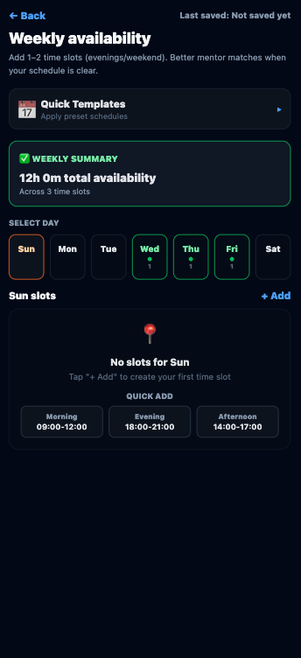
This screen lets users define when they are available during the week.
Availability helps SkillBridge match users with mentors or learners who are free at similar times.
Request session:
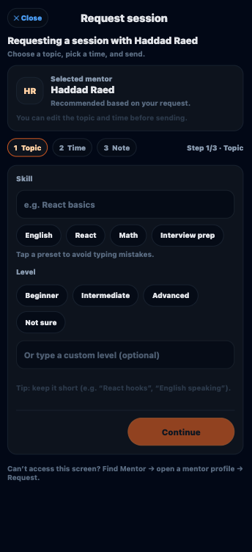
This screen lets the user choose the topic of the session.
The user selects a skill, chooses their level, or enters a custom topic before continuing.

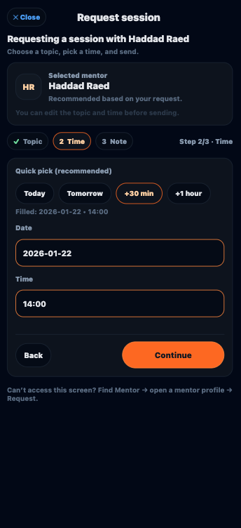
This screen is used to select the session date and time.
The user can quickly pick a suggested time or manually choose a specific date and hour.

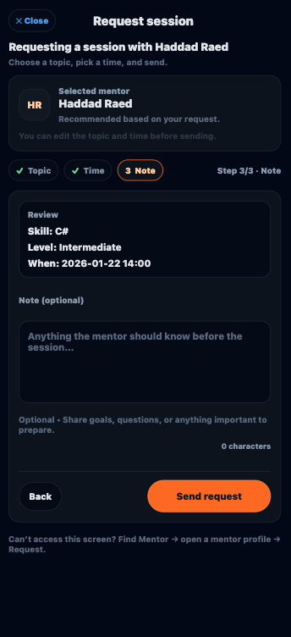
This screen allows the user to review the session details and optionally add a note.
The user can send additional information or questions to the mentor before submitting the request.
My Sessions:
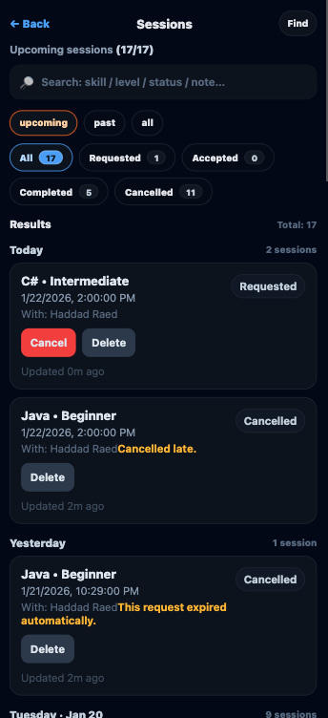
This screen displays all the user’s learning sessions in one place.
The user can search sessions by skill, level, status, or note, and filter them by upcoming, past, or all sessions.
Additional filters allow viewing sessions by status such as requested, accepted, completed, or cancelled.
Each session card shows the skill, level, date and time, mentor name, and current status.From this screen, the user can cancel a pending session or delete past or cancelled sessions.
Accepted Session:
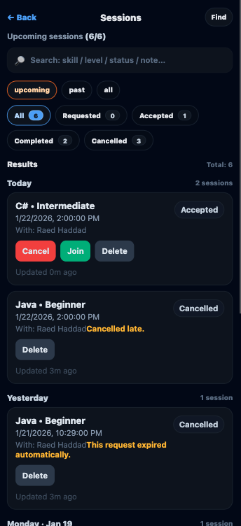
When a mentor accepts a session and the session time is approaching, the session appears as Accepted.
At this stage, the user can Join the session to start the live learning call, Cancel if needed, or Delete the session after it is no longer relevant.This screen helps the user quickly recognize sessions that are about to begin and take action on time.
Completed session and rating:
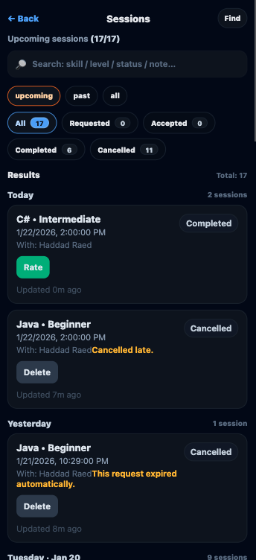
After a session is successfully completed, its status changes to Completed. At this stage, the learner can rate the mentor by clicking the Rate button. This feedback contributes to mentor evaluation and improves future matching quality.

Rate:
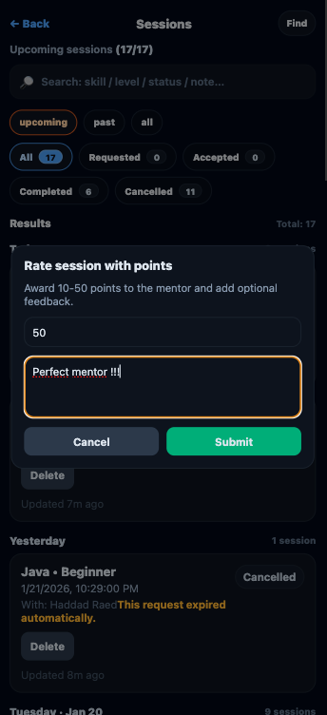
This screen allows the learner to rate a completed session.The user selects how many points to award the mentor (between 10–50 points) and can optionally write short feedback about the session.Click Submit to send the rating and points, or Cancel to close without rating.
Mentor Profile:
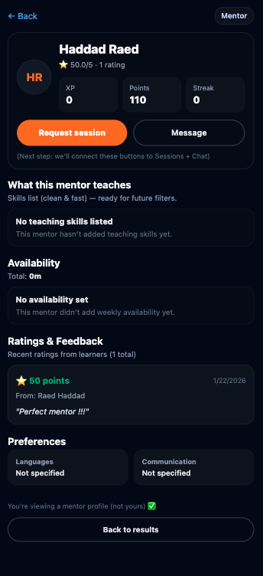
This screen shows the mentor’s public profile.
The learner can see the mentor’s overall rating, total points earned, and recent feedback from previous sessions.Ratings include the number of points awarded and optional written comments, helping learners decide whether to request a session or send a message.
Chats:
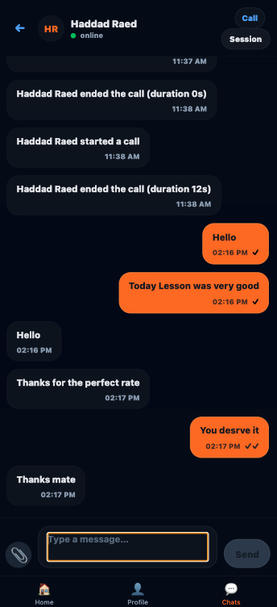
This screen allows users to communicate directly with each other. Both users can send and receive text messages, share files, and start a voice or video call from the chat. The chat also shows call activity (started/ended calls) and message timestamps, making it easy to continue learning and coordination in one place.
Video call:
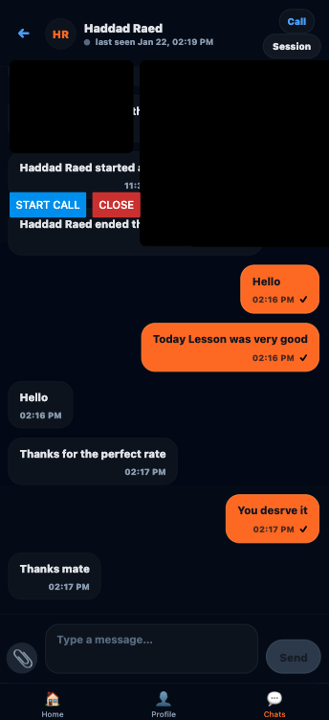
This screen allows two users to start and manage a live video call during a session. Users can start or end the call, see call status (started/ended with duration), and continue chatting alongside the video call in the same conversation.

11.Maintenance Guide

Objective
This guide describes how to maintain, update, and continue using the SkillBridge system after project completion. It focuses on the operating environment, deployment setup, and routine maintenance tasks required to keep the system running reliably.

11.1 System Architecture Overview
SkillBridge follows a modular client–server architecture consisting of a frontend, backend, database, and real-time communication layer. This separation allows independent updates, easier maintenance, and scalability.

11.1.1 Frontend
- Technology: Next.js (React)
- Deployment: Vercel (cloud hosting)
- Responsibilities:
  - User interface and navigation
  - Authentication handling (JWT)
  - Session booking and chat UI
  - WebRTC video call interface
The frontend communicates with the backend using secure REST APIs over HTTPS.

11.1.2 Backend
- Technology: Node.js + Express
- Deployment: AWS EC2 (Ubuntu)
- Responsibilities:
  - User authentication and authorization
  - Matching algorithm execution
  - Gamification and point management
  - Session lifecycle management
  - WebRTC signaling and session metadata
The backend exposes REST endpoints consumed by the frontend and enforces all business rules server-side.

11.1.3 Database
- Technology: MongoDB
- Stored Data:
User profiles and skills
  - Availability schedules
  - Session records
  - Ratings and feedback
  - Point transactions

11.1.4 Real-Time Communication
- Technology: WebRTC
- Purpose:
  - Video calls
  - Voice calls
  - Screen sharing
WebRTC media streams are peer-to-peer, while signaling is handled by the backend server.

11.2 Operating Environment

11.2.1 Software Requirements
Backend Server :
- Ubuntu 20.04+
- Node.js v18+
- npm
- MongoDB
- Nginx (reverse proxy)
Frontend:
- Modern web browser (Chrome, Edge, Firefox)
- Vercel deployment environment

11.2.2 Hardware Requirements
- Backend Server:
  - Minimum: 2 vCPU, 4GB RAM
  - Recommended for scale: 4 vCPU, 8GB RAM
- Clients:
  - Any modern device with camera, microphone, and browser support

11.3 Installation and Startup (Developer / Maintenance Use)

11.3.1 Backend Setup (Local or Server)
git clone https://github.com/<your-org>/SkillBridge.git
cd SkillBridge/server
npm install
Create .env file:
PORT=4000
MONGO_URI=your_mongodb_connection
JWT_SECRET=your_secret
FRONTEND_URL=https://skill-bridge-prod.vercel.app
Start server:
Node server.js

11.3.2 Frontend Setup (Local Development)
cd SkillBridge/
npm install
npm run dev
For production, the frontend is automatically deployed on Vercel:
https://skill-bridge-prod.vercel.app
No manual installation is required for end users.

11.4 Regular Maintenance Tasks

11.4.1 Dependency Updates
- Periodically update Node.js dependencies:
npm outdated
npm update
- Update frontend dependencies via Vercel deployments.

11.4.2 Database Maintenance
- Enable automatic MongoDB backups
- Periodically review indexes on:
  - skillsToTeach
  - skillsToLearn
  - availability
- Monitor database size and performance

11.4.3 Log Monitoring
- Backend logs (Node.js / Nginx)
- Monitor:
  - API errors
  - Failed authentication attempts
  - Session creation issues
- Rotate logs regularly to avoid disk overflow

11.5 Security Maintenance
- Rotate JWT secrets periodically
- Enforce HTTPS only (via Nginx)
- Review CORS settings when frontend URL changes
- Regularly update OS security patches on EC2

11.6 Monitoring and Future Improvements

11.6.1 Monitoring
Recommended tools:
- Prometheus + Grafana
Monitor:
  - CPU and memory usage
  - API response times
  - Active sessions
  - Error rates

11.6.2 Alerts
- Configure alerts for:
  - Server downtime
  - High memory usage
  - Database connection failures

11.7 Troubleshooting

Common Issues
- Video call fails: Check TURN/STUN availability and firewall ports
- CORS errors: Verify Nginx headers
- Login issues: Validate JWT secret consistency
- No matches: Check user skills and availability data

11.8 Documentation and Updates
- Keep API and system documentation updated
- Use GitHub for version control
- Tag stable releases
- Document major changes before deployment

12. References
Beck, K., et al. (2001). Manifesto for Agile Software Development. Retrieved from https://agilemanifesto.org/
Vercel. (2024). Next.js Documentation. Retrieved from https://nextjs.org/docs
Meta Platforms, Inc. (2024). React Documentation. Retrieved from https://react.dev/
MongoDB Inc. (2024). MongoDB Documentation. Retrieved from https://www.mongodb.com/docs/
Nielsen, J. (1994). Usability Engineering. Morgan Kaufmann.
OpenAI. (2024). AI Tools and Techniques: ChatGPT.
Pressman, R. S. (2014). Software Engineering: A Practitioner’s Approach (8th ed.). McGraw-Hill.
Sommerville, I. (2016). Software Engineering (10th ed.). Pearson Education.
W3C. (2024). WebRTC 1.0: Real-Time Communication Between Browsers.
Retrieved from https://www.w3.org/TR/webrtc/
Google & W3C. (2024). WebRTC: Real-Time Communication for the Web.
Retrieved from https://webrtc.org/
Mongoose Team. (2024). Mongoose ODM Documentation. Retrieved from https://mongoosejs.com/docs/guide.html
Shneiderman, B., & Plaisant, C. (2010). Designing the User Interface: Strategies for Effective Human-Computer Interaction (5th ed.). Boston, MA: Pearson.
Bootstrap Team. (2024). Bootstrap Documentation. Retrieved from https://getbootstrap.com/docs/
SkillSwap. (n.d.). SkillSwap – Skill Exchange Platform. Retrieved from https://skillswap.io/

