work_flow

blind

2024-04-15

target_dir <- "../../ppcc_iflu_data/read_data"  
# Reading the data back in  
s_exp1 <- read.csv(file.path(target_dir, "s_exp1.csv"))  
s_exp1_et <- read.csv(file.path(target_dir, "s_exp1_et.csv"))  
digit_span <- read.csv(file.path(target_dir, "digit_span.csv"))  
battery <- read.csv(file.path(target_dir, "battery.csv"))  
lextale <- read.csv(file.path(target_dir, "lextale.csv"))  
italian_lextale <- read.csv(file.path(target_dir, "italian_lextale.csv"))  
autism <- read.csv(file.path(target_dir, "autism.csv"))  
acoustic_data <- read.csv(file.path(target_dir, "acoustic_data.csv"))  
removal <- read.csv(file.path(target_dir, "removal.csv"))

#battery tasks

conflicts_prefer(dplyr::filter)

## [conflicted] Will prefer dplyr::filter over any other package.

battery_tidy<-battery%>%  
 select(participant.private.id,tree.node.key,task.name,screen.name,screen.number,display,reaction.time,response,sound1,sound2,base1,base2,same)%>%  
 filter(display=="block" &screen.name == "Screen 3")%>%  
 mutate(responses=case_when(response == "'z'"~1,  
 response == "'m'"~0),  
 correct=if_else(responses==same,1,0),  
 difference=abs(base1-base2))  
  
battery_tidy%>%ggplot(aes(x=reaction.time))+  
 geom_histogram()+  
 facet_wrap(participant.private.id~.)

## `stat_bin()` using `bins = 30`. Pick better value with `binwidth`.

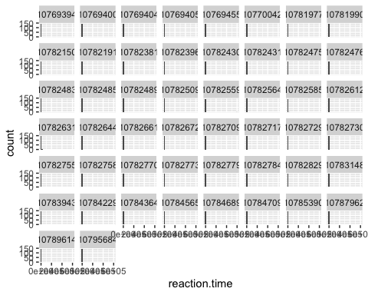

mad_standard=3  
  
battery_cleaned<-battery_tidy%>%  
 #group_by(participant.private.id)%>%  
 dplyr::filter(reaction.time>200)%>%  
 mutate(log_rt=sqrt(reaction.time))%>%  
 mutate(display_medians = median(log_rt),  
 abs_distance = abs(display_medians-log_rt),  
 mean_distance = mean(abs_distance),  
 upper_mad = display_medians+(mean_distance*mad_standard),  
 lower_mad = display_medians-(mean_distance*mad_standard))%>%  
 group_by(participant.private.id)%>%  
 mutate(participants_medians = median(log_rt))%>%  
 dplyr::filter(log_rt<upper_mad &log_rt>lower_mad)  
  
  
removal[nrow(removal) + 1, ] <- c("battery removal",   
 nrow(battery_tidy) - nrow(battery_cleaned))  
  
battery_cleaned%>%ggplot(aes(x=log_rt))+  
 geom_histogram()+  
 geom_point(aes(x=upper_mad,y=0),color="red")+  
 geom_point(aes(x=lower_mad,y=0),color="blue")+  
 facet_wrap(participant.private.id~.)

## `stat_bin()` using `bins = 30`. Pick better value with `binwidth`.

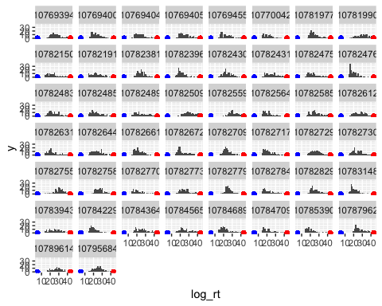

battery_cleaned%>%ggplot(aes(x=factor(participant.private.id),y=participants_medians))+  
 geom_point()+  
 geom_point(aes(y=upper_mad,x=factor(participant.private.id)),color="red")+  
 geom_point(aes(y=lower_mad,x=factor(participant.private.id)),color="blue")

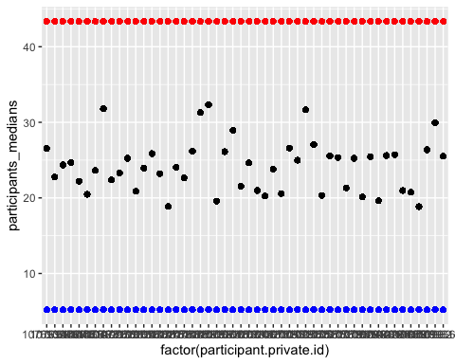

battery_cleaned_part_agg<-battery_cleaned%>%  
 group_by(participant.private.id)%>%  
summarise(score=mean(correct))%>%  
 ungroup()%>%  
 mutate(medians = median(score),  
 abs_distance = abs(medians-score),  
 mean_distance = mean(abs_distance),  
 upper_mad = medians+(mean_distance*mad_standard),  
 lower_mad = medians-(mean_distance*mad_standard))  
  
battery_cleaned_part_agg%>%  
 ggplot(aes(x=factor(participant.private.id),y=score))+  
 geom_point()+  
 geom_point(aes(x=factor(participant.private.id),y=upper_mad),color="red")+  
 geom_point(aes(x=factor(participant.private.id),y=lower_mad),color="red")+  
 theme(axis.text.x = element_text(angle = 90, hjust = 1, vjust = 0.5))

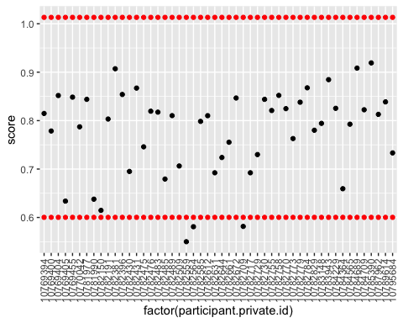

battery_cleaned_part_agg_keep<-battery_cleaned_part_agg%>%  
 filter(score<upper_mad & score>lower_mad)  
  
battery_cleaned_item_agg<-battery_cleaned%>%  
 group_by(difference,participant.private.id)%>%  
summarise(score=mean(correct))%>%  
 ungroup()%>%  
 mutate(medians = median(score),  
 abs_distance = abs(medians-score),  
 mean_distance = mean(abs_distance),  
 upper_mad = medians+(mean_distance*mad_standard),  
 lower_mad = medians-(mean_distance*mad_standard))

## `summarise()` has grouped output by 'difference'. You can override using the  
## `.groups` argument.

battery_cleaned_item_agg%>%  
 ggplot(aes(x=factor(difference),y=score))+  
 geom_boxplot()+  
 geom_point()+  
 geom_point(aes(x=factor(difference),y=upper_mad),color="red")+  
 geom_point(aes(x=factor(difference),y=lower_mad),color="red")+  
 theme(axis.text.x = element_text(angle = 90, hjust = 1, vjust = 0.5))

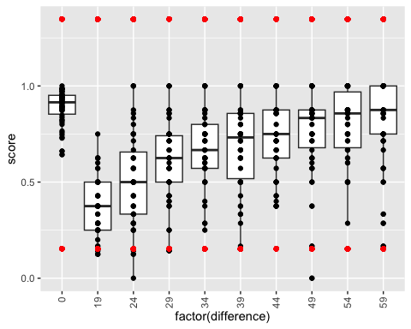

battery_agg2<-battery_cleaned%>%  
 group_by(participant.private.id, task.name) %>%  
 summarize(score=mean(correct))

## `summarise()` has grouped output by 'participant.private.id'. You can override  
## using the `.groups` argument.

battery_agg2%>%ggplot(aes(x=task.name,y=score,color=factor(task.name)))+  
 geom_boxplot()+  
 geom_jitter()+  
 theme_minimal()

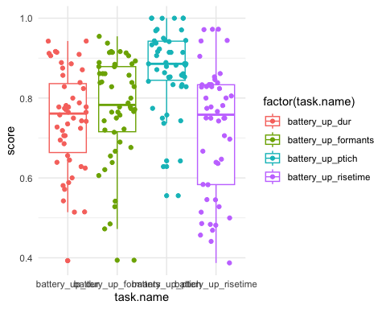

battery_agg<-battery_cleaned%>%  
 mutate(  
 hit = if_else(same == 1 & responses == 1L, 1L, 0L),  
 f_a = if_else(same == 0 & responses == 1L, 1L, 0L),  
 miss = if_else(same == 0 & responses == 0L, 1L, 0L),  
 c_r = if_else(same == 1 & responses == 0L, 1L, 0L))%>%  
 group_by(participant.private.id, task.name) %>%  
 summarize(  
 score=mean(correct)+.5,  
 hit_count = sum(hit)+.5,  
 f_a_count = sum(f_a)+.5,  
 miss_count = sum(miss)+.5,  
 c_r_count = sum(c_r)+.5,  
 .groups = 'drop')%>%  
 mutate(  
 dprime = dprime(hit_count,   
 f_a_count,   
 hit_count + miss_count,   
 f_a_count + c_r_count)$dprime,  
 c = dprime(hit_count,   
 f_a_count,   
 hit_count + miss_count,   
 f_a_count + c_r_count)$c)%>%  
 select(participant.private.id, task.name, dprime, c)  
  
  
battery_agg%>%ggplot(aes(x=factor(task.name),y=dprime,color=factor(task.name),alpha=.4))+  
 geom_line(aes(group=factor(participant.private.id)),color="black")+  
 geom_violin()+  
 geom_boxplot(width=.5)+  
 geom_point()+  
 theme_minimal()

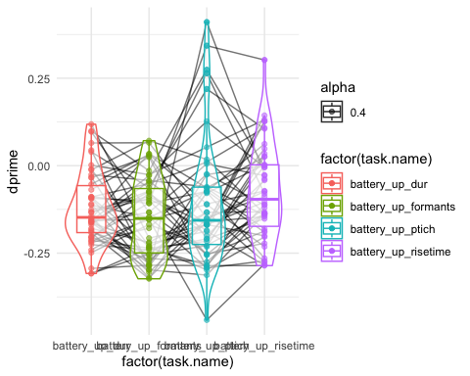

battery_agg%>%ggplot(aes(x=c,y=dprime,color=factor(task.name)))+  
 geom_point()+  
 theme_minimal()+  
 facet_grid(.~factor(task.name))

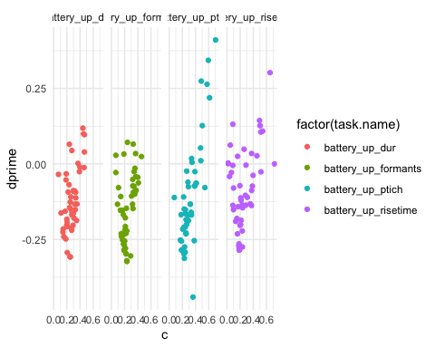

battery_agg_wider<-battery_agg%>%  
 pivot_wider(names_from = task.name,values_from = c(dprime:c))  
  
battery_agg_wider_simp<-battery_agg_wider  
ggpairs(battery_agg_wider_simp%>%select(!participant.private.id))

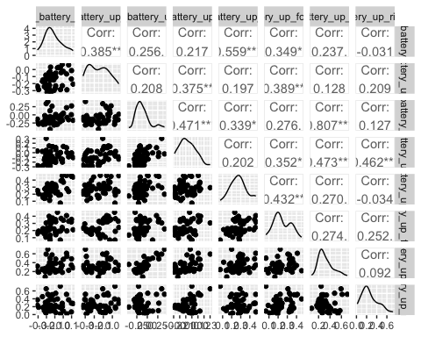

#digit span

digit_tidy<-digit_span%>%  
 select(participant.private.id,tree.node.key,task.name,  
 target,response,length,correct.,total.correct)%>%  
 filter(correct.==1)%>%  
 group_by(participant.private.id)%>%  
 mutate(length=as.numeric(length))%>%  
 summarize(max_working_memory=max(length),  
 min_working_memory=min(length),  
 mean_working_memory=mean(length),  
 max_correct=max(total.correct))  
  
digit_tidy%>%  
 ggplot(aes(x=1,y=max_correct,color=factor(max_working_memory)))+  
 geom_jitter()

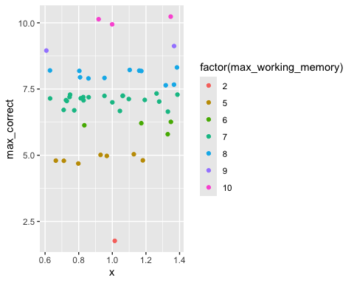

digit_cleaned<-digit_tidy%>%  
 ungroup()%>%  
 mutate(display_medians = median(max_correct),  
 abs_distance = abs(display_medians-mean_working_memory),  
 mean_distance = mean(abs_distance),  
 upper_mad = display_medians+(mean_distance*mad_standard),  
 lower_mad = display_medians-(mean_distance*mad_standard))%>%  
 filter(max_correct<upper_mad &max_correct>lower_mad)  
  
digit_cleaned%>%  
 ggplot(aes(x=mean_working_memory))+  
 geom_histogram()

## `stat_bin()` using `bins = 30`. Pick better value with `binwidth`.

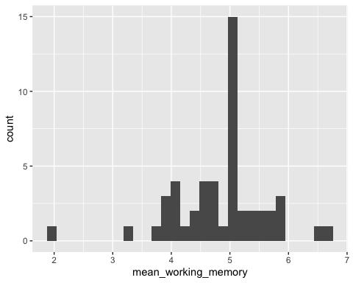

digit_cleaned%>%  
 ggplot(aes(x=1,y=mean_working_memory,color=factor(max_working_memory)))+  
 geom_jitter()

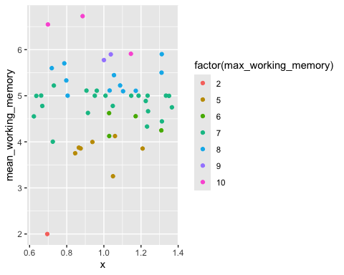

removal[nrow(removal) + 1, ] <- c("digit_span_participant",   
 nrow(digit_tidy) - nrow(digit_cleaned))  
  
digit_cleaned_simp<-digit_cleaned%>%select(participant.private.id,mean_working_memory)

#lextale English

lextale_tidy<-lextale%>%  
 select(participant.private.id,screen.name,zone.type,reaction.time,correct)%>%  
 filter(zone.type=="response_keyboard")%>%  
 filter(reaction.time>250)  
  
lextale_tidy%>%ggplot(aes(x=reaction.time))+geom_histogram()

## `stat_bin()` using `bins = 30`. Pick better value with `binwidth`.

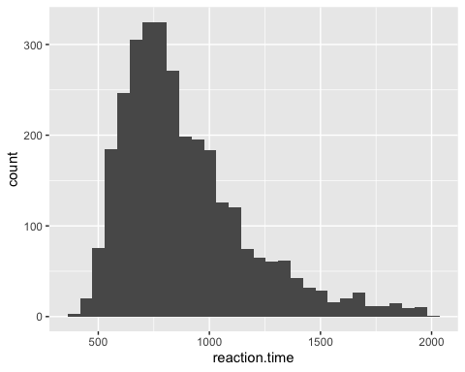

lextale_agg<-lextale_tidy%>%  
 group_by(participant.private.id)%>%  
 summarize(lextale_score=mean(correct))  
  
lextale_agg_cleaned<-lextale_agg%>%  
 ungroup()%>%  
 mutate(medians = median(lextale_score),  
 abs_distance = abs(medians-lextale_score),  
 mean_distance = mean(abs_distance),  
 upper_mad = medians+(mean_distance*mad_standard),  
 lower_mad = medians-(mean_distance*mad_standard))%>%  
 filter(lextale_score<upper_mad &lextale_score>lower_mad)  
  
  
lextale_agg_cleaned%>%ggplot(aes(x=lextale_score))+  
 geom_histogram()

## `stat_bin()` using `bins = 30`. Pick better value with `binwidth`.

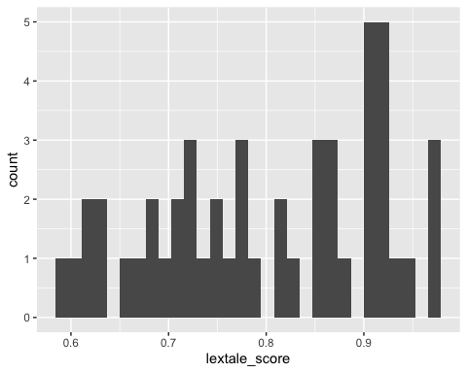

removal[nrow(removal) + 1, ] <- c("lextale_agg_participant",   
 nrow(lextale_agg) - nrow(lextale_agg_cleaned))  
  
lextale_agg_cleaned_simp<-lextale_agg_cleaned%>%select(lextale_score,participant.private.id)

#lextale italian

italian_lextale_tidy<-italian_lextale%>%  
 select(participant.private.id,screen.name,zone.type,reaction.time,correct)%>%  
 filter(zone.type=="response_keyboard")%>%  
 filter(reaction.time>250)  
  
italian_lextale_tidy%>%ggplot(aes(x=reaction.time))+geom_histogram()

## `stat_bin()` using `bins = 30`. Pick better value with `binwidth`.

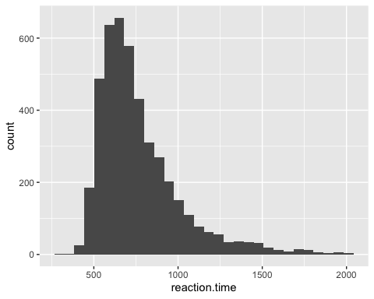

italian_lextale_agg<-italian_lextale_tidy%>%  
 group_by(participant.private.id)%>%  
 summarize(italian_lextale_score=mean(correct))  
  
italian_lextale_agg_cleaned<-italian_lextale_agg%>%  
 ungroup()%>%  
 mutate(medians = median(italian_lextale_score),  
 abs_distance = abs(medians-italian_lextale_score),  
 mean_distance = mean(abs_distance),  
 upper_mad = medians+(mean_distance*mad_standard),  
 lower_mad = medians-(mean_distance*mad_standard))%>%  
 filter(italian_lextale_score<upper_mad &italian_lextale_score>lower_mad)  
  
  
italian_lextale_agg_cleaned%>%ggplot(aes(x=italian_lextale_score))+  
 geom_histogram()

## `stat_bin()` using `bins = 30`. Pick better value with `binwidth`.

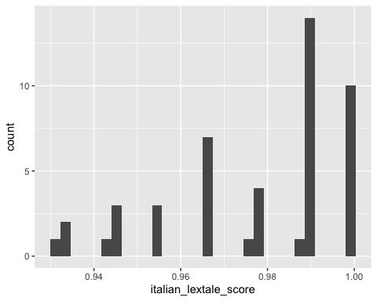

removal[nrow(removal) + 1, ] <- c("italian_lextale_agg_participant",   
 nrow(italian_lextale_agg) - nrow(italian_lextale_agg_cleaned))  
  
italian_lextale_agg_cleaned_simp<-italian_lextale_agg_cleaned%>%select(italian_lextale_score,participant.private.id)

#ASD scores

autism_tidy<-autism%>%  
 select(participant.private.id,question.key,response)%>%  
 filter(str_detect(question.key, "quantised"))%>%  
 mutate(response=as.numeric(response))  
  
  
agree<-c(1, 2, 4, 5, 6, 7, 9, 12, 13, 16, 18, 19, 20, 21,   
 22, 23, 26, 33, 35, 39, 41,42, 43, 45, 46)  
disagree<-c(3, 8, 10, 11, 14, 15, 17, 24, 25, 27, 28, 29,   
 30, 31, 32,34, 36, 37, 38, 40, 44, 47, 48, 49, 50)  
agr_key<-c("1","2")  
dis_key<-c("3","4")  
  
autism_cleaned<-autism_tidy%>%  
 mutate(key_response = str_replace_all(question.key, "AQ", ""))%>%  
 mutate(key_response = str_replace_all(key_response, "-quantised", ""))%>%  
 mutate(points=case_when(key_response%in%agree & response %in% agr_key~1,  
 key_response%in%agree & response %in% dis_key~0,  
 key_response%in%disagree & response %in% dis_key~1,  
 key_response%in%disagree & response %in% agr_key~0))%>%  
 group_by(participant.private.id)%>%  
 summarize(autism_score=mean(points))  
  
autism_cleaned%>%ggplot(aes(x=autism_score))+geom_histogram()

## `stat_bin()` using `bins = 30`. Pick better value with `binwidth`.

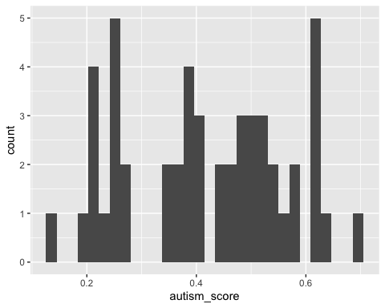 #minor task clean up above #experiment 1 behaviorial data clean up

s_exp1_cleaned<-s_exp1%>%  
 select(participant.private.id,spreadsheet.row,response,real_1_distractor_0,zone.type,display,audio,  
 q1_image,q2_image,q3_image,q4_image,  
 id,grouping_id,sorting,audio)%>%  
 filter(zone.type=="response_button_image")%>%  
 mutate(audio=tolower(audio),  
 word_play = str_remove(str_extract(audio, "^[^_]+"), "\\.wav"),  
 word_play_start = substr(word_play, 1, 3),  
 stress_play = str_remove(str_extract(audio, "(?<=_)[^_]+"), "\\.wav"),  
 response_word = str_extract(response, "(?<=\\d)[a-zA-Z]+(?=\\.jpeg)"),  
 response_thing = str_extract(response, "(?<=\\D)\\d{2}(?=[a-zA-Z]+\\.jpeg)"),  
 correct=if_else(response_word==word_play,1,0))%>%  
 mutate(stress_play=if_else(stress_play=="p","Penultimate","Anti-penultimate"),  
 q1_word= str_extract(q1_image, "(?<=\\d)[a-zA-Z]+(?=\\.jpeg)"),  
 q2_word= str_extract(q2_image, "(?<=\\d)[a-zA-Z]+(?=\\.jpeg)"),  
 q3_word= str_extract(q3_image, "(?<=\\d)[a-zA-Z]+(?=\\.jpeg)"),  
 q4_word= str_extract(q4_image, "(?<=\\d)[a-zA-Z]+(?=\\.jpeg)"))%>%  
 mutate(target_quantile=case_when(q1_word==word_play~1,  
 q2_word==word_play~2,  
 q3_word==word_play~3,  
 q4_word==word_play~4),  
 competitor_quantile = case_when(  
 q1_word != word_play & str_detect(q1_word,word_play_start) ~ 1,  
 q2_word != word_play & str_detect(q2_word,word_play_start) ~ 2,  
 q3_word != word_play & str_detect(q3_word,word_play_start) ~ 3,  
 q4_word != word_play & str_detect(q4_word,word_play_start) ~ 4))%>%  
 rowwise() %>%  
 mutate(distractor_1_quantile = {  
 possible_values <- setdiff(1:4, c(target_quantile, competitor_quantile))  
 sample(possible_values, 1)  
 })%>%  
 mutate(distractor_2_quantile = 10-sum(distractor_1_quantile,target_quantile,competitor_quantile))%>%  
 ungroup()  
  
s_exp1_cleaned<-s_exp1_cleaned%>%  
 mutate(target = case_when(target_quantile == 1 ~ q1_word,  
 target_quantile == 2 ~ q2_word,  
 target_quantile == 3 ~ q3_word,  
 target_quantile == 4 ~ q4_word),  
 competitor = case_when(competitor_quantile == 1 ~ q1_word,  
 competitor_quantile == 2 ~ q2_word,  
 competitor_quantile == 3 ~ q3_word,  
 competitor_quantile == 4 ~ q4_word),  
 dist_1 = case_when(distractor_1_quantile == 1 ~ q1_word,  
 distractor_1_quantile == 2 ~ q2_word,  
 distractor_1_quantile == 3 ~ q3_word,  
 distractor_1_quantile == 4 ~ q4_word),  
 dist_2 = case_when(distractor_2_quantile == 1 ~ q1_word,  
 distractor_2_quantile == 2 ~ q2_word,  
 distractor_2_quantile == 3 ~ q3_word,  
 distractor_2_quantile == 4 ~ q4_word))

item_agg<-s_exp1_cleaned%>%group_by(word_play)%>%  
 summarise(score=mean(correct))%>%  
 ungroup()%>%  
 mutate(medians = median(score),  
 abs_distance = abs(medians-score),  
 mean_distance = mean(abs_distance),  
 upper_mad = medians+(mean_distance*mad_standard),  
 lower_mad = medians-(mean_distance*mad_standard))  
  
item_agg%>%  
 ggplot(aes(x=factor(word_play),y=score))+  
 geom_point()+  
 geom_point(aes(x=factor(word_play),y=upper_mad),color="red")+  
 geom_point(aes(x=factor(word_play),y=lower_mad),color="red")+  
 theme(axis.text.x = element_text(angle = 90, hjust = 1, vjust = 0.5))

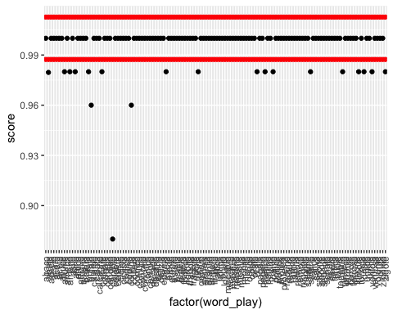

item_agg_keep<-item_agg%>%  
 filter(score<upper_mad & score>lower_mad)  
  
removal[nrow(removal) + 1, ] <- c("exp1_item_removed",   
 length(unique(item_agg$word_play)) - length(unique(item_agg_keep$word_play)))  
  
part_agg<-s_exp1_cleaned%>%group_by(participant.private.id)%>%  
 summarise(score=mean(correct))%>%  
 ungroup()%>%  
 mutate(medians = median(score),  
 abs_distance = abs(medians-score),  
 mean_distance = mean(abs_distance),  
 upper_mad = medians+(mean_distance*mad_standard),  
 lower_mad = medians-(mean_distance*mad_standard))  
  
part_agg%>%  
 ggplot(aes(x=factor(participant.private.id),y=score))+  
 geom_point()+  
 geom_point(aes(x=factor(participant.private.id),y=upper_mad),color="red")+  
 geom_point(aes(x=factor(participant.private.id),y=lower_mad),color="red")+  
 theme(axis.text.x = element_text(angle = 90, hjust = 1, vjust = 0.5))

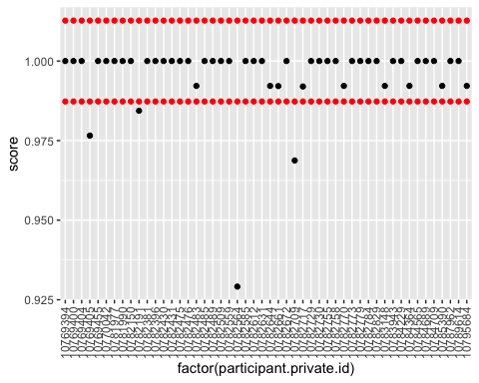

part_agg_keep<-part_agg%>%  
 filter(score<upper_mad & score>lower_mad)  
  
removal[nrow(removal) + 1, ] <- c("exp1_part_removed",   
 length(unique(part_agg$participant.private.id)) - length(unique(part_agg_keep$participant.private.id)))  
  
#s_exp1_cleaned<-s_exp1_cleaned%>%filter(participant.private.id%in%part_agg_keep$participant.private.id)  
#s_exp1_cleaned<-s_exp1_cleaned%>%filter(word_play%in%item_agg_keep$word_play)  
  
length(unique(s_exp1_cleaned$participant.private.id))

## [1] 50

length(unique(s_exp1_cleaned$word_play))

## [1] 128

list_o_word<-c('canapa','candido','celebre','codice','comico','eremo','estero','federa','forbice','fragola','impeto','lattice','loculo','macabro','mastice','missile','monito','panico','protesi','remora','salice','senape','tonaca','zigomo','canale','candito','celeste','codino','comizio','erede','esteta','fedele','forbito','fragore','impero','lattina','locusta','macaco','mastino','missiva','monile','panino','protesta','remoto','saliva','senato','tonale','zigote')  
  
s_exp1_cleaned<-s_exp1_cleaned%>%  
 filter(correct==1)%>%  
 filter(word_play%in%list_o_word)  
  
prac<-s_exp1_cleaned%>%ungroup()%>%group_by(real_1_distractor_0,stress_play,word_play)%>%count()

#exp 1 eye-tracking data clean up

s_exp1_et_cleaned<-s_exp1_et%>%  
 select(participant_id,spreadsheet_row,type,time_stamp,  
 time_elapsed,x_pred_normalised,y_pred_normalised,face_conf)%>%  
 mutate(participant.private.id=participant_id,  
 spreadsheet.row=spreadsheet_row)%>%  
 select(!c(participant_id,spreadsheet_row))%>%  
 filter(type=="prediction")  
   
origin<-c(0,0)  
s_exp1_data_all <- s_exp1_et_cleaned %>%  
 left_join(s_exp1_cleaned)%>%  
 na.omit()%>%  
 filter(face_conf>.5)%>%  
 mutate(x_pred_normalised=x_pred_normalised-.5,  
 y_pred_normalised=y_pred_normalised-.5)%>%  
 filter(x_pred_normalised<1&x_pred_normalised>-1)%>%  
 filter(y_pred_normalised<1&y_pred_normalised>-1)%>%  
 mutate(current_quadrant = case_when(  
 x_pred_normalised < origin[1] & y_pred_normalised > origin[2] ~ q1_word,  
 x_pred_normalised > origin[1] & y_pred_normalised > origin[2] ~ q2_word,  
 x_pred_normalised < origin[1] & y_pred_normalised < origin[2] ~ q3_word,  
 x_pred_normalised > origin[1] & y_pred_normalised < origin[2] ~ q4_word))%>%  
 mutate(target_looks=if_else(current_quadrant==target,1,0),  
 competitor_looks=if_else(current_quadrant==competitor,1,0),  
 dist1_looks=if_else(current_quadrant==dist_1,1,0),  
 dist2_looks=if_else(current_quadrant==dist_2,1,0))%>%  
 group_by(participant.private.id,spreadsheet.row,stress_play)%>%  
 mutate(time=time_stamp-min(time_stamp),  
 time_rounded = round(time / 50) * 50)%>%  
 mutate(time_rounded=time_rounded-1000)%>%  
 mutate(time_rounded=time_rounded-200)%>%  
 filter(time_rounded<1000&time_rounded>=0)

## Joining with `by = join_by(participant.private.id, spreadsheet.row)`

ets_exp1_all_agg<-s_exp1_data_all%>%  
 group_by(stress_play,time_rounded)%>%  
 summarise(mean_target_looks=mean(target_looks),  
 mean_competitor_looks=mean(competitor_looks),  
 mean_dist1_looks=mean(dist1_looks),  
 mean_dist2_looks=mean(dist2_looks))%>%  
 ungroup()%>%  
 pivot_longer(cols=c(mean_target_looks:mean_dist2_looks),names_to = "names",values_to="values")

## `summarise()` has grouped output by 'stress_play'. You can override using the  
## `.groups` argument.

penn_times<-c(300, 500, 650)  
anti_times<-c(390, 530, 625)  
  
df_1 <- data.frame(  
 time_rounded = penn_times,  
 values = 0.6,  
 labels = c("ca", "LA", "ta")  
)  
  
df_2 <- data.frame(  
 time_rounded = anti_times,  
 values = 0.6,  
 labels = c("CA", "la", "mo")  
)  
  
plot1<-ets_exp1_all_agg %>%  
 filter(stress_play == "Penultimate") %>%  
 ggplot(aes()) +  
 geom_text(data=df_1,aes(label=labels,x = time_rounded, y = values),  
 family = "Arial", size = 4, fontface = "bold")+  
 geom_point(aes(x = time_rounded, y = values, color = names)) +  
 geom_smooth(aes(x = time_rounded, y = values, color = names),se=FALSE)+  
 scale_y_continuous(breaks=seq(0, 1, by = .25),  
 labels=seq(0, 1, by = .25))+  
 scale_x_continuous(  
 breaks = seq(min(ets_exp1_all_agg$time_rounded, na.rm = TRUE),   
 max(ets_exp1_all_agg$time_rounded, na.rm = TRUE), by = 200),  
 labels = seq(min(ets_exp1_all_agg$time_rounded, na.rm = TRUE),   
 max(ets_exp1_all_agg$time_rounded, na.rm = TRUE), by = 200),  
 minor_breaks = c(0,200,201, 396, 566, 699,800),   
 position = "bottom")+  
 theme_minimal() +  
 theme(  
 axis.text.x.top = element_text(color = "black"),  
 axis.text.x = element_text(color = "black"),  
 panel.grid.major.x = element_line(color = "grey", size = 0.1),  
 panel.grid.minor.x = element_line(linetype = "dotted", color = "black", size = 0.5),  
 panel.grid.minor.y = element_blank(),  
 panel.grid.major.y = element_line(color = "grey", size = 0.1),  
 legend.position = c(0.1, 0.9),  
 legend.justification = c(0, 1),  
 legend.background = element_rect(fill = "white", colour = "black"))+  
 labs(x = NULL,y= "") +  
 guides(color = guide_legend(title = "Looks to:"))+  
 scale_color_manual(  
 values = c("mean_target_looks" = "#c41230", "mean_competitor_looks" = "#007bc0",   
 "mean_dist1_looks" = "#A7A7A9", "mean_dist2_looks" = "#000000"),  
 labels = c("Competitor", "Distractor", "Distractor","Target")  
 )

## Warning: The `size` argument of `element_line()` is deprecated as of ggplot2 3.4.0.  
## ℹ Please use the `linewidth` argument instead.  
## This warning is displayed once every 8 hours.  
## Call `lifecycle::last_lifecycle_warnings()` to see where this warning was  
## generated.

## Warning: A numeric `legend.position` argument in `theme()` was deprecated in ggplot2  
## 3.5.0.  
## ℹ Please use the `legend.position.inside` argument of `theme()` instead.  
## This warning is displayed once every 8 hours.  
## Call `lifecycle::last_lifecycle_warnings()` to see where this warning was  
## generated.

plot2<-ets_exp1_all_agg %>%  
 filter(stress_play == "Anti-penultimate") %>%  
 ggplot(aes()) +  
 geom_text(data=df_2,aes(label=labels,x = time_rounded, y = values),  
 family = "Arial", size = 4, fontface = "bold")+  
 geom_point(aes(x = time_rounded, y = values, color = names)) +  
 geom_smooth(aes(x = time_rounded, y = values, color = names),se=FALSE)+  
 scale_y_continuous(breaks=seq(0, 1, by = .25),  
 labels=seq(0, 1, by = .25))+  
 scale_x_continuous(  
 breaks = seq(min(ets_exp1_all_agg$time_rounded, na.rm = TRUE),   
 max(ets_exp1_all_agg$time_rounded, na.rm = TRUE), by = 200),  
 labels = seq(min(ets_exp1_all_agg$time_rounded, na.rm = TRUE),   
 max(ets_exp1_all_agg$time_rounded, na.rm = TRUE), by = 200),  
 minor_breaks = c(0,200,201, 499, 566, 669,800),  
 position = "bottom")+  
 theme_minimal() +  
 theme(  
 axis.text.x.top = element_text(color = "black"),  
 axis.text.x = element_blank(),  
 panel.grid.major.x = element_line(color = "grey", size = 0.1),  
 panel.grid.minor.x = element_line(linetype = "dotted", color = "black", size = 0.5),  
 panel.grid.minor.y = element_blank(),  
 panel.grid.major.y = element_line(color = "grey", size = 0.1),  
 legend.position = "none",  
 legend.justification = c(0, 1),  
 legend.background = element_rect(fill = "white", colour = "black"))+  
 labs(x = NULL,y= "") +  
 guides(color = guide_legend(title = "Looks to:"))+  
 scale_color_manual(  
 values = c("mean_target_looks" = "#c41230", "mean_competitor_looks" = "#007bc0",   
 "mean_dist1_looks" = "#A7A7A9", "mean_dist2_looks" = "#000000"),  
 labels = c("Competitor", "Distractor", "Distractor","Target")  
 )  
  
combined_plot <- plot_grid(plot1, plot2, ncol = 1)+  
 draw_label("Anti-penultimate (bottom) and penultimate (top) items proportion of looks", x = 0.02, y = 0.5, angle = 90, size = 14)

## `geom_smooth()` using method = 'loess' and formula = 'y ~ x'  
## `geom_smooth()` using method = 'loess' and formula = 'y ~ x'

combined_plot

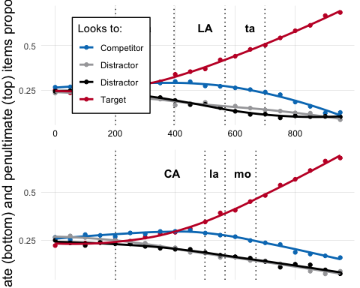

ggsave("../visuals/pen_vs_anti_pen.jpeg", plot = combined_plot, width = 6, height = 8, dpi = 300)

penn_times<-c(396, 566,699)  
anti_times<-c(499, 566,669)  
  
comp_targ<-s_exp1_data_all%>%  
 ungroup()%>%  
 filter(time_rounded<699)%>%  
 mutate(syllable=case_when(time_rounded<200~0,  
 stress_play=="Penultimate" & time_rounded>200 &  
 time_rounded<penn_times[1]~1,  
 stress_play=="Penultimate" & time_rounded>=penn_times[1] &  
 time_rounded<mean(penn_times[2],penn_times[3]) ~2,  
 stress_play=="Penultimate" & time_rounded<=penn_times[3]~3,  
 stress_play=="Anti-penultimate" & time_rounded>200 &  
 time_rounded<anti_times[1]~1,  
 stress_play=="Anti-penultimate" & time_rounded>=anti_times[1] &  
 time_rounded<mean(anti_times[2],anti_times[3]) ~2,  
 stress_play=="Anti-penultimate" & time_rounded<=anti_times[3]~3))  
  
comp_tar_longer<-comp_targ%>%  
 pivot_longer(cols=c(target_looks:dist2_looks),names_to = "names",values_to="values")%>%  
 mutate(syllable=as.factor(syllable),  
 stress_play=as.factor(stress_play))  
  
  
contrasts(comp_tar_longer$stress_play)<-c(.5,-.5)  
contrasts(comp_tar_longer$stress_play)

## [,1]  
## Anti-penultimate 0.5  
## Penultimate -0.5

comp_tar_longer$names<-as.factor(comp_tar_longer$names)  
contrasts(comp_tar_longer$names)

## dist1_looks dist2_looks target_looks  
## competitor_looks 0 0 0  
## dist1_looks 1 0 0  
## dist2_looks 0 1 0  
## target_looks 0 0 1

#data$looks <- factor(data$looks, levels = c("dist1_looks", "dist2_looks", "target_looks", "competitor_looks"))  
  
  
contrasts(factor(comp_tar_longer$names))

## dist1_looks dist2_looks target_looks  
## competitor_looks 0 0 0  
## dist1_looks 1 0 0  
## dist2_looks 0 1 0  
## target_looks 0 0 1

contrasts(comp_tar_longer$stress_play)

## [,1]  
## Anti-penultimate 0.5  
## Penultimate -0.5

levels(comp_tar_longer$stress_play)<-c("Anti-penultimate","Penultimate")  
levels(comp_tar_longer$stress_play)

## [1] "Anti-penultimate" "Penultimate"

comp_tar_model<-glm(values~names*stress_play*syllable,data=comp_tar_longer,family = "binomial")  
comp_tar_model1<-glm(values~stress_play*names+syllable,data=comp_tar_longer,family = "binomial")  
comp_tar_model2<-glm(values~stress_play+names*syllable,data=comp_tar_longer,family = "binomial")  
comp_tar_model3<-glm(values~stress_play+names+syllable,data=comp_tar_longer,family = "binomial")  
summary(comp_tar_model)

##   
## Call:  
## glm(formula = values ~ names * stress_play * syllable, family = "binomial",   
## data = comp_tar_longer)  
##   
## Deviance Residuals:   
## Min 1Q Median 3Q Max   
## -0.9914 -0.7900 -0.7024 -0.1089 1.8932   
##   
## Coefficients:  
## Estimate Std. Error z value Pr(>|z|)  
## (Intercept) -0.988512 0.025298 -39.074 < 2e-16  
## namesdist1_looks -0.123628 0.036344 -3.402 0.00067  
## namesdist2_looks -0.157474 0.036485 -4.316 1.59e-05  
## namestarget_looks -0.165842 0.036528 -4.540 5.62e-06  
## stress_play1 -0.032196 0.050597 -0.636 0.52457  
## syllable1 0.088697 0.036242 2.447 0.01439  
## syllable2 0.065407 0.040449 1.617 0.10588  
## syllable3 -0.034831 0.039581 -0.880 0.37887  
## namesdist1_looks:stress_play1 0.190704 0.072688 2.624 0.00870  
## namesdist2_looks:stress_play1 -0.022838 0.072971 -0.313 0.75430  
## namestarget_looks:stress_play1 -0.039573 0.073056 -0.542 0.58804  
## namesdist1_looks:syllable1 -0.263739 0.053018 -4.975 6.54e-07  
## namesdist2_looks:syllable1 -0.229563 0.053070 -4.326 1.52e-05  
## namestarget_looks:syllable1 0.111961 0.051916 2.157 0.03104  
## namesdist1_looks:syllable2 -0.531512 0.061174 -8.689 < 2e-16  
## namesdist2_looks:syllable2 -0.462963 0.060964 -7.594 3.10e-14  
## namestarget_looks:syllable2 0.550645 0.056570 9.734 < 2e-16  
## namesdist1_looks:syllable3 -0.345453 0.058742 -5.881 4.08e-09  
## namesdist2_looks:syllable3 -0.361715 0.059176 -6.112 9.81e-10  
## namestarget_looks:syllable3 0.680661 0.055045 12.365 < 2e-16  
## stress_play1:syllable1 0.064657 0.072483 0.892 0.37238  
## stress_play1:syllable2 0.007727 0.080899 0.096 0.92390  
## stress_play1:syllable3 0.009700 0.079162 0.123 0.90248  
## namesdist1_looks:stress_play1:syllable1 -0.196291 0.106035 -1.851 0.06414  
## namesdist2_looks:stress_play1:syllable1 -0.060220 0.106140 -0.567 0.57047  
## namestarget_looks:stress_play1:syllable1 -0.006079 0.103831 -0.059 0.95332  
## namesdist1_looks:stress_play1:syllable2 -0.155372 0.122348 -1.270 0.20412  
## namesdist2_looks:stress_play1:syllable2 0.086234 0.121927 0.707 0.47940  
## namestarget_looks:stress_play1:syllable2 0.054556 0.113140 0.482 0.62967  
## namesdist1_looks:stress_play1:syllable3 -0.100767 0.117485 -0.858 0.39105  
## namesdist2_looks:stress_play1:syllable3 0.180015 0.118353 1.521 0.12826  
## namestarget_looks:stress_play1:syllable3 -0.045756 0.110090 -0.416 0.67769  
##   
## (Intercept) ***  
## namesdist1_looks ***  
## namesdist2_looks ***  
## namestarget_looks ***  
## stress_play1   
## syllable1 *   
## syllable2   
## syllable3   
## namesdist1_looks:stress_play1 **   
## namesdist2_looks:stress_play1   
## namestarget_looks:stress_play1   
## namesdist1_looks:syllable1 ***  
## namesdist2_looks:syllable1 ***  
## namestarget_looks:syllable1 *   
## namesdist1_looks:syllable2 ***  
## namesdist2_looks:syllable2 ***  
## namestarget_looks:syllable2 ***  
## namesdist1_looks:syllable3 ***  
## namesdist2_looks:syllable3 ***  
## namestarget_looks:syllable3 ***  
## stress_play1:syllable1   
## stress_play1:syllable2   
## stress_play1:syllable3   
## namesdist1_looks:stress_play1:syllable1 .   
## namesdist2_looks:stress_play1:syllable1   
## namestarget_looks:stress_play1:syllable1   
## namesdist1_looks:stress_play1:syllable2   
## namesdist2_looks:stress_play1:syllable2   
## namestarget_looks:stress_play1:syllable2   
## namesdist1_looks:stress_play1:syllable3   
## namesdist2_looks:stress_play1:syllable3   
## namestarget_looks:stress_play1:syllable3   
## ---  
## Signif. codes: 0 '***' 0.001 '**' 0.01 '*' 0.05 '.' 0.1 ' ' 1  
##   
## (Dispersion parameter for binomial family taken to be 1)  
##   
## Null deviance: 120704 on 107323 degrees of freedom  
## Residual deviance: 118909 on 107292 degrees of freedom  
## AIC: 118973  
##   
## Number of Fisher Scoring iterations: 4

summary(comp_tar_model1)

##   
## Call:  
## glm(formula = values ~ stress_play * names + syllable, family = "binomial",   
## data = comp_tar_longer)  
##   
## Deviance Residuals:   
## Min 1Q Median 3Q Max   
## -0.8745 -0.8084 -0.6854 -0.1224 1.7943   
##   
## Coefficients:  
## Estimate Std. Error z value Pr(>|z|)   
## (Intercept) -9.536e-01 1.749e-02 -54.531 < 2e-16 ***  
## stress_play1 -5.629e-03 2.742e-02 -0.205 0.83736   
## namesdist1_looks -3.754e-01 2.028e-02 -18.515 < 2e-16 ***  
## namesdist2_looks -3.927e-01 2.033e-02 -19.319 < 2e-16 ***  
## namestarget_looks 1.336e-01 1.901e-02 7.029 2.07e-12 ***  
## syllable1 3.060e-15 1.862e-02 0.000 1.00000   
## syllable2 -1.843e-15 2.045e-02 0.000 1.00000   
## syllable3 -7.267e-15 2.033e-02 0.000 1.00000   
## stress_play1:namesdist1_looks 1.210e-01 4.056e-02 2.983 0.00285 **   
## stress_play1:namesdist2_looks 4.065e-02 4.065e-02 1.000 0.31736   
## stress_play1:namestarget_looks -1.060e-01 3.802e-02 -2.789 0.00528 **   
## ---  
## Signif. codes: 0 '***' 0.001 '**' 0.01 '*' 0.05 '.' 0.1 ' ' 1  
##   
## (Dispersion parameter for binomial family taken to be 1)  
##   
## Null deviance: 120704 on 107323 degrees of freedom  
## Residual deviance: 119609 on 107313 degrees of freedom  
## AIC: 119631  
##   
## Number of Fisher Scoring iterations: 4

summary(comp_tar_model2)

##   
## Call:  
## glm(formula = values ~ stress_play + names * syllable, family = "binomial",   
## data = comp_tar_longer)  
##   
## Deviance Residuals:   
## Min 1Q Median 3Q Max   
## -0.9705 -0.7954 -0.6994 -0.1091 1.8801   
##   
## Coefficients:  
## Estimate Std. Error z value Pr(>|z|)   
## (Intercept) -9.886e-01 2.530e-02 -39.079 < 2e-16 ***  
## stress_play1 -1.442e-14 1.454e-02 0.000 1.000000   
## namesdist1_looks -1.212e-01 3.631e-02 -3.337 0.000847 ***  
## namesdist2_looks -1.575e-01 3.648e-02 -4.316 1.59e-05 ***  
## namestarget_looks -1.658e-01 3.652e-02 -4.538 5.67e-06 ***  
## syllable1 9.316e-02 3.559e-02 2.617 0.008859 **   
## syllable2 6.969e-02 3.905e-02 1.785 0.074302 .   
## syllable3 -3.476e-02 3.958e-02 -0.878 0.379881   
## namesdist1_looks:syllable1 -2.670e-01 5.194e-02 -5.140 2.75e-07 ***  
## namesdist2_looks:syllable1 -2.405e-01 5.210e-02 -4.616 3.90e-06 ***  
## namestarget_looks:syllable1 1.058e-01 5.096e-02 2.075 0.037957 *   
## namesdist1_looks:syllable2 -5.400e-01 5.883e-02 -9.179 < 2e-16 ***  
## namesdist2_looks:syllable2 -4.737e-01 5.873e-02 -8.066 7.28e-16 ***  
## namestarget_looks:syllable2 5.480e-01 5.460e-02 10.037 < 2e-16 ***  
## namesdist1_looks:syllable3 -3.474e-01 5.871e-02 -5.917 3.29e-09 ***  
## namesdist2_looks:syllable3 -3.599e-01 5.914e-02 -6.086 1.16e-09 ***  
## namestarget_looks:syllable3 6.807e-01 5.504e-02 12.368 < 2e-16 ***  
## ---  
## Signif. codes: 0 '***' 0.001 '**' 0.01 '*' 0.05 '.' 0.1 ' ' 1  
##   
## (Dispersion parameter for binomial family taken to be 1)  
##   
## Null deviance: 120704 on 107323 degrees of freedom  
## Residual deviance: 118932 on 107307 degrees of freedom  
## AIC: 118966  
##   
## Number of Fisher Scoring iterations: 4

summary(comp_tar_model3)

##   
## Call:  
## glm(formula = values ~ stress_play + names + syllable, family = "binomial",   
## data = comp_tar_longer)  
##   
## Deviance Residuals:   
## Min 1Q Median 3Q Max   
## -0.8543 -0.8074 -0.6858 -0.1253 1.7762   
##   
## Coefficients:  
## Estimate Std. Error z value Pr(>|z|)   
## (Intercept) -9.537e-01 1.749e-02 -54.537 < 2e-16 ***  
## stress_play1 4.271e-15 1.450e-02 0.000 1   
## namesdist1_looks -3.738e-01 2.026e-02 -18.449 < 2e-16 ***  
## namesdist2_looks -3.924e-01 2.032e-02 -19.307 < 2e-16 ***  
## namestarget_looks 1.337e-01 1.901e-02 7.034 2.01e-12 ***  
## syllable1 -2.135e-15 1.862e-02 0.000 1   
## syllable2 4.415e-14 2.044e-02 0.000 1   
## syllable3 -5.769e-15 2.032e-02 0.000 1   
## ---  
## Signif. codes: 0 '***' 0.001 '**' 0.01 '*' 0.05 '.' 0.1 ' ' 1  
##   
## (Dispersion parameter for binomial family taken to be 1)  
##   
## Null deviance: 120704 on 107323 degrees of freedom  
## Residual deviance: 119642 on 107316 degrees of freedom  
## AIC: 119658  
##   
## Number of Fisher Scoring iterations: 4

anova(comp_tar_model,comp_tar_model1)

## Analysis of Deviance Table  
##   
## Model 1: values ~ names * stress_play * syllable  
## Model 2: values ~ stress_play * names + syllable  
## Resid. Df Resid. Dev Df Deviance  
## 1 107292 118909   
## 2 107313 119609 -21 -699.6

anova(comp_tar_model1,comp_tar_model2)

## Analysis of Deviance Table  
##   
## Model 1: values ~ stress_play * names + syllable  
## Model 2: values ~ stress_play + names * syllable  
## Resid. Df Resid. Dev Df Deviance  
## 1 107313 119609   
## 2 107307 118932 6 676.56

anova(comp_tar_model2,comp_tar_model3)

## Analysis of Deviance Table  
##   
## Model 1: values ~ stress_play + names * syllable  
## Model 2: values ~ stress_play + names + syllable  
## Resid. Df Resid. Dev Df Deviance  
## 1 107307 118932   
## 2 107316 119642 -9 -710.46

bic_model = BIC(comp_tar_model)  
bic_model1 = BIC(comp_tar_model1)  
bic_model2 = BIC(comp_tar_model2)  
bic_model3 = BIC(comp_tar_model3)  
  
bic_model

## [1] 119279.7

bic_model1

## [1] 119736

bic_model2

## [1] 119128.9

bic_model3

## [1] 119735.1

#analysis 1 (target vs competitor analysis)

library(broom)  
tidy_model <- tidy(comp_tar_model2, effects = "fixed")%>%  
 mutate(  
 main = case_when(  
 str_detect(term, ":") ~ 1,  
 TRUE ~ 0))%>%  
 mutate(  
 looks = case_when(  
 str_detect(term, "target") ~ "target",  
 str_detect(term, "dist1") ~ "distractor_1",  
 str_detect(term, "dist2") ~ "distractor_2",  
 TRUE ~ "Base_looks"))%>%  
 mutate(  
 syllable = case_when(  
 str_detect(term, "syllable1") ~ "1",  
 str_detect(term, "syllable2") ~ "2",  
 str_detect(term, "syllable3") ~ "3",  
 TRUE ~ "0"))%>%  
 mutate(  
 term=str_replace(term, "syllable1","Syllable 1"),  
 term=str_replace(term, "syllable2","Syllable 1.5"),  
 term=str_replace(term, "syllable3","Syllable 2"),  
 term=str_replace(term, "_looks",""),  
 term=str_replace(term, "names","Looks "),  
 term=str_replace(term, "stress_play","Stress"),  
 term=str_replace(term, "Stress1","Stress Ante"))%>%  
 arrange(main, syllable, looks) %>%  
 mutate(  
 row_number = row_number(),  
 looks = as.factor(looks),  
 Significance = case_when(  
 p.value < 0.001 ~ "***",  
 p.value < 0.01 ~ "**",  
 p.value < 0.05 ~ "*",  
 TRUE ~ ""))  
  
  
colors <- c("Base_looks" = "#007bc0", "distractor_1" = "#A7A7A9",   
 "distractor_2" = "#000000", "target" = "#c41230")  
  
pen_anti_model<-ggplot(tidy_model, aes(x = estimate, y = row_number,color=factor(looks))) +  
 geom_point() +  
 geom_errorbarh(aes(xmin = estimate - 1.96 * std.error, xmax = estimate + 1.96 * std.error), height = 0) +  
 labs(title = , x = "Estimated Coefficients", y = "",color = "Looks to grouping") +  
 theme_minimal()+  
 geom_vline(xintercept = 0,color = "#007bc0")+  
 scale_y_continuous(breaks = tidy_model$row_number, labels = tidy_model$term)+  
 scale_color_manual(  
 values = c( "Base_looks" = "#007bc0", "distractor_1" = "#A7A7A9",   
 "distractor_2" = "#000000","target" = "#c41230"),  
 labels = c( "Base", "Distractor 1", "Distractor 2","Target")  
 )+  
 annotate("rect", xmin = -2.7, xmax = -1.45, ymin = -1.5, ymax = 17.5, fill = "white",color="grey") +  
 geom_text(aes(y = row_number,x=-1.5, label = term, color = factor(looks)),hjust = 1, size = 4,angle=40,show.legend = FALSE)+  
 xlim(-2.7, 1)+  
 coord_flip()+  
 theme(axis.text.y = element_text(angle = 15, hjust = 1),  
 axis.text.x = element_blank(),  
 panel.grid.minor.x = element_blank(),  
 panel.grid.minor.y = element_blank(),  
 axis.title.y = element_text(hjust = .75, vjust = 0.0),  
 axis.title.x = element_text(hjust = .0, vjust = 0),  
 panel.border = element_blank(),  
 legend.position = "bottom")+  
 scale_x_continuous(breaks=seq(-1, 1, by = .5))+  
 geom_text(aes(y = 1,x=-2.5, label = "Terms"),color = "black",hjust = 1, size = 5,angle=0,show.legend = FALSE)+  
 geom_text(aes(y = row_number, x = -1.2, label = Significance), hjust = 0, vjust = .5,angle=90, color = "black", show.legend = FALSE)

## Scale for x is already present.  
## Adding another scale for x, which will replace the existing scale.

pen_anti_model

## Warning in geom_text(aes(y = 1, x = -2.5, label = "Terms"), color = "black", : All aesthetics have length 1, but the data has 17 rows.  
## ℹ Please consider using `annotate()` or provide this layer with data containing  
## a single row.

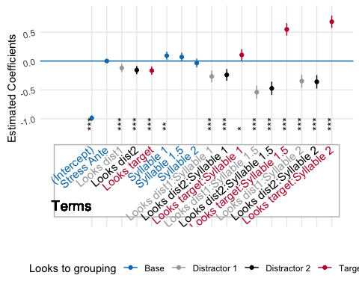

#ggsave("../visuals/pen_vs_anti_pen_model.jpeg", plot = pen_anti_model, width = 10, height = 6.6, dpi = 300)

#analysis 2 (target distributional bias)

tar_longer<-comp_tar_longer%>%  
 filter(names=="target_looks")%>%  
 group_by(word_play,stress_play,syllable)%>%  
 summarize(tar_prop_o_looks=mean(values))%>%  
 filter(syllable==c(2,3))%>%ungroup()

## `summarise()` has grouped output by 'word_play', 'stress_play'. You can  
## override using the `.groups` argument.

tar_ana1<-lme4::lmer(tar_prop_o_looks~stress_play*syllable+(1|word_play),data=tar_longer)  
tar_ana2<-lme4::lmer(tar_prop_o_looks~stress_play+syllable+(1|word_play),data=tar_longer)  
tar_ana3<-lme4::lmer(tar_prop_o_looks~syllable+(1|word_play),data=tar_longer)  
tar_ana4<-lme4::lmer(tar_prop_o_looks~stress_play+(1|word_play),data=tar_longer)  
  
summary(tar_ana1)

## Linear mixed model fit by REML ['lmerMod']  
## Formula: tar_prop_o_looks ~ stress_play * syllable + (1 | word_play)  
## Data: tar_longer  
##   
## REML criterion at convergence: -210.2  
##   
## Scaled residuals:   
## Min 1Q Median 3Q Max   
## -1.59089 -0.43531 0.00725 0.55208 1.60197   
##   
## Random effects:  
## Groups Name Variance Std.Dev.  
## word_play (Intercept) 0.006061 0.07785   
## Residual 0.001919 0.04380   
## Number of obs: 96, groups: word_play, 48  
##   
## Fixed effects:  
## Estimate Std. Error t value  
## (Intercept) 0.368440 0.012893 28.576  
## stress_play1 -0.004686 0.025787 -0.182  
## syllable3 0.007875 0.008941 0.881  
## stress_play1:syllable3 -0.021011 0.017882 -1.175  
##   
## Correlation of Fixed Effects:  
## (Intr) strs_1 syllb3  
## stress_ply1 0.000   
## syllable3 -0.347 0.000   
## strss_pl1:3 0.000 -0.347 0.000

summary(tar_ana2)

## Linear mixed model fit by REML ['lmerMod']  
## Formula: tar_prop_o_looks ~ stress_play + syllable + (1 | word_play)  
## Data: tar_longer  
##   
## REML criterion at convergence: -215  
##   
## Scaled residuals:   
## Min 1Q Median 3Q Max   
## -1.51246 -0.52886 -0.02352 0.52863 1.71578   
##   
## Random effects:  
## Groups Name Variance Std.Dev.  
## word_play (Intercept) 0.006053 0.07780   
## Residual 0.001934 0.04398   
## Number of obs: 96, groups: word_play, 48  
##   
## Fixed effects:  
## Estimate Std. Error t value  
## (Intercept) 0.368440 0.012900 28.562  
## stress_play1 -0.015191 0.024187 -0.628  
## syllable3 0.007875 0.008977 0.877  
##   
## Correlation of Fixed Effects:  
## (Intr) strs_1  
## stress_ply1 0.000   
## syllable3 -0.348 0.000

summary(tar_ana3)

## Linear mixed model fit by REML ['lmerMod']  
## Formula: tar_prop_o_looks ~ syllable + (1 | word_play)  
## Data: tar_longer  
##   
## REML criterion at convergence: -220.3  
##   
## Scaled residuals:   
## Min 1Q Median 3Q Max   
## -1.53523 -0.51694 -0.01162 0.55191 1.69300   
##   
## Random effects:  
## Groups Name Variance Std.Dev.  
## word_play (Intercept) 0.005963 0.07722   
## Residual 0.001934 0.04398   
## Number of obs: 96, groups: word_play, 48  
##   
## Fixed effects:  
## Estimate Std. Error t value  
## (Intercept) 0.368440 0.012826 28.725  
## syllable3 0.007875 0.008977 0.877  
##   
## Correlation of Fixed Effects:  
## (Intr)  
## syllable3 -0.350

summary(tar_ana4)

## Linear mixed model fit by REML ['lmerMod']  
## Formula: tar_prop_o_looks ~ stress_play + (1 | word_play)  
## Data: tar_longer  
##   
## REML criterion at convergence: -221.9  
##   
## Scaled residuals:   
## Min 1Q Median 3Q Max   
## -1.55896 -0.47448 0.04201 0.48256 1.62967   
##   
## Random effects:  
## Groups Name Variance Std.Dev.  
## word_play (Intercept) 0.006058 0.07783   
## Residual 0.001925 0.04387   
## Number of obs: 96, groups: word_play, 48  
##   
## Fixed effects:  
## Estimate Std. Error t value  
## (Intercept) 0.37238 0.01209 30.792  
## stress_play1 -0.01519 0.02419 -0.628  
##   
## Correlation of Fixed Effects:  
## (Intr)  
## stress_ply1 0.000

#no significant results here- no bias

########analysis 3 (acoustics)

acoustic_data<-read.csv("acoustic_data_ppcc.csv")  
  
aco_agg<-acoustic_data%>%  
 group_by(stress,vowel)%>%  
 na.omit()%>%  
 summarize(mean_pitch=mean(mean_pitch),  
 mean_amplitude=mean(mean_amplitude),  
 mean_dur=mean(duration)*1000,  
 mean_tilt=mean(mean_tilt))

## `summarise()` has grouped output by 'stress'. You can override using the  
## `.groups` argument.

acoustic_data<-acoustic_data%>%  
 mutate(  
 stress_play = ifelse(stress == "antipenultimate", "Anti-penultimate", "Penultimate"),  
 syllable = ifelse(vowel == "v1", 1, 3),  
 syllable=as.factor(syllable),  
 word=tolower(word))%>%  
 select(-X)  
  
penn_accoustic_data<-acoustic_data%>%  
 filter(stress_play=="Penultimate")  
ante_penn_accoustic_data<-acoustic_data%>%  
 filter(stress_play!="Penultimate")  
  
levels(penn_accoustic_data$syllable)

## [1] "1" "3"

# Create a function to run t-tests for each predictor  
run_t_tests <- function(data, predictors, group_var) {  
 results <- data.frame(Predictor = character(), T_value = numeric(), P_value = numeric(), Significance = character(), stringsAsFactors = FALSE)  
   
 for (predictor in predictors) {  
 cat("Running t-tests for predictor:", predictor, "\n")  
 formula <- as.formula(paste(predictor, "~", group_var))  
 t_test_result <- t.test(formula, data = data)  
   
 # Determine significance level  
 p_value <- t_test_result$p.value  
 significance <- if (p_value < 0.001) {  
 "***"  
 } else if (p_value < 0.01) {  
 "**"  
 } else if (p_value < 0.05) {  
 "*"  
 } else {  
 ""  
 }  
   
 # Append results to dataframe  
 results <- rbind(results, data.frame(Predictor = predictor, T_value = t_test_result$statistic, P_value = p_value, Significance = significance))  
 }  
 return(results)  
}  
  
  
# Define the predictors and group variable  
predictors <- c("mean_amplitude", "mean_pitch", "duration","mean_tilt")  
group_var <- "syllable"  
  
# Run t-tests  
t_test_results_penn <- run_t_tests(penn_accoustic_data, predictors, group_var)

## Running t-tests for predictor: mean_amplitude   
## Running t-tests for predictor: mean_pitch   
## Running t-tests for predictor: duration   
## Running t-tests for predictor: mean_tilt

t_test_results_ante_penn <- run_t_tests(ante_penn_accoustic_data, predictors, group_var)

## Running t-tests for predictor: mean_amplitude   
## Running t-tests for predictor: mean_pitch   
## Running t-tests for predictor: duration   
## Running t-tests for predictor: mean_tilt

# Print the results  
t_test_results_penn

## Predictor T_value P_value Significance  
## t mean_amplitude 5.1787925 6.681214e-07 ***  
## t1 mean_pitch 6.9926294 7.017645e-11 ***  
## t2 duration -20.8351541 5.296237e-40 ***  
## t3 mean_tilt 0.3321044 7.403028e-01

t_test_results_ante_penn

## Predictor T_value P_value Significance  
## t mean_amplitude 7.507733 1.481562e-11 ***  
## t1 mean_pitch 13.171503 2.130472e-22 ***  
## t2 duration 13.111704 8.801271e-23 ***  
## t3 mean_tilt 8.256081 2.160439e-13 ***

#analysis 3 target fixation analysis

ets_binary_analysis_syl_1<-comp_tar_longer%>%  
 pivot_wider(names_from = names,values_from = values)%>%  
 filter(syllable!=2)%>%  
 filter(syllable!=0)%>%  
 mutate(word=target)%>%  
 left_join(acoustic_data)%>%  
 filter(syllable==1)%>%  
 mutate(mean_pitch_scaled = scale(mean_pitch),  
 mean_amplitude_scaled = scale(mean_amplitude),  
 mean_tilt_scaled = scale(mean_tilt),  
 duration_scaled = scale(duration))

## Joining with `by = join_by(stress_play, syllable, word)`

ap_data_1<-ets_binary_analysis_syl_1%>%filter(stress_play!="Penultimate")  
pp_data_1<-ets_binary_analysis_syl_1%>%filter(stress_play=="Penultimate")  
  
mod_full<-glmer(target_looks~mean_pitch_scaled*mean_amplitude_scaled*mean_tilt_scaled*duration_scaled  
 +(1|word),family=binomial, data= ap_data_1)

## boundary (singular) fit: see help('isSingular')

mod_full_2<-glmer(target_looks~mean_pitch_scaled*mean_amplitude_scaled*mean_tilt_scaled*duration_scaled  
 +(1|word),family=binomial, data= pp_data_1)

## Warning in checkConv(attr(opt, "derivs"), opt$par, ctrl = control$checkConv, :  
## Model failed to converge with max|grad| = 0.00802168 (tol = 0.002, component 1)

ets_binary_analysis_syl_3<-comp_tar_longer%>%  
 pivot_wider(names_from = names,values_from = values)%>%  
 filter(syllable!=2)%>%  
 filter(syllable!=0)%>%  
 mutate(word=target)%>%  
 left_join(acoustic_data)%>%  
 filter(syllable==3)%>%  
 mutate(mean_pitch_scaled = scale(mean_pitch),  
 mean_amplitude_scaled = scale(mean_amplitude),  
 mean_tilt_scaled = scale(mean_tilt),  
 duration_scaled = scale(duration))

## Joining with `by = join_by(stress_play, syllable, word)`

ap_data_3<-ets_binary_analysis_syl_3%>%filter(stress_play!="Penultimate")  
pp_data_3<-ets_binary_analysis_syl_3%>%filter(stress_play=="Penultimate")  
  
  
mod_full_1_3<-glmer(target_looks~mean_pitch_scaled*mean_amplitude_scaled*mean_tilt_scaled*duration_scaled  
 +(1|word),family=binomial, data= ap_data_3)

## boundary (singular) fit: see help('isSingular')

mod_full_2_3<-glmer(target_looks~mean_pitch_scaled*mean_amplitude_scaled*mean_tilt_scaled*duration_scaled  
 +(1|word),family=binomial, data= pp_data_3)

## boundary (singular) fit: see help('isSingular')

summary(mod_full)

## Generalized linear mixed model fit by maximum likelihood (Laplace  
## Approximation) [glmerMod]  
## Family: binomial ( logit )  
## Formula:   
## target_looks ~ mean_pitch_scaled * mean_amplitude_scaled * mean_tilt_scaled *   
## duration_scaled + (1 | word)  
## Data: ap_data_1  
##   
## AIC BIC logLik deviance df.resid   
## 5508.4 5618.2 -2737.2 5474.4 4718   
##   
## Scaled residuals:   
## Min 1Q Median 3Q Max   
## -0.7721 -0.6542 -0.5760 1.3696 2.4321   
##   
## Random effects:  
## Groups Name Variance Std.Dev.  
## word (Intercept) 0 0   
## Number of obs: 4735, groups: word, 23  
##   
## Fixed effects:  
## Estimate  
## (Intercept) -1.35736  
## mean_pitch_scaled 0.05746  
## mean_amplitude_scaled 0.11058  
## mean_tilt_scaled 0.43284  
## duration_scaled 0.27806  
## mean_pitch_scaled:mean_amplitude_scaled 0.20027  
## mean_pitch_scaled:mean_tilt_scaled 0.08976  
## mean_amplitude_scaled:mean_tilt_scaled 0.65550  
## mean_pitch_scaled:duration_scaled 0.10331  
## mean_amplitude_scaled:duration_scaled -0.12135  
## mean_tilt_scaled:duration_scaled -0.29873  
## mean_pitch_scaled:mean_amplitude_scaled:mean_tilt_scaled 0.21292  
## mean_pitch_scaled:mean_amplitude_scaled:duration_scaled 0.30921  
## mean_pitch_scaled:mean_tilt_scaled:duration_scaled -0.59884  
## mean_amplitude_scaled:mean_tilt_scaled:duration_scaled -0.89933  
## mean_pitch_scaled:mean_amplitude_scaled:mean_tilt_scaled:duration_scaled -0.75100  
## Std. Error  
## (Intercept) 0.13196  
## mean_pitch_scaled 0.14945  
## mean_amplitude_scaled 0.22998  
## mean_tilt_scaled 0.13597  
## duration_scaled 0.09177  
## mean_pitch_scaled:mean_amplitude_scaled 0.28133  
## mean_pitch_scaled:mean_tilt_scaled 0.16733  
## mean_amplitude_scaled:mean_tilt_scaled 0.17107  
## mean_pitch_scaled:duration_scaled 0.10915  
## mean_amplitude_scaled:duration_scaled 0.17742  
## mean_tilt_scaled:duration_scaled 0.14827  
## mean_pitch_scaled:mean_amplitude_scaled:mean_tilt_scaled 0.13804  
## mean_pitch_scaled:mean_amplitude_scaled:duration_scaled 0.21837  
## mean_pitch_scaled:mean_tilt_scaled:duration_scaled 0.15568  
## mean_amplitude_scaled:mean_tilt_scaled:duration_scaled 0.20104  
## mean_pitch_scaled:mean_amplitude_scaled:mean_tilt_scaled:duration_scaled 0.26374  
## z value  
## (Intercept) -10.286  
## mean_pitch_scaled 0.384  
## mean_amplitude_scaled 0.481  
## mean_tilt_scaled 3.183  
## duration_scaled 3.030  
## mean_pitch_scaled:mean_amplitude_scaled 0.712  
## mean_pitch_scaled:mean_tilt_scaled 0.536  
## mean_amplitude_scaled:mean_tilt_scaled 3.832  
## mean_pitch_scaled:duration_scaled 0.947  
## mean_amplitude_scaled:duration_scaled -0.684  
## mean_tilt_scaled:duration_scaled -2.015  
## mean_pitch_scaled:mean_amplitude_scaled:mean_tilt_scaled 1.542  
## mean_pitch_scaled:mean_amplitude_scaled:duration_scaled 1.416  
## mean_pitch_scaled:mean_tilt_scaled:duration_scaled -3.847  
## mean_amplitude_scaled:mean_tilt_scaled:duration_scaled -4.473  
## mean_pitch_scaled:mean_amplitude_scaled:mean_tilt_scaled:duration_scaled -2.847  
## Pr(>|z|)  
## (Intercept) < 2e-16  
## mean_pitch_scaled 0.700645  
## mean_amplitude_scaled 0.630659  
## mean_tilt_scaled 0.001456  
## duration_scaled 0.002446  
## mean_pitch_scaled:mean_amplitude_scaled 0.476545  
## mean_pitch_scaled:mean_tilt_scaled 0.591692  
## mean_amplitude_scaled:mean_tilt_scaled 0.000127  
## mean_pitch_scaled:duration_scaled 0.343882  
## mean_amplitude_scaled:duration_scaled 0.494018  
## mean_tilt_scaled:duration_scaled 0.043928  
## mean_pitch_scaled:mean_amplitude_scaled:mean_tilt_scaled 0.122957  
## mean_pitch_scaled:mean_amplitude_scaled:duration_scaled 0.156769  
## mean_pitch_scaled:mean_tilt_scaled:duration_scaled 0.000120  
## mean_amplitude_scaled:mean_tilt_scaled:duration_scaled 7.7e-06  
## mean_pitch_scaled:mean_amplitude_scaled:mean_tilt_scaled:duration_scaled 0.004407  
##   
## (Intercept) ***  
## mean_pitch_scaled   
## mean_amplitude_scaled   
## mean_tilt_scaled **   
## duration_scaled **   
## mean_pitch_scaled:mean_amplitude_scaled   
## mean_pitch_scaled:mean_tilt_scaled   
## mean_amplitude_scaled:mean_tilt_scaled ***  
## mean_pitch_scaled:duration_scaled   
## mean_amplitude_scaled:duration_scaled   
## mean_tilt_scaled:duration_scaled *   
## mean_pitch_scaled:mean_amplitude_scaled:mean_tilt_scaled   
## mean_pitch_scaled:mean_amplitude_scaled:duration_scaled   
## mean_pitch_scaled:mean_tilt_scaled:duration_scaled ***  
## mean_amplitude_scaled:mean_tilt_scaled:duration_scaled ***  
## mean_pitch_scaled:mean_amplitude_scaled:mean_tilt_scaled:duration_scaled **   
## ---  
## Signif. codes: 0 '***' 0.001 '**' 0.01 '*' 0.05 '.' 0.1 ' ' 1

##   
## Correlation matrix not shown by default, as p = 16 > 12.  
## Use print(x, correlation=TRUE) or  
## vcov(x) if you need it

## optimizer (Nelder_Mead) convergence code: 0 (OK)  
## boundary (singular) fit: see help('isSingular')

summary(mod_full_2)

## Generalized linear mixed model fit by maximum likelihood (Laplace  
## Approximation) [glmerMod]  
## Family: binomial ( logit )  
## Formula:   
## target_looks ~ mean_pitch_scaled * mean_amplitude_scaled * mean_tilt_scaled *   
## duration_scaled + (1 | word)  
## Data: pp_data_1  
##   
## AIC BIC logLik deviance df.resid   
## 3358.3 3459.6 -1662.2 3324.3 2842   
##   
## Scaled residuals:   
## Min 1Q Median 3Q Max   
## -0.8893 -0.6752 -0.5326 1.2260 2.2371   
##   
## Random effects:  
## Groups Name Variance Std.Dev.  
## word (Intercept) 0.01422 0.1193   
## Number of obs: 2859, groups: word, 24  
##   
## Fixed effects:  
## Estimate  
## (Intercept) -1.20754  
## mean_pitch_scaled 0.39125  
## mean_amplitude_scaled -2.40163  
## mean_tilt_scaled -0.05164  
## duration_scaled -0.09770  
## mean_pitch_scaled:mean_amplitude_scaled -2.49809  
## mean_pitch_scaled:mean_tilt_scaled -0.15619  
## mean_amplitude_scaled:mean_tilt_scaled -3.19909  
## mean_pitch_scaled:duration_scaled 0.63661  
## mean_amplitude_scaled:duration_scaled -2.45907  
## mean_tilt_scaled:duration_scaled -0.08173  
## mean_pitch_scaled:mean_amplitude_scaled:mean_tilt_scaled -1.30310  
## mean_pitch_scaled:mean_amplitude_scaled:duration_scaled -2.53978  
## mean_pitch_scaled:mean_tilt_scaled:duration_scaled -0.06819  
## mean_amplitude_scaled:mean_tilt_scaled:duration_scaled -3.15979  
## mean_pitch_scaled:mean_amplitude_scaled:mean_tilt_scaled:duration_scaled -1.28875  
## Std. Error  
## (Intercept) 0.74381  
## mean_pitch_scaled 0.80779  
## mean_amplitude_scaled 3.59167  
## mean_tilt_scaled 0.94677  
## duration_scaled 0.81161  
## mean_pitch_scaled:mean_amplitude_scaled 3.67626  
## mean_pitch_scaled:mean_tilt_scaled 1.04027  
## mean_amplitude_scaled:mean_tilt_scaled 3.34152  
## mean_pitch_scaled:duration_scaled 0.86995  
## mean_amplitude_scaled:duration_scaled 3.71385  
## mean_tilt_scaled:duration_scaled 0.88847  
## mean_pitch_scaled:mean_amplitude_scaled:mean_tilt_scaled 3.45882  
## mean_pitch_scaled:mean_amplitude_scaled:duration_scaled 3.73623  
## mean_pitch_scaled:mean_tilt_scaled:duration_scaled 0.97625  
## mean_amplitude_scaled:mean_tilt_scaled:duration_scaled 3.23502  
## mean_pitch_scaled:mean_amplitude_scaled:mean_tilt_scaled:duration_scaled 3.27218  
## z value  
## (Intercept) -1.623  
## mean_pitch_scaled 0.484  
## mean_amplitude_scaled -0.669  
## mean_tilt_scaled -0.055  
## duration_scaled -0.120  
## mean_pitch_scaled:mean_amplitude_scaled -0.680  
## mean_pitch_scaled:mean_tilt_scaled -0.150  
## mean_amplitude_scaled:mean_tilt_scaled -0.957  
## mean_pitch_scaled:duration_scaled 0.732  
## mean_amplitude_scaled:duration_scaled -0.662  
## mean_tilt_scaled:duration_scaled -0.092  
## mean_pitch_scaled:mean_amplitude_scaled:mean_tilt_scaled -0.377  
## mean_pitch_scaled:mean_amplitude_scaled:duration_scaled -0.680  
## mean_pitch_scaled:mean_tilt_scaled:duration_scaled -0.070  
## mean_amplitude_scaled:mean_tilt_scaled:duration_scaled -0.977  
## mean_pitch_scaled:mean_amplitude_scaled:mean_tilt_scaled:duration_scaled -0.394  
## Pr(>|z|)  
## (Intercept) 0.104  
## mean_pitch_scaled 0.628  
## mean_amplitude_scaled 0.504  
## mean_tilt_scaled 0.957  
## duration_scaled 0.904  
## mean_pitch_scaled:mean_amplitude_scaled 0.497  
## mean_pitch_scaled:mean_tilt_scaled 0.881  
## mean_amplitude_scaled:mean_tilt_scaled 0.338  
## mean_pitch_scaled:duration_scaled 0.464  
## mean_amplitude_scaled:duration_scaled 0.508  
## mean_tilt_scaled:duration_scaled 0.927  
## mean_pitch_scaled:mean_amplitude_scaled:mean_tilt_scaled 0.706  
## mean_pitch_scaled:mean_amplitude_scaled:duration_scaled 0.497  
## mean_pitch_scaled:mean_tilt_scaled:duration_scaled 0.944  
## mean_amplitude_scaled:mean_tilt_scaled:duration_scaled 0.329  
## mean_pitch_scaled:mean_amplitude_scaled:mean_tilt_scaled:duration_scaled 0.694

##   
## Correlation matrix not shown by default, as p = 16 > 12.  
## Use print(x, correlation=TRUE) or  
## vcov(x) if you need it

## optimizer (Nelder_Mead) convergence code: 0 (OK)  
## Model failed to converge with max|grad| = 0.00802168 (tol = 0.002, component 1)

summary(mod_full_1_3)

## Generalized linear mixed model fit by maximum likelihood (Laplace  
## Approximation) [glmerMod]  
## Family: binomial ( logit )  
## Formula:   
## target_looks ~ mean_pitch_scaled * mean_amplitude_scaled * mean_tilt_scaled *   
## duration_scaled + (1 | word)  
## Data: ap_data_3  
##   
## AIC BIC logLik deviance df.resid   
## 3480.8 3581.0 -1723.4 3446.8 2660   
##   
## Scaled residuals:   
## Min 1Q Median 3Q Max   
## -1.0057 -0.7770 -0.6576 1.2314 1.8784   
##   
## Random effects:  
## Groups Name Variance Std.Dev.   
## word (Intercept) 2.595e-14 1.611e-07  
## Number of obs: 2677, groups: word, 23  
##   
## Fixed effects:  
## Estimate  
## (Intercept) -6.6805  
## mean_pitch_scaled -7.3133  
## mean_amplitude_scaled -7.5312  
## mean_tilt_scaled 6.8617  
## duration_scaled -5.3622  
## mean_pitch_scaled:mean_amplitude_scaled -7.9596  
## mean_pitch_scaled:mean_tilt_scaled 7.7238  
## mean_amplitude_scaled:mean_tilt_scaled -0.3461  
## mean_pitch_scaled:duration_scaled -6.4490  
## mean_amplitude_scaled:duration_scaled -7.2997  
## mean_tilt_scaled:duration_scaled 4.8232  
## mean_pitch_scaled:mean_amplitude_scaled:mean_tilt_scaled 0.2661  
## mean_pitch_scaled:mean_amplitude_scaled:duration_scaled -7.8219  
## mean_pitch_scaled:mean_tilt_scaled:duration_scaled 5.4536  
## mean_amplitude_scaled:mean_tilt_scaled:duration_scaled -2.1295  
## mean_pitch_scaled:mean_amplitude_scaled:mean_tilt_scaled:duration_scaled -1.8007  
## Std. Error  
## (Intercept) 2.0526  
## mean_pitch_scaled 2.8747  
## mean_amplitude_scaled 2.3077  
## mean_tilt_scaled 7.2037  
## duration_scaled 1.9872  
## mean_pitch_scaled:mean_amplitude_scaled 2.3649  
## mean_pitch_scaled:mean_tilt_scaled 8.6769  
## mean_amplitude_scaled:mean_tilt_scaled 5.8816  
## mean_pitch_scaled:duration_scaled 2.7610  
## mean_amplitude_scaled:duration_scaled 2.2047  
## mean_tilt_scaled:duration_scaled 6.6331  
## mean_pitch_scaled:mean_amplitude_scaled:mean_tilt_scaled 8.5534  
## mean_pitch_scaled:mean_amplitude_scaled:duration_scaled 2.3461  
## mean_pitch_scaled:mean_tilt_scaled:duration_scaled 7.9323  
## mean_amplitude_scaled:mean_tilt_scaled:duration_scaled 5.3915  
## mean_pitch_scaled:mean_amplitude_scaled:mean_tilt_scaled:duration_scaled 7.7251  
## z value  
## (Intercept) -3.255  
## mean_pitch_scaled -2.544  
## mean_amplitude_scaled -3.264  
## mean_tilt_scaled 0.953  
## duration_scaled -2.698  
## mean_pitch_scaled:mean_amplitude_scaled -3.366  
## mean_pitch_scaled:mean_tilt_scaled 0.890  
## mean_amplitude_scaled:mean_tilt_scaled -0.059  
## mean_pitch_scaled:duration_scaled -2.336  
## mean_amplitude_scaled:duration_scaled -3.311  
## mean_tilt_scaled:duration_scaled 0.727  
## mean_pitch_scaled:mean_amplitude_scaled:mean_tilt_scaled 0.031  
## mean_pitch_scaled:mean_amplitude_scaled:duration_scaled -3.334  
## mean_pitch_scaled:mean_tilt_scaled:duration_scaled 0.688  
## mean_amplitude_scaled:mean_tilt_scaled:duration_scaled -0.395  
## mean_pitch_scaled:mean_amplitude_scaled:mean_tilt_scaled:duration_scaled -0.233  
## Pr(>|z|)  
## (Intercept) 0.001136  
## mean_pitch_scaled 0.010959  
## mean_amplitude_scaled 0.001100  
## mean_tilt_scaled 0.340833  
## duration_scaled 0.006968  
## mean_pitch_scaled:mean_amplitude_scaled 0.000764  
## mean_pitch_scaled:mean_tilt_scaled 0.373379  
## mean_amplitude_scaled:mean_tilt_scaled 0.953073  
## mean_pitch_scaled:duration_scaled 0.019506  
## mean_amplitude_scaled:duration_scaled 0.000930  
## mean_tilt_scaled:duration_scaled 0.467142  
## mean_pitch_scaled:mean_amplitude_scaled:mean_tilt_scaled 0.975177  
## mean_pitch_scaled:mean_amplitude_scaled:duration_scaled 0.000856  
## mean_pitch_scaled:mean_tilt_scaled:duration_scaled 0.491754  
## mean_amplitude_scaled:mean_tilt_scaled:duration_scaled 0.692860  
## mean_pitch_scaled:mean_amplitude_scaled:mean_tilt_scaled:duration_scaled 0.815682  
##   
## (Intercept) **   
## mean_pitch_scaled *   
## mean_amplitude_scaled **   
## mean_tilt_scaled   
## duration_scaled **   
## mean_pitch_scaled:mean_amplitude_scaled ***  
## mean_pitch_scaled:mean_tilt_scaled   
## mean_amplitude_scaled:mean_tilt_scaled   
## mean_pitch_scaled:duration_scaled *   
## mean_amplitude_scaled:duration_scaled ***  
## mean_tilt_scaled:duration_scaled   
## mean_pitch_scaled:mean_amplitude_scaled:mean_tilt_scaled   
## mean_pitch_scaled:mean_amplitude_scaled:duration_scaled ***  
## mean_pitch_scaled:mean_tilt_scaled:duration_scaled   
## mean_amplitude_scaled:mean_tilt_scaled:duration_scaled   
## mean_pitch_scaled:mean_amplitude_scaled:mean_tilt_scaled:duration_scaled   
## ---  
## Signif. codes: 0 '***' 0.001 '**' 0.01 '*' 0.05 '.' 0.1 ' ' 1

##   
## Correlation matrix not shown by default, as p = 16 > 12.  
## Use print(x, correlation=TRUE) or  
## vcov(x) if you need it

## optimizer (Nelder_Mead) convergence code: 0 (OK)  
## boundary (singular) fit: see help('isSingular')

summary(mod_full_2_3)

## Generalized linear mixed model fit by maximum likelihood (Laplace  
## Approximation) [glmerMod]  
## Family: binomial ( logit )  
## Formula:   
## target_looks ~ mean_pitch_scaled * mean_amplitude_scaled * mean_tilt_scaled *   
## duration_scaled + (1 | word)  
## Data: pp_data_3  
##   
## AIC BIC logLik deviance df.resid   
## 3670.9 3771.6 -1818.4 3636.9 2744   
##   
## Scaled residuals:   
## Min 1Q Median 3Q Max   
## -1.0486 -0.8021 -0.6854 1.1248 1.6062   
##   
## Random effects:  
## Groups Name Variance Std.Dev.  
## word (Intercept) 1.03e-13 3.21e-07  
## Number of obs: 2761, groups: word, 24  
##   
## Fixed effects:  
## Estimate  
## (Intercept) -0.52557  
## mean_pitch_scaled 0.23788  
## mean_amplitude_scaled 0.25235  
## mean_tilt_scaled 0.37625  
## duration_scaled -0.06645  
## mean_pitch_scaled:mean_amplitude_scaled -0.25924  
## mean_pitch_scaled:mean_tilt_scaled -0.32735  
## mean_amplitude_scaled:mean_tilt_scaled -0.08979  
## mean_pitch_scaled:duration_scaled 0.10687  
## mean_amplitude_scaled:duration_scaled -0.09348  
## mean_tilt_scaled:duration_scaled -0.38639  
## mean_pitch_scaled:mean_amplitude_scaled:mean_tilt_scaled 0.39126  
## mean_pitch_scaled:mean_amplitude_scaled:duration_scaled -0.25763  
## mean_pitch_scaled:mean_tilt_scaled:duration_scaled 0.59576  
## mean_amplitude_scaled:mean_tilt_scaled:duration_scaled 0.09401  
## mean_pitch_scaled:mean_amplitude_scaled:mean_tilt_scaled:duration_scaled -0.33147  
## Std. Error  
## (Intercept) 0.43540  
## mean_pitch_scaled 0.28385  
## mean_amplitude_scaled 0.51760  
## mean_tilt_scaled 0.50162  
## duration_scaled 0.34138  
## mean_pitch_scaled:mean_amplitude_scaled 0.44601  
## mean_pitch_scaled:mean_tilt_scaled 0.32803  
## mean_amplitude_scaled:mean_tilt_scaled 0.48944  
## mean_pitch_scaled:duration_scaled 0.21838  
## mean_amplitude_scaled:duration_scaled 0.44712  
## mean_tilt_scaled:duration_scaled 0.48212  
## mean_pitch_scaled:mean_amplitude_scaled:mean_tilt_scaled 0.34162  
## mean_pitch_scaled:mean_amplitude_scaled:duration_scaled 0.63138  
## mean_pitch_scaled:mean_tilt_scaled:duration_scaled 0.54071  
## mean_amplitude_scaled:mean_tilt_scaled:duration_scaled 0.33543  
## mean_pitch_scaled:mean_amplitude_scaled:mean_tilt_scaled:duration_scaled 0.31459  
## z value  
## (Intercept) -1.207  
## mean_pitch_scaled 0.838  
## mean_amplitude_scaled 0.488  
## mean_tilt_scaled 0.750  
## duration_scaled -0.195  
## mean_pitch_scaled:mean_amplitude_scaled -0.581  
## mean_pitch_scaled:mean_tilt_scaled -0.998  
## mean_amplitude_scaled:mean_tilt_scaled -0.183  
## mean_pitch_scaled:duration_scaled 0.489  
## mean_amplitude_scaled:duration_scaled -0.209  
## mean_tilt_scaled:duration_scaled -0.801  
## mean_pitch_scaled:mean_amplitude_scaled:mean_tilt_scaled 1.145  
## mean_pitch_scaled:mean_amplitude_scaled:duration_scaled -0.408  
## mean_pitch_scaled:mean_tilt_scaled:duration_scaled 1.102  
## mean_amplitude_scaled:mean_tilt_scaled:duration_scaled 0.280  
## mean_pitch_scaled:mean_amplitude_scaled:mean_tilt_scaled:duration_scaled -1.054  
## Pr(>|z|)  
## (Intercept) 0.227  
## mean_pitch_scaled 0.402  
## mean_amplitude_scaled 0.626  
## mean_tilt_scaled 0.453  
## duration_scaled 0.846  
## mean_pitch_scaled:mean_amplitude_scaled 0.561  
## mean_pitch_scaled:mean_tilt_scaled 0.318  
## mean_amplitude_scaled:mean_tilt_scaled 0.854  
## mean_pitch_scaled:duration_scaled 0.625  
## mean_amplitude_scaled:duration_scaled 0.834  
## mean_tilt_scaled:duration_scaled 0.423  
## mean_pitch_scaled:mean_amplitude_scaled:mean_tilt_scaled 0.252  
## mean_pitch_scaled:mean_amplitude_scaled:duration_scaled 0.683  
## mean_pitch_scaled:mean_tilt_scaled:duration_scaled 0.271  
## mean_amplitude_scaled:mean_tilt_scaled:duration_scaled 0.779  
## mean_pitch_scaled:mean_amplitude_scaled:mean_tilt_scaled:duration_scaled 0.292

##   
## Correlation matrix not shown by default, as p = 16 > 12.  
## Use print(x, correlation=TRUE) or  
## vcov(x) if you need it

## optimizer (Nelder_Mead) convergence code: 0 (OK)  
## boundary (singular) fit: see help('isSingular')

#competitor looks analyses

#  
#comp_mod_full<-glmer(competitor_looks~mean_pitch_scaled*mean_amplitude_scaled*mean_tilt_scaled*duration_scaled  
# +(1|word),family=binomial, data= ap_data)  
  
#comp_mod_full_2<-glmer(competitor_looks~mean_pitch_scaled*mean_amplitude_scaled*mean_tilt_scaled*duration_scaled  
# +(1|word),family=binomial, data= pp_data)  
  
#comp_mod_full_1_3<-glmer(competitor_looks~mean_pitch_scaled*mean_amplitude_scaled*mean_tilt_scaled*duration_scaled  
# +(1|word),family=binomial, data= ap_data_3)  
  
#comp_mod_full_2_3<-glmer(competitor_looks~mean_pitch_scaled*mean_amplitude_scaled*mean_tilt_scaled*duration_scaled  
 # +(1|word),family=binomial, data= pp_data_3)  
  
#summary(comp_mod_full)  
#summary(comp_mod_full_2)  
  
#summary(comp_mod_full_1_3)  
#summary(comp_mod_full_2_3)

#individual differences for target and competitor fixations

comp_tar_longer_id<-comp_tar_longer%>%  
 left_join(battery_agg_wider_simp)%>%  
 left_join(digit_cleaned_simp)%>%  
 left_join(lextale_agg_cleaned_simp)%>%  
 left_join(italian_lextale_agg_cleaned_simp)%>%  
 left_join(autism_cleaned)%>%  
 filter(syllable!=0)%>%  
 filter(names=="target_looks")

## Joining with `by = join_by(participant.private.id)`  
## Joining with `by = join_by(participant.private.id)`  
## Joining with `by = join_by(participant.private.id)`  
## Joining with `by = join_by(participant.private.id)`  
## Joining with `by = join_by(participant.private.id)`

comp_tar_longer_id_penn<-comp_tar_longer_id%>%filter(stress_play=="Penultimate")  
comp_tar_longer_id_a_penn<-comp_tar_longer_id%>%filter(stress_play!="Penultimate")

lASSO Function

fit_models <- function(data, stress_filter) {  
 # Filter the data  
 data_filtered <- data %>% filter(stress_play == stress_filter)  
 data_filtered <- na.omit(data_filtered)  
   
 # Create the design matrix and response vector  
 x <- model.matrix(values ~ syllable * (dprime_battery_up_dur + dprime_battery_up_ptich + dprime_battery_up_risetime + dprime_battery_up_formants + lextale_score + autism_score + italian_lextale_score + lextale_score), data = data_filtered)[, -1]  
 y <- data_filtered$values  
   
 # Set up lambda values for LASSO regression  
 lambda_search_space <- 10^seq(10, -2, length = 100)  
   
 # Fit the LASSO regression model  
 lasso_model <- glmnet(x, y, alpha = 1, lambda = lambda_search_space, family = "binomial")  
   
 # Cross-validation to find the best lambda  
 cv <- cv.glmnet(x, y, alpha = 1, family = "binomial")  
 best_lambda <- cv$lambda.min  
   
 # Extract coefficients for the best lambda  
 coef_lasso_best <- coef(lasso_model, s = best_lambda)  
   
 # Convert coefficients to data frame for visualization  
 coef_df <- as.data.frame(as.matrix(coef_lasso_best))  
 coef_df$Predictor <- rownames(coef_df)  
 rownames(coef_df) <- NULL  
   
 # Visualize the coefficients  
 coef_plot <- ggplot(coef_df, aes(x = Predictor, y = s1)) +  
 geom_bar(stat = "identity") +  
 coord_flip() +  
 labs(title = paste("LASSO Regression Coefficients at Best Lambda (", round(best_lambda, 4), ")", sep = ""),  
 x = "Predictor",  
 y = "Coefficient Value") +  
 theme_minimal()  
 print(coef_plot)  
   
 # Select significant variables based on LASSO coefficients  
 significant_vars <- coef_df %>%  
 filter(s1 != 0) %>%  
 pull(Predictor)  
   
 # Clean up the variable names by replacing syllable1, syllable2, and syllable3 with syllable  
 significant_vars <- gsub("syllable[123]", "syllable", significant_vars)  
   
 # Remove duplicate variables  
 significant_vars <- unique(significant_vars)  
   
 # Prepare formula for GLMM using significant variables  
 significant_vars <- significant_vars[significant_vars != "(Intercept)"] # Remove intercept if present  
 formula_str <- paste("values ~", paste(significant_vars, collapse = " + "), "+ (1|word_play)")  
   
 # Convert the string to a formula object  
 formula <- as.formula(formula_str)  
   
 # Fit GLMM with selected variables  
 model_selected <- glmer(formula, data = data_filtered, family = "binomial")  
   
 # Print the summary of the GLMM  
 print(summary(model_selected))  
   
 # Return the summary and the plot  
 list(summary = summary(model_selected), plot = coef_plot)  
}

comp_tar_longer_id <- comp_tar_longer %>%  
 left_join(battery_agg_wider_simp) %>%  
 left_join(digit_cleaned_simp) %>%  
 left_join(lextale_agg_cleaned_simp) %>%  
 left_join(italian_lextale_agg_cleaned_simp) %>%  
 left_join(autism_cleaned) %>%  
 filter(syllable != 0) %>%  
 filter(names == "target_looks")

## Joining with `by = join_by(participant.private.id)`  
## Joining with `by = join_by(participant.private.id)`  
## Joining with `by = join_by(participant.private.id)`  
## Joining with `by = join_by(participant.private.id)`  
## Joining with `by = join_by(participant.private.id)`

# Fit models for Penultimate stress  
summary_penultimate <- fit_models(comp_tar_longer_id, "Penultimate")

## Warning in checkConv(attr(opt, "derivs"), opt$par, ctrl = control$checkConv, :  
## Model failed to converge with max|grad| = 0.0081802 (tol = 0.002, component 1)

## Generalized linear mixed model fit by maximum likelihood (Laplace  
## Approximation) [glmerMod]  
## Family: binomial ( logit )  
## Formula:   
## values ~ lextale_score + italian_lextale_score + syllable:dprime_battery_up_dur +   
## syllable:lextale_score + syllable:autism_score + syllable:italian_lextale_score +   
## (1 | word_play)  
## Data: data_filtered  
##   
## AIC BIC logLik deviance df.resid   
## 10866.7 10965.6 -5419.4 10838.7 8635   
##   
## Scaled residuals:   
## Min 1Q Median 3Q Max   
## -1.3423 -0.7284 -0.5918 1.1495 2.3940   
##   
## Random effects:  
## Groups Name Variance Std.Dev.  
## word_play (Intercept) 0.1483 0.3851   
## Number of obs: 8649, groups: word_play, 24  
##   
## Fixed effects:  
## Estimate Std. Error z value Pr(>|z|)   
## (Intercept) -5.02711 1.22079 -4.118 3.82e-05 ***  
## lextale_score -0.04220 0.38805 -0.109 0.913405   
## italian_lextale_score 4.23226 1.27848 3.310 0.000932 ***  
## syllable1:dprime_battery_up_dur -0.31647 0.46465 -0.681 0.495811   
## syllable2:dprime_battery_up_dur -0.08322 0.38092 -0.218 0.827054   
## syllable3:dprime_battery_up_dur -0.80535 0.43533 -1.850 0.064314 .   
## lextale_score:syllable2 0.83900 0.50270 1.669 0.095119 .   
## lextale_score:syllable3 0.78831 0.53056 1.486 0.137334   
## syllable1:autism_score -0.22055 0.31420 -0.702 0.482711   
## syllable2:autism_score 0.45215 0.25938 1.743 0.081296 .   
## syllable3:autism_score 0.47694 0.29560 1.613 0.106645   
## italian_lextale_score:syllable2 -0.52111 0.44830 -1.162 0.245072   
## italian_lextale_score:syllable3 -0.47563 0.47568 -1.000 0.317364   
## ---  
## Signif. codes: 0 '***' 0.001 '**' 0.01 '*' 0.05 '.' 0.1 ' ' 1

##   
## Correlation matrix not shown by default, as p = 13 > 12.  
## Use print(summary(model_selected), correlation=TRUE) or  
## vcov(summary(model_selected)) if you need it

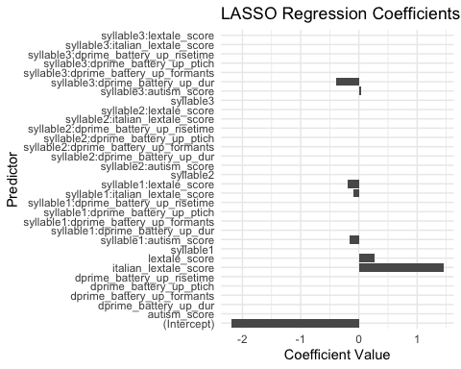

## optimizer (Nelder_Mead) convergence code: 0 (OK)  
## Model failed to converge with max|grad| = 0.0081802 (tol = 0.002, component 1)

# Fit models for non-Penultimate stress  
summary_anti_penultimate <- fit_models(comp_tar_longer_id, "Anti-penultimate")

## Warning in checkConv(attr(opt, "derivs"), opt$par, ctrl = control$checkConv, :  
## Model failed to converge with max|grad| = 0.00211687 (tol = 0.002, component 1)

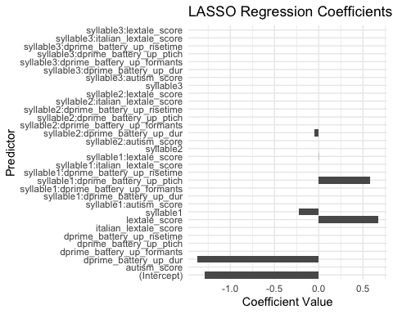

## Generalized linear mixed model fit by maximum likelihood (Laplace  
## Approximation) [glmerMod]  
## Family: binomial ( logit )  
## Formula:   
## values ~ syllable + dprime_battery_up_dur + lextale_score + syllable:dprime_battery_up_dur +   
## syllable:dprime_battery_up_ptich + syllable:lextale_score +   
## (1 | word_play)  
## Data: data_filtered  
##   
## AIC BIC logLik deviance df.resid   
## 10870.6 10962.7 -5422.3 10844.6 8806   
##   
## Scaled residuals:   
## Min 1Q Median 3Q Max   
## -1.3772 -0.7079 -0.5853 1.1847 2.6029   
##   
## Random effects:  
## Groups Name Variance Std.Dev.  
## word_play (Intercept) 0.07606 0.2758   
## Number of obs: 8819, groups: word_play, 24  
##   
## Fixed effects:  
## Estimate Std. Error z value Pr(>|z|)   
## (Intercept) -1.5634 0.2436 -6.419 1.37e-10 ***  
## syllable2 -0.4597 0.4323 -1.064 0.2875   
## syllable3 -0.5004 0.3779 -1.324 0.1854   
## dprime_battery_up_dur -1.7392 0.3613 -4.814 1.48e-06 ***  
## lextale_score 0.6349 0.2927 2.169 0.0301 *   
## syllable2:dprime_battery_up_dur -0.7630 0.6721 -1.135 0.2562   
## syllable3:dprime_battery_up_dur -0.4225 0.5793 -0.729 0.4658   
## syllable1:dprime_battery_up_ptich 0.8879 0.2138 4.154 3.27e-05 ***  
## syllable2:dprime_battery_up_ptich 0.7265 0.3539 2.053 0.0401 *   
## syllable3:dprime_battery_up_ptich 0.4800 0.2869 1.673 0.0943 .   
## syllable2:lextale_score 0.9517 0.5350 1.779 0.0753 .   
## syllable3:lextale_score 0.9875 0.4674 2.113 0.0346 *   
## ---  
## Signif. codes: 0 '***' 0.001 '**' 0.01 '*' 0.05 '.' 0.1 ' ' 1  
##   
## Correlation of Fixed Effects:  
## (Intr) syllb2 syllb3 dpr___ lxtl_s  
## syllable2 -0.533   
## syllable3 -0.610 0.343   
## dprm_bttr__ 0.134 -0.076 -0.086   
## lextale_scr -0.940 0.529 0.606 0.046   
## syllbl2:dprm_bttry_p_d -0.072 0.150 0.046 -0.539 -0.024  
## syllbl3:dprm_bttry_p_d -0.083 0.047 0.147 -0.624 -0.029  
## syllbl1:___ -0.038 0.021 0.024 -0.198 0.117  
## syllbl2:dprm_bttry_p_p 0.000 -0.059 0.001 0.000 0.000  
## syllbl3:dprm_bttry_p_p 0.000 0.000 -0.057 0.000 0.000  
## syllbl2:lx_ 0.514 -0.965 -0.331 -0.025 -0.546  
## syllbl3:lx_ 0.589 -0.331 -0.966 -0.029 -0.627  
## syllbl2:dprm_bttry_p_d syllbl3:dprm_bttry_p_d s1:___  
## syllable2   
## syllable3   
## dprm_bttr__   
## lextale_scr   
## syllbl2:dprm_bttry_p_d   
## syllbl3:dprm_bttry_p_d 0.337   
## syllbl1:___ 0.107 0.124   
## syllbl2:dprm_bttry_p_p -0.200 0.000 0.000  
## syllbl3:dprm_bttry_p_p 0.000 -0.180 0.000  
## syllbl2:lx_ 0.030 0.016 -0.064  
## syllbl3:lx_ 0.016 0.030 -0.073  
## syllbl2:dprm_bttry_p_p syllbl3:dprm_bttry_p_p syl2:_  
## syllable2   
## syllable3   
## dprm_bttr__   
## lextale_scr   
## syllbl2:dprm_bttry_p_d   
## syllbl3:dprm_bttry_p_d   
## syllbl1:___   
## syllbl2:dprm_bttry_p_p   
## syllbl3:dprm_bttry_p_p 0.000   
## syllbl2:lx_ 0.132 0.000   
## syllbl3:lx_ -0.001 0.128 0.342  
## optimizer (Nelder_Mead) convergence code: 0 (OK)  
## Model failed to converge with max|grad| = 0.00211687 (tol = 0.002, component 1)

summary_penultimate$summary

## Generalized linear mixed model fit by maximum likelihood (Laplace  
## Approximation) [glmerMod]  
## Family: binomial ( logit )  
## Formula:   
## values ~ lextale_score + italian_lextale_score + syllable:dprime_battery_up_dur +   
## syllable:lextale_score + syllable:autism_score + syllable:italian_lextale_score +   
## (1 | word_play)  
## Data: data_filtered  
##   
## AIC BIC logLik deviance df.resid   
## 10866.7 10965.6 -5419.4 10838.7 8635   
##   
## Scaled residuals:   
## Min 1Q Median 3Q Max   
## -1.3423 -0.7284 -0.5918 1.1495 2.3940   
##   
## Random effects:  
## Groups Name Variance Std.Dev.  
## word_play (Intercept) 0.1483 0.3851   
## Number of obs: 8649, groups: word_play, 24  
##   
## Fixed effects:  
## Estimate Std. Error z value Pr(>|z|)   
## (Intercept) -5.02711 1.22079 -4.118 3.82e-05 ***  
## lextale_score -0.04220 0.38805 -0.109 0.913405   
## italian_lextale_score 4.23226 1.27848 3.310 0.000932 ***  
## syllable1:dprime_battery_up_dur -0.31647 0.46465 -0.681 0.495811   
## syllable2:dprime_battery_up_dur -0.08322 0.38092 -0.218 0.827054   
## syllable3:dprime_battery_up_dur -0.80535 0.43533 -1.850 0.064314 .   
## lextale_score:syllable2 0.83900 0.50270 1.669 0.095119 .   
## lextale_score:syllable3 0.78831 0.53056 1.486 0.137334   
## syllable1:autism_score -0.22055 0.31420 -0.702 0.482711   
## syllable2:autism_score 0.45215 0.25938 1.743 0.081296 .   
## syllable3:autism_score 0.47694 0.29560 1.613 0.106645   
## italian_lextale_score:syllable2 -0.52111 0.44830 -1.162 0.245072   
## italian_lextale_score:syllable3 -0.47563 0.47568 -1.000 0.317364   
## ---  
## Signif. codes: 0 '***' 0.001 '**' 0.01 '*' 0.05 '.' 0.1 ' ' 1

##   
## Correlation matrix not shown by default, as p = 13 > 12.  
## Use print(x, correlation=TRUE) or  
## vcov(x) if you need it

## optimizer (Nelder_Mead) convergence code: 0 (OK)  
## Model failed to converge with max|grad| = 0.0081802 (tol = 0.002, component 1)

summary_anti_penultimate$summary

## Generalized linear mixed model fit by maximum likelihood (Laplace  
## Approximation) [glmerMod]  
## Family: binomial ( logit )  
## Formula:   
## values ~ syllable + dprime_battery_up_dur + lextale_score + syllable:dprime_battery_up_dur +   
## syllable:dprime_battery_up_ptich + syllable:lextale_score +   
## (1 | word_play)  
## Data: data_filtered  
##   
## AIC BIC logLik deviance df.resid   
## 10870.6 10962.7 -5422.3 10844.6 8806   
##   
## Scaled residuals:   
## Min 1Q Median 3Q Max   
## -1.3772 -0.7079 -0.5853 1.1847 2.6029   
##   
## Random effects:  
## Groups Name Variance Std.Dev.  
## word_play (Intercept) 0.07606 0.2758   
## Number of obs: 8819, groups: word_play, 24  
##   
## Fixed effects:  
## Estimate Std. Error z value Pr(>|z|)   
## (Intercept) -1.5634 0.2436 -6.419 1.37e-10 ***  
## syllable2 -0.4597 0.4323 -1.064 0.2875   
## syllable3 -0.5004 0.3779 -1.324 0.1854   
## dprime_battery_up_dur -1.7392 0.3613 -4.814 1.48e-06 ***  
## lextale_score 0.6349 0.2927 2.169 0.0301 *   
## syllable2:dprime_battery_up_dur -0.7630 0.6721 -1.135 0.2562   
## syllable3:dprime_battery_up_dur -0.4225 0.5793 -0.729 0.4658   
## syllable1:dprime_battery_up_ptich 0.8879 0.2138 4.154 3.27e-05 ***  
## syllable2:dprime_battery_up_ptich 0.7265 0.3539 2.053 0.0401 *   
## syllable3:dprime_battery_up_ptich 0.4800 0.2869 1.673 0.0943 .   
## syllable2:lextale_score 0.9517 0.5350 1.779 0.0753 .   
## syllable3:lextale_score 0.9875 0.4674 2.113 0.0346 *   
## ---  
## Signif. codes: 0 '***' 0.001 '**' 0.01 '*' 0.05 '.' 0.1 ' ' 1  
##   
## Correlation of Fixed Effects:  
## (Intr) syllb2 syllb3 dpr___ lxtl_s  
## syllable2 -0.533   
## syllable3 -0.610 0.343   
## dprm_bttr__ 0.134 -0.076 -0.086   
## lextale_scr -0.940 0.529 0.606 0.046   
## syllbl2:dprm_bttry_p_d -0.072 0.150 0.046 -0.539 -0.024  
## syllbl3:dprm_bttry_p_d -0.083 0.047 0.147 -0.624 -0.029  
## syllbl1:___ -0.038 0.021 0.024 -0.198 0.117  
## syllbl2:dprm_bttry_p_p 0.000 -0.059 0.001 0.000 0.000  
## syllbl3:dprm_bttry_p_p 0.000 0.000 -0.057 0.000 0.000  
## syllbl2:lx_ 0.514 -0.965 -0.331 -0.025 -0.546  
## syllbl3:lx_ 0.589 -0.331 -0.966 -0.029 -0.627  
## syllbl2:dprm_bttry_p_d syllbl3:dprm_bttry_p_d s1:___  
## syllable2   
## syllable3   
## dprm_bttr__   
## lextale_scr   
## syllbl2:dprm_bttry_p_d   
## syllbl3:dprm_bttry_p_d 0.337   
## syllbl1:___ 0.107 0.124   
## syllbl2:dprm_bttry_p_p -0.200 0.000 0.000  
## syllbl3:dprm_bttry_p_p 0.000 -0.180 0.000  
## syllbl2:lx_ 0.030 0.016 -0.064  
## syllbl3:lx_ 0.016 0.030 -0.073  
## syllbl2:dprm_bttry_p_p syllbl3:dprm_bttry_p_p syl2:_  
## syllable2   
## syllable3   
## dprm_bttr__   
## lextale_scr   
## syllbl2:dprm_bttry_p_d   
## syllbl3:dprm_bttry_p_d   
## syllbl1:___   
## syllbl2:dprm_bttry_p_p   
## syllbl3:dprm_bttry_p_p 0.000   
## syllbl2:lx_ 0.132 0.000   
## syllbl3:lx_ -0.001 0.128 0.342  
## optimizer (Nelder_Mead) convergence code: 0 (OK)  
## Model failed to converge with max|grad| = 0.00211687 (tol = 0.002, component 1)

summary_penultimate$plot



summary_anti_penultimate$plot



library(conflicted)  
ets_exp1_all_agg_part_wider<-comp_tar_longer%>%  
 pivot_wider(names_from = names,values_from = values)%>%  
 filter(syllable!=0)%>%  
 group_by(participant.private.id,stress_play,syllable)%>%  
 summarise(mean_target_looks=mean(target_looks),  
 mean_competitor_looks=mean(competitor_looks),  
 mean_dist1_looks=mean(dist1_looks),  
 mean_dist2_looks=mean(dist2_looks))%>%  
 mutate(proportion_o_looks=mean_target_looks-mean_competitor_looks)%>%  
 left_join(battery_agg_wider_simp)%>%  
 left_join(digit_cleaned_simp)%>%  
 left_join(lextale_agg_cleaned_simp)%>%  
 left_join(italian_lextale_agg_cleaned_simp)%>%  
 left_join(autism_cleaned)  
  
  
ets_exp1_all_agg_part_wider%>%  
 ggplot(aes(x=dprime_battery_up_dur,y=proportion_o_looks))+  
 geom_point()+  
 geom_smooth()+  
 facet_grid(syllable~stress_play)

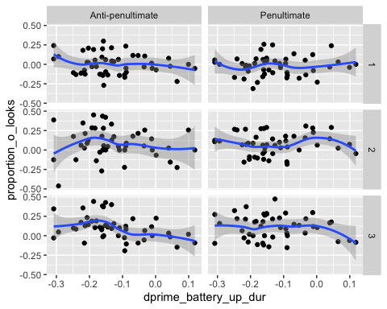

ets_exp1_all_agg_part_wider%>%  
 ggplot(aes(x=dprime_battery_up_formants,y=proportion_o_looks))+  
 geom_point()+  
 geom_smooth()+  
 facet_grid(syllable~stress_play)

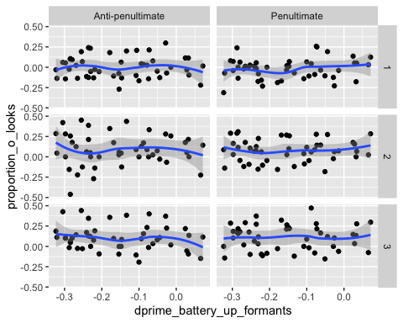

ets_exp1_all_agg_part_wider%>%  
 ggplot(aes(x=dprime_battery_up_ptich,y=proportion_o_looks))+  
 geom_point()+  
 geom_smooth()+  
 facet_grid(syllable~stress_play)

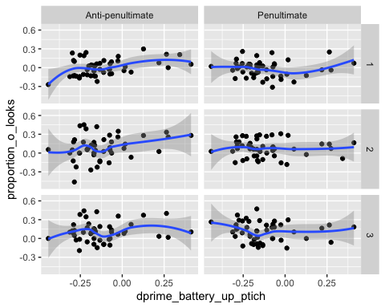

ets_exp1_all_agg_part_wider%>%  
 ggplot(aes(x=dprime_battery_up_risetime,y=proportion_o_looks))+  
 geom_point()+  
 geom_smooth()+  
 facet_grid(syllable~stress_play)

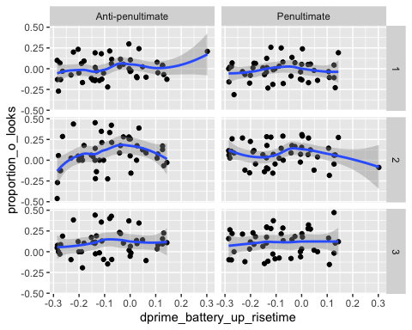

ets_exp1_all_agg_part_wider%>%  
 ggplot(aes(x=autism_score,y=proportion_o_looks))+  
 geom_point()+  
 geom_smooth()+  
 facet_grid(syllable~stress_play)

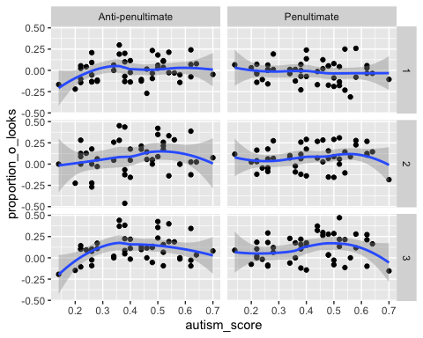

ets_exp1_all_agg_part_wider%>%  
 ggplot(aes(x=lextale_score,y=proportion_o_looks))+  
 geom_point()+  
 geom_smooth()+  
 facet_grid(syllable~stress_play)

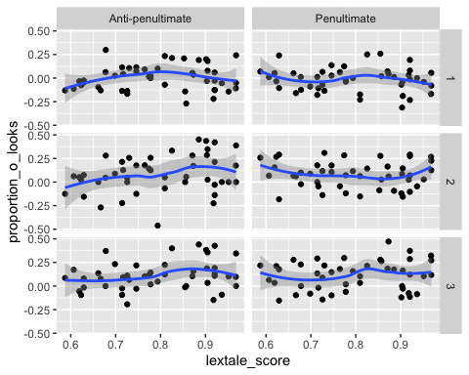

ets_exp1_all_agg_part_wider%>%  
 ggplot(aes(x=italian_lextale_score,y=proportion_o_looks))+  
 geom_point()+  
 geom_smooth()+  
 facet_grid(syllable~stress_play)

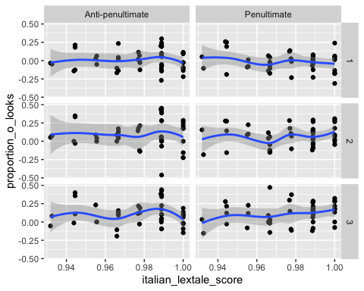

ets_exp1_all_agg_part_wider%>%  
 ggplot(aes(x=mean_working_memory,y=proportion_o_looks))+  
 geom_point()+  
 geom_smooth()+  
 facet_grid(syllable~stress_play)

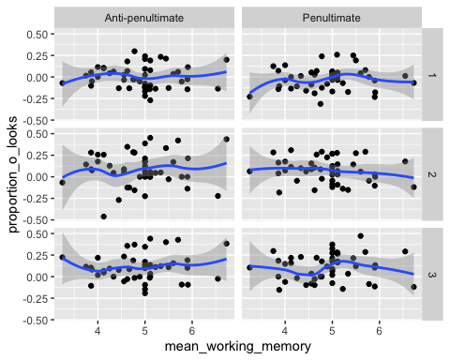

ets_exp1_all_agg_part_wider%>%  
 ggplot(aes(y=proportion_o_looks,x=dprime_battery_up_ptich,size=dprime_battery_up_dur,alpha=.2))+  
 geom_point()+  
 geom_smooth()+  
 facet_grid(syllable~stress_play)

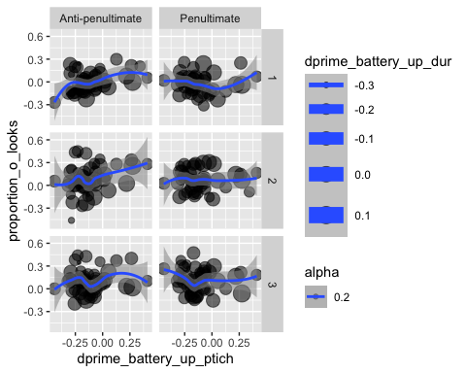

ets_exp1_all_agg_part_wider%>%  
 ggplot(aes(y=mean_target_looks,x=autism_score,size=italian_lextale_score,color=syllable,alpha=.2))+  
 geom_point()+  
 geom_smooth()+  
 facet_grid(.~stress_play)

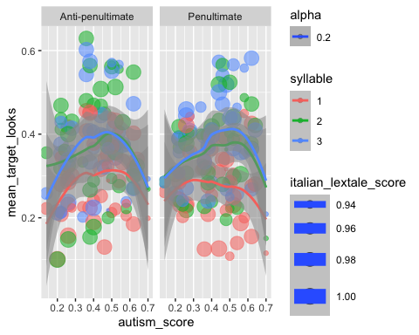

write.csv(ets_exp1_all_agg_part_wider, "../../ppcc_iflu_data/ets_exp1_all_agg_part_wider.csv")

fit_models_acoustic_id <- function(data) {  
 # Filter the data  
 data_filtered <- na.omit(data)  
   
 # Create the design matrix and response vector  
 x <- model.matrix(target_looks ~ (dprime_battery_up_dur +   
 dprime_battery_up_ptich +   
 dprime_battery_up_risetime +   
 dprime_battery_up_formants +   
 lextale_score + autism_score +   
 italian_lextale_score +   
 lextale_score)*  
 (mean_pitch_scaled+  
 duration_scaled+  
 mean_amplitude_scaled+  
 mean_tilt_scaled), data = data_filtered)[, -1]  
 y <- data_filtered$target_looks  
   
 # Set up lambda values for LASSO regression  
 lambda_search_space <- 10^seq(10, -2, length = 100)  
   
 # Fit the LASSO regression model  
 lasso_model <- glmnet(x, y, alpha = 1, lambda = lambda_search_space, family = "binomial")  
   
 # Cross-validation to find the best lambda  
 cv <- cv.glmnet(x, y, alpha = 1, family = "binomial")  
 best_lambda <- cv$lambda.min  
   
 # Extract coefficients for the best lambda  
 coef_lasso_best <- coef(lasso_model, s = best_lambda)  
   
 # Convert coefficients to data frame for visualization  
 coef_df <- as.data.frame(as.matrix(coef_lasso_best))  
 coef_df$Predictor <- rownames(coef_df)  
 rownames(coef_df) <- NULL  
   
 # Visualize the coefficients  
 coef_plot <- ggplot(coef_df, aes(x = Predictor, y = s1)) +  
 geom_bar(stat = "identity") +  
 coord_flip() +  
 labs(title = paste("LASSO Regression Coefficients at Best Lambda (", round(best_lambda, 4), ")", sep = ""),  
 x = "Predictor",  
 y = "Coefficient Value") +  
 theme_minimal()  
 print(coef_plot)  
   
 # Select significant variables based on LASSO coefficients  
 significant_vars <- coef_df %>%  
 filter(s1 != 0) %>%  
 pull(Predictor)  
   
 # Clean up the variable names by replacing syllable1, syllable2, and syllable3 with syllable  
 significant_vars <- gsub("syllable[123]", "syllable", significant_vars)  
   
 # Remove duplicate variables  
 significant_vars <- unique(significant_vars)  
   
 # Prepare formula for GLMM using significant variables  
 significant_vars <- significant_vars[significant_vars != "(Intercept)"] # Remove intercept if present  
 formula_str <- paste("target_looks ~", paste(significant_vars, collapse = " + "), "+ (1|word)")  
   
 # Convert the string to a formula object  
 formula <- as.formula(formula_str)  
 formula  
 # Fit GLMM with selected variables  
 model_selected <- glmer(formula, data = data_filtered, family = "binomial")  
   
 # Print the summary of the GLMM  
 print(summary(model_selected))  
   
 # Return the summary and the plot  
 list(summary = summary(model_selected), plot = coef_plot)  
}

# Prepare datasets  
ap_data_1_id <- ap_data_1 %>%  
 left_join(battery_agg_wider_simp) %>%  
 left_join(digit_cleaned_simp) %>%  
 left_join(lextale_agg_cleaned_simp) %>%  
 left_join(italian_lextale_agg_cleaned_simp) %>%  
 left_join(autism_cleaned)

## Joining with `by = join_by(participant.private.id)`  
## Joining with `by = join_by(participant.private.id)`  
## Joining with `by = join_by(participant.private.id)`  
## Joining with `by = join_by(participant.private.id)`  
## Joining with `by = join_by(participant.private.id)`

ap_data_3_id <- ap_data_3 %>%  
 left_join(battery_agg_wider_simp) %>%  
 left_join(digit_cleaned_simp) %>%  
 left_join(lextale_agg_cleaned_simp) %>%  
 left_join(italian_lextale_agg_cleaned_simp) %>%  
 left_join(autism_cleaned)

## Joining with `by = join_by(participant.private.id)`  
## Joining with `by = join_by(participant.private.id)`  
## Joining with `by = join_by(participant.private.id)`  
## Joining with `by = join_by(participant.private.id)`  
## Joining with `by = join_by(participant.private.id)`

pp_data_1_id <- pp_data_1 %>%  
 left_join(battery_agg_wider_simp) %>%  
 left_join(digit_cleaned_simp) %>%  
 left_join(lextale_agg_cleaned_simp) %>%  
 left_join(italian_lextale_agg_cleaned_simp) %>%  
 left_join(autism_cleaned)

## Joining with `by = join_by(participant.private.id)`  
## Joining with `by = join_by(participant.private.id)`  
## Joining with `by = join_by(participant.private.id)`  
## Joining with `by = join_by(participant.private.id)`  
## Joining with `by = join_by(participant.private.id)`

pp_data_3_id <- pp_data_3 %>%  
 left_join(battery_agg_wider_simp) %>%  
 left_join(digit_cleaned_simp) %>%  
 left_join(lextale_agg_cleaned_simp) %>%  
 left_join(italian_lextale_agg_cleaned_simp) %>%  
 left_join(autism_cleaned)

## Joining with `by = join_by(participant.private.id)`  
## Joining with `by = join_by(participant.private.id)`  
## Joining with `by = join_by(participant.private.id)`  
## Joining with `by = join_by(participant.private.id)`  
## Joining with `by = join_by(participant.private.id)`

result_ap_data_1 <- fit_models_acoustic_id(ap_data_1_id)

## Warning in checkConv(attr(opt, "derivs"), opt$par, ctrl = control$checkConv, :  
## Model failed to converge with max|grad| = 0.011968 (tol = 0.002, component 1)

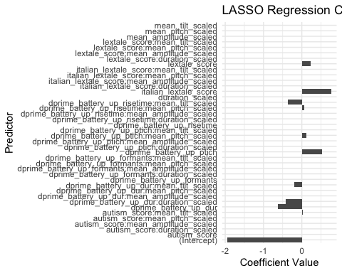

## Generalized linear mixed model fit by maximum likelihood (Laplace  
## Approximation) [glmerMod]  
## Family: binomial ( logit )  
## Formula: target_looks ~ dprime_battery_up_dur + dprime_battery_up_ptich +   
## lextale_score + italian_lextale_score + dprime_battery_up_dur:duration_scaled +   
## dprime_battery_up_dur:mean_tilt_scaled + dprime_battery_up_ptich:mean_pitch_scaled +   
## dprime_battery_up_risetime:mean_pitch_scaled + dprime_battery_up_risetime:mean_tilt_scaled +   
## autism_score:mean_tilt_scaled + (1 | word)  
## Data: data_filtered  
##   
## AIC BIC logLik deviance df.resid   
## 5082.1 5158.6 -2529.0 5058.1 4345   
##   
## Scaled residuals:   
## Min 1Q Median 3Q Max   
## -1.1859 -0.6473 -0.5480 1.2329 2.9375   
##   
## Random effects:  
## Groups Name Variance Std.Dev.  
## word (Intercept) 0.08389 0.2896   
## Number of obs: 4357, groups: word, 23  
##   
## Fixed effects:  
## Estimate Std. Error z value  
## (Intercept) -4.7168 1.7104 -2.758  
## dprime_battery_up_dur -1.0733 0.4461 -2.406  
## dprime_battery_up_ptich 0.9954 0.2214 4.496  
## lextale_score 0.6437 0.3072 2.095  
## italian_lextale_score 3.1846 1.7753 1.794  
## dprime_battery_up_dur:duration_scaled -0.8175 0.4079 -2.004  
## dprime_battery_up_dur:mean_tilt_scaled -0.1021 0.3737 -0.273  
## dprime_battery_up_ptich:mean_pitch_scaled 0.2781 0.2303 1.207  
## mean_pitch_scaled:dprime_battery_up_risetime 0.2858 0.3211 0.890  
## mean_tilt_scaled:dprime_battery_up_risetime -0.6141 0.2922 -2.101  
## mean_tilt_scaled:autism_score 0.2614 0.1680 1.556  
## Pr(>|z|)   
## (Intercept) 0.00582 **   
## dprime_battery_up_dur 0.01614 *   
## dprime_battery_up_ptich 6.93e-06 ***  
## lextale_score 0.03614 *   
## italian_lextale_score 0.07284 .   
## dprime_battery_up_dur:duration_scaled 0.04507 *   
## dprime_battery_up_dur:mean_tilt_scaled 0.78463   
## dprime_battery_up_ptich:mean_pitch_scaled 0.22728   
## mean_pitch_scaled:dprime_battery_up_risetime 0.37338   
## mean_tilt_scaled:dprime_battery_up_risetime 0.03561 *   
## mean_tilt_scaled:autism_score 0.11969   
## ---  
## Signif. codes: 0 '***' 0.001 '**' 0.01 '*' 0.05 '.' 0.1 ' ' 1  
##   
## Correlation of Fixed Effects:  
## (Intr) dprm_bttry_p_d dprm_bttry_p_p lxtl_s itln__ dp___:_  
## dprm_bttry_p_d 0.059   
## dprm_bttry_p_p -0.023 -0.156   
## lextale_scr 0.057 0.034 0.114   
## itln_lxtl_s -0.989 -0.042 0.017 -0.195   
## dprm_bt__:_ -0.001 -0.515 -0.012 0.003 0.001   
## dprm_bttry_p_d:__ -0.023 -0.140 0.009 0.006 0.016 -0.172   
## dprm_bttry_p_p:__ 0.004 -0.018 -0.066 -0.006 -0.004 0.007   
## mn_ptc_:___ -0.024 -0.012 -0.008 -0.019 0.026 0.001   
## mn_tlt_:___ -0.045 0.007 -0.110 -0.054 0.053 0.017   
## mn_tlt_sc:_ -0.075 -0.063 -0.023 -0.004 0.063 -0.037   
## dprm_bttry_p_d:__ dprm_bttry_p_p:__ mn_p_:___ mn_t_:___  
## dprm_bttry_p_d   
## dprm_bttry_p_p   
## lextale_scr   
## itln_lxtl_s   
## dprm_bt__:_   
## dprm_bttry_p_d:__   
## dprm_bttry_p_p:__ 0.047   
## mn_ptc_:___ -0.019 -0.436   
## mn_tlt_:___ -0.246 -0.014 0.191   
## mn_tlt_sc:_ 0.463 0.003 0.015 0.021   
## optimizer (Nelder_Mead) convergence code: 0 (OK)  
## Model failed to converge with max|grad| = 0.011968 (tol = 0.002, component 1)

result_pp_data_1 <- fit_models_acoustic_id(pp_data_1_id)

## Warning in checkConv(attr(opt, "derivs"), opt$par, ctrl = control$checkConv, :  
## Model failed to converge with max|grad| = 0.00760328 (tol = 0.002, component 1)

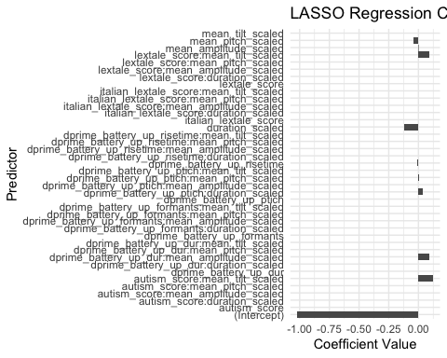

## Generalized linear mixed model fit by maximum likelihood (Laplace  
## Approximation) [glmerMod]  
## Family: binomial ( logit )  
## Formula: target_looks ~ dprime_battery_up_risetime + mean_pitch_scaled +   
## duration_scaled + mean_amplitude_scaled + dprime_battery_up_dur:mean_amplitude_scaled +   
## dprime_battery_up_ptich:mean_pitch_scaled + dprime_battery_up_ptich:duration_scaled +   
## lextale_score:mean_tilt_scaled + autism_score:mean_tilt_scaled +   
## italian_lextale_score:mean_amplitude_scaled + (1 | word)  
## Data: data_filtered  
##   
## AIC BIC logLik deviance df.resid   
## 3089.8 3160.3 -1532.9 3065.8 2622   
##   
## Scaled residuals:   
## Min 1Q Median 3Q Max   
## -0.9948 -0.6322 -0.5346 1.1321 2.3729   
##   
## Random effects:  
## Groups Name Variance Std.Dev.  
## word (Intercept) 0.1263 0.3554   
## Number of obs: 2634, groups: word, 24  
##   
## Fixed effects:  
## Estimate Std. Error z value  
## (Intercept) -1.04585 0.29216 -3.580  
## dprime_battery_up_risetime -0.39073 0.40509 -0.965  
## mean_pitch_scaled -0.06378 0.09418 -0.677  
## duration_scaled -0.11509 0.27094 -0.425  
## mean_amplitude_scaled 0.58582 1.80642 0.324  
## mean_amplitude_scaled:dprime_battery_up_dur 0.25248 0.38781 0.651  
## mean_pitch_scaled:dprime_battery_up_ptich 0.11475 0.27933 0.411  
## duration_scaled:dprime_battery_up_ptich 0.19011 0.30430 0.625  
## lextale_score:mean_tilt_scaled 0.18939 0.19524 0.970  
## mean_tilt_scaled:autism_score 0.18958 0.30221 0.627  
## mean_amplitude_scaled:italian_lextale_score -0.66010 1.84596 -0.358  
## Pr(>|z|)   
## (Intercept) 0.000344 ***  
## dprime_battery_up_risetime 0.334766   
## mean_pitch_scaled 0.498288   
## duration_scaled 0.670999   
## mean_amplitude_scaled 0.745712   
## mean_amplitude_scaled:dprime_battery_up_dur 0.515024   
## mean_pitch_scaled:dprime_battery_up_ptich 0.681214   
## duration_scaled:dprime_battery_up_ptich 0.532131   
## lextale_score:mean_tilt_scaled 0.332025   
## mean_tilt_scaled:autism_score 0.530449   
## mean_amplitude_scaled:italian_lextale_score 0.720650   
## ---  
## Signif. codes: 0 '***' 0.001 '**' 0.01 '*' 0.05 '.' 0.1 ' ' 1  
##   
## Correlation of Fixed Effects:  
## (Intr) dpr___ mn_pt_ drtn_s mn_mp_ mn_m_:___ mn_p_:___ d_:___  
## dprm_bttr__ 0.114   
## mn_ptch_scl -0.093 -0.003   
## duratn_scld 0.925 0.052 -0.192   
## mn_mpltd_sc -0.014 -0.028 0.004 -0.009   
## mn_mpl_:___ 0.001 -0.010 0.014 0.002 0.046   
## mn_ptc_:___ -0.004 -0.009 0.417 -0.037 0.013 0.043   
## drtn_sc:___ 0.040 0.322 -0.090 0.160 0.003 0.001 -0.223   
## lxtl_scr:__ 0.221 -0.005 0.085 0.130 0.084 -0.027 -0.049 0.068  
## mn_tlt_sc:_ 0.056 0.012 0.053 0.021 -0.104 0.041 0.060 -0.073  
## mn_mplt_:__ 0.001 0.028 -0.001 0.000 -0.999 -0.019 -0.012 -0.003  
## lx_:__ mn__:_  
## dprm_bttr__   
## mn_ptch_scl   
## duratn_scld   
## mn_mpltd_sc   
## mn_mpl_:___   
## mn_ptc_:___   
## drtn_sc:___   
## lxtl_scr:__   
## mn_tlt_sc:_ -0.700   
## mn_mplt_:__ -0.096 0.103  
## optimizer (Nelder_Mead) convergence code: 0 (OK)  
## Model failed to converge with max|grad| = 0.00760328 (tol = 0.002, component 1)

result_ap_data_3 <- fit_models_acoustic_id(ap_data_3_id)

## Warning in checkConv(attr(opt, "derivs"), opt$par, ctrl = control$checkConv, :  
## Model failed to converge with max|grad| = 0.0039877 (tol = 0.002, component 1)

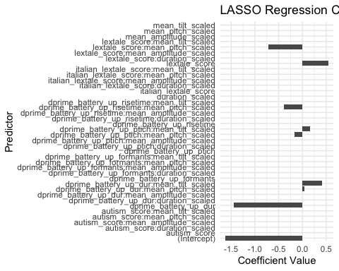

## Generalized linear mixed model fit by maximum likelihood (Laplace  
## Approximation) [glmerMod]  
## Family: binomial ( logit )  
## Formula:   
## target_looks ~ dprime_battery_up_dur + lextale_score + dprime_battery_up_dur:mean_pitch_scaled +   
## dprime_battery_up_dur:mean_tilt_scaled + dprime_battery_up_ptich:mean_pitch_scaled +   
## dprime_battery_up_ptich:mean_tilt_scaled + dprime_battery_up_risetime:mean_pitch_scaled +   
## lextale_score:mean_pitch_scaled + (1 | word)  
## Data: data_filtered  
##   
## AIC BIC logLik deviance df.resid   
## 3195.0 3253.1 -1587.5 3175.0 2465   
##   
## Scaled residuals:   
## Min 1Q Median 3Q Max   
## -1.4416 -0.7549 -0.6334 1.1529 1.9937   
##   
## Random effects:  
## Groups Name Variance Std.Dev.  
## word (Intercept) 0.03065 0.1751   
## Number of obs: 2475, groups: word, 23  
##   
## Fixed effects:  
## Estimate Std. Error z value  
## (Intercept) -1.9924 0.3051 -6.531  
## dprime_battery_up_dur -2.3587 1.4371 -1.641  
## lextale_score 0.6420 0.4704 1.365  
## dprime_battery_up_dur:mean_pitch_scaled -0.2635 1.6336 -0.161  
## dprime_battery_up_dur:mean_tilt_scaled 0.5143 0.5085 1.011  
## mean_pitch_scaled:dprime_battery_up_ptich -0.7025 0.3616 -1.942  
## mean_tilt_scaled:dprime_battery_up_ptich 0.4910 0.3569 1.376  
## mean_pitch_scaled:dprime_battery_up_risetime -0.7644 0.4579 -1.669  
## lextale_score:mean_pitch_scaled -1.1386 0.3560 -3.199  
## Pr(>|z|)   
## (Intercept) 6.52e-11 ***  
## dprime_battery_up_dur 0.10074   
## lextale_score 0.17236   
## dprime_battery_up_dur:mean_pitch_scaled 0.87183   
## dprime_battery_up_dur:mean_tilt_scaled 0.31184   
## mean_pitch_scaled:dprime_battery_up_ptich 0.05208 .   
## mean_tilt_scaled:dprime_battery_up_ptich 0.16885   
## mean_pitch_scaled:dprime_battery_up_risetime 0.09509 .   
## lextale_score:mean_pitch_scaled 0.00138 **   
## ---  
## Signif. codes: 0 '***' 0.001 '**' 0.01 '*' 0.05 '.' 0.1 ' ' 1  
##   
## Correlation of Fixed Effects:  
## (Intr) dpr___ lxtl_s dprm_bttry_p_dr:mn_p_  
## dprm_bttr__ 0.046   
## lextale_scr -0.756 0.417   
## dprm_bttry_p_dr:mn_p_ 0.003 0.942 0.427   
## dprm_bttry_p_dr:mn_t_ -0.005 0.327 0.054 0.263   
## mn_ptch_scld:dprm_bttry_p_p 0.105 0.017 -0.065 -0.043   
## mn_tlt_:___ 0.006 -0.102 -0.106 -0.069   
## mn_ptch_scld:dprm_bttry_p_r -0.119 -0.003 0.091 -0.055   
## lxtl_scr:__ 0.009 0.648 0.608 0.678   
## dprm_bttry_p_dr:mn_t_ mn_ptch_scld:dprm_bttry_p_p  
## dprm_bttr__   
## lextale_scr   
## dprm_bttry_p_dr:mn_p_   
## dprm_bttry_p_dr:mn_t_   
## mn_ptch_scld:dprm_bttry_p_p 0.080   
## mn_tlt_:___ -0.517 -0.163   
## mn_ptch_scld:dprm_bttry_p_r 0.011 -0.325   
## lxtl_scr:__ 0.069 0.116   
## mn_t_:___ mn_ptch_scld:dprm_bttry_p_r  
## dprm_bttr__   
## lextale_scr   
## dprm_bttry_p_dr:mn_p_   
## dprm_bttry_p_dr:mn_t_   
## mn_ptch_scld:dprm_bttry_p_p   
## mn_tlt_:___   
## mn_ptch_scld:dprm_bttry_p_r 0.000   
## lxtl_scr:__ -0.143 0.022   
## optimizer (Nelder_Mead) convergence code: 0 (OK)  
## Model failed to converge with max|grad| = 0.0039877 (tol = 0.002, component 1)

result_pp_data_3 <- fit_models_acoustic_id(pp_data_3_id)

## Warning in checkConv(attr(opt, "derivs"), opt$par, ctrl = control$checkConv, :  
## Model failed to converge with max|grad| = 0.0557315 (tol = 0.002, component 1)

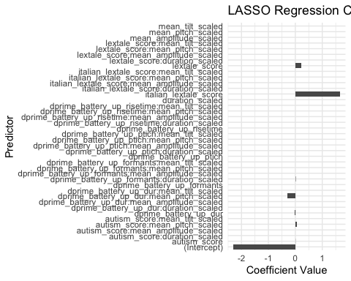

## Generalized linear mixed model fit by maximum likelihood (Laplace  
## Approximation) [glmerMod]  
## Family: binomial ( logit )  
## Formula: target_looks ~ dprime_battery_up_dur + lextale_score + autism_score +   
## italian_lextale_score + dprime_battery_up_dur:mean_pitch_scaled +   
## dprime_battery_up_formants:duration_scaled + autism_score:mean_pitch_scaled +   
## (1 | word)  
## Data: data_filtered  
##   
## AIC BIC logLik deviance df.resid   
## 3392.5 3445.1 -1687.2 3374.5 2552   
##   
## Scaled residuals:   
## Min 1Q Median 3Q Max   
## -1.2893 -0.7930 -0.6725 1.1483 1.7532   
##   
## Random effects:  
## Groups Name Variance Std.Dev.  
## word (Intercept) 0.08264 0.2875   
## Number of obs: 2561, groups: word, 24  
##   
## Fixed effects:  
## Estimate Std. Error z value Pr(>|z|)  
## (Intercept) -7.6840 2.2153 -3.469 0.000523  
## dprime_battery_up_dur -0.8787 0.6379 -1.377 0.168388  
## lextale_score 0.7306 0.3624 2.016 0.043791  
## autism_score 0.3281 0.3595 0.913 0.361505  
## italian_lextale_score 6.5459 2.2736 2.879 0.003989  
## dprime_battery_up_dur:mean_pitch_scaled -0.2193 0.5289 -0.415 0.678439  
## dprime_battery_up_formants:duration_scaled 0.6316 0.3416 1.849 0.064511  
## autism_score:mean_pitch_scaled 0.1938 0.2296 0.844 0.398641  
##   
## (Intercept) ***  
## dprime_battery_up_dur   
## lextale_score *   
## autism_score   
## italian_lextale_score **   
## dprime_battery_up_dur:mean_pitch_scaled   
## dprime_battery_up_formants:duration_scaled .   
## autism_score:mean_pitch_scaled   
## ---  
## Signif. codes: 0 '***' 0.001 '**' 0.01 '*' 0.05 '.' 0.1 ' ' 1  
##   
## Correlation of Fixed Effects:  
## (Intr) dpr___ lxtl_s atsm_s itln__ d___:__ dp___:_  
## dprm_bttr__ 0.063   
## lextale_scr 0.062 0.034   
## autism_scor -0.243 0.352 0.016   
## itln_lxtl_s -0.989 -0.064 -0.190 0.193   
## dprm_b__:__ -0.020 -0.701 -0.006 -0.329 0.023   
## dprm_bt__:_ -0.195 -0.305 0.065 -0.099 0.207 0.125   
## atsm_scr:__ 0.003 -0.394 -0.010 -0.513 -0.003 0.589 -0.038   
## optimizer (Nelder_Mead) convergence code: 0 (OK)  
## Model failed to converge with max|grad| = 0.0557315 (tol = 0.002, component 1)

# Print summaries and display plots  
print(result_ap_data_1$summary)

## Generalized linear mixed model fit by maximum likelihood (Laplace  
## Approximation) [glmerMod]  
## Family: binomial ( logit )  
## Formula: target_looks ~ dprime_battery_up_dur + dprime_battery_up_ptich +   
## lextale_score + italian_lextale_score + dprime_battery_up_dur:duration_scaled +   
## dprime_battery_up_dur:mean_tilt_scaled + dprime_battery_up_ptich:mean_pitch_scaled +   
## dprime_battery_up_risetime:mean_pitch_scaled + dprime_battery_up_risetime:mean_tilt_scaled +   
## autism_score:mean_tilt_scaled + (1 | word)  
## Data: data_filtered  
##   
## AIC BIC logLik deviance df.resid   
## 5082.1 5158.6 -2529.0 5058.1 4345   
##   
## Scaled residuals:   
## Min 1Q Median 3Q Max   
## -1.1859 -0.6473 -0.5480 1.2329 2.9375   
##   
## Random effects:  
## Groups Name Variance Std.Dev.  
## word (Intercept) 0.08389 0.2896   
## Number of obs: 4357, groups: word, 23  
##   
## Fixed effects:  
## Estimate Std. Error z value  
## (Intercept) -4.7168 1.7104 -2.758  
## dprime_battery_up_dur -1.0733 0.4461 -2.406  
## dprime_battery_up_ptich 0.9954 0.2214 4.496  
## lextale_score 0.6437 0.3072 2.095  
## italian_lextale_score 3.1846 1.7753 1.794  
## dprime_battery_up_dur:duration_scaled -0.8175 0.4079 -2.004  
## dprime_battery_up_dur:mean_tilt_scaled -0.1021 0.3737 -0.273  
## dprime_battery_up_ptich:mean_pitch_scaled 0.2781 0.2303 1.207  
## mean_pitch_scaled:dprime_battery_up_risetime 0.2858 0.3211 0.890  
## mean_tilt_scaled:dprime_battery_up_risetime -0.6141 0.2922 -2.101  
## mean_tilt_scaled:autism_score 0.2614 0.1680 1.556  
## Pr(>|z|)   
## (Intercept) 0.00582 **   
## dprime_battery_up_dur 0.01614 *   
## dprime_battery_up_ptich 6.93e-06 ***  
## lextale_score 0.03614 *   
## italian_lextale_score 0.07284 .   
## dprime_battery_up_dur:duration_scaled 0.04507 *   
## dprime_battery_up_dur:mean_tilt_scaled 0.78463   
## dprime_battery_up_ptich:mean_pitch_scaled 0.22728   
## mean_pitch_scaled:dprime_battery_up_risetime 0.37338   
## mean_tilt_scaled:dprime_battery_up_risetime 0.03561 *   
## mean_tilt_scaled:autism_score 0.11969   
## ---  
## Signif. codes: 0 '***' 0.001 '**' 0.01 '*' 0.05 '.' 0.1 ' ' 1  
##   
## Correlation of Fixed Effects:  
## (Intr) dprm_bttry_p_d dprm_bttry_p_p lxtl_s itln__ dp___:_  
## dprm_bttry_p_d 0.059   
## dprm_bttry_p_p -0.023 -0.156   
## lextale_scr 0.057 0.034 0.114   
## itln_lxtl_s -0.989 -0.042 0.017 -0.195   
## dprm_bt__:_ -0.001 -0.515 -0.012 0.003 0.001   
## dprm_bttry_p_d:__ -0.023 -0.140 0.009 0.006 0.016 -0.172   
## dprm_bttry_p_p:__ 0.004 -0.018 -0.066 -0.006 -0.004 0.007   
## mn_ptc_:___ -0.024 -0.012 -0.008 -0.019 0.026 0.001   
## mn_tlt_:___ -0.045 0.007 -0.110 -0.054 0.053 0.017   
## mn_tlt_sc:_ -0.075 -0.063 -0.023 -0.004 0.063 -0.037   
## dprm_bttry_p_d:__ dprm_bttry_p_p:__ mn_p_:___ mn_t_:___  
## dprm_bttry_p_d   
## dprm_bttry_p_p   
## lextale_scr   
## itln_lxtl_s   
## dprm_bt__:_   
## dprm_bttry_p_d:__   
## dprm_bttry_p_p:__ 0.047   
## mn_ptc_:___ -0.019 -0.436   
## mn_tlt_:___ -0.246 -0.014 0.191   
## mn_tlt_sc:_ 0.463 0.003 0.015 0.021   
## optimizer (Nelder_Mead) convergence code: 0 (OK)  
## Model failed to converge with max|grad| = 0.011968 (tol = 0.002, component 1)

print(result_pp_data_1$summary)

## Generalized linear mixed model fit by maximum likelihood (Laplace  
## Approximation) [glmerMod]  
## Family: binomial ( logit )  
## Formula: target_looks ~ dprime_battery_up_risetime + mean_pitch_scaled +   
## duration_scaled + mean_amplitude_scaled + dprime_battery_up_dur:mean_amplitude_scaled +   
## dprime_battery_up_ptich:mean_pitch_scaled + dprime_battery_up_ptich:duration_scaled +   
## lextale_score:mean_tilt_scaled + autism_score:mean_tilt_scaled +   
## italian_lextale_score:mean_amplitude_scaled + (1 | word)  
## Data: data_filtered  
##   
## AIC BIC logLik deviance df.resid   
## 3089.8 3160.3 -1532.9 3065.8 2622   
##   
## Scaled residuals:   
## Min 1Q Median 3Q Max   
## -0.9948 -0.6322 -0.5346 1.1321 2.3729   
##   
## Random effects:  
## Groups Name Variance Std.Dev.  
## word (Intercept) 0.1263 0.3554   
## Number of obs: 2634, groups: word, 24  
##   
## Fixed effects:  
## Estimate Std. Error z value  
## (Intercept) -1.04585 0.29216 -3.580  
## dprime_battery_up_risetime -0.39073 0.40509 -0.965  
## mean_pitch_scaled -0.06378 0.09418 -0.677  
## duration_scaled -0.11509 0.27094 -0.425  
## mean_amplitude_scaled 0.58582 1.80642 0.324  
## mean_amplitude_scaled:dprime_battery_up_dur 0.25248 0.38781 0.651  
## mean_pitch_scaled:dprime_battery_up_ptich 0.11475 0.27933 0.411  
## duration_scaled:dprime_battery_up_ptich 0.19011 0.30430 0.625  
## lextale_score:mean_tilt_scaled 0.18939 0.19524 0.970  
## mean_tilt_scaled:autism_score 0.18958 0.30221 0.627  
## mean_amplitude_scaled:italian_lextale_score -0.66010 1.84596 -0.358  
## Pr(>|z|)   
## (Intercept) 0.000344 ***  
## dprime_battery_up_risetime 0.334766   
## mean_pitch_scaled 0.498288   
## duration_scaled 0.670999   
## mean_amplitude_scaled 0.745712   
## mean_amplitude_scaled:dprime_battery_up_dur 0.515024   
## mean_pitch_scaled:dprime_battery_up_ptich 0.681214   
## duration_scaled:dprime_battery_up_ptich 0.532131   
## lextale_score:mean_tilt_scaled 0.332025   
## mean_tilt_scaled:autism_score 0.530449   
## mean_amplitude_scaled:italian_lextale_score 0.720650   
## ---  
## Signif. codes: 0 '***' 0.001 '**' 0.01 '*' 0.05 '.' 0.1 ' ' 1  
##   
## Correlation of Fixed Effects:  
## (Intr) dpr___ mn_pt_ drtn_s mn_mp_ mn_m_:___ mn_p_:___ d_:___  
## dprm_bttr__ 0.114   
## mn_ptch_scl -0.093 -0.003   
## duratn_scld 0.925 0.052 -0.192   
## mn_mpltd_sc -0.014 -0.028 0.004 -0.009   
## mn_mpl_:___ 0.001 -0.010 0.014 0.002 0.046   
## mn_ptc_:___ -0.004 -0.009 0.417 -0.037 0.013 0.043   
## drtn_sc:___ 0.040 0.322 -0.090 0.160 0.003 0.001 -0.223   
## lxtl_scr:__ 0.221 -0.005 0.085 0.130 0.084 -0.027 -0.049 0.068  
## mn_tlt_sc:_ 0.056 0.012 0.053 0.021 -0.104 0.041 0.060 -0.073  
## mn_mplt_:__ 0.001 0.028 -0.001 0.000 -0.999 -0.019 -0.012 -0.003  
## lx_:__ mn__:_  
## dprm_bttr__   
## mn_ptch_scl   
## duratn_scld   
## mn_mpltd_sc   
## mn_mpl_:___   
## mn_ptc_:___   
## drtn_sc:___   
## lxtl_scr:__   
## mn_tlt_sc:_ -0.700   
## mn_mplt_:__ -0.096 0.103  
## optimizer (Nelder_Mead) convergence code: 0 (OK)  
## Model failed to converge with max|grad| = 0.00760328 (tol = 0.002, component 1)

print(result_ap_data_3$summary)

## Generalized linear mixed model fit by maximum likelihood (Laplace  
## Approximation) [glmerMod]  
## Family: binomial ( logit )  
## Formula:   
## target_looks ~ dprime_battery_up_dur + lextale_score + dprime_battery_up_dur:mean_pitch_scaled +   
## dprime_battery_up_dur:mean_tilt_scaled + dprime_battery_up_ptich:mean_pitch_scaled +   
## dprime_battery_up_ptich:mean_tilt_scaled + dprime_battery_up_risetime:mean_pitch_scaled +   
## lextale_score:mean_pitch_scaled + (1 | word)  
## Data: data_filtered  
##   
## AIC BIC logLik deviance df.resid   
## 3195.0 3253.1 -1587.5 3175.0 2465   
##   
## Scaled residuals:   
## Min 1Q Median 3Q Max   
## -1.4416 -0.7549 -0.6334 1.1529 1.9937   
##   
## Random effects:  
## Groups Name Variance Std.Dev.  
## word (Intercept) 0.03065 0.1751   
## Number of obs: 2475, groups: word, 23  
##   
## Fixed effects:  
## Estimate Std. Error z value  
## (Intercept) -1.9924 0.3051 -6.531  
## dprime_battery_up_dur -2.3587 1.4371 -1.641  
## lextale_score 0.6420 0.4704 1.365  
## dprime_battery_up_dur:mean_pitch_scaled -0.2635 1.6336 -0.161  
## dprime_battery_up_dur:mean_tilt_scaled 0.5143 0.5085 1.011  
## mean_pitch_scaled:dprime_battery_up_ptich -0.7025 0.3616 -1.942  
## mean_tilt_scaled:dprime_battery_up_ptich 0.4910 0.3569 1.376  
## mean_pitch_scaled:dprime_battery_up_risetime -0.7644 0.4579 -1.669  
## lextale_score:mean_pitch_scaled -1.1386 0.3560 -3.199  
## Pr(>|z|)   
## (Intercept) 6.52e-11 ***  
## dprime_battery_up_dur 0.10074   
## lextale_score 0.17236   
## dprime_battery_up_dur:mean_pitch_scaled 0.87183   
## dprime_battery_up_dur:mean_tilt_scaled 0.31184   
## mean_pitch_scaled:dprime_battery_up_ptich 0.05208 .   
## mean_tilt_scaled:dprime_battery_up_ptich 0.16885   
## mean_pitch_scaled:dprime_battery_up_risetime 0.09509 .   
## lextale_score:mean_pitch_scaled 0.00138 **   
## ---  
## Signif. codes: 0 '***' 0.001 '**' 0.01 '*' 0.05 '.' 0.1 ' ' 1  
##   
## Correlation of Fixed Effects:  
## (Intr) dpr___ lxtl_s dprm_bttry_p_dr:mn_p_  
## dprm_bttr__ 0.046   
## lextale_scr -0.756 0.417   
## dprm_bttry_p_dr:mn_p_ 0.003 0.942 0.427   
## dprm_bttry_p_dr:mn_t_ -0.005 0.327 0.054 0.263   
## mn_ptch_scld:dprm_bttry_p_p 0.105 0.017 -0.065 -0.043   
## mn_tlt_:___ 0.006 -0.102 -0.106 -0.069   
## mn_ptch_scld:dprm_bttry_p_r -0.119 -0.003 0.091 -0.055   
## lxtl_scr:__ 0.009 0.648 0.608 0.678   
## dprm_bttry_p_dr:mn_t_ mn_ptch_scld:dprm_bttry_p_p  
## dprm_bttr__   
## lextale_scr   
## dprm_bttry_p_dr:mn_p_   
## dprm_bttry_p_dr:mn_t_   
## mn_ptch_scld:dprm_bttry_p_p 0.080   
## mn_tlt_:___ -0.517 -0.163   
## mn_ptch_scld:dprm_bttry_p_r 0.011 -0.325   
## lxtl_scr:__ 0.069 0.116   
## mn_t_:___ mn_ptch_scld:dprm_bttry_p_r  
## dprm_bttr__   
## lextale_scr   
## dprm_bttry_p_dr:mn_p_   
## dprm_bttry_p_dr:mn_t_   
## mn_ptch_scld:dprm_bttry_p_p   
## mn_tlt_:___   
## mn_ptch_scld:dprm_bttry_p_r 0.000   
## lxtl_scr:__ -0.143 0.022   
## optimizer (Nelder_Mead) convergence code: 0 (OK)  
## Model failed to converge with max|grad| = 0.0039877 (tol = 0.002, component 1)

print(result_pp_data_3$summary)

## Generalized linear mixed model fit by maximum likelihood (Laplace  
## Approximation) [glmerMod]  
## Family: binomial ( logit )  
## Formula: target_looks ~ dprime_battery_up_dur + lextale_score + autism_score +   
## italian_lextale_score + dprime_battery_up_dur:mean_pitch_scaled +   
## dprime_battery_up_formants:duration_scaled + autism_score:mean_pitch_scaled +   
## (1 | word)  
## Data: data_filtered  
##   
## AIC BIC logLik deviance df.resid   
## 3392.5 3445.1 -1687.2 3374.5 2552   
##   
## Scaled residuals:   
## Min 1Q Median 3Q Max   
## -1.2893 -0.7930 -0.6725 1.1483 1.7532   
##   
## Random effects:  
## Groups Name Variance Std.Dev.  
## word (Intercept) 0.08264 0.2875   
## Number of obs: 2561, groups: word, 24  
##   
## Fixed effects:  
## Estimate Std. Error z value Pr(>|z|)  
## (Intercept) -7.6840 2.2153 -3.469 0.000523  
## dprime_battery_up_dur -0.8787 0.6379 -1.377 0.168388  
## lextale_score 0.7306 0.3624 2.016 0.043791  
## autism_score 0.3281 0.3595 0.913 0.361505  
## italian_lextale_score 6.5459 2.2736 2.879 0.003989  
## dprime_battery_up_dur:mean_pitch_scaled -0.2193 0.5289 -0.415 0.678439  
## dprime_battery_up_formants:duration_scaled 0.6316 0.3416 1.849 0.064511  
## autism_score:mean_pitch_scaled 0.1938 0.2296 0.844 0.398641  
##   
## (Intercept) ***  
## dprime_battery_up_dur   
## lextale_score *   
## autism_score   
## italian_lextale_score **   
## dprime_battery_up_dur:mean_pitch_scaled   
## dprime_battery_up_formants:duration_scaled .   
## autism_score:mean_pitch_scaled   
## ---  
## Signif. codes: 0 '***' 0.001 '**' 0.01 '*' 0.05 '.' 0.1 ' ' 1  
##   
## Correlation of Fixed Effects:  
## (Intr) dpr___ lxtl_s atsm_s itln__ d___:__ dp___:_  
## dprm_bttr__ 0.063   
## lextale_scr 0.062 0.034   
## autism_scor -0.243 0.352 0.016   
## itln_lxtl_s -0.989 -0.064 -0.190 0.193   
## dprm_b__:__ -0.020 -0.701 -0.006 -0.329 0.023   
## dprm_bt__:_ -0.195 -0.305 0.065 -0.099 0.207 0.125   
## atsm_scr:__ 0.003 -0.394 -0.010 -0.513 -0.003 0.589 -0.038   
## optimizer (Nelder_Mead) convergence code: 0 (OK)  
## Model failed to converge with max|grad| = 0.0557315 (tol = 0.002, component 1)

print(result_ap_data_1$plot)



print(result_pp_data_1$plot)



print(result_ap_data_3$plot)



print(result_pp_data_3$plot)



# Install and load ggtext if not already installed  
if (!requireNamespace("ggtext", quietly = TRUE)) {  
 install.packages("ggtext")  
}  
library(ggtext)  
  
# Define variables  
acoustic_vars <- c("mean_pitch_scaled", "mean_amplitude_scaled", "mean_tilt_scaled", "duration_scaled")  
id_vars <- c("dprime_battery_up_dur", "dprime_battery_up_ptich", "dprime_battery_up_risetime", "dprime_battery_up_formants", "lextale_score", "autism_score", "italian_lextale_score", "lextale_score")  
  
# Convert the summaries into data frames  
result_ap_data_1_coefs <- as.data.frame(result_ap_data_1$summary$coef)  
result_ap_data_1_coefs$model <- "ap_data_1"  
result_ap_data_3_coefs <- as.data.frame(result_ap_data_3$summary$coef)  
result_ap_data_3_coefs$model <- "ap_data_3"  
result_pp_data_1_coefs <- as.data.frame(result_pp_data_1$summary$coef)  
result_pp_data_1_coefs$model <- "pp_data_1"  
result_pp_data_3_coefs <- as.data.frame(result_pp_data_3$summary$coef)  
result_pp_data_3_coefs$model <- "pp_data_3"  
all_coefs <- rbind(result_ap_data_1_coefs, result_ap_data_3_coefs, result_pp_data_1_coefs, result_pp_data_3_coefs)  
  
# Prepare data for plotting  
all_coefs <- all_coefs %>%  
 rownames_to_column("term") %>%  
 mutate(conf.low = Estimate - 1.96 * `Std. Error`,  
 conf.high = Estimate + 1.96 * `Std. Error`,  
 significance = case_when(  
 `Pr(>|z|)` < 0.001 ~ "***",  
 `Pr(>|z|)` < 0.01 ~ "**",  
 `Pr(>|z|)` < 0.05 ~ "*",  
 TRUE ~ ""  
 ),  
 model_type = ifelse(str_detect(model, "1"), "Model 1", "Model 3"),  
 model_color = ifelse(str_detect(model, "pp"), "PP", "AP"),  
 term_label = case_when(  
 term %in% acoustic_vars & term %in% id_vars ~ "both",  
 term %in% acoustic_vars ~ "acoustic",  
 term %in% id_vars ~ "id",  
 TRUE ~ "other"  
 ),  
 interaction_label = case_when(  
 str_detect(term, "Intercept") ~ 1,  
 str_detect(term, ":") ~ 3,  
 TRUE ~ 2  
 ))  
  
# Update term names for better readability and bold acoustic terms  
all_coefs <- all_coefs %>%  
 mutate(old_term = term) %>%  
 mutate(term = str_replace_all(term, "1", "")) %>%  
 mutate(term = str_replace_all(term, "2", "")) %>%  
 mutate(term = str_replace_all(term, "3", "")) %>%  
 mutate(term = str_replace_all(term, "_", " ")) %>%  
 mutate(term = str_replace_all(term, "dprime battery up", "(battery d')")) %>%  
 mutate(term = str_replace_all(term, "mean", "")) %>%  
 mutate(term = str_replace_all(term, "italian lextale score", "lextale (Italian)")) %>%  
 mutate(term = str_replace_all(term, "lextale score", "lextale (English)")) %>%  
 mutate(term = str_replace_all(term, "scaled", "")) %>%  
 mutate(term = str_replace_all(term, "dprime", "")) %>%  
 mutate(term = str_replace_all(term, "Autism score", "score")) %>%  
 mutate(term = str_replace_all(term, "tilt", "spec tilt")) %>%  
 mutate(term = str_replace_all(term, "(battery d') dur", "(battery d') duration")) %>%  
 mutate(term = ifelse(old_term %in% acoustic_vars, paste0("**", term, "**"), term))  
  
# Define the order of terms  
ordered_terms <- all_coefs %>%  
 arrange(interaction_label, term_label, model) %>%  
 pull(term) %>%  
 unique()  
ordered_terms

## [1] "(Intercept)" "** pitch **"   
## [3] "**duration **" "** amplitude **"   
## [5] "(battery d') dur" "(battery d') ptich"   
## [7] "lextale (English)" "lextale (Italian)"   
## [9] "(battery d') risetime" "autism score"   
## [11] "(battery d') dur:duration " "(battery d') dur: spec tilt "   
## [13] "(battery d') ptich: pitch " " pitch :(battery d') risetime"   
## [15] " spec tilt :(battery d') risetime" " spec tilt :autism score"   
## [17] "(battery d') dur: pitch " " pitch :(battery d') ptich"   
## [19] " spec tilt :(battery d') ptich" "lextale (English): pitch "   
## [21] " amplitude :(battery d') dur" "duration :(battery d') ptich"   
## [23] "lextale (English): spec tilt " " amplitude :lextale (Italian)"   
## [25] "(battery d') formants:duration " "autism score: pitch "

# Set factor levels for term  
all_coefs$term <- factor(all_coefs$term, levels = ordered_terms)  
  
# Function to create coefficient plot with confidence intervals and significance markers  
create_coef_plot <- function(coef_df, model_label, remove_y_labels = FALSE) {  
 plot <- ggplot(coef_df, aes(x = Estimate, y = term, color = model_color)) +  
 geom_point(position = position_dodge(width = 0.5)) +  
 geom_errorbarh(aes(xmin = conf.low, xmax = conf.high), height = 0.2, position = position_dodge(width = 0.5)) +  
 geom_text(aes(label = significance, x = -11, color = model_color), vjust = 0.5, position = position_dodge(width = 0.5)) +  
 labs(title = paste("Coefficient Estimates with Confidence Intervals -", model_label),  
 x = "Estimate",  
 y = if (remove_y_labels) NULL else "Predictor",  
 color = "Model Type") +  
 theme_minimal() +  
 theme(legend.position = "top",  
 axis.text.y = if (remove_y_labels) element_blank() else element_markdown(),  
 axis.ticks.y = if (remove_y_labels) element_blank() else element_line()) +  
 facet_wrap(~ model_type, scales = "free")  
 return(plot)  
}  
  
# Create and display the plot  
plot <- create_coef_plot(all_coefs, "")  
plot

