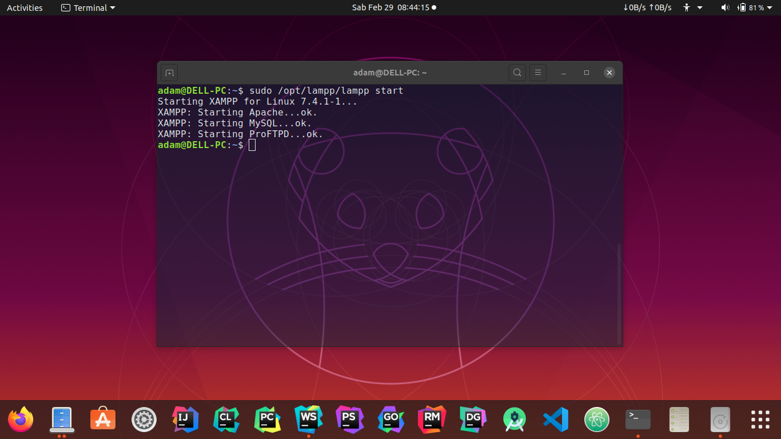Adam Arthur Faizal

M3119001

Ti A 2019