**LAPORAN PRAKTIKUM OOP DASAR**

**MODUL 9**

**OBJECT & DRIVER CLASS**



**Adam Arthur Faizal**

**M3119001**

**TI A**

**PROGRAM STUDI TEKNIK INFORMATIKA**

**SEKOLAH VOKASI**

**UNIVERSITAS SEBELAS MARET**

**SURAKARTA**

**2020**

**MODUL 9. OBJECT & DRIVER CLASS**

**Capaian Pembelajaran Praktikum:**

* Create an Object class
* Create a Driver clasS

**Tools:**

* Java Development Kit (JDK)
* Eclipse

**Terminologi:**

Isikan terminology yang sesuai untuk definisi dibawah ini:

[Packages] A group of related Java classes.

[Code Block] Sections of code that are enclosed inside a set of curly braces. {}

[Upper camel case] First letter uppercase and the first letter of each internal word capitalized. Example: SavingsAccount

[Constant] A named value that does not change.

[Lower camel case] First letter lowercase and the first letter of each internal word capitalized. Example: studentFirstName

[Driver class] A class that contains a main method.

[Import statement] A code statement in a Java class file that includes java code from another package or class.

[Programmer-created object class] A class that defines instances of objects to be used in another class.

[Java comments] Code that is preceded by //. Comments are used to clarify programming logic. Comments are ignored by the compiler.

[Java Keywords] A word that has a special function in the Java language, and cannot be used as names for classes, methods, or variables.

[Java API] The library of Java classes available to import into a programmercreated class.

[Object class] The outline of an object, including class variables, constructors, and methods.

[Constructor] A special kind of method that is a template for an object.

[Arguments] Values that are sent into a method or constructor to be used in a calculation or substituted with values from the class.

[Variables] Values, such as numbers, characters, or booleans. References to objects, such as a BankAccount object.

[Acces modifiers] Keywords used to specify the accessibility of a class (or type) and its members. Ex: public, private, protected, default

[Method] A block of code inside a class that is used to change or access information about the class.

**TRY IT / SOLVE IT:**

1. Sebutkan komponen secara urut dalam membuat sebuah class di java.
   1. Access Modifiers
   2. Class Declaration
   3. Field/Variables
   4. Constructor
   5. Methods
2. 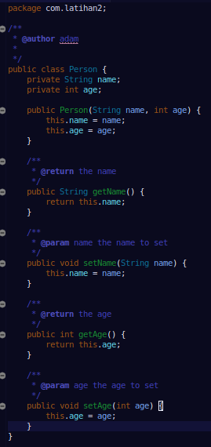Buatlah proyek baru, namai dengan Universitas. Kemudian buat package dengan nama person. Setelah itu buatlah object class Person.java (didalam package person) seperti gambar di bawah ini. Berikan penjelasan untuk source code yang anda tuliskan.
   1. Kita membuat Object class bernama Person. Lalu terdapat beberapa class variables didalamnya, diantaranya ada String name dan int age. Lalu di dalam class tersebut juga terdapat constructor berparameter, dimana saat kelas lain menginstansiasi object dari kelas ini, maka statement yang ada di dalam constructor tersebut akan dijalankan. Selain constructor, juga terdapat method getter and setter yang berfungsi untuk mengambil dan mengubah value dari class variables tersebut jika sedang diakses dari kelas yang lain.

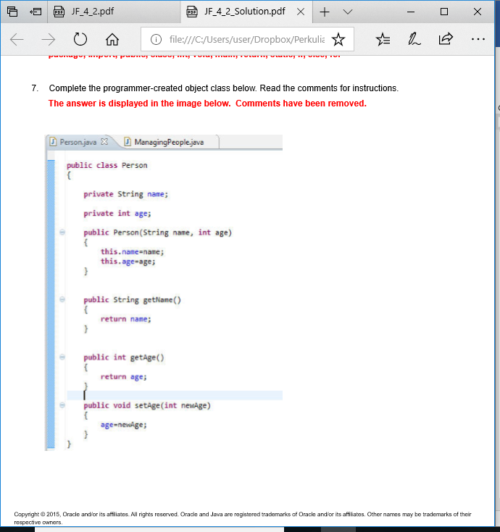

1. Buat driver kelas, namai dengan ManagingPeople.java seperti gambar di bawah ini. Kemudian compile dan jalankan. Berikan penjelasan untuk source code yang anda tuliskan.
   1. Kita menginstansiasi 2 object baru di kelas ManagingPeople sekaligus memberikan argument pada Constructor nya karena sebelumnya kita membuat Constructor berparameter pada kelas Person. Kali ini kita membuat nilai argument nya berbeda, setelah itu kita buat if else yang mengecek age dari tiap2 object, jika age nya sama, maka akan mengeluarkan output sedemikian rupa, sebaliknya jika age nya tidak sama, maka juga akan mengeluarkan output yang berbeda.

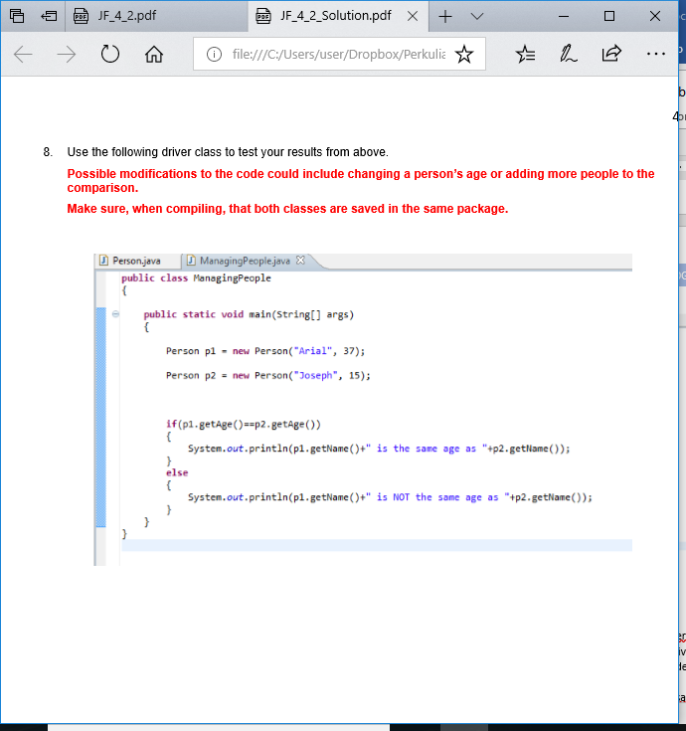

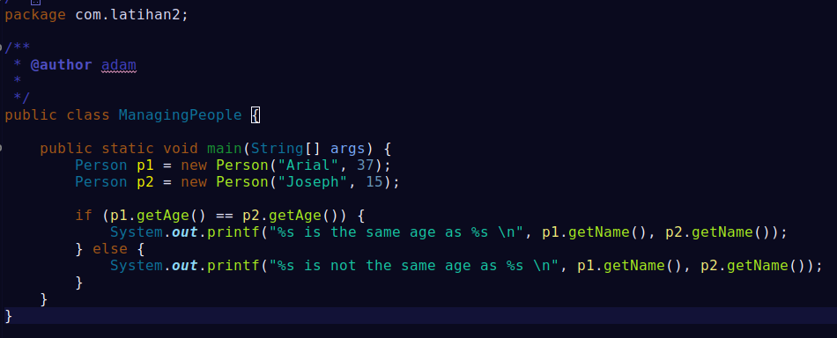

1. Sebutkan setidaknya 20 keyword di java.
   1. [abstract](https://www.javatpoint.com/abstract-keyword-in-java): Java abstract keyword is used to declare abstract class. Abstract class can provide the implementation of interface. It can have abstract and non-abstract methods.
   2. [boolean:](https://www.javatpoint.com/boolean-keyword-in-java) Java boolean keyword is used to declare a variable as a boolean type. It can hold True and False values only.
   3. [break](https://www.javatpoint.com/java-break): Java break keyword is used to break loop or switch statement. It breaks the current flow of the program at specified condition.
   4. [byte](https://www.javatpoint.com/byte-keyword-in-java): Java byte keyword is used to declare a variable that can hold an 8-bit data values.
   5. [case](https://www.javatpoint.com/case-keyword-in-java): Java case keyword is used to with the switch statements to mark blocks of text.
   6. [catch](https://www.javatpoint.com/try-catch-block): Java catch keyword is used to catch the exceptions generated by try statements. It must be used after the try block only.
   7. [char](https://www.javatpoint.com/char-keyword-in-java): Java char keyword is used to declare a variable that can hold unsigned 16-bit Unicode characters
   8. [class](https://www.javatpoint.com/class-keyword-in-java): Java class keyword is used to declare a class.
   9. [continue](https://www.javatpoint.com/java-continue): Java continue keyword is used to continue the loop. It continues the current flow of the program and skips the remaining code at the specified condition.
   10. [default](https://www.javatpoint.com/default-keyword-in-java): Java default keyword is used to specify the default block of code in a switch statement.
   11. [do](https://www.javatpoint.com/java-do-while-loop): Java do keyword is used in control statement to declare a loop. It can iterate a part of the program several times.
   12. [double](https://www.javatpoint.com/double-keyword-in-java): Java double keyword is used to declare a variable that can hold a 64-bit floating-point numbers.
   13. [else](https://www.javatpoint.com/java-if-else): Java else keyword is used to indicate the alternative branches in an if statement.
   14. [enum](https://www.javatpoint.com/enum-in-java): Java enum keyword is used to define a fixed set of constants. Enum constructors are always private or default.
   15. [extends](https://www.javatpoint.com/inheritance-in-java): Java extends keyword is used to indicate that a class is derived from another class or interface.
   16. [final](https://www.javatpoint.com/final-keyword): Java final keyword is used to indicate that a variable holds a constant value. It is applied with a variable. It is used to restrict the user.
   17. [finally](https://www.javatpoint.com/finally-block-in-exception-handling): Java finally keyword indicates a block of code in a try-catch structure. This block is always executed whether exception is handled or not.
   18. [float](https://www.javatpoint.com/float-keyword-in-java): Java float keyword is used to declare a variable that can hold a 32-bit floating-point number.
   19. [for](https://www.javatpoint.com/java-for-loop): Java for keyword is used to start a for loop. It is used to execute a set of instructions/functions repeatedly when some conditions become true. If the number of iteration is fixed, it is recommended to use for loop.
   20. [if](https://www.javatpoint.com/java-if-else): Java if keyword tests the condition. It executes the if block if condition is true.

LATIHAN:

1. Buatlah sebuah object class Student yang memiliki variabel studentID, name, NIM, IPK. Kemudian buatlah method setter dan getter nya. (anda bisa melihat modul/slide)

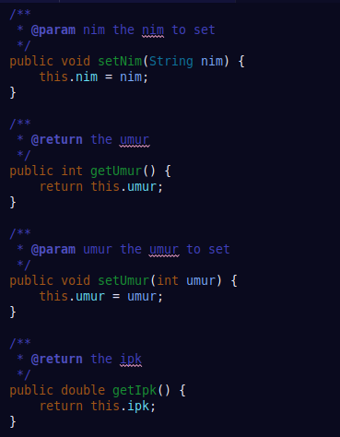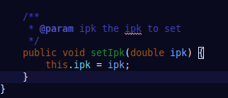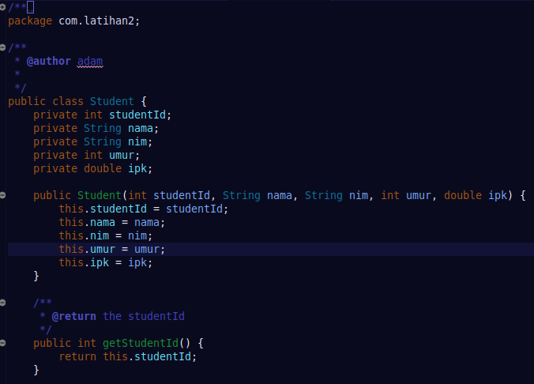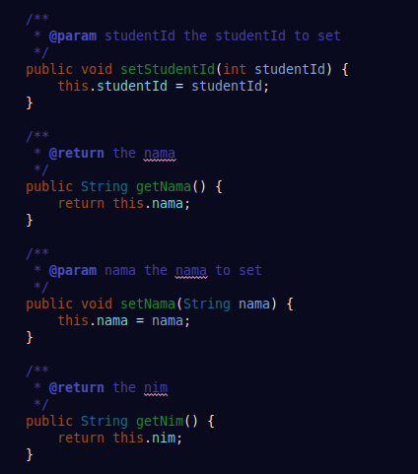

1. Buatlah driver class untuk menguji object class yang anda buat al, membuat objek, memanggil method dan mencetak data objek Student. (anda bisa melihat modul/slide)

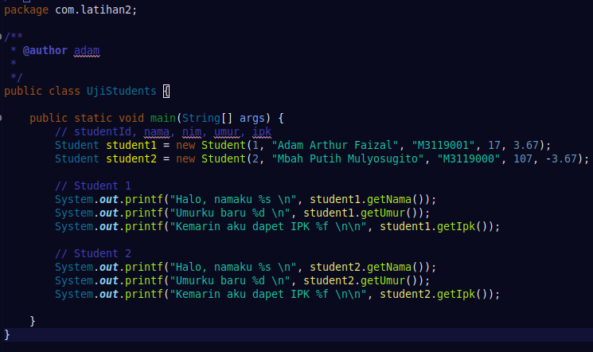

1. Jalankan program yang anda buat! Tuliskan hasilnya!
2. 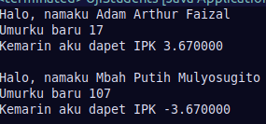Catat hasil yang anda peroleh dari step nomor 5 & 6, kemudian berikan penjelasan bilamana perlu.
   1. Saya membuat kelas Student, yang didalamnya terdapat beberapa class variables, yaitu studentId, nama, nim, umur, ipk. Lalu juga terdapat constructor berparameter untuk memberikan nilai pada masing-masing class variables yang sudah di deklarasikan sebelumnya. Tak lupa method getter and setter untuk masing-masing class variables agar mereka semua dapat diambil dan dimodifikasi valuenya dari kelas lain.

***Setelah sesi praktikum SELESAI, laporan praktikum harus dikirim/diupload ke google classroom pada hari yang berikutnya.***