# Brief:

For my application, I want to create a web-based application where project supervisors or management can oversee teams with their chats, calendars, and also monitor project progress through Gantt charts and/or to-do lists. Managers will also have an overview of all projects, tasks, and team activities to ensure efficient workflow and resource allocation.

A company will create an account on my website, where they can manage teams and assign tasks. Each company can have multiple projects running simultaneously, with the option to connect related projects.

Key Features:

1. **Managerial Overview**:
   * Managers will have access to an overview of all projects within their company.
   * They can monitor the progress of each project, track tasks, and view team activity in real-time.
   * Tools for assigning, reassigning, or modifying tasks and deadlines will be included.
2. **Chat Integration**:
   * Chats for the entire company (e.g., for announcements or notice board content).
   * Project-specific chats accessible to all members assigned to the project.
   * One-on-one chats and group chats for project leaders and specific groups.
   * Linked Project Chats: Dedicated chats for connected projects, allowing seamless communication between teams working on interrelated tasks.
3. **Task and Project Management**:
   * Projects are created for specific tasks, with employees assigned to complete those tasks.
   * Each project will have an assigned project leader.
4. **Company Overview**:
   * A dashboard to assign roles to employees and view their roles within the company.
   * The dashboard will also show an employee's position and involvement in specific projects.
5. **Calendars**:
   * Shared calendars to manage deadlines, meetings, and task schedules.
   * Project-specific calendars to track important milestones and events.
   * Employee-Specific Calendars: Personalized calendars for employees, showing their assigned tasks, deadlines, and project-related schedules to help them stay organized.
6. **Joining the Platform**:
   * Users can join a company’s page either by invitation or by sending a request to join.

This system is designed to improve communication, task management, and oversight within organizations, enabling managers and teams to collaborate more effectively and achieve their goals efficiently.

# Wireframes:

1. Start/Home Page (Top Left)

* Header: Displays the application name "TeamFlow."
* Main Options:
  + Sign into Company: A button labelled "Sign into Company Flow or Request Invite" for existing users to join their company page or request access.
  + Create Company: A button labelled "Create Company Flow" for new companies to register on the platform.
* Navigation/Icons: Top right has icons for user and settings

2. About Page (Middle Left)

* Header: Displays "TeamFlow."
* Content Area:
  + Titled "About Us," it provides information about the platform or company. Below this title, there is placeholder space for text or graphics (e.g., mission statement, purpose, or key features of TeamFlow).
* Navigation/Icons: Similar to the home page, there are icons at the top right.

3. Sign-In Screen (Bottom Left)

* Header: Identifies the page purpose with a title or branding.
* Form Fields:
  + Username/Email: Field to input a username or email address.
  + Password: Field to input the password, with an option to toggle "Show Password."
* Buttons:
  + Sign In: Button to log into the platform.

4. Creation Screen (Bottom Right)

* Header: Indicates the page is for creating a new company account.
* Form Fields:
  + Company Name: Input field for the company's name.
  + Industry: Dropdown or input field to specify the industry type.
  + Size: Dropdown to select the size of the company (e.g., small, medium, large).
* Tabs: Includes tabs for:
  + Company Info: General company details.
  + Supervisors: To assign supervisors.
  + Team Members: For adding employees.
* Buttons:
  + Create: A button to finalize and create the company account.

5. Flow Creation Screen (Top Right)

* Header: Indicates the creation process.
* Main Content:
  + Central button labelled "Create" to begin creating a company flow.

These wireframes represent the core structure of the application, emphasizing simplicity in navigation and user onboarding.

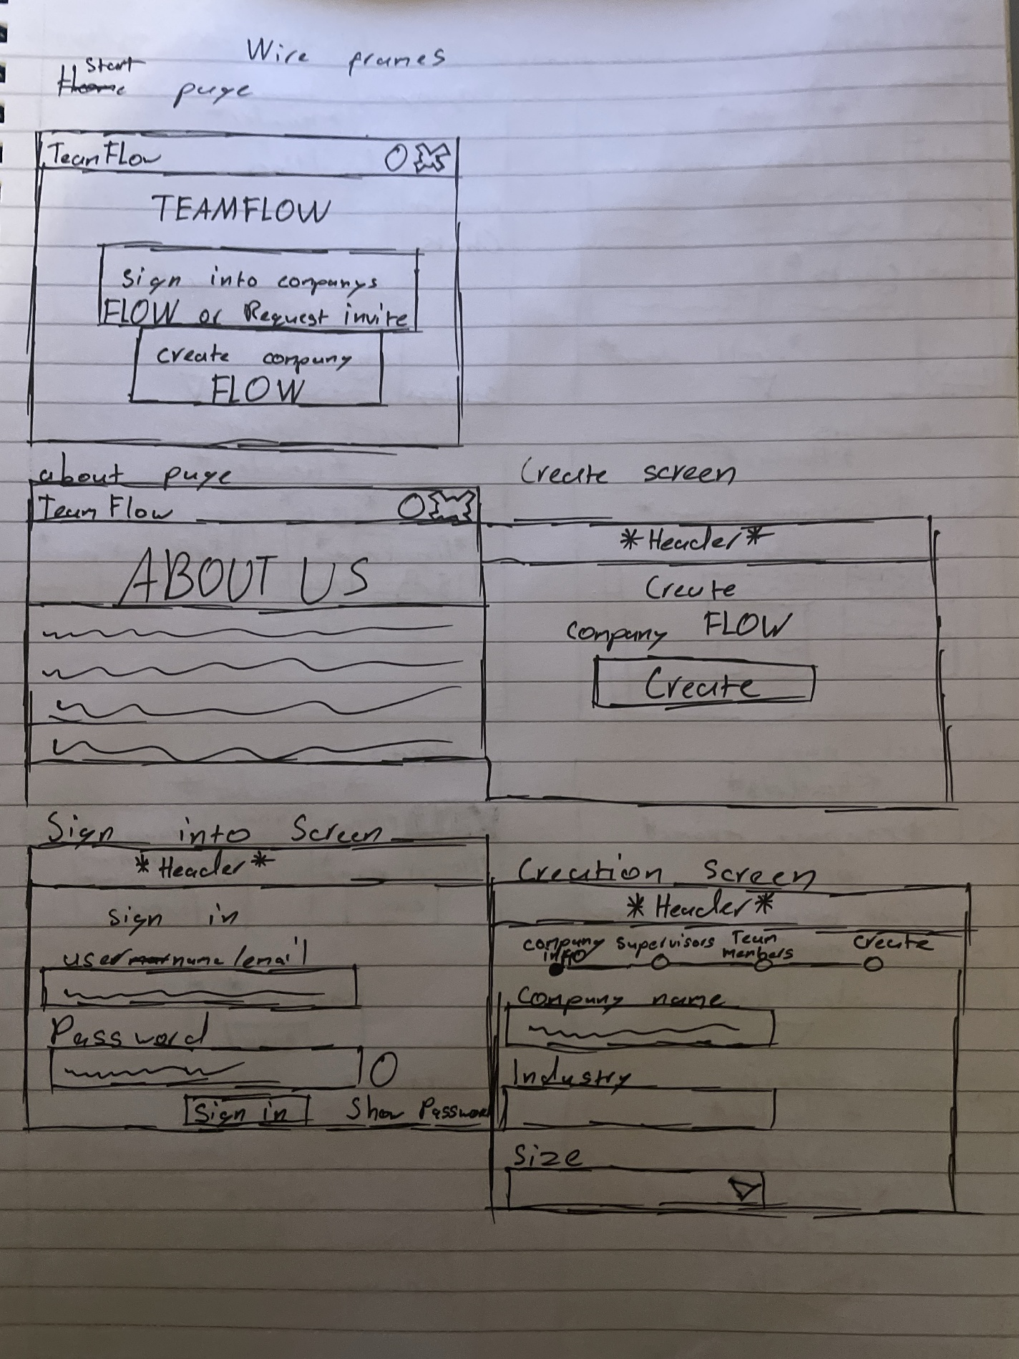

Left (Manager-Facing Wireframes)

1. Home Page (Top Left)
   * Header: *Stays the same*
   * Main Sections:
     + Deadlines Overview: A section showing important deadlines for the manager to monitor.
     + Chats: A panel for ongoing chats related to projects or members.
   * Scrollable Area: Indicated by a scroll icon, allowing managers to view more content.
   * Side bar: where you can get to members of the company and all projects and chats, also get settings here.
2. Members Page (Middle Left)
   * Header: *Stays the same*
   * Title: Includes the title "*Company name* Members."
   * Main Section:
     + A table or card layout displaying:
       - Member Name.
       - Position/Role.
       - The projects that they are in
   * Navigation Icon: A back arrow to return to the previous page.
3. Project Page (Bottom Left)
   * Header: *Stays the same*
   * Main Sections:
     + A list of active projects with:
       - Project Name.
       - Project manager and button to chat to the manager 1 on 1.
       - Deadline.
       - Links to "View" the project or "Chat" about the project.
   * Scrollable Area: Allows the manager to browse through multiple projects.
   * Navigation Icon: A back arrow to return to the previous page.
4. Invite Screen (Bottom Left)
   * Header: *Stays the same*
   * Form Section:
     + User ID: Field to input the ID of the user to invite.
     + Role: Dropdown to assign a role to the new user.
     + Invite Button: Finalizes the addition of the user to the platform.
   * Navigation Icon: A back arrow to return to the previous page.

Right (Employee-Facing Wireframes)

1. Home Page (Top Right)
   * Header: *Stays the same*
   * Main Sections:
     + Deadlines: Shows tasks and deadlines assigned to the employee.
     + Notice Board: For company-wide announcements or updates.
     + See all incoming chats to user
   * Sidebar: see all projects and chats that the user is in and also access the settings here.
2. Projects Screen (Middle Right)
   * Header: *Stays the same*
   * Main Sections:
     + Displays active projects in a card layout with:
       - Project Name.
       - A "View" button to access details of the project.
       - Key metrics, such as how many members there are.
   * Navigation Icon: A back arrow to return to the previous page.
3. Chats Screen (Middle Right)
   * Header: *Stays the same*
   * Title: Chats
   * Main Sections:
     + A tabbed structure:
       - All Chats: Displays all available chats.
       - Projects: chats for non-linked projects.
       - Linked Projects: Chats for linked or interconnected projects.
       - People/Group Chats: For one-on-one or group conversations.
     + Input area for direct message with the option to Enter user info.
   * Navigation Icon: A back arrow to return to the previous page.
4. Settings Screen (Bottom Right)
   * Header: *Stays the same*
   * Title: Settings
   * Main Sections:
     + User Profile Picture: Displays the user’s profile image with an option to change it.
     + Light Mode Toggle: For switching between light and dark themes.
     + Change Password: Button to access password update functionality.

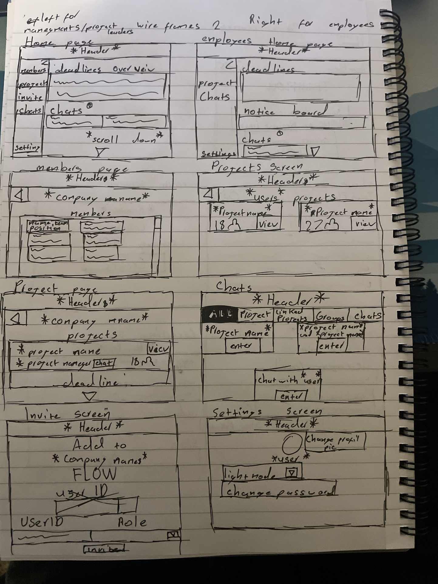

Left (Manager-Facing Wireframes)

1. User Profile (Top Left)
   * Header: *Same as before*
   * Displays the user's profile with their name or title.
   * Profile Picture: Placeholder for the user’s profile picture.
   * Projects Section:
     + A list of projects the user is associated with, displayed in rows.
     + Options for viewing or managing each project.
   * Chat Button: Shortcut to start a chat with the user.
   * Remove from Company: A button labelled "Remove" to remove the user from the company.
2. Chats Screen (Middle Left) *(Updated with new features)*
   * Header: *Same as before*
   * Tabs:
     + All Chats: Displays all available chats.
     + Projects: Displays project-specific chats.
     + Linked Projects: Shows chats for interconnected projects.
     + Groups: Chats for group discussions.
     + 1-on-1 Chats: Dedicated option for private one-on-one conversations with employees or team members.
     + Leaders: Allows the manager to chat specifically with project leaders to discuss progress or updates.
   * Search Bar: Allows searching for specific chats, users, or project groups.
   * Chat Preview: Displays a list of ongoing chats with user/project names and a preview of the latest message.
3. Settings Page (Bottom Left)
   * Header: *Same as before*
   * Title: User Settings
   * Profile Section:
     + Option to Change Profile Picture.
   * Light Mode Toggle: Switch between light and dark themes.
   * Change Password: A button to update the account password.
4. Project Page (Bottom Left)
   * Header: *Same as before*
   * Title: Displays the project name and options.
   * Tabs/Options:
     + Tasks: View tasks related to the project.
     + View Calendar: Access the project’s calendar.
     + View Chats: Open the project-specific chats.
   * Project Call Dropdown: Allows the manager to initiate a call related to the project.

Additional Note: An arrow is shown indicating connections between linked projects to highlight relationships or dependencies.

Right (Employee-Facing Wireframes)

1. User Profile (Top Right)
   * Header: *Same as before*
   * Title: Displays the user's profile title.
   * Profile Picture: Placeholder for the user’s photo.
   * Projects Section:
     + A list of projects the user is part of, with an option to view details.
   * Chat Button: Shortcut to start a chat with their manager or team members.

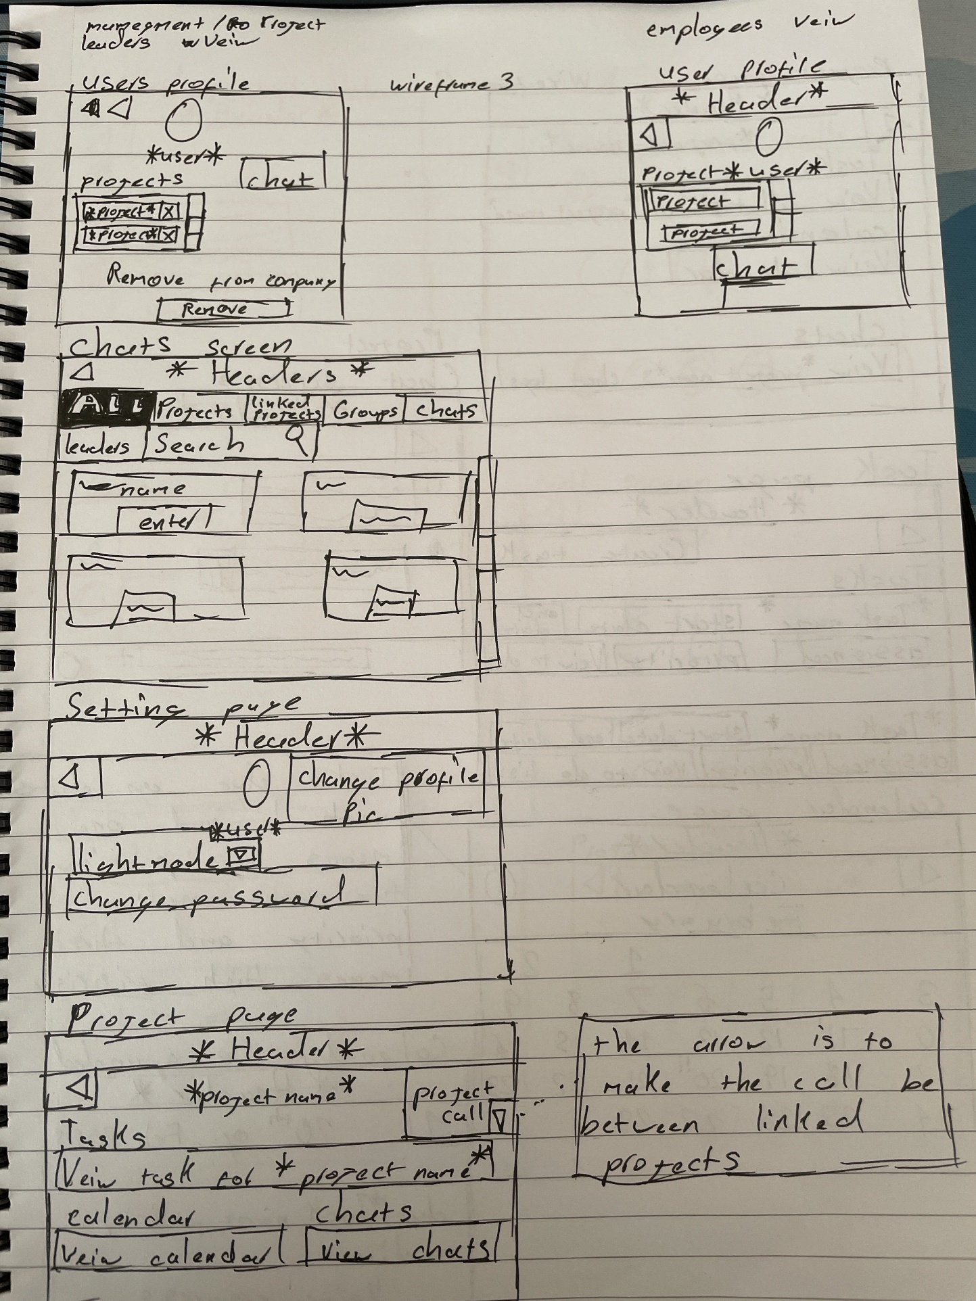

1. Project Page (Top Left)

* Header: *Same as before*.
* Options:
  + Tasks:
    - View all tasks associated with the project.
    - Button to see a detailed task list for the project.
  + Calendar:
    - Option to view the project-specific calendar.
  + Chats:
    - View the project’s chat logs to review team discussions.

2. Task Page (Middle Left)

* Header: *Same as before*.
* Options:
  + Create Task: Button to add a new task to the project.
* Task Table:
  + Columns include:
    - Task Name.
    - Start Date.
    - End Date.
    - Assigned Team Members.
    - Priority (High, Medium, or Low).
  + A View To-Do List button to see the task's associated checklist.

3. Calendar Page (Bottom Left)

* Header: *Same as before*.
* Calendar View:
  + A grid layout representing the selected month (e.g., February).
  + Days with tasks are marked with symbols:
    - One symbol (!): Low-priority tasks.
    - Two symbols (!!): Medium-priority tasks.
    - Three symbols (!!!): High-priority tasks.
* Navigation:
  + Back button to return to the previous page.

4. Expanded Calendar View (Bottom Right)

* Header: Displays the selected date (e.g., "20th of February 2023").
* Details Section:
  + Due Tasks: Lists tasks due on the selected date.
    - Includes task names and their priorities.
  + View Progress: Button to monitor task completion.
  + To-Do List: Button to see associated checklists for the tasks.

5. Project Chat Screen (Top Right)

* Header: *Same as before*.
* Chat Window:
  + Displays messages in a timeline format, grouped by user.
  + Messages can include text and attachments.
* Input Field:
  + Allows users to type messages.
  + Includes a "+" button to attach files or images.
* Send Button: Sends the message.
* Button to go back.

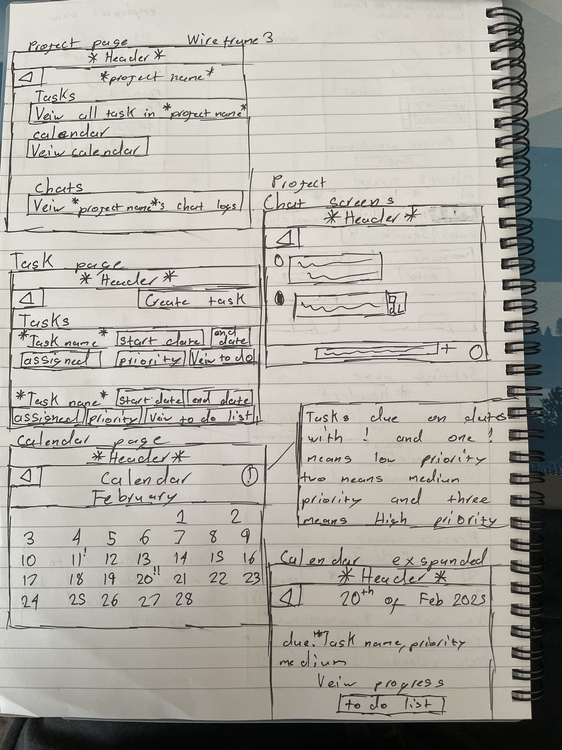

1. Linked Project Chat (Top Left) *(Simplified)*

* Header: *Same as before*, with a Back Button to navigate to the previous screen.
* Main Content:
  + Messages:
    - Each message displays:
      * Sender's Name.
      * Project Name: Indicates which project the sender belongs to.
    - Messages appear in a timeline format for easy reading.
* Chat Input Section:
  + A text field to type messages.
  + A "+" button to attach files (optional).
  + A "Send" button to submit messages.

2. Linked Projects Call Screen (Top Right)

* Top Section:
  + A Back Button to navigate to the previous screen (no header present).
* Main Content:
  + Ongoing Call Display:
    - A visual indication that a call is active, such as a "CALL IN PROGRESS" label or animated elements.
    - Participant icons showing who is currently in the call.
  + No input fields or options to initiate a call, as the screen is focused on the ongoing call.

3. Group Chats Screen (Middle Left)

* Header: *Same as before*.
* Main Content:
  + A list of group chats showing:
    - Group Name.
    - Chats
  + Chat Input Section:
    - A text field to type messages.
    - A "+" button to attach files.
    - A "Send" button to submit messages.

4. Call Screen (Middle Right)

* Top Section:
  + Back Button to navigate to the previous screen (no header present).
* Main Content:
  + Ongoing Call Display:
    - A prominent indicator showing a call is currently in progress.
    - Icons for participants currently in the call displayed at the bottom.

5. Individual Chat (Bottom Left)

* Header: *Same as before*.
* Main Content:
  + Displays the chat history between two users.
  + Chat Input Section:
    - A text field to type messages.
    - A "+" button to attach files.
    - A "Send" button to submit messages.

6. Project Call Screen (Bottom Right)

* Top Section:
  + Back Button to navigate to the previous screen (no header present).
* Main Content:
  + Ongoing Call Display:
    - A clear indication of an active call, labeled as "CALL IN PROGRESS."
    - Participant icons to show who is currently in the call.