Use of unfamiliar libraries and/or constructs:

In the process of doing my development of my graded unit I learned about a python library called openpyxl which allowed me to create and load up excel and to also once they are opened up to read and write to those excel files using just my python code and to learn about this library I used websites such as this <https://openpyxl.readthedocs.io/en/stable/> and <https://pypi.org/project/openpyxl/>.

Error Handling:

Through the whole of my program, I have error handling such as screen that will come up that will tell you where you inputted the wrong value or if you left a important field empty like this:

And also I have where if you don’t use number it will change a text box to let the user know it is text only:

Also the user when signing up will be told that they cant use the username and password the have chosen if another already has it:

If the user uses the wrong format for the date they will also get a error message for that they will also get that message if they try to use characters:

Internal documentation:

For my internal documentation I have for my comments for every instance of a function to go over what they do and I also have code to go with anything thing I initialised outside of the functions or imported and at the start of my coding file I have a comment that tells you the authors name and also the projects name and start date.





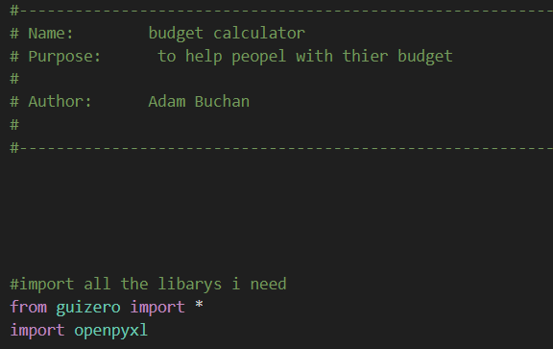

I have also made a file called README.docx that will go over how make sure your machine can run my program and tell you how the program works and if needed also show you how to download the library’s you need.

I think in my code I have used appropriate naming conventions such as with my textbox which I have names tb1 to tb14 and I have done the same with other gui objects such as list boxes and pushbuttons and text and also with the name of my excel file were the workbook is called the wb and the worksheet is called ws and adding numbers onto it when I need other workbooks and worksheets.



In my code I have also made appropriate use of indentation by having all function have at least 3 lines apart and having all if, for`s and whiles loops have at least a line apart from all other parts of code.

Test plan and run:

For the testing I did I used white box testing.

|  |  |  |  |  |
| --- | --- | --- | --- | --- |
| Test run (Item tested) | Data used | Expected result | Actual Result | Action taken |
| Error message | Tb1.value and tb2.value | To produce a error message if username or password isn’t filled in | Error message appears | N/A |
| Error message 2:  If username or password is in uses produce error message | Tb1.value and tb2.vale | Produces an error message with that says chooses a different username and password | Error message appears | N/A |
| Error message 3:  Wont enter income and date boxes | Tb5.value and tb6.value | Error message will appear that says user didn’t fill in textboxes | Error message appears | N/A |
| Error Text 4.1:income box can only be numbers | Tb5.value | Text will change to says income has to be numbers if income isn’t numbers | Text changes but the rest of the text stays on | Need to add a clear to the text before I append it and also add the original text back every time the function is called |
| Error message 4.2 | Tb5.value | Text will change to says income has to be numbers if income isn’t numbers | Text changes | N/A |
| Error message 5: date can only be numbers | Tb6.value | Error message will appear | Error message will appear | N/A |
| Error message 6: date can only be entered in format DD/MM/YYYY | Tb6.value | Error message will appear if not in format | Error message appears | N/A |
| Error message 7:expenses and date cant be left blank | Tb10.value and tb11.value | If expenses or date blank error message will appear | Error message appears | N/A |
| Error message 8:expenses cam only be numbers | Tb10.value | If expenses not numbers a error message will appear | Error message appears | N/A |
| Error message 9: date can only be numbers | Tb11.value | A error message will appear if the date isn’t numbers | Error message appears | N/A |
| Error message 10:date can only be in format of DD/MM/YYYY | Tb11.value | A error message will appear if the date isn’t in format | Error message appear | N/A |
| Error text 11: if user doesn’t use numbers for the user goals | Tb14.value | A text will change to says that goals must be numbers only and wont change back until the goal is a number | Text changes | N/A |
| To produce percentage1.1 :To how close the users balance is to the goal in percentages | Tb14.value and c | A message will appear that tells how close they are to getter their goal | It works when the users goal or balance is over 0 but If ether their goal or their balance is 0 it produces a error | To have a if statement to produce a different text if ether are 0 |
| To produce percentage1.2 :To how close the users balance is to the goal in percentages | Tb14.value | A message will appear that tells how close they are to getter their goal | A message will appear that say how close they are if their balance and goal are over 0 and if not will produce a message that says can not divide 0 | N/A |
| Username and password written to user.xlsx | Tb1.value and tb2.value | The username and password will be written the excel file | The username and password will be written the excel filet | N/A |
| To display the users balance on the home screen | Tb5.value and tb10.value | The users balance will always be display on the home screen | The user’s balance is displayed on the home screen | N/A |
| To display the user’s goal on the home screen | Tb14.value | The user’s goal will be display on the home screen | The user’s goal is displayed on the home screen | N/A |
| User info 1.1: The user can display all their income and expenses on one screen | Ws2.cells() | To display the income, date and description and expenses date and description | Its display all the information but if you call the function again it produces the results a second time under the first results | Ever time the lists are called they are cleared so new results can go in |
| User info 1.2: | Ws2.cell() | To display the income, date and description and expenses date and description | Its display all the information |  |
| Monthly goal: to set up a monthly goal that can be updated at anytime | Tb14.value | The goal in the users personal excel file will change | The goal changes | N/A |
| Home button | Home1,2,3,ect | The home button will take you to the home screen | Home screen | N/A |
| Exit | Exit1,2,3,ect | The exit button will close the program and saves all the excel files | Program closes and excel saved | N/A |

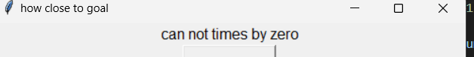



I have also made the program user friendly by labelling everything so the user will know what will happen when they click a button or when they want to know what happens on a particular screen.

User documentation:

This is a budget calculator that allows the user to set up an account with a set username and password and then log in to save their incomes, date and description if needed and also it allows the user to input their expense, date and description if needed and it also allows the user to display all their income and expenses onto one screen and the user can also set up a goal for themselves that they can change at anytime and on the home screen they will be able to see their balance and they can also how far away from their goal they are and once they have done all they needed to do they can exit the program.

In this program I have also submitted a README.docx file that ill allow the user to download all the needed libraries.

Stuff that helped me were these <https://openpyxl.readthedocs.io/en/stable/> and <https://pypi.org/project/openpyxl/>. Which helped me with guizero and the openpyxl and I also got help from https://openpyxl.readthedocs.io/en/stable/ and <https://pypi.org/project/openpyxl/> And <https://stackoverflow.com/questions/31893057/how-to-create-a-new-xlsx-file-using-openpyxl> and <https://stackoverflow.com/questions/51800122/using-openpyxl-to-find-rows-that-contain-cell-with-specific-value> .