Games developmemt

Design

Adam Buchan

2107616

hit 'em back

Table of Contents

Introduction 3

References 3

Gantt Chart 3

Mood board 5

Functional and Non-Functional Requirements 5

Functional Requirements: 5

Non-Functional Requirements: 6

Accessibility Analysis 6

Game layout Wireframe 7

UI and UX Wireframe 9

GUI/HUD Wireframe 10

Extended Accessibility Analysis 11

Sources 11

# Introduction

This is a first-person sword fighting game where you are a knight trying to save your princess from the top of the tower and you will have to reach the top to save here which will put you against the enemies in the tower.

# References

The main references for this games look and feel will be super-hot for the games look for its characters and also for its background which has been called a minimalistic environment but some things from super-hot won’t be included such as the time stopping ability and also the guns in the game[1].

The UI and menu reference for this game would be dishonoured 1 where you have a health bar you “magic” stamina which will just be the stamina in my game and then your item which will have more slots for all the sword the player will have[2].

The main background of this game is mainly influenced by old gimmick of the princess trapped at the top of the tower and the knight coming to save her that are most common are in fairy tales.

# Gantt Chart

I have my development of my game split 4 ways into design, implementation, testing and debugging in my excel Gantt chart to record and keep track of my progress



# Mood board

# Functional and Non-Functional Requirements

## Functional Requirements:

* **A Level Design**: The level layout includes set enemy and health item placement.
* **Movement**: Players have movement controls, and basic AI enables enemies to pursue and attack.
* **Usable Objects**: Players can collect health packs to restore health and swords with unique abilities.
* **UI/Menu**: The UI displays health, attack readiness, and current sword. Menus include start, quit, and restart options.
* **Sword Inventory**: Sword inventory appears in the UI, showing available consumable swords and their status.
* **Health Display**: Hearts in the UI represent health, decreasing when the player is attacked and increasing the player uses the health packs.
* **Level Completion Cue**: A cue triggers when all enemies in a level are defeated that will end the level.
* **Level Reset**: The level resets to the start if the player dies or he resets from the menu.

These requirements define the core gameplay loop.

## Non-Functional Requirements:

* **Screens**: Includes death, start, level complete, and game-over screens.
* **Reset Button**: Allows players to restart the level from the menu or death screen.
* **Sound**: Adds sounds for movement, attacks, and consumable items.
* **Volume and Resolution Settings**: Adjustable in the menu for better user control.
* **Instructions**: The main menu includes instructions on using consumables and understanding the UI.
* **Background Story**: Adds game context by explaining the events and character motivations.
* **Visual Refinements**: Enhanced models and textures for characters and objects.

These non-functional elements enhance the overall user experience.

# Accessibility Analysis

There are many scenarios where you will need accessibility in games with people who are deaf, colour blind, Customizable Controls for people with physical disability and Toggle for Flashing Effects for people with epilepsy.

Examples of games going out of their way to include people with accessibility problems would be games like Stanley parable with its use of multi-language subtitles which is include in the game that allows players to be able to understand what is going on in the game if they are deaf and/or hard of hearing and also allow people that don’t have English as their native language to be able to understand what is going on in the game which will increase the demographic that will now also be able to enjoy the game.

Which is why my game will also include the use of multiple languages for all spoken text for people in other languages with the use of Unity Localization[3].

Another example of a game that accessible is diabotical which has settings for custom colour blend for support of the colour blind where they can set it to pre-set settings for the colours and if they don’t find a set that works for their specific case of colour blindness, they can create a custom setting that would want to play the game

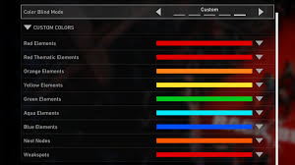

The colour blind will be include in my game because my main colours of the play area will be colour-blind-friendly palette[4] for the enemy and the health and sword laying around the level and even for the HUD there will also be written explanations for each element in the HUD so that the player if they are colour blind and the colour-blind-friendly palette doesn’t work for them will be able to know what is on the HUD and what they do.

# Game layout Wireframe

These are the wireframes for the two levels that will be in the game and the outside view of the tower to see how the game level match to the tower and the player and the backstory of the player.

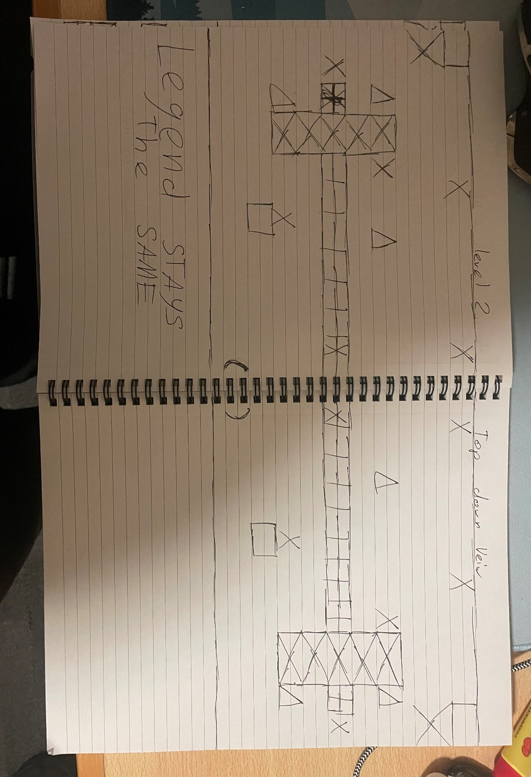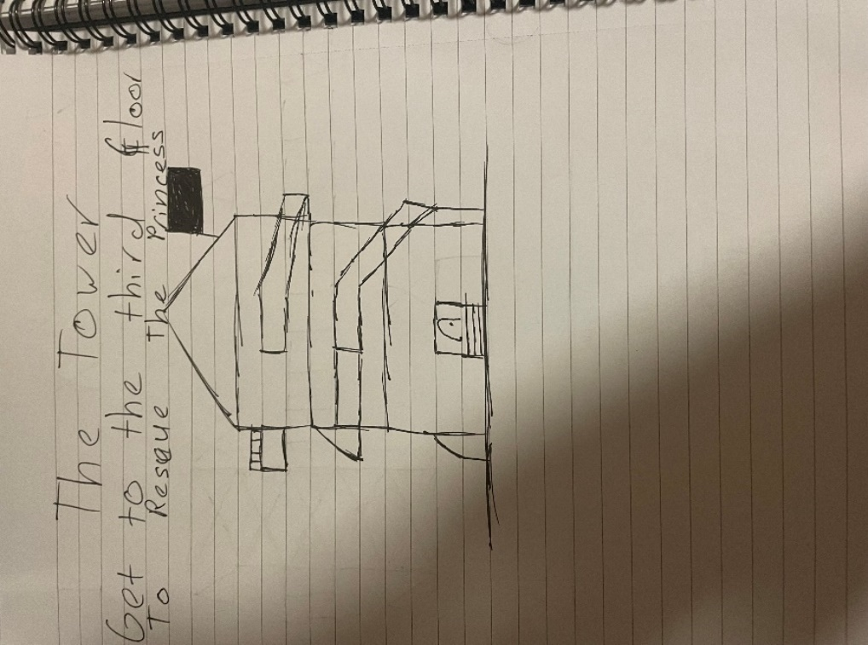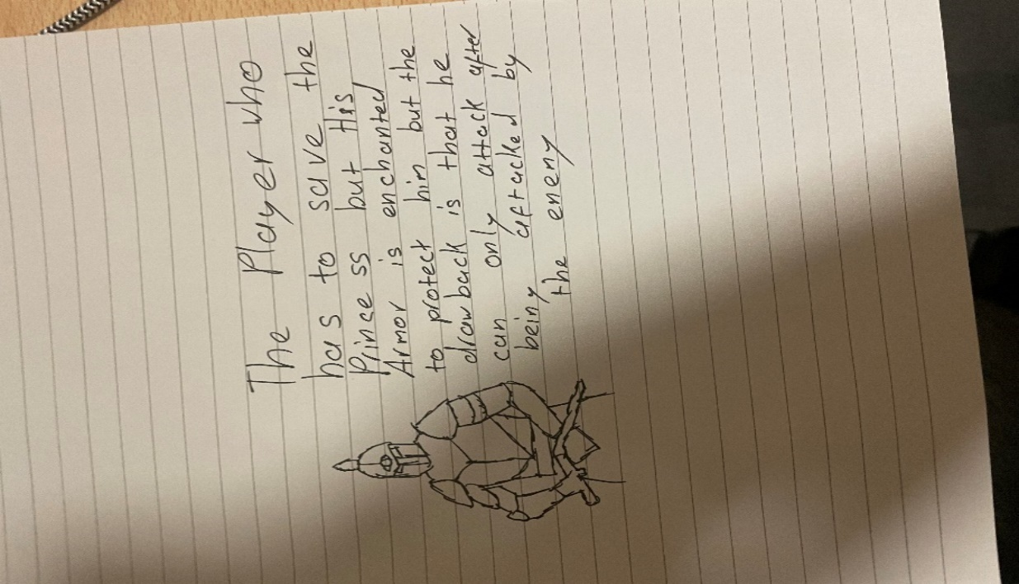[5]

# UI and UX Wireframe

* **Start Screen**:  
  The **Start Screen** includes buttons for starting the game, adjusting settings, viewing the explanation, or exiting.
* **Settings Screen**:  
  The **Settings Screen** allows the player to change the volume, adjust resolution, and return to the previous screen using the back button.
* **Explanation Screen**:  
  The **Explanation Screen** provides details on how to use the swords and health packs, with a clickable "!" for more information.
* **Pause Screen**:  
  The **Pause Screen** lets the player resume, change settings, restart the game, or exit.
* **Game Over Screen**:  
  The **Game Over Screen** shows a message when the player dies and provides options to try again, exit, or return to the start.
* **Game Pass Screen**:  
  The **Game Pass Screen** displays a message when the player completes the game, offering the option to return to the start screen.

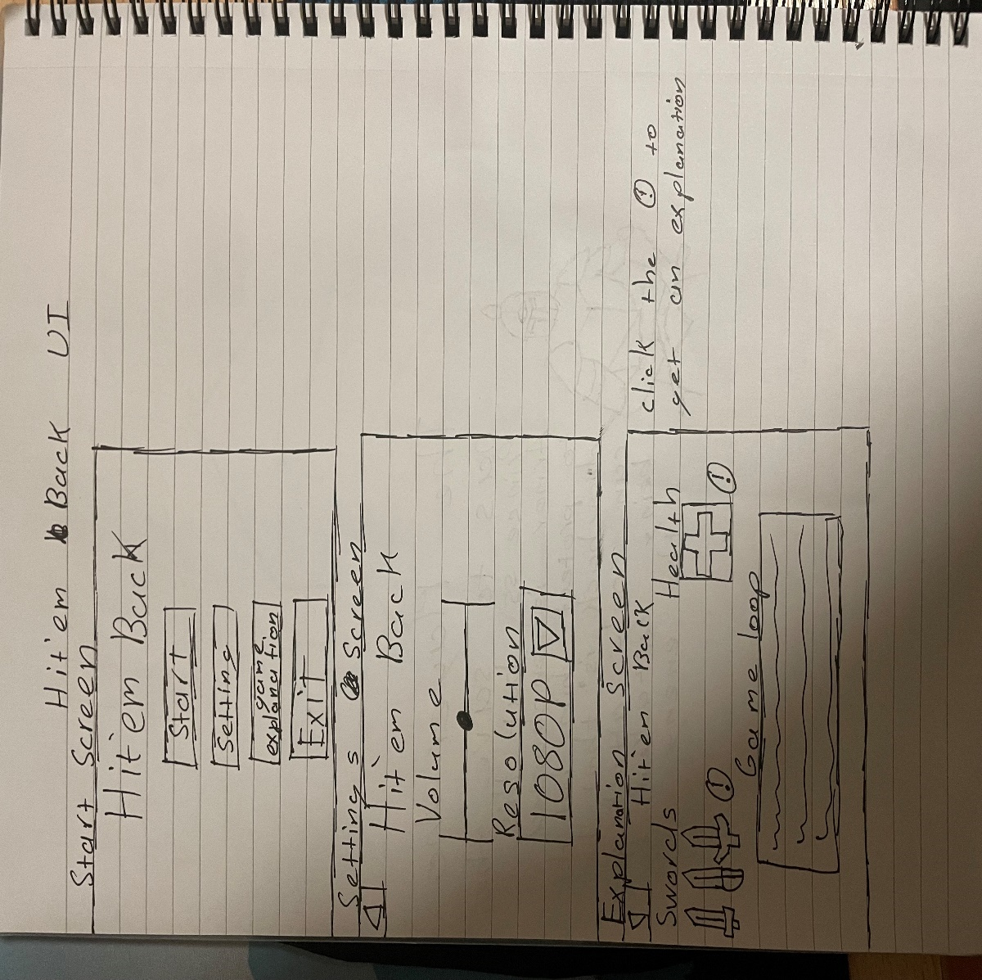

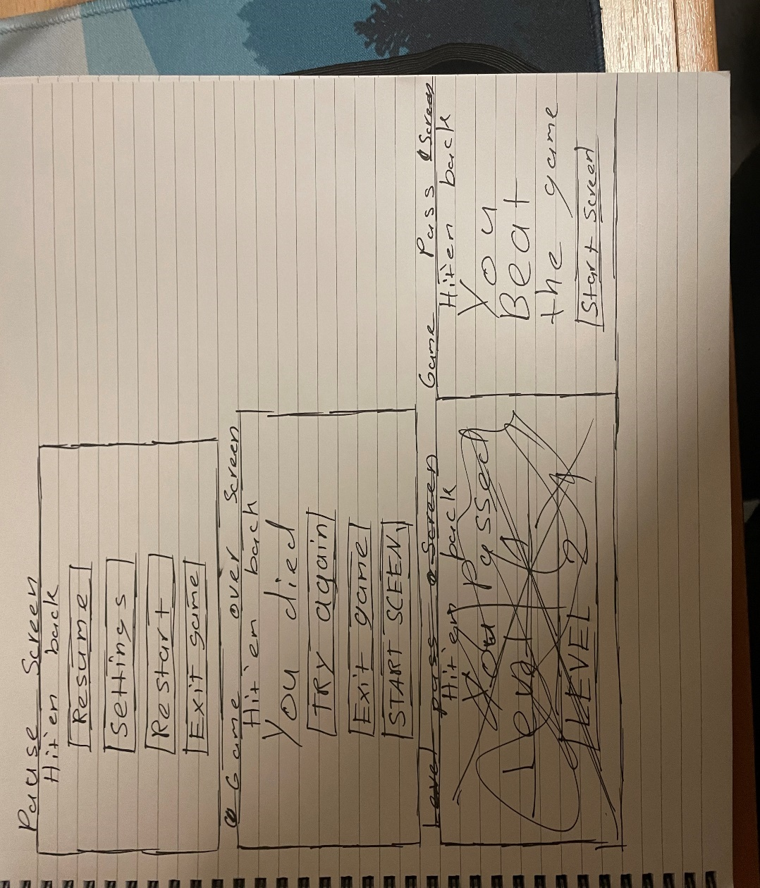

# GUI/HUD Wireframe

* **Basic HUD**:  
  The **Basic HUD** shows the player's health, stamina, attack gauge, and usable swords at the bottom of the screen.
* **Health Popup**:  
  The **Health Popup** appears when the player’s health drops below 30%, prompting them to find a health pack.
* **Sword Usage Popup**:  
  The **Sword Usage Popup** informs the player on how to use a newly picked-up sword.
* **Can't Attack Popup**:  
  The **Can't Attack Popup** notifies the player that they cannot attack yet because the attack gauge is empty.
* **Enemy Health Bar**:  
  The **Enemy Health Bar** displays the health of enemies above their heads during combat.

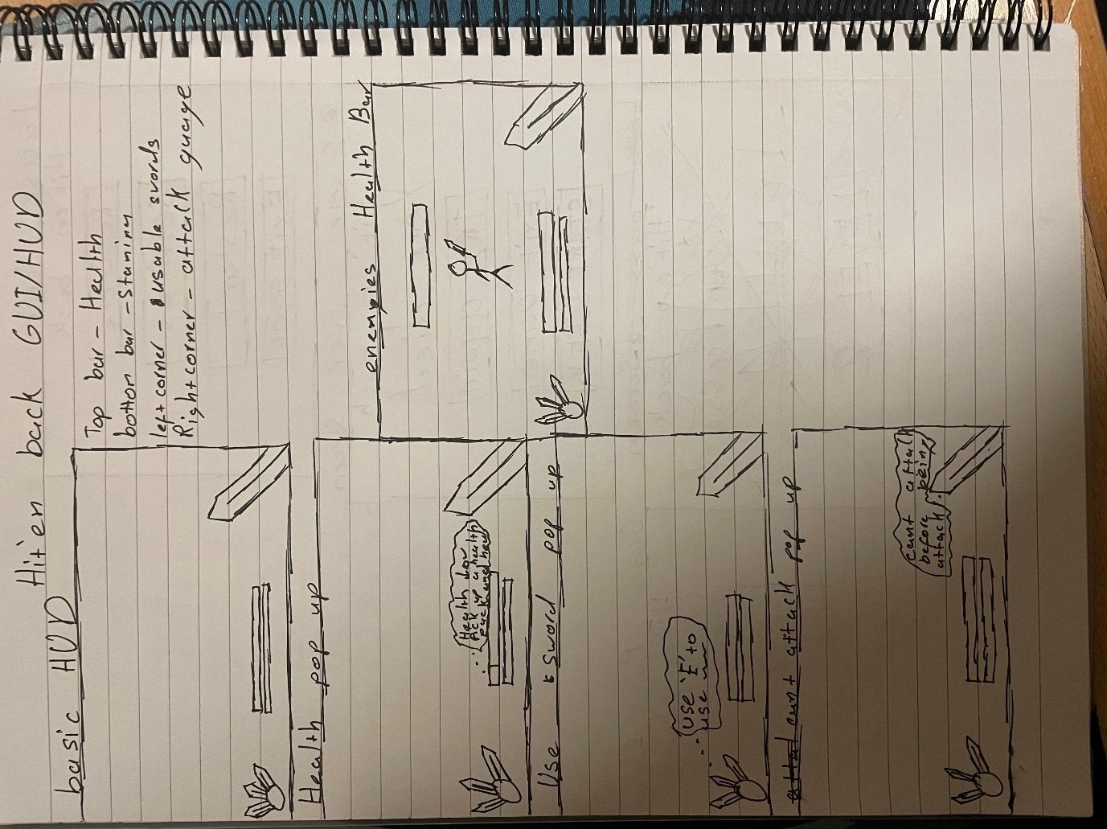

# Extended Accessibility Analysis

Another accessibility considerations in one published game would be the game Doom from 2016 which has a difficulty which can be something that can add to a game in both ways in people might be looking for a game where they have to try sixty times before they are able to beat a level once but also you have the other side of the spectrum where the player could just want a easy game to beat in their spare time and you could just have someone trying to beat it on normal difficulty and if they beat the game their they could try to beat the higher difficulties which keeps users playing the game[6].

This will be include in my game by including in the game a option for difficulty where they can set the difficulty to east, normal and hard which will just increase/decrease the amount the player is healed by the health pack and also increase/decrease the damage that the player will take from enemies attacks.

# Sources

1. *Superhot* (2020) *Wikipedia*. Available at: <https://en.wikipedia.org/wiki/Superhot>. [Accessed: 29/10/24]
2. Wikipedia Contributors (2019) *Dishonored*, *Wikipedia*. Wikimedia Foundation. Available at: <https://en.wikipedia.org/wiki/Dishonored>. [Accessed: 29/10/24]

   ‌
3. *About Localization | Package Manager UI website* (2018) *Unity3d.com*. Available at: <https://docs.unity3d.com/Packages/com.unity.localization@0.4/manual/index.html> (Accessed: 30 October 2024).

   ‌
4. Shaffer, J. (no date) *5 tips on designing colour-blind-friendly visualizations*, *Tableau*. Available at: <https://www.tableau.com/en-gb/blog/examining-data-viz-rules-dont-use-red-green-together>. [Accessed: 30/10/24]

   ‌
5. *Tattoo Design Alternative Sketch* (2024) *Stablediffusionweb.com*. Available at: <https://stablediffusionweb.com/image/15684645-tattoo-design-alternative-sketch> (Accessed: 3 November 2024).
6. to, C. (2024) *Skill level*, *Doom Wiki*. Fandom, Inc. Available at: <https://doom.fandom.com/wiki/Skill_level#Doom> (Accessed: 4 November 2024).

   ‌