Digiaktiv explanation of output of WSCAD parser (Adam)

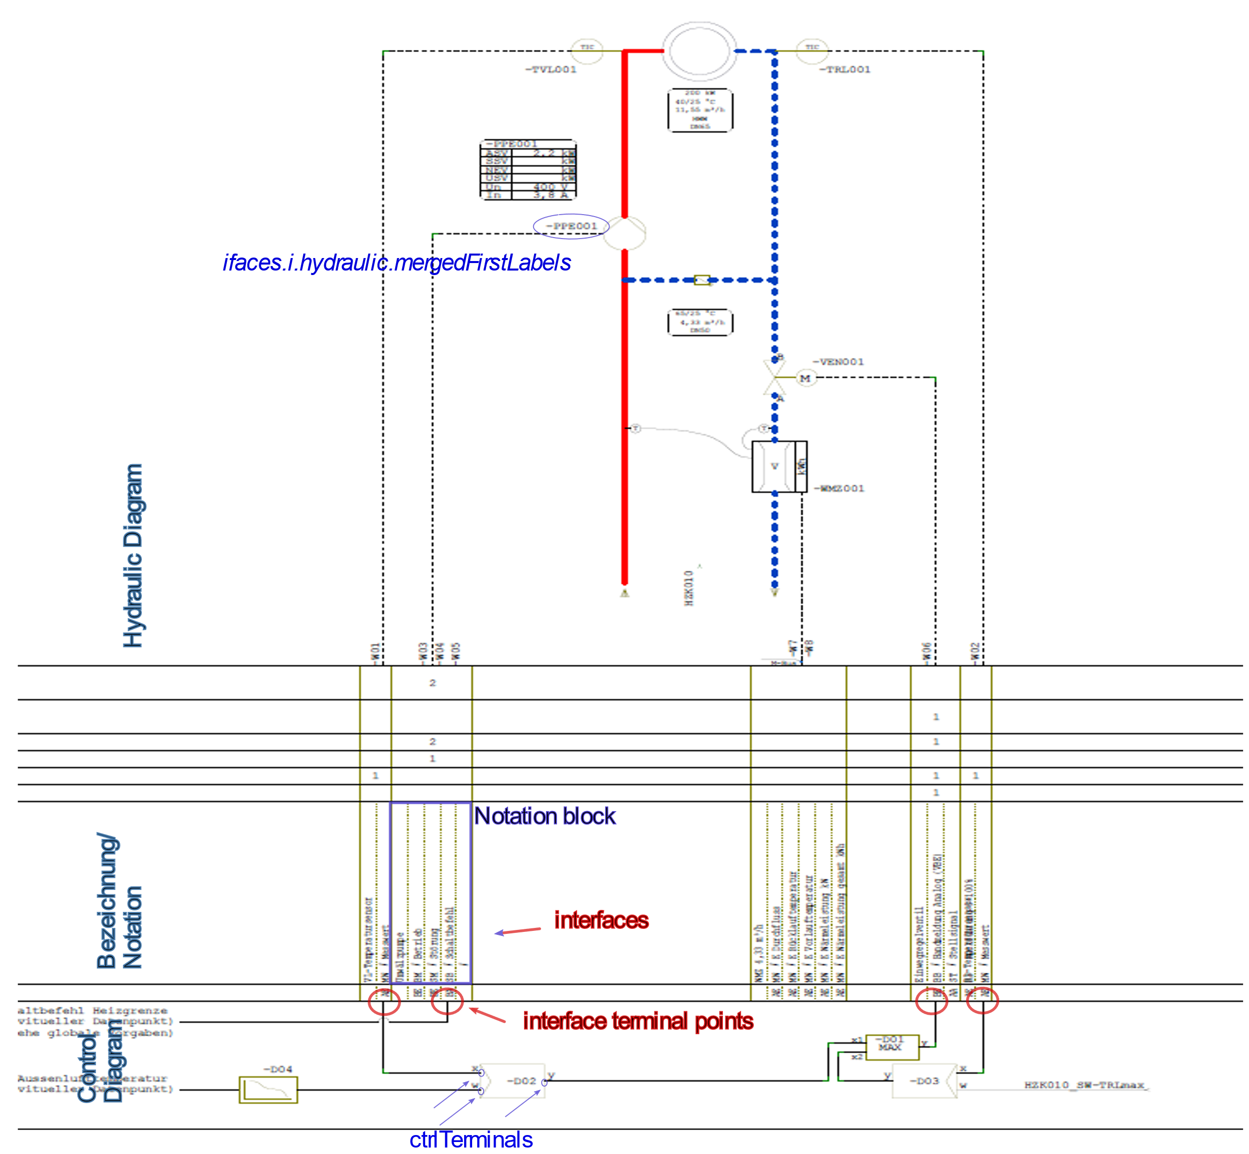

The text file contains 2 objects:

Ifaces : information about the interfaces, that contains the

* Terminal Point coordinates on the page (x-vertical, y horizontal coordinates)
* Lines : the vertical line on the control diagram, that end in the Interface terminal point
* Index: index of the line in the pdf
* textLabel: The Notation Block, with x_range: the horizontal coordinates – this is used to get the matching hydraulic component, and all the text-labels.
* Hydraulic: the matching hydraulic component, that is extracted from the Hydraulic diagram.
* ctrlBlockIndices : the index of the control block, that is connected with the interface terminal

Controls: information extracted from the control blocks, a dictionary with fields:

* rectangles: the coordinates in the pdf of the Control block rectangles.
* text2rectangles: text exctracted per each control rectangle ( a list of multiple labels, first is the best match ) for example [‘-D03’, ‘-D03’, ‘x’, ‘y’,’MAX’]
* ctrlTerminals: terminal points of control block connections for each control block (for example the terminal points for x,y, w inputs/outputs)
* iface2ctrl_mapping: for each interface terminal point the index of control block, where it is connected to.
* Iface2ctrl_labelled : interface terminal -control block connections . similar to the above, but also contains the control-terminal labels (x or y for example). From this labels the direction of the arrow (input or output) on the diagram is determined.
* Connectdict: dictionary of the control diagram line connections, it is only used internally.
* Ctrl2ctrl: this list contains the control block connections. For each control block the list of control-block indices, where it is connected to.