Holiday Planner App

PROJECT STATEMENT OF WORK

Project: | Holiday Planner App
Prepared By: | Adam Choy, Kanmani Vijay, (Sophia Jimenez)
Start Date: | 20th April 2026
Submission Date: | 27th April 2026

Contents
1. Introduction 3
2. Project Objectives 3
3. Scope of Work 4
3.1 In Scope 4
3.2 Out of Scope 4
3.3 Future Work 4
4. Deliverables 5
5. Project Schedule 5
5.1 Timeline 6
5.2 Trello Board 7
6. Team Structure 8
7. Budget 9

1. Introduction

This Statement of Work defines the objectives, scope, deliverables timeline, team structure, and budget for the Rockborne Holiday Planner App project. The application will aggregate live weather data, cost-of-living information, nightlife density, and accommodation pricing across a curated list of cities, score them against user-defined preferences, and present the results through an interactive Streamlit interface.

2. Project Objectives

Travel decisions are strongly influenced by multiple factors such as budget, weather, safety, cost of living, and available activities. Choosing the right destination can be complex due to the large amount of information required to compare locations effectively. This project aims to simplify the decision-making process by using data-driven analysis and AI-generated recommendations.
By combining structured destination data with external APIs and AI-generated summaries, the application provides personalised holiday recommendations through a Streamlit-based interface.
The objectives of this application are:
- Provide an intuitive user interface for entering travel preferences such as budget, dates, and holiday type.
- Calculate trip metrics including trip duration, daily budget, and budget per person.
- Analyse and compare potential destinations based on structured data (e.g. cost, weather, safety, and attractions).
- Use external APIs to enrich destination data (e.g. weather conditions, geographic location, and points of interest).
- Generate personalised travel itineraries and destination suggestions using the OpenAI API.
- Present results in a clear, visual, and user-friendly format suitable for non-technical users.
- Provide a simplified alternative to manual travel research by consolidating multiple data sources into one application.

3. Scope of Work

3.1 In Scope

- Python backend: data ingestion pipeline, scoring logic, database integration
- Google APIs: Places (nightlife/restaurant scoring), Maps (visualisation)
- OpenWeatherMap API: temperature, humidity, cloud cover, wind speed per city
- Web scraping: one external source for cost-of-living or accommodation pricing
- LLM integration: recommendation and comparison text generation
- Streamlit frontend: map, charts, preference sliders
- SQLite or PostgreSQL database for storing fetched and scored destination data
- Deployment on Streamlit Cloud with secrets management
- Project documentation: README, SOW, Trello board, 5-slide presentation

3.2 Out of Scope

- Native mobile application development (iOS/Android)
- User authentication systems or personal user accounts
- Real-time flight booking or integration with airline booking platforms
- Direct integration with paid travel APIs (e.g. Booking.com, Airbnb official APIs)
- Payment processing or commercial transaction systems
- Multilingual or internationalised interface support

3.3 Future Work

- Integration of real-time flight pricing APIs to improve cost accuracy of travel recommendations
- Expansion of destination dataset to include global coverage with richer metadata per location
- Introduction of user profiling to allow personalised recommendations based on past preferences
- Implementation of machine learning models to improve destination ranking accuracy over time
- Development of a map-based interactive exploration feature using advanced GIS visualisation tools
- Adding seasonal forecasting to better predict destination suitability across different times of year
- Enhancing AI-generated itineraries with real-time event data (festivals, local events, attractions)

4. Deliverables

- GitHub repository with full source code
- Presentation (maximum 5 slides): introduction, solution design, key findings, LLM usage, conclusions
- Live demonstration of the application
- This Statement of Work
- Trello board showing project progress
- README.md with setup instructions and architecture overview

5. Project Schedule

The project will run over a 7-day period, beginning on 20th April and concluding on 27th April.
- Start Date: 20th April
- Development Period: 20th April – 26th April
- Submission Deadline: Final project deliverables will be submitted to SharePoint by 27th April
- Presentation & Demo: A live demonstration and presentation of the final product will be delivered to the Cohort and Rockborne Stakeholders on 28th April
This timeline ensures sufficient time for development, testing, integration, and preparation for the final presentation.

5.1 Timeline

Milestone | Tasks | Date
Project setup and planning | • Read project brief  Liaise with team members  • Define scope and objectives  • Set up Trello board  • Write Statement of Work | 21th April
Frontend and backend work | • Add computed fields  • Decide theme of webapp | 22nd April
Frontend and backend work | • Validate data types for API inputs (weather, places, OpenAI)  • Handle missing or invalid API responses | 23rd April
Integration between frontend and backend | • Connect Streamlit frontend with backend recommendation engine  • Integrate OpenAI API for personalised travel itinerary generation  • Ensure full end-to-end workflow (input → processing → output)  • Improve UI/UX and handle edge cases and errors | 24th April
Submission | • Submit deliverables to stakeholders by 11:59PM 27th April  • Present and live demo to stakeholders on 28th April | 27-28th April

5.2 Trello Board

A screenshot of the Trello board created for this project, captured halfway through the project:
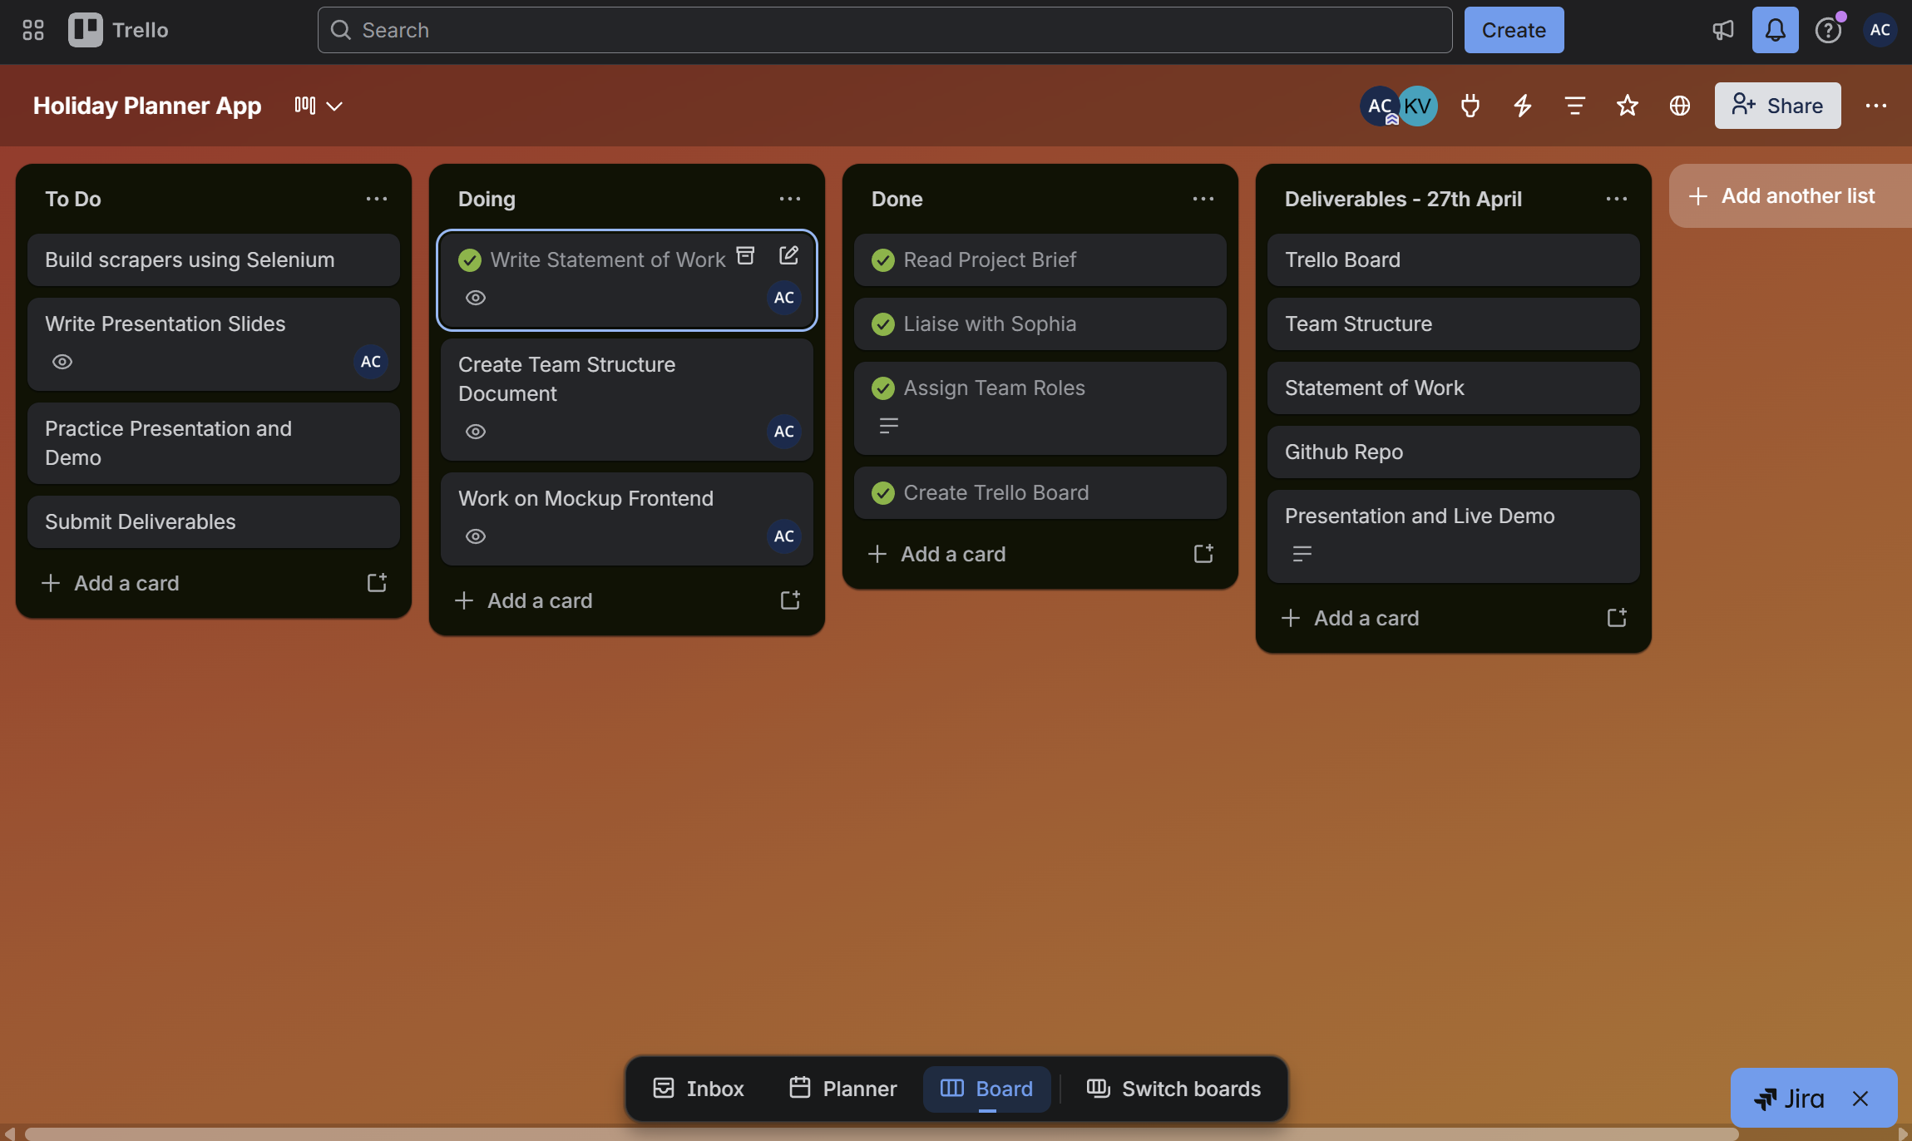

6. Team Structure
The project team is structured to ensure clear ownership of responsibilities across development and delivery functions.
- Frontend Development & Project Management: Adam will be responsible for the frontend design and implementation, including building the user interface, developing user-facing features, ensuring responsive design, and integrating the frontend with backend services. Adam will also lead project management activities, including planning, task coordination, timeline management, progress tracking, and ensuring project deliverables are completed on schedule.
- Backend Development: Kanmani will be responsible for the backend design and implementation, including developing and maintaining server-side logic, building APIs, managing data handling and storage, and ensuring system security, reliability, and performance.
Due to unforeseen circumstances, Sophia is currently unable to participate in the project. As a result, the project will be delivered by Adam and Kanmani, who will work collaboratively to ensure all requirements are met and the solution is delivered successfully.

7. Budget

This is an software development project that does not require any external procurement or paid infrastructure. The application is built using open-source libraries (such as Streamlit and Python packages) and publicly available APIs where applicable. Any tools or services used are either free-tier, already available, or provided by the Rockborne Coaches. As a result, the project is expected to incur no direct financial cost, with the only resource required being development time.
Resource | Cost | Use
Microsoft Word | £0 (already own license) | SoW, EDA Report
GitHub | £0 | Uploading progress to public repository
Trello (free version) | £0 | Project management and task organisation
Python | £0 | Frontend and backend
Work Hours | 80 hours | Monday 20th – Monday 27th April, 9am – 5pm

