**Bitcoin: My Two Bits**

**\*\*\*\*\*\***

I can provide Bitcoin Mining Setup for homes and businesses. I will assist in buying and setting up the mining equipment. If you have space, electricity and cash, it might be a great investment. The price is currently $285/bitcoin but it spiked to over $1100 about a year ago. If the Bitcoin economy takes off, a single bitcoin could be worth thousands. You can buy bitcoin now at some of the popular exchanges more easily than this. You can do that on your own. This ad is specifically for people that might be interested in setting up mining equipment at their home or office. The mining equipment is loud, so you would not want the equipment set-up in your living quarters.

**\*\*\*\*\*\***

Make a business plan to set-up bitcoin mining operation in the barn. Calculate the math for the costs of the hardware, electricity, rent, redoing walls, etc… for 1 year and try to get business loan for that amount. Pitch the profits from the bitcoin and the profits from leasing out space to others that are interested.

******

Make a website that gives 1 uBit to each unique email/bitcoin address - freemicrobit.io

**\*\*\*\*\*\***

Find a datacenter in argentina that will host hardware at cheap electricity costs. Rent a warehouse down there and hire people to monitor it. Find investors to fund it. It will get bitcoin for cheaper than the market rate if done by a crowd. Start a crowdfunding campaign to pay for it. User’s could get a share in the business. Money would be used to create the bitcoin and hold on to it until it hit a certain threshold. The threshold could be voted on by the community depending on how much they paid into it.

**\*\*\*\*\*\***

**Other Open Decentralized Networks**

Search Engines, Email, Social Networks. These could all be created in a similar fashion. They would cut out the big players that are making a huge cut in users online activities. If a community of servers could solve problems like search, social networks, shopping, almost any human to human interaction that we do with a computer. There could be nodes like “miners” in Bitcoin that would contain the correct answers for user queries. The network could intelligently organize any information and reward the organizers. An open source catalog could contain a valid list of the cheapest products that anybody could purchase. All of the computers would work together to locate the best available products for the lowest price. The could connect businesses with consumers and cut out the costs of a third party like Amazon.

**Introduction**

The e-book will go over some of the basics of Bitcoin. Bitcoin is a international, decentralized network that contains a blockchain with stores of value in it at certain addresses. A user would need a password [and private key?] to access that address. Users can make transactions that transfer bitcoin from one address to another. The blockchain is an open network where anybody willing to participate is allowed if they follow the rules. In this document, I will write about some of the most important parts of the entirety of Bitcoin. I will also give my opinion on the state of the related market surrounding Bitcoin. The glossary contains information about the underlying technologies behind Bitcoin.

**History of Bitcoin**

**Bitcoin Has a Bad Name**

**General Beliefs About Bitcoin**

**Growing Pains**

Google had its’ problems with web spam, computer viruses, and many more. These problems still exist even after Google has been around since 1998. Bitcoin has been around since 2008 and it has had problems like Mt. Gox and other illegal activity that happens using bitcoin. Mt. Gox had nothing to do with the core technology of Bitcoin. It was a third party that stole the bitcoin that people had stored on their servers. It is believed to be an inside job.

**Mt. Gox**

**Digital Contracts**

A third-party could use Bitcoin to create digital wallets. One user could create and store the first half of the password and the other user could create and store the second half of the password. This could help parties come into an agreement without as much risk. If one party does not honor their commitments, then the funds are stuck in the wallet forever. This could entice both sides of the parties to honor their agreements.

**Credit Limit**

Users need to be able to get a credit limit with Bitcoin. This also needs to be reported to some credit bureaus.

**Credit History**

People like to have their spending recorded on their credit reports. This shows to the banks that they are capable of repaying a debt. If someone only used bitcoin then they could not build a credit history that is widely accepted lie TransUnion, Equifax and Experian. If there was a serious credit agency that could be listed at the end for specifically bitcoin credit history. Bitcoin could allow for an effective international credit reporting agency.

**Opinion**

It will be useful for micro payments online. I personally like it for that. I like to pay $1 or so for goods. I wouldn't give a company my credit card or bank information for such a small amount. I have been signed up for cycled billing for a minimum 12 months at $29. I should have read the terms and conditions. It would be harder for businesses to do that with bitcoin.

They will be good for international orders also... the international credit card transactions sometimes fail and have to be manually approved

It is cheaper than western union and paypal if you convert USD to bitcoin for free.

Businesses usually pay about 3% CC fees and those are passed on to the customers. If the businesses/consumers could lower their prices by 3% for bitcoin customers, it would cut out the banks 3% fee for almost each and every transaction. It adds up after the same $100 gets a 3% transaction fee 10 times as the money spreads through the economy.

**Cryptography**

**Hoarders**

Hoarding will have to be balanced. If wealthy individuals hoard all of the bitcoin, then people will not want to buy it, so they have to sell some a fair market rate. They price should not skyrocket too much because nobody will buy it when it does and everybody that has it will want to sell it when it does. Again, the price should find an equilibrium. There is a finite amount of bitcoin - there will only be 21,000,000 bitcoin ever and there is currently about 14,000,000. Most bitcoin has already been mined and pretty much all of it will be mined by 2024. There are currently 7,000,000,000 people on the planet. That is 0.003 bitcoin per person on the planet. That seems like a very small amount of bitcoin per person. The numbers are not really important. Give 0.003 a name, like a millibit, then there are 3 millibits per person. The numbers are infinitely divisible. So people will be able to make transactions at small increments like 0.000003 bitcoin - this is called 3 microbits. Even if wealthy individuals hoard all of the bitcoin, the majority of people will still be able to make cheap or nearly free transactions with bitcoin. This will make a lot of competition for the current banking markets. It will also make competition for creditors. It may go as far as making a strong competition against national currencies.

**Based on Computing Power**

It would be difficult to create a new cryptocurrency that is as fair as bitcoin because if it did start getting big, the people that were in early will get rewarded more than later on.

A system could not be based on pure randomness for each wallet because whoever has the most wallets would get the most bitcoin. It will end up being a race for whoever has the most computing power. Bitcoin has a good lead on any new cryptocurrency since it has had so much time to mature. Currently, the newcomers with the most hashing power will earn the biggest rewards. If a similar system came out now, then the few major miners would take a majority of the mining reward. It would be a monopoly on the system. It is good that there were some little guys that got in at the beginning of Bitcoin. It is still the beginning of Bitcoin.

**Printing Hard Copy of Bitcoin**

It will be possible to have a wallet containing bitcoin converted to paper. Further, someone could verify that the paper wallet still contains the bitcoin. This would be done with a barcode. The password could be built into the barcode, so that it could be redeemed by whoever possesses it. A potential security problem for this would be that someone could steal it by taking a picture of it. A scratch off surface such as on lottery tickets could be utilized. A trusted corporation could manufacture a large number of these scratch cards and sell them at a small mark-up. It would be a huge business. The government is not as efficient as the free market!

**Anonymity**

**Liquidity**

Many large companies liquidate their bitcoin immediately after receiving it. If this is how bitcoin will be utilized by many companies, then this may cause the bitcoin to stay at lower prices for a while. People will want to buy bitcoin for its’ benefits of shopping online and other reasons. Then they will spend the bitcoin and it will be sold again. However, there will be hoarders that will buy up the bitcoin and wait for the price to rise. This will work over time and it will work short term if people buy in the crashes and sell in the bubbles. Then again, when a lot of people are buying during a crash, then the price will rise. If a lot of people are selling during a bubble, the price will fall. Again, some equilibrium will be found with this as an important factor.

**Balancing Account**

Some variation of a spending & saving account could conceptually be created. They would contain an equal amount of bitcoin and dollar when adding funds to it could be used to maximize saving and spending. If the price of bitcoin has fallen since making a deposit, then spend cash on the current purchase. If the price of bitcoin has risen since making a deposit, then spend bitcoin on the current purchase.

**Amplification**

A wealthy individual could have a large impact on the market. The way the buys and sells are setup is that people make a bid to buy or sell a certain number of bitcoin at a certain price. There are only so many bitcoin listed on the market **[insert image of buy/sell graph]** . If someone wanted to buy 100,000 bitcoin, they would not be able to buy that many at the current market rate. They would have to buy some of those bitcoin from sellers that list their price at higher than the current market rate. This would in turn bring the rate up. A single exchange might not be able to handle that many bitcoin. The wealthy individual would be better off buying 10,000 bitcoin from each of the major exchanges. Further, they would be better of buying a percentage of these bitcoin each day over a longer period of time. However, they would risk that the price goes into a temporary bubble or a longer term increase in price. There would need to be a carefully planned entry into the market for these individuals to get a maximum amount of bitcoin for the most minimal price possible. There would be no perfect solution for this. It is a gamble on the unknown of the market.

**Arbitrage**

Arbitrage is when investors buy a bitcoin from one exchange at a lower price and sell it at another price for a higher price. This balances the price between the exchanges. It can be profitable for the investors engaged in this activity. It is a risk, though. If the price is crashing before they make the buy and sell.

**High Prices**

The high price of bitcoin are making it so average people will not buy or use Bitcoin. The prices need to come down so that people will buy them and use them. Once more people use Bitcoin, then the value of the market will increase. Once the value of the market increases, bitcoin will have a higher price tag. The price will find an equilibrium between this and several other factors. The price to mine a bitcoin will be factored into the price. Why would someone pay $400 for a bitcoin when they can mine one for $300 or less? The price to mine a bitcoin has been decreasing. This decrease will hit a critical point and then start getting more expensive to mine. The halving of the block reward that is predicted for around 2016 will make for a price increase of a possible factor of 2. Moore’s law suggests that computing power on a processor doubles every two years. For the ASICs that mine bitcoin, they have doubled every 6 months. This will make it cheaper and cheaper to mine bitcoin until around 2016. However, if the demand for bitcoin increases to a number larger than what the miners are generating and selling, then current bitcoin holders will sell their holding or the price will rise. Buyers will have to be willing to spend the higher amount of cash for a bitcoin or wait for someone to sell at a lower price. Some people depend on selling their bitcoin to pay their bills, so they can’t wait forever to buy bitcoin. All of these factors will make for a natural market. There could be short-lived crashes and bubbles, but I think the price will stay at around the price of mining with the supply & demand also factored into the equation.

**Volatility Insurance**

Companies are afraid to hold onto bitcoin that they receive because it could go down by 20% in the next few days. That would make them lose money on a sale. An insurance to cover volatility could be created. It could be commission based on the fluctuations. The insurance company would collect a percentage of the increase in value in an exchange to cover the dips in value. This would take the risk out of a crash for some companies that may hold bitcoin.

**Hash Rate**

The hash rate has grown to be very powerful and a lot of companies have been dedicated to hashing Bitcoin. The network is currently at about 300 Terahertz (300,000,000 hertz). Hertz means cycles per second. I would not be surprised to see this number get very large. It is growing at an exponential rate. It could soon be measured in petahertz, exahertz, zettahertz or yottahertz. Those are real words, too! petahertz means 100,000,000 cycles per second. Yottahertz means 100,000,000,000 cycles per second. The network is currently around 300,000,000 hertz.



**Total Bitcoins in Circulation**

A graph showing the historical total number of bitcoins which have been mined.

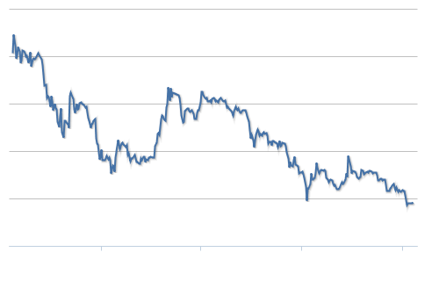

**Market Capitalization**

A graph showing the total number of bitcoins in circulation * the market price in USD.

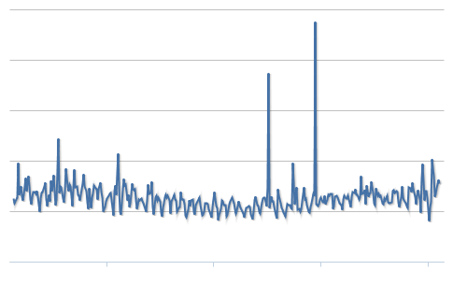

**Total Transaction Fees**

A chart showing the total BTC value of transaction fees miners earn per day.

* **Transaction Fees in USD**
* [**Network Deficit Per Day**](https://blockchain.info/charts/network-deficit) **- Shows difference between transaction fees and cost of bitcoin mining.**

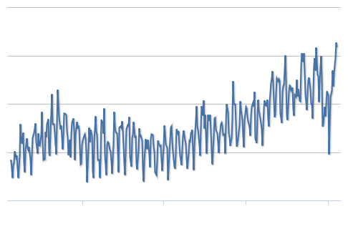

**Number of Transactions**

A chart of the total number of unique bitcoin transactions per day.

* **Total Number of transactions**

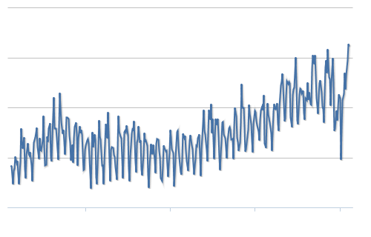

**Number of Transactions excluding Popular Addresses**

A chart showing the total number of unique bitcoin transactions per day excluding those which involve any of the top 100 most popular addresses popular addresse[s](https://blockchain.info/popular-addresses).

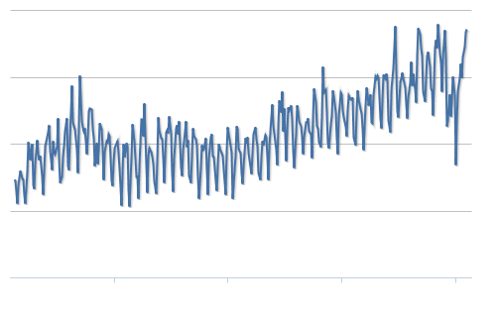

**Number of Transactions excluding Long Chains**

A chart showing the total number of bitcoin transactions per day excluding those part of long chain transaction chains. There are many legitimate reasons to create long transaction chains however they may also be caused by coin mixing or possible attempts to manipulate transaction volume.

* **Number of Transactions Excluding Chains Longer Than 10**
* **Number of Transactions Excluding Chains Longer Than 100**
* **Number of Transactions Excluding Chains Longer Than 1000**
* **Number of Transactions Excluding Chains Longer Than 10,000**

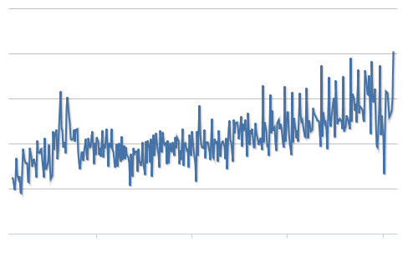

**Number of Unique Bitcoin Addresses Used**

A chart of the number of unique bitcoin addresses used per day.

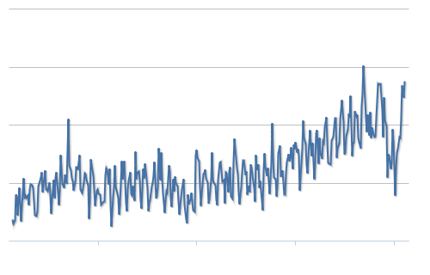

**Average Number of Transactions per Block**

A chart of the average number of transactions per block.

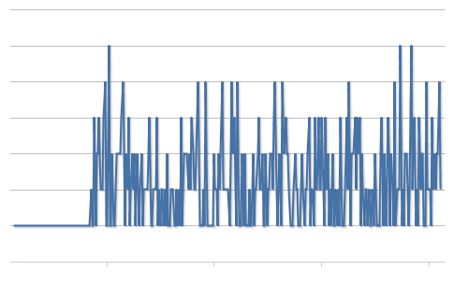

**Number of Orphaned Blocks**

Number of blocks mined per day not part of the main chain.

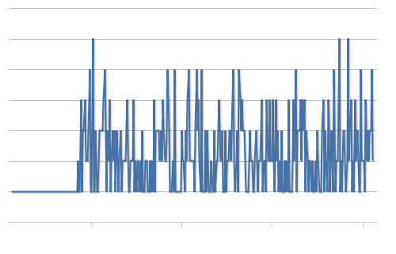

**Total Output Volume**

The total value of all transaction outputs per day. This includes coins that were returned to the sender as change.

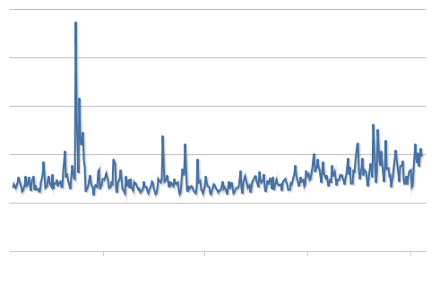

**Estimated Transaction Volume**

Similar to the total output volume with the addition of an algorithm which attempts to remove change from the total value. This may be a more accurate reflection of the true transaction volume.

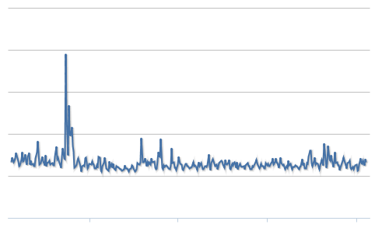

**Estimated USD Transaction Volume**

The Estimated Transaction Volume in USD value.

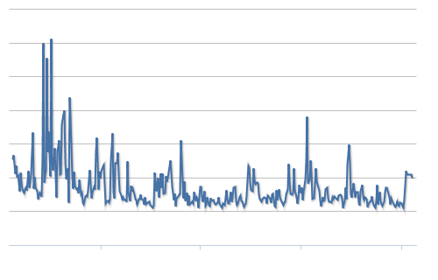

**USD Exchange Trade Volume**

A chart showing the USD trade volume from the top exchanges.

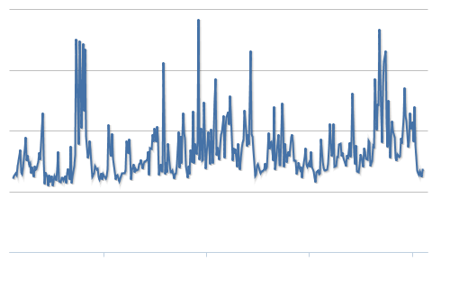

**Trade Volume vs Transaction Volume Ratio**

Chart showing the relationship between BTC transaction volume and USD exchange volume. Discussion

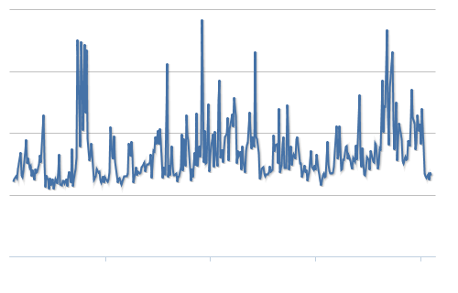

**Market Price (USD)**

A chart showing the USD market price from the major exchanges

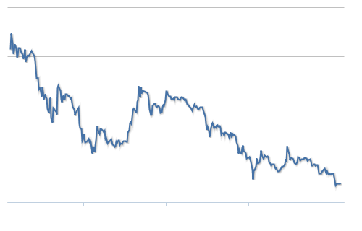

**Cost % of Transaction Volume**

A chart showing miners revenue as percentage of the transaction volume.

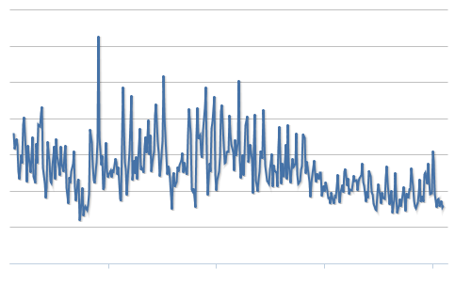

**Cost per Transaction**

A chart showing miners revenue divided by the number of transactions.

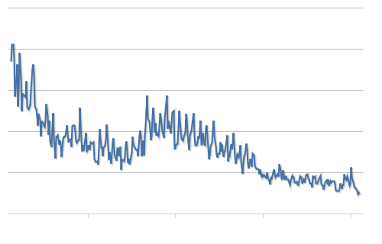

**Hash Rate**

The estimated number of giga hashes per second (billions of hashes per second) the bitcoin network is performing.

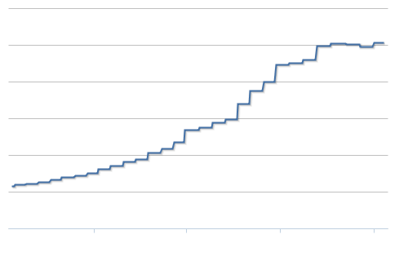

**Difficulty**

A chart showing difficulty changes over time. Difficulty is a measure of how difficult it is to find a new block compared to the easiest it can ever be.

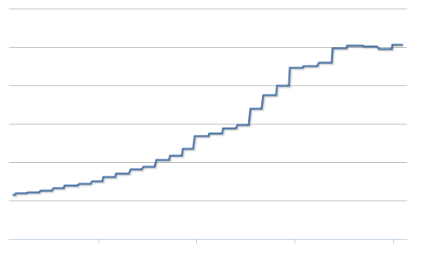

**Miners Revenue**

Historical chart showing (number of bitcoins mined per day + transaction fees) * market price.

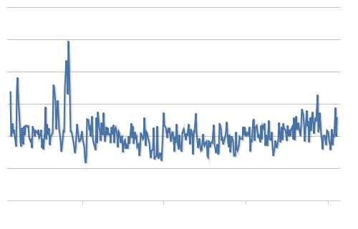

Average Transaction Confirmation Time

The Average time take for transactions to be accepted into a block.

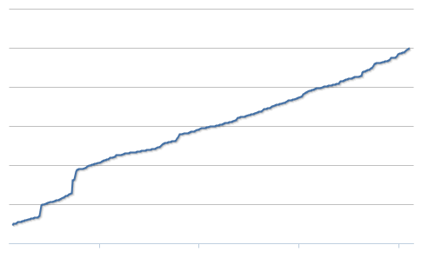

Bitcoin Days Destroyed Cumulative

Bitcoin Days Destroyed is a measure of the transaction volume of Bitcoin. If someone has 100 BTC that they received a week ago and they spend it then 700 bitcoin days have been destroyed. If they take those 100BTC and send them to several addresses and then spend them then although the total transaction volume could be arbitrarily large the number of bitcoin days destroyed is still 700.

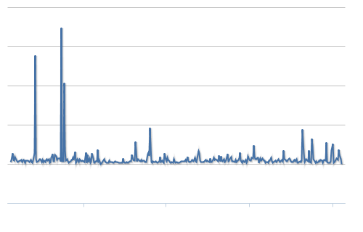

Bitcoin Days Destroyed

A none cumulative version of Bitcoin Days Destroyed.

* **Bitcoin Days Destroyed (Filtered By Min Age 1 Week) - Filtered by minimum input age of 1 week.**
* **Bitcoin Days Destroyed (Filtered By Min Age 1 Month) - Filtered by minimum input age of 1 month.**
* **Bitcoin Days Destroyed (Filtered By Min Age 1 Year) - Filtered by minimum input age of 1 year.**

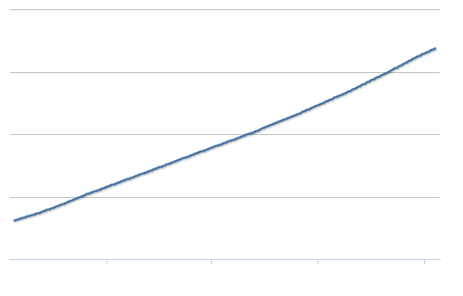

Blockchain Size

The total size of all block headers and transactions. Not including database indexes.

* **Average Block Size - The Average block size in MB**

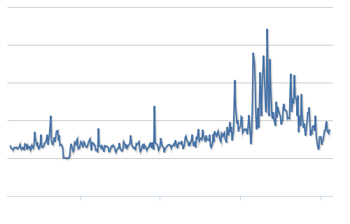

My Wallet Transaction Volume

24hr Transaction Volume of our My Wallet service.

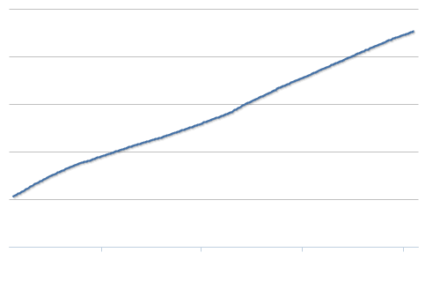

My Wallet Number of Users

Number of wallets hosts using our My Wallet Service.

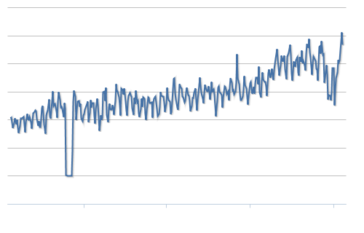

My Wallet Number of Transactions per Day

Number of transactions made by My Wallet users per day.

**Trustless Currency**

The parties do not need to trust each other for an exchange to happen. For credit cards and ACH, a lot of trust is required. That is not so much for the credit card case, but it is not a good experience to have your credit card numbers stolen. Your credit card company is responsible to cover any unauthorized purchases on your account. With bitcoin, if you use it properly, somebody can’t steal any bitcoin from you if you don’t give them your password and/or private key.

**Insured Accounts FDIC**

There are currently insured accounts available at some exchanges. I’m sure more will grow. They are responsible for any bitcoin that was lost or stolen because of them. This includes hackers attacking their systems. It does not include someone getting ahold of your username and password. Also, they usually have 2 factor authentication so they would need your password and either your email or cellphone authentication. Authentication would be done by sending an e-mail with a confirmation link or sending a text message with a confirmation code that needs to be entered into the site before a transaction can take place. Fund that are stolen from a traditional debit card are usually not insured. However, funds stolen off of a credit card are usually covered by the credit card company. Those funds come from the consumers through fees and high interest rates. The problem with insurance is relatively easy to address for Bitcoin. Corporations will provide this service. They will need to make a profit for that service, so bitcoin holders that choose these services will probably pay for them. Some companies make their profits through other ways that will offload the costs to the customer.

**Irreversible Transactions**

**Bitcoin Scratch Off Cards**

It would be simple for a company to create a scratch card that holds a small value of bitcoin. They could be redeemed by a store and hold a remaining balance. These would be much more convenient and much cheaper than prepaid credit cards.

**Etc…**

The US Dollar Could Be crypto currency in the future

Which CryptoCurrency will be most “hashed” will be advanced

A new CryptoCoin could surpass Bitcoin quickly if enough computing resources were put towards it

Bitcoin will succeed because it has such a powerful network (blockchain) backing it.

There will be over 14 million that want 1 bitcoin for their investment portfolio

There will be over 1 million that want 14 bitcoin for their investment portfolio

There will be a few very rich people that will want much more than 14 bitcoin

Then, there will be the rest of the people that will want much less.

Bitcoin sidechain technology will work well because it could guarantee a store of value backed by bitcoin.

Someone should invent a bitcoin mining space heater. In the future, all heat would come from mining bitcoin or crunching other numbers in homes and businesses.

**Estimate**

If someone was to ask me what the price of bitcoin will be at the end of 2015, I would say that it could be between $250 and $2000. I don’t think that is a fair question due to the volatility of bitcoin. The price will dip and peak at a moments notice. A more fair question to ask would be what will the average price of bitcoin be for the entire 2015 year. I think that price would be in the range of $200-$600. I can not see the price of a bitcoin falling below what it costs to mine a bitcoin. I would approximate it that it costs at least $200 a bitcoin to mine. That might not be accurate, but whatever the price is, I think it will be a barrier that the price will not fall below. If the price does fall below, the money used to mine bitcoin will be redirected to purchasing bitcoin directly from the people that already own bitcoin. This will, in turn, cause more people to stop mining and that, in turn, will make it more profitable to mine bitcoin. This cycle will ensure that bitcoin does not fall below the $200 threshold for any significant period of time.

**Volatility**

There are very few bitcoin relative the number of people that there are. People are psychological creatures and 1 bitcoin will be a milestone for someone to own. If there are 14 million such people that will want to own 1 bitcoin, the price of a bitcoin will skyrocket. There does not yet exist 14 million bitcoin and it will not happen for at least a few months into 2015. By the end of 2015, there will be about 14.5 million bitcoin. 90% of these bitcoins will be hoarded by investors and people that got into bitcoin very early.

**Market Manipulation**

There will be a lot of rich and average people that will want to use the market to make a profit. They will be attempting buy at low prices and sell them at high prices. This will make the market swing up and down. This will hurt the average person because they will not have the best judgement as to when to buy and when to sell. They will buy the bitcoins when they need them or at a random time buy them for future use. The people that buy bitcoins on a downward slope will be forfeiting wealth to the people that buy and sell stocks for profit. This will hurt Bitcoin by stopping some people from entering the bitcoin market.

**Uses**

**Value**

The value of the bitcoin is set by the popular exchanges. It works similar to the stock market. People list a certain number of bitcoins for sale on the exchange. This is called a sell order. People make bids to buy a certain number of bitcoins at a certain price. This is called a buy order. If somebody places a buy order for a price at or above a previously listed sell order, then a “buy” occurs. If somebody places a sell order for a price at or below a previously listed buy order, then a “sell” occurs. This will set the price. The latest trade price will be the current value of a bitcoin. This is affected by supply and demand. Some people think that bitcoin will be worth thousands of dollars someday. This has a chain reaction that affects the price. If enough people think they will be worth thousands of dollars someday, then the value will go up. This could feed itself and make them worth thousands of dollars someday. This is not a pyramid scheme because there is great utility in Bitcoin. The value of the network needs to be considered. It is a powerful network of computers that are hashing at a rate of 340,000,000 GH/s. That is a powerful network and the blockchain might be the most encrypted and secure piece of information that exists. It will have a history of all the transactions that happened on the blockchain. This will be an excellent way to store & exchange wealth.

**Charts**

TODO make a paragraph describing each chart from blockchain.info

**Cost**

It is expensive to run the bitcoin network. However, the network has so much utility, that it is worth the costs.

**Fork**

A fork is in Bitcoin is when there are two separate version that have been worked on and they share a previous point where they were the same. For example, github hosts software projects for developers. If someone has a public project up there, I could fork a copy of the current version and start working on it. The original developer would also be working on the original version. We would both save our copy and they would be different and not share the changes that were made by both of the parties. Some people suggest that a fork in the bitcoin could be used. It would take a majority of the miners to approve a different version that will be accepted by the community.

**51% Attack**

**Myths About Bitcoin**

**Facts About Bitcoin**

**Major Mining Pools**

**Mining Hardware**

**Mining At Home**

**GPUs**

**ASICs**

**Worth**

What is Bitcoin worth? The current market value (number of bitcoins X USD trade rate) is around $4 billion. It was up to $12 billion about a year ago.

TODO: Some other comparable companies, assets, etc… that are worth $1 Billion - $100 Billion.

**Alternative Uses**

A lot of people are hoping that bitcoin will be used by the mainstream for daily purchases. I think it will be used by a niche and be very good at what it does. My guess is that it will be used mostly for:

1. A store of wealth
2. Investment
3. Online Micro-purchases
4. Online Tipping
5. Transfer of wealth between individuals
6. Banking & Currency for Undeveloped Countries
7. Buying Illegal Goods & Services

**Unfair**

A lot of people argue that it is unfair that the ownership of all the bitcoins is skewed towards such a small number of people. With the maturity of bitcoin compared to any other crypto-currency, it would be hard to make another more fair currency. Whoever gets in on the next currency first will have more coins. If the algorithm was designed to not rewards so many coins at the beginning, then that would make it more fair for people that come in later. With the price lowering as of early 2015, this should force some of the early adopters to sell some of their bitcoins to others that are interested in joining the market.

In the long run, there will be some early adopters that might join the status of billionaire (USD). Currently, there are 1,645 billionaires in the world. There were 268 newcomers in 2014. There is plenty of room for a few more of them. The creator of Bitcoin, Satoshi Nakamoto, has over 1 million bitcoins. When the price of bitcoin surged to over $1,100, Satoshi’s worth was valued over $1 Billion. However, if he tried to sell them all for $1,1000 each, the demand would fall and the price of the bitcoin would fall with it. I don’t think bitcoin is going to shift the wealth of the world very much. Those early adopters would be better off slowly selling bitcoins over the years. If they sell too many, the price will plummet. If they hold onto them, the price should rise, but it will be lowered once they start to sell them. They will need to sell some of them to live a billionaire lifestyle. Not everybody accepts bitcoin as a payment. Even if they do accept bitcoin as a payment, then the bitcoin will be distributed more. Wealthy people will get their hands on their share of the bitcoin. They have to power to manipulate the bitcoin markets and get it from the early adopters for cheaper than what it will be worth. In the long run, I think the bitcoin will end up in the pockets of some of the existing rich people.

**Bitcoin as an Investment**

**Side-chain Applications**

**Killer Apps**

**Hot List**

There could be a hot list added to Bitcoin. If enough miners agreed to update the core code, then hot list of addresses holding stolen bitcoin could be frozen. This would render them unspendable to make it not so profitable for bad people to steal bitcoin from people. This would be hard to maintain and it should be hard for a person to place addresses in their but it would be beneficial. The original holder of the bitcoin would have to prove that the bitcoin is indeed theres. Once it is on the host list, it would be worth little to nothing. This might even influence some hackers to give the bitcoin back for an agreed small percentage of legal bitcoin.

**Bitcoin Credit & Financing**

People want credit. There is currently no credit with Bitcoin. You will not, yet, get the same 0% APR for 18 months with a $10,000 limit as easily as you could with VISA/MasterCard/American Express/Discover. People would rather spend money that they don’t have to pay immediately. Most people have debt that they would rather put that money towards so they don’t have to pay interest on it. That entire concept is another story. Hopefully, there will be Bitcoin credit cards where people with excellent credit can get a 10 bitcoin credit where they must pay back just like they do with current credit cards.

**Altcoins**

I don’t think an alt-coin will replace Bitcoin. It will have a small hash history and therefore be less mature. The new alt-coin would be worth about the same price as bitcoin in terms of computing power. Buying a crypto-currency will be directly proportional to how much effort it takes to create it. However, this will not hold true for alt-coins that die. If they get abandoned, then they will not be worth as much to a bitcoin in terms of computing power consumed in their generation. There will be cases where an alt-coin rewards more to mine than bitcoin. However, miners will switch their hardware to that alt-coin and then bitcoin will be easier to mine. This will enforce the price of all of the crypto-currencies to be balanced in the long-term. Some lucky people might get in early on some new alt-coins that will take off and it will be extremely profitable. But as soon as the price for an alt-coin starts rising, more miners will throw their equipment at it.

**Advancement of Processing**

**Moore’s Law**

**Robotics**

**Commentary**

I think the price of bitcoin is going to be hovering around the cost to mine a bitcoin. It can be calculated how much it would cost to invest in mining bitcoin versus buying bitcoin. People with deep pockets will choose the cheapest of the two. Over 3600 new bitcoin get mined every day. At $260, that is nearly $1 million everyday of new bitcoins that people will need to buy. The number of miners is growing. There is an all time high of the hash rate right now and it is growing. There are plenty of people that are buying bitcoin and saving them as a store of value. Also, the value of the USD is growing so more bitcoin can be purchased for less. There are plenty of people that want to buy bitcoin at lower prices. There are fewer people that are willing to sell the bitcoin for prices any lower. The technology and the computing power dedicated to bitcoin is huge. It will be used by the masses for many different purposes in the future. Once more people see that, more people are going to want to buy and hold onto bitcoin as a store of wealth. There are only about 13.8 million bitcoin available right now and there can only ever be 21 million bitcoin. The network behind bitcoin will be a lot more powerful than some banks holding hundreds of billions as a store of wealth. Currently, all bitcoin is worth about $4 billion. I think it will be worth hundreds of billions in the not too distant future. That being said, multiply the $260 by about 25 if all of bitcoin would be worth $100 billion. A lot of very rich people don't want to buy bitcoin because that is like funding the competitor for the current investments. Someone that is well vested into banking stocks, they don't want to see bitcoin take 10% of the market. That would be a loss for them. There are a lot of people that don't want bitcoin to succeed. There are also a lot of semi-rich and powerful people that do want to see bitcoin succeed. It will be used to send money around the world for free without having to give the banks a cut in the transfer. It will be used as simply a store of wealth. It will be used to safely make small purchases online so you don't have to worry about entering your credit card information for a $0.99 purchase at a random website. It will be worth a lot someday.

<http://www.amazon.com/Bitcoin-Internals-Technical-Guide-ebook/dp/B00DG8EPT0>

“Bitcoin is a revolutionary new digital currency that has the potential to create a paradigm shift in money and banking. No government or corporation controls Bitcoin; it's operated by a decentralized network of computers that anyone can join. This is the first time the world has ever seen such a radically new monetary system. But to fully appreciate Bitcoin, you need to see what's going on under the hood.”

**Should I Buy Bitcoin?**

In my opinion, I would say yes. Investing is always risky and this risk is higher than average. However, with great risks, come great rewards. It has the potential to go to extreme heights, but it is impossible to tell when. It could fall to a lower price and stay there for a while. We don’t know what that price might be. It could be replaced with a superior cryptocurrency. Governments could start creating their own crypto currencies. The USD might someday be a crypto-currency that will printed on paper embedded with a tiny chip.

**Should I Mine Bitcoin?**

In my opinion, I would say yes if you would enjoy doing it. It is not a significant difference compared to buying it right now. However, you could be mining bitcoin for cheaper than you could buy buy bitcoin. If the price jumps up in a few months, you won’t be able to buy it for as cheap as you could mine it. I would recommend mining bitcoin if you are a DIY hobbyist type of a person that would enjoy doing such a thing.

**Protocol Specification**

**https://en.bitcoin.it/wiki/Protocol_specification**

TODO find some data, charts from <https://blockchain.info/>

Make a write up explaining what each chart means.