Using Neural Networks for basic 1D and 2D regression tasks and investigating their hyperparameters.
First, work through the two notebooks on 1D and 2D regression. After that, you will have some machine learning scripts with:
- Highly customisable PyTorch-based MLP model
- A PyTorch-based training loop
- Loss plots to analyse training and validate the final model

Using $Δ$-ML to map ZINDO first excited state calculations onto more expensive TDDFT methods by learning their systematic deviations.
ZINDO is a semi-empirical quantum chemistry method that gives you a fast but cheap calculation of a molecules electronic structure, where ZINDO specifically specialises in producing information on excited-state spectra. ). In normal, ground-state DFT, it only focuses on a single energy state, so to accurately model excitation dynamics, you need to use Time-Dependent Density Functional Theory (TDDFT). This requires diagonalizing large matrices or propagating wavefunctions in time, and as such is significantly more expensive than standard DFT. Like most semi-empirical methods, ZINDO is nowhere near as accurate as a proper TDDFT calculation but it does capture 90% of the underlying physics and get close enough to the answer, albeit with some systematic biases and outliers depending on the type of molecule and its functional group. However, what if you were able to figure out these systematic adjustments and apply them to a ZINDO result to get closer to the true TDDFT value at the price of a ZINDO calculation?
Modelling molecular excited states opens up a plethora of interesting physics that can be investigated, but most machine learning for molecules only considers ground states. This is unsurprising, as modelling the electronic structure becomes increasingly difficult for excited states; you still have to use more expensive quantum chemistry to generate a lot of training data, and then spend a lot of time developing novel descriptors to capture the intricacies of the electronic structure. Delta-machine learning ($Δ$ML) gives us a mechanism to do this by learning the deviations between “lower” and “higher” -levels of theory. The idea is that the data driven model learns the systematic biases between the two physical methods and allows you to make predictions of the higher-level result at the cost of the lower-level method. In the main task we will look into using $Δ$ML to map ZINDO first excited state (S1) energies onto TDDFT S1 energies.

Suppose we have training data of S1 energies: $E_{ZINDO}^{True}$ and $E_{TDDFT}^{True}$
We could initially do a linear fit to get a basic prediction and plot the data:
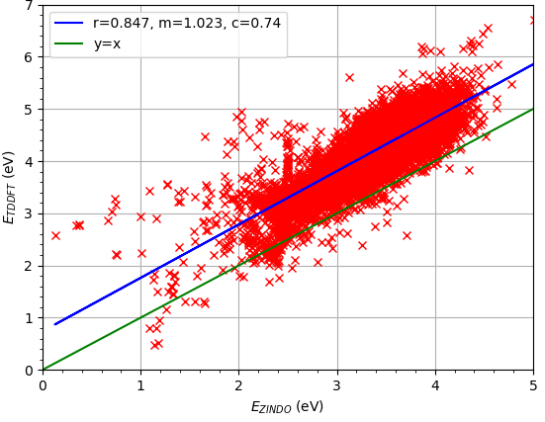
$E_{TDDFT}^{Pred-linear}=mE_{ZINDO}^{True}+c$
In the figure, the blue line shows the linear fit with a correlation of $0.847$, it has a similar gradient to $y=x$, but is offset by $\sim 1eV$. This indicates that there are many systematic deviations, ZINDO seems to underestimate S1 energies in particular.
The extent of deviations may be related to certain functional groups or elements that clusters of molecules have. We can use machine learning and some suitable descriptors that capture the structure to learn these deviations and adjust the linear fitting accordingly:
$$E_{TDDFT}^{Pred-ML}=E_{TDDFT}^{Pred-linear}+ΔE_{ML}^{Pred} =mE_{ZINDO}^{True}+c+ΔE_{ML}^{Pred}.$$
Note, to avoid confusion there are two $ΔE$ values we can define; the error between $E_{ZINDO}^{True}$ and $E_{TDDFT}^{True}$, which we’ll call the true deviation, and the error between $E_{TDDFT}^{True}$ and the linear fit prediction $E_{TDDFT}^{Pred-linear}$, which we’ll call the linear-fit offset:
$$ΔE^{linear-offset}=E_{TDDFT}^{Pred-linear}-E_{TDDFT}^{True},$$
$$ΔE^{True}=E_{ZINDO}^{True}-E_{TDDFT}^{True}.$$
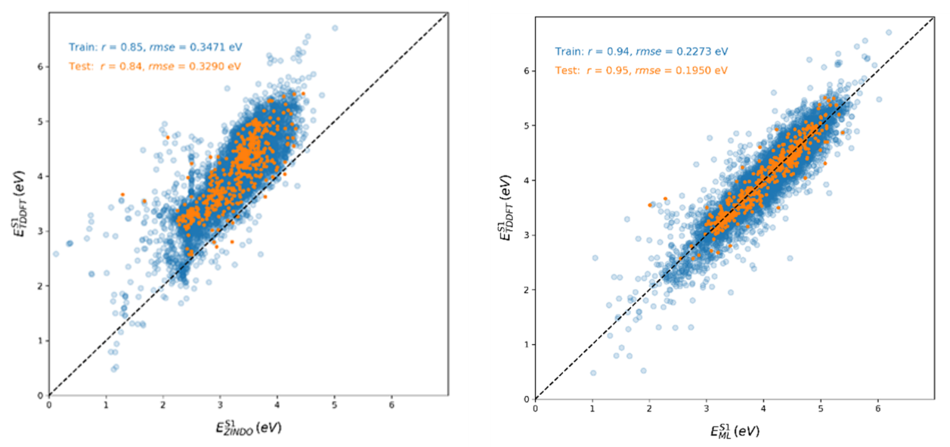
In some previous work I applied a machine learning correction using neural networks, which not only improved the linear fit correlation of 0.85 to 0.95, but also centred the distribution onto the y=x line. In the figure below the true distribution with the correlations for a linear fitting is shown on the left and the ML-correction on the right. In the main task, you will do the same.
In the workshop_files.zip, there are 2 csvs of training and testing data that contains Morgan fingerprints, S1 ZINDO energies and S1 TDDFT energies. There is also “delta_ml_submission.py” that reads in the data for you. Use the code and what you have learned from the previous notebooks to attempt the Main Task.
Main Task: With $E_{ZINDO}$ and the Morgan fingerprint as descriptors, train a model to predict $E_{TDDFT}$. Use MSE Loss as the final validation metric so results can be compared. A training/validation set of molecules with 10k unique conjugated cores is provided and a testing set of 500 analogue cores (that correspond to 500 cores in the training set).
- Per molecule, use the Morgan Fingerprint and/or $E_{ZINDO}$ as descriptors (inputs).
- Use a multi-layer perceptron with 2 or more hidden layers.
- Ensure you split off validation data from the training data
- Ensure you normalise/unnormalize data properly, at the right stage.
- Create a loss plot of the training and validation loss.
- For the test data, create a plot of $E_{TDDFT}^{True}$ versus $E_{TDDFT}^{Pred}$ and $ΔE^{Pred}$ versus $ΔE^{True}$. Report the correlations for both.
- Use the MSE loss criterion, so results can be compared.
- Use the rhoc_calc function for correlation, so results can be compared.
- You should be able to achieve a test correlation of at least 0.90.
- Briefly report your results in a presentable way.
  - Only need 100 - 300 words, upload as pdf.
  - Write a few sentences to evaluate how well your model corrects $E_{ZINDO}$ to the true $E_{TDDFT}$.
  - Show your hyperparameters and loss plot/s.
  - Show your train, validation and test losses and correlations (no more than 5 dp or 5 sf please).
  - Show the graph of $E_{TDDFT}^{True}$ versus $E_{TDDFT}^{Pred}$ for the testing data and report the correlation.
- Upload a .zip/tar/7z file called name_submission that contains: delta_ml_submission.py and report.pdf
- Read the hints and tips below …
Extension: Use any other models or descriptors that you like. Check out PyTorch Geometric [1] for different pre-built models and RDKit [2.1], [2.2] which, as you saw in Sam’s workshop, has several descriptors that you could apply to a molecule. Maybe try a 1D Convolutional Network instead of the MLP?

Hints and tips:
Edit the file named “delta_ml_submission.py”. I recommend using the .py in an IDE (like spyder or vscode) but you can use an .ipynb file if you prefer working in Jupyter (although its bad practice outside of workshops as jupyter is meant for tutorials/presentations/reports).
On my own solution, I played around with the hyperparameters and the best test correlation I got was 0.95. The linear fitting gives 0.83, so you should be able to get at least as good as the linear fitting, but really 0.90+ is very possible. If you are getting lower than this, then there is likely an error somewhere. Try out different combinations and see how much performance improvement you can get. If you can get a correlation of more than 0.96, then email Adam Coxson and Alessandro Troisi (acoxson@liverpool.ac.uk, atroisi@liverpool.ac.uk) …

For validation data, just arbitrarily choose 10-20% of the data or even better, use k-fold cross-validation with 5 folds. You might find this or this useful.
Normalisation is important, but be careful for two reasons. First, Ezindo is a scalar value and the fingerprint is binary, so do we need to scale all columns? You might find StandardScaler() useful, or in stats_and_plot_functions.py I have provided a ‘CustomScaler’ class that works in the same way as StandardScaler but is only applied to the first columns of the input array (although, if you find applying scaling to all columns improves your model then I won’t complain). Second, only scale your data after splitting, otherwise you may commit the machine learning crime of data leakage.
First try $E_{ZINDO}^{True}$+ descriptors and then later try $E_{TDDFT}^{pred-linear fit}$+ descriptors or another combination as your network input. You can train to predict $E_{TDDFT}$ directly, or to predict $ΔE^{linear-offset}$ and then add this to $E_{TDDFT}^{pred-linear fit}$ after the training. The second target basically trains the network to correct the linear fit, so there is ‘less work’ for the network to do. Do the different ways give the same or different results?
The Morgan fingerprint is a radial fingerprint, so it does not have fixed bit positions that correspond to a particular functional group. Training on a fingerprint is more like computer vision, where it picks out similar features that occur along the feature vectors. So actually, a Convolutional network is probably more suited to analyse the fingerprint than a dense network, but the MLP still works surprisingly well and you should do this for your main submission (CNN would be an extension).
For the extension, feel free to use any algorithm or methods that you want to. However, do it on a separate .py file and document any new packages you install so we can reproduce your work, include this with your submission, or if you find something worthwhile at a later date, email us.
################################################################################
[1] https://pytorch-geometric.readthedocs.io/en/latest/modules/nn.html#models
[2.1] https://www.rdkit.org/docs/source/rdkit.Chem.Descriptors.html
[2.2] https://www.rdkit.org/docs/source/rdkit.Chem.rdMolDescriptors.html

Some notes on mixing and matching Pytorch, Sklearn and Skorch packages.
This workshop used PyTorch based models and training loop, but there are many other packages available, each offering different levels of control.
PyTorch is more flexible and dynamic, with low-level coding. For example, you write your own training loop, whereas other packages like Sklearn and Keras provide you with more high-level functionality: i.e model.fit(x=train_data, y=target_data). For serious development of new algorithms, you want to use PyTorch, as coding your own solutions makes it more flexible and offers you more control (once you have done the front-loaded work of building some scripts).
However, as you have seen in previous workshops, a package like sklearn has many pre-built models and cross-compatible training functionality which allows for faster prototyping and switching between models. A package called Skorch, allows you to combine PyTorch models with sklearn training frameworks.
Personally, I use sklearn initially to get some rough scripts setup and do some initial development. Later I transition to PyTorch-based network classes and Skorch-based training loops.
Also for interest, here is a perceptron coded from scratch using only numpy.

