**Objective**

Understand various logic gates

|  |
| --- |
| 1. Complete questions below a, b, c below |
|  |

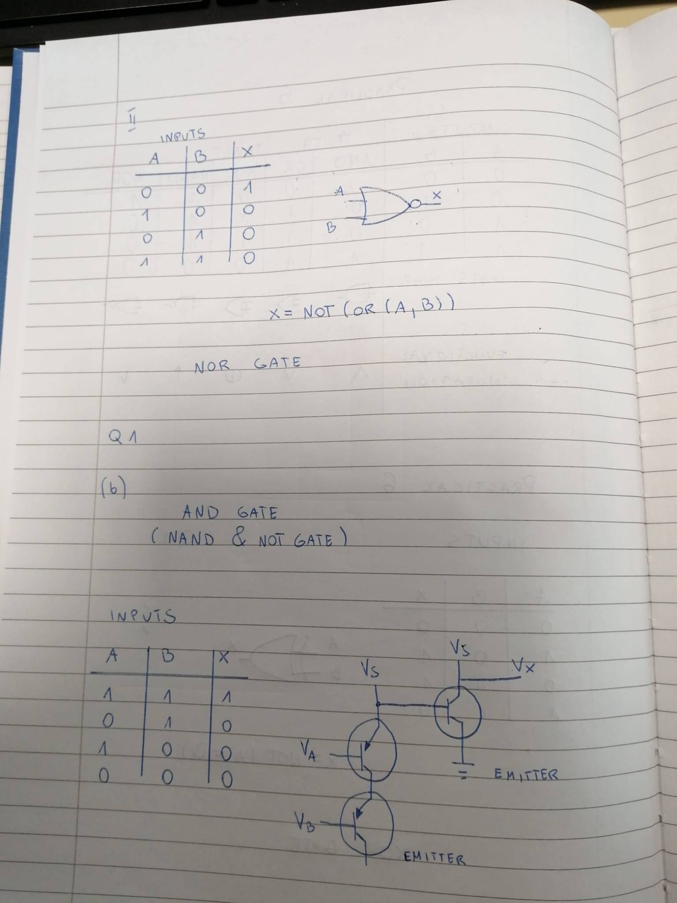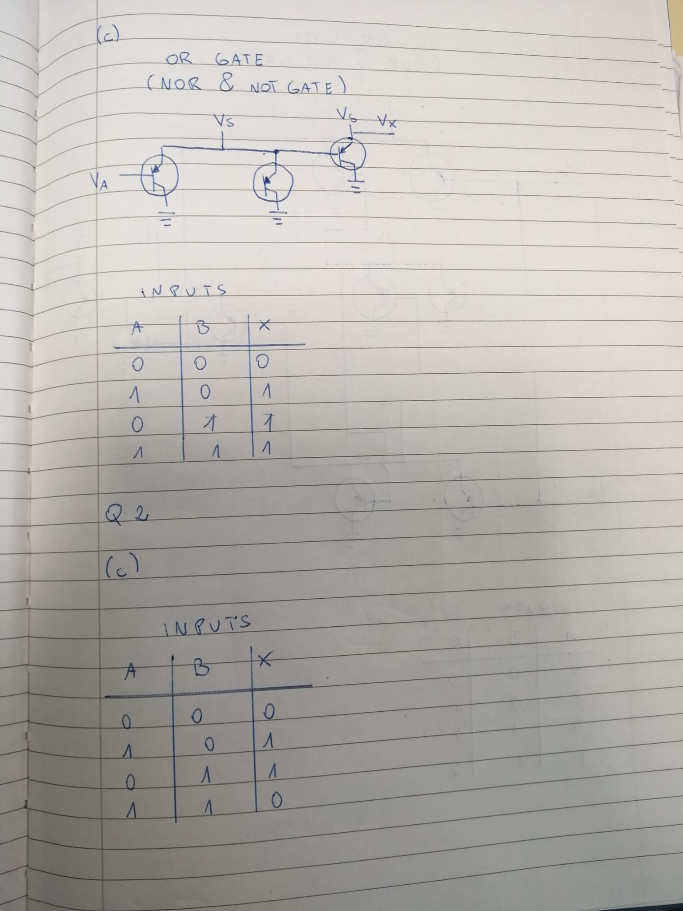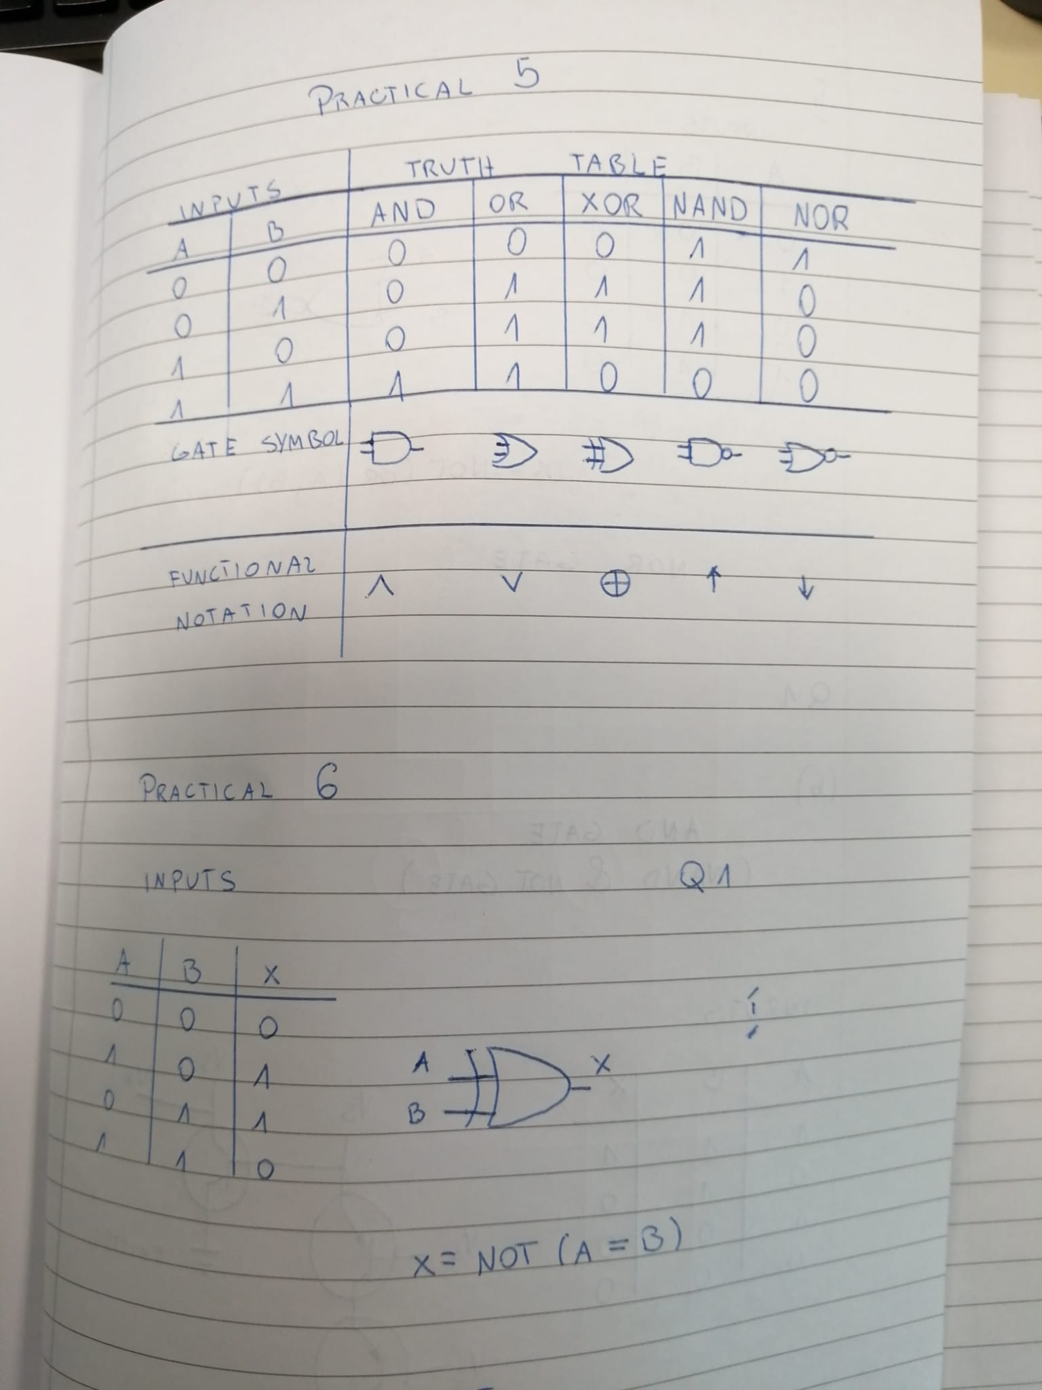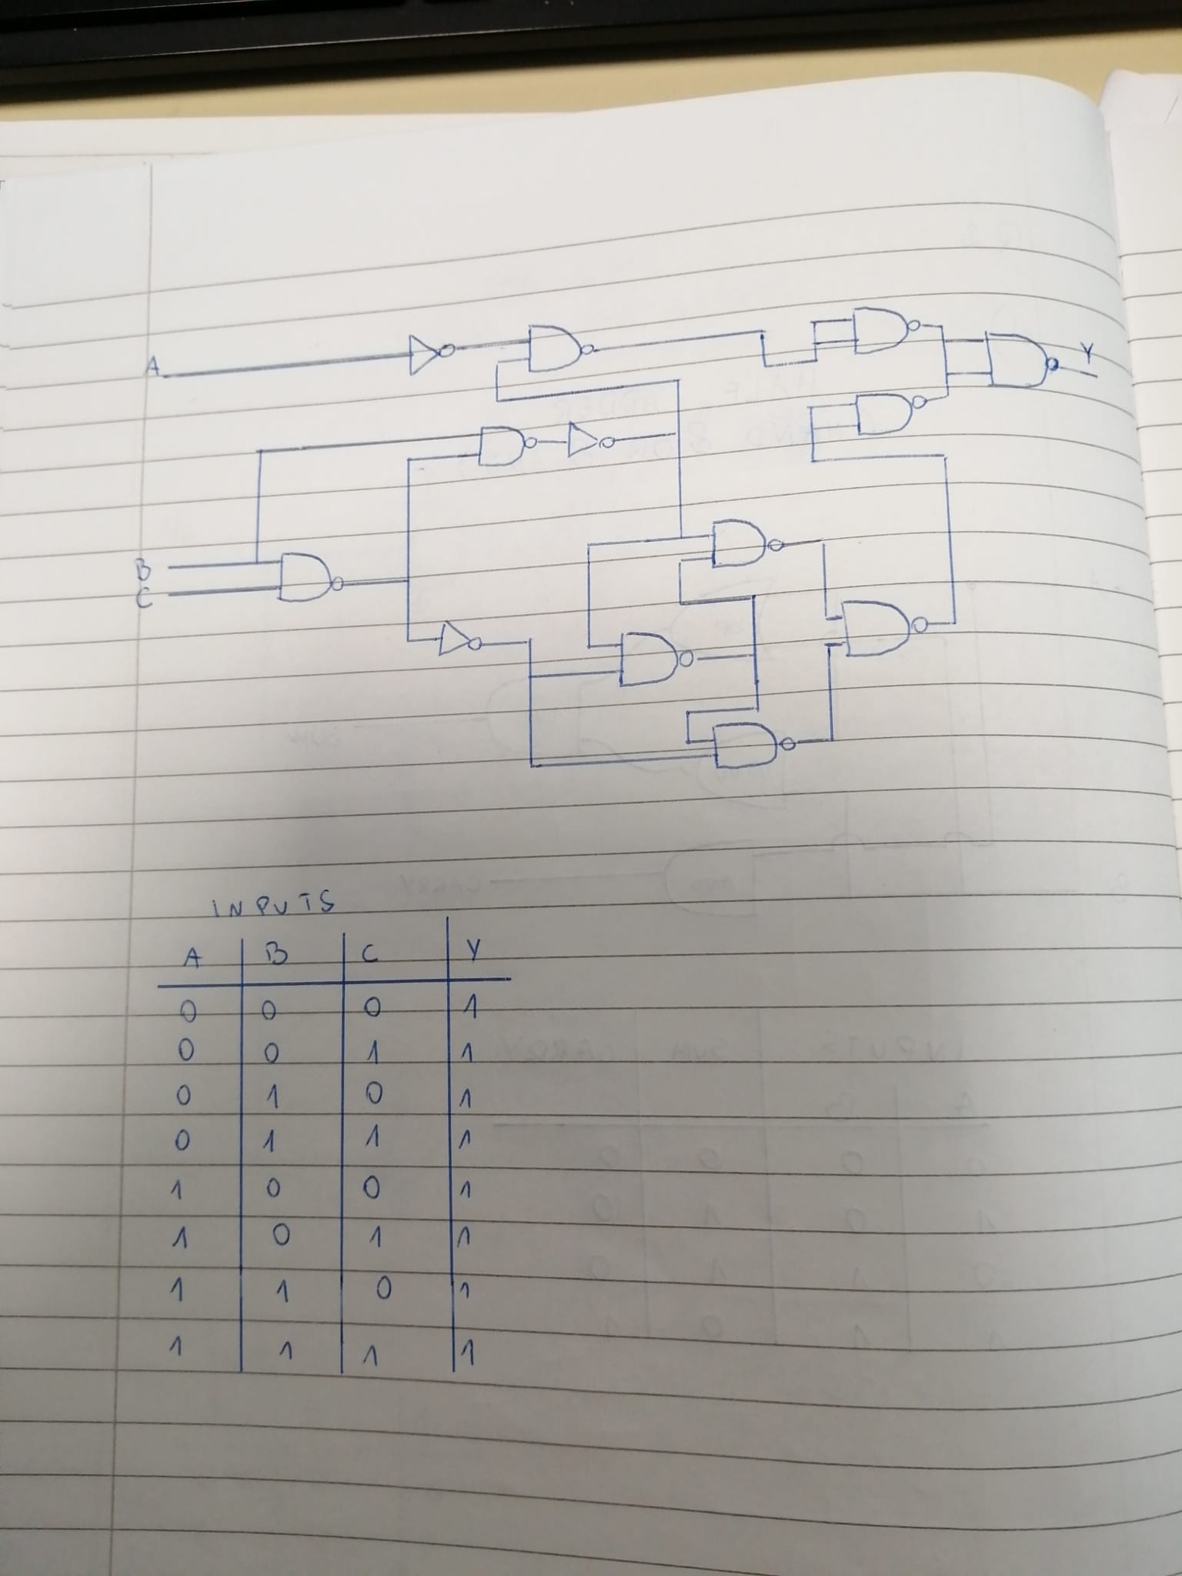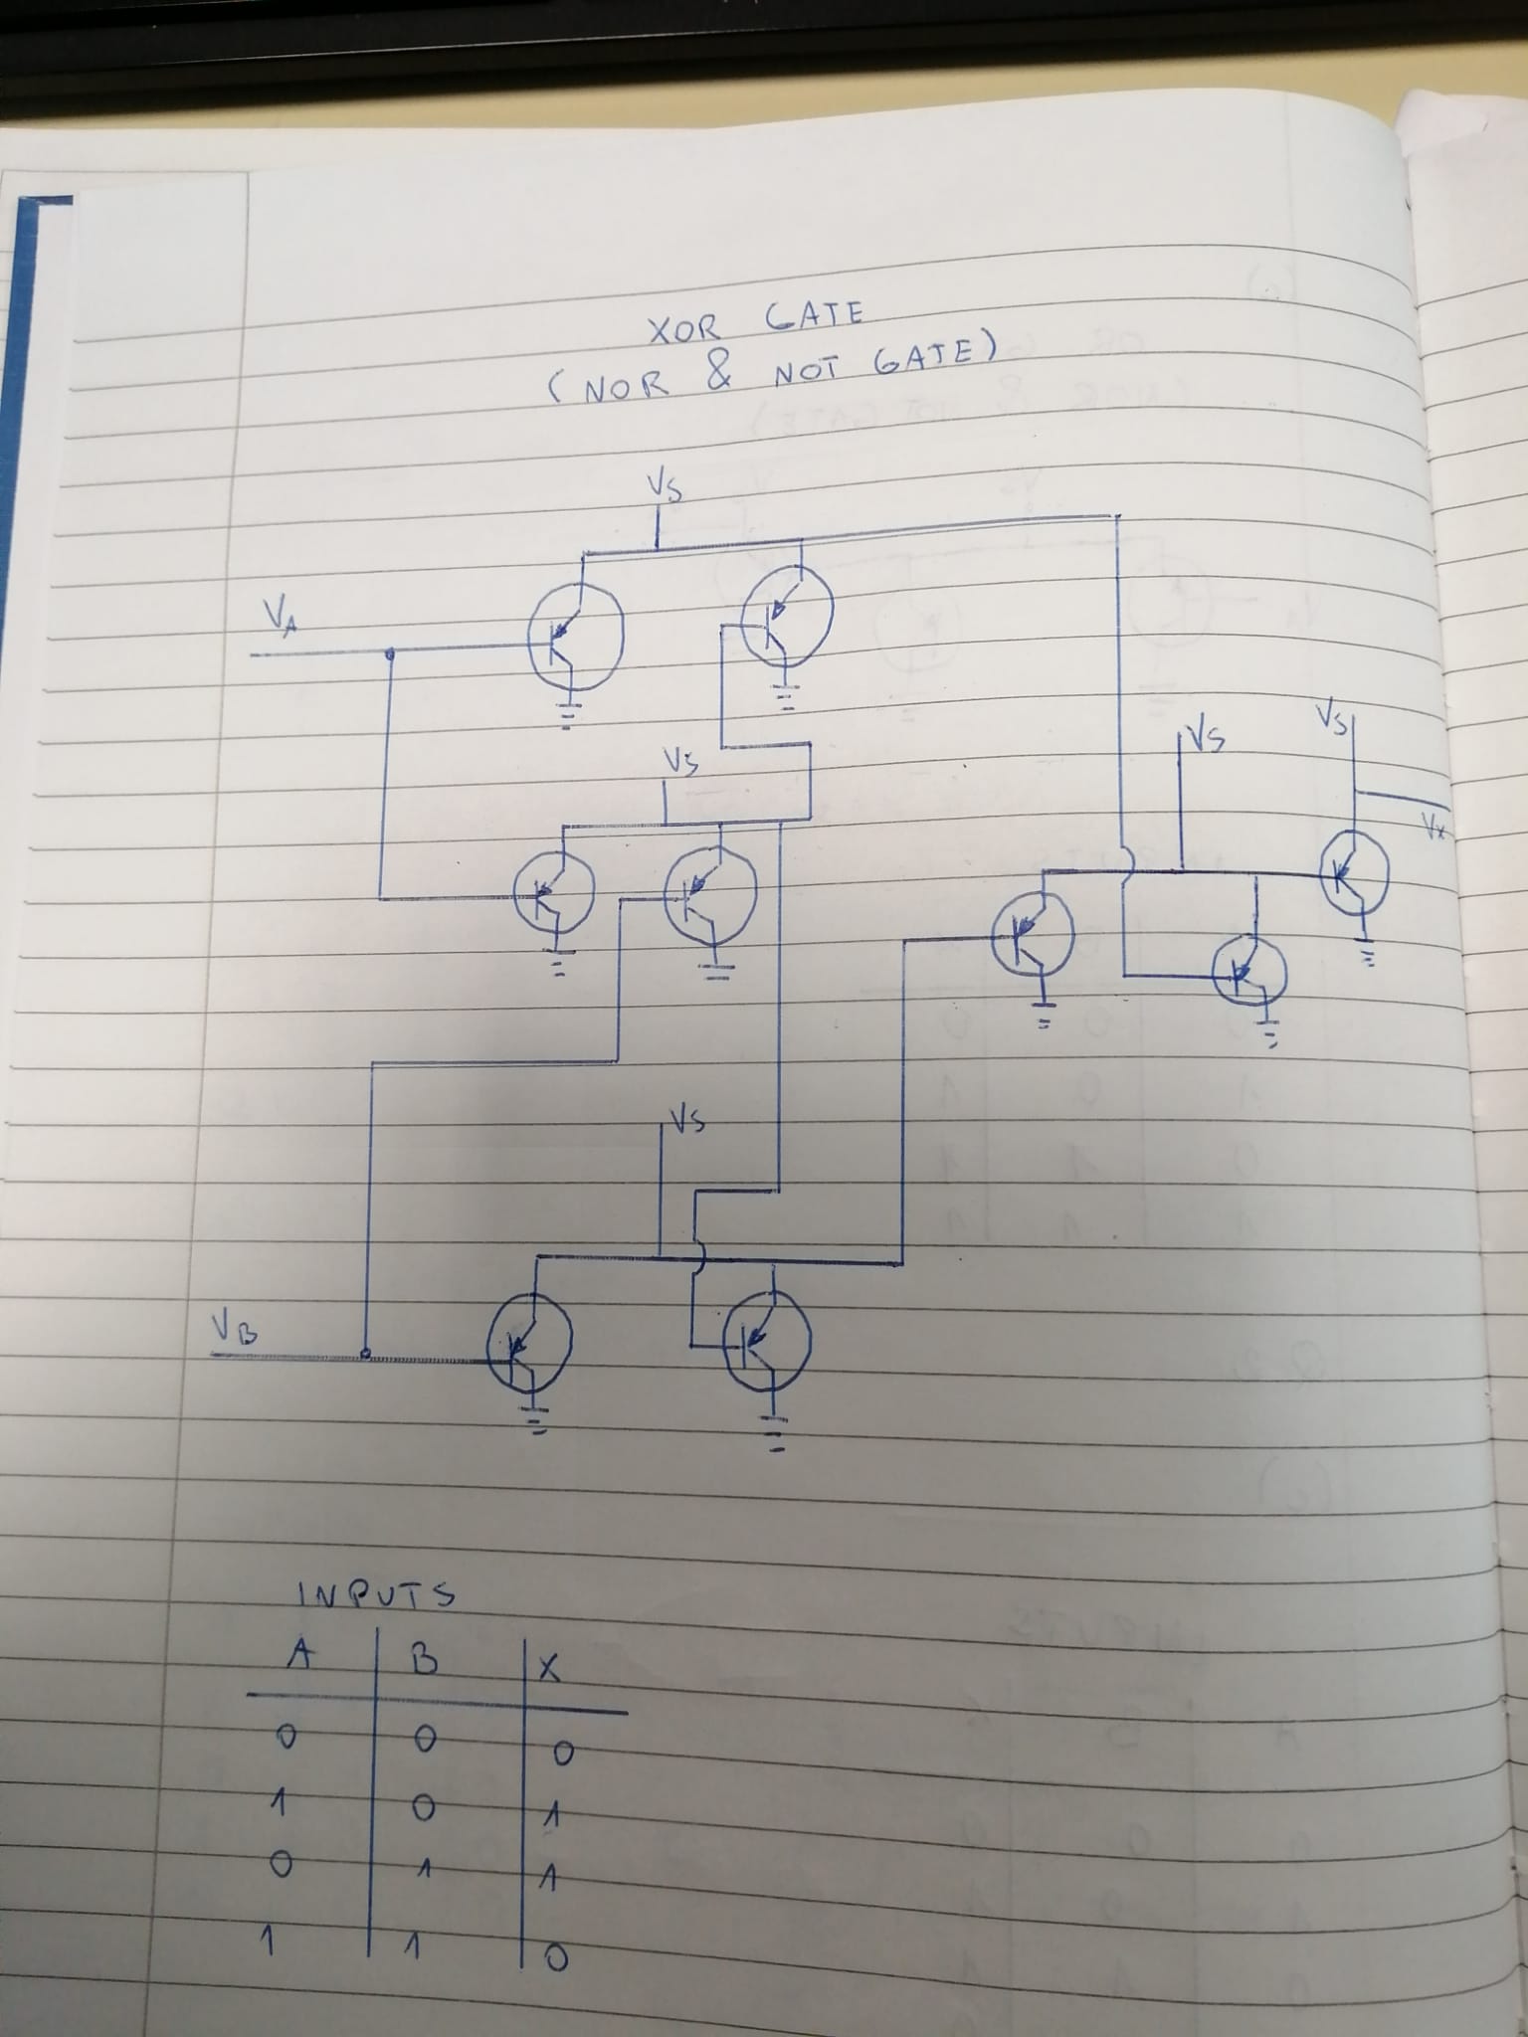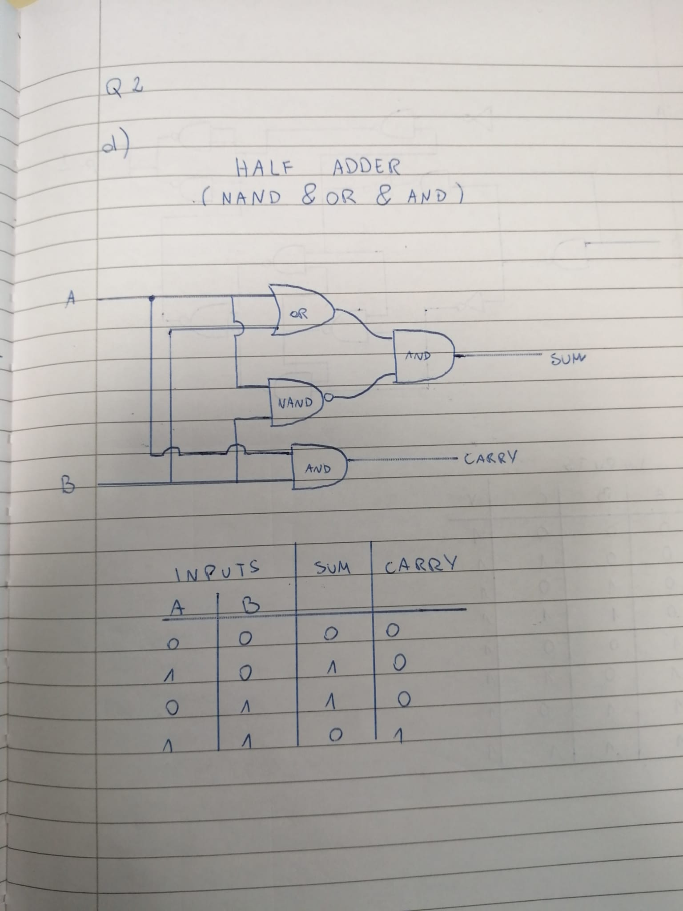

|  |
| --- |
| 1. Complete questions below |
|  |
| 1. Complete questions below |
| Construct the following Circuit using NAND and NOT Gates and complete Truth Tables  https://adamwsonu.files.wordpress.com/2010/03/quizcircuit.png |

Complete Questions in Logbook

|  |  |  |  |
| --- | --- | --- | --- |
| **Student Name** |  | **Student Number** |  |
| **Date** |  |  |  |
| **Group** | **A / B** |  |  |