The Hodgkin-Huxley model of a neuron is a complex dynamical model which depends on many variables and parameters. Many scientists have developed modified models, usually to simplify the system. One simplified model, the Hindmarsh-Rose model (below), was developed to capture the qualitative necessities of neuronal behavior with three variables and eight parameters [2]:

Equation 1  
 Equation 2  
 Equation 3

x – membrane voltage

y – fast ion exchange (of sodium and potassium ions and is also known as the spiking variable)

z – slow ion exchange (of other ions and is also known as the bursting variable)

a – (I could not find a description for this)

b – switch between spiking to bursting and controls spike frequency

c – base fast ion exchange rate

d – scale membrane feedback

I – membrane input current

r – control variation of slow ion exchange

s – adaptation, determines spiking without accommodation and subthreshold adaptation

x0 – resting membrane potential

There have been several explorations of the parameter space, usually in two-dimensional parameter spaces. González-Miranda explored the r x I parameter space [1], Rech explored the b x I parameter space [4], Storace, et al. explored the s x I, log(r) x I, b x I, and the r x b x I spaces [5]. Furthermore, an experimental study on the b x I parameter space has been presented by Linaro, et al. [3].

I have focused on the b x I parameter space as presented by Rech. I present the bifurcation diagrams for each variable as b is varied and several time series which visualize some attractors. I then present beyond the work presented by Rech by creating bifurcation diagrams cutting through different lines through the parameter space Rech explored. I also show Poincare maps for different chaotic regions as well as periodic regions. Furthermore, I present visualizations of chaotic regimes in three parameter spaces not yet explored in the literature (as far as I know) by calculating an estimated Lyapunov exponent in the a x I, a x c, and c x I spaces.

Following the prescription outlined by Rech, I began by setting a = c = 1.0, d = 5.0, r = 0.01, s = 4.0, and x0 = -1.6. The initial condition was P0 = (x0,y0,z0) = (0.1,0.1,0.1). Parameter I is determined by b such that

Equation 4

with b ranging between 2.6 and 3.2. The bifurcation diagrams for each of the coordinates were developed by taking 1000 equal steps for increasing b and represent the maxima of the coordinates for the last 5*105 time steps out of 107 total steps of 10-3 time increments. However, the first bifurcation diagram (Figure 1) is meant to recreate Rech’s Figure 2, so it is scaled appropriately. Figures 2, 3 and 4 are created in the same way, but are for the coordinates x, y and z, respectively. Magnification of various regions are shown in Figures 5-11. Code corresponding to capturing peaks can be found in the function, *get_Maxima3D.m*. I should note that unlike some other neuron models where interspike intervals are measured, each source I found measures the maxima to describe the dynamics, so I followed this trend. Numerical integration code is found in the function, *Hindmarsh_Rose.m*. The primary setup for obtaining simulation data is found in the function, *main_Hindmarsh_Rose.m*.

Leaving all parameters except b and I the same and with the initial condition P0, Figures 12, 13, and 14 show periodic attractors for four values of b and I such that I is determined by Equation 4. These figures replicate Rech’s Figure 3 a-d, which are plotted by the last 1.25*105 points with 5*106 total steps by increments of 10-3.

I next investigated a chaotic regime pointed out by Rech. Choosing b = 3.045 with I determined by equation 4, chaos is observed in Figures 15-19 with initial conditions P0, a time step of 5x10-3, and taking the last 106 steps of 107 total steps. Figure 20 summarizes the perspectives side by side.

Of course, simply looking at an attractor doesn’t indicate whether it is chaotic. There are three requirements for a system to be chaotic. The first is that the system be deterministic. Equations 1-3 are contain no noise, so the system is deterministic. The second requirement is that the system have sensitive dependence on initial conditions. This may be measured by calculating Lyapunov exponents. I will demonstrate this next, but first I should note the third requirement for a system to be chaotic. The system must show long-term aperiodic behavior. I will show this through Lorenz maps and cobweb diagrams later.

Granted I chose parameters which were determined by Rech to exhibit chaotic behavior, I still determined an estimated Lyapunov exponent. For the chaotic attractor shown in Figures 16-20 the estimated Lyapunov exponent is 0.0029. A plot of how the Euclidean distance between two neighboring trajectories (separated by 10-15 along each variable) grows is seen in Figures 21 and 22. Furthermore, following the same parameters that create the bifurcation diagrams in Figures 1-4, the estimated Lyapunov exponents are shown in Figure 23. Chaotic regimes determined by positive Lyapunov exponents match closely with chaotic regimes seen in the bifurcation diagrams in Figures 2-4. Using equal steps, 100 values of b between 2.6 and 3.1 were used to generate Figure 23. The essentials of the linear fit of the slope estimate were to discard transience from the calculation and to discard any distances after the first detection the distance reached a magnitude of zero. The reason for this is because the attractor size is on the order of 100. At this point, the trajectories can never increase further due to the finite nature of the attractor. This is a very rough estimate but more detail may be found in the function, *get_Lyapunov_Exponent.m*.

Next, I checked different Poincare maps of the chaotic attractor in Figure 20. Taking three slices each parallel with a unique plane, I checked for instances when the attractor crossed the desired plane in a single direction. Figures 24, 25 and 26 correspond to slices level with x = <x>, y = <y>, and z = <z>, respectively. I used the average of the time series coordinates to ensure that the sections cut through the heart of the attractor. To demonstrate the Poincare maps capture the relevant dynamics, Figures 27, 28, and 29 show how similar slices capture the dynamics of known periodic attractors where b is 2.85 and I is determined by equation 4. Note that Figure 29 picks up the period 6 behavior predicted by the bifurcation diagram of Figure 2. In Figure 28, there are seven points due to the resetting of the attractor which accounts for one of the seven points. The other six points correspond to the period 6 behavior predicted by the y vs. b bifurcation diagram in Figure 3. Code used to generate all Poincare maps is found in the function, *Poincare_Section.m*.

To demonstrate long-term periodic behavior, I generated Lorenz maps. Lorenz maps may only be used if the attractor is two-dimensional. All attractors considered here are two dimensional since they primarily wrap around the surface of a slightly conical structure. To show that an attractor is chaotic, the absolute value of the slope of a Lorenz map as it intersects with the xn+1 = xn line must be greater than one. The Lorenz maps for each variable are shown in Figures 30-32.  
I am not sure how exactly to categorize any of the Lorenz maps. For variable, x, the structure looks pseudo-unimodal. There is a trough, so perhaps this is what maps corresponding to period halving look like generally. For variable, y, I noticed that for values less than ~-3.5 in the cluster in quadrant II, they always led to the cluster near the yn+1 = yn line, whereas values greater than ~-3.5 in quadrant II led to the cluster in quadrant IV. For variable, z, the structure looks as though unimodal is the best description. For each of the maps, the slope of the structures are each less than -1, but the key is that the absolute value of the slopes is greater than 1, so if any limit cycles exist then they are unstable. Therefore trajectories will not settle to a stable cycle which would indicate periodic solutions instead of chaotic ones. Furthermore, corresponding cobweb diagrams are seen in Figures 33-35. The last 5*106 steps of each time series were used to generate each cobweb diagram and Lorenz map.

Time series of the data being analyzed may be seen in Figures 36-38. These are of data shown in the Lorenz maps. Figures 39-47 show time series of a non-chaotic solution with period 34. Included are magnifications of burst intervals and spikes within bursts. The three-dimensional phase plot is shown in Figure 48.

Finally, I decided to explore other bifurcation diagrams by taking slices through the b x I parameter space. I chose a few slices which decrease parameter I for constant values of b equal to 2.85, 3.02 and 3.045 and all beginning with P0 as the initial condition. Figures 49-52 examine x vs. I for b = 2.85. I noticed that the cascading to a window of period 6 occurs which is consistent with the bifurcation diagram of x vs. b since I was dependent upon b according to equation 4. Similarly, consistency was also seen for y vs. I (Figures 53-55) which had interesting behavior with two greatly divided branches. For z vs. I, the close tie of z with x appears in the bifurcation diagrams in Figure 56 which can be compared with Figure 49. For b = 2.85, similar bifurcation diagrams are seen in Figures 57-59. For b = 3.045, peculiar bifurcation diagrams are seen which contrast with the qualitative geometry seen in traces of I through known periodic regimes. Most interesting to me is the exit from chaos which somewhat shows possible multi-periodicity before going to period 1 with decreasing I. These are seen in Figures 60-63.

To conclude, there are many ways in which to scan for interesting dynamics throughout the parameter space. The Hindmarsh-Rose neuron model is rich with possibilities with eight parameters to tune. There is much more I could continue to explore (and I did), but I have presented various scenarios relating to periodic solutions and chaotic solutions. For chaotic scenarios, I presented Lyapunov exponent estimates, Poincare sections, Lorenz maps. I did not find fractal nature in the Poincare sections, but I did find evidence from Lyapunov exponent estimates and Lorenz map analysis to determine that certain scenarios are indeed chaotic. Finally, I presented several interesting bifurcation diagrams not seen in the literature as well as time series and phase plots of parameters which may not be physically possible (I found no indication for physically reasonable values) but result in fascinating structures.

Figure 1: Recreation of Rech’s Figure 2 of the x vs. b bifurcation diagram with I determined by equation 4.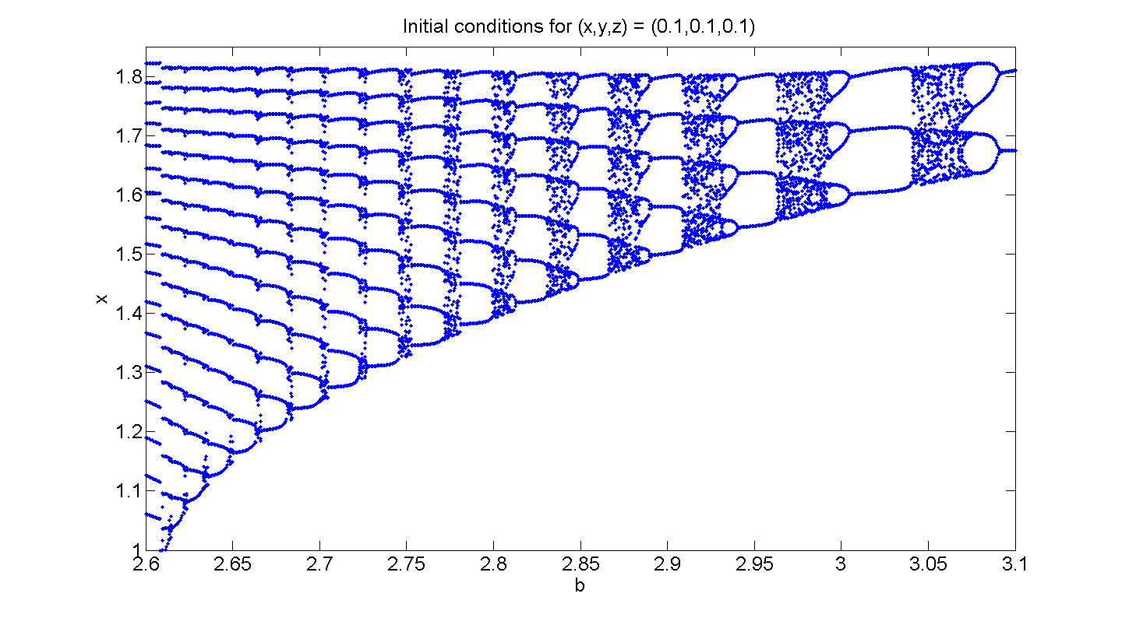

Figure 2: Bifurcation diagram of x vs. b with I determined by equation 4.

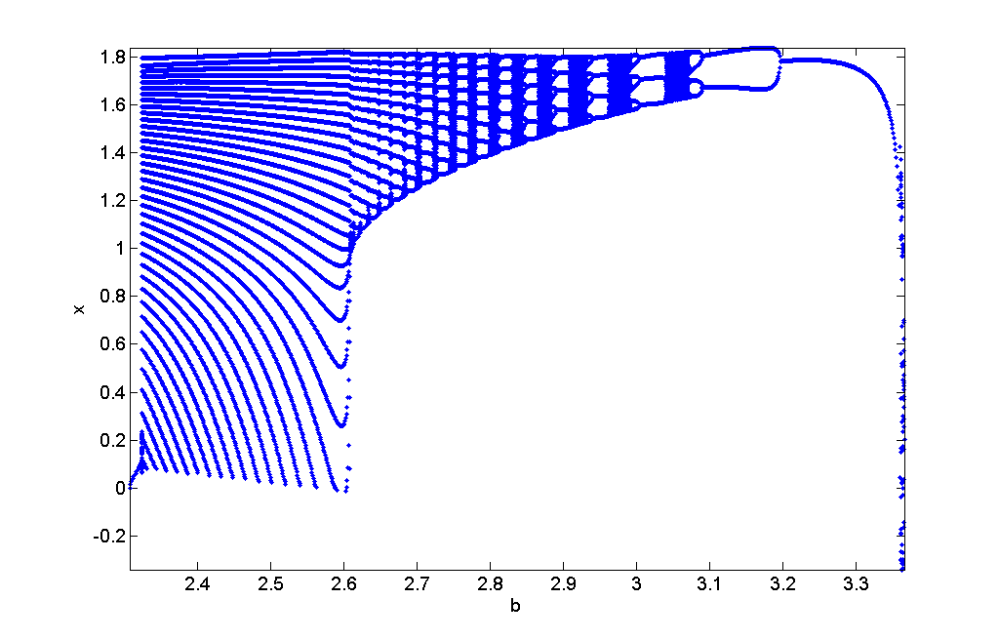

Figure 3: Bifurcation diagram of y vs. b with I determined by equation 4.

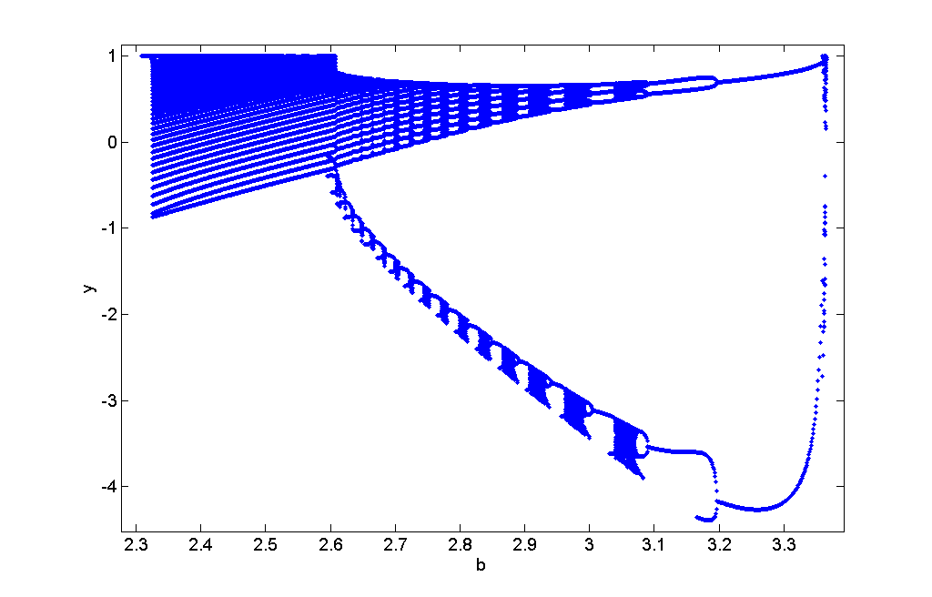

Figure 4: Bifurcation diagram of z vs. b with I determined by equation 4. Notice the similarities as compared with x vs. b in Figure 2. This makes sense considering how z depends on x in equation 3.

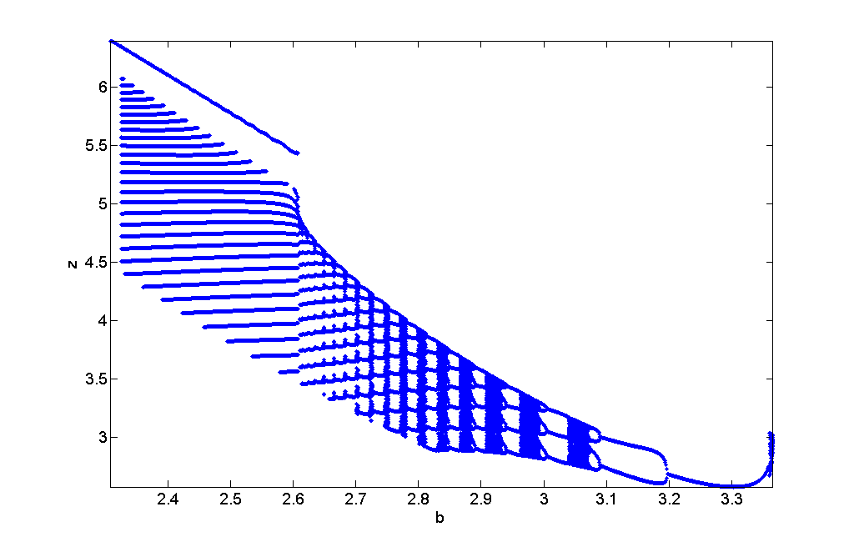

Figure 5: Magnification of Figure 2. There is possible chaotic ending (since parameter b was increased over the course of constructing the bifurcation diagram) after period halving route from chaos.

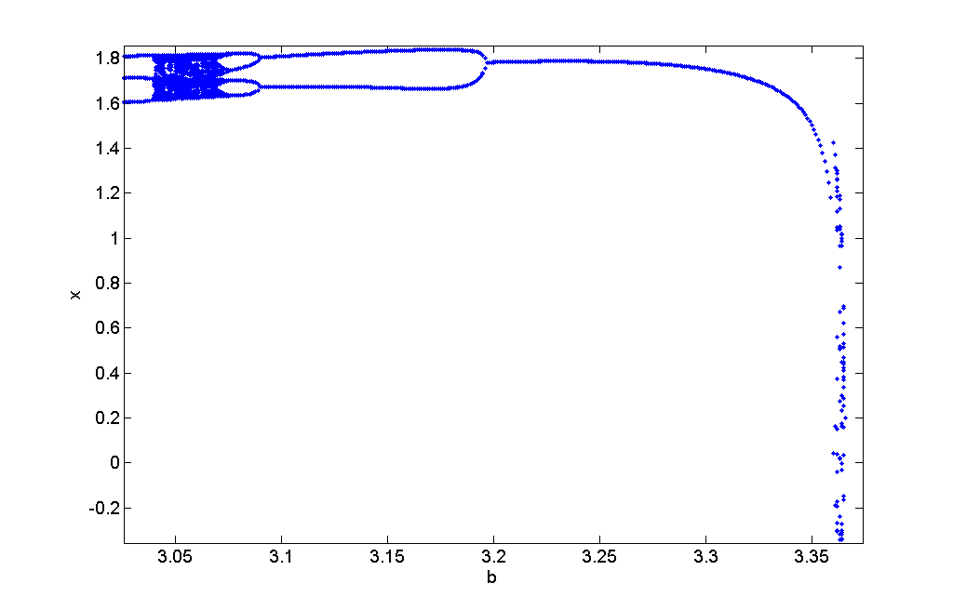

Figure 6: Magnification of Figure 2. Period halving for x, the membrane potential.

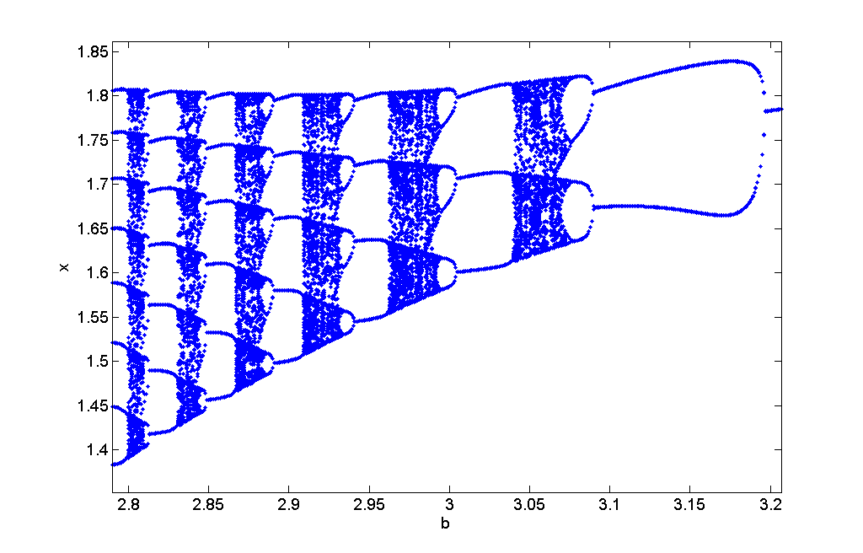

Figure 7: Magnification of Figure 2. Single period stability bursts out to period 39 which gradually reduces to period 18 behavior to proceed to period halve as seen in Figure 6.

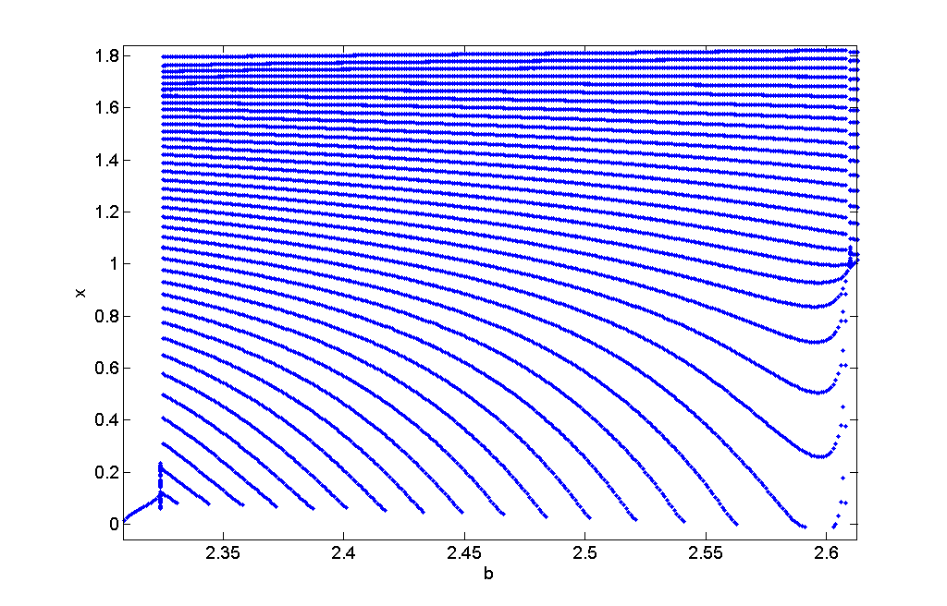

Figure 8: Magnification of Figure 3. Period halving for the fast ion exchange variable, y.

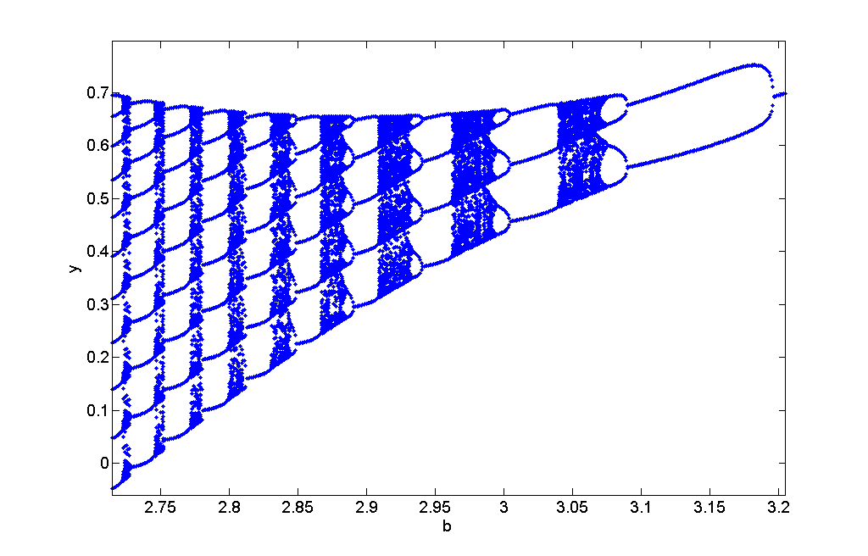

Figure 14: Magnification of Figure 4. Period destruction is seen for b~2.625 to b~2.8, but typical period halving behavior is noticeable above b~2.8. A similar end is seen for the slow ion exchange variable, z, as was seen for the membrane potential variable, x.

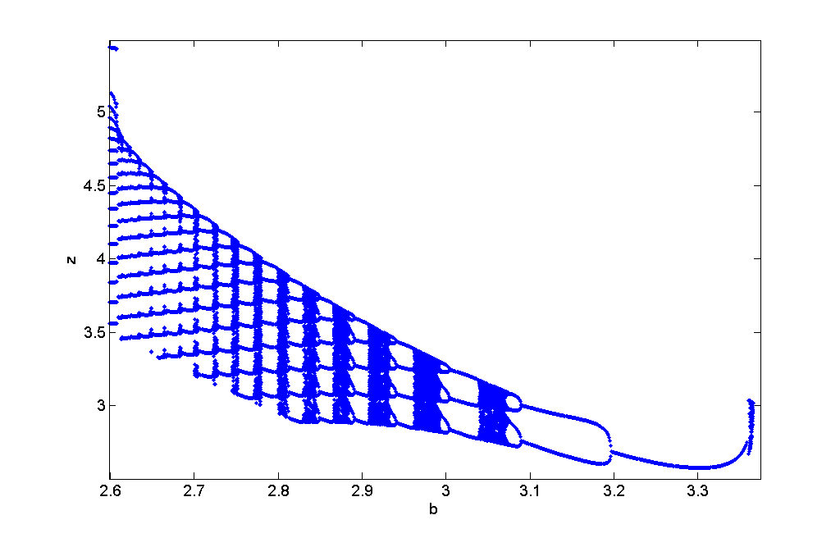

Figure 10: Magnification of Figure 4. Period halving.

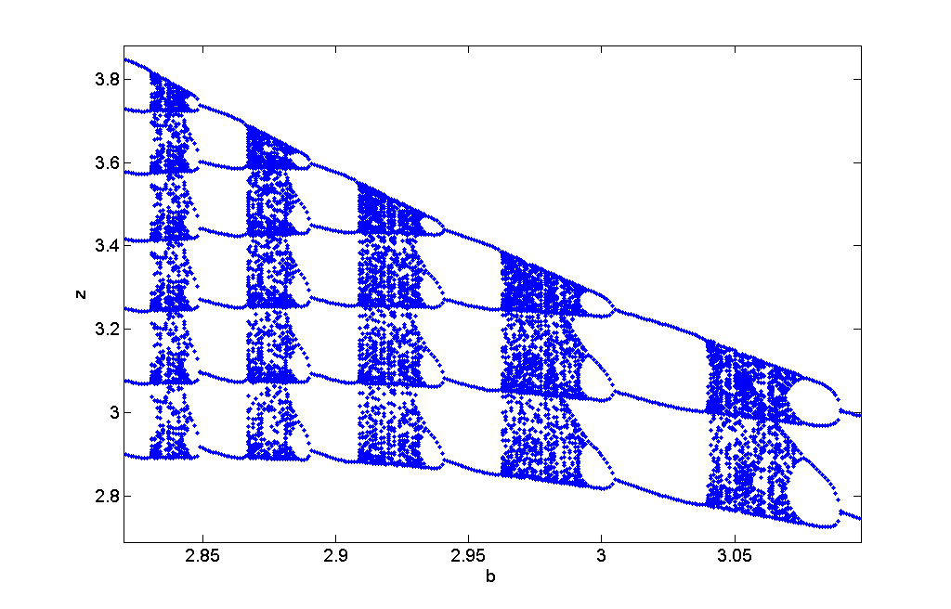

Figure 11: Magnification of Figure 4. Period 1 behavior into period 21 behavior followed by period destruction until period 15 behavior picks up into period halving.

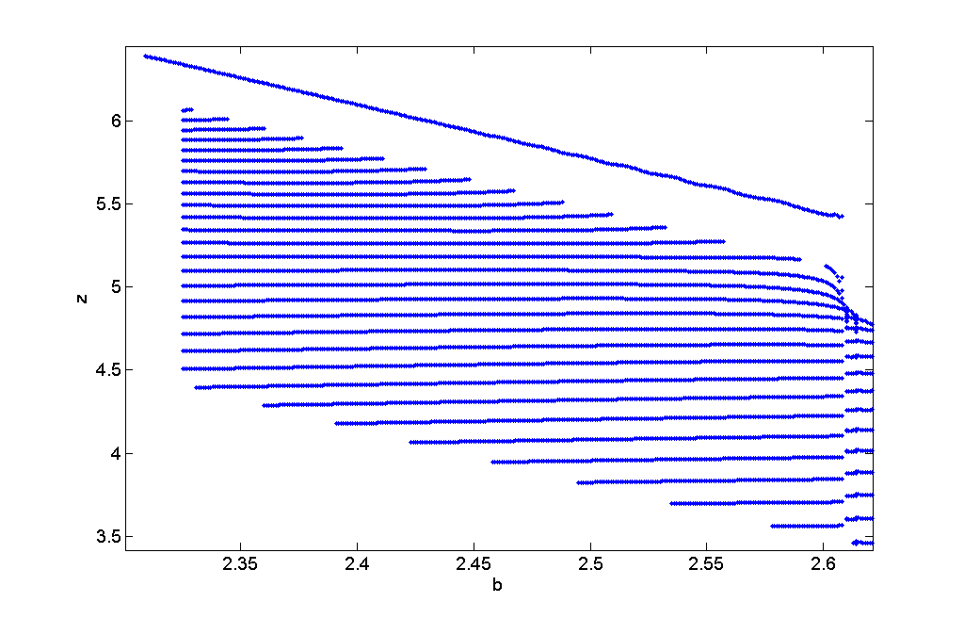

Figure 12: Reconstruction of Rech’s Figure 3a of a period three attractor.

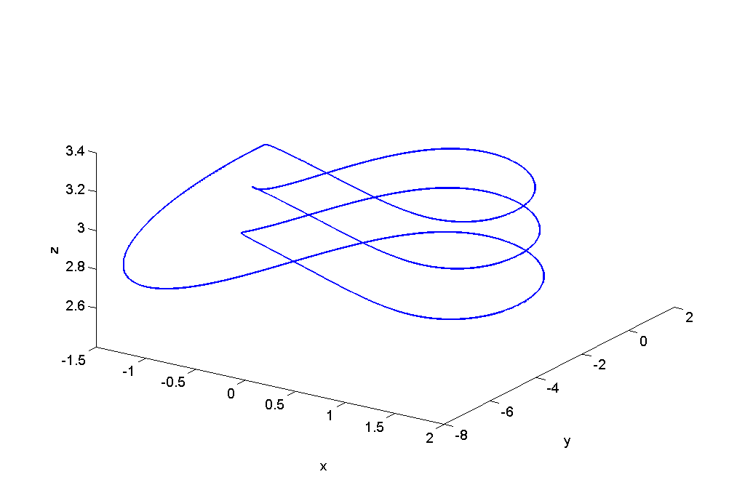

Figure 13: Reconstruction of Rech’s Figure 3b of a period four attractor.

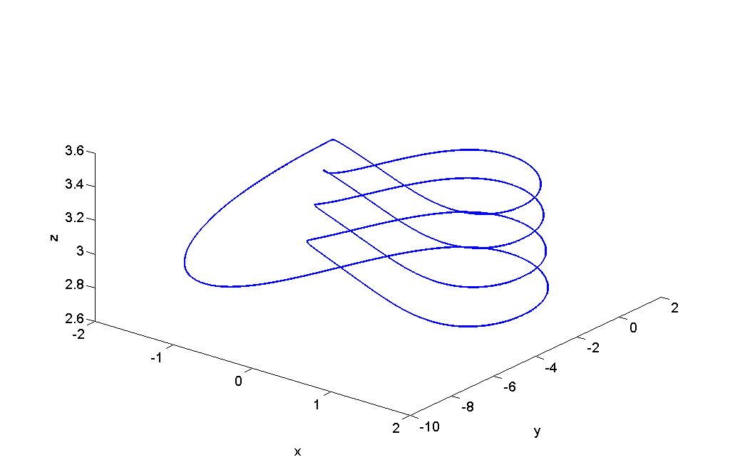

Figure 14: Reconstruction of Rech’s Figure 3c of a period five attractor.

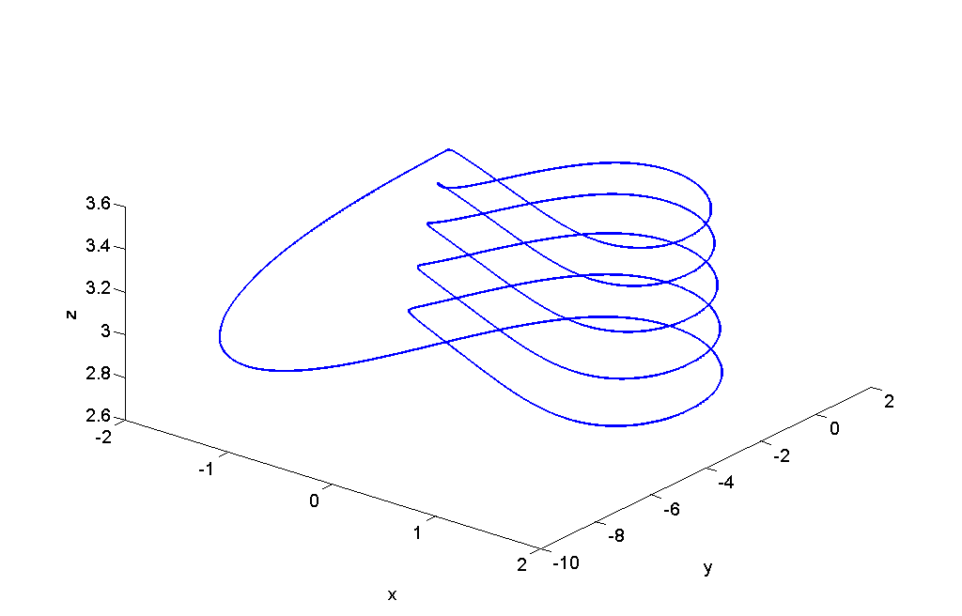

Figure 15: Reconstruction of Rech’s Figure 3d of a period six attractor.

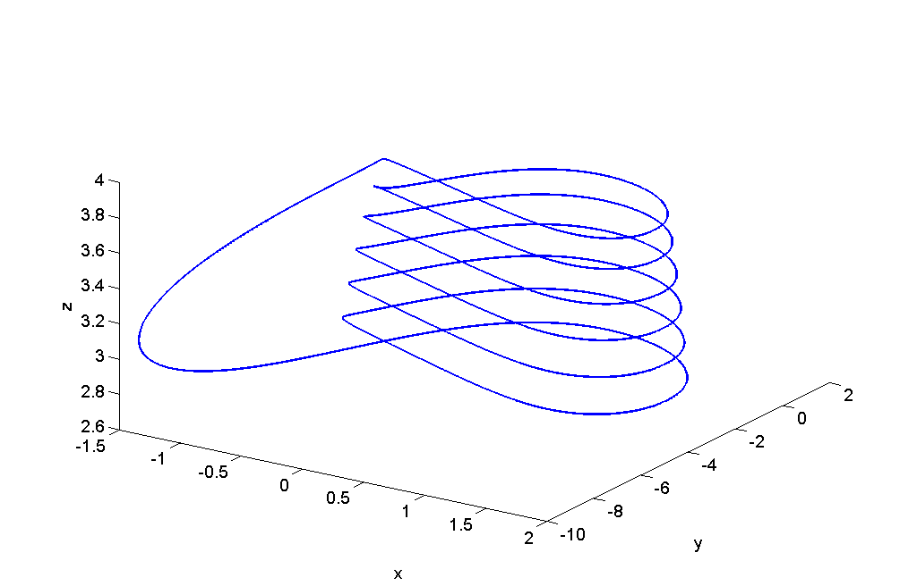

Figure 16: Chaotic attractor with b = 3.045 and I determined by equation 4 and initial condition P0.

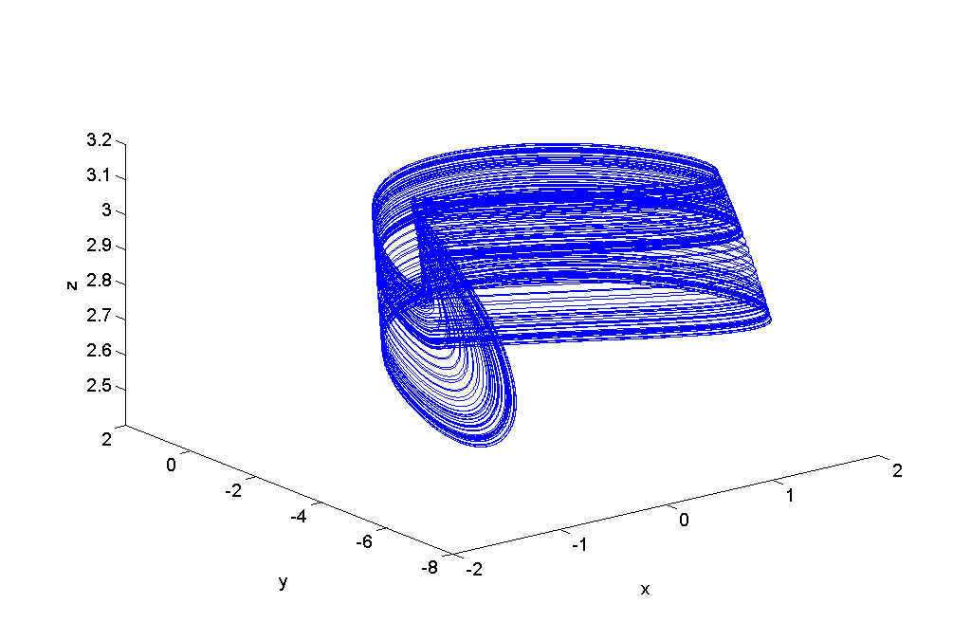

Figure 17: The x-y plane perspective of the chaotic attractor in Figure 14.

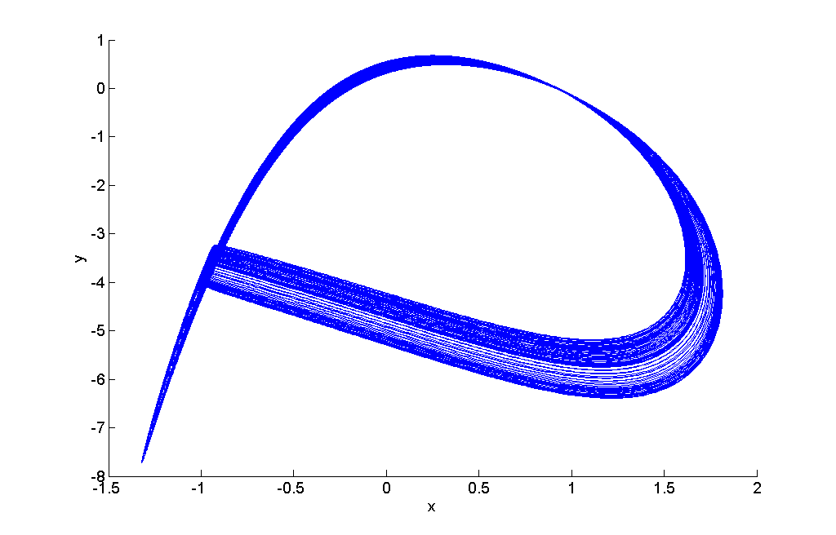

Figure 18: The x-y plane perspective of the chaotic attractor in Figure 14.

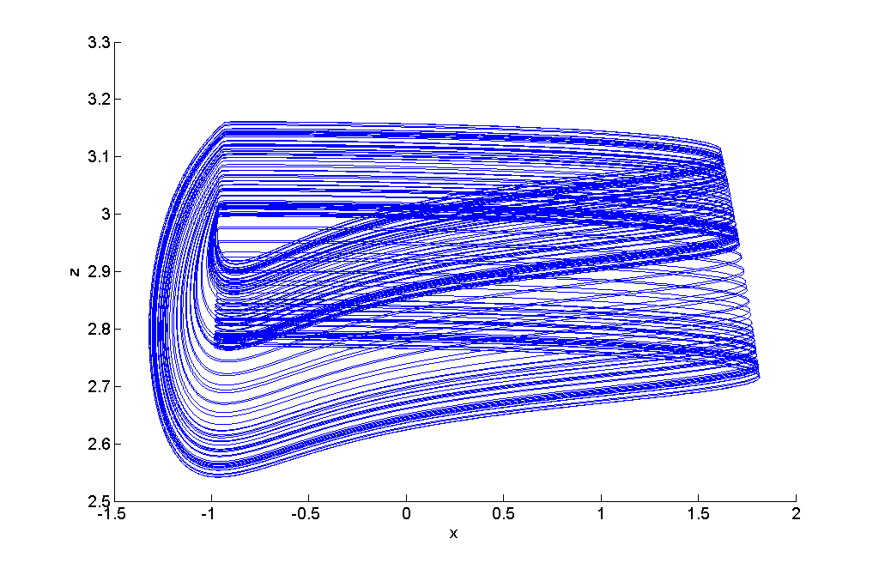

Figure 19: The y-z plane perspective of the chaotic attractor in Figure 14.

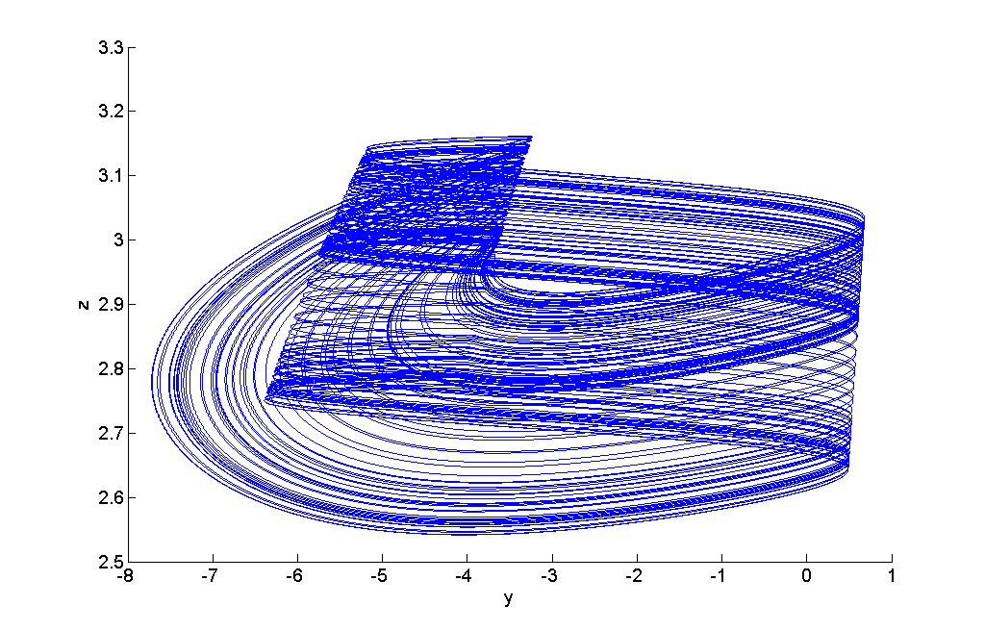

Figure 20: Summarization of perspectives of the chaotic attractor in Figure 14.

. 



Figure 21: Growing Euclidean distance between two neighboring trajectories (blue). Non-rigorous estimated linear fit of the slope used to determine the Lyapunov exponent to be 0.0029.

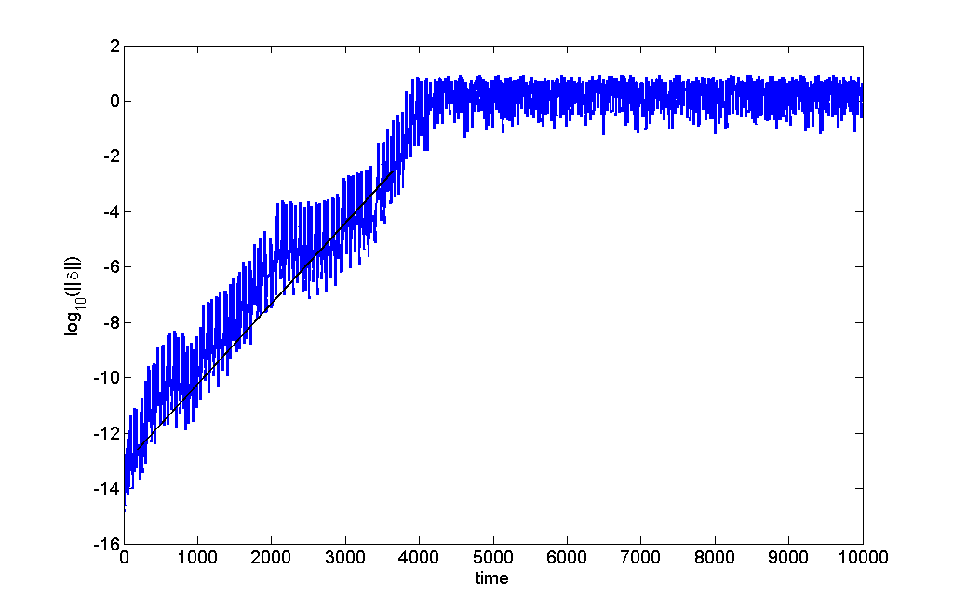

Figure 22: Magnification of Figure 21. Approximately linear growth of the divergence of two nearby trajectories (blue) with the line estimating the Lyapunov exponent (black).

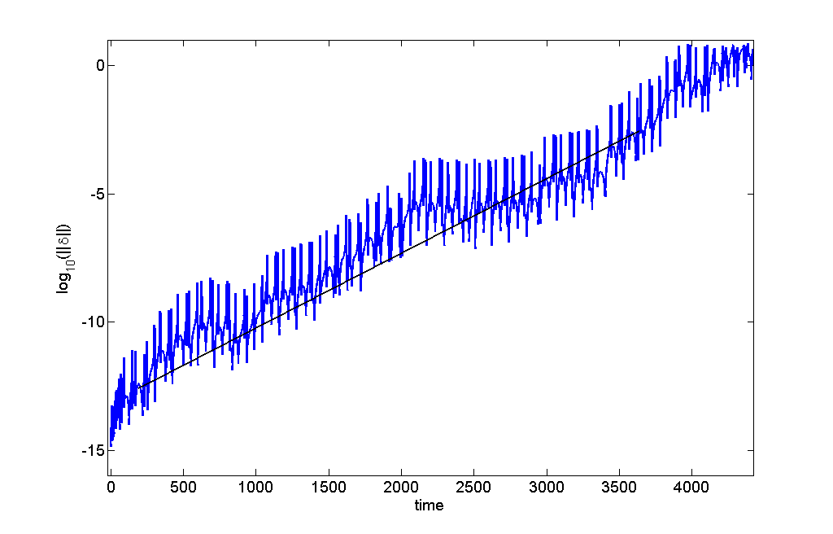

Figure 23: Estimated Lyapunov Exponents for the same parameters in Figure 1. Some gaps exist due to –Inf and NaN values found by Matlab. For comparison, note positive exponents with chaotic regions in Figure 1.

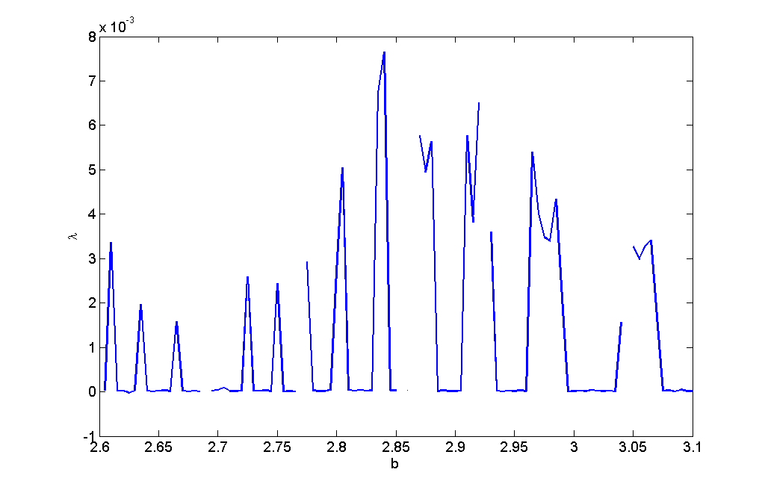

Figure 24: Poincare map through the chaotic attractor in Figures 16-20. The slice is the plane parallel with z = <z> and initial condition P0.

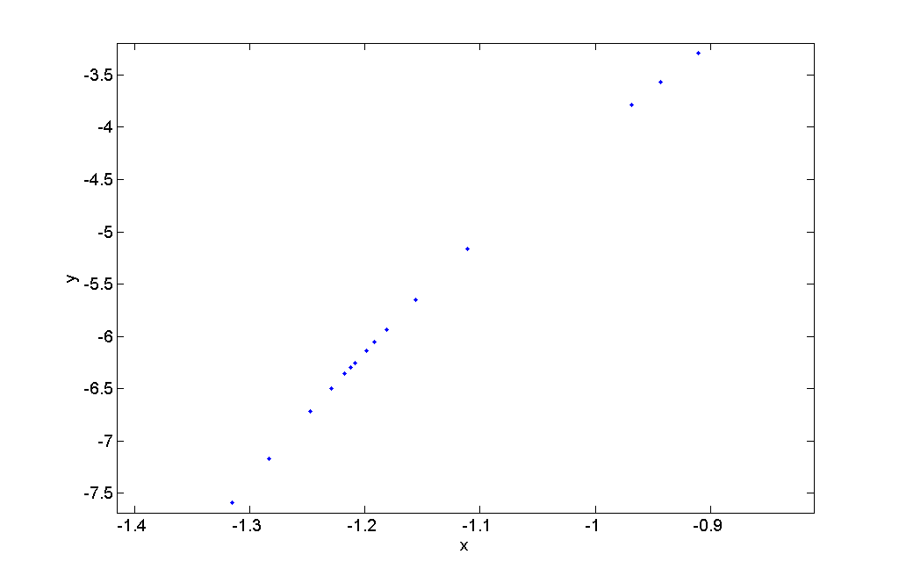

Figure 25: Poincare map through the chaotic attractor in Figures 16-20. The slice is the plane parallel with y = <y> and initial condition P0.

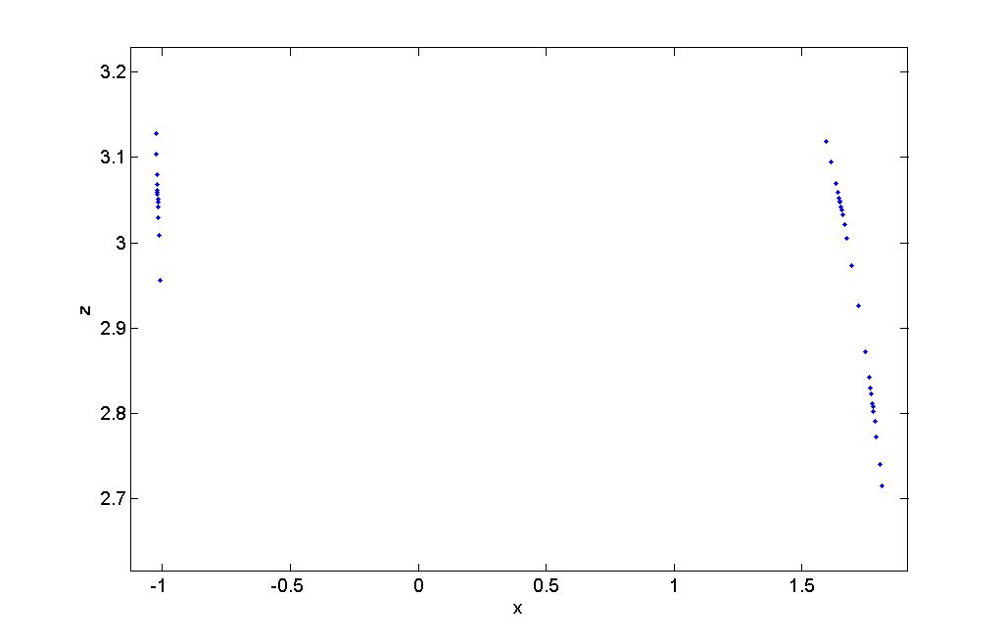

Figure 26: Poincare map through the chaotic attractor in Figures 16-20. The slice is the plane parallel with x = <x> and initial condition P0.

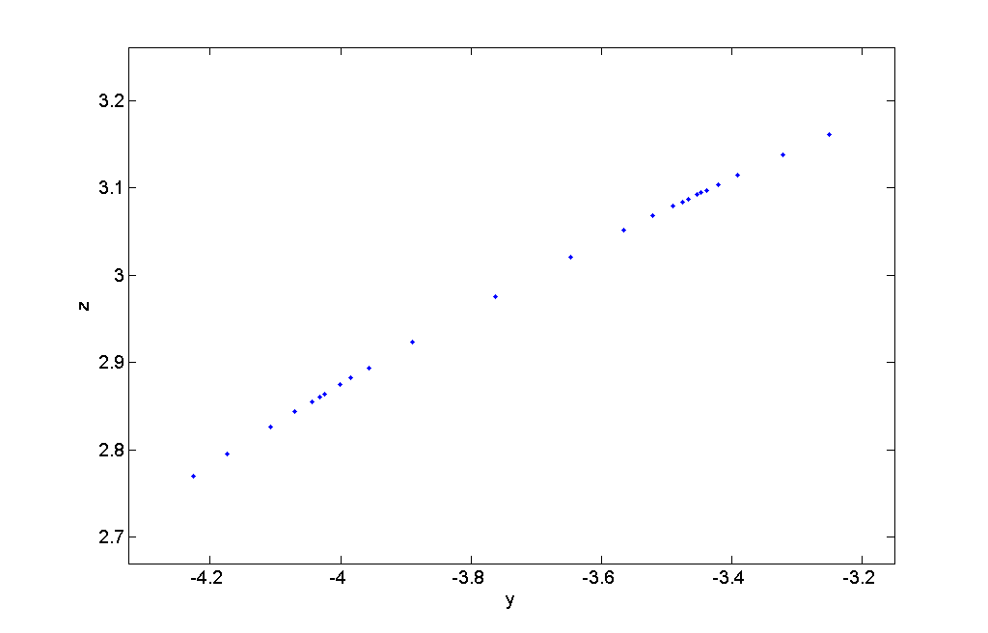

Figure 27: Poincare map through the period 6 attractor in Figure 15. The slice is the plane parallel with z = <z> and initial condition P0.

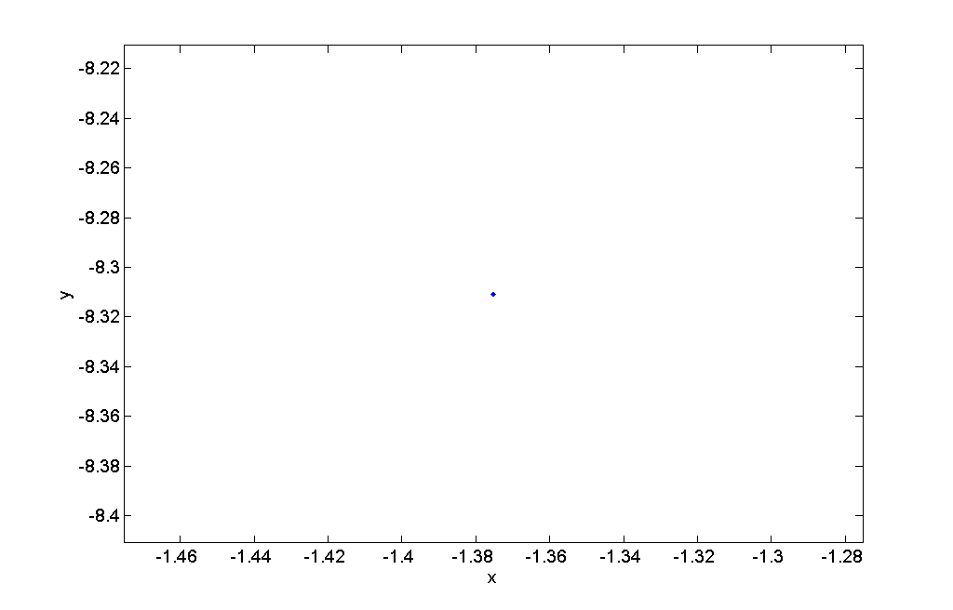

Figure 28: Poincare map through the period 6 attractor in Figure 15. The slice is the plane parallel with y = <y> and initial condition P0.

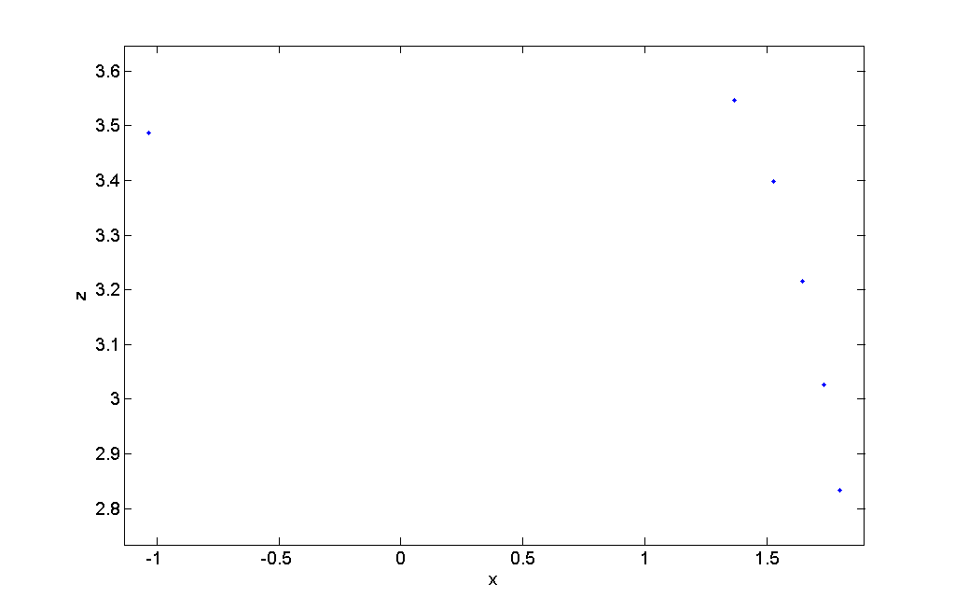

Figure 29: Poincare map through the period 6 attractor in Figure 15. The slice is the plane parallel with x = <x> and initial condition P0.

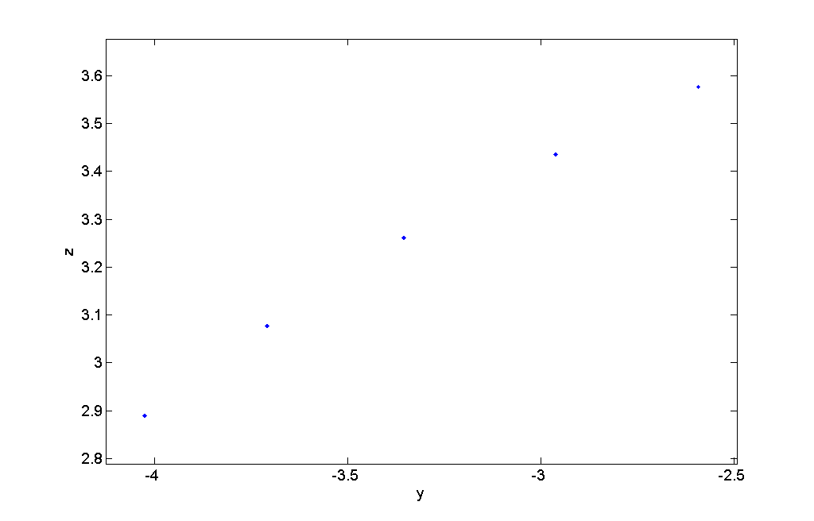

Figure 30:Lorenz map of maxima x values with b = 3.045 and initial condition P0.

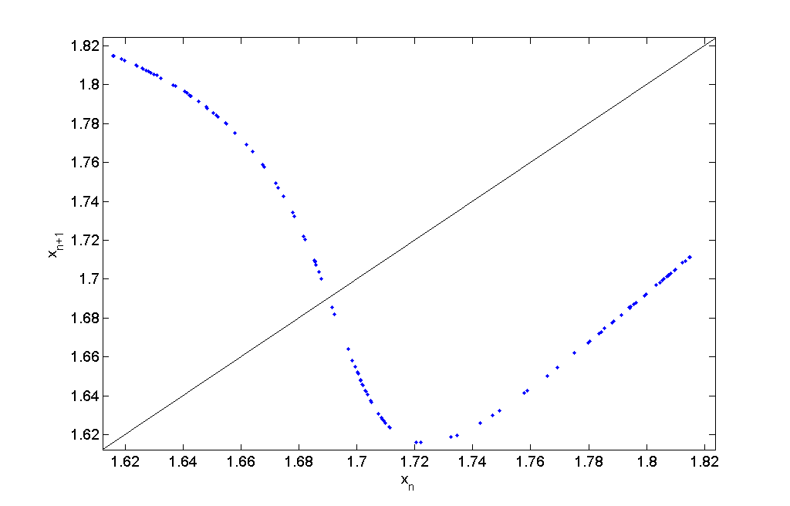

Figure 31: Lorenz map of maxima y values with b = 3.045 and initial condition P0.

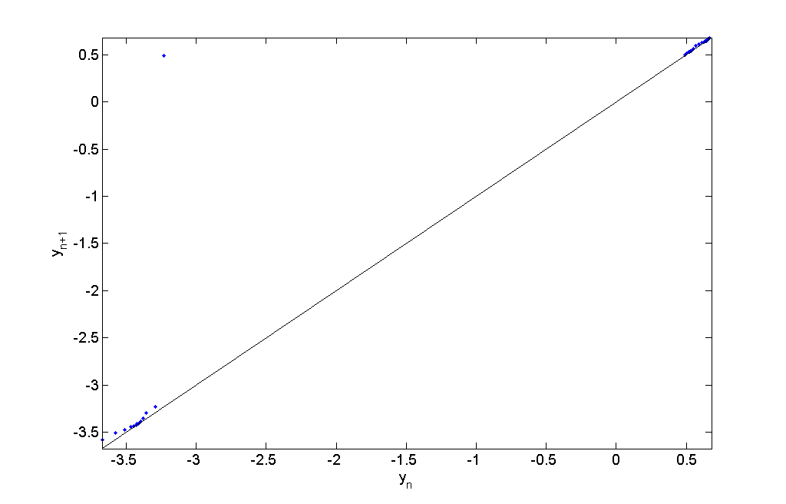

Figure 32: Lorenz map of maxima z values with b = 3.045 and initial condition P0.

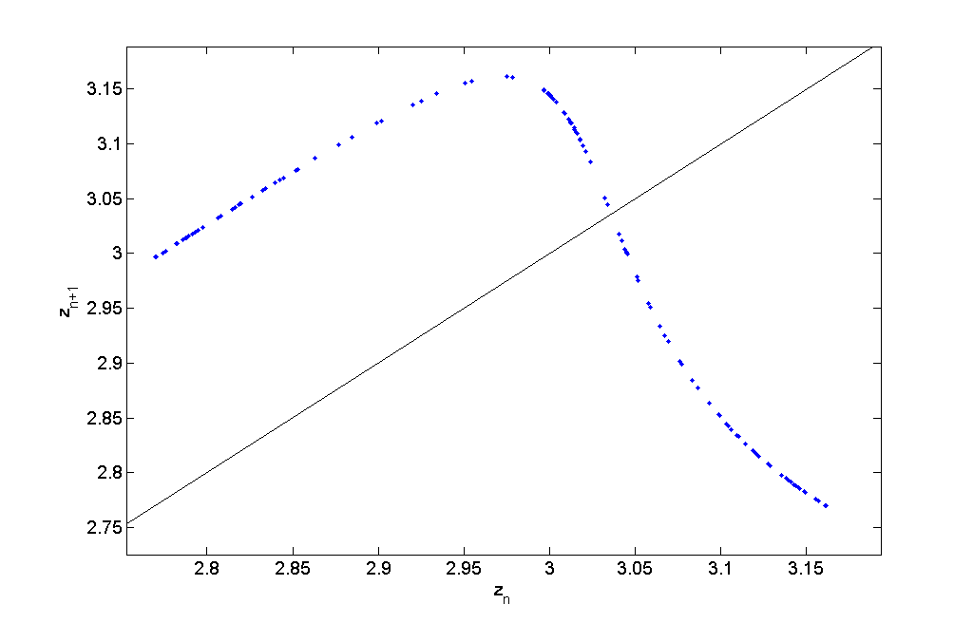

Figure 33: Cobweb diagram on the x Lorenz map for b = 3.045 and initial condition P0.

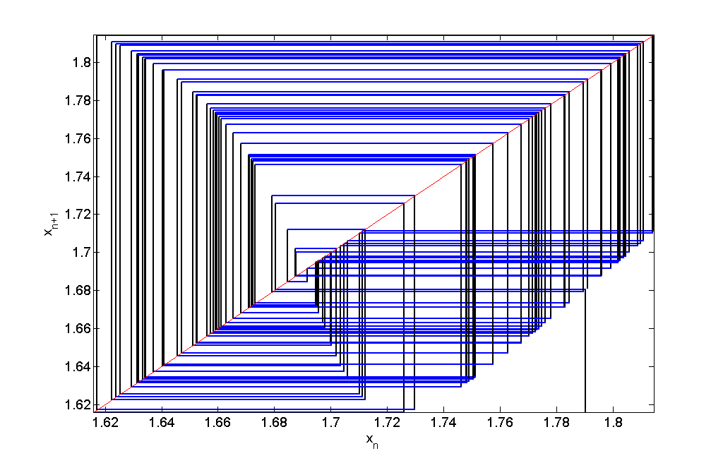

Figure 34: Cobweb diagram on the y Lorenz map for b = 3.045 and initial condition P0.

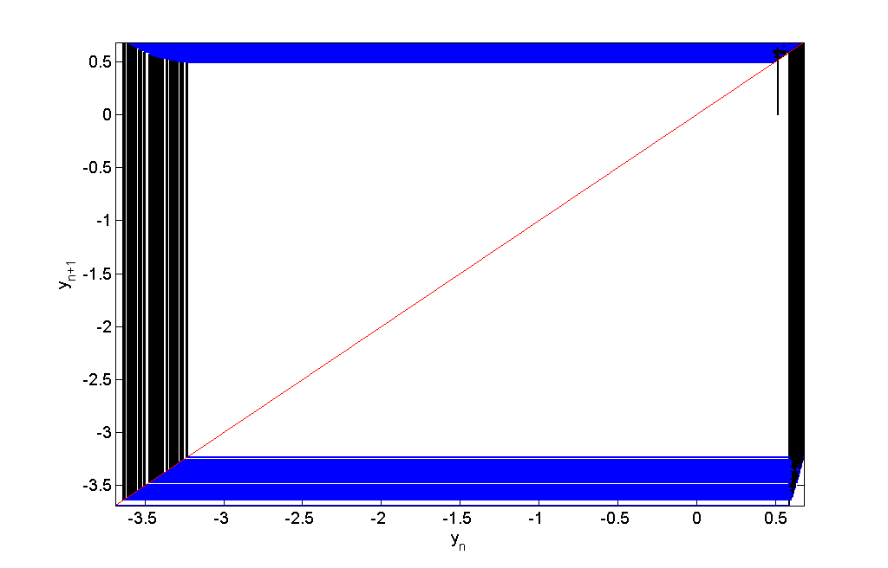

Figure 35: Cobweb diagram on the z Lorenz map for b = 3.045 and initial condition P0.

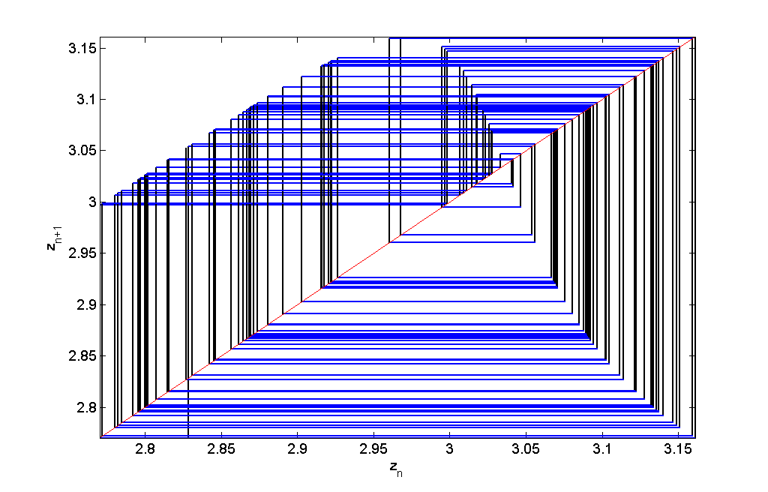

Figure 36: Time series of x for b = 3.045 and initial condition P0.

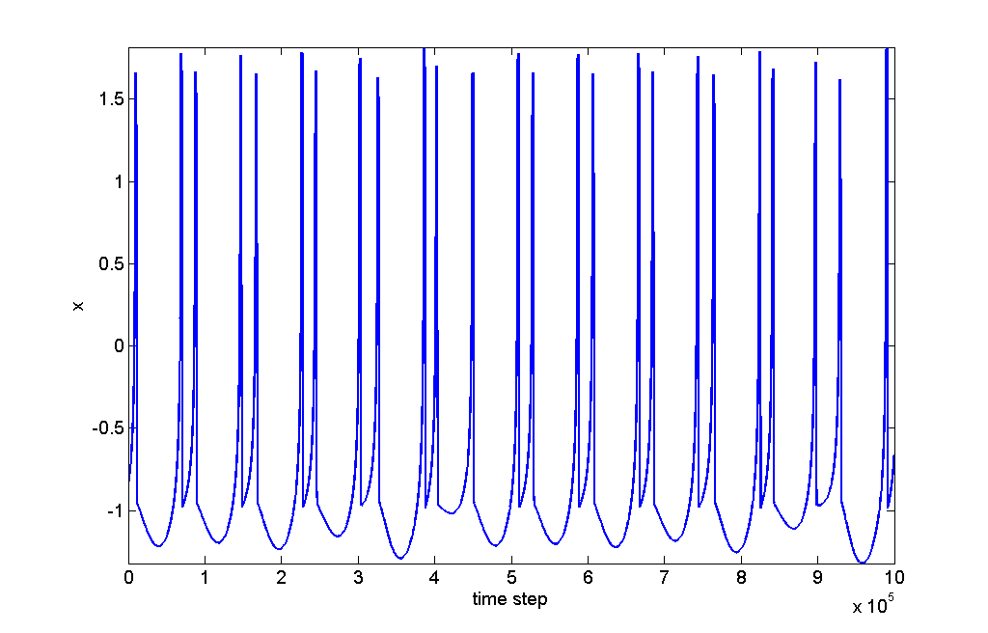

Figure 37: Time series of y for b = 3.045 and initial condition P0.

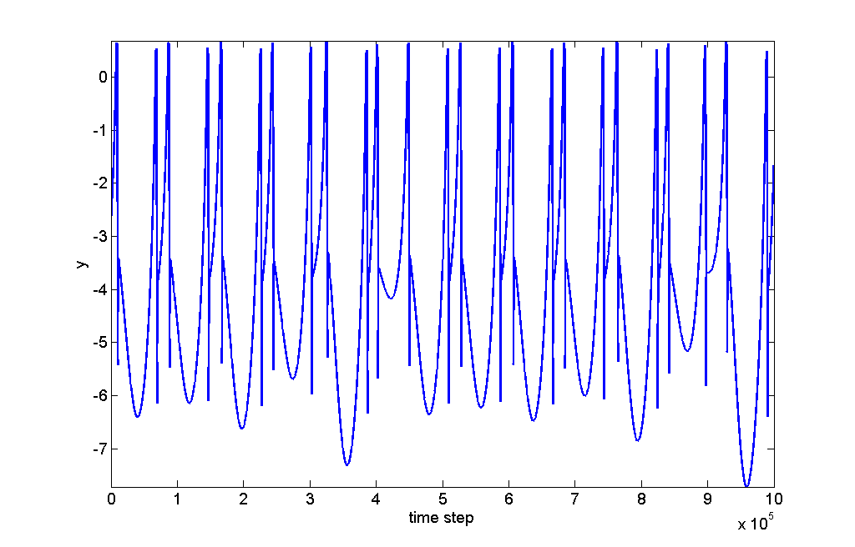

Figure 38: Time series of z for b = 3.045 and initial condition P0.

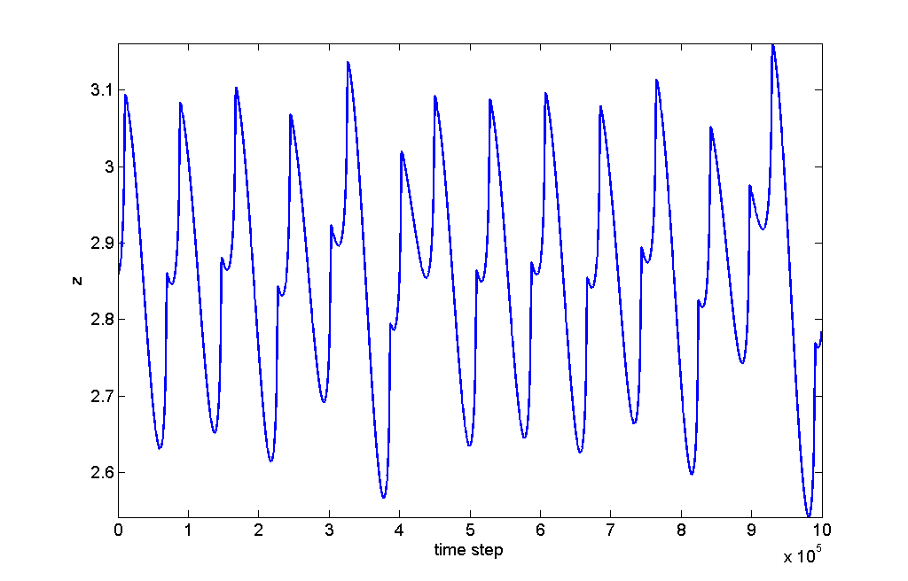

Figure 39: Time series of x for b = 2.4 and initial condition P0.

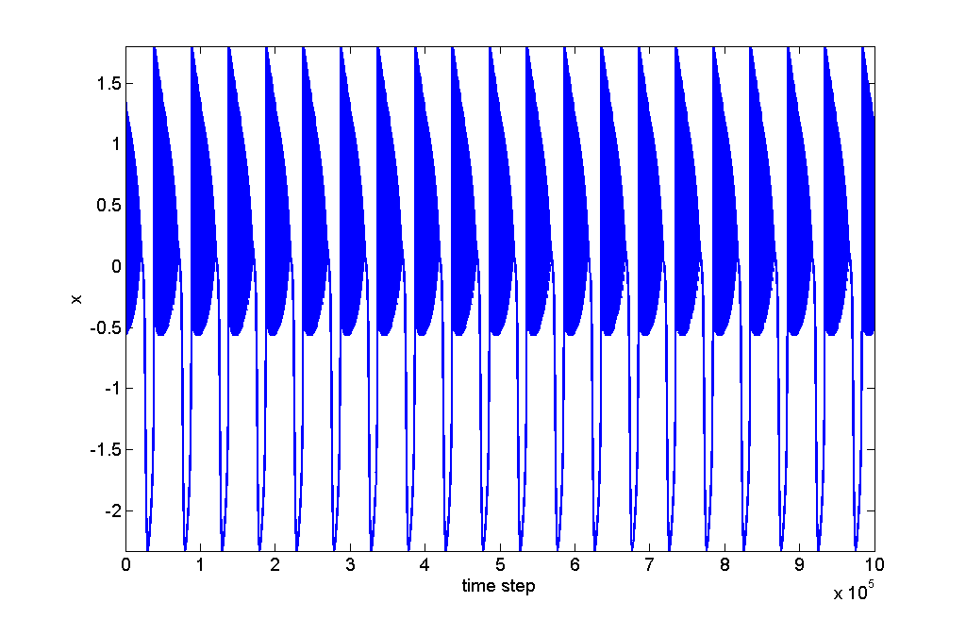

Figure 40: Magnification of Figure 39.

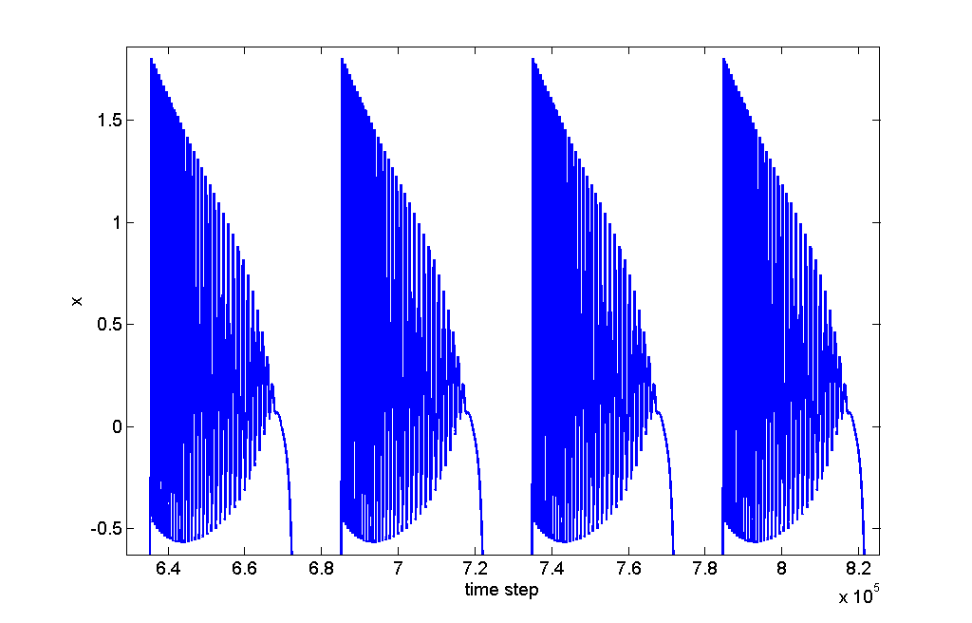

Figure 41: Magnification of Figure 40.

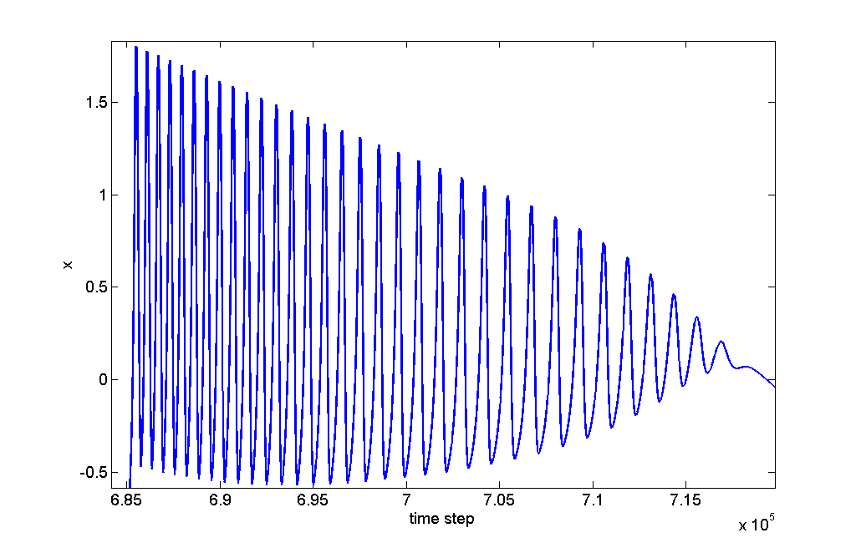

Figure 42: Time series of y for b = 3.045 and initial condition P0.

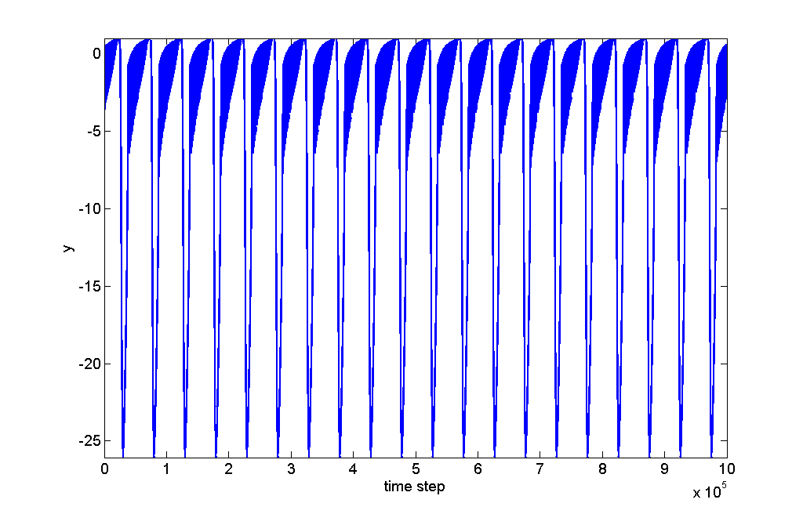

Figure 43: Magnification of Figure 42.

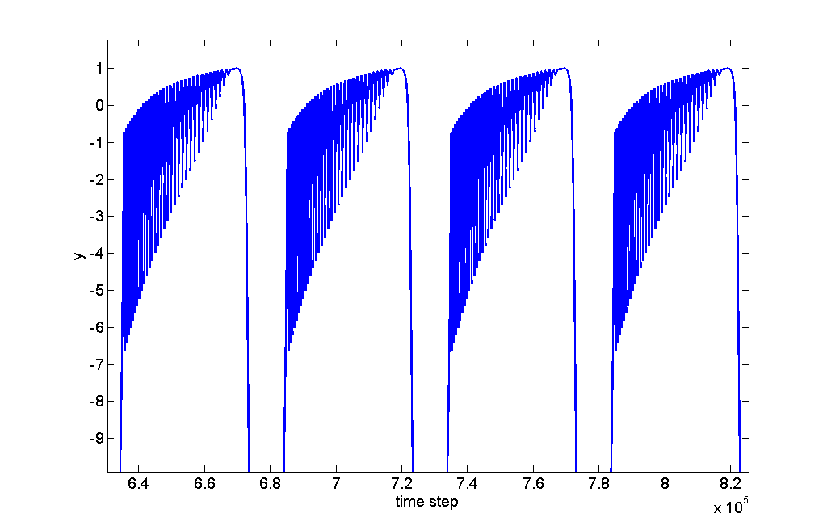

Figure 44: Magnification of Figure 43.

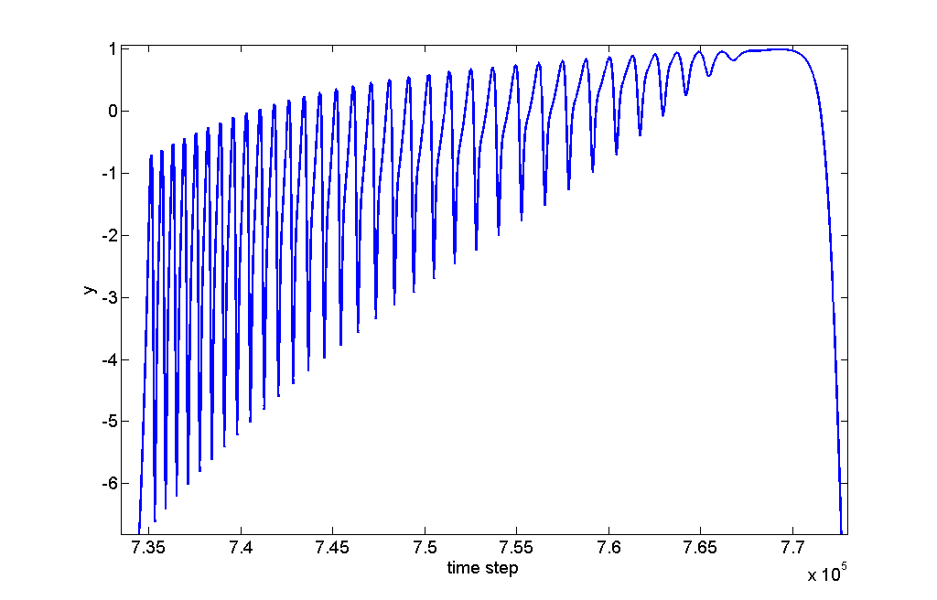

Figure 45: Time series of z for b = 3.045 and initial condition P0.

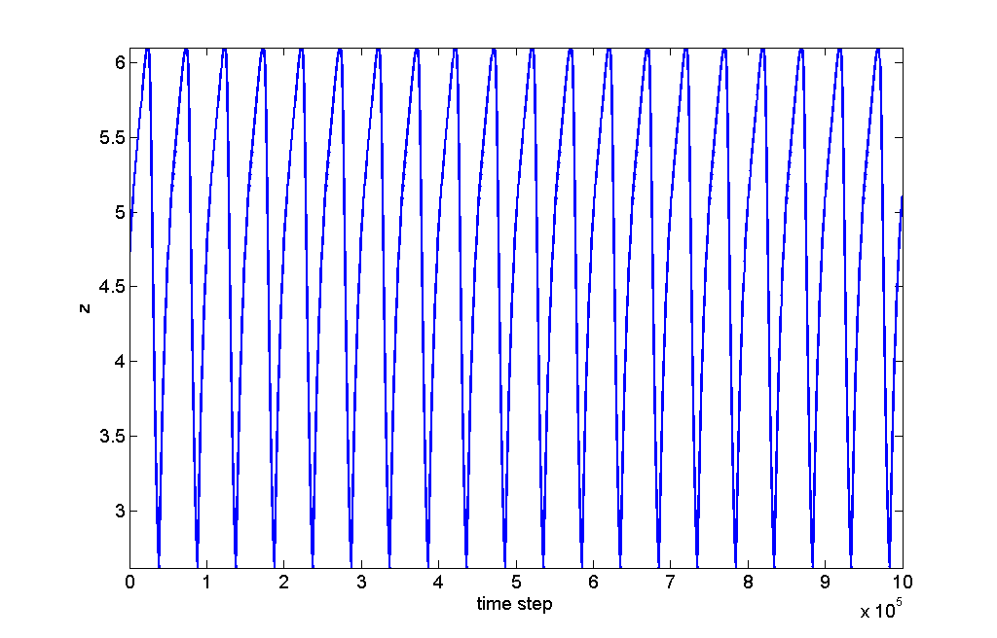

Figure 46: Magnification of Figure 45.

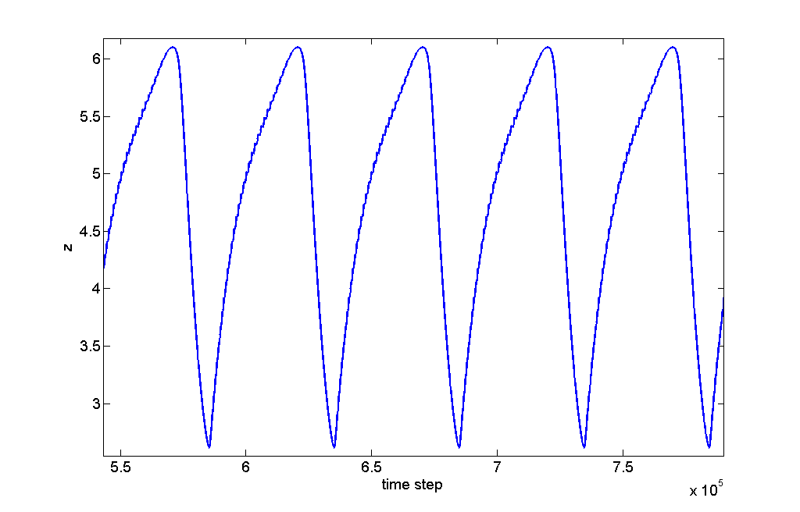

Figure 47: Magnification of Figure 46.

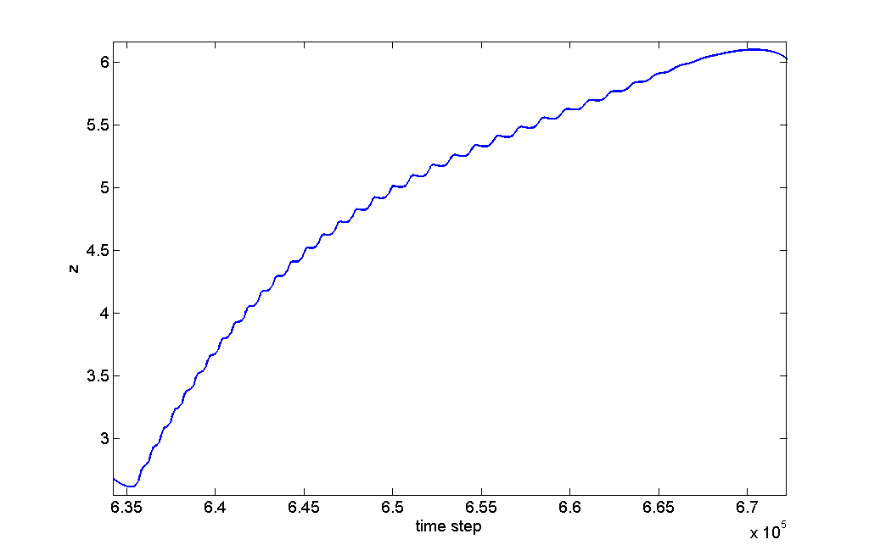

Figure 48: Three-dimensional phase plot with b = 2.4 and initial condition P0. It looks like a birdcage!

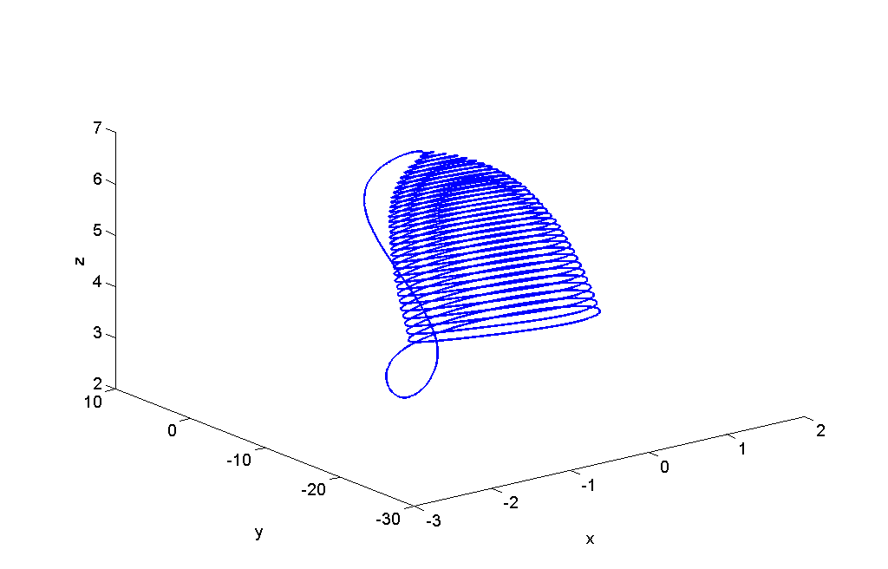

Figure 49: x vs. I bifurcation diagram for b = 2.85 and initial condition P0.

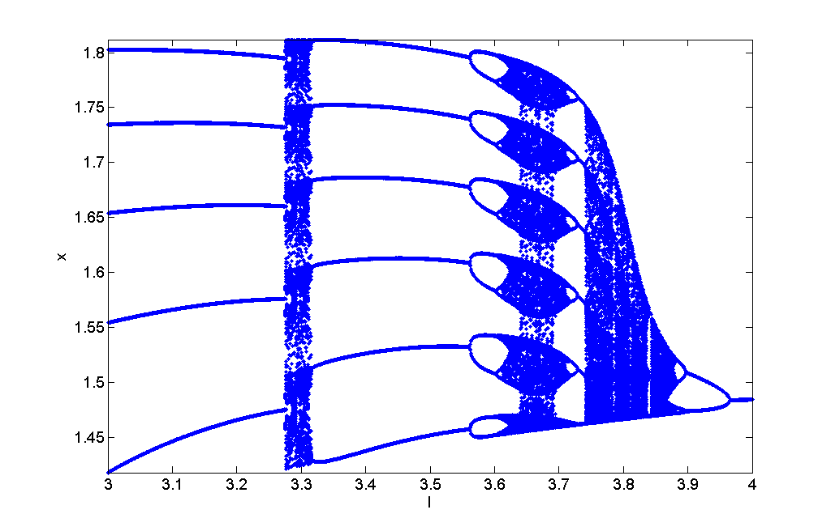

Figure 50: Magnification of cascade in Figure 49.

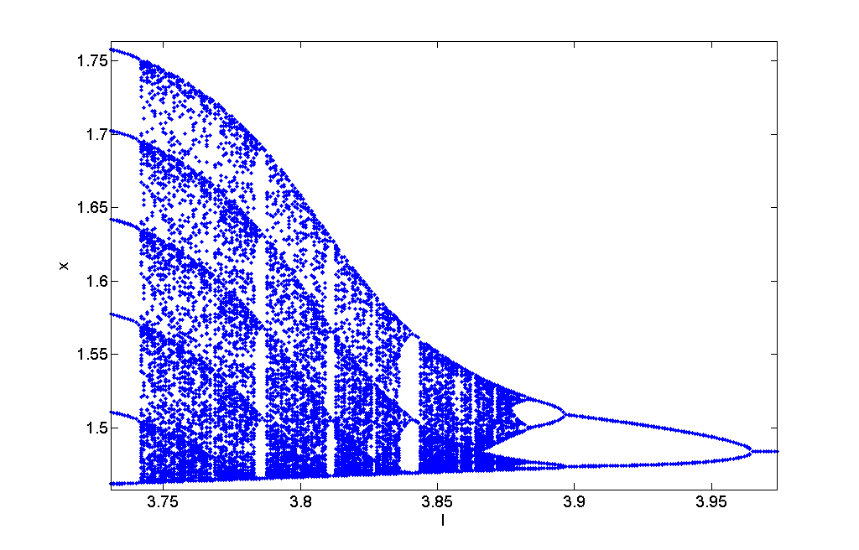

Figure 51: Magnification of period halving and doubling connected from Figure 49.

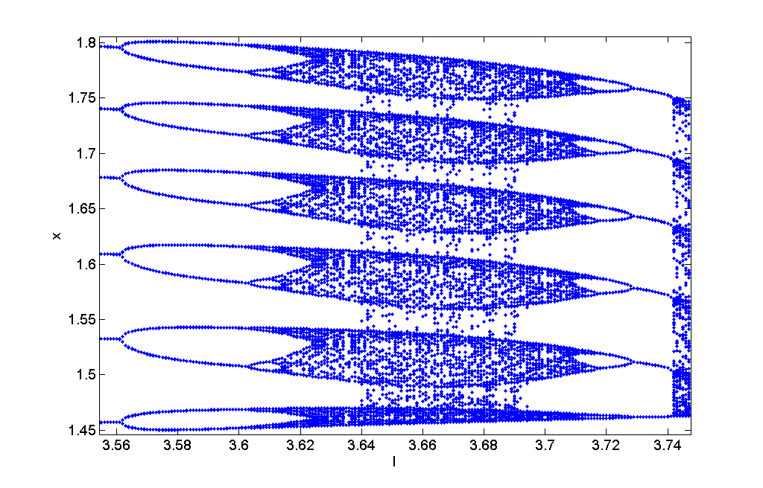

Figure 52: Magnification of peculiar behavior from Figure 49.

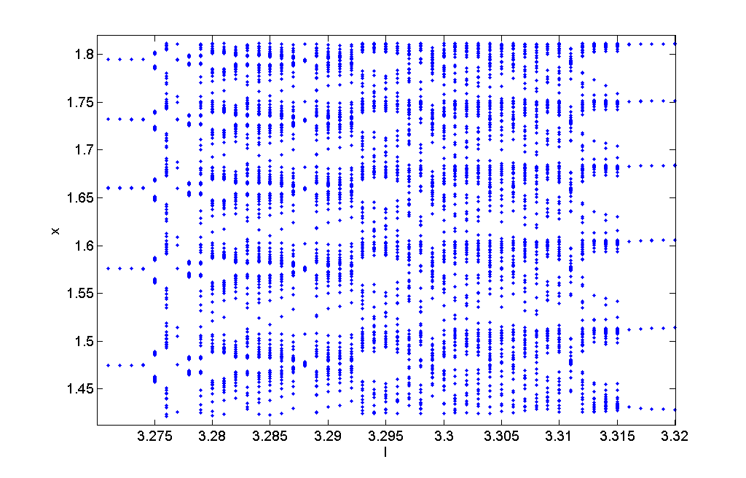

Figure 53: y vs. I bifurcation diagram for b = 2.85 and initial condition P0.

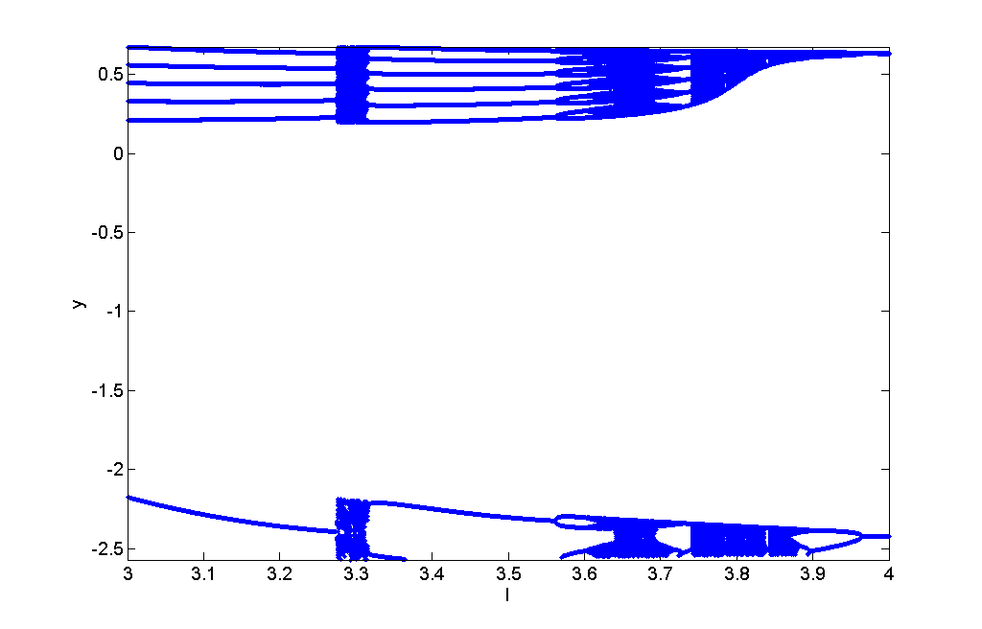

Figure 54: Magnification of upper portion from Figure 53.

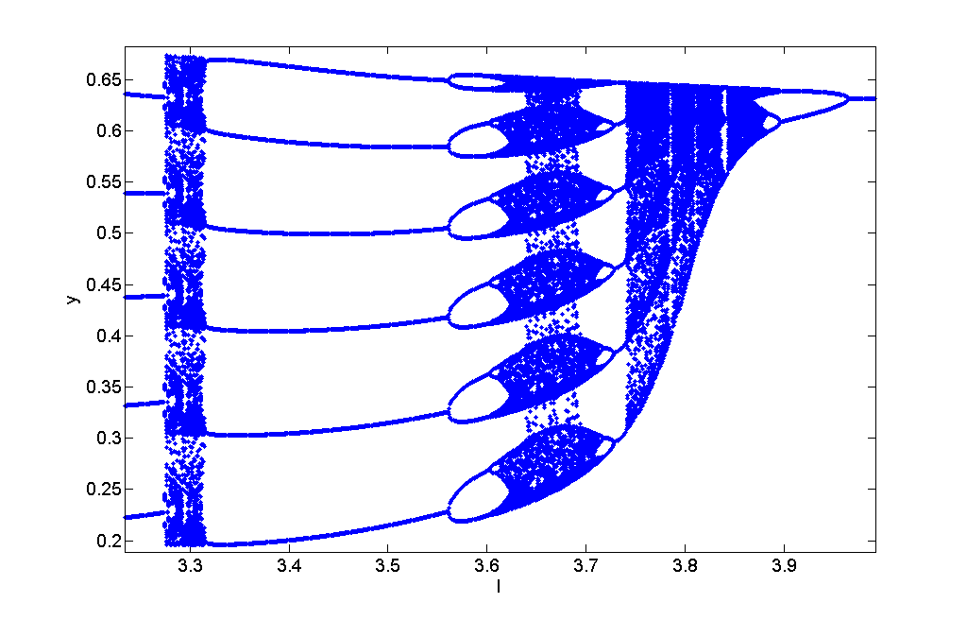

Figure 55: Magnification of lower portion from Figure 53.

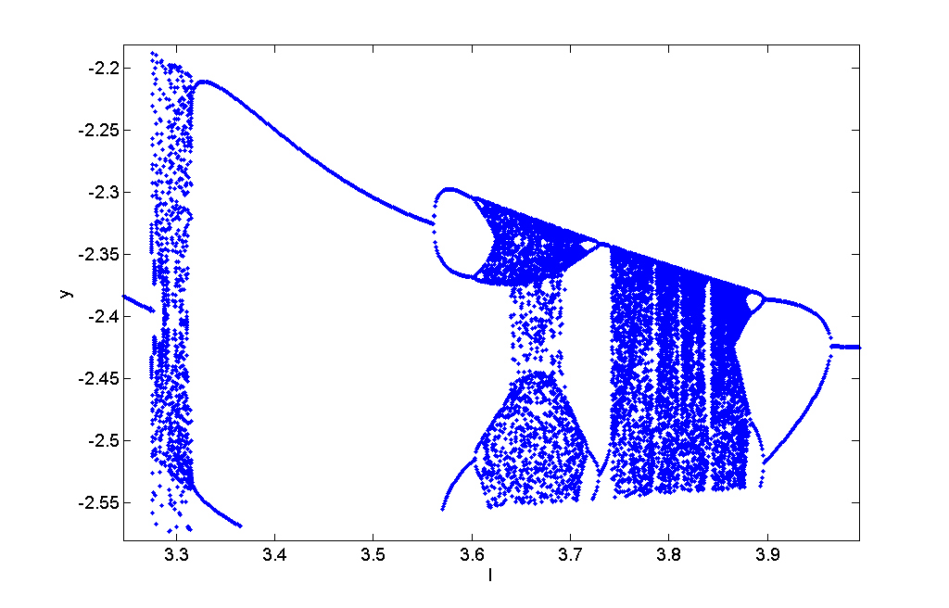

Figure 56: z vs. I bifurcation diagram for b = 2.85 and initial condition P0.

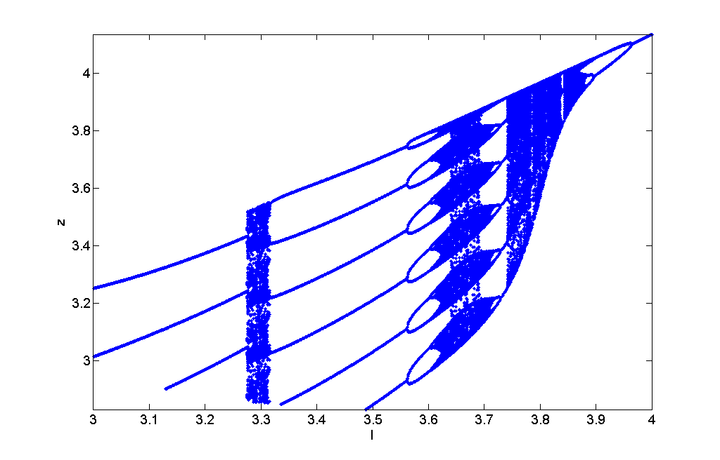

Figure 57: x vs. I bifurcation diagram for b = 2.95 and initial condition P0.

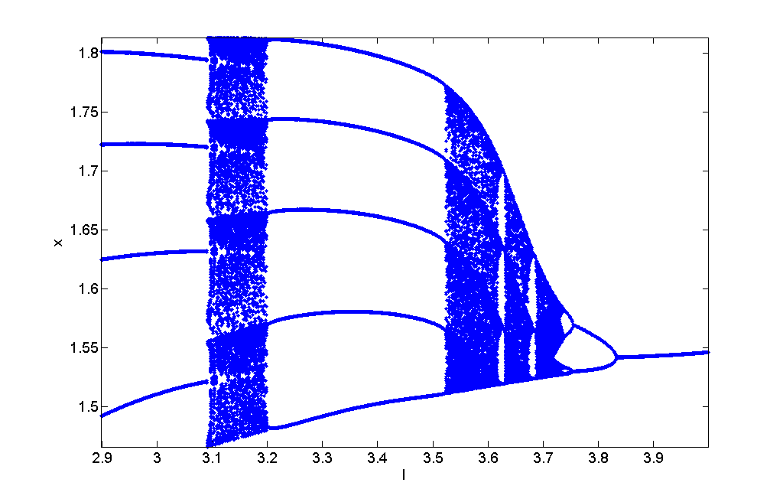

Figure 58: y vs. I bifurcation diagram for b = 2.95 and initial condition P0.

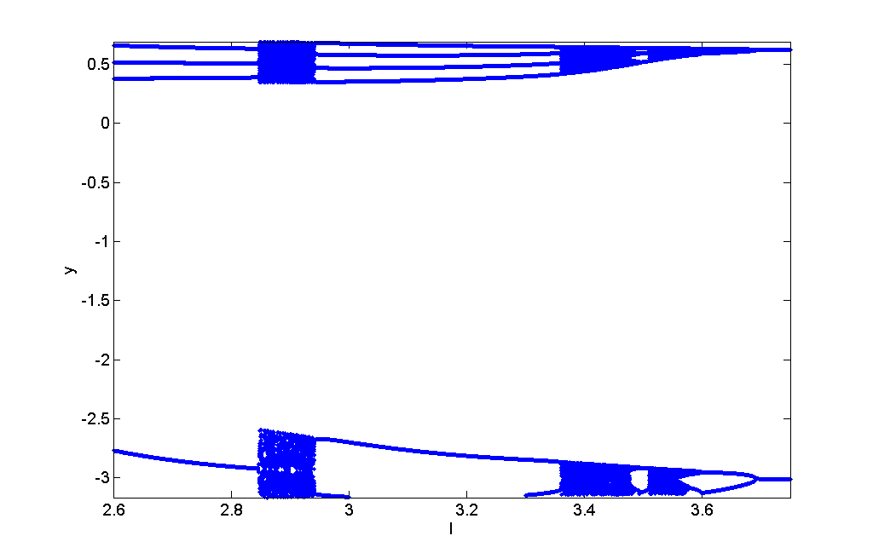

Figure 59: z vs. I bifurcation diagram for b = 2.95 and initial condition P0.

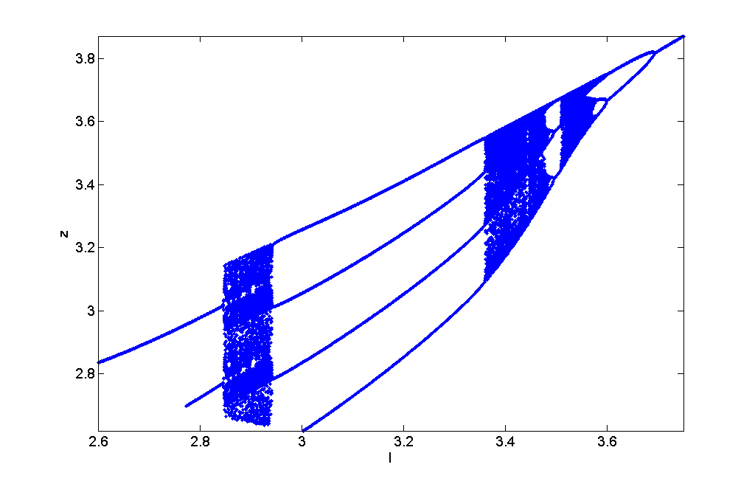

Figure 60: x vs. I bifurcation diagram for b = 3.045 and initial condition P0.

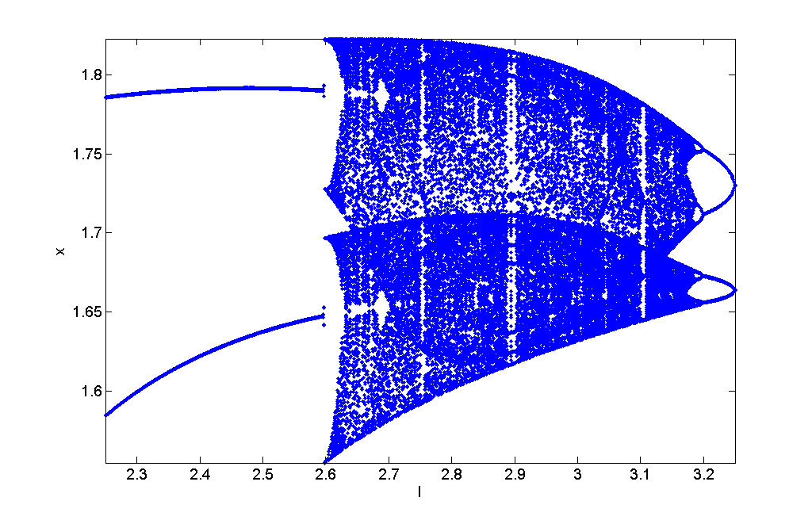

Figure 61: Lower portion of y vs. I bifurcation diagram for b = 3.045 and initial condition P0.

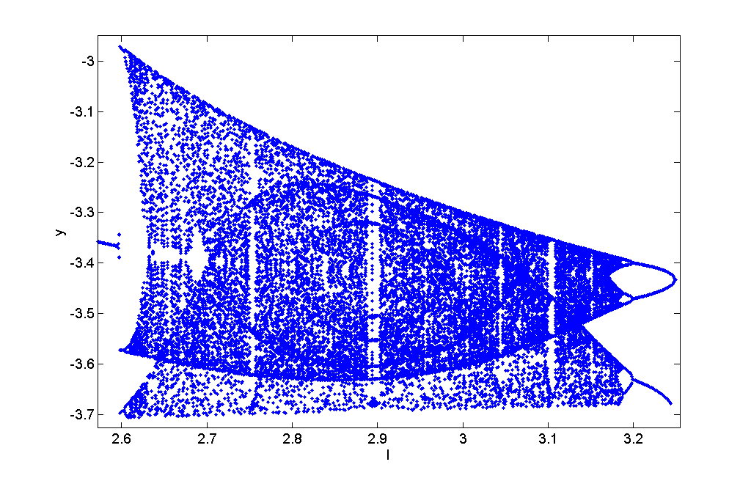

Figure 62: Upper portion of y vs. I bifurcation diagram for b = 3.045 and initial condition P0.

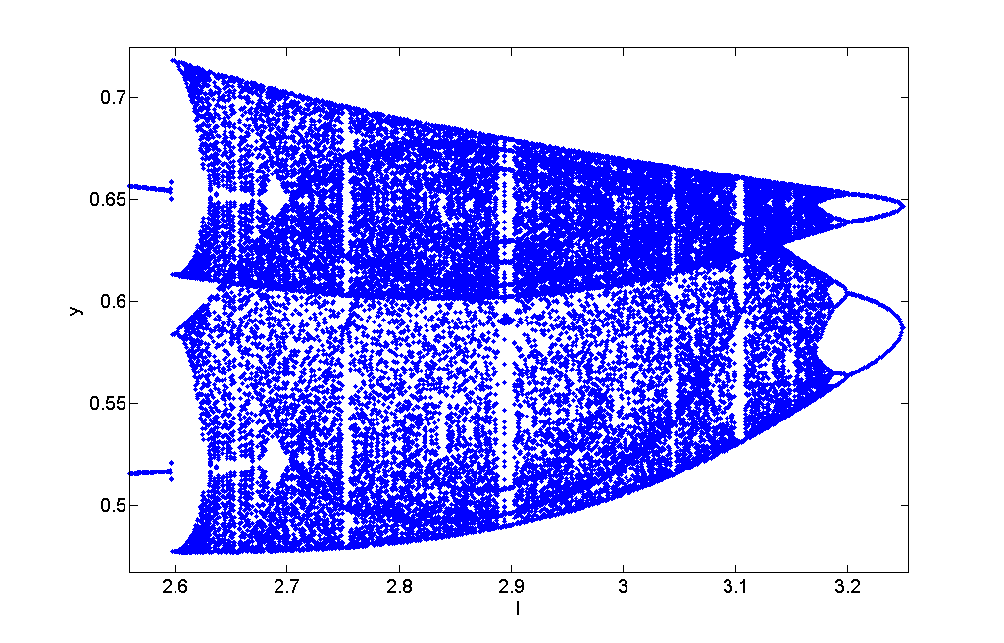

Figure 63: z vs. I bifurcation diagram for b = 3.045 and initial condition P0.

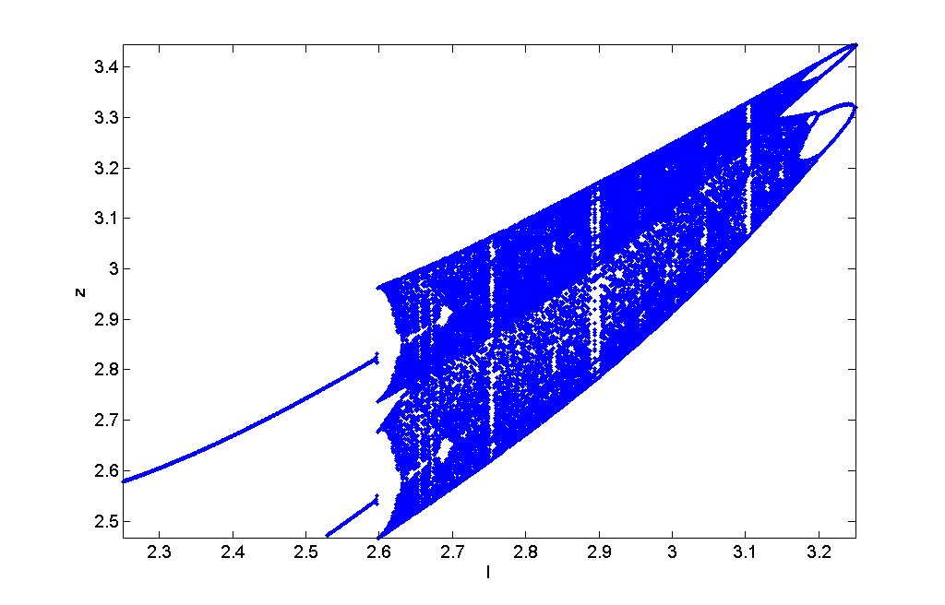

References:

1. Gonzalez-Miranda, J. M. (2007) Complex Bifurcation Structure in the Hindmarsh-Rose Neuron Model, International Journal of Bifurcation and Chaos, Vol 17, No 9, 3071-3083.
2. Hindmarsh J. L., and Rose R. M. (1984) A model of neuronal bursting using three coupled first order differential equations. Proc. R. Soc. London, Ser. B 221:87–102.
3. Linaro D., Poggi, T., and Storace, M. (2010) Experimental bifurcation diagram of a circuit-implemented neuron model, Phys Lett. A, 374, 4589-4593.
4. Rech P. C. (2011) Dynamics of a neuron model in different two-dimensional parameter-spaces, Phys. Lett. A, 375, 1461-1464.
5. Storace M., Linaro D., and de Lange E. (2008) The Hindmarsh–Rose neuron model: Bifurcation analysis and piecewise-linear approximations, Chaos 18, 033128, DOI: 10.1063/1.2975967.