# Lab 4: Vulnerability Analysis and Pen Testing

## A Challenge

Our challenge is to perform a vulnerability analysis for **MyCorp Incorp**, where each of you will be allocated a network and hosts to configure and get on-line (Figure 1). For this you will be allocated your own network which you can access from the vCenter Cloud infrastructure (vSoC.napier.ac.uk). Table 1 outlines your challenges and how you might achieve them. You have a **pfSense firewall**, a Linux host, and a Windows host to achieve your objectives.

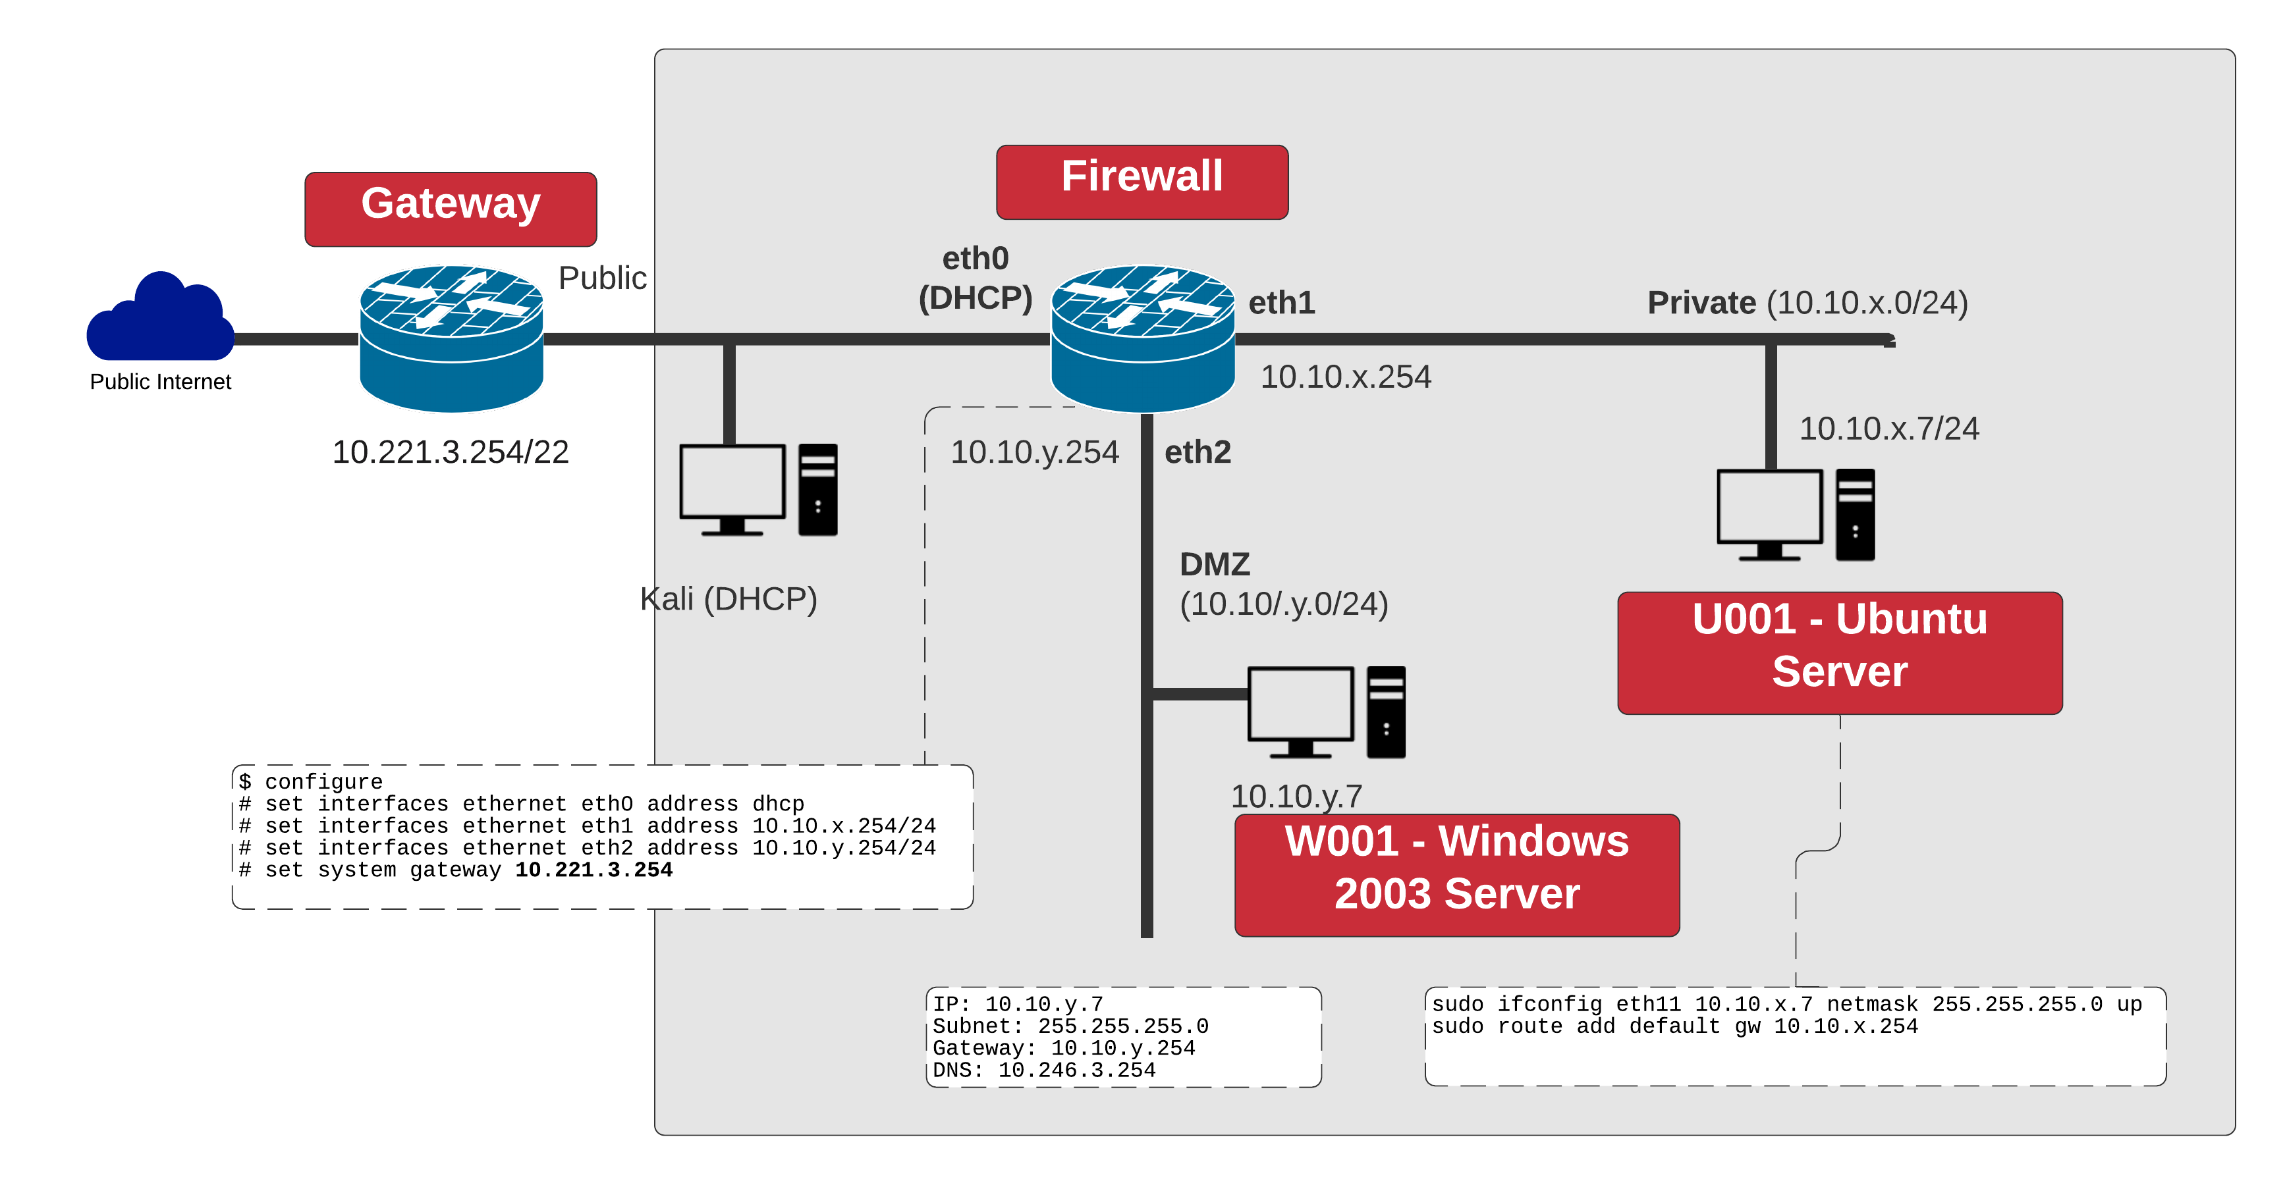

**Figure 1:** My Corp architecture

**Table 1:** Your challenges (**to be completed at the end of the lab**)

|  |  |  |  |
| --- | --- | --- | --- |
| **Challenge** | **Description** | **How will I do this?** | **Completed** |
| **1** | Setup Pfsense and the hosts so that you can connect all the required hosts. | Successful pings. |  |
| **2** | You should be able to discover the hosts on all your networks, and the services on hosts in your own network (DMZ and LAN)  **Test:** List the hosts | Run NMAP with a range of options, including –sP (to perform a host scan), and -sS (to perform a service scan on a host). |  |
| **3** | You should be able to discover the operating system of the hosts on your network (DMZ and LAN)  **Test:** List the operating systems. | Run NMAP with the –O flag. |  |
| **4** | You should be able to discover the Web services that are running and their version.  **Test:** List the Web services. | Run NMAP with the –sV flag. |  |
| **5** | You should be able to craft network packets which can exercise servers and the firewall.  **Test:** Use hping to assess response. | Run hping with various flags. |  |
| **6** | You should be able to setup basic IDS rules.  **Test:** Use Snort to detect simple network events. | Run Snort for detection. |  |

## B Setting up the network

In this lab we will connect multiple firewalls to the main gateway, and be able to complete the challenges in Table 1. You will be given two things:

Network Allocation: A

<https://asecuritysite.com/csn09112/prep>

Demo: <https://youtu.be/1wn2io8EWvs>

User logins: Ubuntu (User: napier, Password: napier123), Windows: (User: Administrator, Password: napier), Vyatta (User: vyatta, Password: vyatta), pfsense (User: admin, Password: pfsense), Metasploitable (User: user, Password: user), Kali (User: root, Password: toor).

## C Opening the firewall

We will be testing from the LAN network to the DMZ, and vice-versa. First setup your network, and **open up** TCP, UDP and ICMP from the DMZ to the LAN network.

|  |  |  |
| --- | --- | --- |
| **From → To** | **Command** | **Observation** |
| **LAN to DMZ** | **ping 10.10.y.7**  **ping 10.10.y.254**  Try Web browser to 10.10.y.7 | Do you have connectivity from LAN to DMZ: [Yes] [No] |
| **DMZ to LAN** | **ping 10.10.x.7**  **ping 10.10.x.254**  Try Web browser to 10.10.x.7 | Do you have connectivity from DMZ to LAN: [Yes] [No] |

## D Identifying Services

Within a network infrastructure we have services which run on hosts. These services provide a given functionality, such as for sending/receiving email, file storage, and so on.

|  |  |  |
| --- | --- | --- |
| **From → To** | **Command** | **Observation** |
| **DMZ** | On your Windows host, run the command:  netstat –a  and outline some of the services which are running on your host (define the port number and the name of the service and only pick off the LISTENING status on the port). | Outline some of the services which are running on your host (define the port number and the name of the service): |
| **LAN** | For the Ubuntu Virtual Machine, and run the command:  netstat –l. | Outline some of the services which are running on your host (define the port number and the name of the service): |
| **DMZ** | Next we will determine if these services are working. There should be a Web server working on each of the virtual machines (Ubuntu and Windows 2003), so from the Windows host and using a Web browser, access the home page:  [http://10.10.x.7](http://172.16.x.7) | Is the service working: [Yes] [No] |
| **LAN** | From Ubuntu, access the Web server at:  [http://10.10.y.7](http://172.16.y.7) | Is the service working: [Yes] [No] |
| **LAN** | Next we will determine if these services are working using a command line. From your UBUNTU host, undertake the following:  telnet 10.10.y.7 80  then enter: GET / | Outline the message that is returned: |
| **DMZ** | Repeat the previous example from the WINDOWS host:  telnet 10.10.x.7 80 |  |
| **DMZ** | There should be an FTP server working on Ubuntu and Windows 2003. From WINDOWS, access the FTP server on the UBUNTU server:  telnet 10.10.x.7 21  then enter:  USER napier  PASS napier123  QUIT | Outline the messages that you received:  What happens to each of these when you try with an incorrect username and password: |
| **LAN** | From UBUNTU access the WINDOWS host with  telnet 10.10.x.7 21  then enter:  USER Administrator  PASS napier  QUIT | Outline the messages that you received:  What happens to each of these when you try with an incorrect username and password: |
| **DMZ** | On the UBUNTU instance you will see that the **VNC** service is running, which is the remote access service. From your WINDOWS host, access the VNC service using a VNC client, and see what happens. | What does this service do: |
| **DMZ** | Next we will assess the SMTP service running on the WINDOWS virtual machine. From your UBUNTU machine console run a service to access SMTP:  telnet 10.10.y.7 25  Table 1 outlines the commands to use. | On the WINDOWS virtual machine, go into the C:\inetpub\mailroot\queue folder, and view the queued email message.  Was the mail successfully queued? If not, which mail folder has the file in?  Outline the format of the EML file? |

**Table 1:** SMTP commands

220 napier Microsoft ESMTP MAIL Service, Version: 6.0.3790.3959 ready at Sun, 2 Dec 2009 21:56:01 +0000

**help**

214-This server supports the following commands:

214 HELO EHLO STARTTLS RCPT DATA RSET MAIL QUIT HELP AUTH TURN ETRN BDAT VRFY

**helo me**

250 napier Hello [10.10.75.1]

**mail from: email@domain.com**

250 2.1.0 email@domain.com....Sender OK

**rcpt to: fred@mydomain.com**

250 2.1.5 fred@mydomain.com

**Data**

354 Start mail input; end with <CRLF>.<CRLF>

**From: Bob <bob@test.org>**

**To: Alice <alice@test.org >**

**Date: Sun, 20 Dec 2013**

**Subject: Test message**

**Hello Alice.**

**This is an email to say hello**

**.**

250 2.6.0 <NAPIERMp7lzvxrMVHFb00000001@napier> Queued mail for delivery

## E Enumeration – Host scan

**Nmap** is one of the most popular network scanning tools. It is widely available, for Windows and Linux/Unix platforms, and has both a Command Line Interface (CLI) and a Graphical User Interface (GUI).

|  |  |  |
| --- | --- | --- |
| **From → To** | **Command** | **Observation** |
| **LAN to WAN** | **sudo nmap –sP –r 10.221.0.0/24** | Which hosts are on-line: |
| **LAN to DMZ** | **sudo nmap –sP –r 10.10.y.0/24** | Which hosts are on-line: |
| **DMZ to LAN** | **nmap –sP –r 10.10.x.0/24** | Which hosts are on-line: |
| **LAN to DMZ** | Run Wireshark on host in LAN, and run:  **sudo nmap –sP –r 10.10.y.0/24** | Which transport layer protocol does NMAP use to discover the host:  [ICMP] or [ARP] |
| **LAN to LAN** | Run Wireshark on host in LAN, and run:  **sudo nmap –sP –r 10.10.x.0/24** | Which transport layer protocol does NMAP use to discover the host:  [ICMP] or [ARP] |

## F Enumeration - Operating System Fingerprinting

**Enumeration** is the gathering of information about target hosts. After discovering live target systems, we want to identify which machines are running which OSs. A useful feature of **nmap**, is determining the operating system of hosts on the network. It performs active OS fingerprinting by sending packets to the target system.

|  |  |  |
| --- | --- | --- |
| **From → To** | **Command** | **Observation** |
| **LAN to DMZ** | Perform an OS Fingerprint Scan on some of the hosts discovered on the network, using a command such as:  **sudo nmap –O 10.10.y.0/24** | Which operating systems does it return: |
| **DMZ to LAN** | Perform an OS Fingerprint Scan on some of the hosts discovered on the network, using a command such as:  **nmap –O 10.10.x.0/24** | Which operating systems does it return: |

## G Enumeration – Application Fingerprinting

**Application Fingerprinting** or **Banner Grabbing** covers techniques to enumerate OSs and Applications running on target hosts. An attacker or security tester would be specifically looking for versions of applications and operating systems which have vulnerabilities. **Nmap** can be used to check applications and versions for network services running on the target for the open ports it finds during a port scan.

|  |  |  |
| --- | --- | --- |
| **From → To** | **Command** | **Observation** |
| **LAN to DMZ** | Perform an application and version scan for networked services:  sudo nmap –sS 10.10.y.7/24 | Which services are running on the Windows host: |
| **DMZ to LAN** | Perform an application and version scan for networked services:  nmap –sS 10.10.x.7/24 | Which services are running on the Linux host: |
| **LAN to DMZ** | Scan the Web server in the DMZ for its version:  sudo nmap –sV 10.10.y.7/24 –p 80 | Which Web server type is being used: |
| **DMZ to LAN** | Scan the Web server in the LAN for its version:  nmap –sV 10.10.x.7/24 –p 80 | Which Web server type is being used: |

**Telnet** is another tool commonly used for banner grabbing. Once open ports have been found using a scanner, Telnet can be used to connect to a service and return its banner.

|  |  |  |
| --- | --- | --- |
| **From → To** | **Command** | **Observation** |
| **DMZ to LAN** | Connect to port 80, with:  telnet 10.10.x.7 80  and then send the HTTP OPTIONS command to the web server:  OPTIONS / HTTP/1.0 | What is returned and how can this be used to fingerprint the WebServer?  Which WebServer is running and which version? |
| **DMZ to LAN** | Similarly, other HTTP commands such as HEAD (get a HTML page header) and GET (get the whole HTML page) can be used to footprint a web server. Try the following and observe:  HEAD / HTTP/1.0  GET / HTTP/1.0 | What do you observe from using these HTTP requests: |

## H Network Packet Crafting and DoS - Hping

Hping is used by an intruder to craft network packets which can look to exploit a system. For example, an intruder might send in a network packet which has all the TCP flags set in order to exploit a weakness in the system. For all of the following, within the UBUNTU virtual instance, open two Terminal windows and in one capture your data packets with.

|  |  |  |
| --- | --- | --- |
| **From → To** | **Command** | **Observation** |
| **LAN to DMZ** | **On UBUNTU capture packets with:**  **sudo tcpdump -i eth11**  Start Wireshark on the WINDOWS.  Next go to your UBUNTU virtual machine, and run the command of:  **sudo hping 10.10.y.7** | Let it run for a few seconds, and the stop it with the Ctrl-C keystroke. Next go back to your WINDOWS instance and stop the trace. What can you observe from the trace:  Which TCP ports have been used:  Why is there no reply? |
| **LAN to DMZ** | Investigate the following:  **sudo hping –S 10.10.x.7 –p 80** | How might an intruder use this command: |
| **LAN to DMZ** | Investigate the following:  **sudo hping – 10.10.x.7 –1** | How might an intruder use this command: |
| **LAN to DMZ** | View the options for hping with **hping –help**, and create a scan with a spoof address of 10.0.0.1. | What can you identify on the scanned host: |

## I Network Scanning Detection, using an IDS

Snort is one of the most popular intrusion detection systems, where an agent is used to detect network threats.

|  |  |  |
| --- | --- | --- |
| **From → To** | **Command** | **Observation** |
| **LAN** | From UBUNTU, run the **Wireshark** packet sniffer with the command:  **sudo wireshark &** |  |
| **DMZ** | Basic Host Discovery can beperformed using ICMP or ARP traffic, typically with tools such as **ping** and **arping**. This type of active network scanning is easy to detect using an Intrusion Detection System (IDS), such as Snort.  From WINDOWS2003, create a folder named *MYSNORT* and create a **snort detection rules file** in this folder named **icmp.rules**, and add the following snort variables, and detection rule:  alert icmp any any -> any any (msg:"ICMP ping"; sid:999) |  |
| **DMZ** | Run Snort on WINDOWS with:  snort -c c:\MYSNORT\icmp.rules -i 1 -p -l c:\MYSNORT -K ascii |  |
| **LAN to DMZ** | From UBUNTU, **ping** the WINDOWS2003 VM. | Did Snort detect the pings from UBUNTU? |
| **LAN and DMZ** | Create a rule on UBUNTU and also on WINDOWS2003 which will detect an initial Telnet connection and the end of it? | Did it detect the start and end of the connection? |
| **LAN to DMZ** | Then from UBUNTU, perform an ICMP **Host Scan** against the WINDOWS2003 VM, using **nmap** with  nmap –PE *10.10.y.7* | Did Snort detect the **Host Scan** from UBUNTU? |
| **DMZ** | Scanningspecific hosts to find theservicestheyare running is another common technique. This can be detected network auditing systems, by collecting traffic streams together and analysing them for scanning packets.  From WINDOWS2003, create a new IDS detection rules file call **portscan.rules** which will detect network scanning traffic, and add:  preprocessor sfportscan: proto { all } scan_type { all } sense_level { high } logfile { portscan.log } |  |
| **LAN to DMZ** | Run Snort with the detection portscan rules on WINDOWS with:  **snort -c c:\mysnort\portscan.rules -i 1 -p -l c:\mysnort -K ascii**  and from UBUNTU, perform a **Port Scan** on WINDOWS using:  **nmap** ***10.10.y.7***. | Did Snort detect the port scan:  What type of port scan has been performed (which protocol is being used): |

## J Enumeration – Password Cracking with Hydra

**NOTE: Hydra should only be used on private networks. Do not use on any systems on the Internet.**

|  |  |  |
| --- | --- | --- |
| **From → To** | **Command** | **Observation** |
| **LAN** | Create a new user **fred** on the FTP server in UBUNTU, using (check by viewing the **/etc/passwd file**):  **sudo useradd fred -p fredpass -d /home/fred -s /bin/false –m**  sudo passwd fred | View the password file with:  sudo cat /etc/shadow  Can you locate the fred user: |
| **DMZ to LAN** | Next try go to WINDOWS and log into the TELNET server with the username and password that you have created. Use:  telnet 10.10.x.7  USER fred  PASSWORD *password*  Next try to crack the TELNET password by going to WINDOWS, and running **hydra**, such as:  C:\hydra> hydra -L user.txt -P pass.txt *10.10.x.7* telnet | What modifications were required to detect the user fred: |
| **DMZ to LAN** | Go UBUNTU, and run Wireshark, and rescan with Hydra, and capture the trace. Now find the successful login from the trace. | Can you find the network packet at which Hydra cracked the TELNET password: |