NOTE:

Band6 = observation (the reference)

Model480_tw1100 = Should be centrally too bright compared to reference

Model480_tw400_x0 = Correct model, should look like band6

Model480_tw400_obs-mod = residual. It is the observation – the good model, so it should look like “noise” or “nothing”.

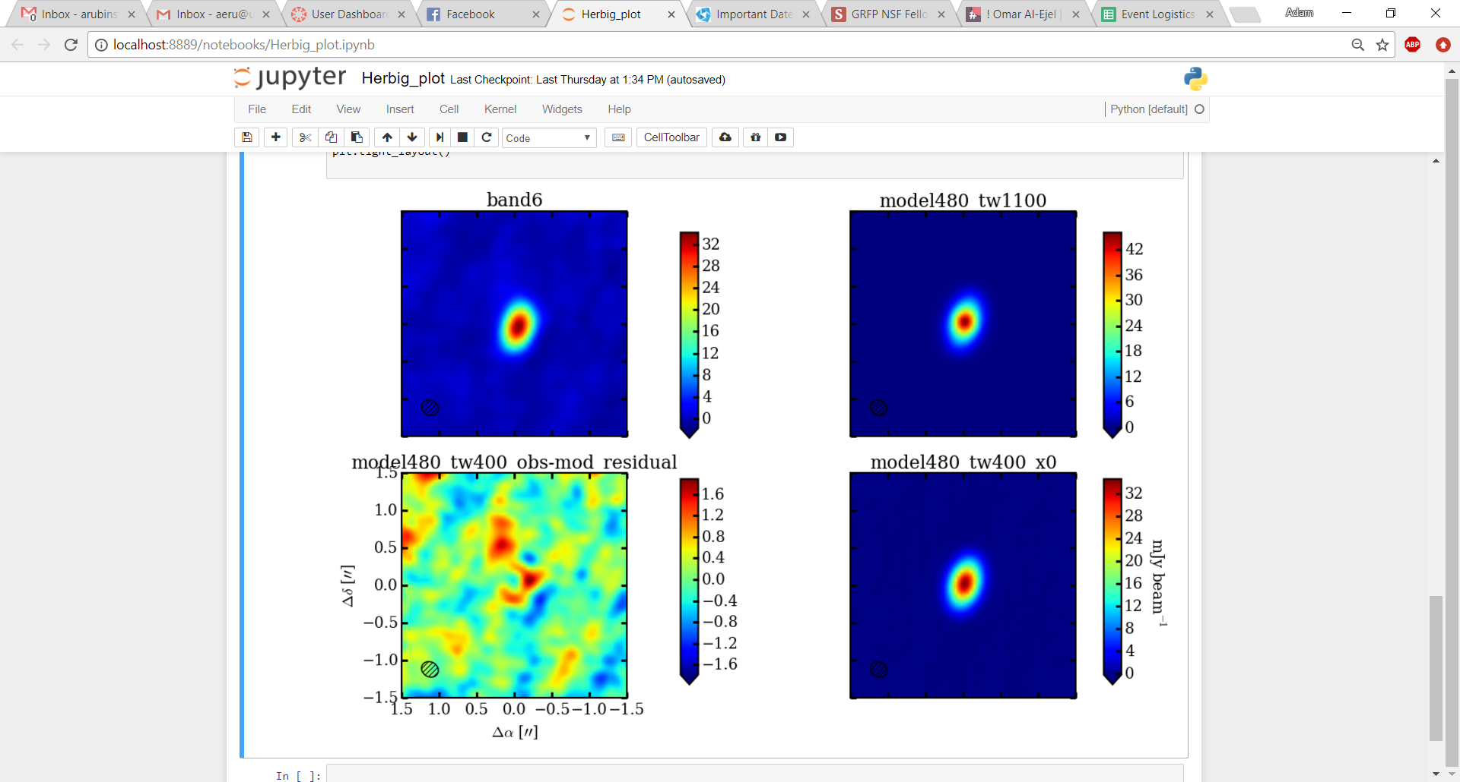JET

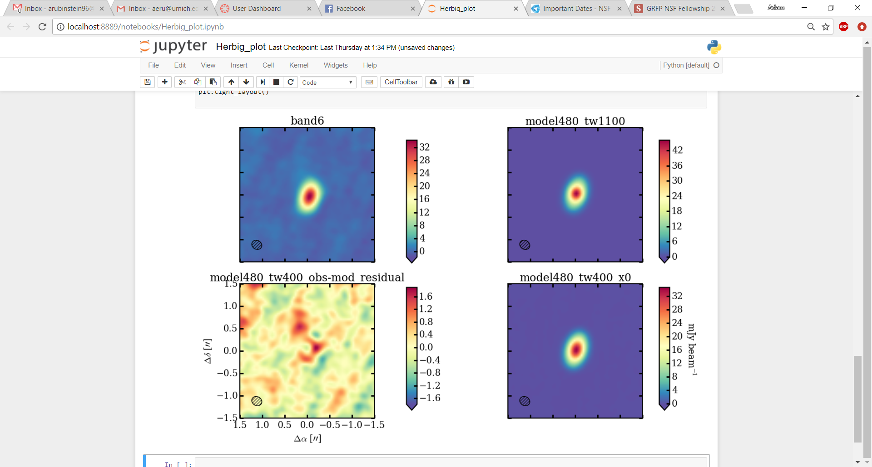[spectral]

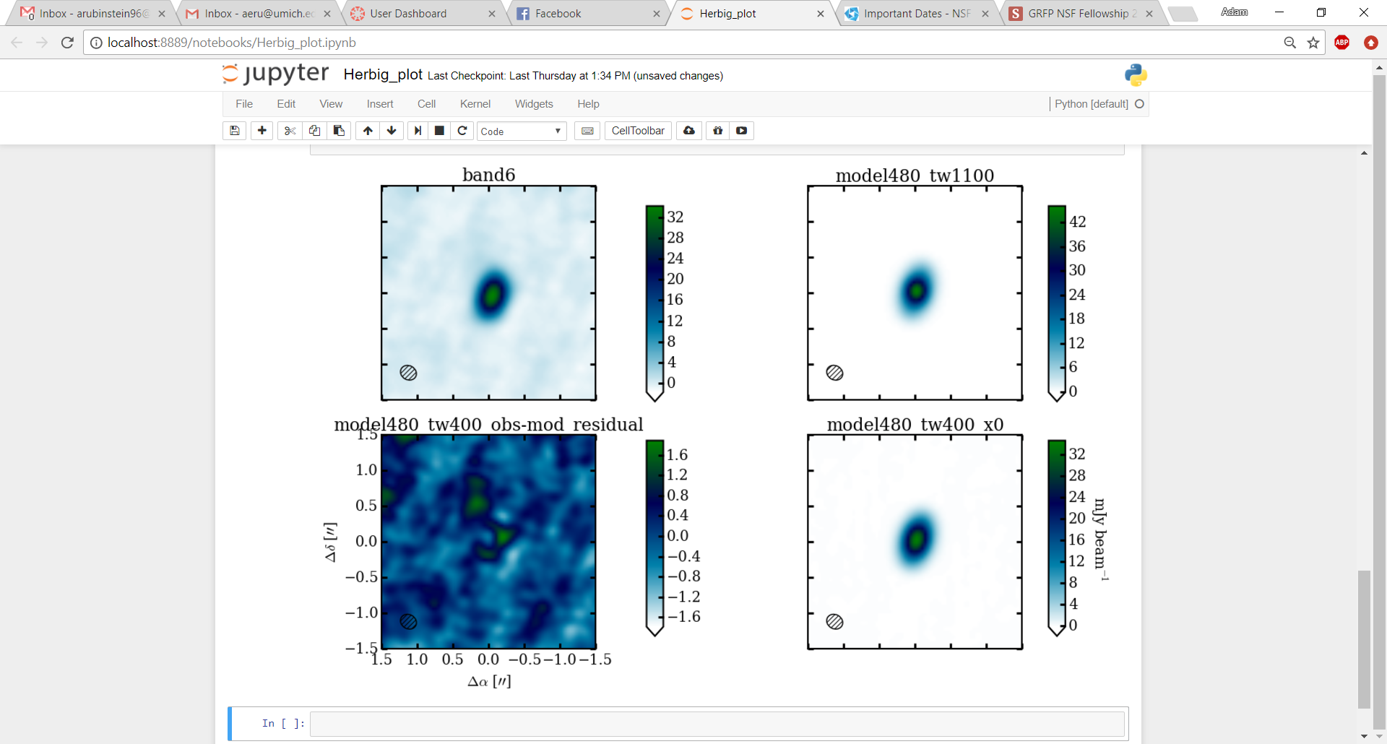OCEAN

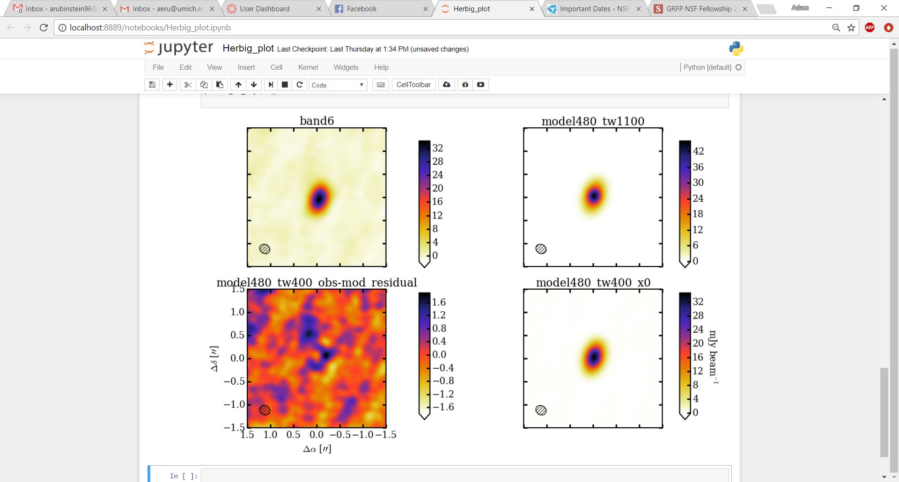[CMR]

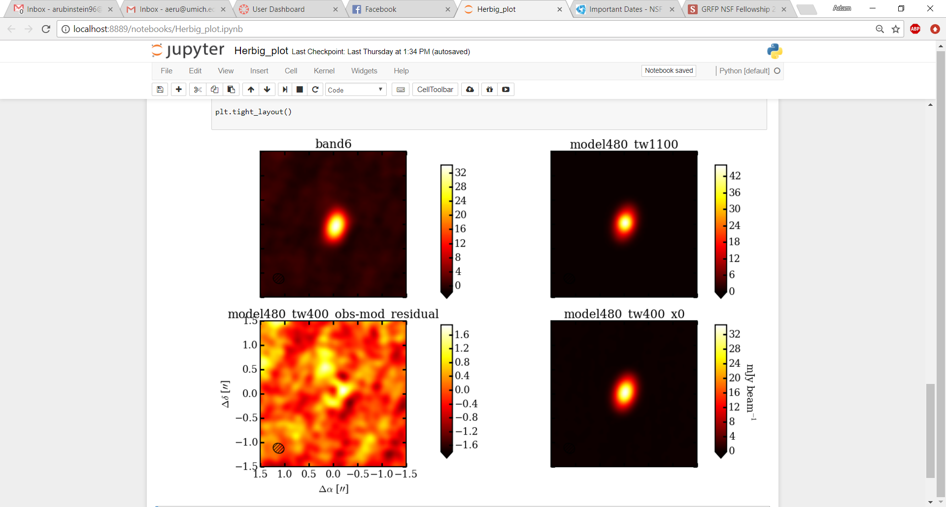[hot]

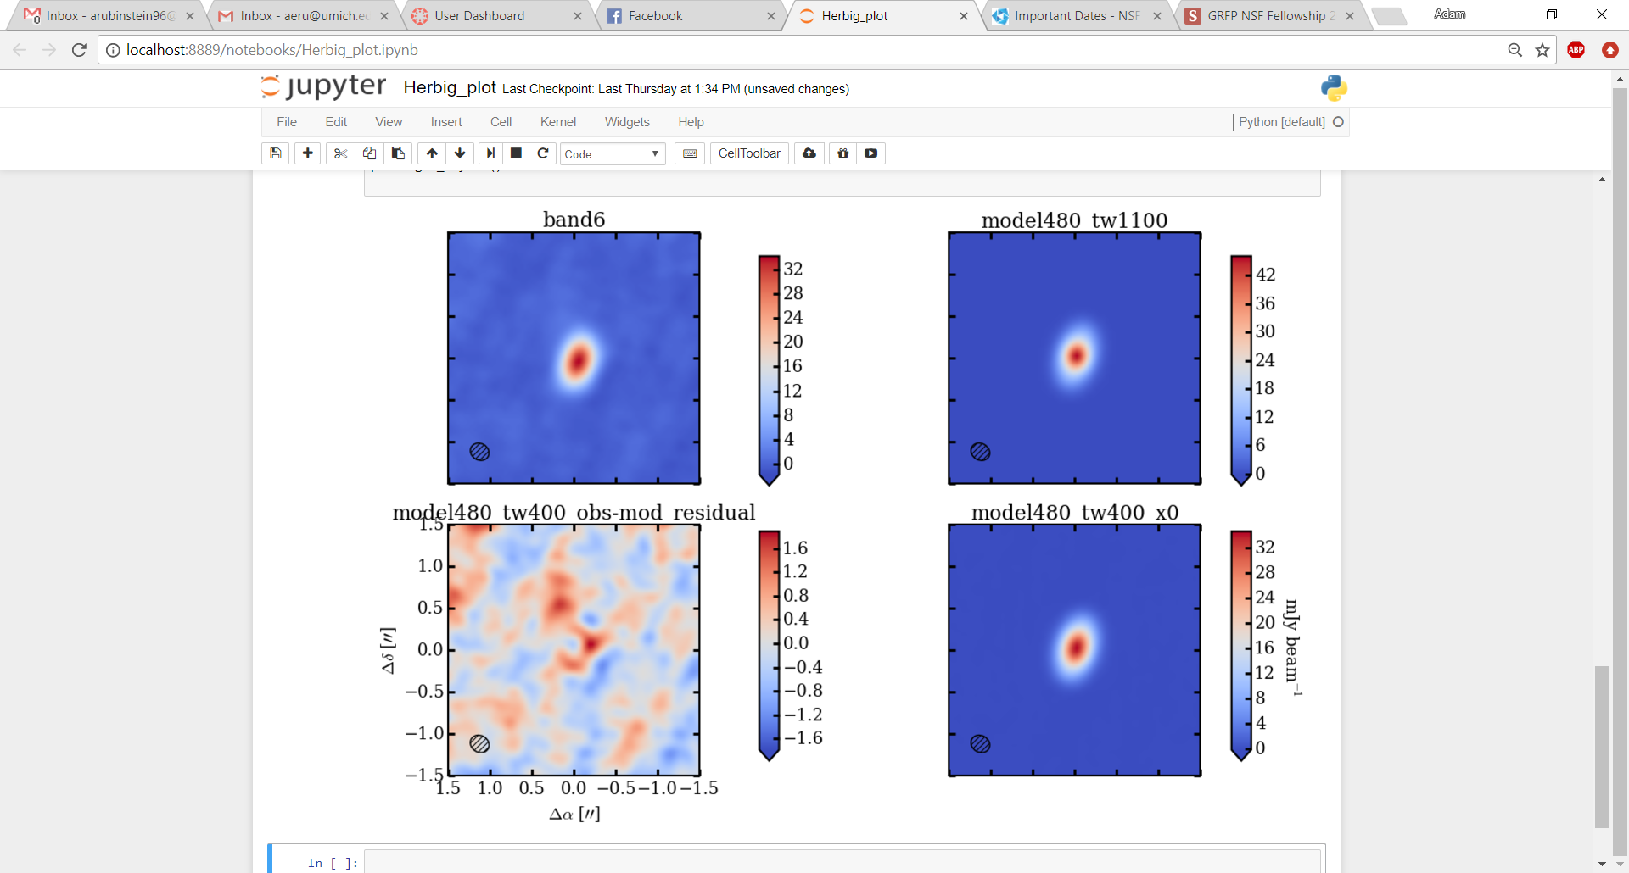[coolwarm]

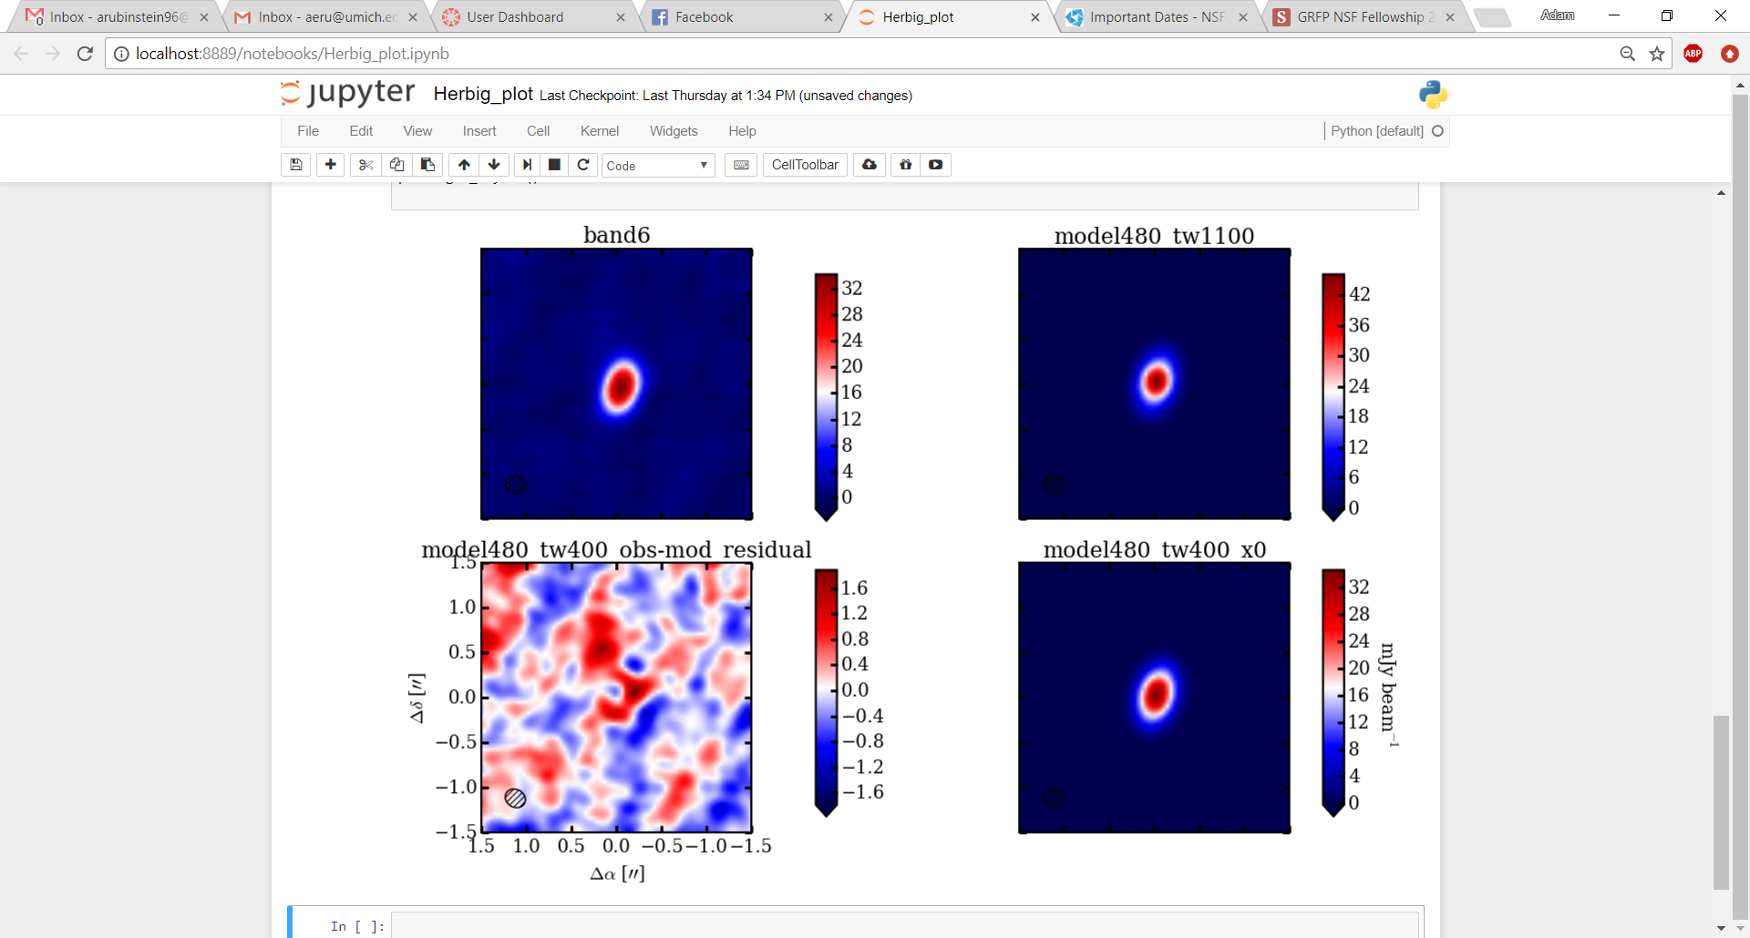[seismic]