|  |  |
| --- | --- |
| **ID** | **SED Chi^2 (Ignoring IRS)** |
| 004 | 1047 |
| 025 | 2320.5 |
| 361 | 3612.92 |
| 403 | 1066 |
| 810 | 597 |
| 356 | 907 |

**Order:** Stats -> model descriptions -> radial profiles -> contour plots (same unit contour level) -> separate images for comparison (same data range) -> residual images

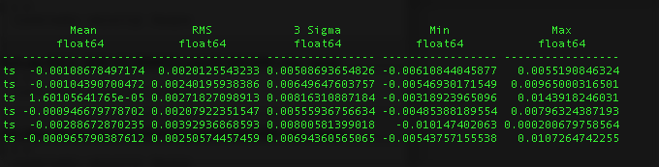

Job Number, amaxs, amaxw, epsilon, mstar, tstar, rstar, dist, mdot, mdotstar, tshock, alpha, mui, rdisk, temp, altinh, fracolive, fracpyrox, fracforst, fracent, lamaxb, d2g

361, 3, 1, 0.01, 1.957, 7580, 2.198, 150.1172854670921, 3e-08, 3e-08, 8000, 0.01, 0.58, 60, 1400, 1, 0.65, 0.3, 0, 0.05, '1mm', 0.0065

810, 100, 100, 0.01, 1.957, 7580, 2.198, 150.1172854670921, 3.75e-08, 3.75e-08, 8000, 0.01, 0.58, 60, 1400, 1, 0.65, 0.3, 0, 0.05, '1cm', 0.0065

356, 0.1, 4, 0.0001, 1.957, 7580, 2.198, 150.1172854670921, 8e-08, 8e-08, 8000, 0.01, 0.58, 60, 1600, 1, 0.65, 0.3, 0, 0.05, '1cm', 0.0065

25, 3, 1, 0.01, 1.957, 7580, 2.198, 150.1172854670921, 2.5e-08, 2.5e-08, 8000, 0.01, 0.58, 60, 1400, 1, 0.65, 0.3, 0, 0.05, '1mm', 0.0065

4, 1, 2, 0.001, 1.936, 7580, 2.13, 150.1, 3e-08, 3e-08, 8000, 0.01, 0.55, 70, 1500, 1, 0.65, 0.3, 0, 0.05, '1mm', 0.0065

403, 2.0, 1.0, 0.001, 1.936, 7580, 2.13, 150.1, 3.25e-08, 3.25e-08, 8000, 0.01, 0.58, 60, 1400, 1, 0.65, 0.3, 0, 0.05, '1mm', 0.0065

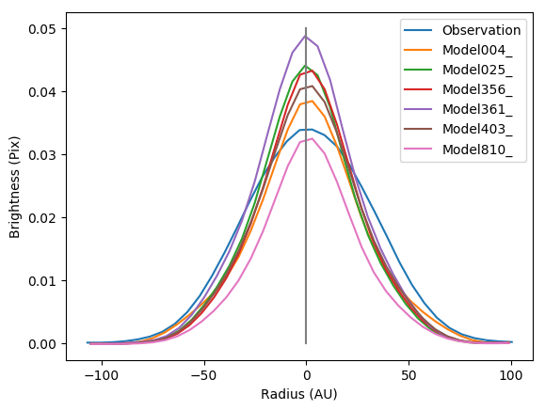[Radial Profile, Major Axis]

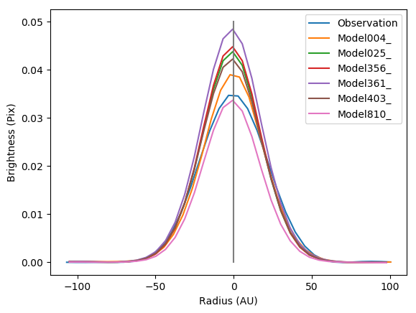[Radial Profile, Minor Axis]

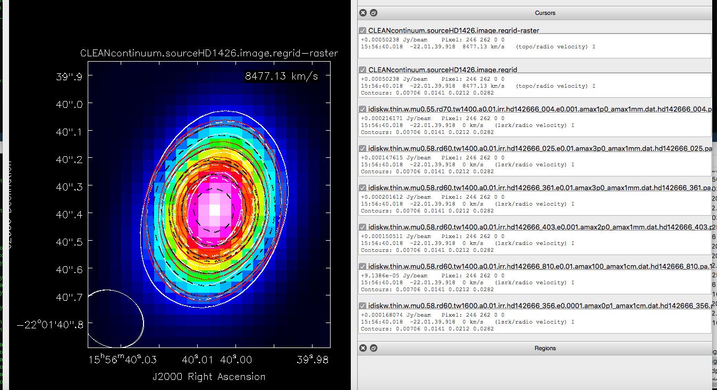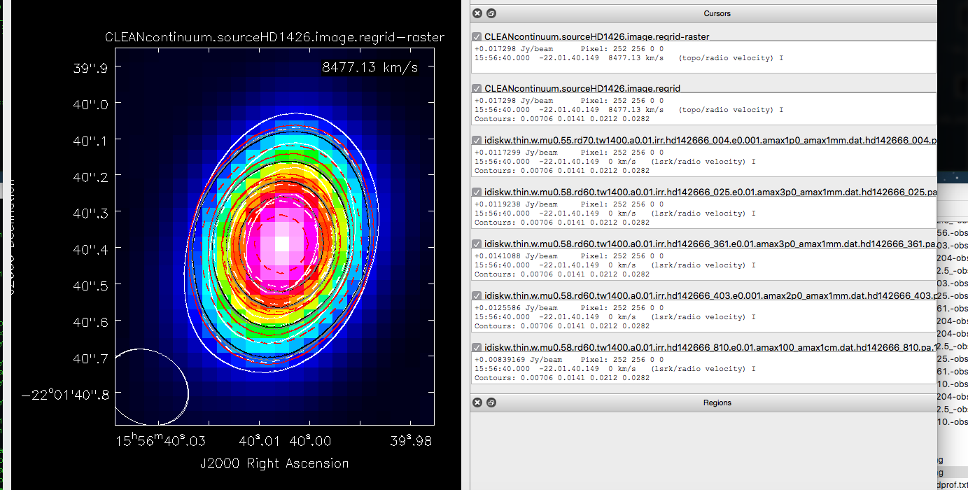

Outside to inside (by next page): Obs, 004, 403, 361, 025, 356, 810 [adjusting unit contour level]

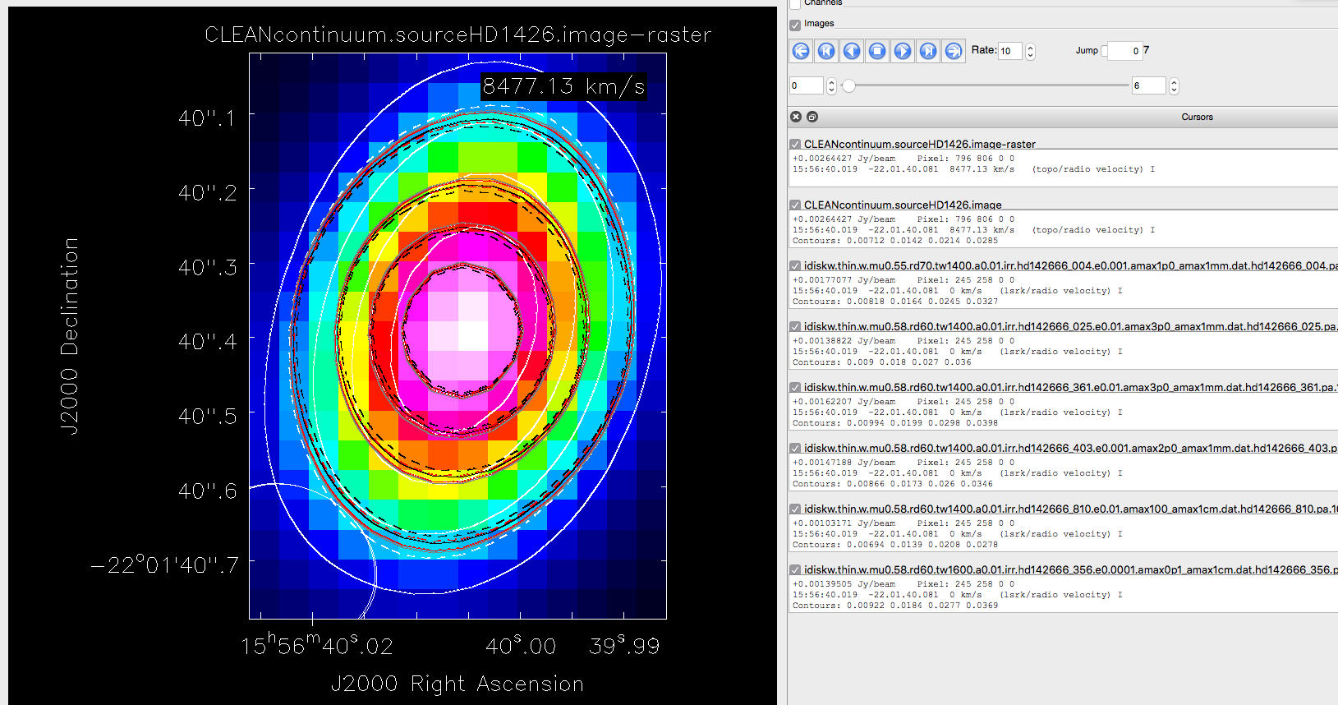

|  |
| --- |
| Solid White |
| Dashed White |
| Solid Black |
| Solid Red |
| Solid Grey |
| Dashed Black |
| Dashed Red |

The images that were scaled to the max and min of the observation are below:

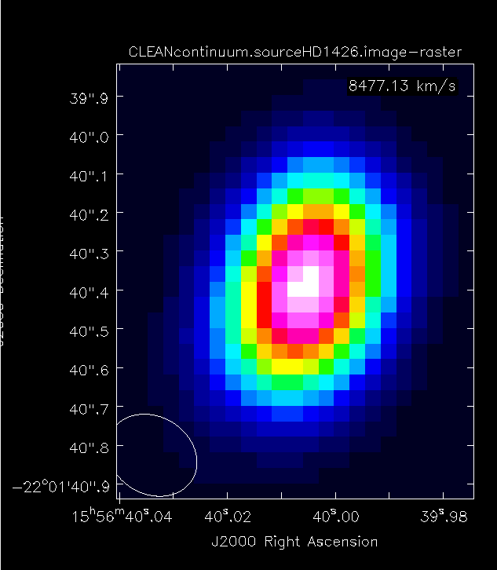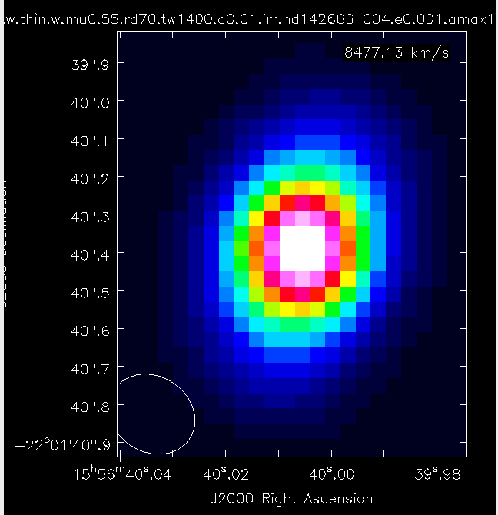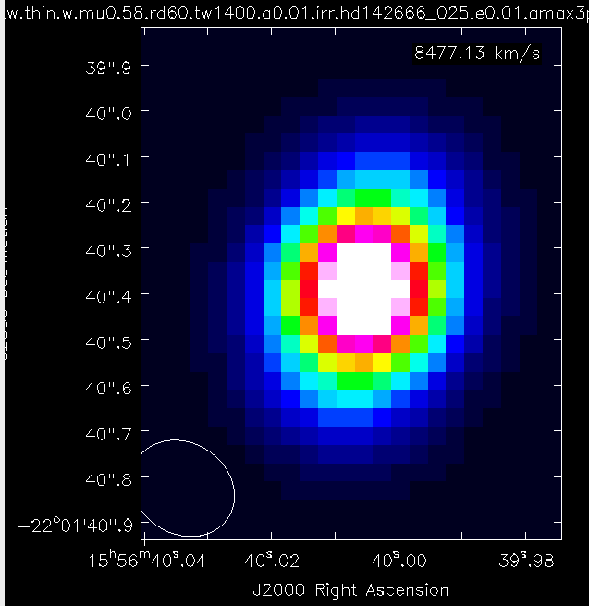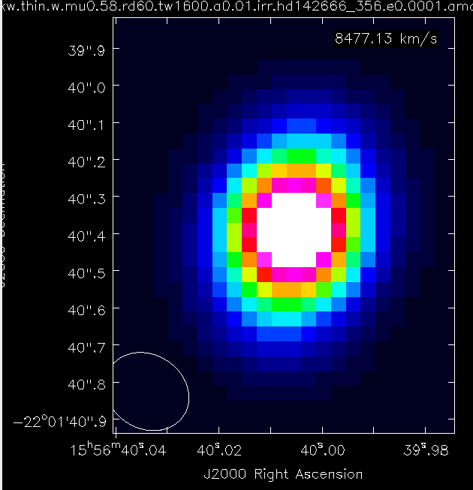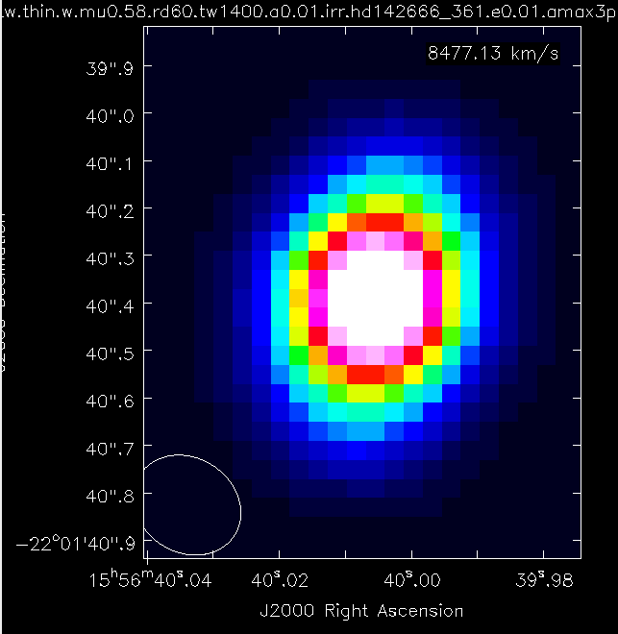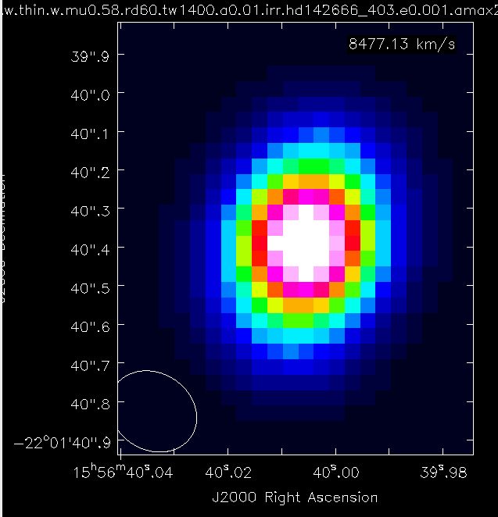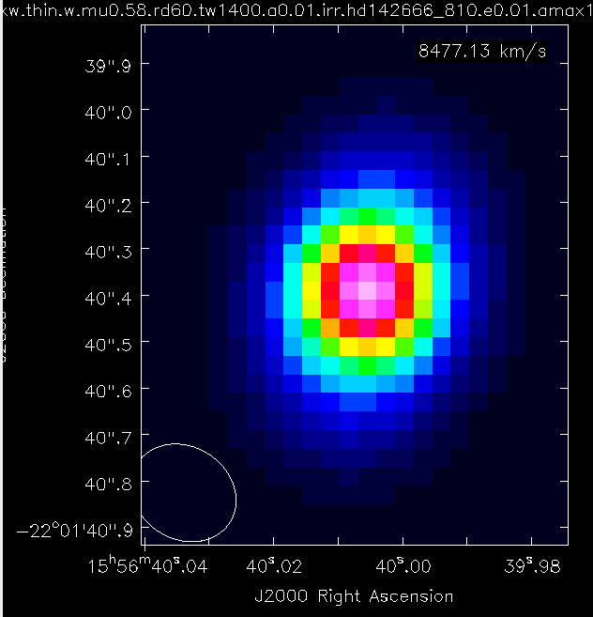

Lastly, there are the residuals…

They are all on the next page. The top left is unscaled (using the image’s own data range). The rest use that of the observation.

The order of the images by job number is:

|  |  |
| --- | --- |
| 004 | 025 |
| 361 | 353 |
| 403 | 810 |

Job Number, amaxs, amaxw, epsilon, mstar, tstar, rstar, dist, mdot, mdotstar, tshock, alpha, mui, rdisk, temp, altinh, fracolive, fracpyrox, fracforst, fracent, lamaxb, d2g

361, 3, 1, 0.01, 1.957, 7580, 2.198, 150.1172854670921, 3e-08, 3e-08, 8000, 0.01, 0.58, 60, 1400, 1, 0.65, 0.3, 0, 0.05, '1mm', 0.0065

810, 100, 100, 0.01, 1.957, 7580, 2.198, 150.1172854670921, 3.75e-08, 3.75e-08, 8000, 0.01, 0.58, 60, 1400, 1, 0.65, 0.3, 0, 0.05, '1cm', 0.0065

356, 0.1, 4, 0.0001, 1.957, 7580, 2.198, 150.1172854670921, 8e-08, 8e-08, 8000, 0.01, 0.58, 60, 1600, 1, 0.65, 0.3, 0, 0.05, '1cm', 0.0065

25, 3, 1, 0.01, 1.957, 7580, 2.198, 150.1172854670921, 2.5e-08, 2.5e-08, 8000, 0.01, 0.58, 60, 1400, 1, 0.65, 0.3, 0, 0.05, '1mm', 0.0065

4, 1, 2, 0.001, 1.936, 7580, 2.13, 150.1, 3e-08, 3e-08, 8000, 0.01, 0.55, 70, 1500, 1, 0.65, 0.3, 0, 0.05, '1mm', 0.0065

403, 2.0, 1.0, 0.001, 1.936, 7580, 2.13, 150.1, 3.25e-08, 3.25e-08, 8000, 0.01, 0.58, 60, 1400, 1, 0.65, 0.3, 0, 0.05, '1mm', 0.0065

