***Need to add on KK Oph

AK Sco (HIP 82747) = 2012.1.00496.S, band 6, from Sean Andrews AND 2012.1.00688.S, band 6, from John Carpenter

HD 31648 (MWC 480) = 2013.1.00226.S, band 6, from Karin Oberg

HD 98922 =

HD 104237 = 2013.1.00592.S, band 6, from Davide Fedele, AND 2015.1.01600.S, band 6, from Olja Panic

HD 141569 = 2013.1.00883.S, band 3, from Jessica Pericaud

HD 142666 = 2013.1.00498.S. band 6, from Laura Perez

HD 163296 = 2013.1.00527.S, band 8, from Mihkel Kama AND 2013.1.00226.S, band 6, from Karin Oberg AND 2013.1.00601.S, band 6, from Andrea Isella AND 2013.1.0053.S, band 7, from Christophe Pinte

HD 34282 =

CQ Tau = 2013.1.00498.S, band 6, from Laura Perez [also avail = 2011.0.00320.S, band 7, from Edwige Chapillon]

HD 36112 (MWC 758) = 2012.1.00725.S, band 7, from Andrea Isella

T Cha = 2015.1.00979.S, band 3, from Illaria Pascucci AND 2012.1.00182.S, band 7, from Joana Brown

The Images

**AK Sco**:

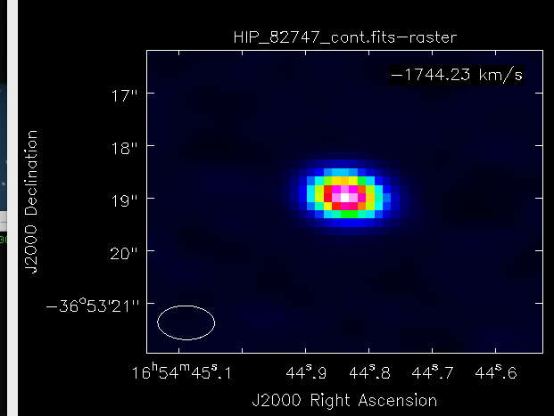

**HD 31648**:

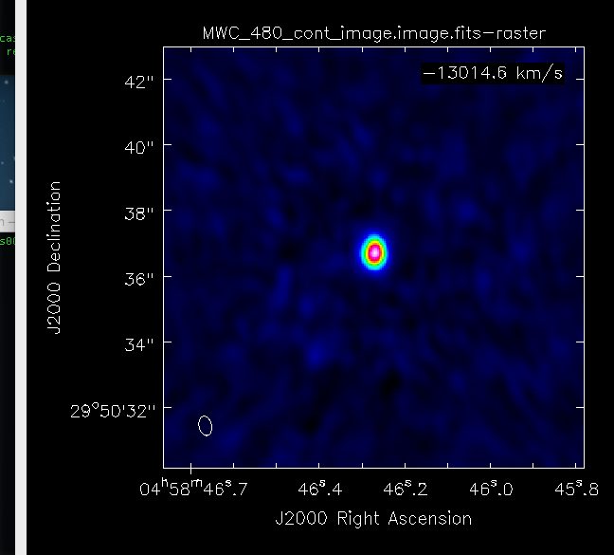

**HD 98922**:

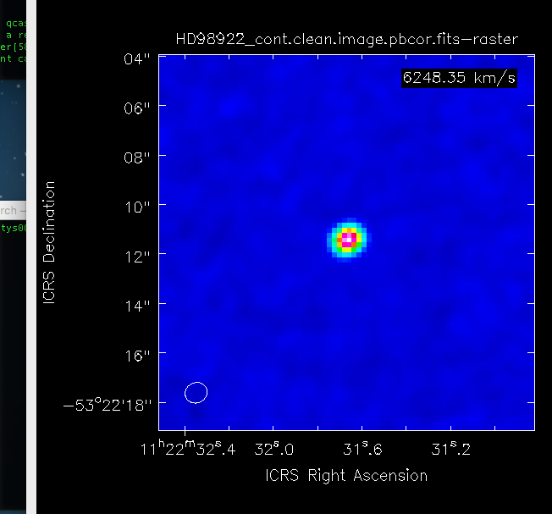

**HD 104237**:

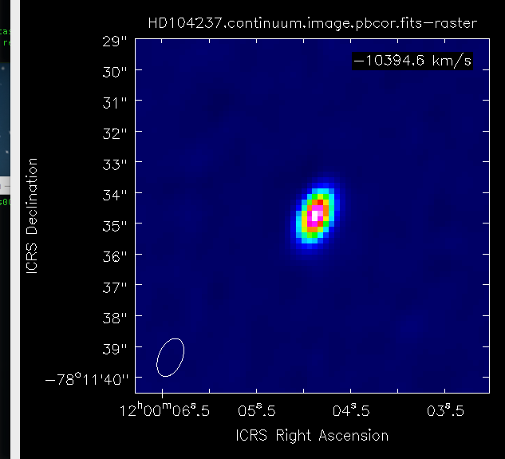

**HD 141569**:

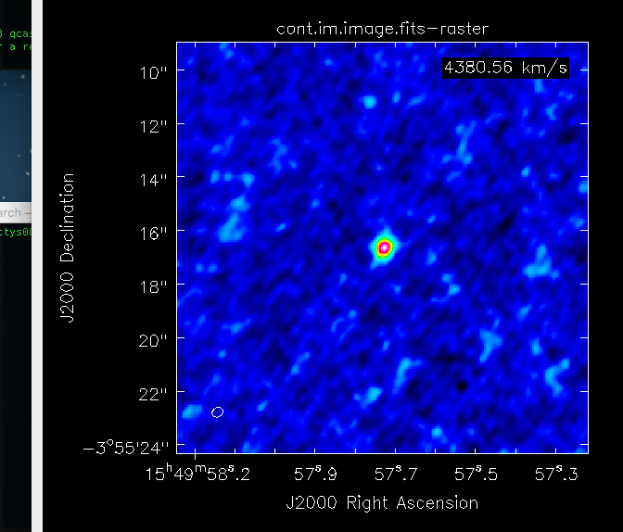

**HD 163296 (has four images):**

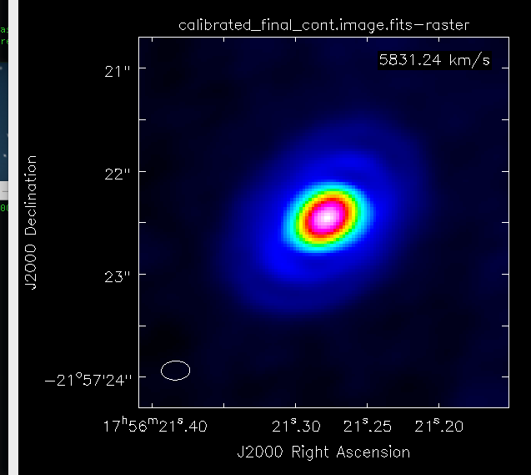

**HD 34282**:

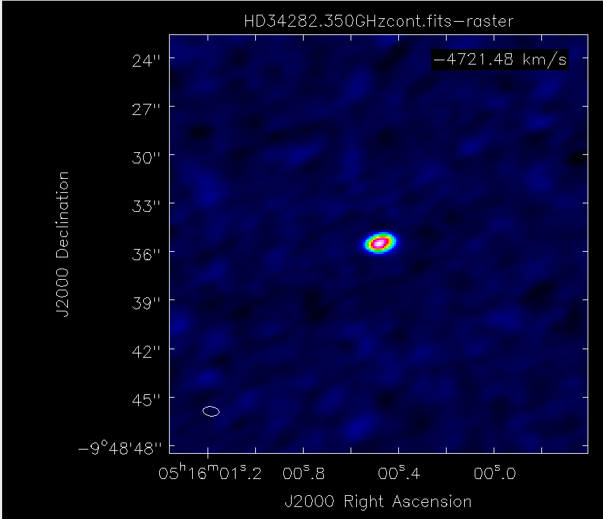

**CQ Tau**:

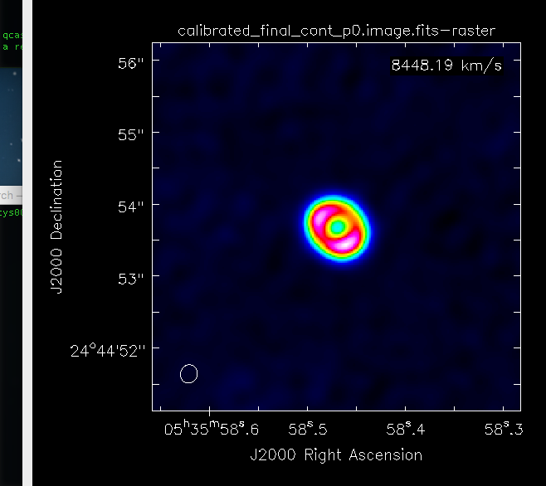

**HD 36112**:

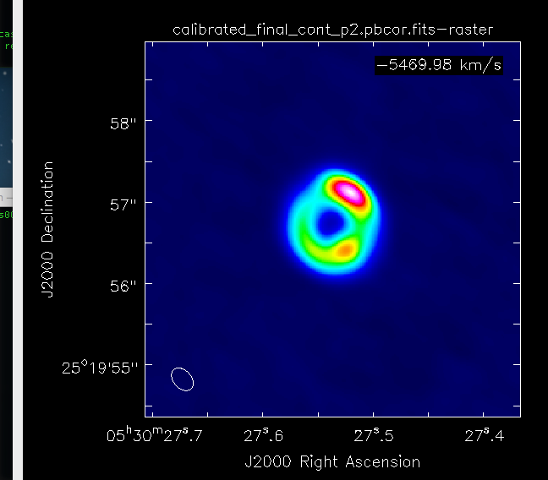

**T Cha** (has two images):

