3. Constraining mdot and using ALMA flux (updated SED, but image model too small with cm grains). First page = summary, details are on following pages.
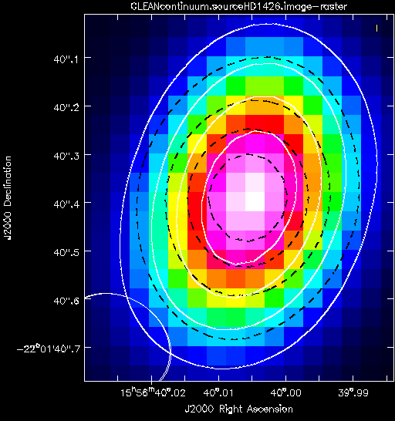

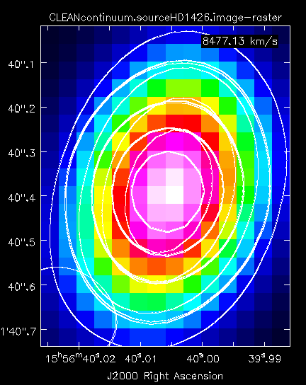[32][50]
Job Number, amaxs, amaxw, epsilon, mstar, tstar, rstar, dist, mdot, mdotstar, tshock, alpha, mui, rdisk, temp, altinh, fracolive, fracpyrox, fracforst, fracent, lamaxb, d2g
32, 0.1, 100, 0.0001, 1.936, 7580, 2.13, 150.1, 1e-07, 1e-07, 8000, 0.01, 0.58, 60, 1400, 1, 0.65, 0.3, 0, 0.05, '1cm', 0.0065
50, 0.25, 1.0, 0.0001, 1.936, 7580, 2.13, 150.1, 1e-07, 1e-07, 8000, 0.01, 0.58, 60, 1400, 1, 0.65, 0.3, 0, 0.05, '1cm', 0.0065

The grid was mdot = [1E-7, 1.48E-7, 1.86E-7]; amaxs=amaxsw=[0.1, 0.25, 1, 5, 10, 100];rd=60, mu=0.58. amaxb=[1cm, 1mm]

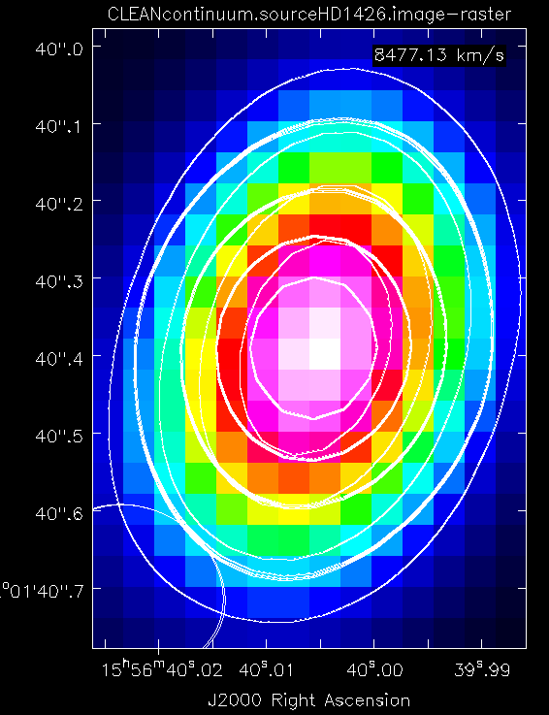[122]
[556] [060]

Job Number, amaxs, amaxw, epsilon, mstar, tstar, rstar, dist, mdot, mdotstar, tshock, alpha, mui, rdisk, temp, altinh, fracolive, fracpyrox, fracforst, fracent, lamaxb, d2g
122, 0.1, 4.0, 0.0001, 1.936, 7580, 2.13, 150.1, 1e-07, 1e-07, 8000, 0.01, 0.58, 60, 1400, 1, 0.65, 0.3, 0, 0.05, '1cm', 0.0065
556, 3.0, 2.0, 0.001, 1.936, 7580, 2.13, 150.1, 7.75e-08, 7.75e-08, 8000, 0.01, 0.58, 60, 1400, 1, 0.65, 0.3, 0, 0.05, '1cm', 0.0065
60, 0.1, 1.0, 0.0001, 1.936, 7580, 2.13, 150.1, 9.25e-08, 9.25e-08, 8000, 0.01, 0.58, 60, 1400, 1, 0.65, 0.3, 0, 0.05, '1cm', 0.0065

Consisted of 3 grids…
- Mdot Large -> mdot = [1E-7, 1.08E-7, 1.15E-7, 1.23E-7, 1.3E-7, 1.38E-7, 1.45E-7, 1.6E-7, 1.68E-7, 1.75E-7, 1.83E-7], amaxs = amaxsw=[0.1,0.25,1,2,3,4], amaxb=[1mm, 1cm]
- Mdot Small, eps = 0.0001 -> mdot=[2.5e-8, 3.25e-8, 4e-8, 4.75e-8, 5.5e-8, 6.25e-8,7e-8, 7.75e-8, 8.5e-8, 9.25e-8], amaxs = amaxsw=[0.1,0.25,1,2,3,4], amaxb=[1mm, 1cm]
- Mdot Small, eps = 0.001 -> mdot=[2.5e-8, 3.25e-8, 4e-8, 4.75e-8, 5.5e-8, 6.25e-8,7e-8, 7.75e-8, 8.5e-8, 9.25e-8], amaxs = amaxsw=[0.1,0.25,1,2,3,4], amaxb=[1mm, 1cm]

