4: Trying mdot between 2E-8 and 8E-8 with different amaxb, different rdisk (from ~70 to 300)
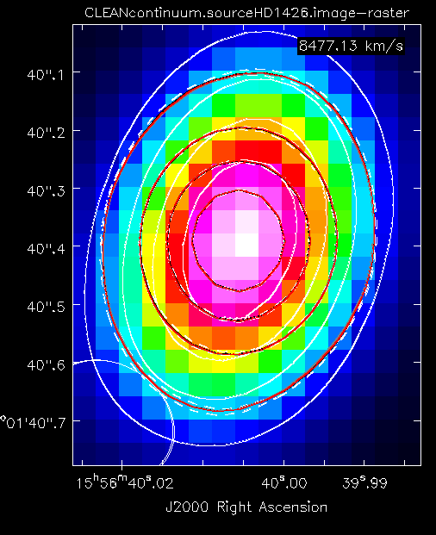
Here the inner dashed line = model 182, the outer dashed line = 192, the red line = 200 (15, 196 and black and gray, but they are basically on the red line)

Job Number, amaxs, amaxw, epsilon, mstar, tstar, rstar, dist, mdot, mdotstar, tshock, alpha, mui, rdisk, temp, altinh, fracolive, fracpyrox, fracforst, fracent, lamaxb, d2g
15, 0.25, 1.0, 0.001, 1.936, 7580, 2.13, 150.1, 3e-08, 3e-08, 8000, 0.01, 0.58, 75, 1400, 1, 0.65, 0.3, 0, 0.05, '1mm', 0.0065
182, 0.25, 1.0, 0.0001, 1.936, 7580, 2.13, 150.1, 7e-08, 7e-08, 8000, 0.01, 0.58, 100, 1400, 1, 0.65, 0.3, 0, 0.05, '1cm', 0.0065
192, 0.25, 1.0, 0.0001, 1.936, 7580, 2.13, 150.1, 8e-08, 8e-08, 8000, 0.01, 0.58, 85, 1400, 1, 0.65, 0.3, 0, 0.05, '1cm', 0.0065
196, 0.25, 1.0, 0.0001, 1.936, 7580, 2.13, 150.1, 8e-08, 8e-08, 8000, 0.01, 0.59, 68, 1400, 1, 0.65, 0.3, 0, 0.05, '1cm', 0.0065
200, 0.25, 1.0, 0.0001, 1.936, 7580, 2.13, 150.1, 8e-08, 8e-08, 8000, 0.01, 0.59, 72, 1400, 1, 0.65, 0.3, 0, 0.05, '1cm', 0.0065

The grid consisted of …
- An epsilon=0.0001 grid with 1 cm grains, amaxs=amaxw=[0.25,1], mdot=[4E-8, 5E-8, 6E-8, 7E-8, 8E-8], rd = [68,69,70,71,72], mu = [0.56, 0.57, 0.58, 0.59]
- Based on this, another with eps = [0.001, 0.0001], amaxs=0.25, amaxsw=1, amaxb = [1 cm, 1mm], mu=[0.58], rd=[75,77,80,83,85,90,100], mdot=[2E-8, 3E-8, 4E-8, 5E-8, 6E-8, 7E-8, 8E-8]
[15] [182] [192][196][200]

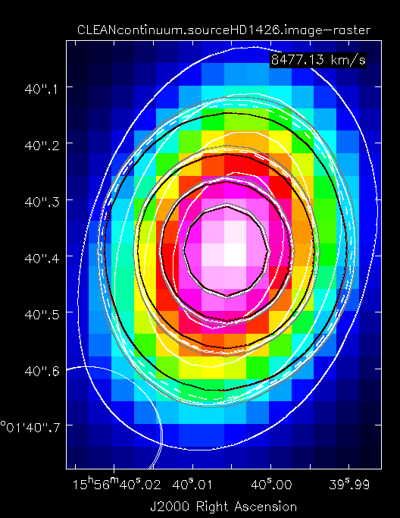
NOTE:
Red/black = rd300, gray = rd130, dashed = rd200 (this is b/c a combo of low mdot AND cm sized grains that still happen to fit the SED ALMA point)

Job Number, amaxs, amaxw, epsilon, mstar, tstar, rstar, dist, mdot, mdotstar, tshock, alpha, mui, rdisk, temp, altinh, fracolive, fracpyrox, fracforst, fracent, lamaxb, d2g
1, 0.25, 1.0, 0.001, 1.936, 7580, 2.13, 150.1, 2e-08, 2e-08, 8000, 0.01, 0.58, 130, 1400, 1, 0.65, 0.3, 0, 0.05, '1mm', 0.0065
28, 0.25, 1.0, 0.001, 1.936, 7580, 2.13, 150.1, 3e-08, 3e-08, 8000, 0.01, 0.58, 300, 1400, 1, 0.65, 0.3, 0, 0.05, '1cm', 0.0065
140, 0.25, 1.0, 0.0001, 1.936, 7580, 2.13, 150.1, 4e-08, 4e-08, 8000, 0.01, 0.58, 300, 1400, 1, 0.65, 0.3, 0, 0.05, '1cm', 0.0065
148, 0.25, 1.0, 0.0001, 1.936, 7580, 2.13, 150.1, 5e-08, 5e-08, 8000, 0.01, 0.58, 200, 1400, 1, 0.65, 0.3, 0, 0.05, '1cm', 0.0065
156, 0.25, 1.0, 0.0001, 1.936, 7580, 2.13, 150.1, 6e-08, 6e-08, 8000, 0.01, 0.58, 130, 1400, 1, 0.65, 0.3, 0, 0.05, '1cm', 0.0065

The grid consisted of…
- eps = [0.001, 0.0001], amaxs=0.25, amaxsw=1, amaxb = [1 cm, 1mm], mu=[0.58], rd=[130,150,180,200,230,250,300], mdot=[2E-8, 3E-8, 4E-8, 5E-8, 6E-8, 7E-8, 8E-8]

[1][28][140] [148][156]

