5: Trying mdots closer to 1E-7 with different amaxb, different rdisk. Note none with mm grains fit the ALMA flux, which means either lower mdot or lower rdisk would be needed to use mm grains.
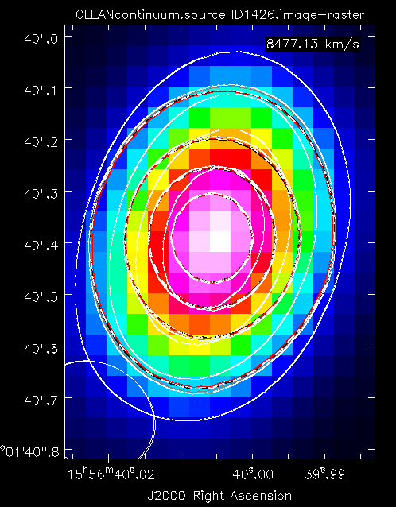
Color meaning is that gray is 18, red is 2, black is 8, dashed is 6 and 4

Job Number, amaxs, amaxw, epsilon, mstar, tstar, rstar, dist, mdot, mdotstar, tshock, alpha, mui, rdisk, temp, altinh, fracolive, fracpyrox, fracforst, fracent, lamaxb, d2g
2, 0.25, 1.0, 0.0001, 1.936, 7580, 2.13, 150.1, 7e-08, 7e-08, 8000, 0.01, 0.58, 80, 1400, 1, 0.65, 0.3, 0, 0.05, '1cm', 0.0065
4, 0.25, 1.0, 0.0001, 1.936, 7580, 2.13, 150.1, 7e-08, 7e-08, 8000, 0.01, 0.58, 90, 1400, 1, 0.65, 0.3, 0, 0.05, '1cm', 0.0065
6, 0.25, 1.0, 0.0001, 1.936, 7580, 2.13, 150.1, 7e-08, 7e-08, 8000, 0.01, 0.58, 100, 1400, 1, 0.65, 0.3, 0, 0.05, '1cm', 0.0065
8, 0.25, 1.0, 0.0001, 1.936, 7580, 2.13, 150.1, 7e-08, 7e-08, 8000, 0.01, 0.58, 110, 1400, 1, 0.65, 0.3, 0, 0.05, '1cm', 0.0065
18, 0.25, 1.0, 0.0001, 1.936, 7580, 2.13, 150.1, 8e-08, 8e-08, 8000, 0.01, 0.58, 80, 1400, 1, 0.65, 0.3, 0, 0.05, '1cm', 0.0065
20, 0.25, 1.0, 0.0001, 1.936, 7580, 2.13, 150.1, 8e-08, 8e-08, 8000, 0.01, 0.58, 90, 1400, 1, 0.65, 0.3, 0, 0.05, '1cm', 0.0065

The grid consisted of…
- eps = [0.0001], amaxs=0.25, amaxsw=1, amaxb = [1 cm, 1mm], mu=[0.58], rd=[80, 90, 100, 110, 120, 130, 200, 300], mdot=[7E-8, 8E-8, 9E-8, 1E-7, 1.86E-7]
[2][4][6][8][18][20]

