6: Trying both extremes of mdots, but changing mu now. Found that two good combinations to fit are eps ~ 0.001, 1 mm for amaxb, 1-4 for amaxs and amaxw, and low mdot
…OR
eps ~ 0.0001, 1 cm for amaxb, 0.1/0.25 for amaxs and 2/3 for amaxw, and high mdot

The grids, images, and SEDs are below…

A first grid testing high and low mdots with the different pairs of eps, mus (and an image too):
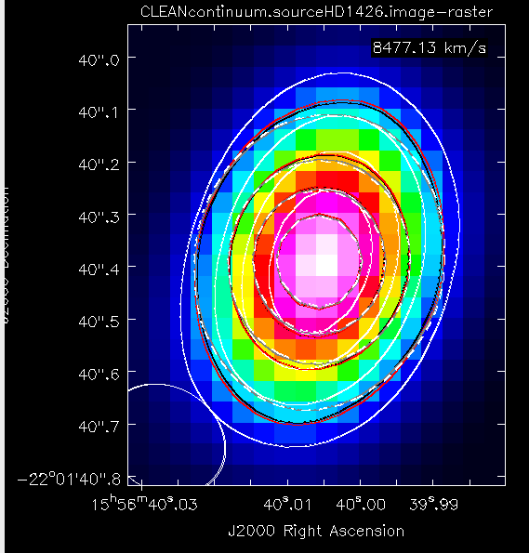
Note: The gray and dashed lines are 761 and 012. The red and black lines are 753 and 605.

The grid consisted of…
- For larger Mdot:
eps = [0.0001], amaxs=[1,2] ,amaxsw=[2, 3, 4], amaxb = [1cm], mu=[0.55, 0.65, 0.77], rd=[70, 80, 90, 100], mdot=[7.5E-8, 8E-8, 9E-8, 1E-7]
- For smaller Mdot:
eps = [0.001], amaxs=[1,2] ,amaxsw=[2, 3, 4], amaxb = [1mm], mu=[0.55, 0.65, 0.77], rd=[60, 70, 80], mdot=[3e-8, 4e-8, 5e-8, 6.5e-8, 7.5e-8]

Job Number, amaxs, amaxw, epsilon, mstar, tstar, rstar, dist, mdot, mdotstar, tshock, alpha, mui, rdisk, temp, altinh, fracolive, fracpyrox, fracforst, fracent, lamaxb, d2g
12, 1, 2, 0.0001, 1.936, 7580, 2.13, 150.1, 7.5e-08, 7.5e-08, 8000, 0.01, 0.66, 70, 1500, 1, 0.65, 0.3, 0, 0.05, '1cm', 0.0065
605, 2, 3, 0.001, 1.936, 7580, 2.13, 150.1, 3e-08, 3e-08, 8000, 0.01, 0.55, 80, 1400, 1, 0.65, 0.3, 0, 0.05, '1mm', 0.0065
753, 2, 4, 0.001, 1.936, 7580, 2.13, 150.1, 3e-08, 3e-08, 8000, 0.01, 0.55, 70, 1400, 1, 0.65, 0.3, 0, 0.05, '1mm', 0.0065
761, 2, 4, 0.001, 1.936, 7580, 2.13, 150.1, 3e-08, 3e-08, 8000, 0.01, 0.66, 60, 1400, 1, 0.65, 0.3, 0, 0.05, '1mm', 0.0065

[12]
[605]
[753]
[761]

The grid consisted of…
- eps = [0.001], amaxs=1 or 2 ,amaxsw=[2, 3, 4], amaxb = [1mm], mu=[0.45, 0.48, 0.5, 0.55, 0.58], rd=[120, 140, 160], mdot=[3e-8, 4e-8, 5e-8, 6.5e-8, 7.5e-8]

Job Number, amaxs, amaxw, epsilon, mstar, tstar, rstar, dist, mdot, mdotstar, tshock, alpha, mui, rdisk, temp, altinh, fracolive, fracpyrox, fracforst, fracent, lamaxb, d2g
2, 1, 2, 0.001, 1.957, 7580, 2.198, 150.1172854670921, 3e-08, 3e-08, 8000, 0.01, 0.45, 120, 1500, 1, 0.65, 0.3, 0, 0.05, '1mm', 0.0065

[2]

The grid consisted of…
- eps = [0.0001], amaxs=0.1 or 0.25, amaxsw=2 or 3, amaxb = [1 cm], mu=[0.45,0.48,0.5,0.58], rd=[60,80,100], mdot=[7.5E-8, 8E-8, 9E-8, 1E-7, 1.86E-7]

Job Number, amaxs, amaxw, epsilon, mstar, tstar, rstar, dist, mdot, mdotstar, tshock, alpha, mui, rdisk, temp, altinh, fracolive, fracpyrox, fracforst, fracent, lamaxb, d2g
866, 0.25, 4, 0.0001, 1.957, 7580, 2.198, 150.1172854670921, 1e-07, 1e-07, 8000, 0.01, 0.58, 60, 1600, 1, 0.65, 0.3, 0, 0.05, '1cm', 0.0065

[866]

